Additional file 1

In silico secretome analyses of the polyphagous root-knot nematode Meloidogyne javanica: A resource for studying M. javanica secreted proteins.
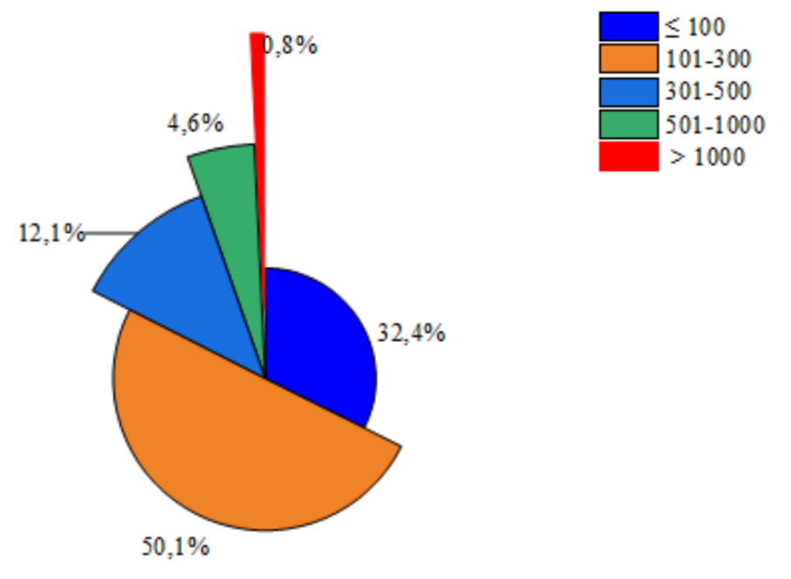
Figure S1. Proteins size distribution analysis in the predicted secretome of M. javanica.
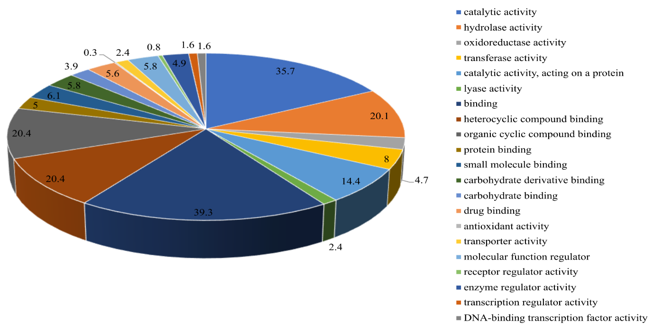
Figure S2. Distribution of Molecular function sub-categories of the predicted M. javanica secreted proteins.

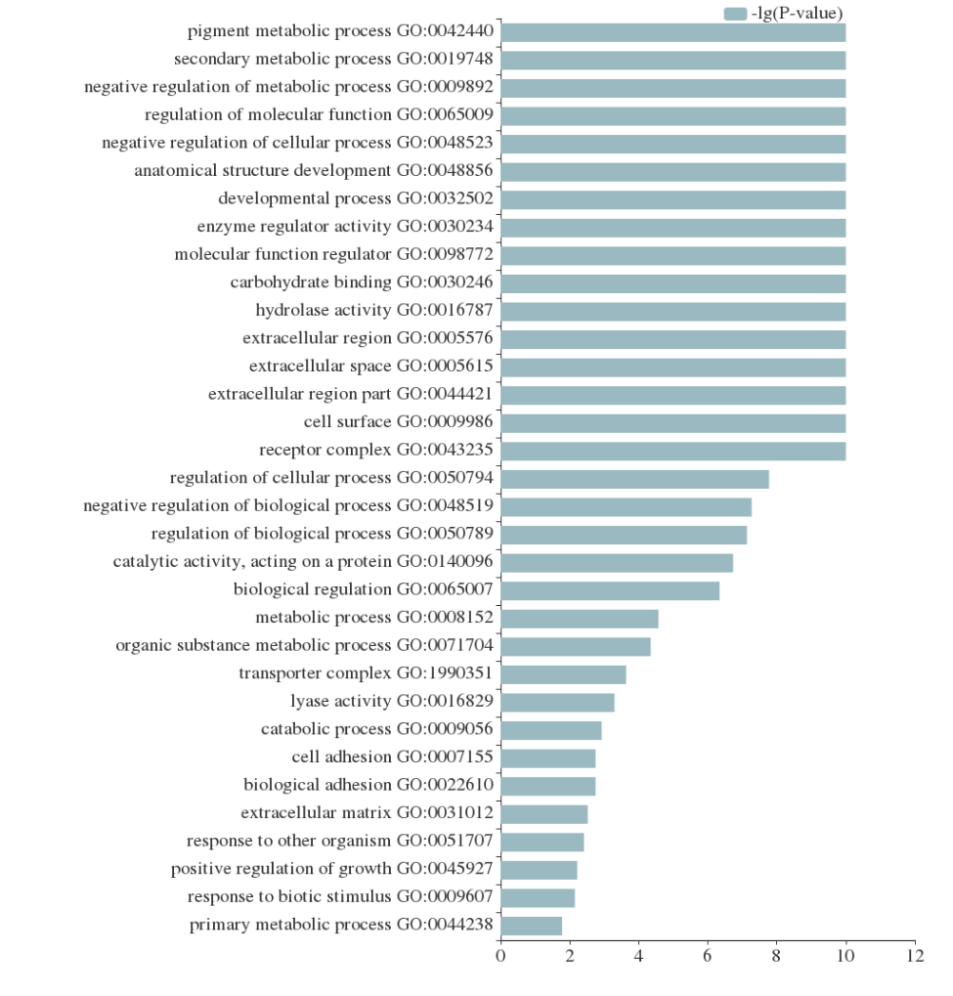
Figure S3. Gene ontology enrichment analysis of the predicted M. javanica secretome.

Figure S4. The distribution of cell-wall degrading enzymes functional classes in the predicted secretome of M. javanica.
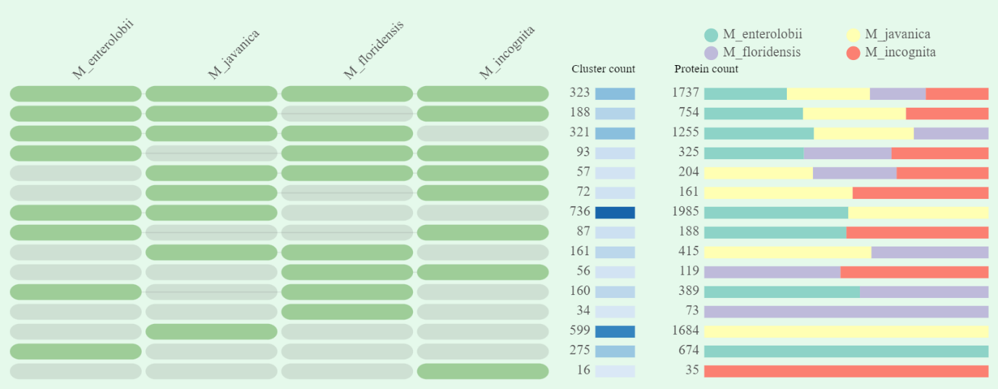
Figure S5. Orthovenn analysis illustrating the distribution of orthologous protein clusters of the predicted secretomes of four closely related Meloidogyne species. The unique and shared protein counts and clusters are shown.
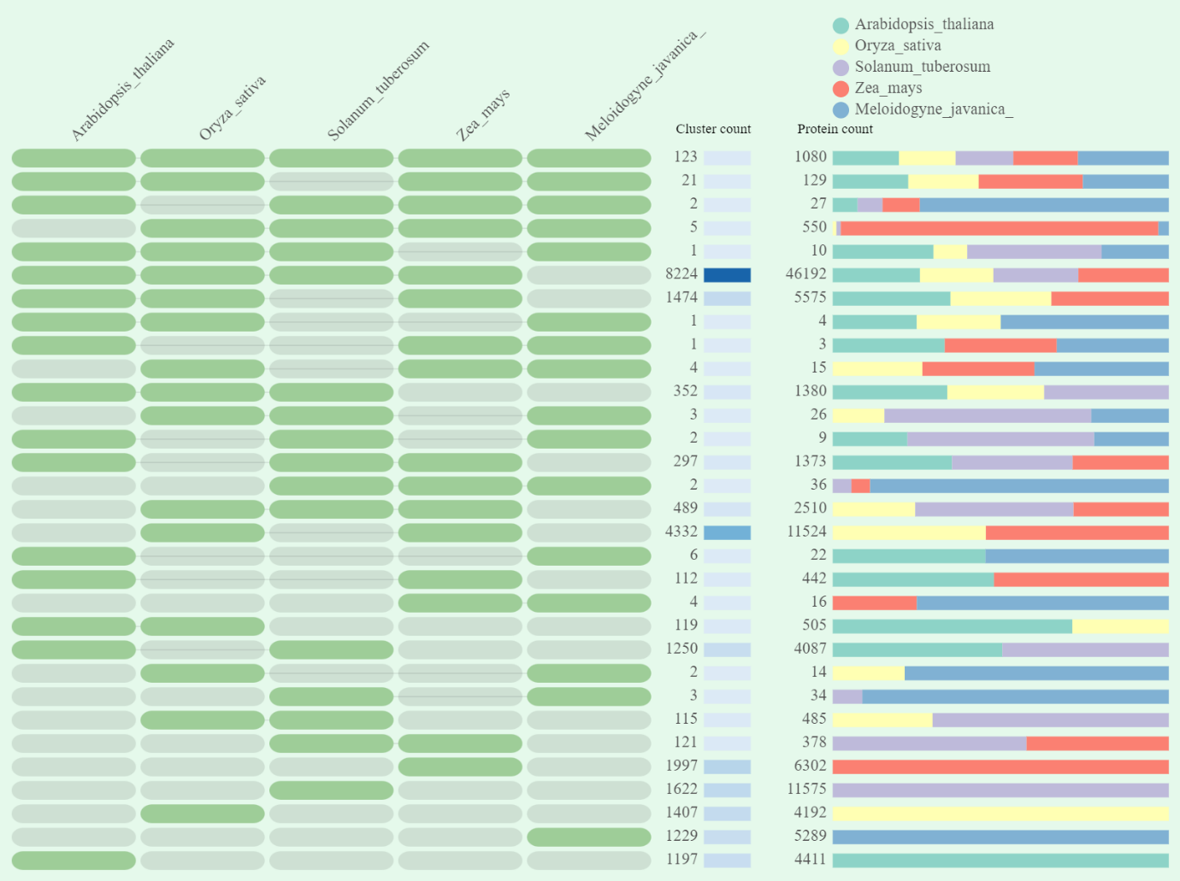
Figure S6. Cluster analysis depicting protein and cluster counts shared between M. javanica and host plant species.

