Supplementary data

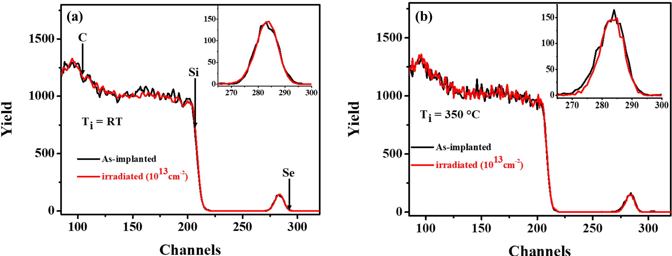
Fig. S1. RBS spectra of SiC implanted at (a) RT, and (b) 350 ℃ before and after SHIs irradiation. The insert(s) shows the Se profile.

