Multi-functional pheromones for efficient bioprotection against legume pests and enhanced food productivity

Hilaire Kpongbe¹*, Fathiya M. Khamis¹, Xavier Cheseto¹, Hillary K. Kirwa¹, Manuele Tamò²*, Baldwyn Torto^{1,3}*

¹International Centre of Insect Physiology and Ecology (icipe), Nairobi, Kenya
²International Institute of Tropical Agriculture (IITA), Cotonou, Benin
³Department of Zoology and Entomology, University of Pretoria, Private Bag X20, Hatfield 0028, South Africa

Correspondence: hkpongbe@icipe.org; m.tamo@cgiar.org; btorto@icipe.org

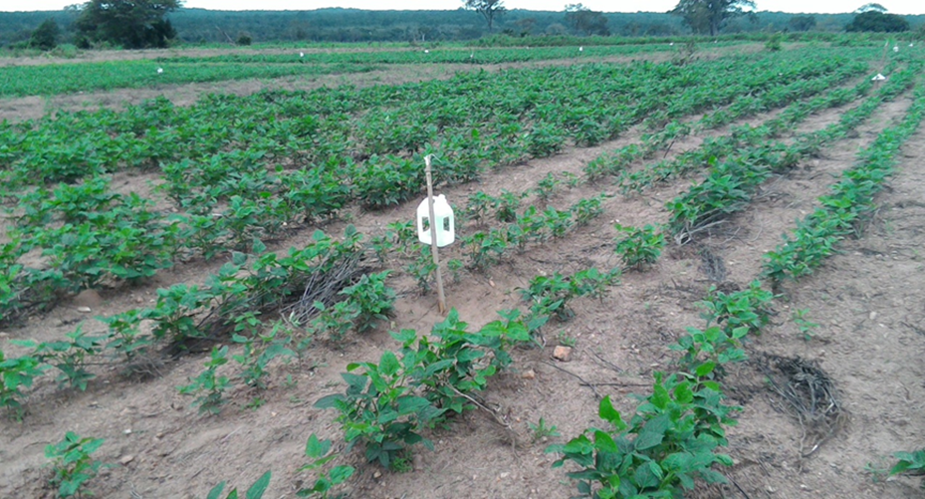
Fig. S1. Experimental field of pheromone-baited and -unbaited delta traps and water pan traps in a cowpea farm.

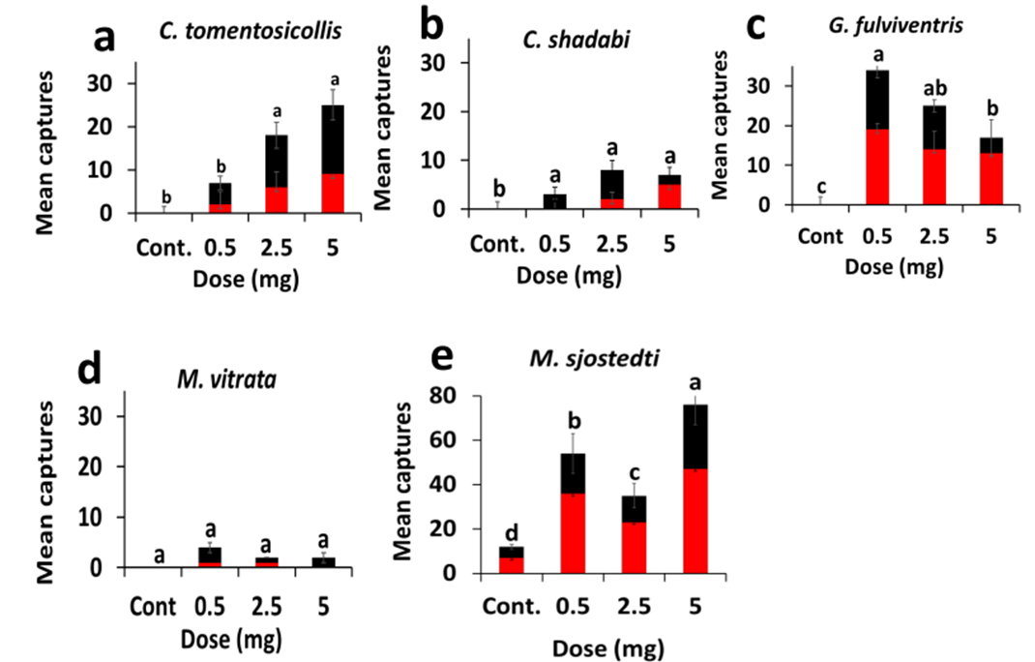


Fig. S2 Mean ± SE of trap captures of legume pests and natural enemy Gryon fulviventris with delta traps and water-pan traps with the aggregation pheromones of Clavigralla tomentosicollis (isopentyl butanoate) at different doses at a farmer cowpea field- Ahoyeme, Benin.

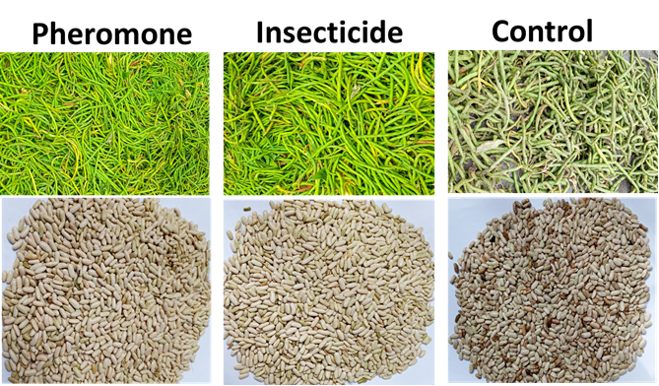
Fig. S3 Representative pods and seeds harvested from pheromone- and insecticide-treatments and control.

Table S1 Effect of different doses of isopentyl butanoate on captures of legume pests in a cowpea field- Ahoyeme (Benin)

 | Dose (mg) | Mean ± SE | P. value
C. tomentosicollis | 0.5 | 3.5 ± 1.5 b | < 0.001
C. tomentosicollis | 2.5 | 9.0 ± 3.0 a | < 0.001
C. tomentosicollis | 5 | 12.5 ± 3.5 a | < 0.001
C. tomentosicollis | Control | 0.0 ± 0.0 b | < 0.001
C. shadabi | 0.5 | 1.5 ± 1.5 a | < 0.01
C. shadabi | 2.5 | 4.0 ± 2.0 a | < 0.01
C. shadabi | 5 | 3.5 ± 1.5 a | < 0.01
C. shadabi | Control | 0.0 ± 0.0 b | < 0.01
G. fulviventris | 0.5 | 17.0 ± 2.0 a | < 0.001
G. fulviventris | 2.5 | 12.5 ± 1.5 ab | < 0.001
G. fulviventris | 5 | 8.5 ± 4.5 b | < 0.001
G. fulviventris | Control | 0.0 ± 0.0 c | < 0.001
M. vitrata | 0.5 | 2.0 ± 1.0 a | > 0.05
M. vitrata | 2.5 | 1.0 ± 0.0 a | > 0.05
M. vitrata | 5 | 1.0 ± 1.0 a | > 0.05
M. vitrata | Control | 0.0 ± 0.0 a | > 0.05
M. sjostedti | 0.5 | 27.0 ± 9.0 b | < 0.001
M. sjostedti | 2.5 | 17.5 ± 5.5 c | < 0.001
M. sjostedti | 5 | 38.0 ± 9.0 a | < 0.001
M. sjostedti | Control | 6.0 ± 1.0 d | < 0.001

Means with different letters in a column by insect species differ significantly (ANOVA, Tukey's honestly significant difference test (Tukey's HSD), P < 0.05). SE = Standard Error.

Table S2a Trap captures with different doses of 2-methylbutyl 2-methylbutanoate in different agroecological zones, Benin.
 |  | Zou (Mean captures) |  |  |  |  | Collines (Mean captures)
Species | Doses (mg) | Delta | Water | χ² | df | p-value | Delta | Water | χ² | df | p-value
C. tomentosicollis | Control | 0 | 0.25 | 0.25 | 1 | 0.617 | 0 | 1 | 1 | 1 | 0.317
C. tomentosicollis | 0.5 | 0.75 | 0.75 | 0 | 1 | 1 | 0 | 2.75 | 2.75 | 1 | 0.097
C. tomentosicollis | 2.5 | 2 | 3.5 | 0.40 | 1 | 0.522 | 0.5 | 4.75 | 3.44 | 1 | 0.063
C. tomentosicollis | 5 | 0.75 | 0.25 | 0.25 | 1 | 0.617 | 0.75 | 3.25 | 1.56 | 1 | 0.211
C. shadabi | Control | 0 | 0.25 | 0.25 | 1 | 0.617 | 0 | 0.5 | 0.5 | 1 | 0.479
C. shadabi | 0.5 | 0 | 0 | - | - | - | 0 | 1 | 1 | 1 | 0.317
C. shadabi | 2.5 | 0.5 | 0.5 | 0 | 1 | 1 | 2 | 2 | 0 | 1 | 1
C. shadabi | 5 | 0.5 | 0.5 | 0 | 1 | 1 | 0.25 | 2.25 | 1.84 | 1 | 0.174
G. fulviventris | Control | 1.5 | 0.5 | 0.5 | 1 | 0.479 | 0.5 | 0 | 0.5 | 1 | 0.479
G. fulviventris | 0.5 | 5.5 | 1 | 3.11 | 1 | 0.077 | 2 | 0.25 | 1.36 | 1 | 0.243
G. fulviventris | 2.5 | 22 | 1.75 | 17.26 | 1 | 3.25e-5 | 5 | 0.25 | 4.29 | 1 | 0.038
G. fulviventris | 5 | 6.75 | 0.75 | 4.8 | 1 | 0.028 | 1.75 | 1.5 | 0.01 | 1 | 0.889
M. vitrata | Control | 0.25 | 0 | 0.25 | 1 | 0.617 | 0 | 0 | - | - | -
M. vitrata | 0.5 | 0.25 | 0 | 0.25 | 1 | 0.617 | 0.75 | 0.5 | 0.05 | 1 | 0.823
M. vitrata | 2.5 | 0.75 | 3 | 1.35 | 1 | 0.245 | 0.5 | 1.75 | 0.69 | 1 | 0.404
M. vitrata | 5 | 0.5 | 0 | 0.5 | 1 | 0.479 | 0.75 | 0.5 | 0.05 | 1 | 0.823
M. sjostedti | Control | 27.25 | 1.25 | 23.71 | 1 | 1.11e-7 | 0 | 0 | - | - | -
M. sjostedti | 0.5 | 50.5 | 3.75 | 40.28 | 1 | 2.19e-11 | 3.25 | 2 | 0.29 | 1 | 0.58
M. sjostedti | 2.5 | 32 | 4 | 21.77 | 1 | 3.06e-07 | 0 | 0.75 | 0.75 | 1 | 0.386
M. sjostedti | 5 | 56.75 | 5.75 | 41.61 | 1 | 1.11e-11 | 0.25 | 0 | 0.25 | 1 | 0.617

χ² = Chi-square, df = degrees of freedom.

Table S2b Trap captures with different doses of isopentyl butanoate in different agroecological zones, Benin.
 |  | Zou (Mean captures) |  |  |  |  | Collines (Mean captures)
Species | Doses (mg) | Delta | Water | χ² | df | P. value | Delta | Water | χ² | df | P. value
C. tomentosicollis | Control | 0 | 0.25 | 0.25 | 1 | 0.617 | 0 | 1 | 1 | 1 | 0.317
C. tomentosicollis | 0.5 | 0 | 1 | 1 | 1 | 0.317 | 1 | 4 | 1.8 | 1 | 0.179
C. tomentosicollis | 2.5 | 1.25 | 5.5 | 2.67 | 1 | 0.101 | 1.25 | 5.75 | 2.89 | 1 | 0.088
C. tomentosicollis | 5 | 2.5 | 4.5 | 0.57 | 1 | 0.449 | 3 | 10 | 3.76 | 1 | 0.052
C. shadabi | Control | 0 | 0.25 | 0.25 | 1 | 0.617 | 0 | 0.5 | 0.5 | 1 | 0.148
C. shadabi | 0.5 | 0.5 | 0 | 0.5 | 1 | 0.479 | 0.75 | 0.5 | 0.05 | 1 | 0.823
C. shadabi | 2.5 | 0.5 | 1.25 | 0.32 | 1 | 0.570 | 0.5 | 0.75 | 0.05 | 1 | 0.823
C. shadabi | 5 | 0.25 | 2.75 | 2.08 | 1 | 0.148 | 1.5 | 1.75 | 0.01 | 1 | 0.889
G. fulviventris | Control | 1.5 | 0.5 | 0.5 | 1 | 0.479 | 0.5 | 0 | 0.5 | 1 | 0.479
G. fulviventris | 0.5 | 10 | 1.75 | 5.79 | 1 | 0.016 | 7 | 4.5 | 0.54 | 1 | 0.461
G. fulviventris | 2.5 | 5.75 | 1 | 3.34 | 1 | 0.067 | 2.5 | 1.25 | 0.41 | 1 | 0.518
G. fulviventris | 5 | 12.75 | 4.75 | 3.65 | 1 | 0.055 | 4.25 | 0.75 | 2.45 | 1 | 0.117
M. vitrata | Control | 0 | 0 | - | - | - | 0 | 0 | - | - | -
M. vitrata | 0.5 | 1.5 | 0 | 1.5 | 1 | 0.220 | 0.5 | 0.5 | 0 | 1 | 1
M. vitrata | 2.5 | 0.25 | 0 | 0.25 | 1 | 0.617 | 2.5 | 1.5 | 0.41 | 1 | 0.518
M. vitrata | 5 | 0.5 | 0.25 | 0.08 | 1 | 0.772 | 1 | 0.25 | 0.45 | 1 | 0.502
M. sjostedti | Control | 8.5 | 1 | 5.92 | 1 | 0.014 | 0.75 | 2.5 | 0.94 | 1 | 0.331
M. sjostedti | 0.5 | 9.5 | 2 | 4.89 | 1 | 0.026 | 0 | 1 | 1 | - | -
M. sjostedti | 2.5 | 12.5 | 2.75 | 6.23 | 1 | 0.012 | 0 | 0 | - |  | -
M. sjostedti | 5 | 9 | 2.5 | 3.67 | 1 | 0.055 | 0 | 0 | - | - | -

χ² = Chi-square, df = degrees of freedom

Table S3a Trap captures with different doses of 2-methylbutyl 2-methylbutanoate in different agroecological zones, Kenya.
 |  | Machakos (Mean captures) |  |  |  |  | Embu (Mean captures)
Species | Doses (mg) | Delta | Water | χ² | df | p-value | Delta | Water | χ² | df | p-value
C. tomentosicollis | Control | 0 | 0 | - | - | - | 0.25 | 0 | 0.25 | 1 | 0.617
C. tomentosicollis | 0.5 | 0.5 | 1 | 0.16 | 1 | 0.683 | 1 | 1.75 | 0.20 | 1 | 0.651
C. tomentosicollis | 2.5 | 1.5 | 3.5 | 0.8 | 1 | 0.371 | 2.5 | 4 | 0.34 | 1 | 0.556
C. tomentosicollis | 5 | 0.75 | 1 | 0.03 | 1 | 0.850 | 2.75 | 5 | 0.65 | 1 | 0.419
C. elongata | Control | 0 | 0.25 | 0.25 | 1 | 0.617 | 0 | 0 | - | - | -
C. elongata | 0.5 | 1,5 | 1.25 | 0.02 | 1 | 0.880 | 0.25 | 0.75 | 0.25 | 1 | 0.617
C. elongata | 2.5 | 3 | 4.25 | 0.21 | 1 | 0.642 | 2 | 0.25 | 1.36 | 1 | 0.243
C. elongata | 5 | 1.5 | 3.25 | 1.8 | 1 | 0.422 | 1 | 2.25 | 0.48 | 1 | 0.488
G. fulviventris | Control | 0.5 | 0.25 | 0.08 | 1 | 0.772 | 1.5 | 0.25 | 0.89 | 1 | 0.344
G. fulviventris | 0.5 | 2 | 4.25 | 0.81 | 1 | 0.368 | 3.75 | 5.75 | 0.42 | 1 | 0.516
G. fulviventris | 2.5 | 2 | 1.75 | 0.01 | 1 | 0.897 | 4.25 | 6 | 0.29 | 1 | 0.584
G. fulviventris | 5 | 3 | 4.75 | 0.39 | 1 | 0.529 | 3.5 | 5.25 | 0.35 | 1 | 0.554
M. vitrata | Control | 0 | 0.25 | 0.25 | 1 | 0.617 | 0 | 0 | - | - | -
M. vitrata | 0.5 | 1.5 | 0.25 | 0.89 | 1 | 0.344 | 0 | 0.25 | 0.25 | 1 | 0.617
M. vitrata | 2.5 | 1.25 | 0.5 | 0.32 | 1 | 0.570 | 0.5 | 0 | 0.5 | 1 | 0.479
M. vitrata | 5 | 2.5 | 0.75 | 0.94 | 1 | 0.331 | 0.5 | 0.25 | 0.08 | 1 | 0.772
M. sjostedti | Control | 2.75 | 0.75 | 1.14 | 1 | 0.285 | 3 | 1.25 | 0.72 | 1 | 0.396
M. sjostedti | 0.5 | 2.25 | 3 | 0.10 | 1 | 0.743 | 1.25 | 2.25 | 0.28 | 1 | 0.59
M. sjostedti | 2.5 | 3.5 | 2.75 | 0.09 | 1 | 0.764 | 6.25 | 2 | 2.18 | 1 | 0.139
M. sjostedti | 5 | 3.5 | 2.75 | 0.09 | 1 | 0.764 | 6.75 | 2.75 | 1.68 | 1 | 0.194
B. tabaci | Control | 4 | 2.25 | 0.49 | 1 | 0.483 | 4.75 | 2.75 | 0.53 | 1 | 0.465
B. tabaci | 0.5 | 54.25 | 33.5 | 4.90 | 1 | 0.026 | 36 | 20.5 | 4.25 | 1 | 0.039
B. tabaci | 2.5 | 36.5 | 24.5 | 2.36 | 1 | 0.124 | 28 | 25.75 | 0.09 | 1 | 0.758
B. tabaci | 5 | 25.75 | 19 | 1.01 | 1 | 0.313 | 19.5 | 13.5 | 1.09 | 1 | 0.296

χ² = Chi-square, df = degrees of freedom.
Table S3b Trap captures with different doses of isopentyl butanoate in different agroecological zones, Kenya.
 |  | Machakos (Mean captures) |  |  |  |  | Embu (Mean captures)
Species | Doses (mg) | Delta catches | Water catches | χ² | df | P. value | Delta catches | Water catches | χ² | df | P. value
C. tomentosicollis | Control | 0 | 0 | - | - | - | 0.25 | 0 | 0.25 | 1 | 0.617
C. tomentosicollis | 0.5 | 0.75 | 1.25 | 0.12 | 1 | 0.723 | 1 | 4 | 1.8 | 1 | 0.179
C. tomentosicollis | 2.5 | 2.25 | 4 | 0.49 | 1 | 0.483 | 6.5 | 13 | 2.16 | 1 | 0.141
C. tomentosicollis | 5 | 3.25 | 9.5 | 3.06 | 1 | 0.080 | 5 | 11 | 2.25 | 1 | 0.133
C. elongata | Control | 0 | 0.25 | 0.25 | 1 | 0.617 | 0 | 0 | - | - | -
C. elongata | 0.5 | 0 | 0.5 | 0.5 | 1 | 0.479 | 0 | 0 | - | - | -
C. elongata | 2.5 | 1,5 | 2.75 | 0.36 | 1 | 0.54 | 1.5 | 1.25 | 0.02 | 1 | 0.880
C. elongata | 5 | 1.75 | 4.25 | 1.04 | 1 | 0.307 | 1 | 1 | 0 | 1 | 1
G. fulviventris | Control | 0.5 | 0.25 | 0.08 | 1 | 0.772 | 1.5 | 0.25 | 0.89 | 1 | 0.344
G. fulviventris | 0.5 | 8.75 | 8.5 | 0 | 1 | 0.952 | 9.5 | 3.75 | 2.32 | 1 | 0.127
G. fulviventris | 2.5 | 4.5 | 2.75 | 0.42 | 1 | 0.51 | 8.25 | 7.75 | 0.01 | 1 | 0.900
G. fulviventris | 5 | 2.5 | 3 | 0.04 | 1 | 0.831 | 4.5 | 7 | 0.54 | 1 | 0.461
M. vitrata | Control | 0 | 0.25 | 0.25 | 1 | 0.617 | 0 | 0 | - | - | -
M. vitrata | 0.5 | 2 | 0.5 | 0.69 | 1 | 0.404 | 0 | 0 | - | - | -
M. vitrata | 2.5 | 0.5 | 1.25 | 0.32 | 1 | 0.570 | 1 | 0 | - | - | -
M. vitrata | 5 | 0.75 | 0 | 0.75 | 1 | 0.386 | 0 | 0 | - | - | -
M. sjostedti | Control | 6 | 0 | 6 | 1 | 0.014 | 0.75 | 1.5 | 0.25 | 1 | 0.617
M. sjostedti | 0.5 | 0.75 | 1.75 | 0.4 | 1 | 0.527 | 0.5 | 1.75 | 0.69 | 1 | 0.404
M. sjostedti | 2.5 | 0.75 | 0 | 0.75 | 1 | 0.386 | 0.25 | 0.5 | 0.08 | 1 | 0.772
M. sjostedti | 5 | 0.5 | 0.25 | 0.08 | 1 | 0.772 | 1.5 | 0.5 | 0.5 | 1 | 0.479

χ² = Chi-square, df = degrees of freedom

Table S4a Comparison of insects captured regardless of trap types and doses at both sites in Benin with C. elongata and C. tomentosicollis pheromones.
 | Benin (2-methylbutyl 2-methylbutanoate) |  |  |  |  | Benin (isopentyl butanoate)
Species | Zou | Collines | χ² | df | p-value | Zou | Collines | χ² | df | p-value
C. tomentosicollis | 32 | 50 | 3.95 | 1 | 0.046 | 58 | 102 | 12.1 | 1 | 0.5e-4
C. shadabi | 9 | 29 | 10.52 | 1 | 0.001 | 21 | 83 | 36.96 | 1 | 1.20e-11
C. elongata | 58 | 27 | 11.30 | 1 | 0.7e-4
G. fulviventris | 70 | 115 | 10.94 | 1 | 9.3e-5 | 148 | 45 | 54.96 | 1 | 1.22e-14
M. vitrata | 9 | 36 | 16.2 | 1 | 5.69e-05 | 10 | 39 | 17.16 | 1 | 3.43e-05
M. sjostedti | 25 | 725 | 653.33 | 1 | < 2.2e-16 | 191 | 17 | 145.56 | 1 | 2.2e-16

Table S4b Comparison of insects captured regardless of trap types and doses at both sites in Kenya with C. elongata and C. tomentosicollis pheromones.
 | Kenya (2-methylbutyl 2-methylbutanoate) |  |  |  |  | Kenya (isopentyl butanoate)
Species | Machakos | Embu | χ² | df | p-value | Machakos | Embu | χ² | df | p-value
C. tomentosicollis | 34 | 67 | 10.78 | 1 | 0.001 | 84 | 163 | 25.26 | 1 | 4.99e-08
C. elongata | 58 | 27 | 11.30 | 1 | 7.7e-4 | 49 | 20 | 12.18 | 1 | 4.8e-4
G. fulviventris | 70 | 115 | 10.94 | 1 | 9.3e-4 | 121 | 166 | 7.05 | 1 | 0.007
M. vitrata | 41 | 3 | 32.81 | 1 | 1.01e-09 | 27 | 0 | 27 | 1 | 2.03e-08
M. sjostedti | 74 | 102 | 4.45 | 1 | 0.035 | 40 | 29 | 1.75 | 1 | 0.18
B. tabaci | 795 | 605 | 25.78 | 1 | 3.81e-07 | - | - | - | - | -

χ² = Chi-square, df = degrees of freedom

Table S5 Statistical analyses associated with both males and females of Clavigralla elongata captured by delta trap and water-pan trap in two agroecological zones in Kenya.
Locality | Trap type | Combination | χ² | df | p-value
Machakos | Delta trap | Male vs Female | 0.2 | 1 | 0.654
Machakos | Water-pan trap | Male vs Female | 0.125 | 1 | 0.724
Embu | Delta trap | Male vs Female | 1.6 | 1 | 0.206
Embu | Water-pan trap | Male vs Female | 0.090 | 1 | 0.763

χ² = Chi-square, df = degrees of freedom

 | Site 1 |  |  |  | Site 2
Treatment | Yield (Kg) | χ² | df | p-value | Yield (Kg) | χ² | df | p-value
Pheromone vs control | 3.66189 vs 1.14785 | 1.31 | 1 | 0.251 | 4.21813 vs 0.85625 | 2.22 | 1 | 0.135
Pesticide vs control | 3.80351 vs 1.14785 | 1.42 | 1 | 0.232 | 5.00337 vs 0.85625 | 2.93 | 1 | 0.08
Pheromone vs pesticide | 3.66189 vs 3.80351 | 0.002 | 1 | 0.958 | 4.21813 vs 5.00337 | 0.06 | 1 | 0.796
Table S6 Comparison of yield from the field treated with 2-methylbutyl 2-methylbutyrate to those from farmer’s practices and absolute control fields in two study sites in Kenya.

χ² ⁼ Chi-square, df= degrees of freedom

