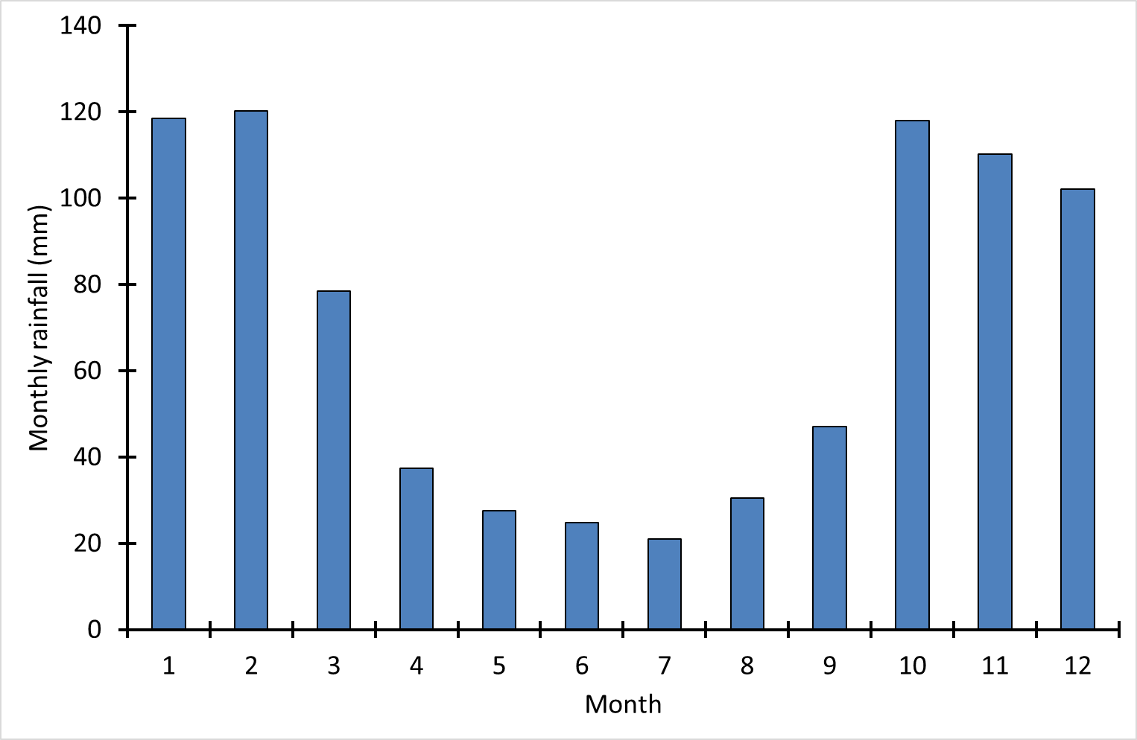
S2 Fig. Monthly rainfall in HiP.

