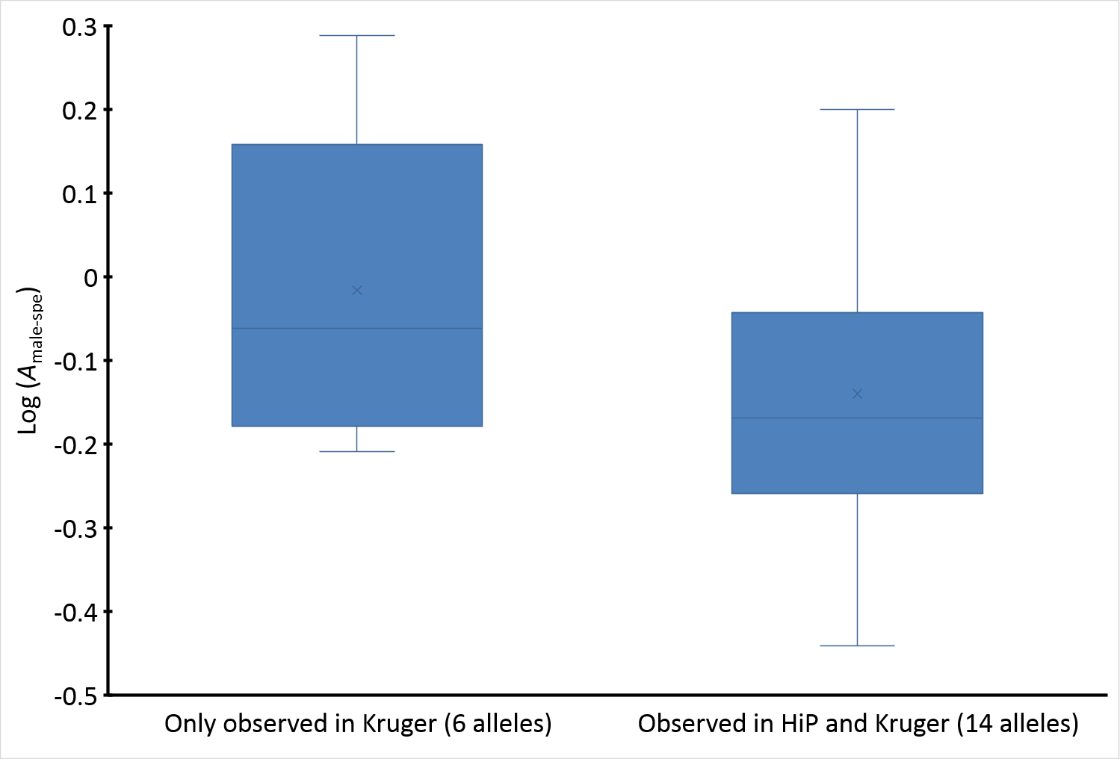 S5 Fig. Difference in A_{male-spec} between SAE_{indvN} alleles from Kruger observed and not observed in HiP
Median difference = 0.08, P = 0.15.

