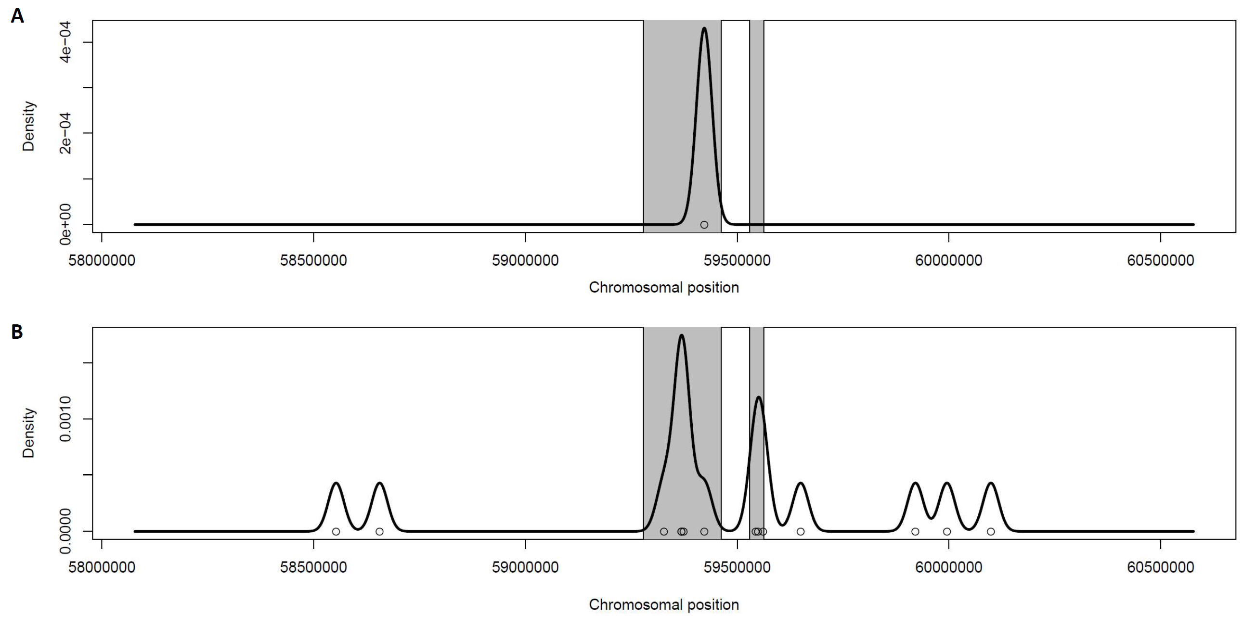

Additional file 3. Distribution of the selected SNVs identified by WGS in the 17q23.1q23.2 CNV deletion region (hg19) showing their enrichment. A) Enrichment of variants with MAF < 10% (GnomAD, r2.0.2) observed in presented patient (AD094). B) Enrichment of variants with MAF < 10% (GnomAD, r2.0.2) observed in patient AD094 and previously reported patients with lethal lung developmental disorder and 17q23.1q23.2 CNV deletion (Karolak et al., 2019).

