Construction of Hierarchical S-Scheme MgIn₂S₄/CeO₂ heterojunction for boosted photocatalytic oxidation of tetracycline and reduction of Cr(VI)
Damilola Caleb Akintayo¹, Tunde Lewis Yusuf², Nonhlangabezo Mabuba^{1,3}
¹Department of Chemical Sciences, Faculty of Science, University of Johannesburg, Doornfontein Campus, Johannesburg, 2028, South Africa.
²Department of Chemistry, Faculty of Natural and Agricultural Sciences, University of Pretoria, Private Bag X20, Hatfield 0028, Pretoria, South Africa.
³ Center for Nanomaterials Science research, Faculty of Science, University of Johannesburg, Doornfontein Campus, Johannesburg, 2028, South Africa.

SUPPLEMENTARY INFORMATION

Figure S1: % TOC removal plot for the photooxidation of tetracycline over MgIn₂S₄/CeO₂

Figure S2: Reusability studies for the photooxidation of tetracycline over MgIn₂S₄/CeO₂

Figure S3: UPLC-MS spectra of the photooxidation of tetracycline over MgIn₂S₄/CeO₂

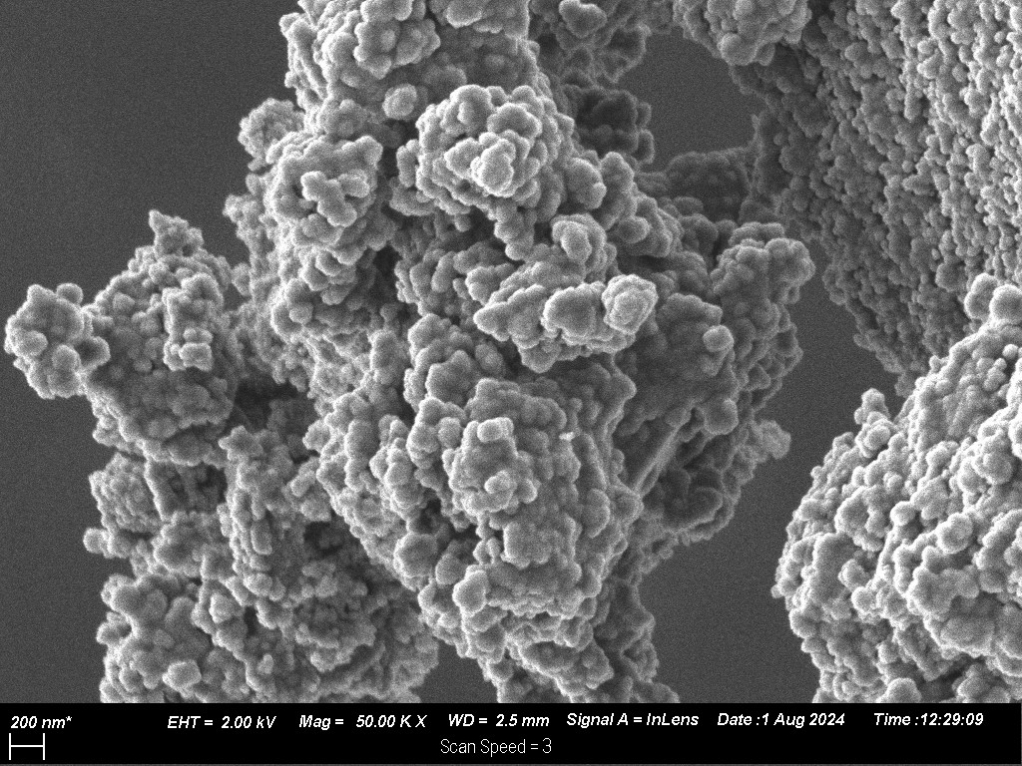

Figure S4: SEM images for CeO₂
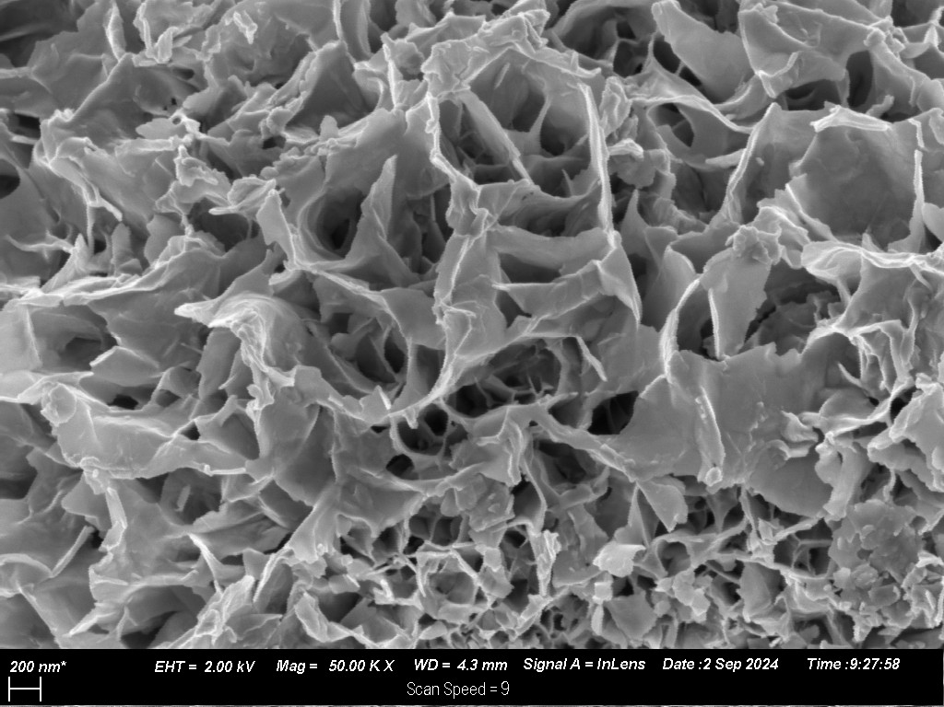
Figure S5: SEM images for MgIn₂S₄

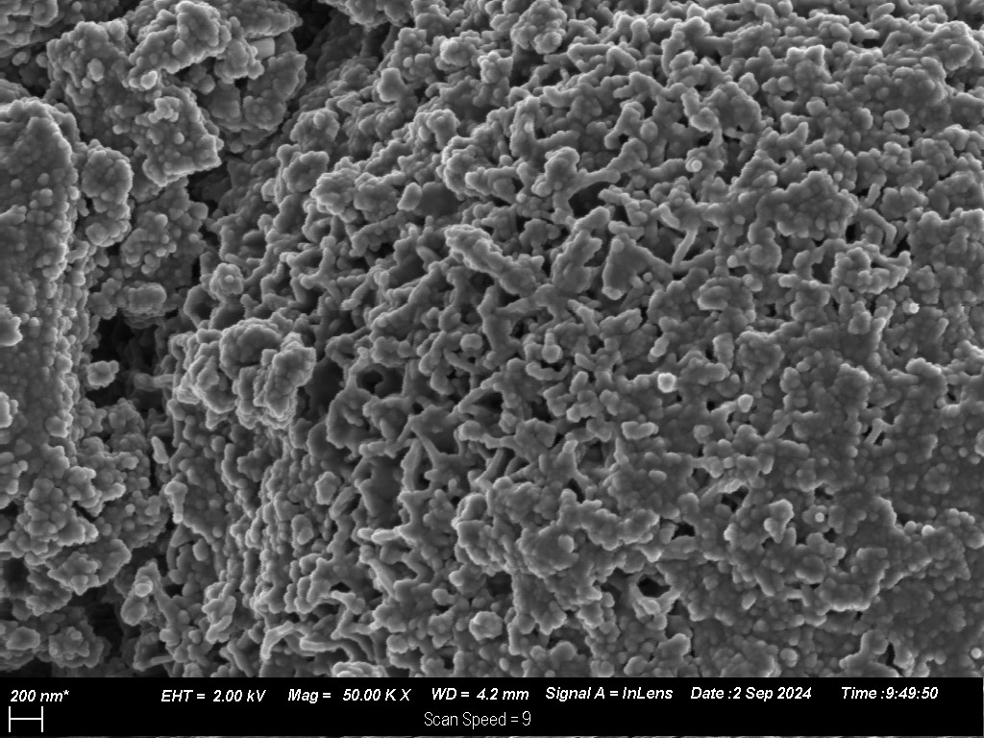
Figure S6: SEM images for MgIn₂S₄/CeO₂

