Supporting Information
Naphthylisoquinoline alkaloids, validated as hit multistage antiplasmodial natural products
Phanankosi Moyo^{a,1}, William Shamburger^{b,1}, Mariëtte E. van der Wattª, Janette Readerª, Ana Carolina C. de Sousa^{c}, Timothy J. Egan^{c,e}, Vinesh J. Maharaj^{d}, Gerhard Bringmann^{b,d}*, Lyn-Marie Birkholtzª*
ª Malaria Parasite Molecular Laboratory, Department of Biochemistry, Genetics and Microbiology, Institute for Sustainable Malaria Control, Faculty of Natural and Agricultural Sciences, University of Pretoria, Private Bag x20, Hatfield 0028, South Africa
^{b} Institute of Organic Chemistry, University of Würzburg, Am Hubland, 97074 Würzburg, Germany
^{c} Department of Chemistry, Faculty of Science, University of Cape Town, Rondebosch 7701, South Africa
^{d} Department of Chemistry, Faculty of Natural and Agricultural Sciences, University of Pretoria, Private Bag x20, Hatfield 0028, South Africa
^{e} Institute of Infectious Disease and Molecular Medicine, University of Cape Town, Observatory, 7925, South Africa
¹ Equal contributors
* Corresponding authors:
Gerhard Bringmann (Compound isolation and synthesis): Tel. +49 931 318 5323; Fax: +49 931 318 4755; E-mail address. bringman@chemie.uni-wuerzburg.de
Lyn-Marie Birkholtz (Biological assays): Tel. +27 12 420 2479; Fax: +27 12 362 5302; E-mail address. lbirkholtz@up.ac.za

Table of Contents
A Auto-Fluorescence Assessment 3
B Synthetic Approach for the Preparation of Compounds 2a and 6 6
C General Synthetic Procedures 9
D Synthesis of the Isoquinoline Building Block 10
E Synthesis of the Naphthalene Building Blocks 13
F Suzuki Coupling and Deprotection Reactions 16
G NMR Spectra 21
G.1 Isoquinolines 21
G.2 Naphthalenes 30
G.3 Coupled Compounds 41
H ECD Spectra 56
I List of Abbreviations 57
J References 57

- Auto-Fluorescence Assessment
To ensure that the tested compounds did not interfere in the readout by auto-fluorescence, an assay was set up to investigate such a possible artefact. Each compound (100 μl of a 10 µM solution in culture medium) was mixed with the SYBR Green-I dye (100 μl) and incubated for 1 h, after which fluorescence was measured as previously described (Verlinden et al., 2011). The determined raw fluorescence units were compared to those of media only, i.e. with no P. falciparum parasite lysate, and to those of chloroquine treated P. falciparum parasites. As the obtained units did not vary significantly, we concluded that none of the tested compounds showed auto-fluorescence (Table S1).
Table S1 Measured raw fluorescence units for naphthylisoquinoline alkaloids and their analogues (n = 1).
Compound | Raw fluorescence units |  |  | Compound | Raw fluorescence units
Compound | Mean | SD |  |  | Mean | SD
Media | 2.62 | 0.06 |  | Simplified NIQs
Chloroquine | 2.58 | 0.08 |  | Compound 11 | 2.95 | 0.04
Monomeric NIQs |  |  |  | Compound 12 | 2.89 | 0.05
Dioncopeltine A (5) | 2.69 | 0.04 |  | Compound 13 | 2.70 | 0.06
Habropetaline A (4) | 2.59 | 0.09 |  | Compound 14 | 2.64 | 0.10
Dioncophylline C (2a) | 2.61 | 0.04 |  | Compound 15 | 2.55 | 0.12
Atropisomer 2b | 2.56 | 0.07 |  | Compound 16 | 2.72 | 0.08
Regioisomer 6 | 2.61 | 0.04 |  | Compound 17 | 2.69 | 0.03
Ancistrocladinium A (7) | 2.74 | 0.05 |  | Compound 18 | 3.17 | 0.10
Dioncophylline A (1) | 2.67 | 0.15 |  | Compound 19 | 2.69 | 0.05
Dimeric NIQs |  |  |  | Compound 20 | 3.25 | 0.13
Jozimine A₂ (3a) | 2.66 | 0.13 |  | Compound 21 | 3.36 | 0.16
Jozibrevine C (3b) | 2.66 | 0.15 |  | Compound 22 | 2.84 | 0.09
Jozilebomine A (10) | 2.64 | 0.08 |  | Compound 23 | 2.70 | 0.07
Ealapasamine C (8) | 2.54 | 0.01 |  | Compound 24 | 2.98 | 0.65
Synthetic dimer 9 | 2.46 | 0.02 |  | Compound 25 | 2.76 | 0.03
 |  |  |  | Compound 26 | 2.87 | 0.17
 |  |  |  | Compound 27 | 2.73 | 0.06
 |  |  |  | Compound 28 | 2.66 | 0.04

Table S2 Antiplasmodial activity of naphthylisoquinoline alkaloids and their analogues

Compound | Inhibition of parasite proliferation IC₅₀ (µM)
 | NF54 | W2 | K1 | Dd2 | 7G8 | HB3 | SB_04 | SB_05 | SB_07
Chloroquine | 0.0130 ± 0.0014 | 0.383 ± 0.086 | 0.157 ± 0.031 | 0.063 ± 0.014 | 0.0411± 0.0057 | 0.0106 ± 0.0018 | 0.00590 ± 0.00049 | 0.00980 ± 0.00019 | 0.0114 ± 0.0049
Monomeric NIQs
Dioncopeltine A (5) | 0.0080 ± 0.0018 | 0.303 ± 0.058 | 0.055 ± 0.011 | 0.038 ± 0.012 | 0.0202 ± 0.0089 | 0.0110 ± 0.0019 | 0.00250 ± 0.00011 | 0.00980 ± 0.00030 | 0.0054 ± 0.0010
Habropetaline A (4) | 0.0156 ± 0.0017 | 0.084 ± 0.028 | 0.0292 ± 0.0058 | 0.0162 ± 0.0048 | 0.0115 ± 0036 | 0.0155 ± 0.0038 | 0.00360 ± 0.00070 | 0.00460 ± 0.00053 | 0.00640 ± 0.00035
Dioncophylline C (2a) | 0.0384 ± 0.0017 | 0.112 ± 0.014 | 0.0436 ± 0.0089 | 0.0297 ± 0.0083 | 0.0217 ± 0.0050 | 0.0303 ± 0.0038 | 0.01380 ± 0.00035 | 0.0173 ± 0.0010 | 0.02360 ± 0.00047
Analogue 2b* | 0.234 ± 0.023 | 0.56 ± 0.11 | 0.355 ± 0.075 | 0.248 ± 0.046 | 0.131 ± 0.027 | 0.1393 ± 0.0088 | 0.0610 ± 0.0052 | 0.1072 ± 0.0057 | 0.1659 ± 0.0065
Analogue 6* | 0.0415 ± 0.0024 | 0.138 ± 0.018 | 0.056 ± 0.013 | 0.0597 ± 0.0069 | 0.0102 ± 0.0046 | 0.0163 ± 0.0030 | 0.0121 ± 0.0011 | 0.0198 ± 0.0023 | 0.0279 ± 0.0024
Ancistrocladinium A (7) | 0.493 ± 0.044 | 1.87 ± 0.53 | 0.626 ± 0.041 | 0.438 ± 0.046 | 0.71 ± 0.16 | 0.416 ± 0.062
Dioncophylline A (1) | 1.327 ± 0.048
Dimeric NIQs
Jozimine A₂ (3a) | 0.151 ± 0.017 | 0.2431 ± 0.0038 | 0.171 ± 0.030 | 0.1160 ± 0.0092 | 0.0866 ± 0.0092 | 0.157 ± 0.017 | 0.0942 ± 0.0070 | 0.1116 ± 0.0041 | 0.222 ± 0.019
Jozibrevine C (3b) | 0.265 ± 0.011 |  | 0.062 ± 0.010 |  |  |  |  | 0.179 ± 0.041
Jozilebomine A (10) | 0.167 ± 0.032 |  | 0.125 ± 0.019 |  |  |  |  | 0.095 ± 0.017
Ealapasamine C (8) | 0.063 ± 0.010 | 0.1336 ± 0.0040 | 0.130 ± 0.019 | 0.0701 ± 0.0013 | 0.096 ± 0.014 | 0.1772 ± 0.0062 | 0.0691 ± 0.0020 | 0.0573 ± 0.0016 | 0.130 ± 0.028
Dimer 9 | 0.0878 ± 0.0025 | 0.184 ± 0.061 | 0.115 ± 0.026 | 0.082 ± 0.010 | 0.070 ± 0.014 | 0.1807 ± 0.0076 | 0.0492 ± 0.0021 | 0.0490 ± 0.0022 | 0.086 ± 0.016
Simplified NIQs#
Compound 11 | 5.09 ± 0.87
Compound 12 | 0.99 ± 0.11 | 0.96 ± 0.27 | 0.446 ± 0.083 | 0.653 ± 0.141 | 0.210 ± 0.048 | 1.03 ± 0.11 | 0.808 ± 0.023 | 0.923 ± 0.037 | 1.235 ± 0.055
Compound 13 | 3.90 ± 0.61
Compound 14 | 4.00 ± 0.57
Compound 15 | 5.110 ± 0.062
Compound 16 | 22.0 ± 3.6
Compound 17 | 1.93 ± 0.22
Compound 18 | 0.74 ± 0.13 | 0.87 ± 0.37 | 0.77 ± 0.31 | 0.60 ± 0.12 | 0.343 ± 0.054 | 0.8928 ± 0.0090 | 0.7944 ± 0.0052 | 0.7887 ± 0.0092 | 1.10 ± 0.11
Compound 19 | 14.53 ± 0.94
Compound 20 | 1.632 ± 0.093
Compound 21 | 1.425 ± 0.055
Compound 22 | 0.715 ± 0.084 | 0.238 ± 0.072 | 0.147 ± 0.011 | 0.208 ± 0.031 | 0.127 ± 0.018 | 0.4148 ± 0.0037 | 0.4926 ± 0.0038 | 0.4646 ± 0.0045 | 0.805 ± 0.051
Compound 23 | 0.517 ± 0.018 | 0.285 ± 0.034 | 0.163 ± 0.033 | 0.213 ± 0.047 | 0.087 ± 0.019 | 0.409 ± 0.013 | 0.338 ± 0.054 | 0.356 ± 0.021 | 0.663 ± 0.067
Compound 24 | 6.09 ± 0.42
Compound 25 | 0.744 ± 0.035 | 2.13 ± 0.40 | 1.62 ± 0.44 | 1.623 ± 0.099 | 0.97 ± 0.21 | 1.14 ± 0.14
Compound 26 | 12.43 ± 0.85
Compound 27 | 0.576 ± 0.027 | 0.80 ± 0.38 | 0.359 ± 0.081 | 0.408 ± 0.077 | 0.183 ± 0.014 | 0.553 ± 0.081 | 0.46390 ± 0.00085 | 0.3807 ± 0.0057 | 0.659 ± 0.067
Compound 28 | 25.4 ± 2.6
IC₅₀ values are from two or more independent biological experiments carried out in technical triplicates (n ≥ 2) with data presented as mean ± SEM (corrected to two significant figures). *Derivatives of dioncophylline C (2a); #Molecular design based on QSAR-guided studies.

Table S3 Origin and drug resistance profile of P. falciparum strains and clinical isolates
Name | Origin | Resistant to | References
NF54 | Undefined | None | (Fidock et al., 2004)
W2 | Indochina | CQ, QN, PYR, SDX | (Fidock et al., 2004)
K1 | Thailand | CQ, PYR | (Fidock et al., 2004)
Dd2 | Indochina | CQ, QN, PYR, SDX | (Fidock et al., 2004)
7G8 | Brazil | CQ, PYR, CYC | (Fidock et al., 2004)
HB3 | Honduras | PYR | (Fidock et al., 2004)
SB 04 | Malawi | PYR | (van der Watt et al., 2018)
SB 05 | Mozambique | PYR, MEF | (van der Watt et al., 2018)
SB 07 | Malawi | PYR, MB | (van der Watt et al., 2018)
CQ – chloroquine, QN – quinine, PYR – pyrimethamine, SDX – sulphadoxine, CYC – cycloguanil, MEF – mefloquine, MB – methylene blue.
Fig. S1. A selection of compounds showing the impact of structural changes on the activity against P. falciparum.

- Synthetic Approach for the Preparation of Compounds 2a and 6
In previous work on the synthesis of naphthylisoquinolines, the Suzuki-Miyaura coupling had been applied successfully to construct biaryl axes (Bringmann et al., 2000; Bringmann et al., 2003; Li et al., 2017). In a slightly modified approach, we synthesised 5-epi-dioncophylline C (2b) and its regioisomer 6 by the coupling of S1 with S2, and S1 with S3, respectively (Scheme 1).
Scheme 1: The Suzuki coupling reaction as a key step in the synthesis of the naphthylisoquinolines 2b and 6.
The synthesis of the isoquinoline building block S1 started from the known compound S4 (Bringmann et al., 2010a). Protection of the free hydroxy function with isopropyl iodide gave S5 as the precursor for the ensuing diastereoselective reduction using LiAlH₄ with AlMe₃, which yielded the 1,3-trans-configured compound S6, in a ratio of 70:30 in favour of the anticipated trans-stereoisomer (Scheme 2). N-Benzylation gave the fully protected, 1R,3R-configured tetrahydroisoquinoline S1.
Scheme 2: Synthesis of the bromo-activated isoquinoline S1.
Due to the similarity of the synthesis of the naphthalenes S2 and S3, these procedures are discussed in parallel (Scheme 3). The construction of the naphthalene framework was based on a method described earlier (Watanabe et al., 1986) and already applied successfully to the total synthesis of several naphthylisoquinolines (Bringmann et al., 2010b; Li et al., 2017; Seupel et al., 2016). It started with the Diels-Alder reaction of S7 and S8 with the acrylic acid amide S9 to yield the naphthols S10 and S11, respectively. The hydroxy function in S10 and S11 was methylated by phase-transfer catalysed reaction with dimethyl sulfate in a mixture of water and dichloromethane to give S12 and S13, respectively. Using N-bromo succinimide as the brominating agent, the respective naphthalenes were halogenated regioselectively to give S14 and S15. Palladium-catalysed borylation generated the 1-boronic acid esters S2 and S3, ready for the transition metal-catalysed coupling reaction.
Scheme 3: Synthesis of the naphthyl boronic acid esters S2 and S3. For an easier comparison of naphthylisoquinoline alkaloids of different coupling types, and as usual in the literature (Lombe et al., 2019), a 2-methyl-4,5-dioxy substitution pattern is applied in the numbering of the naphthalene moiety, regardless of the coupling site.
The coupling of S1 with S2 to S15 proceeded with 56%, the one of S1 with S3 to S16 in 89% yield, using conditions which had been developed particularly for this synthesis (Scheme 4), but had also been applied successfully to the published total synthesis e.g. of dioncophylline F (Li et al., 2017). After removal of the N-benzyl protective groups, the atropo-diastereomers were resolved by preparative HPLC to obtain the atropisomerically pure S17a and S17b, and S18a and S18b. In both cases the faster eluting peak was assigned (by NMR and ECD spectroscopy) to be M-configured at the chiral axis. Even though the atropo-diastereomers 17a/17b and 18a/18b were, in both cases, formed in a 1:1-mixture (resulting from a non-stereoselective biaryl coupling reaction), the chromatographic resolution yielded purer material of the faster eluting peaks, and, thus, provided sufficient quantities for the biological experiments in a reasonable time. Therefore, the following experiments were conducted on S17a and S18a. Deprotection of the isopropyl ether in S17a with boron trichloride led to the anticipated 5-epi-dioncophylline C (2b). In the case of S18a, the methyl group of the methoxy function at C-4 was unexpectedly cleaved alongside the isopropoxy group in the isoquinoline half yielding 6, showing that the methoxy function at C-4 was more reactive towards cleavage than the isopropoxy group.
Scheme 4: Synthesis of 5-epi-dioncophylline C (2b) and its regioisomer 6.
- General Synthetic Procedures
All melting points were measured on a Thermovar-Kofler heating plate microscope by Reichert and have not been corrected. Optical rotation values were obtained with a polarimeter P-1020 of Jasco at the sodium-D line (λ = 589 nm). Infrared spectra were recorded on a spectrometer FT-IR-410 by Jasco equipped with an ATR support. The intensities of the absorption bands are illustrated by the following abbreviations: s = strong, m = medium, w = weak. All spectra were acquired at room temperature. All ¹H und ¹³C NMR spectra were recorded on Bruker Avance III HD 400 spectrometers. Processing of the spectra was done with the software packages of ‘Topspin’. Chemical shifts are given in units of the δ scale and are calibrated on the trace proton signals of the used deuterated solvents for ¹H NMR spectra and the ¹³C signals of the solvents for ¹³C spectra. For ¹H NMR: δ (CDCl₃) = 7.26 ppm; δ (CD₃OD) = 3.31 ppm; δ (acetone-d₆) = 2.05 ppm; and for ¹³C NMR: δ (CDCl₃) = 77.2 ppm; δ (CD₃OD) = 49.2 ppm; δ (acetone-d₆) = 29.8 ppm. Spin multiplicities are given by the following abbreviations: s = singlet, d = doublet, dd = doublet of doublets, t = triplet, q = quartet, sep = septet, m = multiplet. Coupling constants are given in Hertz (Hz). Electronic ionisation (EI) mass spectra were measured on a Finnigan MAT-8200 spectrometer at an ionisation potential of 70 eV. The values in parentheses correspond to the intensities of the corresponding signals in respect to the base peak (I = 100%). Electron spray ionisation (ESI) mass spectra were recorded on a Bruker Daltonics micOTOF focus. The samples were dissolved in MeOH prior to the measurement. The progress of reactions was monitored by thin layer chromatography using Merck aluminum foil silica gel 60 F₂₅₄ plates. Detection was carried out by irradiation and consequent fluorescence quenching at 254 nm or excitation at 366 nm. For column chromatography, silica gel from Merck (0.063−0.2 mm) was used. Silica gel was deactivated by addition of 7.5wt% of concentrated aqueous ammonia. Analysis of samples by HPLC was performed on a system of Jasco consisting of: pump PU-2080, degassing unit DG-2080, auto sampler AS-2050, mixer LG-2080, and diode array detector MD-1510. Experiments were carried out either on a Chromolith-Performance-RP-18 column (Merck), on an Xselect-RP-18 column (Waters), or on a Symmetry-C₁₈ column (Waters). All solvents were distilled prior to use. Water for the HPCL system was purified with a Milli-Q-unit of Millipore and degassed. Acetonitrile, methanol, and trifluoroacetic acid for HPLC were used without further purification. All the other chemicals that were used for synthesis were purchased from Sigma-Aldrich, Alfa Aesar, Merck, VWR, or Acros Organics and were used without further purification. The precursors S4, S8, S11, and S13 were synthesised according to known procedures (Bringmann et al., 2010a; Bringmann et al., 2010b; Watanabe et al., 1986).
- Synthesis of the Isoquinoline Building Block
(R)-5-Bromo-8-hydroxy-1,3-dimethyl-3,4-dihydroisoquinoline (S4)
All reactions were performed under an inert N₂ atmosphere.
A dry Schlenk tube was charged with (R)-5-bromo-8-methoxy-1,3-dimethyl-3,4-dihydroisoquinoline (1.41 g, 1.0 equiv., 5.26 mmol) and 30 mL abs. CH₂Cl₂. The solution was cooled to 0 °C and a 1 m solution of BBr₃ in CH₂Cl₂ (13.1 mL, 2.5 equiv., 13.1 mmol) was added dropwise. The solution was stirred at room temperature for 3 d. To get rid of excess BBr₃ the solution was cooled to 0 °C and methanol was added carefully. The solvent was removed under reduced pressure and the crude product was purified by column chromatography (SiO₂, CH₂Cl₂/MeOH, 12:1) to yield S4 (1.02 g, 4.06 mmol, 76 %) as a yellow solid.
M.p. 209 °C (CH₂Cl₂/MeOH).
[α]$\begin{matrix}24 \\ D\end{matrix}$ = +15.6 ° (c = 0.08, MeOH).
IR (ATR): $\tilde{ν}$ = 3250 (w), 2923 (m), 1585 (m), 1419 (m), 1284 (m), 710 (s) cm⁻¹.
¹H NMR (CDCl₃, 400 MHz): δ = 1.54 (d, J = 7 Hz, 3H, CH₃), 2.73 (dd, J = 17 Hz, 10 Hz, 1H, CH₂), 3.00 (s, 3H, OCH₃), 3.13 (dd, J = 17 Hz, 5 Hz, 1H, CH₂), 3.94 (m, 1H, CH), 6.81 (d, J = 9 Hz, 1H, Ar-H), 7.43 (d, J = 9 Hz, 1H, Ar-H) ppm.
¹³C NMR (CDCl₃, 100 MHz): δ = 18.6, 24.4, 29.8, 34.8, 48.2, 109, 115, 122, 136, 141, 170, 175 ppm.
MS (EI = 70 eV): m/z (%) = 253 (100), 238 (26), 225 (23), 211 (5), 173 (8), 159 (21), 131 (17), 103 (11), 77.1 (13).
HRMS (ESI, positive): calcd. for C₁₁H₁₃BrNO₂ [M + H]⁺: 254.01750; found 254.01673.
The obtained physical and spectroscopic data are in agreement with those reported in the literature (Bringmann et al., 2010a).
(R)-5-Bromo-8-isopropoxy-1,3-dimethyl-3,4-dihydroisoquinoline (S5)
A 100 mL flask was charged with S4 (200 mg, 1.0 equiv., 787 μmol) and 70 mL acetone. Cs₂CO₃ (641 mg, 2.5 equiv., 1.97 mmol) and then isopropyl iodide (535 mg, 314 μL, 4.0 equiv., 3.15 mmol) was added to the mixture. After stirring for 24 h, the suspension was filtered, concentrated under reduced pressure, and purified by column chromatography (SiO₂, CH₂Cl₂/MeOH, 17:1) to yield S5 (190 mg, 642 μmol, 82 %) as a brown oil.
[α]$\begin{matrix}24 \\ D\end{matrix}$ = -55.4 ° (c = 0.09, MeOH).
IR (ATR):$\tilde{ν}$ = 2969 (w), 2927 (w), 2873 (w), 1612 (m), 1569 (w), 1454 (m), 1373 (m), 1273 (s) cm⁻¹.
¹H NMR (CDCl₃, 400 MHz): δ = 1.37 (dd, J = 10 Hz, 6 Hz, 6H, CH(CH₃)₂), 1.41 (d, J = 7 Hz, 3H, CH₃), 2.21 (dd, J = 16 Hz, 14 Hz, 1H, CH₂), 2.46 (s, 3H, CH₃), 2.91 (dd, J = 16 Hz, 4 Hz, 1H, CH₂), 3.30 (m, 1H, CH), 4.60 (sep, J = 6 Hz, 1H, CH(CH₃)₂), 6.74 (d, J = 9 Hz, 1H, Ar-H), 7.45 (d, J = 9 Hz, 1H, Ar-H) ppm.
¹³C NMR (CDCl₃, 100 MHz): δ = 22.0, 22.1, 22.2, 34.4, 51.5, 70.9, 113.6, 113.7, 122, 135, 140, 155, 164 ppm.
MS (EI = 70 eV): m/z (%) = 296 (14) [M]⁺, 295 (80), 255 (62), 254 (100), 252 (96), 238 (29), 225 (23).
HRMS (ESI, positive): calcd. for C₁₄H₁₉BrNO [M + H]⁺: 296.06445; found 296.06437.
(1R,3R)-5-Bromo-8-isopropoxy-1,3-dimethyl-1,2,3,4-tetrahydroisoquinoline (S6)
All reactions were performed under an inert N₂ atmosphere.
In a dry Schlenk tube, S5 (632 mg, 1.0 equiv., 2.13 mmol) was dissolved in 30 mL abs. THF and cooled to -78 °C. LiAlH₄ (284 mg, 3.5 equiv., 7.45 mmol) and then a 2 m solution of AlMe₃ in n-hexane (3.72 mL, 3.5 equiv., 7.45 mmol) was added. The solution was stirred for 90 min at -78 °C, then for 1 h at -40 °C, and then for 90 min at -20 °C before an excess of NaF (9.50 g) was added to destroy the unreacted of AlMe₃. Water was added very carefully at -20 °C. The sluggish mixture was filtrated. The product containing filtrate was extracted with CH₂Cl₂, the solid obtained from the filtration was dissolved in HCl (10%) and also extracted with CH₂Cl₂. The organic phases were combined, dried over MgSO₄, filtrated, and concentrated in vacuo. The crude product was purified by column chromatography (SiO₂, CH₂Cl₂/MeOH, 20:1) to yield S6 as a diastereomeric mixture of 70:30 in favor of the desired trans-configured diastereomer (611 mg, 2.06 mmol, 97%). No full separation of the obtained diastereomeric mixture was possible at this stage.

¹H NMR (CDCl₃, 400 MHz): δ = 1.30 (d, J = 6 Hz, 3H, CH₃), 1.33 (dd, J = 6 Hz, 3 Hz, 6H, CH(CH₃)₂), 1.45 (d, J = 7 Hz, 3H, CH₃), 2.30 (dd, J = 11 Hz, 17 Hz, 1H, CH₂) 2.87 (m, 1H + 1H, CH₂, CH) 4.42 (q, J = 7 Hz, 1H, CH), 4.53 (sept, J = 6 Hz, 1H, CH(CH₃)₂), 6.58 (d, J = 8 Hz, 1H, Ar-H), 7.33 (d, J = 8 Hz, 1H, Ar-H) ppm.
¹³C NMR (CDCl₃, 100 MHz): δ = 21.8, 22.0, 22.1, 22.2, 37.7 42.3, 47.7, 69.7, 111, 115, 130, 131, 134, 153 ppm.
N-Benzyl-(1R,3R)-5-bromo-8-isopropoxy-1,3-dimethyl-1,2,3,4-tetrahydroisoquinoline (S1)
In a flask a trans/cis-diastereomeric mixture of S6 (70:30, at this level not resolvable) (71.0 mg, 1.0 equiv., 238 μmol) was dissolved in 10 mL of acetone. Cs₂CO₃ (194 mg, 2.5 equiv., 595 μmol) and benzyl bromide (102 mg, 70.7 μL, 2.5 equiv., 595 μmol) were added with stirring, which was continued overnight at room temperature, then the suspension was filtered, concentrated in vacuo, and purified by column chromatography (SiO₂, n-hexane/Et₂O, 20:1, 1% NEt₃) to yield the diastereomerically pure S1 (51.0 mg, 131 μmol, 55%) as a colorless powder.
[α]$\begin{matrix}24 \\ D\end{matrix}$ = +28.2 ° (c = 0.09, MeOH).
IR (ATR): $\tilde{ν}$ = 2997 (w), 1565 (m), 1455 (m), 1250 (s) cm⁻¹.
¹H NMR (CDCl₃, 400 MHz): δ = 1.15 (d, J = 6 Hz, 3H, CH(CH₃)₂), 1.25 (d, J = 6 Hz, 3H, CH(CH₃)₂), 1.29 (d, J = 7 Hz, 3H, CH₃), 1.32 (d, J = 7 Hz, 3H, CH₃), 2.43 (dd, J = 18 Hz, 12 Hz, 1H, CH₂) 2.65 43 (dd, J = 18 Hz, 4 Hz, 1H, CH₂), 3.17 (d, J = 14 Hz, 1H, CH₂), 3.51 (m, 1H, CH), 3.82 (d, J = 14 Hz, 1H, CH₂), 3.95 (q, J = 7 Hz, 1H, CH), 4.45 (sept, J = 10 Hz, 1H, CH(CH₃)₂), 6.61 (d, J = 9 Hz, 1H, Ar-H) 7.21-7.38 (m, 6H, Ar-H) ppm.
¹³C NMR (CDCl₃, 100 MHz): δ = 19.7, 20.0, 22.0, 22.1, 33.1, 45.8, 49.8, 51.9, 70.0, 112, 116, 127, 128, 129, 130, 131, 135, 141, 155 ppm.
MS (EI = 70 eV): m/z (%) = 372 (100), 330 (25), 293 (5), 240 (2), 159 (3).
HRMS (ESI, positive): calcd. for C₂₁H₂₇BrNO [M + H]⁺: 388.12705; found 388.12795.

- Synthesis of the Naphthalene Building Blocks
5-Isopropoxy-2-methyl-4-naphthol (S10)
All reactions were performed under an inert N₂ atmosphere.
A 1 L three-necked flask equipped with a 250 mL dropping funnel was charged with N-cyclohexylisopropylamine (28.0 g, 32.6 mL, 3.5 equiv., 198 mmol) and cooled to 0 °C before a 1.6 m solution of n-BuLi in n-hexane (135 mL, 3.8 equiv., 215 mmol) was added dropwise. The solution was stirred for 1 h 30 min at room temperature. The sluggish mixture was diluted with 60 mL abs. THF and cooled to -78 °C. A solution of S9 (8.80 g, 1.0 equiv., 56.7 mmol) in 30 mL abs. THF was added dropwise. After stirring at -78 °C for 2 h, S7 (28.0 g, 2.3 equiv., 130 mmol) was added. The solution was allowed to warm to room temperature over 48 h, upon which the solution turned black. At 0 °C the reaction was quenched by adding a saturated solution of NH₄Cl followed by the addition of a 10% HCl solution. The phases were separated, the aqueous phase was extracted with CH₂Cl₂ and the combined organic phases were washed with water, dried over MgSO₄, filtrated, and concentrated in vacuo. The crude product was purified by column chromatography (SiO₂, n-hexane/Et₂O, 17:1) to yield S10 (2.98 g, 13.8 mmol, 24 %) as a brown oil.
IR (ATR): $\tilde{ν}$ = 3346 (w), 2976 (w), 1620 (m), 1600 (m), 1458 (s), 1372 (s), 1066 (s) cm⁻¹.
¹H NMR (400 MHz, acetone-d₆): δ = 1.52 (d, J = 6 Hz, 6H, CH(CH₃)₂), 2.41 (s, 3H, CH₃), 5.00 (sep, J = 6 Hz, 1H, CH(CH₃)₂),6.66 (d, J = 2 Hz, 1H, Ar-H), 6.95 (dd, J = 7 Hz, J = 2 Hz, 1H, Ar-H), 7.12 (s, 1H, Ar-H), 7.30-7.37 (m, 2H, Ar-H) 9.63 (s, 1H, Ar-OH) ppm.
¹³C NMR (acetone-d₆, 100 MHz): δ = 21.3, 21.8, 73.1, 107, 111.9, 112.1, 118, 121, 127, 137.9, 137.8, 154.7, 155.3, ppm.
MS (EI = 70 eV): m/z (%) = 216 (18) [M]⁺, 192 (15), 174 (100), 150 (11), 128 (9), 91.1 (2), 65.1 (2), 43.1 (3).
HRMS (ESI, positive): calcd. for C₁₄H₁₆NaO₂ [M + Na]⁺ 239.10425; found 239.10496.
5-Isopropoxy-4-methoxy-2-methylnaphthalene (S12)
In a 100 mL flask, naphthol S10 (2.98 g, 1.0 equiv., 13.8 mmol), sodium hydroxide (13.8 g, 25.0 equiv., 0.34 mmol), benzyltributylammonium chloride (2.58 g, 0.6 equiv., 8.27 mmol) were dissolved in 50 mL CH₂Cl₂. The solution was cooled to 0 °C and 10 mL dest. H₂O were added. While stirring at this temperature, Me₂SO₄ (12.2 g, 9.15 mL, 7.0 equiv., 96.5 mmol) was added dropwise. The solution was stirred 48 h at room temperature. After separation, the aqueous phase was extracted with CH₂Cl₂. The combined organic phases were dried over MgSO₄, filtrated and concentrated in vacuo. The crude product was purified by column chromatography (SiO₂, CH₂Cl₂/n-hexane, 1:1) to yield S12 (1.89 g, 8.22 mmol, 60 %) as a brown solid.
M.p. 48 °C (CH₂Cl₂/n-hexane).
IR (ATR): $\tilde{ν}$ = 3050 (w), 2973 (w), 1573 (s), 1454 (m), 1373 (s), 1277 (s) cm⁻¹.
¹H NMR (CDCl₃, 400 MHz): δ = 1.46 (d, J = 6 Hz, 6H, CH(CH₃)₂), 2.50 (s, 3H, CH₃), 3.98 (s, 3H, OCH₃), 4.57 (sep, J = 6 Hz, 1H, CH(CH₃)₂), 6.71 (s, 1H, Ar-H), 6.92 (dd, J = 7 Hz, J = 2 Hz, 1H, Ar-H), 7.23 (m, 1H, Ar-H), 7.37 (m, 2H, Ar-H) ppm.
¹³C NMR (CD₃OD, 100 MHz): δ = 22.6, 23.2, 57.6, 75.4, 111, 115, 120, 122, 123, 128, 138, 140, 156, 159 ppm.
MS (EI = 70 eV): m/z (%) = 230 (39) [M]⁺, 188 (100), 173 (31), 145 (34), 115 (18), 91 (3), 63 (3), 43 (5).
HRMS (ESI, positive): calcd. for C₁₅H₁₈NaO₂ [M + Na]⁺ 253.11990; found 253.12009.
1-Bromo-5-isopropoxy-4-methoxy-2-methylnaphthalene (S14)
In a flask 21 (1.87 g, 1.0 equiv., 8.12 mmol) was dissolved in 40 mL MeCN. NBS (1.45 g, 1.0 equiv., 8.12 mmol) was added. Complete conversion was obtained after 15 min of stirring at room temperature. The solvent was removed under reduced pressure. The crude product was purified by column chromatography (SiO₂, CH₂Cl₂/n-hexane, 1:2) to yield S14 (2.42 g, 7.80 mmol, 96 %) as a colorless solid.
M.p. 64 °C (CH₂Cl₂/n-hexane).
¹H NMR (CDCl₃, 400 MHz): δ = 1.39 (d, J = 6 Hz, 6H, CH(CH₃)₂), 2.58 (s, 3H, CH₃), 3.93 (s, 3H, OCH₃), 4.52 (sep, J = 6 Hz, 1H, CH(CH₃)₂), 6.72 (s, 1H, Ar-H), 6.94 (dd, J = 8 Hz, J = 1 Hz, 1H, Ar-H), 7.43 (m, 1H, Ar-H), 7.94 (dd, J = 8 Hz, J = 1 Hz, 1H, Ar-H) ppm.
¹³C NMR (CDCl₃, 100 MHz): δ = 22.2, 24.7, 56.6, 73.4, 110, 113, 116, 121, 128, 130, 136, 137, 155, 156 ppm.
MS (EI = 70 eV): m/z (%) = 308 (35) [M]⁺, 267 (96), 266 (100). 251 (42), 223 (24), 187 (9), 144 (10), 128 (29), 115 (25).
HRMS (ESI, positive): calcd. for C₁₅H₁₇BrNaO₂ [M + Na]⁺ 331.03041; found 331.02962.

5-Isopropoxy-4-methoxy-2-methylnaphthylboronic acid pinacol ester (S2)
All reactions were performed under an inert N₂ atmosphere. Prior to use, the solvent was degassed.
In a Schlenks tube S14 (640 mg, 1.0 equiv., 2.07 mmol), Pd(PPh₃)₄ (76.3 mg, 0.1 equiv., 207 μmol), KOAc (1.22 g, 6.0 equiv., 12.4 mmol) and (BPin)₂ (1.31 g, 2.5 equiv., 5.17 mmol) were dissolved in 20 mL abs. DMF. The mixture was stirred at 150 °C for 1 h 30 min. It was then passed through a short pad of celite, concentrated in vacuo, and purified by column chromatography (SiO₂, n-hexane/Et₂O, 8:1) to yield S2 (500 mg, 1.41 mmol, 68 %) as a colorless powder.
M.p. 116 °C (CH₂Cl₂/n-hexane).
IR (ATR): $\tilde{ν}$ = 2973 (w), 1593 (s), 1297 (s), 1100 (s) cm⁻¹.
¹H NMR (CDCl₃, 400 MHz): δ = 1.40 (m, 18H, (OC(CH₃)₂)₂ + CH(CH₃)₂ ), 2.48 (s, 3H, CH₃), 3.91 (s, 3H, OCH₃), 4.62 (sep, J = 6 Hz, 1H, CH(CH₃)₂), 6.68 (s, 1H, Ar-H), 6.84 (d, J = 8 Hz, 1H, Ar-H), 7.93 (d, J = 8 Hz, 1H, Ar-H), 8.15 (m, 1H, Ar-H) ppm.
¹³C NMR (CDCl₃, 100 MHz): δ = 21.9, 22.3, 24.7, 25.2, 56.4, 73.3, 77.4, 83.3, 83.6, 109, 113, 120, 121, 126 ppm.
MS (EI = 70 eV): m/z (%) = 356 (35) [M]⁺, 314 (100), 241 (22), 214 (22), 171 (9), 83.1 (4).
HRMS (ESI, positive): calcd. for C₂₁H₂₉BNaO₄ [M + Na]⁺ 379.20511; found 379.20473.
4,5-Dimethoxy-2- methylnaphthylboronic acid pinacol ester (S3)
All reactions were performed under an inert N₂ atmosphere. Prior to use, the solvent was degassed.
In a 50 mL flask bromo-4,5-dimethoxy-2-methylnaphthalene (S13) (795 mg, 1.0 equiv., 2.83 mmol), Pd(PPh₃)₄ (327 mg, 0.1 equiv., 283 μmol), KOAc (1.67 g, 6.0 equiv., 17.0 mmol) and (BPin)₂ (1.08 g, 1.5 equiv., 4.24 mmol) were dissolved in 25 mL abs. DMF. The mixture was stirred at 150 °C for 75 min. The solvent was removed, the resulting residue was dissolved in Et₂O and passed through a short pad of celite. After concentration in vacuo, the crude product was purified by column chromatography (SiO₂, n-hexane/Et₂O, 4:1) to yield S3 (663 mg, 2.00 mmol, 71%) as a colorless solid.
M.p. 97 °C (n-hexane/Et₂O).
IR (ATR): $\tilde{ν}$ = 2973 (w), 1581 (s), 1461 (m), 1376 (m), 1307 (s), 1257 (s), 1130 (s) cm⁻¹.
¹H NMR (CDCl₃, 400 MHz): δ = 1.46 (s, 12H, B(OC(CH₃)₂)₂) 2.57 (s, 3H, CH₃), 3.94 (s, 3H, OCH₃), 3.96 (s, 3H, OCH₃), 6.78 (d, J = 8 Hz, 1H, Ar-H), 7.32 (dd, J = 8 Hz, 8 Hz, 1H, Ar-H), 7.67 (dd, J = 8 Hz, 1 Hz, 1H, Ar-H) ppm.
¹³C NMR (CDCl₃, 100 MHz): δ = 23.0, 24.7, 25.2, 56.2, 56.5, 83.9, 105, 109, 116, 120, 127, 141, 143, 157, 158 ppm.
MS (EI = 70 eV): m/z (%) = 328 (100) [M]⁺, 255 (15), 228 (19), 155 (9), 141 (6), 83.2 (2).
- Suzuki Coupling and Deprotection Reactions
N-Benzyl-(1R,3R)-5-(5’-isopropoxy-4’-methoxy-2’-methylnaphthyl)-8-isopropoxy-1,3-dimethyl-1,2,3,4-tetrahydroisoquinoline (15a/b)
All reactions were performed under an inert N₂ atmosphere. Prior to use, the solvent was degassed.
In a Schlenk tube naphthalene S2 (36.8 mg, 1.0 equiv., 175 μmol), isoquinoline 3 (40.0 mg, 1.0 equiv., 103 μmol), K₃PO₄ (87.5 mg, 4.0 equiv., 412 μmol), SPhos (16.9 mg, 0.4 equiv., 41.2 μmol), and Pd₂(dba)₃ (9.43 mg, 0.1 equiv., 10.3 μmol) were dissolved in 3 mL of abs. toluene. The solution was stirred for 48 h at 100 °C. Then the solvent was removed in vacuo. The residue was dissolved in CH₂Cl₂ and washed with water. The combined organic phases were dried over MgSO₄, filtered, and concentrated in vacuo. The crude product was prepurified by column chromatography (SiO₂, n-hexane/EtOAc, 6:1) to yield S15a/b (31.1 mg, 57.7 μmol, 56%) as a yellow oil.
¹H NMR (CDCl₃, 400 MHz): δ = 0.96-1.37 (m, 20H, 6 x CH₃ + CH₂), 2.05 (s, 3H, CH₃), 3.17 (d, J = 14 Hz, 1H, CH), 3.33 (m, 1H, CH), 3.64 (m, 1H, CH), 3.91 (s, 3H, OCH₃), 4.00 (m, 1H, CH), 4.50 (m, 2H, 2 x CH(CH₃)₂), 6.79-7.30 (m, 11H, 11 x Ar-H) ppm.
MS (EI = 70 eV): m/z (%) = 528 (12), 429 (51), 356 (39), 314 (100), 214 (22).
HRMS (ESI, positive): calcd. for C₃₆H₄₄NO₃ [M + H]⁺: 538.33157; found 538.33085.
(1R,3R)-5-(5’-Isopropoxy-4’-methoxy-2’-methylnaphthyl)-8-isopropoxy-1,3-dimethyl-1,2,3,4-tetrahydroisoquinoline (S17a/b)
S15a/b (40.0 mg, 1.0 equiv., 74.5 μmol) and Pd/C (79.1 mg, 1.0 equiv., 10% Pd, 7.45 μmol) were stirred in MeOH under a H₂ atmosphere for 2 h. The suspension was filtrated over celite. The solvent was removed under reduced pressure. The crude product was purified by column chromatography (SiO₂, CH₂Cl₂/MeOH, 16:1) to yield S17a/b (27.8 mg, 62.1 μmol, 83%) as a yellow oil. The atropo-diastereomers were separated on an XSelect HSS PFP HPLC column using a gradient system consisting of H₂O (A) and MeOH (B) as the components (0 min: 60% B, 19 min: 90% B, 21 min: 100% B, 24 min, 100% B, 25 min, 60% B, 28 min, 60% B).
¹H NMR (MeOD, 400 MHz): δ = 1.26 (d, J = 6.4 Hz, 3H, CH₃), 1.41 (d, J = 2.3 Hz, 3H, CH₃), 1.42 (d, J = 2.4 Hz, 3H, CH₃), 1.45 (d, J = 5.9 Hz, 3H, CH₃), 1.48 (d, J = 6.0 Hz, 3H, CH₃), 1.72 (d, J = 6.8 Hz, 3H, CH₃), 2.15 (s, 3H, CH₃) 2.21 (dd, J = 17.9 Hz, 11.8 Hz, 1H, CH₂), 2.55 (dd, J = 18.0 Hz, 4.9 Hz, 1H, CH₂), 3.78 (m, 1H, CH), 4.00 (s, 3H, OCH₃), 4.60 (sep, J = 6.1, 1H, CH), 4.85 (sep, J = 5.96 Hz, 1H, CH), 4.88 (q, 1H, CH), 6.73 (dd, J = 8.4 Hz, 1.0 Hz, 1H, Ar-H), 6.93 (s, 1H, Ar-H) 6.94 (dd, J = 9.0 Hz, 0.8 Hz, 1H, Ar-H), 7.11 (m, 2H, Ar-H), 7.20 (dd, J = 8.4 Hz, 7.7 Hz, 1H, Ar-H) ppm.
¹³C NMR (MeOD, 100 MHz): δ = 17.0, 17.8, 19.4, 20.9, 20.9, 21.0, 31.4, 43.5, 55.3, 70.0, 73.0, 108.9, 110.6, 112.1, 118.6, 122.3, 126.1, 130.9, 131.4, 134.1, 136.6, 154.9 ppm.
HRMS (ESI, positive): calcd. for C₃₀H₄₀NO₃ [M + H]⁺: 462.3003; found 462.3013.
¹H NMR (MeOD, 400 MHz): δ = 1.28 (d, J = 6.4 Hz, 3H, CH₃), 1.41 (m, 12H, CH₃), 1.72 (d, J = 6.5 Hz, 3H, CH₃), 2.12 (s, 3H, CH₃) 2.31 (dd, J = 18.6 Hz, 10.9 Hz, 1H, CH₂), 2.42 (dd, J = 18.4 Hz, 5.3 Hz, 1H, CH₂), 3.71 (m, 1H, CH), 4.00 (s, 3H, OCH₃), 4.60 (sep, J = 5.9 Hz, 1H, CH), 4.85 (sep, J = 6.2, 1H, CH), 4.89 (q, J = 7.1 Hz, 1H, CH), 6.82 (dd, J = 8.3 Hz, 1.2 Hz, 1H, Ar-H), 6.91 (s, 1H, Ar-H) 6.95 (dd, J = 7.7 Hz, 0.9 Hz, 1H, Ar-H), 7.10 (m, 2H, Ar-H), 7.23 (dd, J = 8.3 Hz, 7.7 Hz, 1H, Ar-H) ppm.
¹³C NMR (MeOD, 100 MHz): δ = 17.0, 19.2, 20.9, 20.9, 21.0, 31.7, 43.5, 55.4, 70.0, 73.0, 108.8, 118.6, 127.9, 130.9 ppm.
HRMS (ESI, positive): calcd. for C₃₀H₄₀NO₃ [M + H]⁺: 462.3003; found 462.3012.
MS (17a/b) (EI = 70 eV): m/z (%) = 447 (22) [M]⁺, 432 (100), 390 (16), 174 (9).
5-epi-Dioncophylline C (2b)
All reactions were performed under an inert N₂ atmosphere.
23a/b (4.50 mg, 1.0 equiv., 10.1 μmol) was dissolved in 2 mL abs. CH₂Cl₂ and cooled to 0 °C. A 1 m solution of BCl₃ in CH₂Cl₂ (5.89 mg, 50.3 μL, 5.0 equiv., 50.3 μmol) was added. This mixture was stirred at 0 °C for 2 h. Cautious addition of water stopped the reaction. The solvent was removed under reduced pressure. The crude product was purified by column chromatography on deactivated silica (SiO₂, CH₂Cl₂/MeOH, 10:1) to yield 2b (2.70 mg, 7.39 μmol, 74 %) as a beige oil.
¹H NMR (MeOD, 400 MHz): δ = 1.26 (d, J = 6.4 Hz, 3H, CH₃), 1.75 (d, J = 6.8 Hz, 3H, CH₃), 2.16 (s, 3H, CH₃) 2.21 (dd, J = 18.0 Hz, 11.9 Hz, 1H, CH₂), 2.51 (dd, J = 18.0 Hz, 4.8 Hz, 1H, CH₂), 3.78 (m, 1H, CH), 4.15 (s, 3H, OCH₃), 4.89 (q, J = 6.8 Hz, 1H, CH), 6.58 (dd, J = 8.4 Hz, 1.0 Hz, 1H, Ar-H), 6.75 (dd, J = 7.7 Hz, 1.0 Hz, 1H, Ar-H), 6.95 (m, 2H, Ar-H), 7.16 (dd, J = 8.4 Hz, 7.7 Hz, 1H, Ar-H) ppm.
¹³C NMR (MeOD, 100 MHz): δ = 18.9, 20.1, 21.7, 33.6, 57.6, 108.7, 111.4, 115.4, 118.2, 129.6, 132.7, 132.9, 138.2, 155.4 ppm.
MS (EI = 70 eV): m/z (%) = 363 (5) [M]⁺, 348 (25), 332 (8), 239 (2), 149 (8), 83 (10), 71.1 (13), 57.1 (20), 44.0 (47).
HRMS (ESI, positive): calcd. for C₂₃H₂₆NO₃ [M + H]⁺: 364.19072; found 364.19073.
N-Benzyl-(1R,3R)-5-(4’,5’-dimethoxy-2’-methylnaphthyl)-8-isopropoxy-1,3-dimethyl-1,2,3,4-tetrahydroisoquinoline (S16a/b)
All reactions were performed under an inert N₂ atmosphere. Prior to use, the solvent had been degassed.
In a Schlenk tube naphthalene S3 (33.8 mg, 2.0 equiv., 103 μmol), isoquinoline S1 (20.0 mg, 1.0 equiv., 51.5 μmol), K₃PO₄ (43.7 mg, 4.0 equiv., 206 μmol), SPhos (8.46 mg, 0.4 equiv., 20.6 μmol,) and Pd₂(dba)₃ (4.72 mg, 0.1 equiv., 5.15 μmol) were dissolved in 3 mL of abs. toluene. This solution was stirred for 19 h at 100 °C. The solvent was removed in vacuo. The residue was dissolved in CH₂Cl₂ and washed with water. The crude product was purified by column chromatography (SiO₂, n-hexane/Et₂O, 1:1, 1% NEt₃) to yield S16a/b (23.0 mg, 45.3 μmol, 89%) as a yellow oil.
¹H NMR (CDCl₃, 400 MHz): δ = 0.96 – 1.41 (m, 14H, 4 x CH₃ + CH₂), 2.00 (d, J = 8 Hz, 1H, CH), 2.14 (s, 3H, CH₃), 3.24 (d, J = 14 Hz, 1H, CH), 3.74 (m, 1H, CH), 3.99 (s, 3H, OCH₃), 4.02 (s, 3H, OCH₃) 4.08 (q, J = 7 Hz, 1H, CH), 4.58 (sep, J = 6 Hz, 1H, CH(CH₃)₂), 6.79-7.37 (m, 11H, 11 x Ar-H) ppm.
MS (EI = 70 eV): m/z (%) = 494 (100), 361 (2), 346 (3), 247 (5), 91 (13).
HRMS (ESI, positive): calcd. for C₃₄H₄₀NO₃ [M + H]⁺: 510.3003; found 510.3004.
(1R,3R)-5-(4’,5’-dimethoxy-2’-methylnaphthyl)-8-isopropoxy-1,3-dimethyl-1,2,3,4-tetrahydroisoquinoline (18a/b)
S16a/b (5.90 mg, 1.0 equiv., 11.6 μmol) and Pd/C (12.3 mg, 1.0 equiv., 10% Pd, 1.16 μmol) were stirred in MeOH under an H₂ atmosphere for 4 h. The suspension was filtrated over celite. The solvent was removed in vacuo. The crude product was purified by column chromatography (SiO₂, CH₂Cl₂/MeOH, 16:1) to yield S18a/b (3.15 mg, 7.54 μmol, 65 %) as a yellow oil. The atropo-diastereomers were separated on an XSelect HSS PFP HPLC column using a gradient system consisting H₂O (A) and MeOH (B) as the solvents (0 min: 60% B, 19 min: 90% B, 21 min: 100% B, 24 min, 100% B, 25 min, 60% B, 28 min, 60% B).
¹H NMR (MeOD, 400 MHz): δ = 1.25 (d, J = 6.4 Hz, 3H, CH₃), 1.46 (d, J = 5.9 Hz, 6H, CH₃), 1.49 (d, J = 5.9 Hz, 6H, CH₃), 1.72 (d, J = 6.8 Hz, 3H, CH₃), 2.15 (s, 3H, CH₃) 2.20 (dd, J = 18.0 Hz, 11.7 Hz, 1H, CH₂), 2.51 (dd, J = 17.8 Hz, 4.9 Hz, 1H, CH₂), 3.79 (m, 1H, CH), 3.96 (s, 3H, OCH₃), 3.99 (s, 3H, OCH₃), 4.85 (sep, J = 6.2, 1H, CH) 4.88 (q, J = 7.0 Hz, 1H, CH), 6.69 (dd, J = 8.4 Hz, 1.0 Hz, 1H, Ar-H), 6.89 (d, J = 7.1 Hz, 1H, Ar-H), 6.94 (s, 1H, Ar-H), 7.10 (m, 2H, Ar-H), 7.21 (dd, J = 8.4 Hz, 7.8 Hz, 1H, Ar-H) ppm.
¹³C NMR (MeOD, 100 MHz): δ = 16.9, 17.8, 19.5, 20.9, 21.0, 25.1, 31.4, 43.4, 55.4, 55.5, 67.5, 70.0, 73.0, 105.6, 108.7, 110.6, 116.2, 117.7, 122.3, 126.4, 127.9, 130.9, 131.4, 134.3, 136.3, 153.1, 156.4, 157.4 ppm.
HRMS (ESI, positive): calcd. for C₂₇H₃₄NO₃ [M + H]⁺: 420.2533; found 420.2539.
¹H NMR (MeOD, 400 MHz): δ = 1.25 (d, J = 6.4 Hz, 3H, CH₃), 1.41 (d, J = 6.0 Hz, 3H, CH₃), 1.46 (d, J = 6.1 Hz, 3H, CH₃), 1.71 (d, J = 6.8 Hz, 3H, CH₃), 2.09 (s, 3H, CH₃) 2.25 (dd, J = 17.9 Hz, 11.4 Hz, 1H, CH₂), 2.36 (dd, J = 12.8 Hz, 5.2 Hz, 1H, CH₂), 3.69 (m, 1H, CH), 3.92 (s, 3H, OCH₃), 3.96 (s, 3H, OCH₃), 4.81 (sep, J = 6.1, 1H, CH) 4.85 (q, J = 8.5 Hz, 1H, CH), 6.7 (m, 1H, Ar-H), 6.89 (m, 2H, Ar-H), 6.94 (s, 1H, Ar-H), 7. 02 (m, 2H, Ar-H), 7.21 (dd, J = 8.2 Hz, 7.8 Hz, 1H, Ar-H) ppm.
¹³C NMR (MeOD, 100 MHz): δ = 18.4, 19.3, 20.6, 22.3, 22.4, 28.8, 33.0, 44.9, 56.4, 71.4, 107.2, 110.3, 112.1, 118.9, 123.9, 128.0, 132.5, 136.3, 137.7, 154.6, 157.9, 158.48 ppm.
HRMS (ESI, positive): calcd. for C₂₇H₃₄NO₃ [M + H]⁺: 420.2533; found 420.2543.
MS (18a/b) (EI = 70 eV): m/z (%) = 419 (23) [M]⁺, 404 (100), 362 (35), 181 (12), 18.1 (29).

5’-O-Methyl-4’-O-demethyl-5-epi-dioncophylline C (6)
All reactions were performed under an inert N₂ atmosphere.
S18a (5.50 mg, 1.0 equiv., 13.1 μmol) was dissolved in 2 mL abs. CH₂Cl₂ and cooled to 0 °C. A 1 m solution of BCl₃ in CH₂Cl₂ (3.84 mg, 32.7 μL, 2.5 equiv., 32.7 μmol) was added. This mixture was stirred at 0 °C for 2 h. Cautious addition of water stopped the reaction. The solvent was removed under reduced pressure. The crude product was purified by column chromatography on deactivated silica (SiO₂, CH₂Cl₂/MeOH, 10:1) to yield 6 (3.20 mg, 8.51 μmol, 65 %) as a beige oil.
¹H NMR (MeOD, 400 MHz): δ = 1.23 (d, J = 6.4 Hz, 3H, CH₃), 1.71 (d, J = 6.8 Hz, 3H, CH₃), 2.06 (s, 3H, CH₃) 2.15 (dd, J = 18.0 Hz, 11.7 Hz, 1H, CH₂), 2.46 (dd, J = 18.0 Hz, 4.8 Hz, 1H, CH₂), 3.73 (m, 1H, CH), 4.08 (s, 3H, OCH₃), 4.85 (q, J = 4.5 Hz, 1H, CH), 6.70 (dd, J = 8.6 Hz, 0.9 Hz, 1H, Ar-H), 6.79 (s, 1H, Ar-H), 6.86 (d, J = 5.4 Hz, 1H, Ar-H), 6.91 (d, J = 13.1 Hz, 1H, Ar-H), 7.17 (dd, J = 8.5 Hz, 7.8 Hz, 1H, Ar-H) ppm.
¹³C NMR (MeOD, 100 MHz): δ = 16.7, 17.8, 19.3, 31.5, 43.6, 55.4, 103.2, 112.1, 113.1, 118.6, 120.2, 125.8, 126.7, 130.2, 130.6, 130.9, 135.5, 135.7, 153.1, 153.7, 156.6 ppm.
HRMS (ESI, positive): calcd. for C₂₃H₂₅NO₃ [M]⁺: 363.1829; found 363.1823.

- NMR Spectra
  - Isoquinolines
(S2a) | ¹H NMR spectrum of (R)-5-bromo-8-hydroxy-1,3-dimethyl-3,4-dihydroisoquinoline (S4) in chloroform-d
(S2b) | ¹³C NMR spectrum of (R)-5-bromo-8-hydroxy-1,3-dimethyl-3,4-dihydroisoquinoline (S4) in chloroform-d
(S3a) | ¹H NMR spectrum of (R)-5-bromo-8-isopropoxy-1,3-dimethyl-3,4-dihydroisoquinoline (S5) in chloroform-d
(S3b) | ¹³C NMR spectrum of (R)-5-bromo-8-isopropoxy-1,3-dimethyl-3,4-dihydroisoquinoline (S5) in chloroform-d
(S4a) | ¹H NMR spectrum of (1R,3R)-5-bromo-8-isopropoxy-1,3-dimethyl-1,2,3,4-tetrahydroisoquinoline (S6) in chloroform-d
(S4b) | ¹³C NMR spectrum of (1R,3R)-5-bromo-8-isopropoxy-1,3-dimethyl-1,2,3,4-tetrahydroisoquinoline (S6) in chloroform-d
(S5a) | ¹H NMR spectrum of N-benzyl-(1R,3R)-5-bromo-8-isopropoxy-1,3-dimethyl-1,2,3,4-tetrahydroisoquinoline (S1) in chloroform-d
(S5b) | ¹³C NMR spectrum of N-benzyl-(1R,3R)-5-bromo-8-isopropoxy-1,3-dimethyl-1,2,3,4-tetrahydroisoquinoline (S1) in chloroform-d

Fig. S2a. ¹H NMR spectrum of (R)-5-bromo-8-hydroxy-1,3-dimethyl-3,4-dihydroisoquinoline (S4) in chloroform-d.
Fig. S2b. ¹³C NMR spectrum (R)-5-bromo-8-hydroxy-1,3-dimethyl-3,4-dihydroisoquinoline (S4) in chloroform-d.
Fig. S3a. ¹H NMR spectrum of (R)-5-bromo-8-isopropoxy-1,3-dimethyl-3,4-dihydroisoquinoline (S5) in chloroform-d.
Fig. S3b. ¹³C NMR spectrum of (R)-5-bromo-8-isopropoxy-1,3-dimethyl-3,4-dihydroisoquinoline (S5) in chloroform-d.
Fig. S4a. ¹H NMR spectrum of (1R,3R)-5-bromo-8-isopropoxy-1,3-dimethyl-1,2,3,4-tetrahydroisoquinoline (S6) in chloroform-d.
Fig. S4b. ¹³C NMR spectrum of (1R,3R)-5-bromo-8-isopropoxy-1,3-dimethyl-1,2,3,4-tetrahydroisoquinoline (S6) in chloroform-d.
Fig. S5a. ¹H NMR spectrum of N-benzyl-(1R,3R)-5-bromo-8-isopropoxy-1,3-dimethyl-1,2,3,4-tetrahydroisoquinoline (S1) in chloroform-d.
Fig. S5b. ¹³C NMR spectrum of N-benzyl-(1R,3R)-5-bromo-8-isopropoxy-1,3-dimethyl-1,2,3,4-tetrahydroisoquinoline (S1) in chloroform-d.
  - Naphthalenes
(S6a) | ¹H NMR spectrum of 5-isopropoxy-2-methyl-4-naphthol (S10) in acetone-d₆
(S6b) | ¹³C NMR spectrum of 5-isopropoxy-2-methyl-4-naphthol (S10) in acetone-d₆
(S7a) | ¹H NMR spectrum of 5-isopropoxy-4-methoxy-2-methylnaphthalene (S12) in chloroform-d
(S7b) | ¹³C NMR spectrum of 5-isopropoxy-4-methoxy-2-methylnaphthalene (S12) in methanol-d₄
(S8a) | ¹H NMR spectrum of 1-bromo-5-isopropoxy-4-methoxy-2-methylnaphthalene (S14) in chloroform-d
(S8b) | ¹³C NMR spectrum of 1-bromo-5-isopropoxy-4-methoxy-2-methylnaphthalene (S14) in chloroform-d
(S9a) | ¹H NMR spectrum of 5-isopropoxy-4-methoxy-2-methylnaphthylboronic acid pinacol ester (S2) in chloroform-d
(S9b) | ¹³C NMR spectrum of 5-isopropoxy-4-methoxy-2-methylnaphthylboronic acid pinacol ester (S2) in chloroform-d
(S10a) | ¹H NMR spectrum of 4,5-dimethoxy-2-methylnaphthylboronic acid pinacol ester (S3) in chloroform-d
(S10b) | ¹³C NMR spectrum of 4,5-dimethoxy-2-methylnaphthylboronic acid pinacol ester (S3) in chloroform-d

Fig. S6a. ¹H NMR spectrum of 5-isopropoxy-2-methyl-4-naphthol (S10) in acetone-d₆.
Fig. S6b. ¹³C NMR spectrum 5-isopropoxy-2-methyl-4-naphthol (S10) in acetone-d₆.
Fig. S7a. ¹H NMR spectrum of 5-isopropoxy-4-methoxy-2-methylnaphthalene (S12) in chloroform-d.
Fig. S7b. ¹³C NMR spectrum of 5-isopropoxy-4-methoxy-2-methylnaphthalene (S12) in methanol-d₄.
Fig. S8a. ¹H NMR spectrum of 1-bromo-5-isopropoxy-4-methoxy-2-methylnaphthalene (S14) in chloroform-d.
Fig. S8b. ¹³C NMR spectrum of 1-bromo-5-isopropoxy-4-methoxy-2-methylnaphthalene (S14) in chloroform-d.
Fig. S9a. ¹H NMR spectrum spectrum of 5-isopropoxy-4-methoxy-2-methylnaphthalylboronic acid pinacol ester (S2) in chloroform-d.
Fig. S9b. ¹³C NMR spectrum spectrum of 5-isopropoxy-4-methoxy-2-methylnaphthalylboronic acid pinacol ester (S2) in chloroform-d.
Fig. S10a. ¹H NMR spectrum of of 4,5-dimethoxy-2-methylnaphthalylboronic acid pinacol ester (S3) in chloroform-d.
Fig. S10b. ¹³C NMR spectrum of 4,5-dimethoxy-2-methylnaphthalylboronic acid pinacol ester (S3) in chloroform-d.

  - Coupled Compounds
(S11a) | ¹H NMR spectrum of N-benzyl-(1R,3R)-5-(5’-isopropoxy-4’-methoxy-2’-methylnaphthyl)-8-isopropoxy-1,3-dimethyl-1,2,3,4-tetrahydroisoquinoline (S15) in chloroform-d
(S12a) | ¹H NMR spectrum of M-(1R,3R)-5-(5’-isopropoxy-4’-methoxy-2’-methylnaphthyl)-8-isopropoxy-1,3-dimethyl-1,2,3,4-tetrahydroisoquinoline (S17a) in methanol-d₄
(S12b) | ¹³C NMR spectrum of M-(1R,3R)-5-(5’-isopropoxy-4’-methoxy-2’-methylnaphthyl)-8-isopropoxy-1,3-dimethyl-1,2,3,4-tetrahydroisoquinoline (S17a) in methanol-d₄
(S13a) | ¹H NMR spectrum of P-(1R,3R)-5-(5’-isopropoxy-4’-methoxy-2’-methylnaphthyl)-8-isopropoxy-1,3-dimethyl-1,2,3,4-tetrahydroisoquinoline (S17b) in methanol-d₄
(S13b) | ¹³C NMR spectrum of P-(1R,3R)-5-(5’-isopropoxy-4’-methoxy-2’-methylnaphthyl)-8-isopropoxy-1,3-dimethyl-1,2,3,4-tetrahydroisoquinoline (S17b) in methanol-d₄
(S14a) | ¹H NMR spectrum of 5-epi-dioncophylline C (2b) in methanol-d₄.
(S14b) | ¹³C NMR spectrum of 5-epi-dioncophylline C (2b) in methanol-d₄.
(S15a) | ¹H NMR spectrum of N-benzyl-(1R,3R)-5-(5’,4’-dimethoxy-2’-methylnaphthyl)-8-isopropoxy-1,3-dimethyl-1,2,3,4-tetrahydroisoquinoline (S16) in chloroform-d
(S16a) | ¹H NMR spectrum of M-(1R,3R)-5-(5’,4’-dimethoxy-2’-methylnaphthyl)-8-isopropoxy-1,3-dimethyl-1,2,3,4-tetrahydroisoquinoline (S18a) in methanol-d₄
(S16b) | ¹³C NMR spectrum of M-(1R,3R)-5-(5’,4’-dimethoxy-2’-methylnaphthyl)-8-isopropoxy-1,3-dimethyl-1,2,3,4-tetrahydroisoquinoline (S18a) in methanol-d₄
(S17a) | ¹H NMR spectrum of P-(1R,3R)-5-(5’,4’-dimethoxy-2’-methylnaphthyl)-8-isopropoxy-1,3-dimethyl-1,2,3,4-tetrahydroisoquinoline (S18b) in methanol-d₄.
(S17b) | ¹³C NMR spectrum of P-(1R,3R)-5-(5’,4’-dimethoxy-2’-methylnaphthyl)-8-isopropoxy-1,3-dimethyl-1,2,3,4-tetrahydroisoquinoline (S18b) in methanol-d₄
(S18a) | ¹H NMR spectrum of 5’-O-methyl-4’-O-demethyl-5-epi-dioncophylline C (6) in methanol-d₄
(S18b) | ¹³C NMR spectrum of 5’-O-methyl-4’-O-demethyl-5-epi-dioncophylline C (6) in methanol-d₄

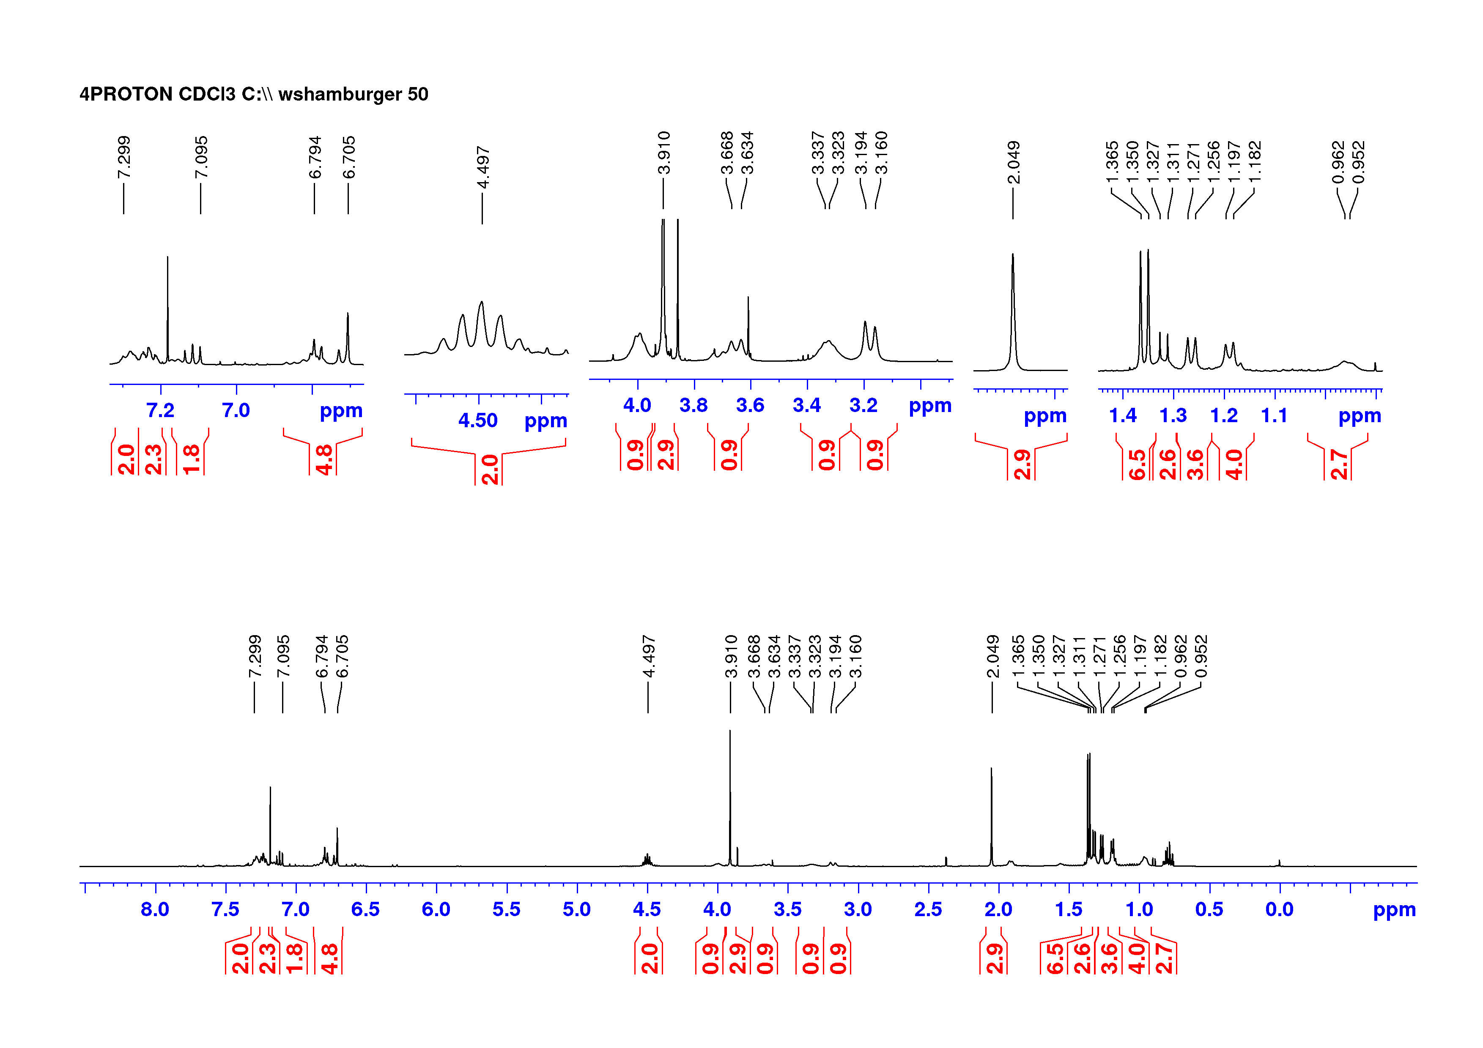
Fig. S11a. ¹H NMR spectrum of N-benzyl-(1R,3R)-5-(5’-isopropoxy-4’-methoxy-2’-methylnaphthyl)-8-isopropoxy-1,3-dimethyl-1,2,3,4-tetrahydroisoquinoline (S15) in methanol-d₄.
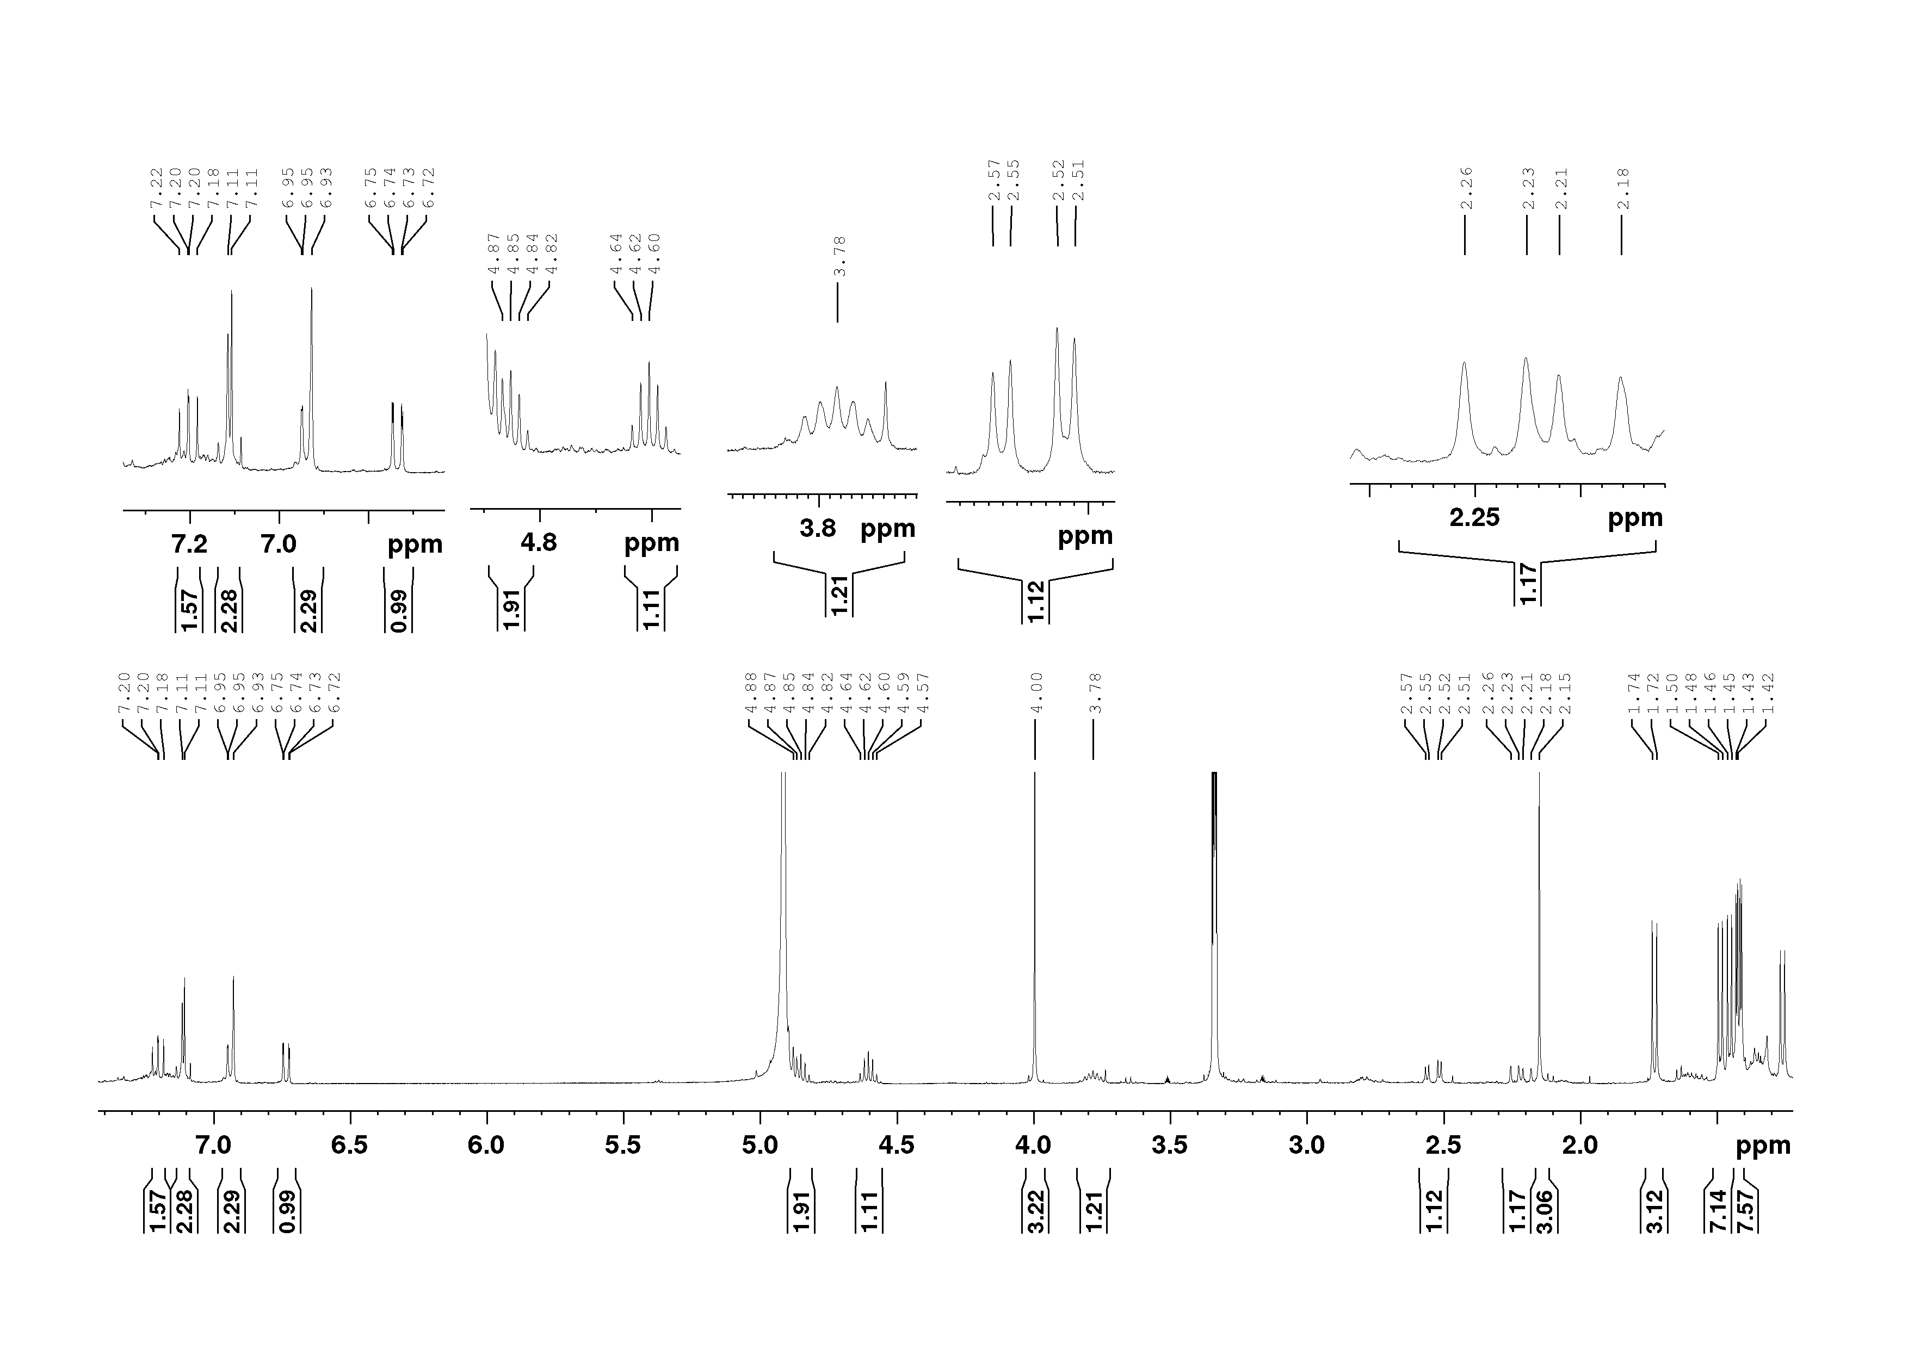
Fig. S12a. ¹H NMR spectrum of M-(1R,3R)-5-(5’-isopropoxy-4’-methoxy-2’-methylnaphthyl)-8-isopropoxy-1,3-dimethyl-1,2,3,4-tetrahydroisoquinoline (S17a) in methanol-d₄.
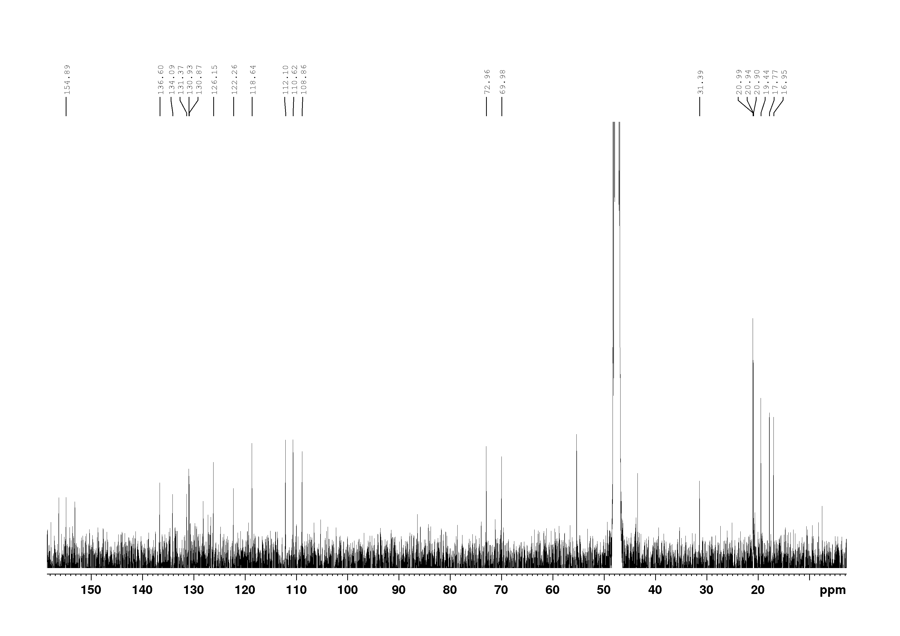
Fig. S12b. ¹³C NMR spectrum of M-(1R,3R)-5-(5’-isopropoxy-4’-methoxy-2’-methylnaphthyl)-8-isopropoxy-1,3-dimethyl-1,2,3,4-tetrahydroisoquinoline (S17a) in methanol-d₄.
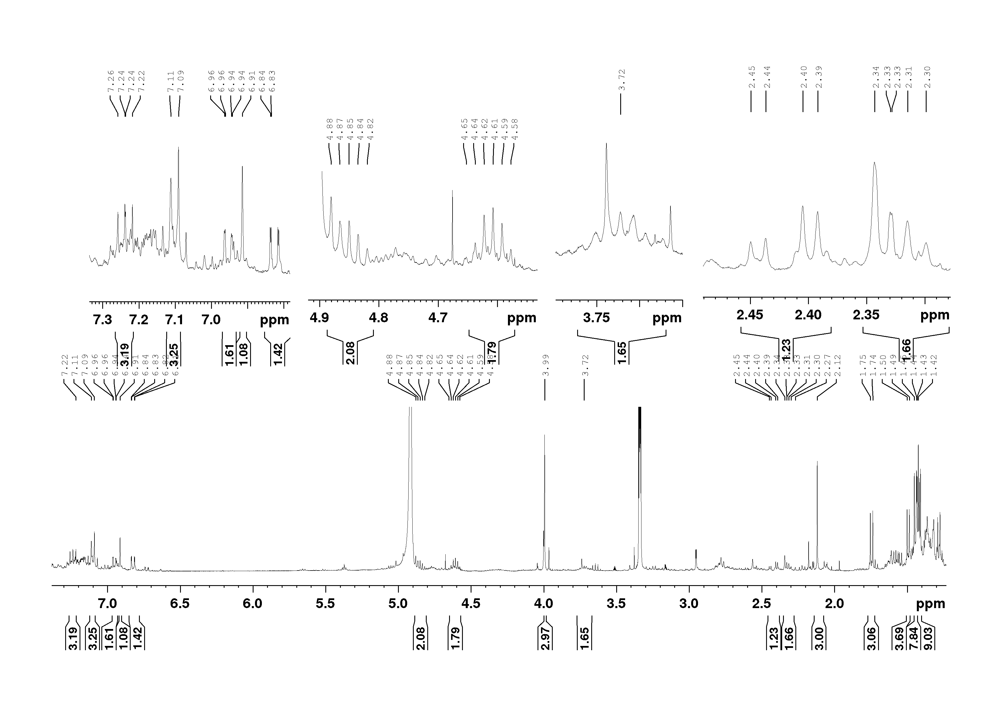
Fig. S13a. ¹H NMR spectrum of P-(1R,3R)-5-(5’-isopropoxy-4’-methoxy-2’-methylnaphthyl)-8-isopropoxy-1,3-dimethyl-1,2,3,4-tetrahydro-isoquinoline (S17b) in methanol-d₄.
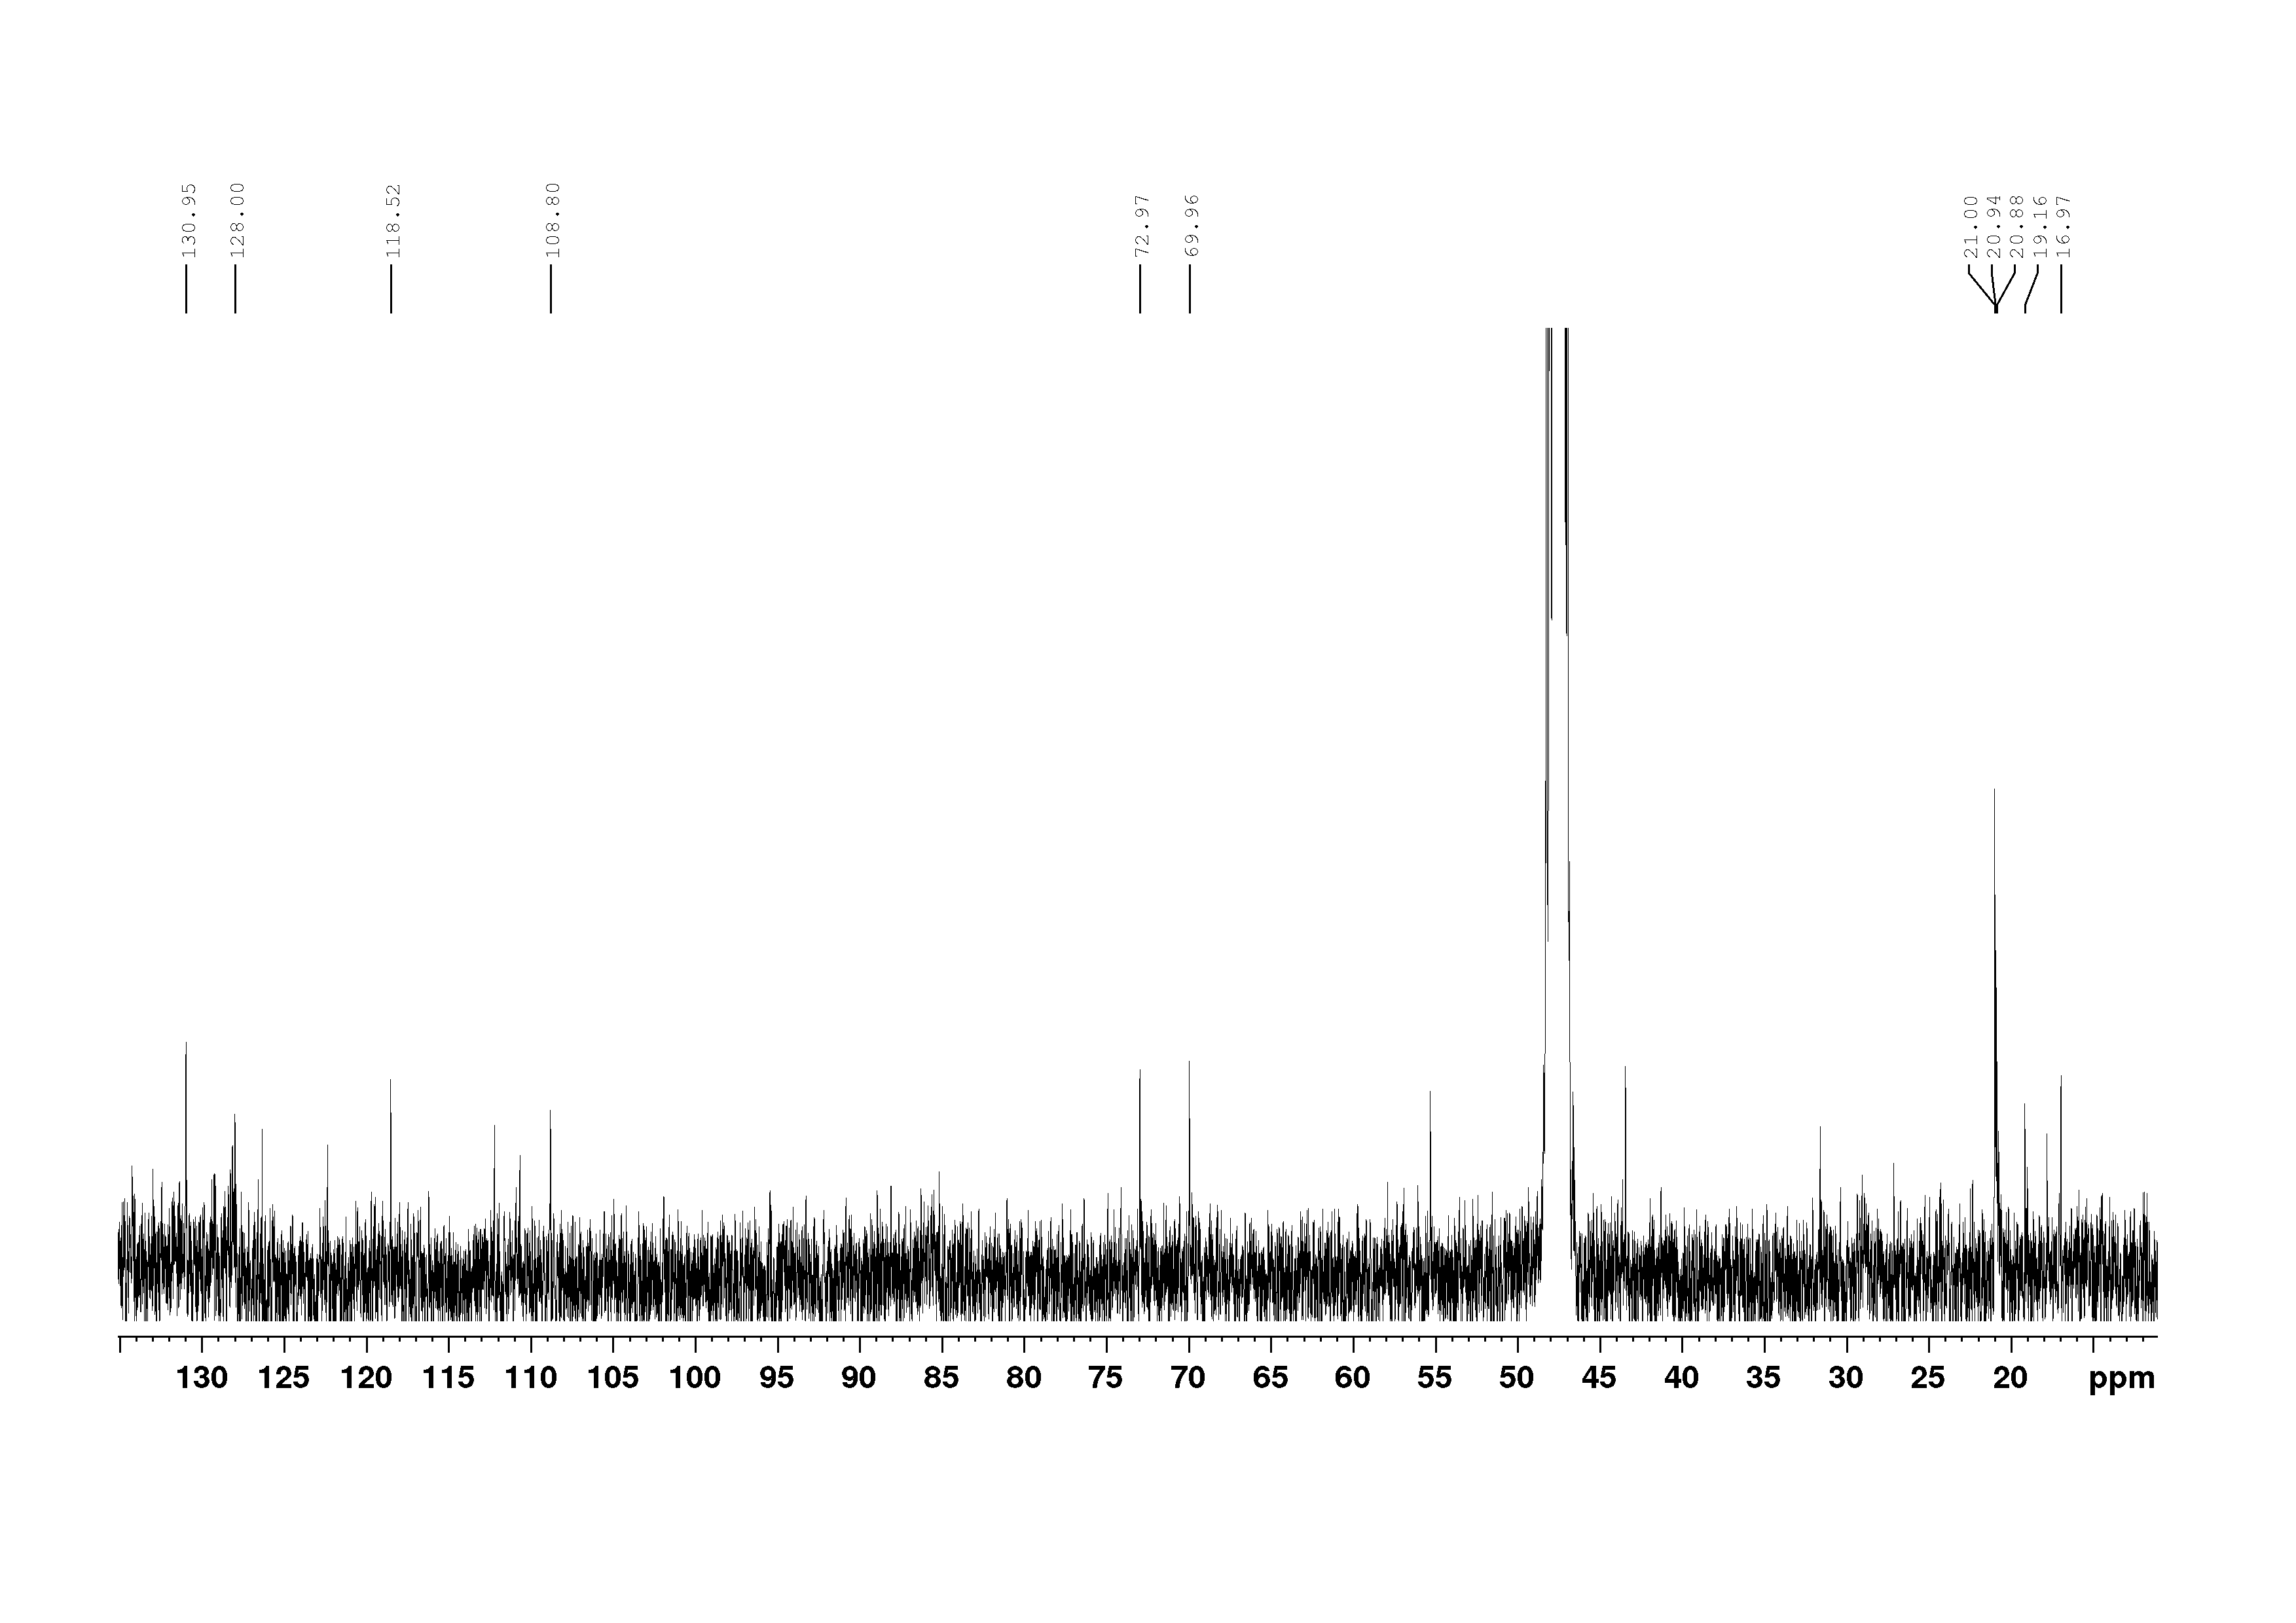
Fig. S13b. ¹³C NMR spectrum of P-(1R,3R)-5-(5’-isopropoxy-4’-methoxy-2’-methylnaphthyl)-8-isopropoxy-1,3-dimethyl-1,2,3,4-tetrahydro-isoquinoline (S17b) in methanol-d₄.
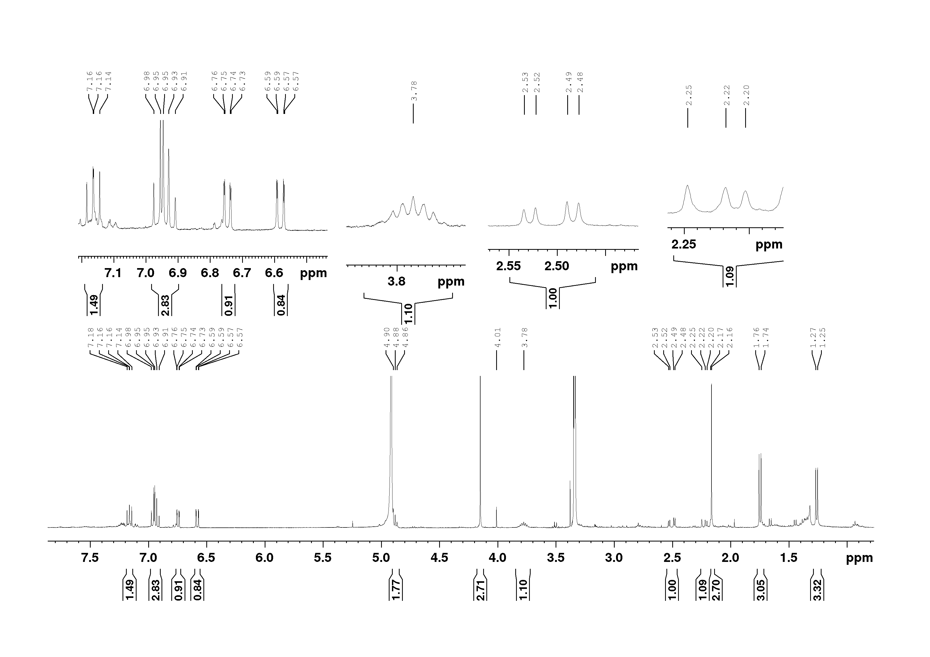
Fig. S14a. ¹H NMR spectrum of 5-epi-dioncophylline C (2b) in methanol-d₄.
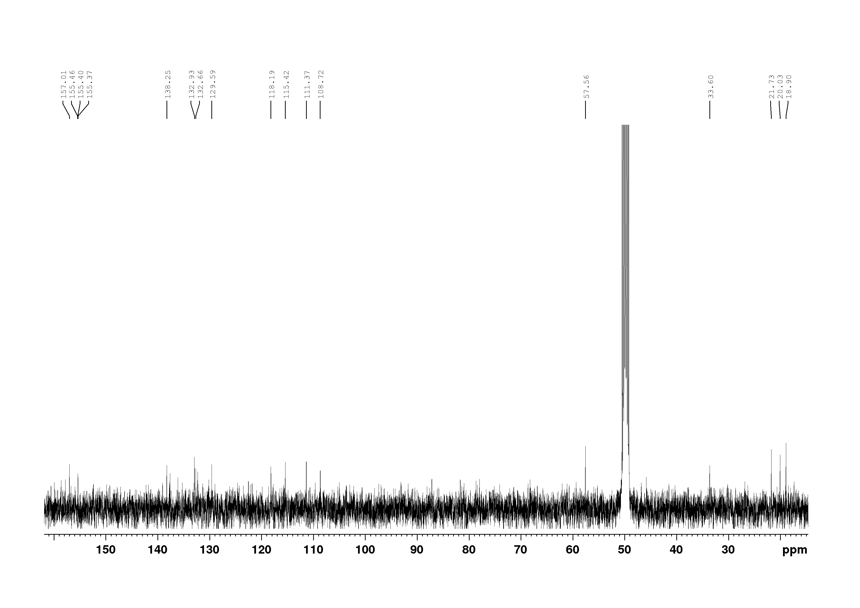
Fig. S14b. ¹³C NMR spectrum of 5-epi-dioncophylline C (2b) in methanol-d₄.

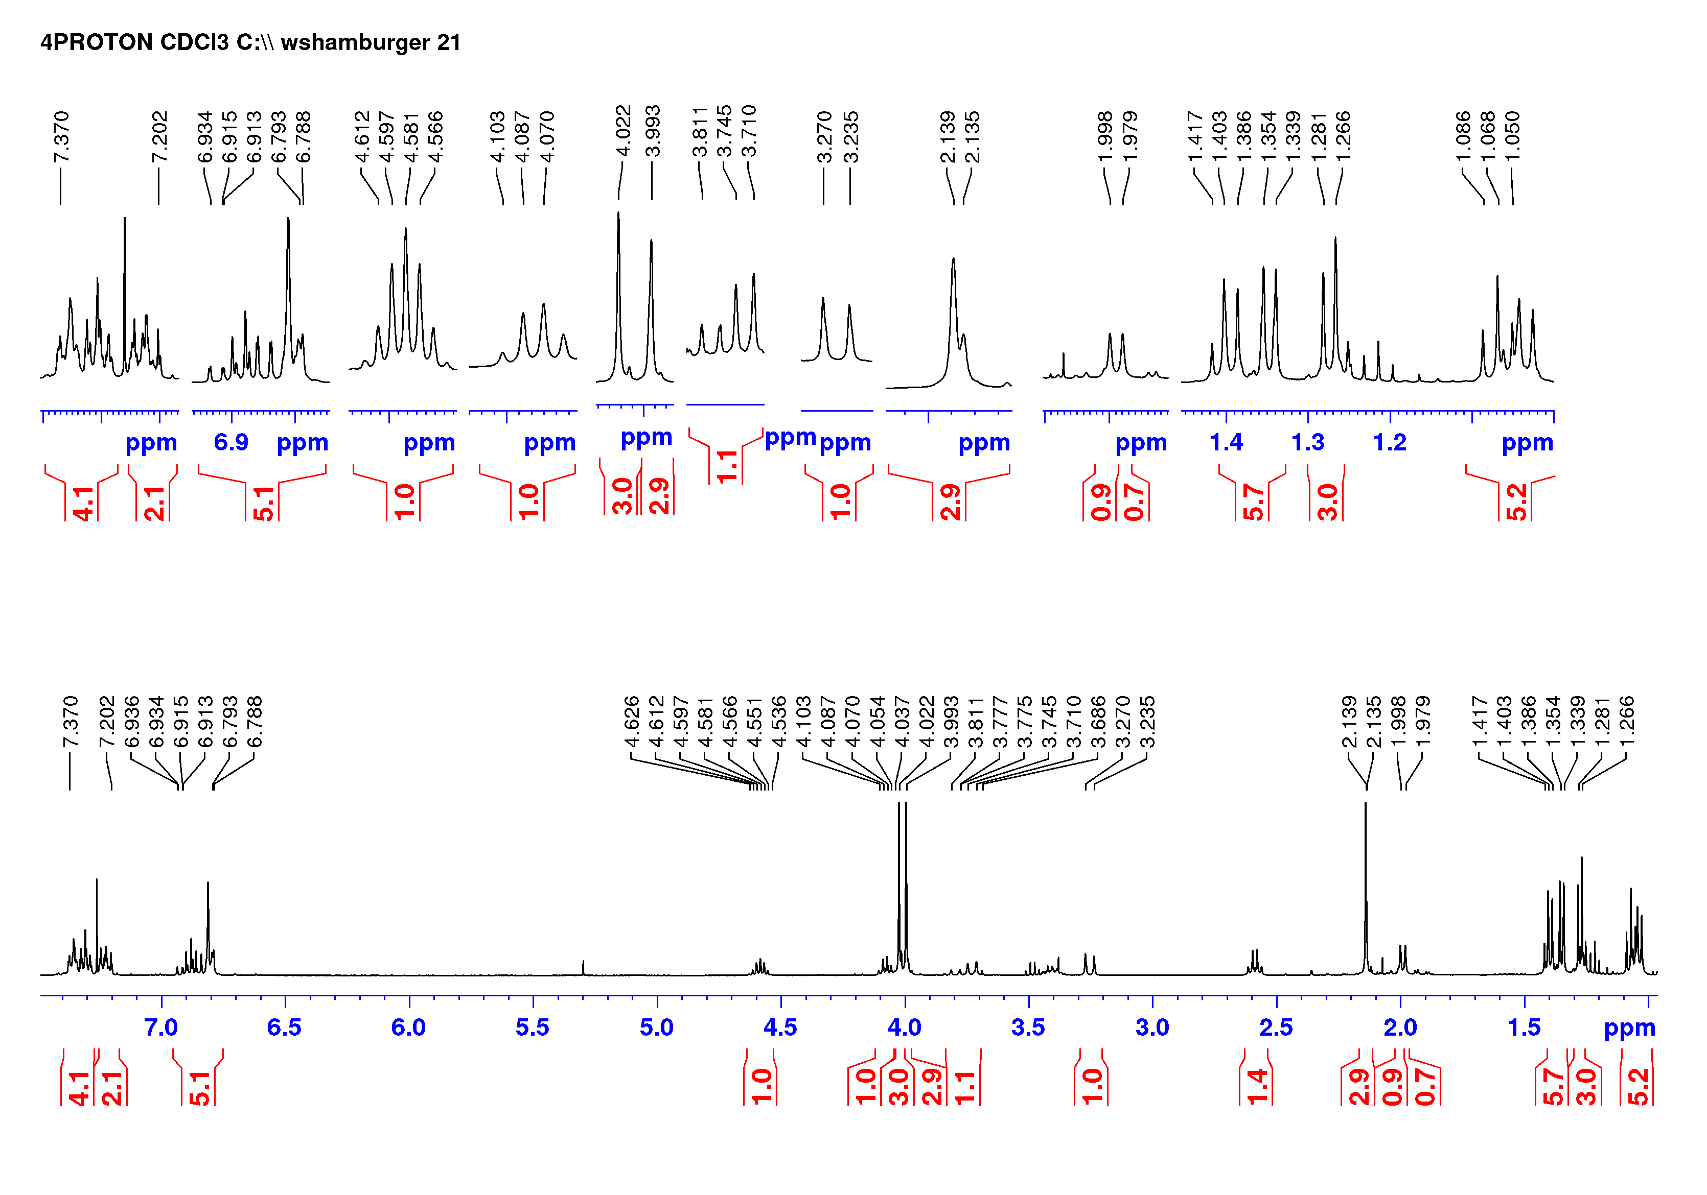
Fig. S15a. ¹H NMR spectrum of N-benzyl-(1R,3R)-5-(5’,4’-dimethoxy-2’-methylnaphthyl)-8-isopropoxy-1,3-dimethyl-1,2,3,4-tetrahydroisoquinoline (S15) in chloroform-d.
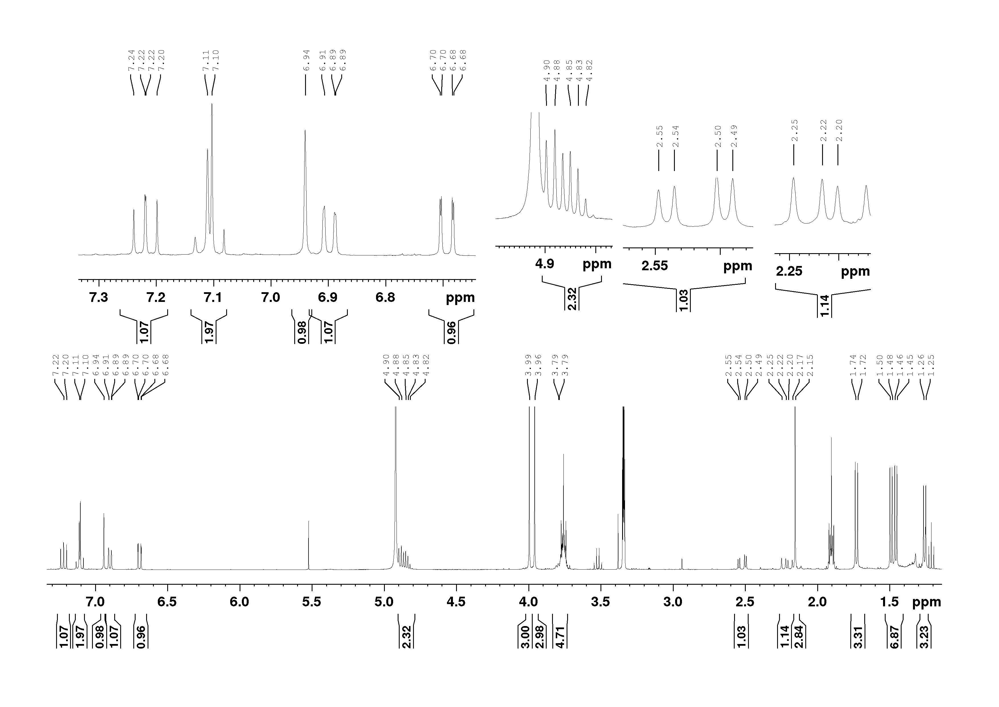
Fig. S16a. ¹H NMR spectrum of M-(1R,3R)-5-(5’,4’-dimethoxy-2’-methylnaphthyl)-8-isopropoxy-1,3-dimethyl-1,2,3,4-tetrahydroisoquinoline (S18a) in methanol-d₄.
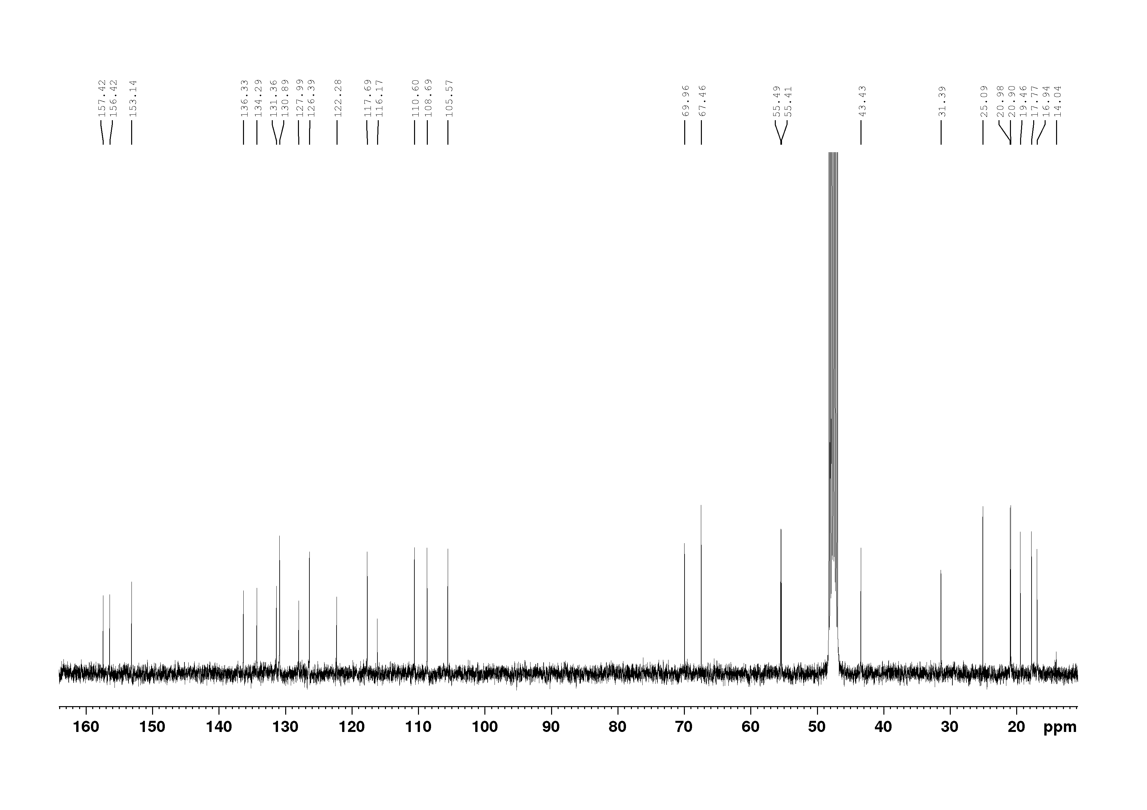
Fig. S16b. ¹³C NMR spectrum of M-(1R,3R)-5-(5’,4’-dimethoxy-2’-methylnaphthyl)-8-isopropoxy-1,3-dimethyl-1,2,3,4-tetrahydroisoquinoline (S18a) in methanol-d₄.
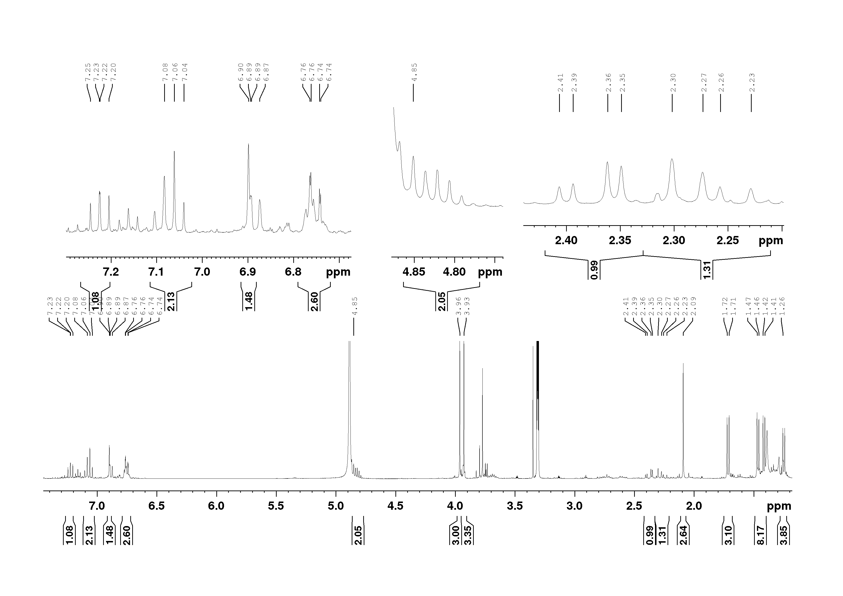
Fig. S17a. ¹H NMR spectrum of P-(1R,3R)-5-(5’,4’-dimethoxy-2’-methylnaphthyl)-8-isopropoxy-1,3-dimethyl-1,2,3,4-tetrahydroisoquinoline (S18b) in methanol-d₄.
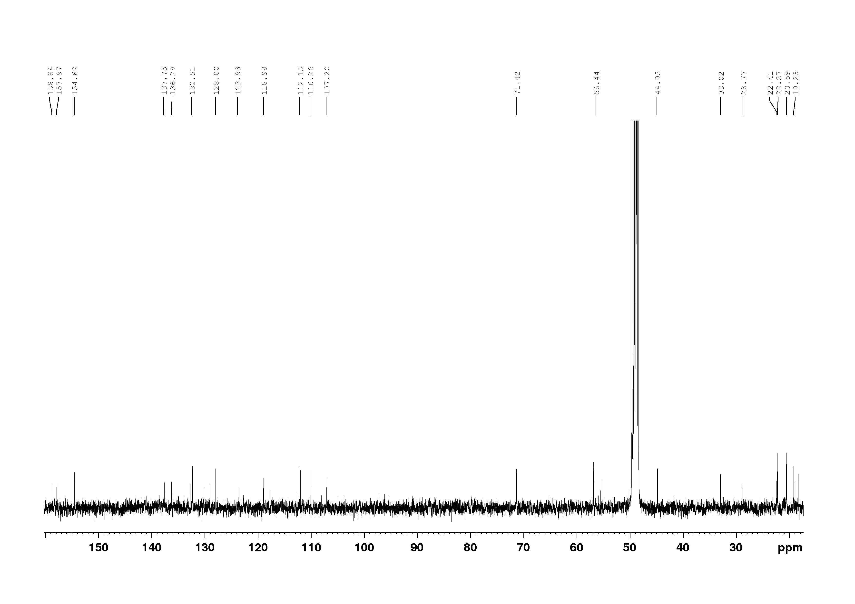
Fig. S17b. ¹³C NMR spectrum of P-(1R,3R)-5-(5’,4’-dimethoxy-2’-methylnaphthyl)-8-isopropoxy-1,3-dimethyl-1,2,3,4-tetrahydroisoquinoline (S18b) in methanol-d₄.
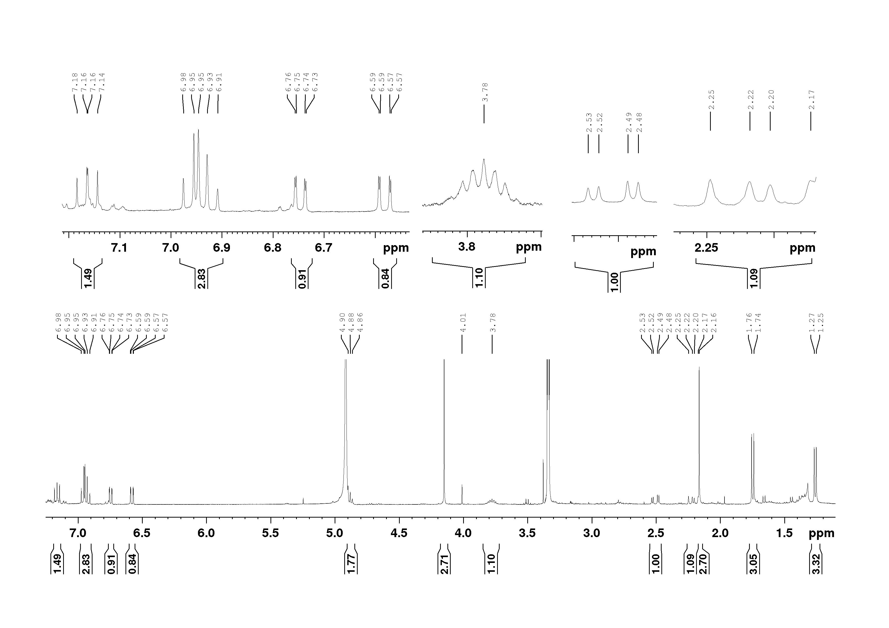
Fig. S18a. ¹H NMR spectrum of 5’-O-methyl-4’-O-demethyl-5-epi-dioncophylline C (6) in methanol-d₄.
Fig. S18b. ¹³C NMR spectrum of 5’-O-methyl-4’-O-demethyl-5-epi-dioncophylline C (6) in methanol-d₄.

- ECD Spectra

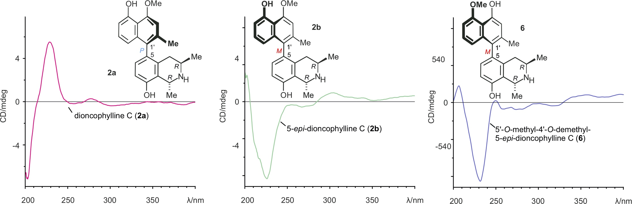

Fig. S19. ECD spectra of dioncophylline C (2a), its atropo-diastereomer 2, and its regioisomer 5’-O-methyl-4’-O-demethyl-5-epi-dioncophylline C (6).
- List of Abbreviations
LiCA: lithium N-cyclohexylisopropylamine; NBS: N-bromosuccinimide; (BPin)₂: Bis(pinacolato)diboron; DMF: N,N-dimethylformamide; dba: dibenzylidenacetone; ECD: electronic circular dichroism.
- References
Bringmann, G., Bischof, S.K., Müller, S., Gulder, T., Winter, C., Stich, A., Moll, H., Kaiser, M., Brun, R., Dreher, J., Baumann, K., 2010a. QSAR guided synthesis of simplified antiplasmodial analogs of naphthylisoquinoline alkaloids. Eur. J. Med. Chem. 45, 5370 - 5383.
Bringmann, G., Gulder, T., Hertlein, B., Hemberger, Y., Meyer, F., 2010b. Total synthesis of the N,C-coupled naphthylisoquinoline alkaloids ancistrocladinium A and B and related analogues. J. Am. Chem. Soc. 132, 1151-1158.
Bringmann, G., Hamm, A., Günther, C., Michel, M., Brun, R., Mudogo, V., 2000. Ancistroealaines A and B, Two New Bioactive Naphthylisoquinolines, and Related Naphthoic Acids from Ancistrocladus ealaensis. J. Nat. Prod. 63, 1465-1470.
Bringmann, G., Hamm, A., Schraut, M., 2003. Atroposelective biaryl coupling with chiral catalysts: Total synthesis of the antileishmanial naphthylisoquinoline alkaloids ancistrotanzanine B and ancistroealaine A. Org. Lett. 5, 2805-2808.
Fidock, D.A., Rosenthal, P.J., Croft, S.L., Brun, R., Nwaka, S., 2004. Antimalarial drug discovery: efficacy models for compound screening. Nat. Rev. Drug Discovery 3, 509-520.
Li, J., Seupel, R., Feineis, D., Mudogo, V., Kaiser, M., Brun, R., Brünnert, D., Chatterjee, M., Seo, E.-J., Efferth, T., Bringmann, G., 2017. Dioncophyllines C2, D2, and F and related naphthylisoquinoline alkaloids from the Congolese liana Ancistrocladus ileboensis with potent activities against Plasmodium falciparum and against multiple myeloma and leukemia cell lines. J. Nat. Prod. 80, 443-458.
Lombe, B.K., Feineis, D., Bringmann, G., 2019. Dimeric naphthylisoquinoline alkaloids: polyketide-derived axially chiral bioactive quateraryls. Nat. Prod. Rep.
Seupel, R., Hertlein-Amslinger, B., Gulder, T., Stawski, P., Kaiser, M., Brun, R., Bringmann, G., 2016. Directed synthesis of all four pure stereoisomers of the N,C-coupled naphthylisoquinoline alkaloid ancistrocladinium A. Org. Lett. 18, 6508-6511.
van der Watt, M.E., Reader, J., Churchyard, A., Nondaba, S.H., Lauterbach, S.B., Niemand, J., Abayomi, S., van Biljon, R.A., Connacher, J.I., van Wyk, R.D., 2018. Potent Plasmodium falciparum gametocytocidal compounds identified by exploring the kinase inhibitor chemical space for dual active antimalarials. J. Antimicrob. Chemother. 73, 1279-1290.
Verlinden, B.K., Niemand, J., Snyman, J., Sharma, S.K., Beattie, R.J., Woster, P.M., Birkholtz, L.-M., 2011. Discovery of novel alkylated (bis) urea and (bis) thiourea polyamine analogues with potent antimalarial activities. J. Med. Chem. 54, 6624-6633.
Watanabe, M., Hisamatsu, S., Hotokezaka, H., Furukawa, S., 1986. Reaction of lithiated senecioamide and related compounds with benzynes: efficient syntheses of naphthols and naphthoquinones. Chem. Pharm. Bull. 34, 2810-2820.

