An in-situ FTIR-LCR meter technique to study the sensing mechanism of MnO2@ZIF-8/CNPs and a direct relationship between the sensitivity of the sensor and the rate of surface reaction
Lesego Malepe¹, Patrick Ndungu², Tantoh Derek Ndinteh¹, Messai Adenew Mamo*^{1,3}.
¹Department of Chemical Science, University of Johannesburg, PO Box 17011, Doornfontein, 2028 Johannesburg, South Africa
²Department of Chemistry, University of Pretoria, Private Bag X20, Hatfield, 0028, Pretoria, South Africa
³ DST-NRF Centre of Excellence in Strong Materials (CoE-SM), University of the Witwatersrand, Johannesburg, Johannesburg, 2000, South Africa

Supporting document

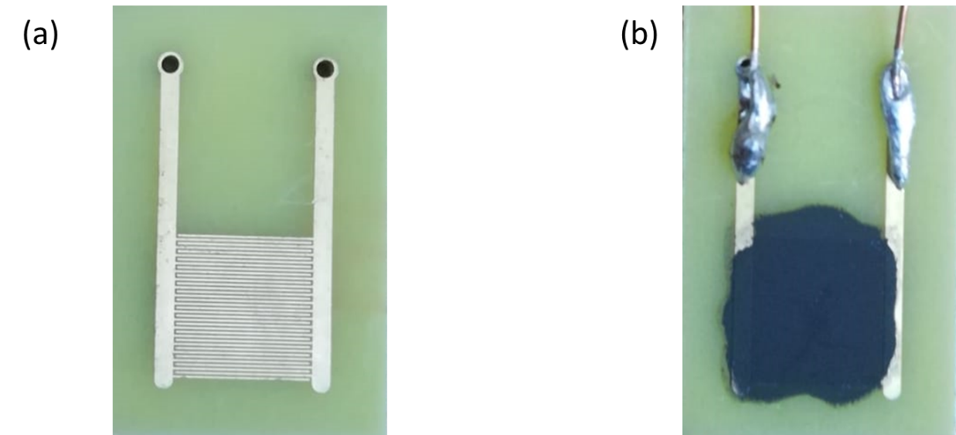

Fig. S1: (a) A gold-plated interdigitated electrode and (b) a prepared sensor
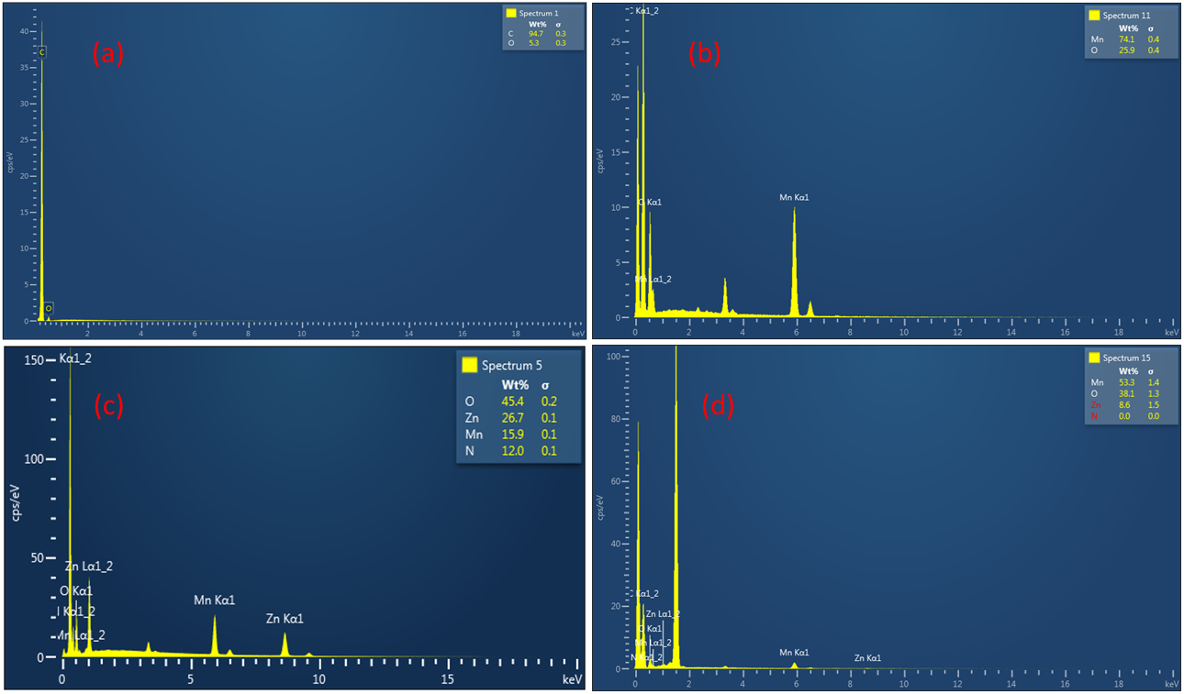
Fig. S2: The SEM-EDS image of (a) CNPs, (b) MnO₂ NRs, (c) MnO₂@ZIF-8 and (d) MnO₂@ZIF-8/CNPs

Table S1
Sensing material | Analytes vapour | Sensitivity (Ωppm⁻¹)
MnO₂ | methanol | -0.108
 | ethanol | -0.119
 | acetone | -0.0517
 | Pentanone-3 | -0.0144
 | diethylamine | -0.294
CNPs  MnO₂@ZIF-8  MnO₂/CNPs | Methanol  Ethanol  Acetone  Pentanone-3  Diethylamine  Methanol  Ethanol  Acetone  Pentanone-3  Diethylamine  Methanol  Ethanol  Acetone  Pentanone-3  Diethylamine | 0.000607  0.00177  0.0001  0.00052  0.00289  -4.12  -2.98  0.196  -3.12  -1.18  0.0000912  -0.000035  0.00158  0.00993  0.00119

Dynamic response of MnO₂-based sensor
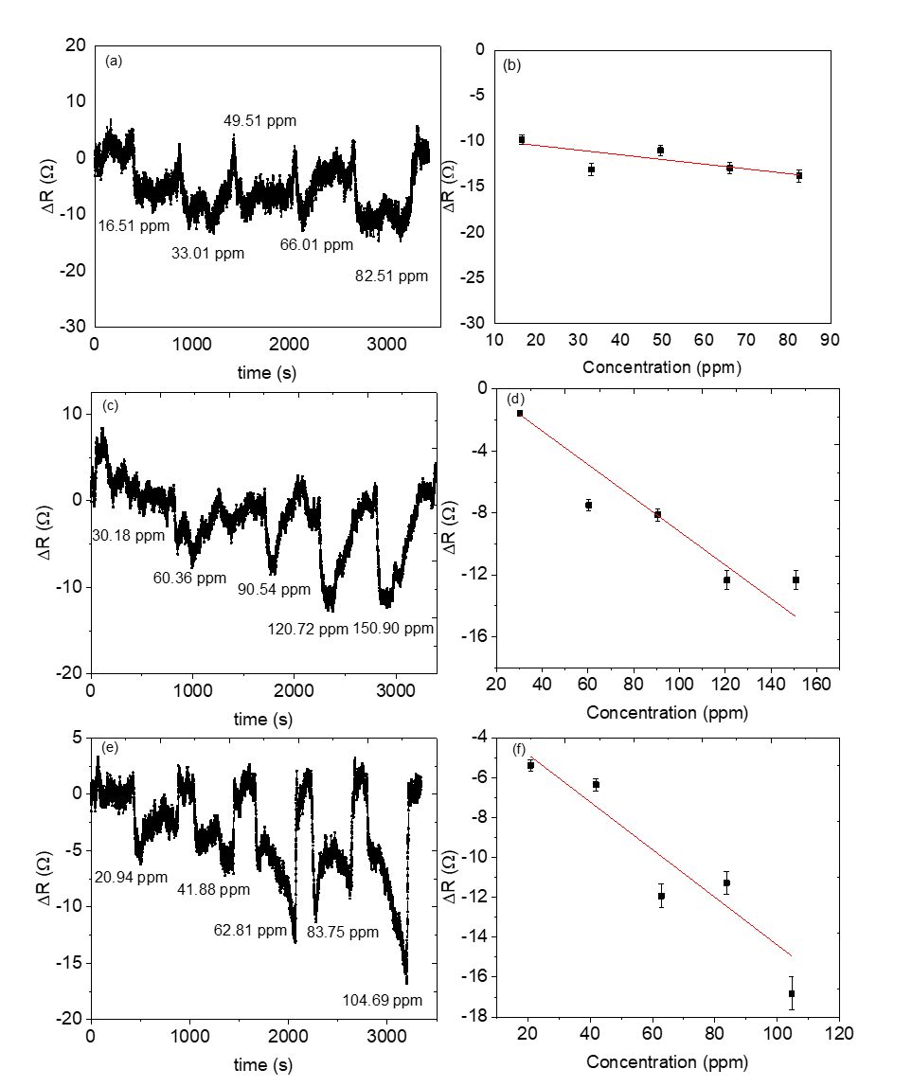

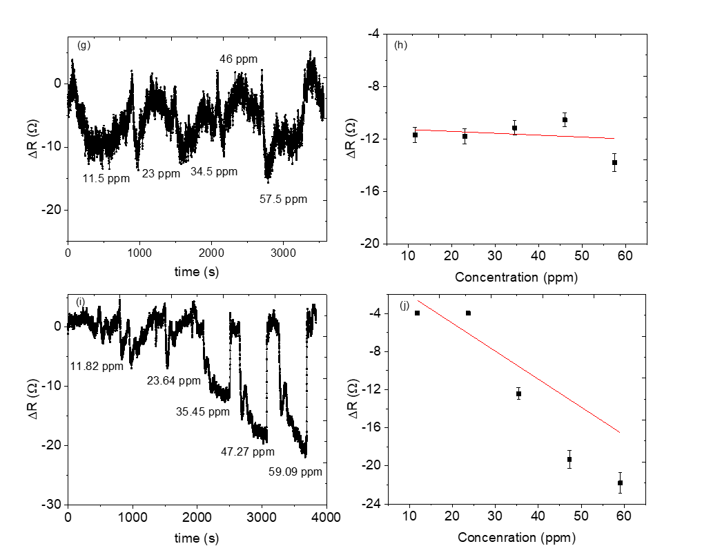

Fig. S3: Dynamic response of MnO₂-based sensor for (a & b) Acetone (c & d) Methanol (e & f) Ethanol (g & h) 3-pentanone (I & h) Diethylamine

Dynamic response of 1:1 mass ratio of MnO₂@ZIF-8/CNPs based sensor

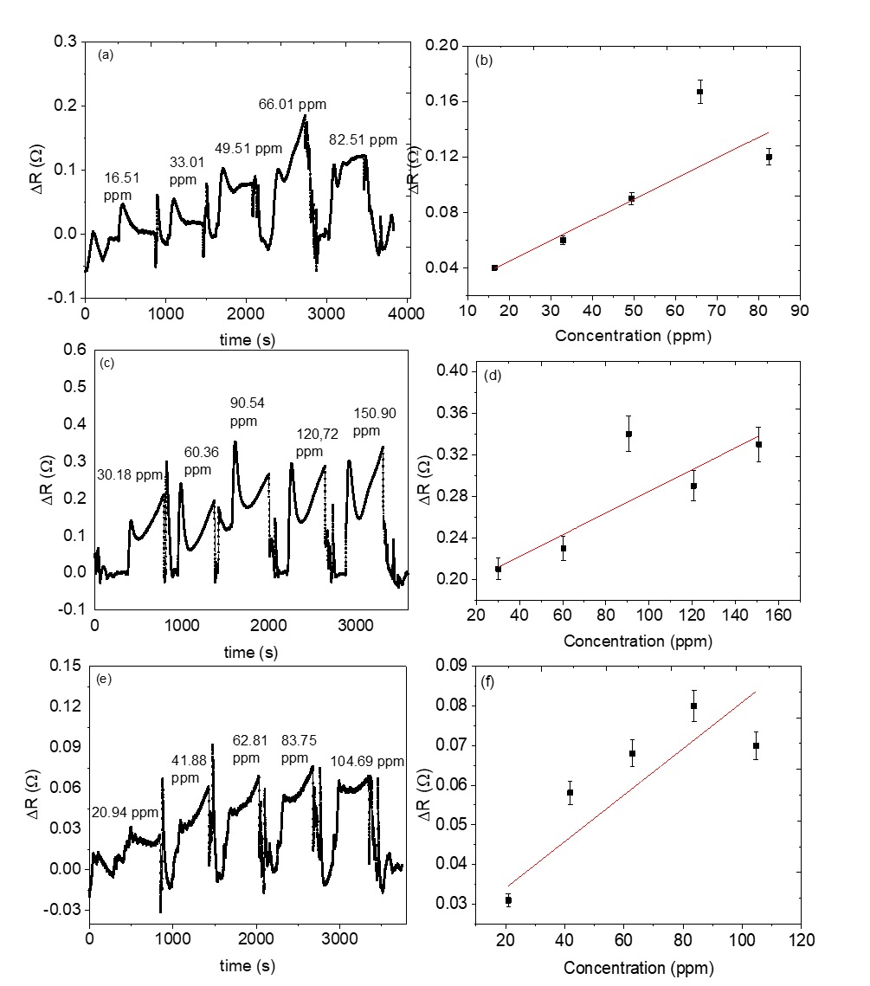

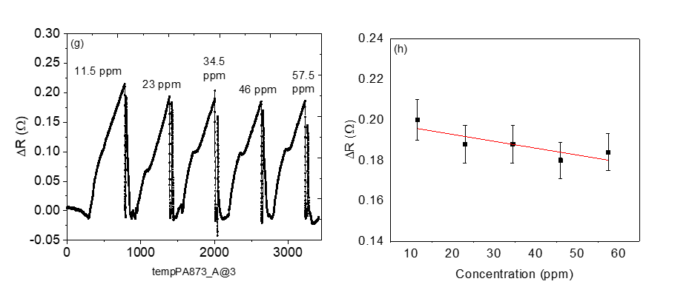

Fig. S4: Dynamic response of 1:1 mass ratio of MnO2@ZIF-8/CNPs based sensor for (a & b) Acetone (c & d) Methanol (e & f) Ethanol (g & h) 3-pentanone

Dynamic response of 2:1 mass ratio of MnO₂@ZIF-8-CNPs based sensors 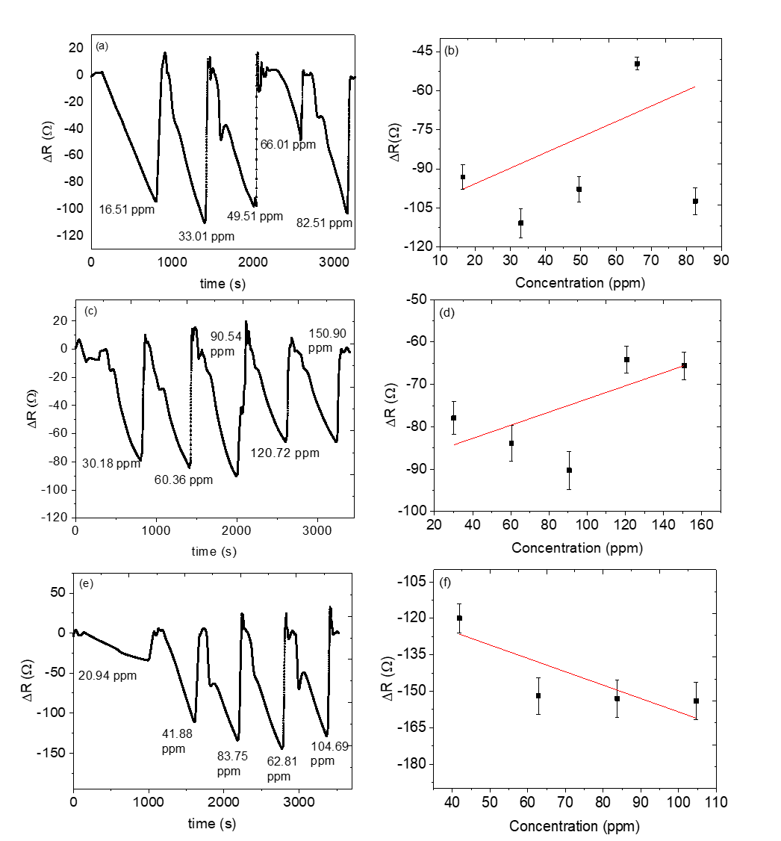

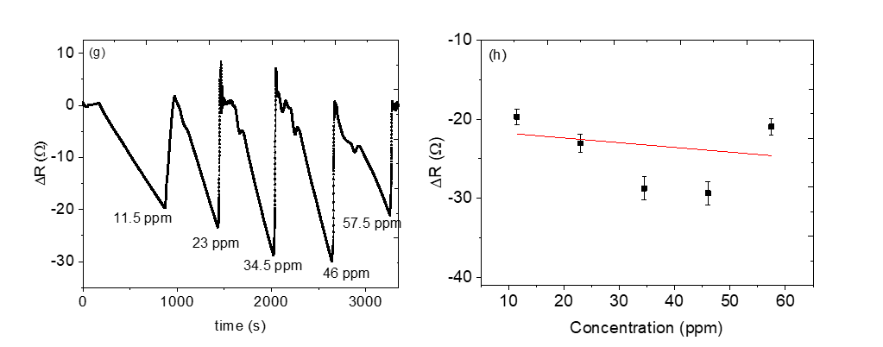
Fig. S5: Dynamic response of 2:1 mass ratio of MnO₂@ZIF-8/CNPs based sensor for (a &b) Acetone (c & d) Methanol (e & f) Ethanol (g & h) 3-pentanone

Dynamic response of 3:1 mass ratio of MnO₂@ZIF-8/CNPs based sensor
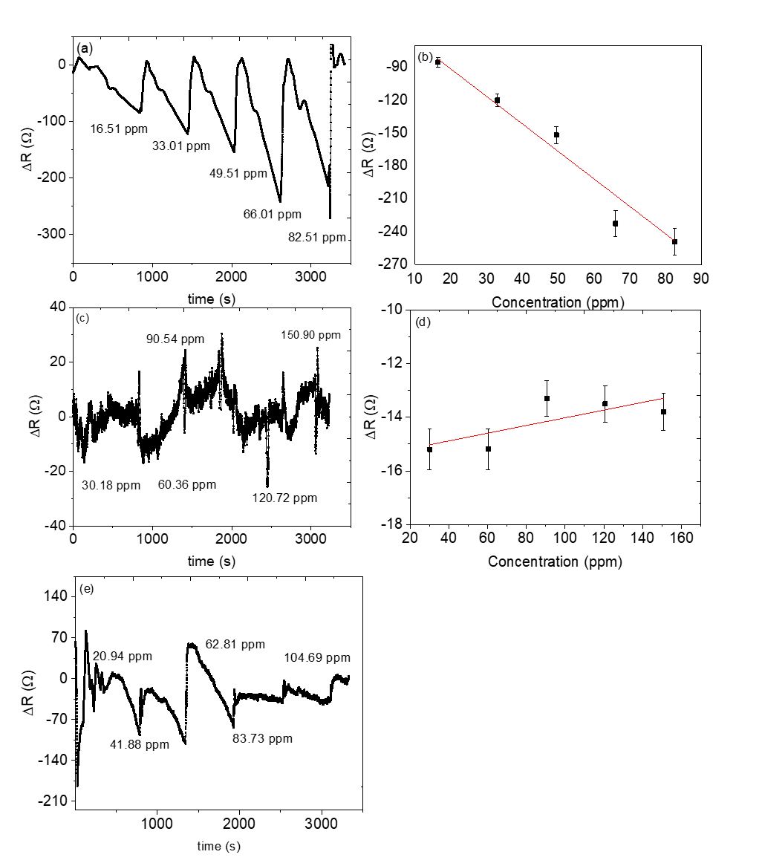

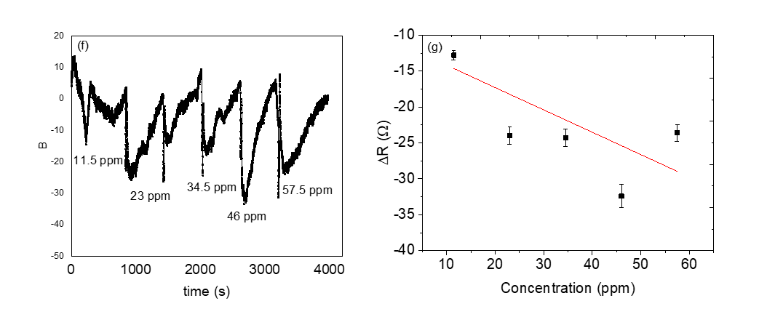
Fig. S6: Dynamic response of 3:1 mass ratio of MnO₂@ZIF-8/CNPs based sensor for (a & b) Acetone (c & d) Methanol (e) Ethanol (f & g) 3-pentanone

Selectivity response
Fig. S7: Static response of 3:1 mass ratio of MnO₂@ZIF-8/CNPs based sensor for mixed analyte

