Supplementary Figures
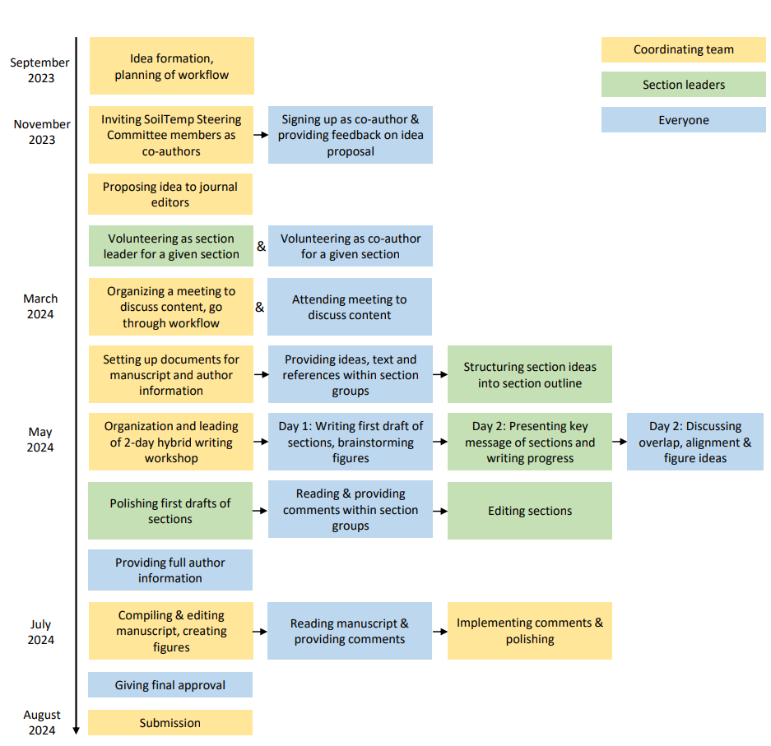
Supplementary Information Figure S1. The workflow of this manuscript, providing a detailed description of how this manuscript was developed, how work tasks were divided and the general flow of the process.
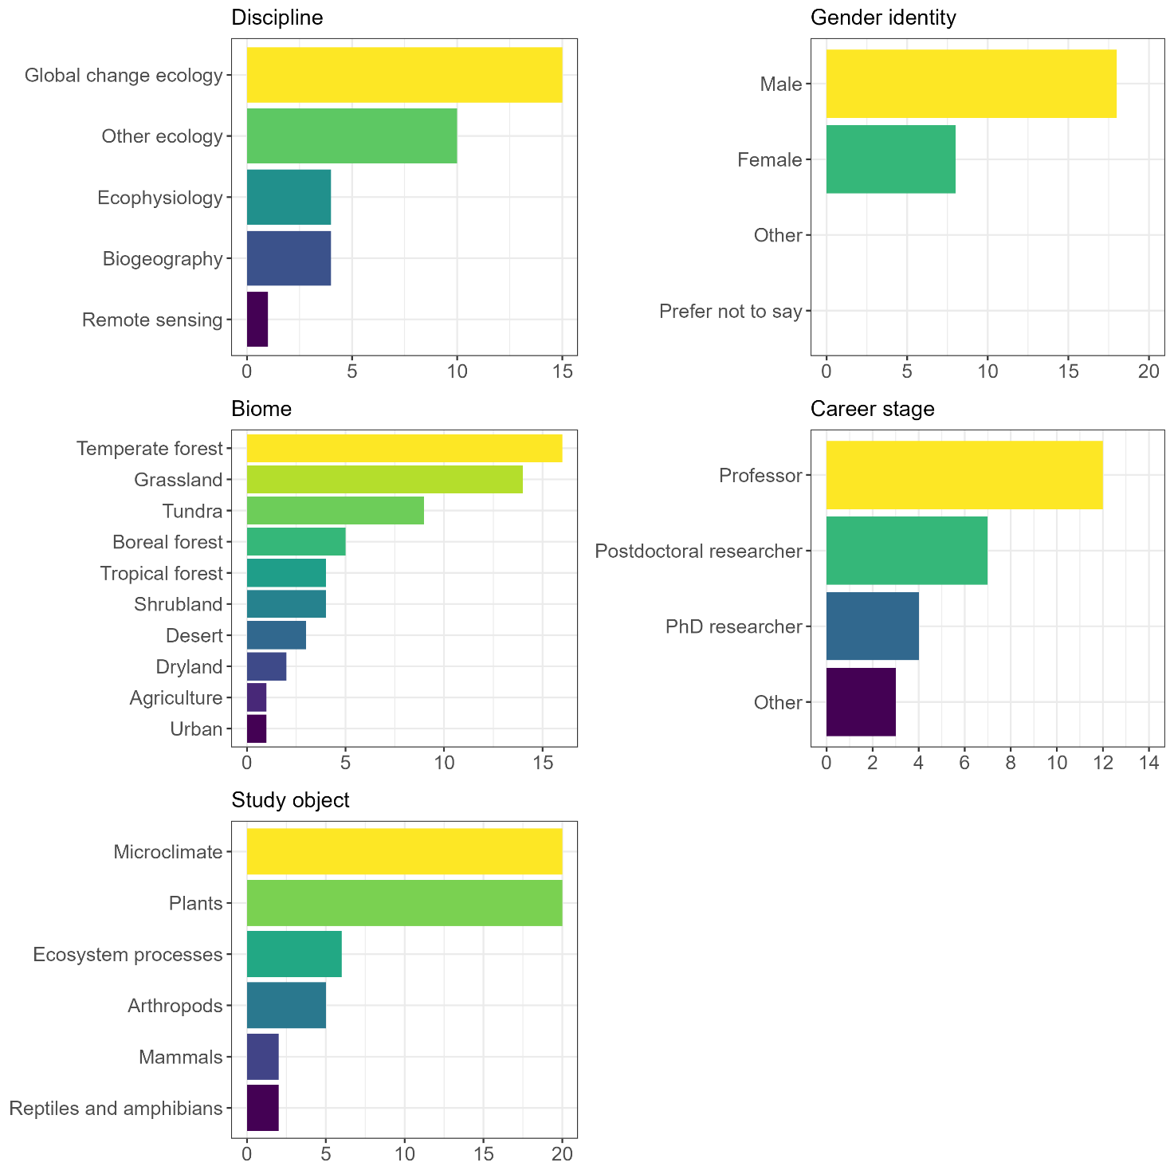
Supplementary information Figure S2. Demographics of the authors of this manuscript. We provide background information on all 27 authors of the manuscript. Note that authors could indicate all options regarding their discipline, most often studied biome and study object.

Supplementary Text

Supplementary Text S1. R-code and visuals for the four steps in the data compilation process (see Fig. 8) in Guideline 8.

Plot data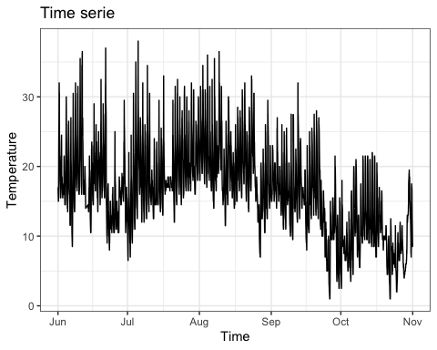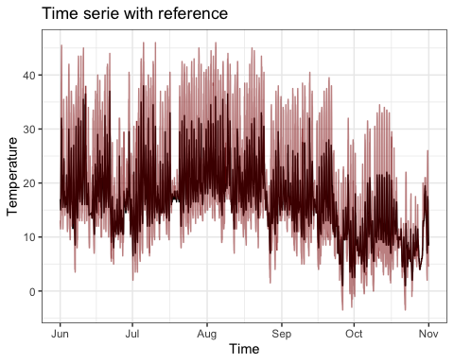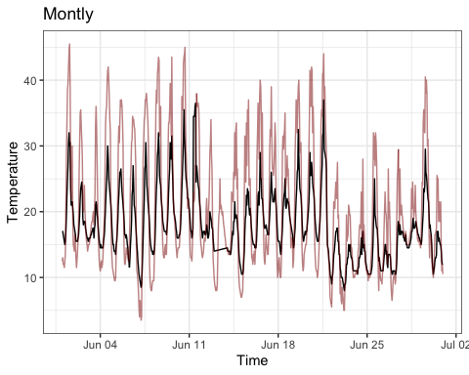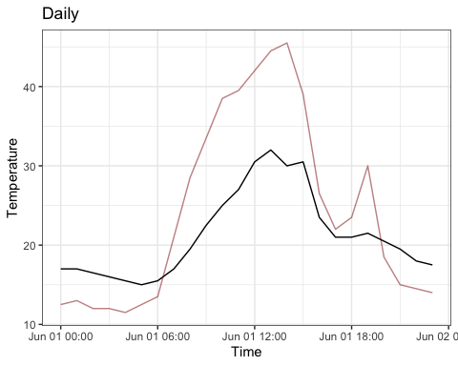

Visual inspection
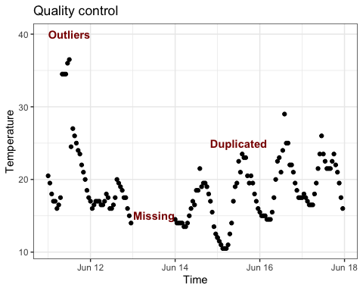

Data handling and quality control using myClim
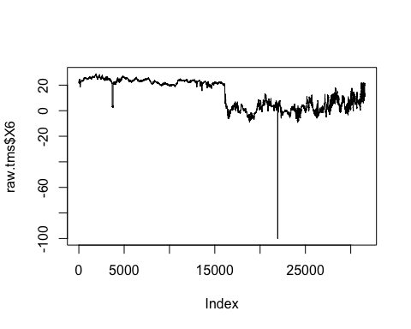

Load data
library(myClim)
# load all TMS files in folder
tms<-mc_read_files("./data/",dataformat_name = "TOMST",
silent = T,clean = F)

Visualize time series
mc_plot_line(tms,sensors = c("TMS_T3","TMS_moist"))
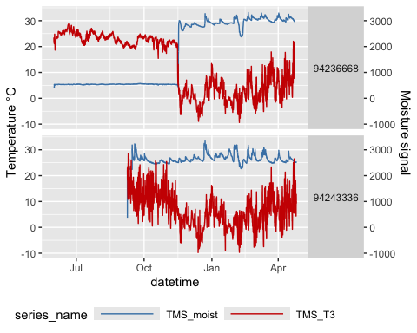

Visualize temperature records
mc_plot_raster(tms,sensors = "TMS_T3")
## [[1]]
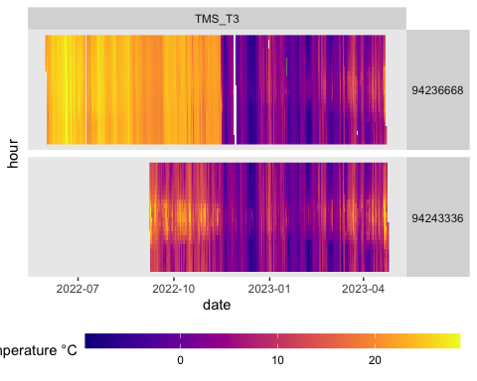

Clean time series (order and duplicated)
# fix order and remove multiplication of records
tms.clean.0<-mc_prep_clean(tms,silent = T)
myClim cleaning log showing the time-series range, number of missing records, records in wrong order and duplicated records.
## serial_number start_date end_date step_seconds
## 94236668 94236668 2022-05-31 16:00:00 2023-04-23 03:15:00 900
## 94243336 94243336 2022-09-08 09:00:00 2023-04-25 10:45:00 900
## count_duplicities count_missing count_disordered rounded
## 94236668 588 352 4 FALSE
## 94243336 0 0 0 FALSE

Missing values filling
# fill small holes (linear approximation)
mc_plot_line(tms.clean.0,sensors = c("TMS_T3","TMS_moist"),
start_crop = as.POSIXct("2023-01-15",tz="UTC"),
end_crop = as.POSIXct("2023-01-20",tz="UTC"))
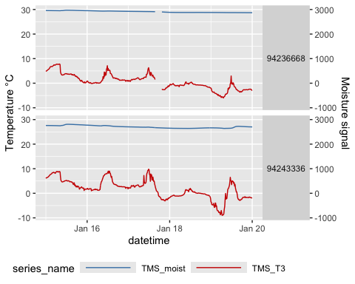
tms.clean.1<-mc_prep_fillNA(tms.clean.0,maxgap = 100)
mc_plot_line(tms.clean.1,sensors = c("TMS_T3","TMS_moist"),
start_crop = as.POSIXct("2023-01-15",tz="UTC"),
end_crop = as.POSIXct("2023-01-20",tz="UTC"))
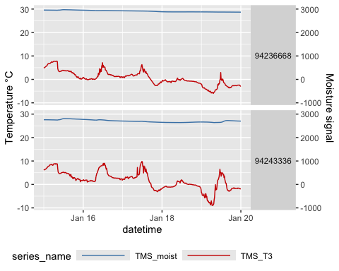

Detect humidity sensor out of the soil
# detect TOMST TMS logger out of soil
tms.clean.2<-mc_prep_TMSoffsoil(tms.clean.1)
mc_plot_line(tms.clean.2,sensors = c("TMS_T3","off_soil"),
start_crop = as.POSIXct("2022-06-15",tz="UTC"))
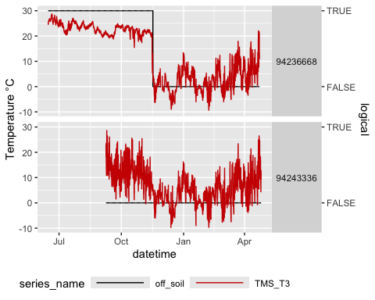

Cropping data
# crop and calculate monthly microclimate variables
tms.clean.3<-mc_prep_crop(tms.clean.2,
start = as.POSIXct("2023-01-01",tz="UTC"),
end = as.POSIXct("2023-05-01",tz="UTC"))
env.temp<-mc_env_temp(tms.clean.3,min_coverage = 0.5,period = "month")
first 10 rows showing myClim microclimate monthly variables calculated from time-series of TMS TOMST loggers
## locality_id sensor_name height datetime time_to value
## 1 94236668 T.soil_8_cm.min5p soil 8 cm 2023-01-01 2023-02-01 2.8750000
## 5 94236668 T.soil_8_cm.frostdays soil 8 cm 2023-01-01 2023-02-01 0.0000000
## 9 94236668 T.soil_8_cm.mean soil 8 cm 2023-01-01 2023-02-01 4.6445838
## 13 94236668 T.soil_8_cm.max95p soil 8 cm 2023-01-01 2023-02-01 7.6562500
## 17 94236668 T.soil_8_cm.drange soil 8 cm 2023-01-01 2023-02-01 0.4032258
## 21 94236668 T.air_2_cm.min5p air 2 cm 2023-01-01 2023-02-01 -0.2500000
## 25 94236668 T.air_2_cm.frostdays air 2 cm 2023-01-01 2023-02-01 6.0000000
## 29 94236668 T.air_2_cm.mean air 2 cm 2023-01-01 2023-02-01 2.7049626
## 33 94236668 T.air_2_cm.max95p air 2 cm 2023-01-01 2023-02-01 8.1875000
## 37 94236668 T.air_2_cm.drange air 2 cm 2023-01-01 2023-02-01 1.8770161

Data alignment

Temporal resolution
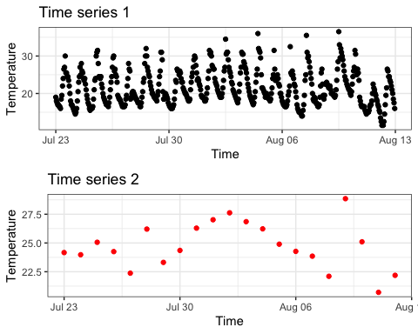

Temporal mismatch
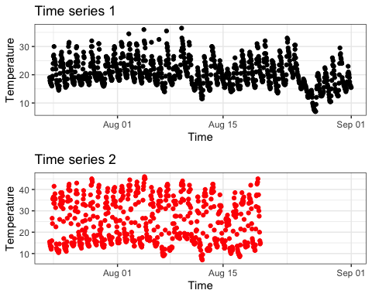

Supplementary information 2
This supplement contains the R-code and visuals related to Guideline 9 on data analysis.

Plotting data

Thermal isoline heatmap
ggplot(data = df,
aes(x = Chron, y = Temperature)) +
geom_raster(data = df,
aes(x = date(Chron), y = hour(Chron), fill = Temperature)) +
scale_fill_gradient2(low="navy", mid="white", high="darkred",
midpoint = mean(df$Temperature)) +
labs(x = 'Days', y = 'Hour') +
theme_bw()
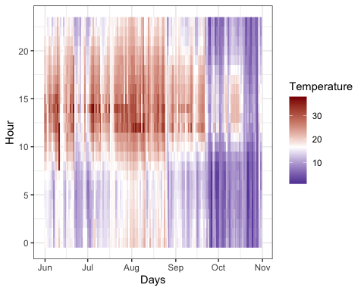
ggplot(data = df,
aes(x = Chron, y = Temperature)) +
geom_raster(data = df,
aes(x = week(Chron), y = hour(Chron), fill = Temperature)) +
scale_fill_gradient2(low="navy", mid="white", high="darkred",
midpoint = mean(df$Temperature)) +
labs(x = 'Week', y = 'Hour') +
theme_bw()
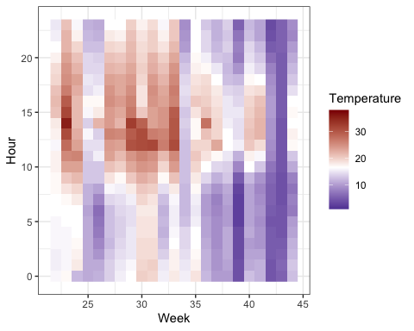
ggplot(data = df,
aes(x = Chron, y = Temperature)) +
geom_raster(data = df,
aes(x = month(Chron), y = hour(Chron), fill = Temperature)) +
scale_fill_gradient2(low="navy", mid="white", high="darkred",
midpoint = mean(df$Temperature)) +
labs(x = 'Month', y = 'Hour') +
theme_bw()
