Supplementary information: Additional file 1
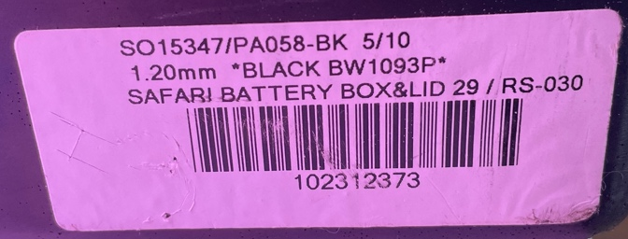
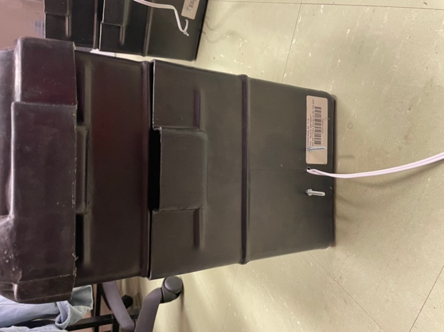 | 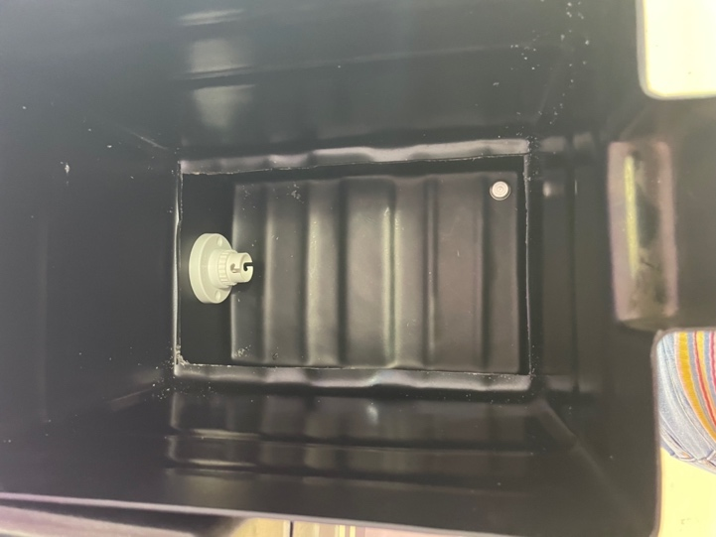
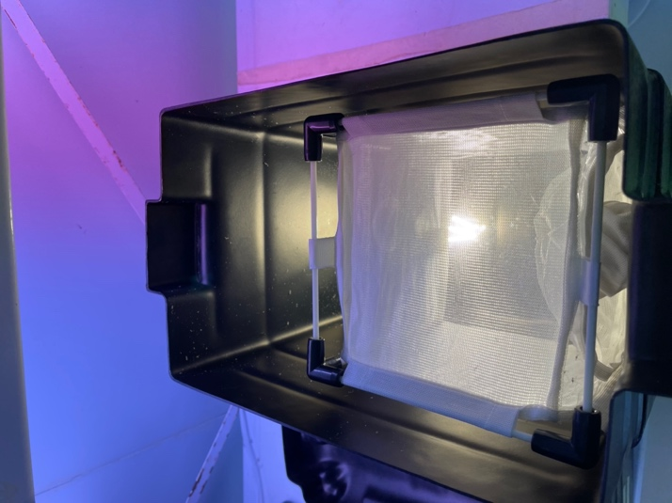 | 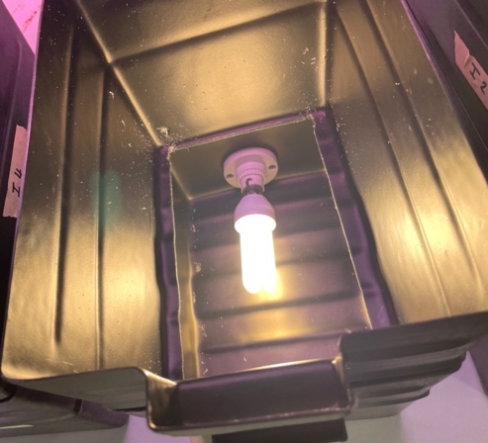
Figure S1. Images showing the design of the experimental containers.

Zeitgeber time (ZT, h)
‘sunrise’
‘sunset’
0
24
12
Light-dark cycle maintenance conditions

- MAINTENANCE CONDITIONS
30-minute Feeding assay
ZT14.00

Light exposure ZT13.30
(30 minute)
1 hour acclimation
ZT12.30 – 13.30
b. EXPERIMENTAL DESIGN

Sunset
ZT12 – 12.30
Light treatment

30-minute Feeding assay
ZT14.00

1 hour acclimation
ZT12.30 – 13.30
Sunset
ZT12 – ZT 12.30
Light control and container control

Figure S2. The percentage of female Anopheles funestus feeding was determined by a standard membrane feeding assay using a Hemotek blood feeding system. (a) Standard maintenance conditions of An. funestus colonies. Bar represents the 12-12 light-dark cycle. ZT0 = start of ‘sunrise’, ZT12 = start of ‘sunset’. (b) Experimental design for the testing of the effect of different light treatments on the percentage of An. funestus feeding.
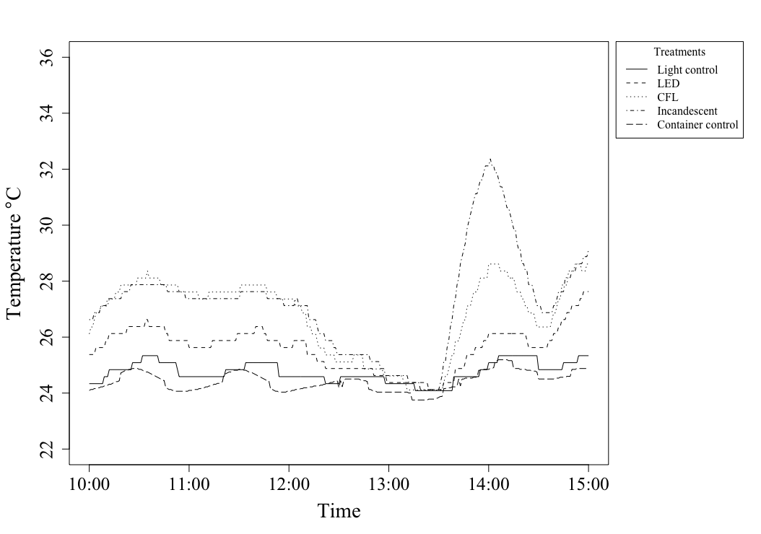 Figure S3. Temperature (℃) in the experimental containers recorded with Thermochron I-buttons. The lighting conditions as well as the time of the light treatment and feeding assay, indicated by an arrow, are shown above the graph.
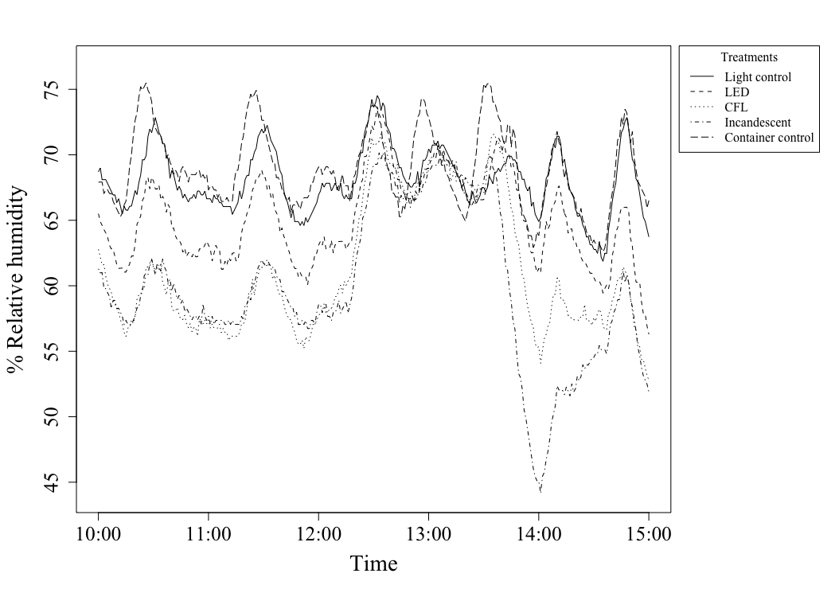
Figure S4. Relative humidity (%) in the experimental containers recorded with Thermochron I-buttons. The lighting conditions as well as the time of the light treatment and feeding assay, indicated by an arrow, are shown above the graph.
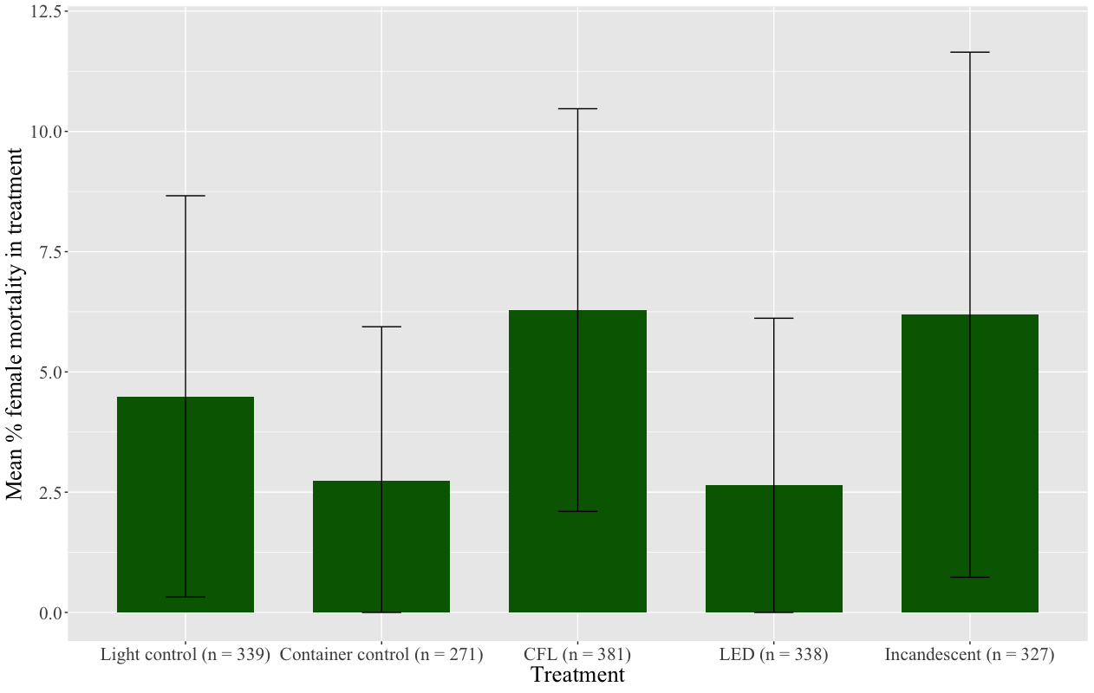
Figure S5. Bar chart of the average female mortality (%) in each treatment with sample sizes indicated in brackets next to the treatment names.
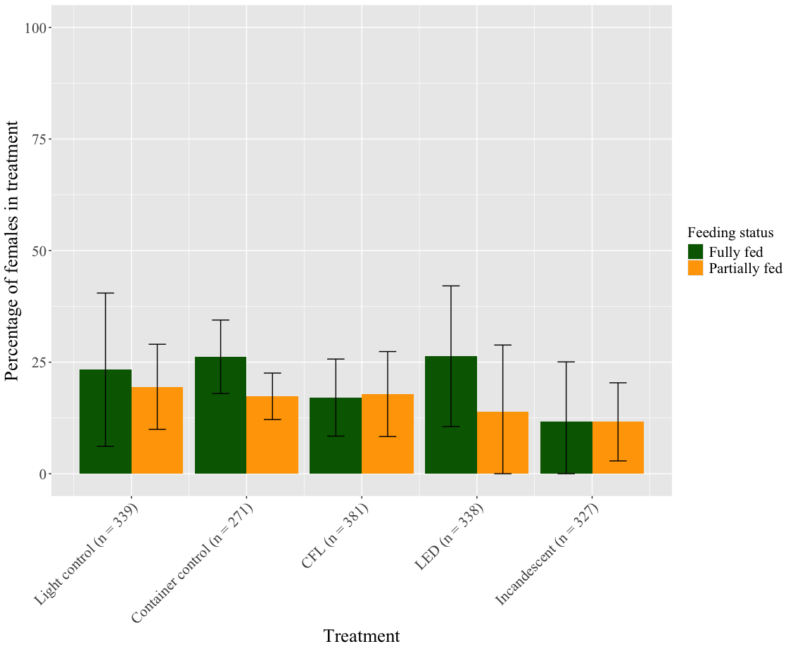
Figure S6. Bar graph of Anopheles funestus (Diptera: Culicidae) female mosquito feeding rate (%) at various light treatments ($±$ standard deviation, sd) showing partially as well as fully fed percentages. Light treatments consisted of compact-fluorescent light (CFL), light-emitting diode (LED) light and incandescent light. Controls included a container with no light (light-control) and a cage fed outside of the container (container-control). Sample sizes in each treatment are indicated in brackets next to treatment name.
Table S1. ANOVA results of the comparison of the percentage of blood-fed females in the various treatments.
 | Df | Sum Sq | Mean sq | F value | P (>F)
Treatment | 4 | 1777 | 444.3 | 1.948 | 0.134
Residuals | 25 | 5704 | 228.1

Table S2. Results of a post hoc Tukey test of the percentage of blood-fed females in the different treatments across all the biological replicates.
Comparison | Difference | Lower CI | Upper CI | P-Adjusted
Container control-CFL | 9.0870196 | -16.524395 | 34.698434 | 0.8334504
Incandescent-CFL | -12.1418334 | -37.753248 | 13.469581 | 0.6379963
LED-CFL | 2.8326443 | -22.778770 | 28.444059 | 0.9974264
Light control-CFL | 8.4751338 | -17.136281 | 34.086548 | 0.8651980
Incandescent-Container control | -21.2288530 | -46.840267 | 4.382561 | 0.1391089
LED-Container control | -6.2543752 | -31.865790 | 19.357039 | 0.9505580
Light control-Container control | -0.6118858 | -26.223300 | 24.999529 | 0.9999941
LED-Incandescent | 14.9744778 | -10.636937 | 40.585892 | 0.4421043
Light control-Incandescent | 20.6169672 | -4.994447 | 46.228382 | 0.1585556
Light control-LED | 5.6424894 | -19.968925 | 31.253904 | 0.9656083

Table S3. ANOVA results of the comparison of the percentage of partially and fully blood-fed females in the various treatments.
Treatment | F value | p-value
CFL | 0.08467537 | 0.77700469
Container control | 6.54730885 | 0.02843304
Incandescent | 0.02974643 | 0.86650750
LED | 0.84795840 | 0.37880972
Light control | 0.20761499 | 0.65837713

Table S4. Generalized linear models fitted with their AIC values, null deviance, residual deviance and estimated deviance explained by the models.
Model | AIC | Null deviance | Residual deviance | Deviance explained (%)
glm(`Feeding status` ~ Treatment, family = "poisson") | 2417.9 | 1218.4 | 1191.9 | 2.177
glm(`Feeding status` ~ `Biological replicate`, family = "poisson") | 2438.1 | 1218.4 | 1218.1 | 0.030
glm(`Feeding status` ~ Treatment + `Biological replicate`, family = "poisson") | 2419.3 | 1218.4 | 1191.3 | 2.224

Table S5. Estimated regression parameters, standard errors, z-values and P-values for the Poisson GLM containing treatment and biological replicate presented in Table S3.
 | Estimate | Standard error | z-value | p-value
Intercept | -1.124 | 0.129 | -8.724 | < 2e-1
Treatment Light control | 0.206 | 0.120 | 1.716 | 0.086
Treatment Container control | 0.227 | 0.127 | 1.790 | 0.074
Treatment Incandescent | -0.407 | 0.144 | -2.827 | 0.005
Treatment LED | 0.138 | 0.122 | 1.134 | 0.257
Biological replicate | 0.019 | 0.025 | 0.752 | 0.452

Table S6. Estimated regression parameters, standard errors, z-values and P-values for the Poisson GLM containing biological replicate presented in Table S3.
 | Estimate | Standard error | z-value | p-value
Intercept | -1.057 | 0.101 | -10.422 | <2e-16
Biological replicate | 0.015 | 0.025 | 0.599 | 0.549

Additional file 2:

Dataset S1. Anopheles funestus feeding rate (%) and female mortality (%) in each treatment.
Treatment | Number of fed females | Number of unfed females | Female mortality | Total female mosquitoes | % fed females | % female mortality
Light control | 145 | 194 | 15 | 339 | 42,77286136 | 4,171149
LED | 136 | 202 | 7 | 338 | 40,23668639 | 3,468018
CFL | 133 | 248 | 22 | 381 | 34,90813648 | 4,185582
Incandescent | 76 | 251 | 22 | 327 | 23,24159021 | 5,457893
Container control | 118 | 153 | 9 | 271 | 43,54243542 | 3,195751

