Supplementary material
Supplementary 1 Further details on the modelling procedure applied in the study. The sub-sections are divided as in the main text to improve readability
Selection and preparation of predictor variables
Co-linearity, the non-independence of predictor variables, can be detrimental to the accuracy of SDM predictions, particularly when a SDM is calibrated on data from one region and projected to another with a unique or unknown structure of co-linearity (Dormann et al. 2013; Petitpierre et al. 2017). Additionally, the presence of co-linearity in a model may ultimately lead to the misidentification of the most relevant predictors (Braunisch et al. 2013; Dormann et al. 2013). Accordingly, for each species we used the Pearson correlation coefficient (‘cor’ function in R) to test for correlation amongst the candidate variables. Co-linear sets of variables (|>0.75|, Dormann et al. 2008) for all species constituted instances where average climatic measures were co-linear with climatic extremes. Specifically, annual mean temperature was co-linear with temperature of the warmest quarter, and mean temperature of the coldest quarter; and annual precipitation was co-linear with precipitation of the wettest quarter, and precipitation of the driest quarter. In these instances, we opted to retain variables that represented extremes, as the use of climatic extremes has shown to improve SDM predictions for other species (e.g., trees; Zimmermann et al. 2009). In addition, we followed the methods presented in West et al. (2016) and consulted the percentage deviance explained by each variable using a univariate generalised additive model (GAM), to ensure that potentially statistically significant variables were not excluded. The use of GAMs was a supportive rather than conclusive approach in the decision to retain or drop co-linear variables. Ultimately, seven predictor variables (land cover, temperature seasonality, mean temperature of the warmest quarter, mean temperature of the coldest quarter, precipitation seasonality, precipitation of the wettest quarter, and precipitation of the driest quarter) were used to build SDMs for each of the six study species.
Background data generation
Models executed using background records from both the native and introduced ranges of a species have outperformed those which considered the native range only (Jiménez-Valverde et al. 2011; Mainali et al. 2015). Additionally, deriving background records from areas that directly contrast the environments indicated by the species occurrence records is a safe, but uninformative method (Lobo et al. 2010). Rather, background record selection should include environments that are unsuitable, but similar to those that are suitable for the species and should reflect the dispersal potential of the species, i.e., if a species can only disperse over a limited distance, background records should be consistent with this (Jiménez-Valverde et al. 2011; Elith 2013; Mainali et al. 2015; Chapman et al. 2019). Accordingly, to select background records in this study, the cleaned occurrence records of each species were superimposed onto a map of the Köppen-Geiger climate zones (Kottek et al. 2006) to identify climates across the globe that are analogous to those occupied by each species. We further restricted the domain for the selection of background points according to the dispersal potential of ferns as this has been shown to reduce bias related to species-environment relationships (Elith 2013; Mainali et al. 2015; Chapman et al. 2019). As a result, background points for each species were selected from a restricted area that was, i) environmentally similar to sites where the species occurs; and ii) within 500 km of the occurrence records based on the potential long-range wind and water dispersal of fern spores (Peck et al. 1990), but excluding areas within 5 km of the occurrence records as we assumed that while the organism has not been recorded at these sites, it likely occurs there (the majority of fern recruitment occurs within 2 m of the parent plants; Rose and Dassler 2017). MaxEnt models perform best when built using a large number of randomly selected background records (e.g., 10 000 records, sensu Phillips and Dudík 2008; Barbet-Massin et al. 2018). Accordingly, we randomly selected 10 000 background points from the selected areas for each species.
Collection and preparation of species occurrence records
There are often errors and issues with the mostly opportunistically collected records that are available on global databases such as GBIF. Therefore, the quality of the occurrence records for each species was assessed and improved using the R packages Biogeo (Robertson et al. 2016) and CoordinateCleaner (Zizka et al. 2019). Environmental outliers are records that are far away from the rest of the records in environmental space. Environmental outliers can have serious consequences for SDMs, and may arise due to a variety of factors, including errors in co-ordinates, records under cultivation, and records for ephemeral populations. The R package Biogeo was used to detect and remove these outliers, with these records being those that fell a distance of 1.5 times beyond the interquartile range. While this may not have removed all such errors (e.g., records in cultivation), any such records remaining were found within the realised climatic niche of the species, and thus the SDM and its outputs would not have been greatly affected by their inclusion.
MaxEnt models
All models were built using MaxEnt Version 3.4.4 (http://biodiversityinformatics.amnh.org/open_source/MaxEnt/; Phillips et al. 2004). In MaxEnt the choice of feature types and setting of the regularisation parameter (RM) are important considerations in the development of predictive models that involve transferal (i.e., when the potential distribution is estimated in a different time period or region than that where the data are from) (Phillips and Dudík 2008). In this study, all models were initially run using all features (auto-features), and with the RM set to the default value of one. We subsequently experimented with applying hinge features only, as such models have been shown to perform well for alien species (sensu Phillips and Dudík 2008). But as the use of hinge features had little impact on the predicted area and the performance of the models, the auto-features setting was retained for modelling. Applying a greater number of feature settings to a MaxEnt model can, however, cause the model to be prone to over-fitting (Phillips and Dudík 2008). This can be avoided by increasing the RM to a value greater than one (Radosavljevic and Anderson 2014; Kong et al. 2019). We consequently increased the RM to 1.5 and monitored model performance. While model performance and the predictions changed very little, having RM set to 1.5 produced smoother, more ecologically plausible response curves. An ecologically plausible response curve is typically a smooth bell-shaped curve that does not have several optima or minima (Merow et al. 2013; Hannemann et al. 2016). But, incomplete response curves (i.e., one side of the bell curve) or linear response curves may be expected if the full fundamental niche has not been captured by the occurrence records (Merow et al. 2013). SDMs produced using smoothed fitted functions have outperformed more complex models when modelling the distributions of alien species (Elith et al. 2010). Accordingly, the distributions of the fern species were modelled using auto-features and a RM value of 1.5. Clamping was also used to avoid extrapolations of the SDM into novel environments.
All models were run using five-fold cross validation (as all records are used for training and testing in this method) and model performance was evaluated using multiple methods, i) evaluating the Area Under the Curve (AUC) statistic, ii) calculating the Continuous Boyce Index (CBI), iii) assessing the fitted response curves; iv) considering the sensibility of the model in terms of fern ecology (Austin 2007); and v) scrutinising the multivariate environmental similarity surface maps (MESS maps). AUC measures the ability of the SDM to differentiate occupied sites from unoccupied sites (i.e., the ability to discriminate) (Phillips et al. 2009; Merow et al. 2013), with an AUC statistic closer to one indicating a better performing model (Phillips et al. 2009; Peterson et al. 2011; Merow et al. 2013). CBI assesses the calibration ability of the SDM, and provides a value between -1 and 1, where values close to one indicate a good model (Boyce et al. 2002; Hirzel et al. 2006; Petitpierre et al. 2017). CBI is considered to be a more reliable indication of model performance relative to other metrics such as AUC, and is specifically appropriate for assessing presence only models (Boyce et al. 2002; Hirzel et al. 2006; Manzoor et al. 2018). The response curves were assessed to determine if they were plausible based on expectations of the general shapes of species-environment relationships (Austin 2007; Merow et al. 2013; Hannemann et al. 2016), and the MESS maps were evaluated to identify any instances of extrapolation (Elith et al. 2010). The relative contribution of each environmental predictor in the model for each species was gauged using the Jack-knife test in MaxEnt which provides the percent contribution of each variable to the model (Phillips et al. 2006). As a precautionary measure the models were re-run using the same features and RM settings, but with 10-fold cross validation. This did not improve model performance with negligible differences noted in the AUC scores, response curves, and the MESS maps; and five-fold cross validation was thus retained.

Supplementary 2 The total number of occurrence records for each study species obtained from the Global Biodiversity Information Facility (GBIF; https://www.gbif.org/) and the number of occurrence records available for modelling post-data cleaning.

Species | Number of records obtained | Subset of records available for modelling | Occurrence database reference
Adiantum raddianum | 6 166 | 1 060 | GBIF.org (29 June 2022) GBIF Occurrence Download https://doi.org/10.15468/dl.s4yytz
Dicksonia antarctica | 15 839 | 3 356 | GBIF.org (29 June 2022) GBIF Occurrence Download https://doi.org/10.15468/dl.uvxkyf
Dryopteris erythrosora | 18 996 | 2979 | GBIF.org (29 June 2022) GBIF Occurrence Download https://doi.org/10.15468/dl.mbk279
Lygodium japonicum | 14 764 | 3760 | GBIF.org (29 June 2022) GBIF Occurrence Download https://doi.org/10.15468/dl.w9wuck
Phlebodium aureum | 5 125 | 1 154 | GBIF.org (29 June 2022) GBIF Occurrence Download https://doi.org/10.15468/dl.6egjxh
Sphaeropteris cooperi | 3 237 | 886 | GBIF.org (29 June 2022) GBIF Occurrence Download https://doi.org/10.15468/dl.7arm62

Supplementary 3 A breakdown of the land cover variable which was acquired from the ESA CCI Land Cover project (http://maps.elie.ucl.ac.be/CCI/viewer/download.php). Left aligned numbers and land cover types are main categories, and right aligned numbers and land cover types are sub-categories.
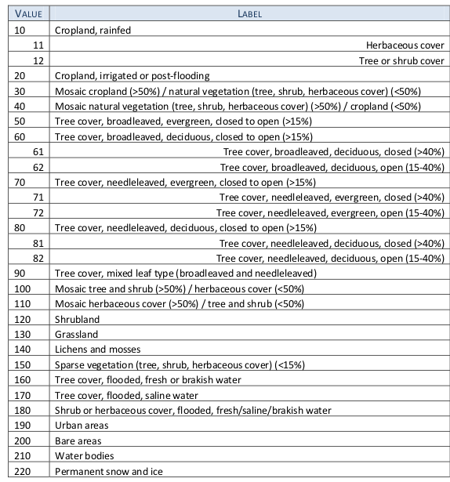

Supplementary 4 Decision tree used for categorising species as per the level of risk posed in countries where they are traded. All species are present in the trading countries considered and all are invasive somewhere in the world – hence ‘yes’ is the only possible response for the first two questions of the decision tree.
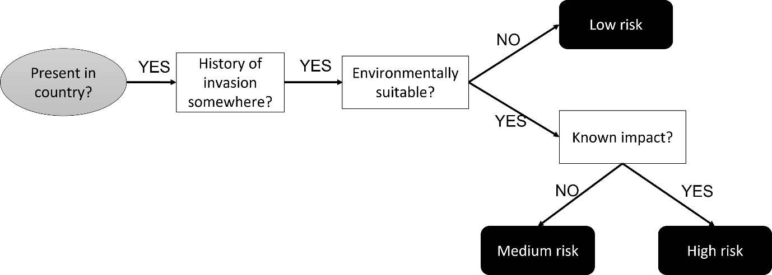

Supplementary 5 Response curves for the SDMs for each study species. Curves show how each environmental variable affects the Maxent prediction and how the predicted probability of presence changes as each environmental variable is varied, keeping all other environmental variables at their average sample value.
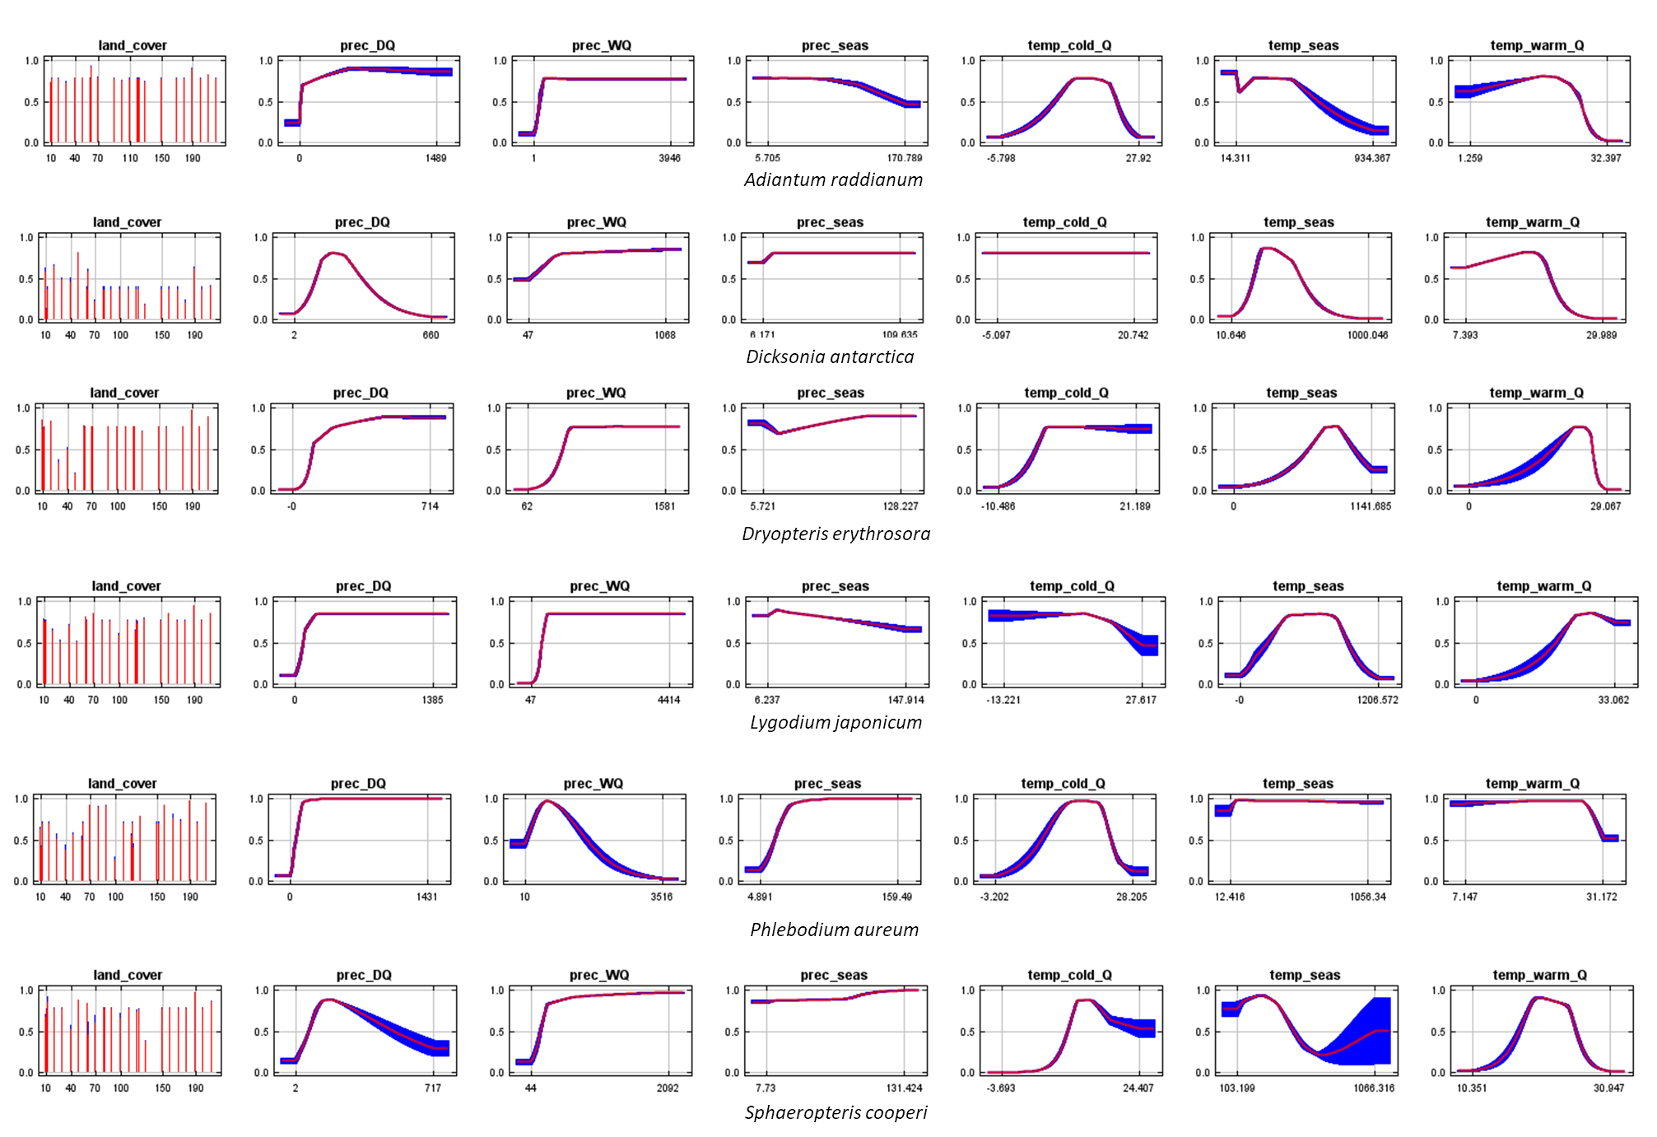
Supplementary References
Austin M (2007) Species distribution models and ecological theory: A critical assessment and some possible new approaches. Ecological Modelling 200:1–19. https://doi.org/10.1016/j.ecolmodel.2006.07.005
Barbet-Massin M, Rome Q, Villemant C, Courchamp F (2018) Can species distribution models really predict the expansion of invasive species? PLoS One 13(3):e0193085. https://doi.org/10.1371/journal.pone.0193085
Boyce MS, Vernier PR, Nielsen SE, Schmiegelow FKA (2002) Evaluating resource selection functions. Ecological Modelling 157:281–300. https://doi.org/10.1016/S0304-3800(02)00200-4
Braunisch V, Coppes J, Arlettaz R, Suchant R, Schmid H, Bollman K (2013) Selecting from correlated climate variables: A major source of uncertainty for predicting species distributions under climate change. Ecography 36:971–983. https://doi.org/10.1111/j.1600-0587.2013.00138.x
Chapman D, Pescott OL, Roy HE, Tanner R (2019) Improving species distribution models for invasive non-native species with biologically informed pseudo-absence selection. Journal of Biogeography 46:1029–1040. https://doi.org/10.1111/jbi.13555
Dormann CF, Purschke O, Márquez JRG, Lautenbach S, Schröder B (2008) Components of uncertainty in species distribution analysis: A case study of the great grey shrike. Ecology 89:3371–3386. https://doi.org/10.1890/07-1772.1
Dormann CF, Elith J, Bacher S, Buchmann C, Carl G, Carré G, García Marquéz JR, Gruber B, Lafourcade B, Leitão PJ, Münkemüller T, McClean C, Osborne PE, Reineking B, Schröder B, Skidmore AK, Zurell D, Lautenbach S (2013) Collinearity: A review of methods to deal with it and a simulation study evaluating their performance. Ecography 36:27–46. https://doi.org/10.1111/j.1600-0587.2012.07348.x
Elith J (2013) Predicting distributions of invasive species. In: Robinson AP, Walshe T, Burgman MA, Nunn M (eds) Invasive species: risk analyses and management. Cambridge University Press, Cambridge, UK, pp 93–129
Elith J, Kearney M, Phillips S (2010) The art of modelling range-shifting species. Methods Ecol Evol 1:330–342. https://doi.org/10.1111/j.2041-210x.2010.00036.x
Hannemann H, Willis KJ, Macias-Fauria M (2016) The devil is in the detail: Unstable response functions in species distribution models challenge bulk ensemble modelling. Global Ecology and Biogeography 25:26–35. https://doi.org/10.1111/geb.12381
Hirzel AH, Le Lay G, Helfer V, Randin C, Guisan A (2006) Evaluating the ability of habitat suitability models to predict species presences. Ecological Modelling 199:142–152. https://doi.org/10.1016/j.ecolmodel.2006.05.017
Jiménez-Valverde A, Peterson AT, Soberón J, et al (2011) Use of niche models in invasive species risk assessments. Biological Invasions 13:2785–2797. https://doi.org/10.1007/s10530-011-9963-4
Kong WY, Li XH, Zou HF (2019) Optimizing MaxEnt model in the prediction of species distribution. China Journal of Applied Ecology 30:2116–2128. https://doi.org/10.13287/j.1001-9332.201906.029
Kottek M, Grieser J, Beck C, Rudolf B, Rubel F (2006) World map of the Köppen-Geiger climate classification updated. Meteorologische Zeitschrift 15:259–263. https://doi.org/10.1127/0941-2948/2006/0130
Lobo JM, Jiménez-Valverde A, Hortal J (2010) The uncertain nature of absences and their importance in species distribution modelling. Ecography 3:103–114. https://doi.org/10.1111/j.1600-0587.2009.06039.x
Mainali KP, Warren DL, Dhileepan K, McConnachie A, Strathie L, Hassan G, Karki G, Shrestha BB, Parmesan C (2015) Projecting future expansion of invasive species: Comparing and improving methodologies for species distribution modeling. Global Change Biology 21:4464–4480. https://doi.org/10.1111/gcb.13038
Manzoor SA, Griffiths G, Lukac M (2018) Species distribution model transferability and model grain size-finer may not always be better. Scientific Reports 8:1–9. https://doi.org/10.1038/s41598-018-25437-1
Merow C, Smith MJ, Silander JA (2013) A practical guide to MaxEnt for modeling species’ distributions: What it does, and why inputs and settings matter. Ecography 6:1058–1069. https://doi.org/10.1111/j.1600-0587.2013.07872.x
Peck JH, Peck CJ, Farrar DR (1990) influences of life history attributes on formation of local and distant fern populations. American Fern Journal 80:126. https://doi.org/10.2307/1547200
Peterson AT, Soberón J, Pearson RG, Anderson RP, Martínez-Meyer E, Nakamura M, Araújo MB (2011) Ecological niches and geographic distributions. Princeton University Press, Oxford, England, 328 pp.
Petitpierre B, Broennimann O, Kueffer C, Daehler C, Guisan A (2017) Selecting predictors to maximize the transferability of species distribution models: lessons from cross-continental plant invasions. Global Ecology and Biogeography 26:275–287. https://doi.org/10.1111/geb.12530
Phillips SJ, Dudík M, Schapire RE (2004) A maximum entropy approach to species distribution modeling. In: Proceedings, Twenty-First International Conference on Machine Learning, ACM Press, New York, USA, 655–662
Phillips SB, Anderson RP, Schapire RE (2006) Maximum entropy modeling of species geographic distributions. Ecological Modelling. 190:231-259 https://doi.org/10.1016/j.ecolmodel.2005.03.026
Phillips SJ, Dudík M (2008) Modeling of species distributions with Maxent: New extensions and a comprehensive evaluation. Ecography 31:161–175. https://doi.org/10.1111/j.0906-7590.2008.5203.x
Phillips SJ, Dudík M, Elith J, Graham CH, Lehmann A, Leathwick J, Ferrier S (2009) Sample selection bias and presence-only distribution models: Implications for background and pseudo-absence data. Ecological Applications 19:181–197. https://doi.org/10.1890/07-2153.1
Radosavljevic A, Anderson RP (2014) Making better Maxent models of species distributions: Complexity, overfitting and evaluation. Journal of Biogeography 41:629–643. https://doi.org/10.1111/jbi.12227
Robertson MP, Visser V, Hui C (2016) Biogeo: An R package for assessing and improving data quality of occurrence record datasets. Ecography 39:394–401. https://doi.org/10.1111/ecog.02118
Rose JP, Dassler CL (2017) Spore Production and Dispersal in Two Temperate Fern Species, With an Overview of the Evolution of Spore Production in Ferns. American Fern Journal 107(3):136-155 https://doi.org/10.1640/0002-8444-107.3.136
West AM, Kumar S, Brown CS, Stohlgren TJ, Bromberg J (2016) Field validation of an invasive species Maxent model. Ecological Informatics 36:126–134. https://doi.org/10.1016/j.ecoinf.2016.11.001
Zimmermann NE, Yoccoz NG, Edwards TC, Meier ES, Thuiller W, Guisan A, Schmatz DR, Pearman PB (2009) Climatic extremes improve predictions of spatial patterns of tree species. Proceedings of the National Academy of Sciences of the United States of America 106:19723–19728. https://doi.org/10.1073/pnas.0901643106
Zizka A, Silvestro D, Andermann T, Azevedo J, Duarte Ritter C, Edler D, Farooq H, Herdean A, Ariza M, Scharn R, Svantesson S, Wengström N, Zizka V, Antonelli A (2019) CoordinateCleaner: Standardized cleaning of occurrence records from biological collection databases. Methods in Ecology and Evolution 10:744–751. https://doi.org/10.1111/2041-210X.13152

