Supplementary Table 1. 15 Soil physiochemical and environmental variables recorded from each sample site.
Sample ID | Zone | Distance from coast (km) | pH | EC (mS/m) | P (mg/l) | Na (mg/l) | K (mg/l) | Ca (mg/l) | Mg (mg/l) | Cl (mg/l) | SO4 (mg/l) | NH4 (mg/l) | NO3 (mg/l) | Carbon (%) | Sand (%) | Clay (%) | Silt (%)
C14.2.A | Fog | 17 | 6.8 | 206 | 0.41 | 151.86 | 39.3 | 912.36 | 24.09 | 176.24 | 1944.13 | 1.39 | 2.52 | 0.07 | 87 | 5 | 8
C14.2.B | Fog | 17 | 7.1 | 226 | 0.31 | 240.06 | 45.86 | 939.12 | 27.3 | 158.51 | 1996.5 | 1.19 | 3.44 | 0.08 | 83 | 5 | 12
C14.2.C | Fog | 17 | 7.1 | 342 | 0.19 | 592.38 | 60.63 | 947.22 | 30.2 | 765.94 | 2172.41 | 1.24 | 2.56 | 0.06 | 75 | 12 | 13
C14.2.D | Fog | 17 | 7.1 | 248 | 0.24 | 254.72 | 35.86 | 957.58 | 16.55 | 345.83 | 1928.89 | 1 | 2.44 | 0.09 | 87 | 7 | 7
C14.4.A | Fog | 37 | 7.1 | 365 | 0.16 | 499.08 | 89.62 | 1011.71 | 64.45 | 850.33 | 1834.54 | 1.18 | 33.3 | 0.08 | 80 | 7 | 13
C14.4.B | Fog | 37 | 7.3 | 249 | 0.31 | 226.6 | 74.26 | 946.25 | 23.27 | 234.39 | 1838.38 | 0.83 | 11.94 | 0.11 | 75 | 7 | 18
C14.4.C | Fog | 37 | 7.2 | 241 | 0.2 | 191.43 | 59.72 | 976.39 | 29.43 | 350.7 | 1818.88 | 1 | 3.81 | 0.07 | 82 | 5 | 13
C14.4.D | Fog | 37 | 7.3 | 218 | 0.25 | 174.12 | 46.05 | 983.01 | 16.97 | 285.1 | 1886.5 | 0.98 | 3.96 | 0.1 | 81 | 2 | 17
C14.6.A | Fog | 57 | 7.1 | 4170 | 0.1 | 11097.1 | 328.33 | 1169.16 | 54.85 | 21162.53 | 2929.32 | 2.02 | 96.65 | 0.28 | 57 | 20 | 23
C14.6.B | Fog | 57 | 7.3 | 1743 | 1.49 | 4967.15 | 176.32 | 1142.59 | 27.91 | 7269.3 | 2832.85 | 1.39 | 27.73 | 0.1 | 73 | 10 | 17
C14.6.C | Fog | 57 | 7.4 | 249 | 0.25 | 181.75 | 24.8 | 988.63 | 9.43 | 247.51 | 1936.93 | 0.82 | 3.33 | 0.11 | 88 | 0 | 12
C14.6.D | Fog | 57 | 7.3 | 188.7 | 0.53 | 78.12 | 17.15 | 976.11 | 8.2 | 74.11 | 1849.29 | 0.99 | 2.02 | 0.08 | 91 | 2 | 7
C14.8.A | Low-rainfall | 77 | 7.2 | 662 | 0.09 | 1513.05 | 141.26 | 693.17 | 77.51 | 2399.93 | 890.21 | 0.95 | 31.97 | 0.06 | 90 | 2 | 8
C14.8.C | Low-rainfall | 77 | 7.5 | 209 | 0.41 | 92.55 | 15.18 | 794.59 | 6.14 | 154.25 | 1450.16 | 1.04 | 3.71 | 0.08 | 91 | 2 | 7
C14.10.A | Low-rainfall | 97 | 7.8 | 33.5 | 0.49 | 23.6 | 12.86 | 91.42 | 6.74 | 21.28 | 142.74 | 0.58 | 2.18 | 0.09 | 77 | 2 | 22
C14.10.B | Low-rainfall | 97 | 7.8 | 28.7 | 0.56 | 19.06 | 12.17 | 76.71 | 4.56 | 14.54 | 100.17 | 0.58 | 2.05 | 0.19 | 77 | 3 | 20
C14.10.C | Low-rainfall | 97 | 7.7 | 34.6 | 0.39 | 20.12 | 9.89 | 97.54 | 4.72 | 26.6 | 122.74 | 0.71 | 4.49 | 0.22 | 84 | 2 | 14
C14.10.D | Low-rainfall | 97 | 7.7 | 29.6 | 0.49 | 13.12 | 8.1 | 85.66 | 4.4 | 22.69 | 83.9 | 0.63 | 5.65 | 0.18 | 87 | 0 | 13
C14.12.A | Low-rainfall | 117 | 7.6 | 30.8 | 0.46 | 12.61 | 16.21 | 88.41 | 5.52 | 16.67 | 107.1 | 0.54 | 3.33 | 0.29 | 72 | 7 | 21
C14.12.B | Low-rainfall | 117 | 7.6 | 23.1 | 0.37 | 6.51 | 10.07 | 70.91 | 3.73 | 10.28 | 79.07 | 0.45 | 1.65 | 0.19 | 71 | 7 | 22
C14.12.C | Low-rainfall | 117 | 7.3 | 137.7 | 0.52 | 13.54 | 12.72 | 763.62 | 8.07 | 15.96 | 1369.73 | 1.2 | 7.55 | 0.13 | 83 | 5 | 12
C14.12.D | Low-rainfall | 117 | 7.5 | 58.4 | 0.68 | 9.64 | 10.88 | 210.17 | 6.07 | 53.19 | 242.26 | 1.91 | 11.92 | 0.3 | 78 | 3 | 18
C14.14.A | Low-rainfall | 137 | 7.6 | 30.1 | 0.82 | 20.85 | 40.76 | 44.01 | 7.96 | 21.63 | 57.84 | 0.66 | 8.17 | 0.24 | 78 | 5 | 17
C14.14.B | Low-rainfall | 137 | 7.6 | 21.1 | 0.56 | 15.61 | 11.04 | 47.13 | 6.96 | 19.86 | 41.81 | 0.47 | 2.36 | 0.17 | 78 | 7 | 16
C14.14.C | Low-rainfall | 137 | 7.6 | 21.4 | 0.78 | 8.58 | 12.32 | 48.99 | 7.89 | 17.73 | 26.05 | 0.53 | 7.62 | 0.16 | 89 | 4 | 7
C14.14.D | Low-rainfall | 137 | 7.5 | 20.3 | 0.56 | 6.45 | 8.93 | 49.92 | 8.03 | 23.05 | 16.22 | 0.71 | 8.75 | 0.13 | 90 | 3 | 8
C14.16.A | High-rainfall | 157 | 7.5 | 16.72 | 0.99 | 4.63 | 8.92 | 47.88 | 6.92 | 8.87 | 19.86 | 1.27 | 3.65 | 0.64 | 51 | 4 | 46
C14.16.B | High-rainfall | 157 | 7.7 | 33.2 | 0.49 | 13.82 | 12.75 | 80.72 | 11.81 | 35.81 | 30.02 | 0.4 | 12.93 | 0.38 | 72 | 3 | 25
C14.16.C | High-rainfall | 157 | 7.3 | 23.5 | 0.56 | 4.9 | 7.9 | 65.16 | 11.21 | 11.7 | 18.79 | 1.13 | 4.05 | 0.7 | 72 | 5 | 23
C14.16.D | High-rainfall | 157 | 7.6 | 26.7 | 0.58 | 8.39 | 8.41 | 59.19 | 11.03 | 14.54 | 27.54 | 0.56 | 5.6 | 0.91 | 71 | 3 | 25
C14.18.A | High-rainfall | 177 | 7.6 | 16.4 | 1.26 | 5.33 | 57.59 | 35.22 | 7.44 | 21.99 | 22.75 | 1 | 2.74 | 0.36 | 85 | 4 | 11
C14.18.B | High-rainfall | 177 | 7.8 | 14.55 | 1.66 | 3.61 | 19.57 | 21.58 | 5.39 | 13.12 | 9.4 | 1.01 | 2.2 | 0.23 | 87 | 3 | 10
C14.18.C | High-rainfall | 177 | 7.4 | 17.83 | 1.31 | 4.52 | 11.36 | 28.28 | 5.6 | 12.41 | 11.65 | 1.86 | 7.6 | 0.07 | 95 | 2 | 3
C14.18.D | High-rainfall | 177 | 7.2 | 20.7 | 2.33 | 4.01 | 16.87 | 30.5 | 8.51 | 10.28 | 15.15 | 0.92 | 9.1 | 0.16 | 96 | 3 | 1
C14.20.A | High-rainfall | 197 | 7.2 | 13.64 | 1.32 | 3.16 | 11.64 | 27.85 | 6.14 | 8.87 | 13.37 | 0.74 | 5.47 | 0.57 | 65 | 5 | 31
C14.20.B | High-rainfall | 197 | 7.3 | 12.71 | 1.08 | 2.37 | 6.87 | 33.77 | 3.09 | 8.16 | 10.31 | 0.54 | 2.29 | 0.62 | 85 | 5 | 10
C14.20.C | High-rainfall | 197 | 7.4 | 18.84 | 1.97 | 2.61 | 9.06 | 44.78 | 4.85 | 7.09 | 12 | 0.74 | 3.73 | 0.52 | 87 | 2 | 11
C14.20.D | High-rainfall | 197 | 7.5 | 18.3 | 1.32 | 3.05 | 9.6 | 36.46 | 3.92 | 10.28 | 7.86 | 0.64 | 5.28 | 0.25 | 87 | 3 | 9

Supplementary Table 2. Statistics of significant fungal taxa at phylum and genus level. Significant tests (p/q < 0.05) are indicated by *.

 | ANOVA (F) | ANOVA  (p-value) | Tukey’s HSD (q-value)
 | ANOVA (F) | ANOVA  (p-value) | Fog-High rainfall | Fog-Low rainfall | Low rainfall-High rainfall
Phyla
Ascomycota | 4.268 | 0.022* | 0.0186141* | 0.1359816 | 0.57506
Chytridiomycota | 19.43 | 0.000011* | 0.0004049* | 0.0000017* | 0.2337637
Unidentified | 6.067 | 0.00547* | 0.0069237* | 0.0248644* | 0.8047402
Genera
Alternaria | 4.0 | 0.019* | 0.0382494* | 0.0329093* | 0.999435
Cladosporium | 7.596 | 0.00182* | 0.0048373* | 0.0046806* | 0.992645
Curvularia | 5.665 | 0.00739* | 0.0657618* | 0.0063603* | 0.657649
Darksidea | 3.501 | 0.0411* | 0.7547612 | 0.0396772* | 0.182833
Malassezia | 8.199 | 0.0012* | 0.0038904* | 0.002865* | 0.999803
Oedocephalum | 10.0 | 0.000367* | 0.9120511 | 0.0008415* | 0.002775*
Preussia | 7.55 | 0.00188* | 0.0037935* | 0.9421274 | 0.006442*
Rhizophlyctis | 9.241 | 0.000599* | 0.0351438* | 0.0004017* | 0.269548
Westerdykella | 21.76 | 0.000000722* | 0.0000008* | 0.1992303 | 7.77E-05*

Supplementary Table 3. Phylogenetic affiliation and relative abundance of the 15 fungal ASVs common to the three xeric zones.
Phylum | Class | Genus | Relative abundance in percentage
Phylum | Class | Genus | Fog | Low rainfall | High rainfall
Ascomycota | Dothideomycetes | Curvularia | 0.178 | 4.410 | 0.246
Ascomycota | Dothideomycetes | Alternaria | 2.518 | 0.431 | 0.494
Ascomycota | Dothideomycetes | Cladosporium | 4.683 | 0.198 | 0.029
Ascomycota | Dothideomycetes | Pseudopithomyces | 0.003 | 0.443 | 1.210
Ascomycota | Dothideomycetes | Didymella | 0.002 | 0.804 | 0.892
Ascomycota | Dothideomycetes | Aureobasidium | 0.067 | 0.58 | 0.240
Basidiomycota | Tremellomycetes | Naganishia | 0.002 | 0.436 | 0.324
Ascomycota | Unidentified | Unidentified | 0.004 | 0.337 | 0.022
Ascomycota | Dothideomycetes | Curvularia | 0.002 | 0.496 | 0.023
Ascomycota | Dothideomycetes | Pseudopithomyces | 0.011 | 0.288 | 0.079
Ascomycota | Dothideomycetes | Phaeodothis | 0.004 | 0.133 | 0.201
Ascomycota | Dothideomycetes | Pseudopithomyces | 0.040 | 0.002 | 0.009
Ascomycota | Dothideomycetes | Alternaria | 0.037 | 0.021 | 0.005
Ascomycota | Sordariomycetes | Unidentified | 0.046 | 0.013 | 0.028
Ascomycota | Dothideomycetes | Preussia | 0.001 | 0.024 | 0.019

Supplementary Table 4. Statistically significant environmental variables (p < 0.05) identified using db-RDA analysis.
Environmental Variable | F | p
Fog | 5.915349 | 0.002
SO₄ | 2.215537 | 0.002
Silt | 1.57568 | 0.002
Mg | 1.553045 | 0.002
P | 1.425163 | 0.008
Ca | 1.352486 | 0.024

Supplementary Figures
Supplementary Figure 1. Box plots showing the differences in the soil physicochemical parameters. The Kruskal-Wallis and Dunn’s posthoc tests were performed for the statistical comparisons of the physiochemical variables. The dotted red line shows the statistical significance cut-off of q≤0.05. F= Fog; L= Low-rainfall; H= High-rainfall
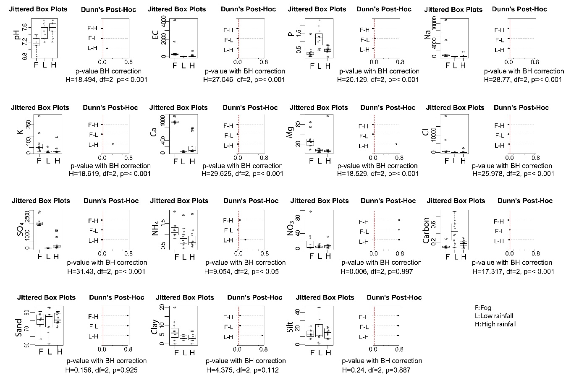

Supplementary Figure 2. Rarefaction curve. The rarefied sequences are showing sufficient coverage for the fungal diversity in the xeric transect soils. 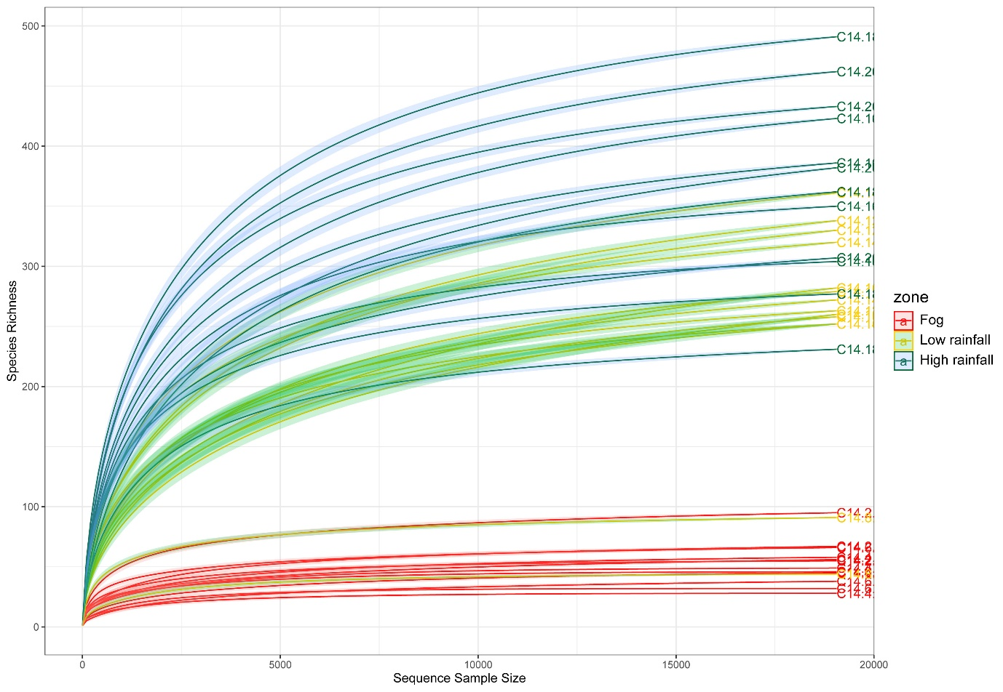

Supplementary Figure 3. Relative abundances of fungal genera in the different sites of each xeric zone.
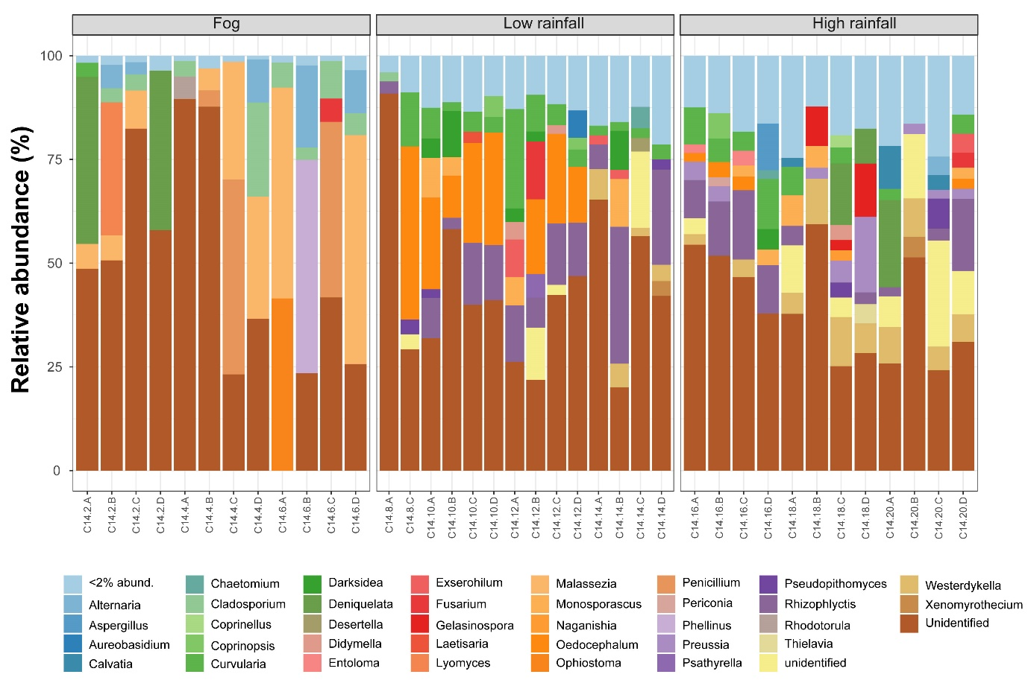

Supplementary Figure 4. Venn diagram showing the shared and xeric-zone specific fungal ASVs
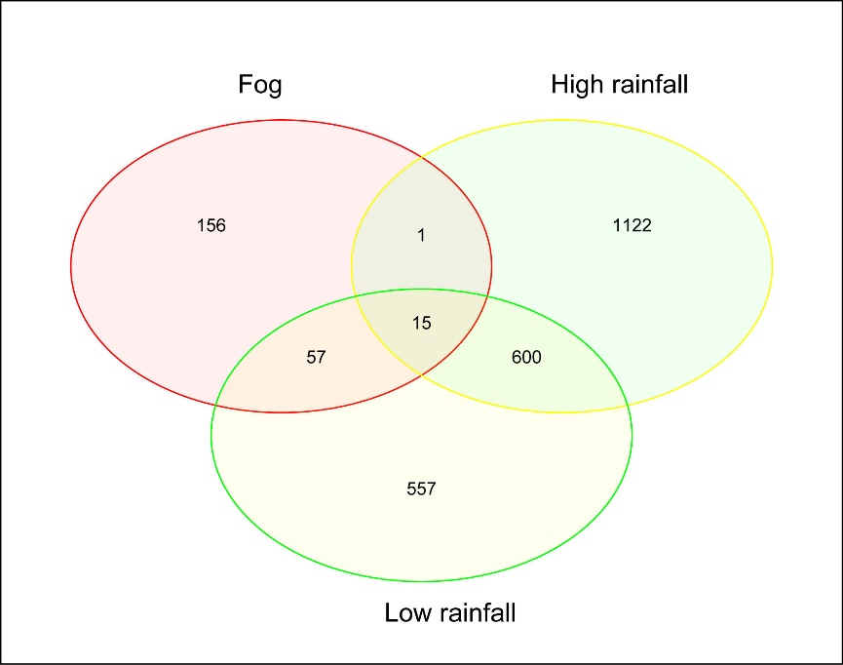

Supplementary Figure 5. Variation partitioning showing the variations explained by the soil physicochemical (X1) and spatial parameters (X2).

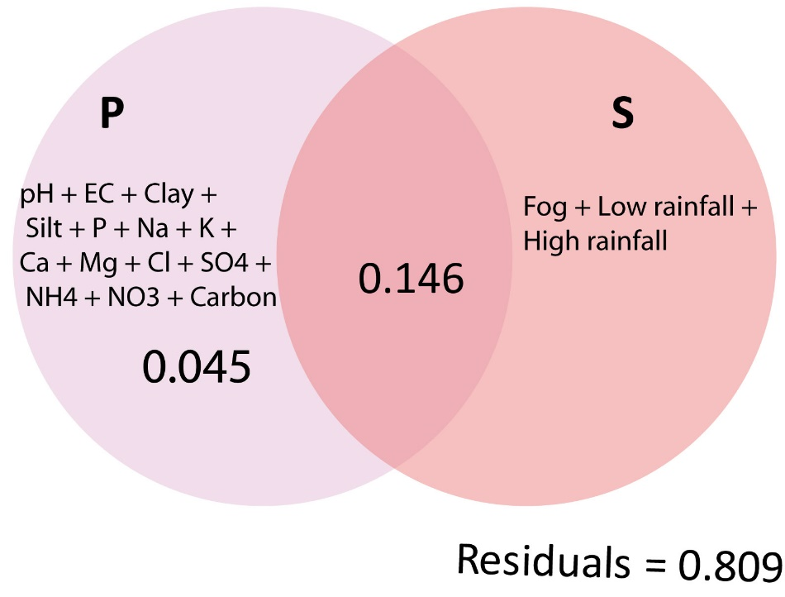

Supplementary Figure 6. The relative importance of different ecological processes was identified using null model analysis in iCAMP tool. The acronyms refer to the assembly processes, whether deterministic (HeS: heterogenous selection; HoS: homogenous selection) or stochastic (DL: dispersal limitation; HD: homogenising dispersal; DR: drift).
