Supplementary Table S1: Overall information on recombinants we report in this study. Information of regional and global prevalence is provided.
Recombinant | Additional Mutations | BW |  | AFR |  | Global |  | First  Reported |  | First SAMpling  in BW |  | First  Reports |  | First Case  (collection) |  | Last Reports |  | Last  Reported |  | Time in Circulation
XBB | - | 2 | 246 |  | 5,107 |  | India |  | 2022-Dec-18 |  | 2022-Sep-09 |  | 2022-Aug-13 |  | 2024-Mar-04 |  | Chile |  | 569
XBB.1.16 | S:E180V, S:478R | 9 | 454 |  | 39,481 |  | Malaysia |  | 2023-May-17 |  | 2022-Dec-21 |  | 2022-Nov-23 |  | 2024-May-03 |  | USA |  | 527
XBB.1.16.18 | ORF7a:T39I, | 2 | 4 |  | 956 |  | USA |  | 2023-Aug-17 |  | 2023-Mar-20 |  | 2023-Mar-13 |  | 2024-Feb-17 |  | England |  | 341
XBB.1.16.2 | ORF3a:V13L, ORF1a:P926H, | 5 | 74 |  | 3,453 |  | India |  | 2023-Jul-06 |  | 2023-Feb-24 |  | 2023-Feb-13 |  | 2024-Jan-28 |  | USA |  | 349
XBB.1.5 | S:F486P | 6 | 1,768 |  | 188,310 |  | India |  | 2022-Dec-06 |  | 2022-Oct-10 |  | 2022-Sep-14 |  | 2024-Apr-12 |  | Canada |  | 576
XBB.1.5.28 | S:K478R, on 17124C polytomy, | 1 | 11 |  | 1,061 |  | USA |  | 2023-Aug-24 |  | 2023-Jan-20 |  | 2022-Dec-26 |  | 2024-Feb-18 |  | USA |  | 419
XBB.1.5.81 | S:478R, G4657A, | 7 | 121 |  | 198 |  | Chile |  | 2023-Jun-21 |  | 2023-Mar-04 |  | 2023-Feb-14 |  | 2023-Oct-24 |  | Mexico |  | 252
XBJ.1.1 | S:G485D, N:R195K, | 1 | 1 |  | 71 |  | Philippines |  | 2023-Jan-30 |  | 2022-Dec-06 |  | 2022-Oct-28 |  | 2023-Apr-10 |  | Korea |  | 164
XM | - | 2 | 6 |  | 585 |  | India |  | - |  | 2022-Jan-17 |  | 2022-Jan-01 |  | 2022-Aug-28 |  | USA |  | 239
XV | - | 4 | 4 |  | 42 |  | Denmark |  | 2022-Apr-02 |  | 2022-Feb-08 |  | 2022-Jan-31 |  | 2022-Apr-27 |  | Italy |  | 86

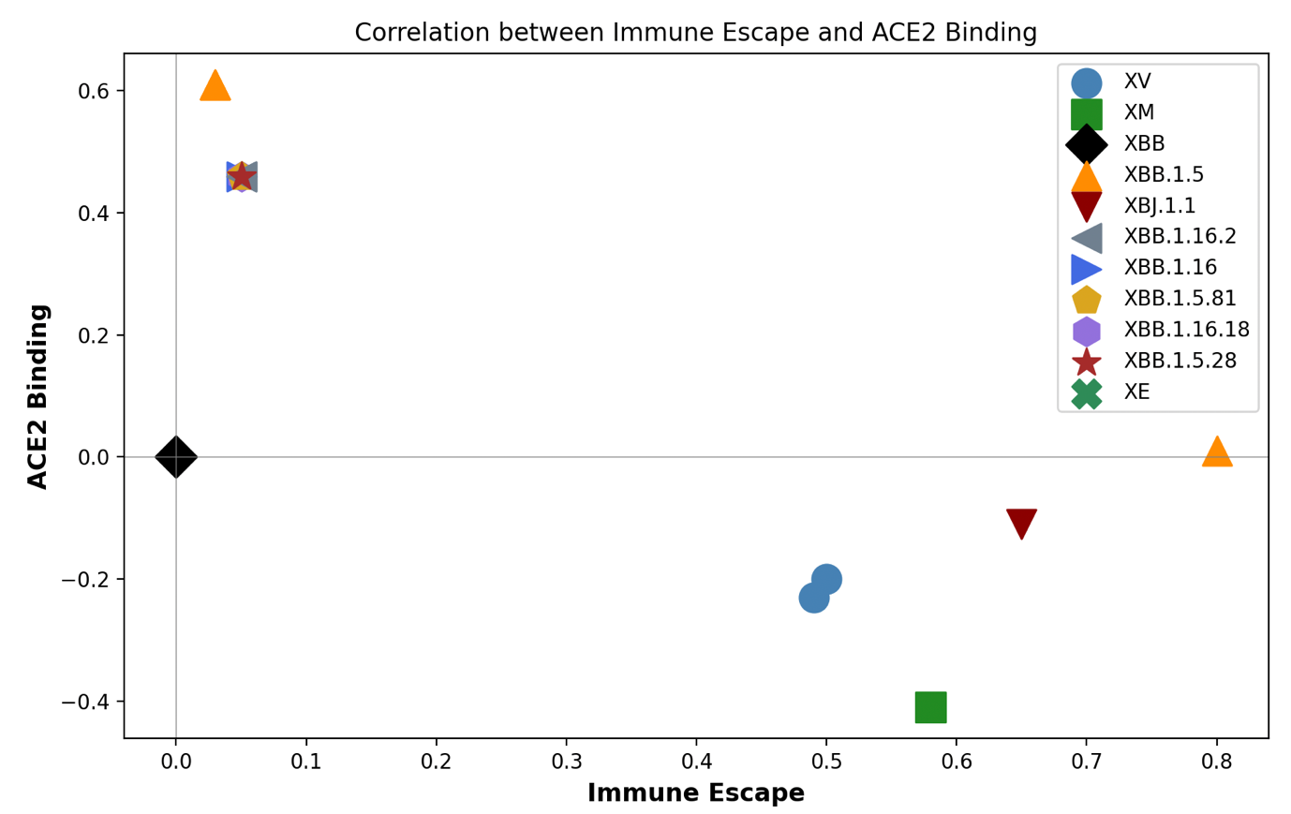

Figure S1: Scatterplot of ACE2 binding versus immune escape estimated values. The plot is bases on valued calculated by Bloom lab's ACE2 binding calculator and Bloom lab's antibody escape calculator, respectively.

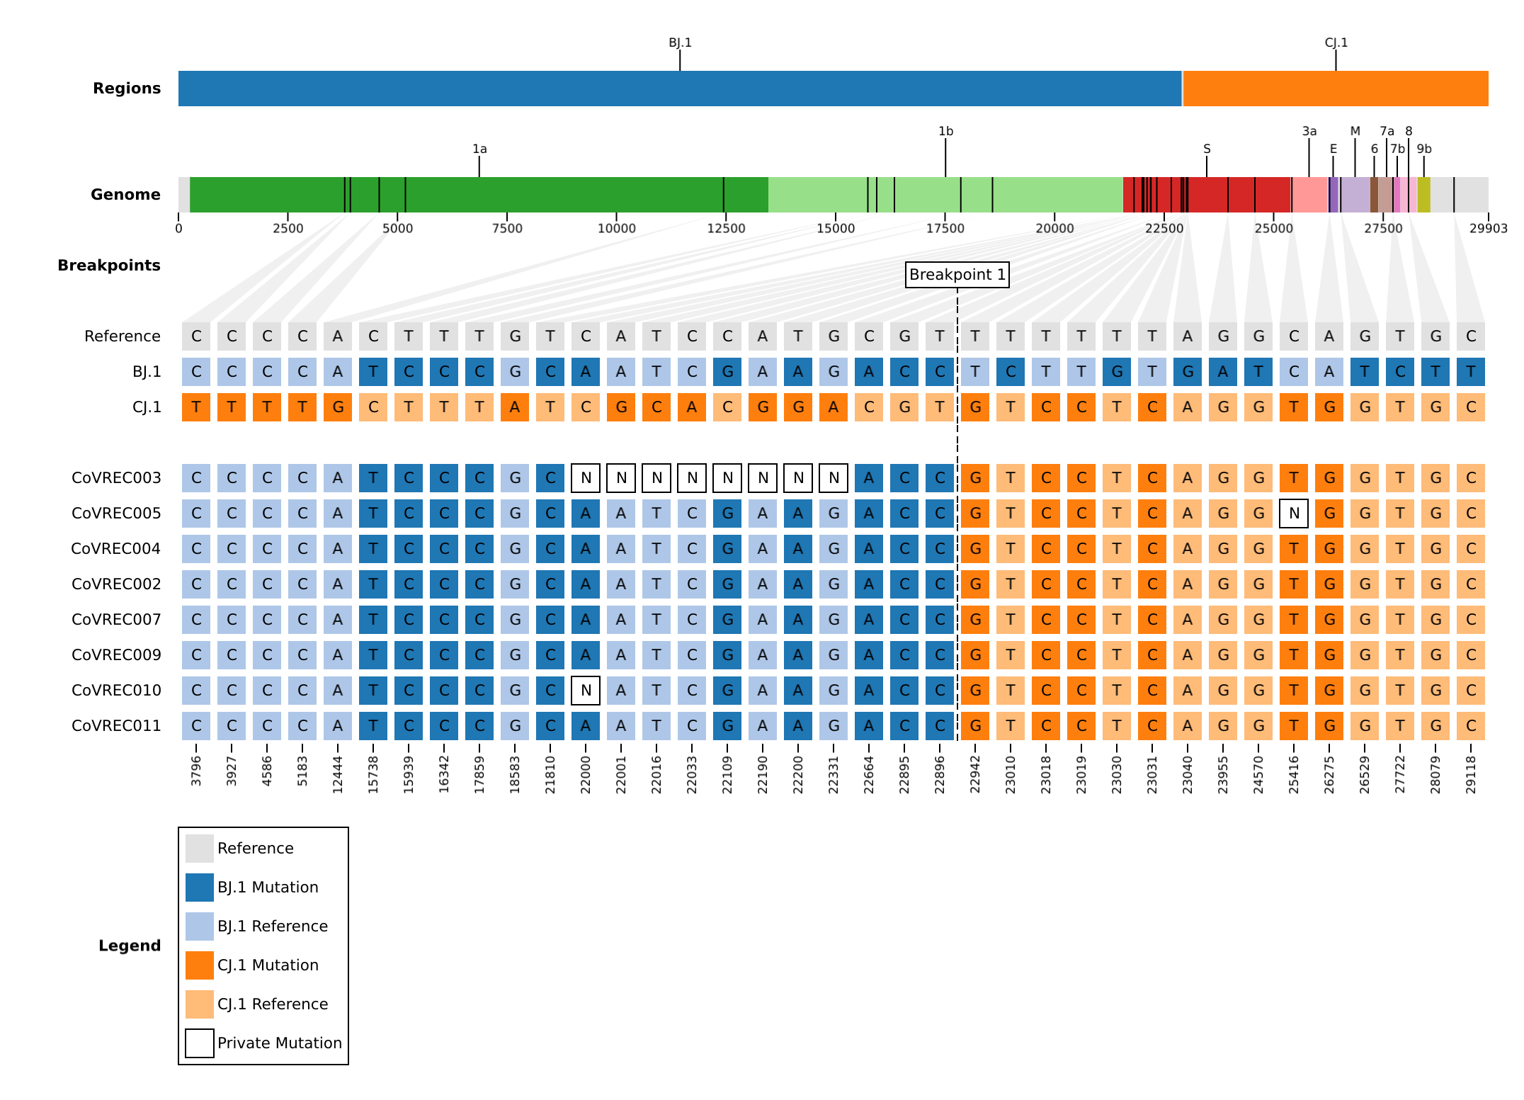

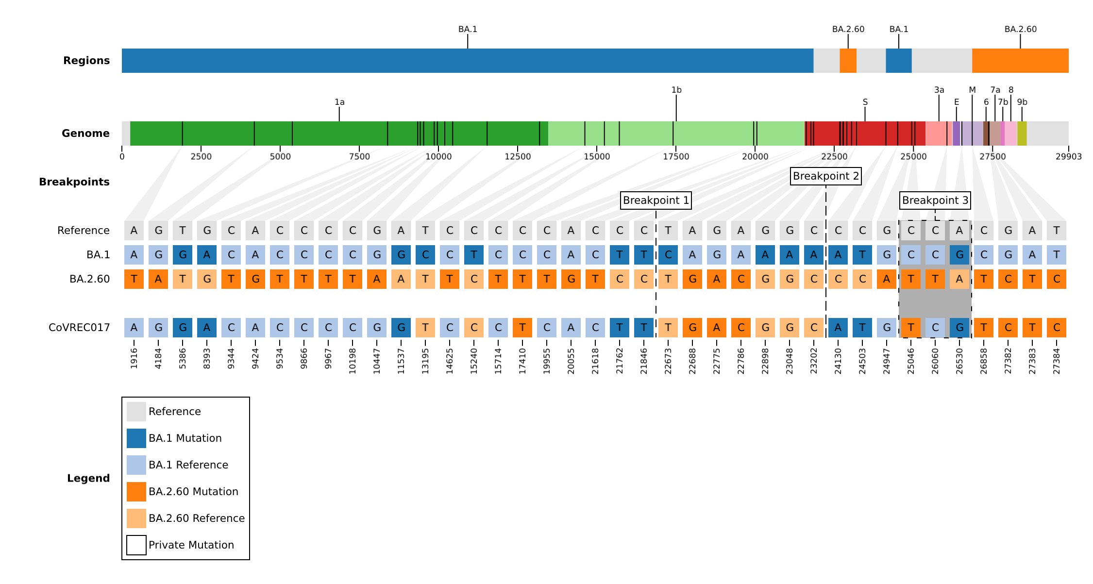
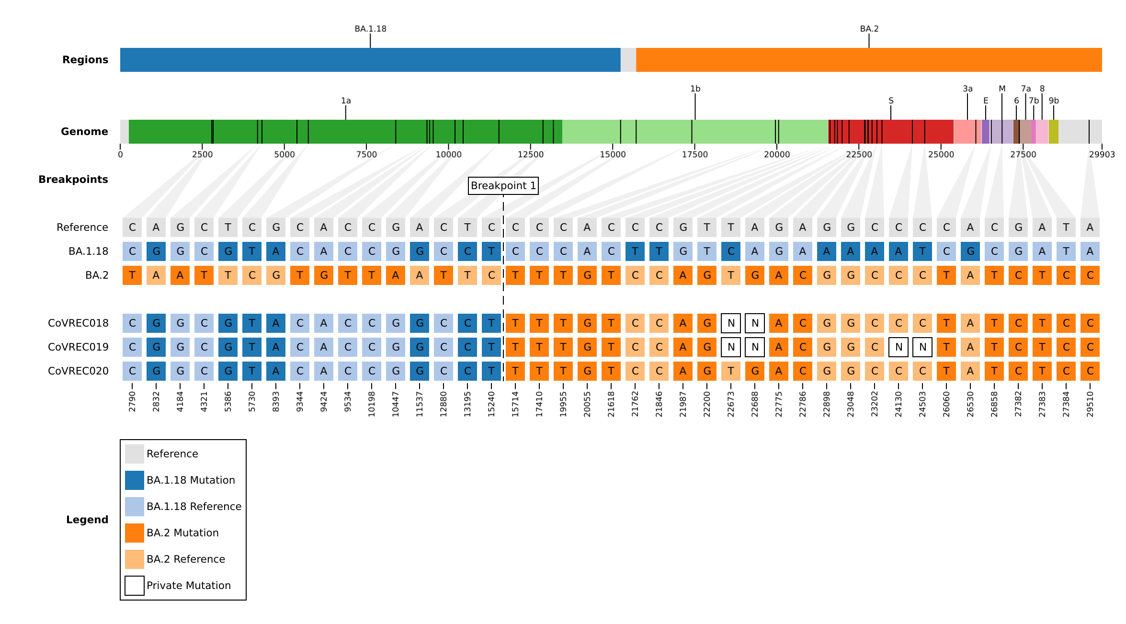
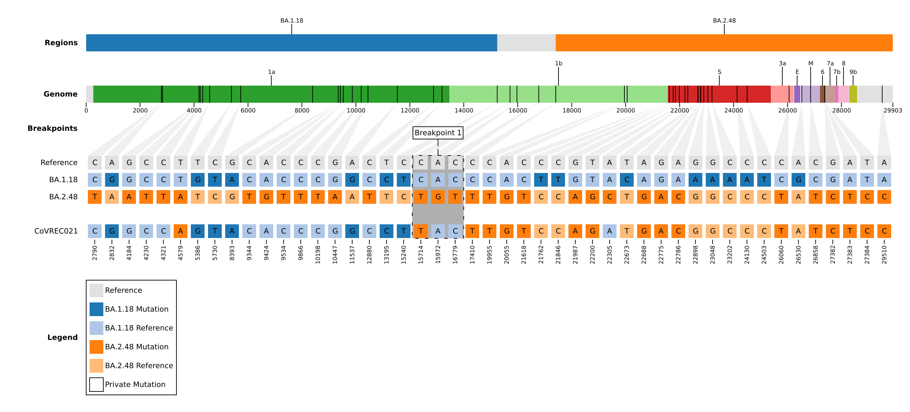
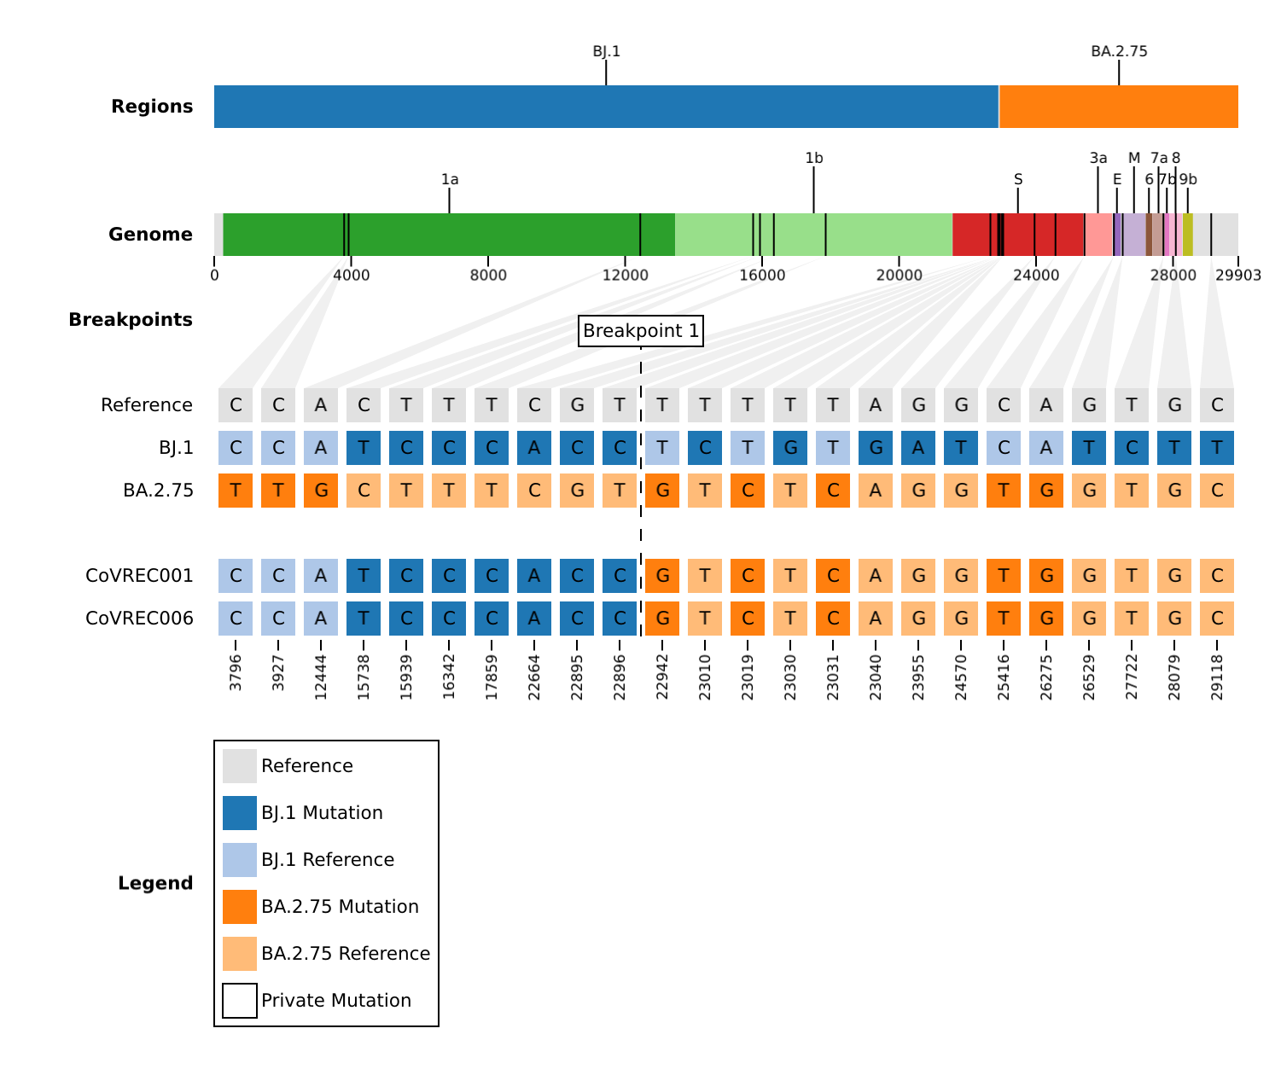Figure S2: Representative mosaic structures showing of some of the putative SARS-CoV-2 recombinant sequences characterised in Botswana.

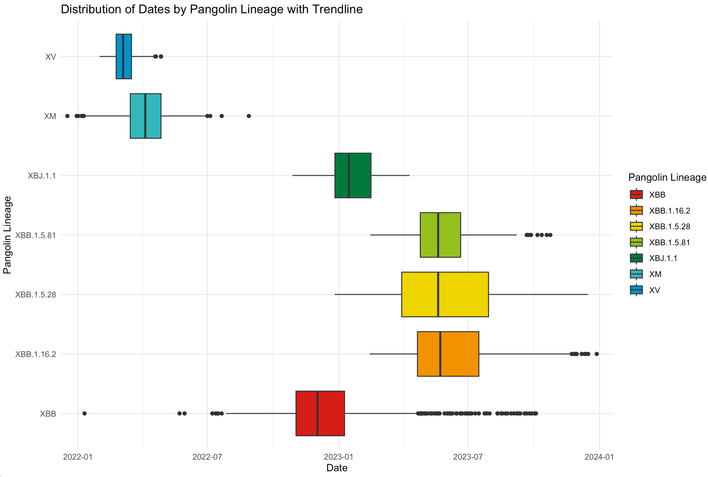
Supplementary Figure 3A. Boxplots showing the distribution of sampling dates for recombinant samples

.

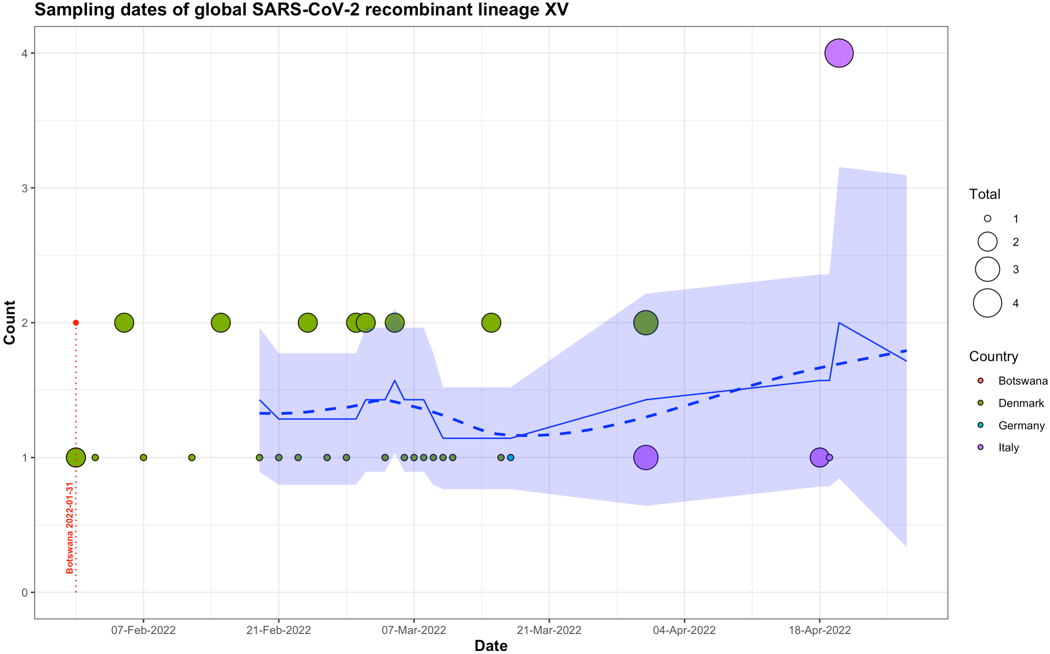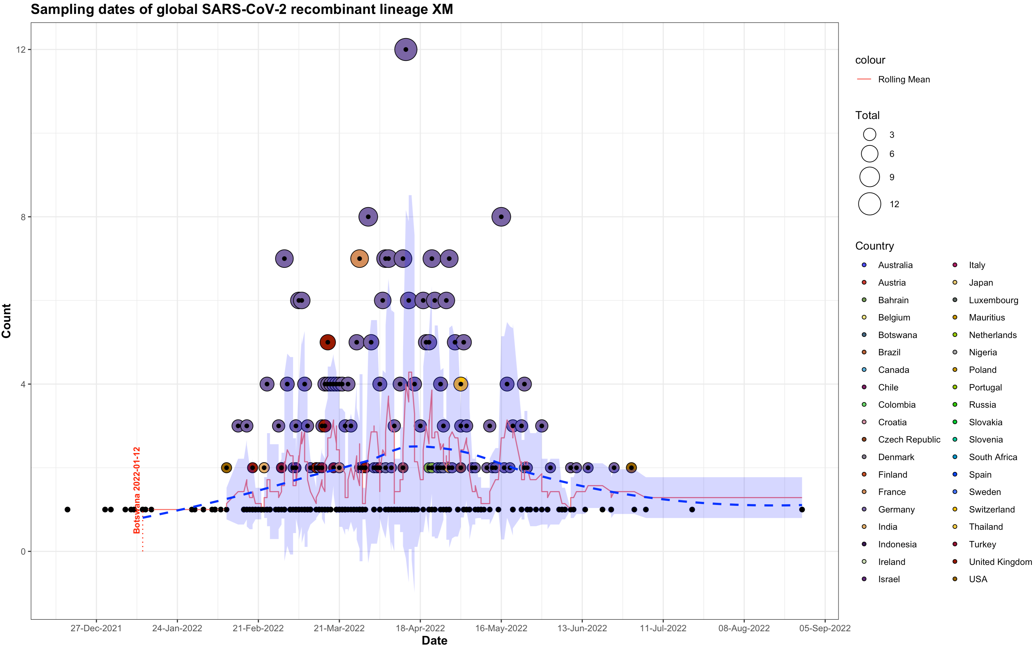

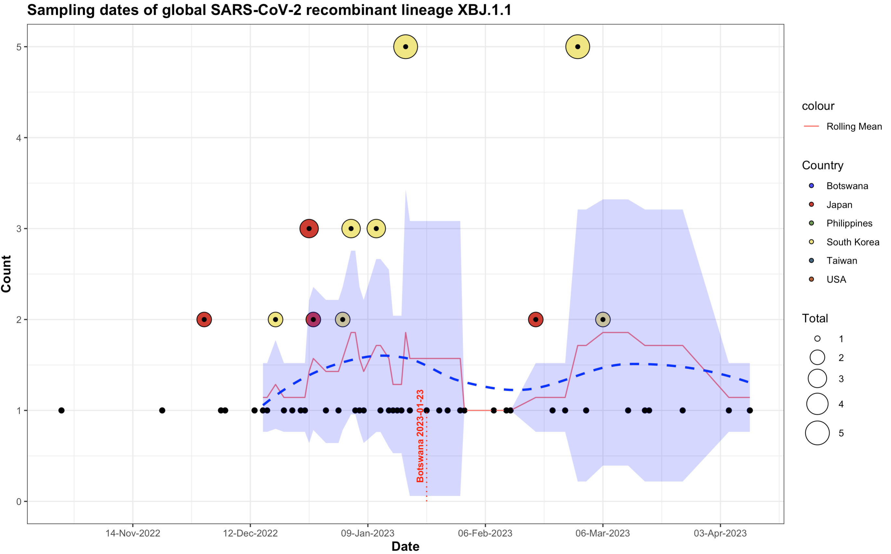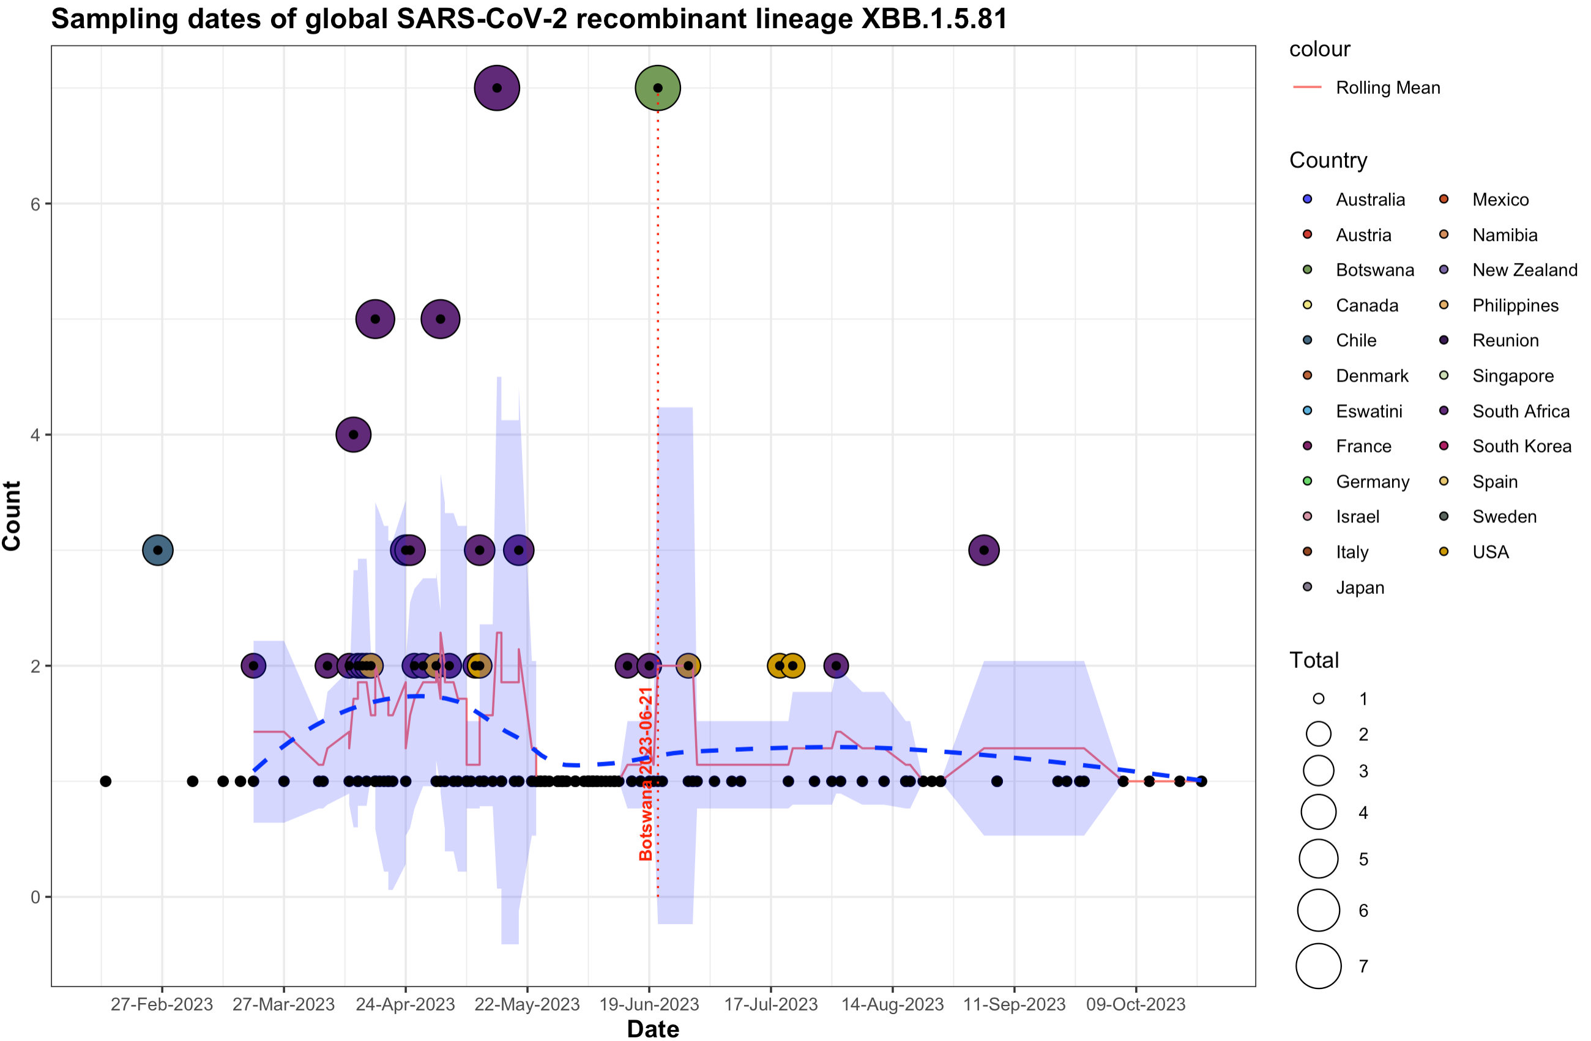

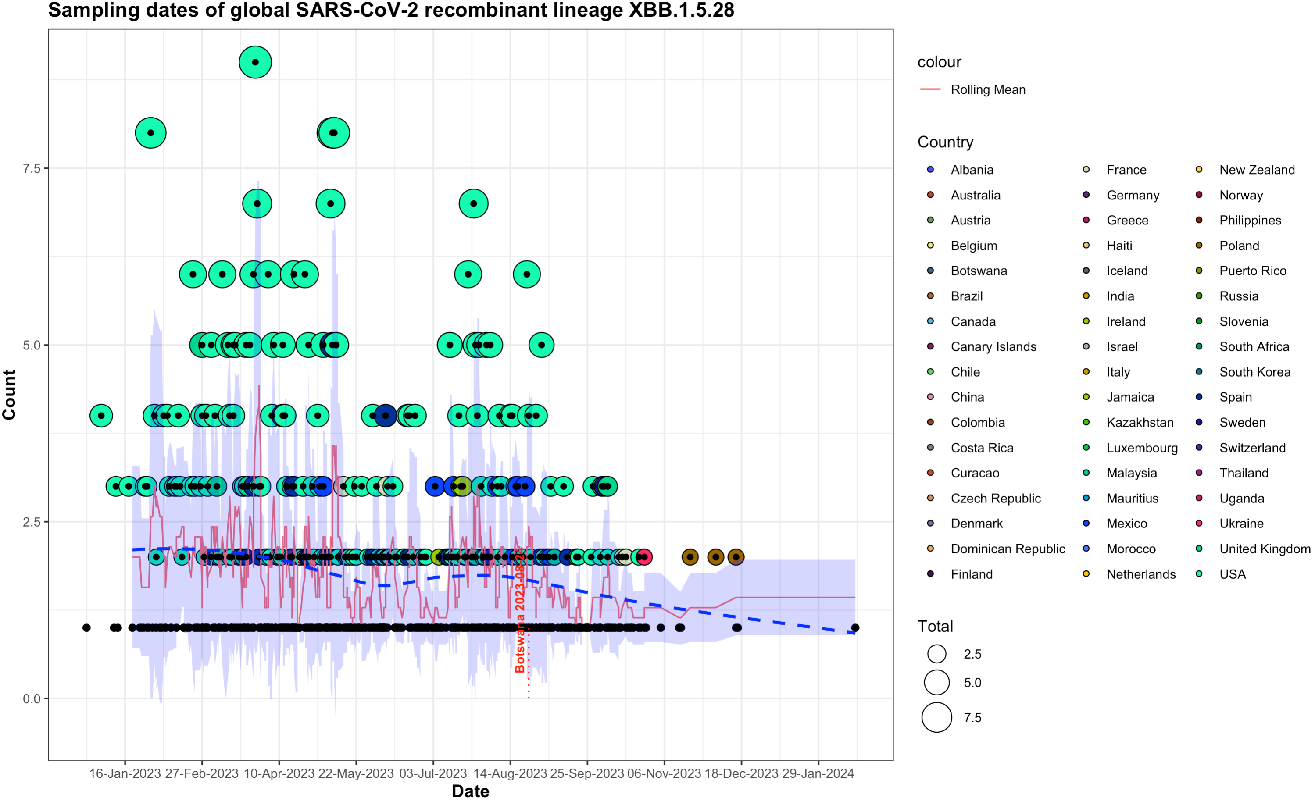

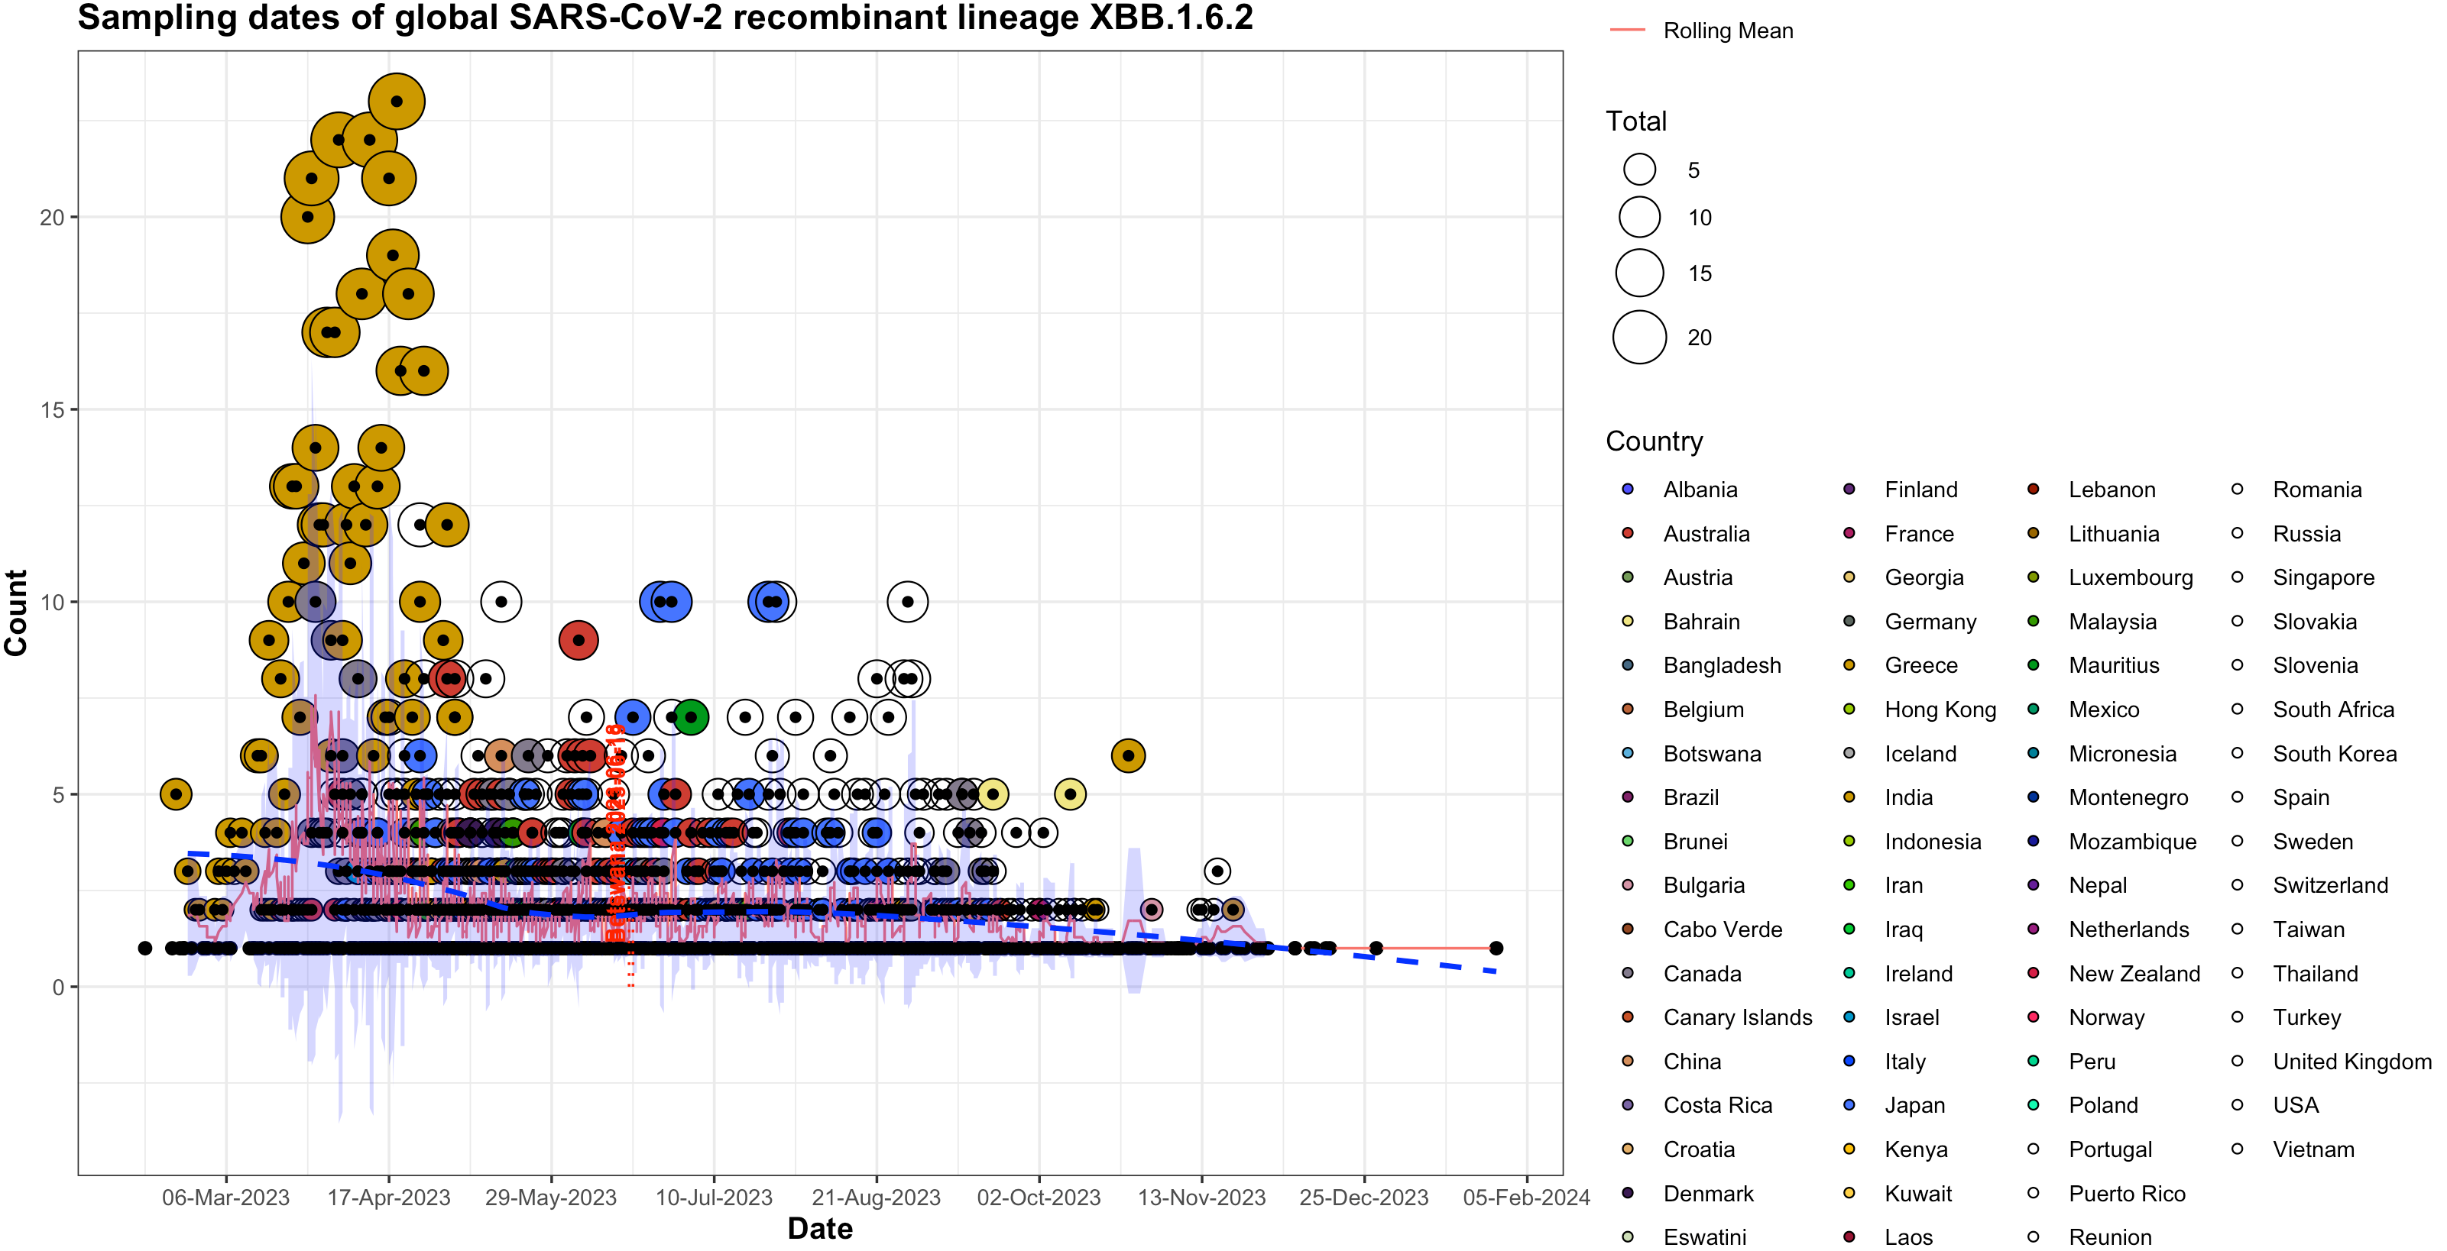

Figure S3B. Timelines of sampling dates of various recombinant lineages based on GISAID data. The sampling times of BW samples are indicated.

A

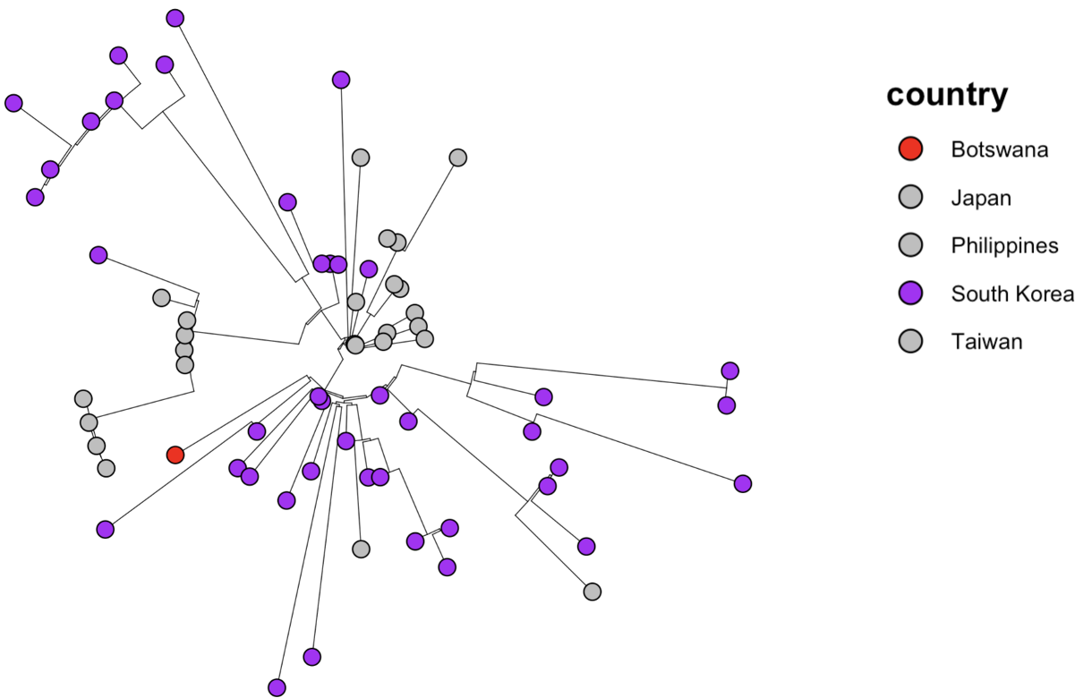

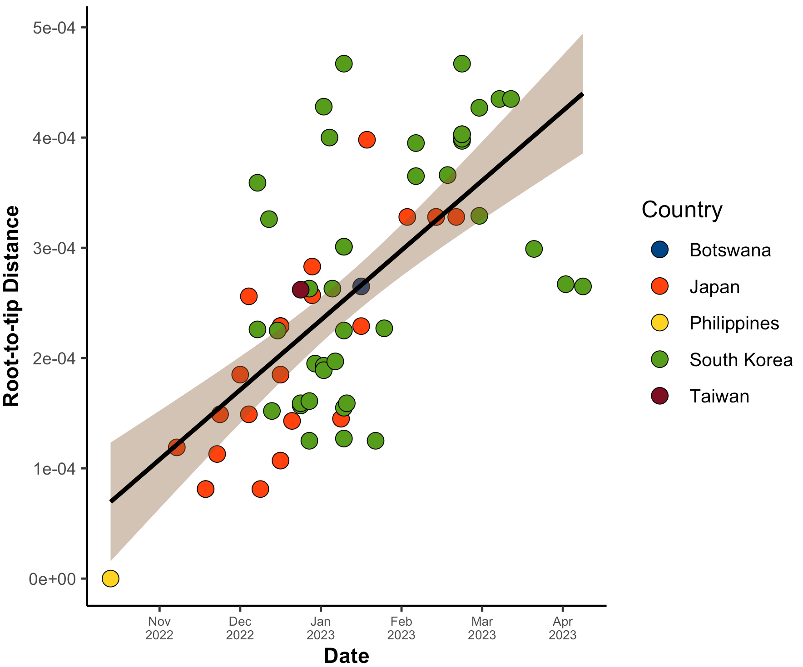
B

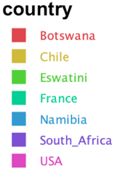
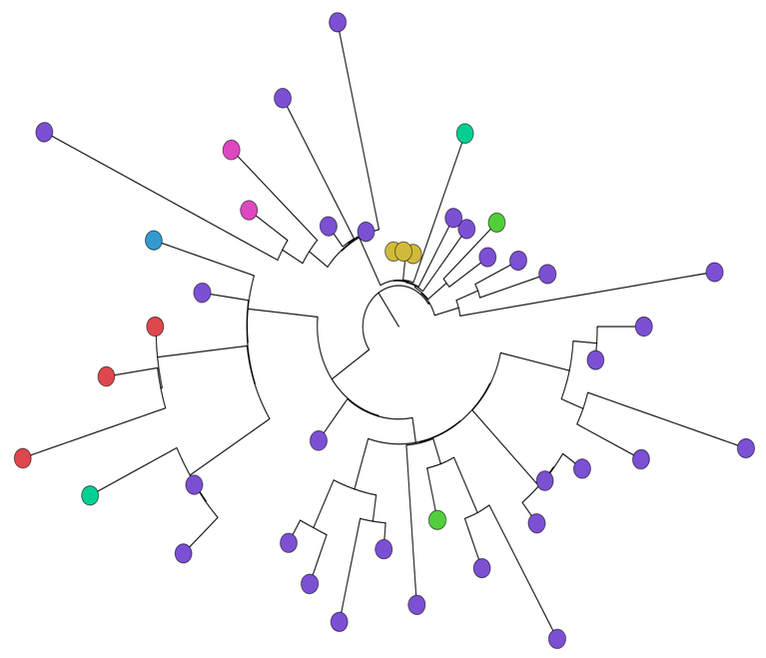
C

E
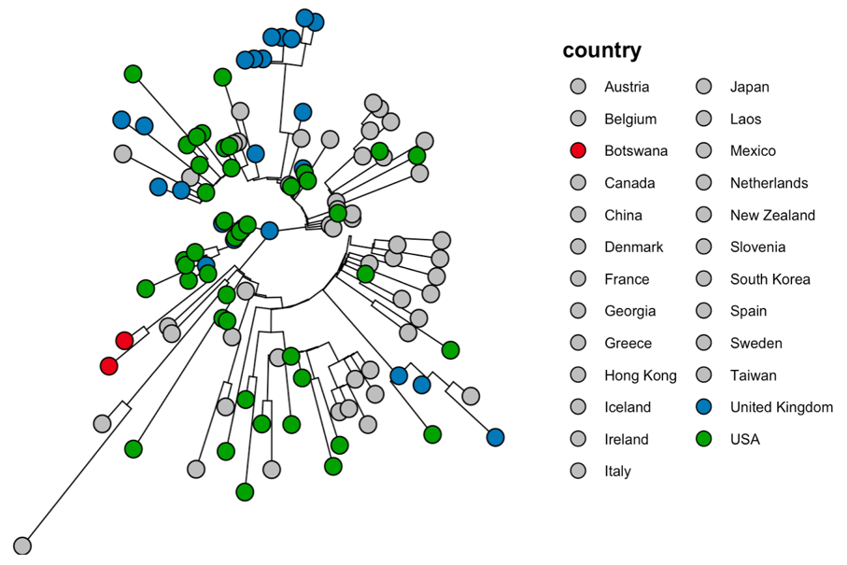

Figure S4: Maximum-likelihood phylogenetic trees showing the relatedness of: all recombinant sequences from Botswana and other representative reference sequences A. XBJ.1.1. Representative graphs of root-to-tip regression analysis showing correlation of sequence based on diversity and time. B. XBJ.1.1. ML phylogenetic trees were for C. XM., and D. XBB.1.5. annotated based on circular topology. Only sub-branches with posterior probability ≥ 0.90 are shown.
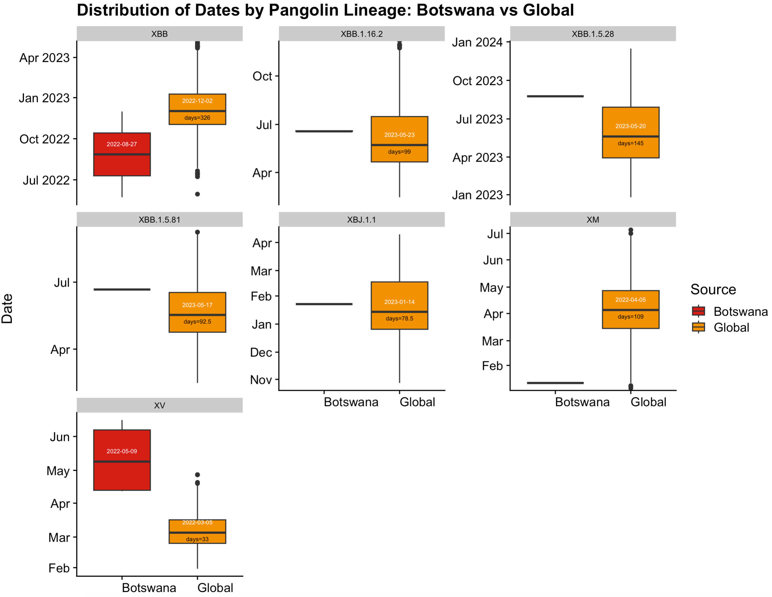

Figure S5: Comparison is shown between Botswana versus the Global sequences.

