A
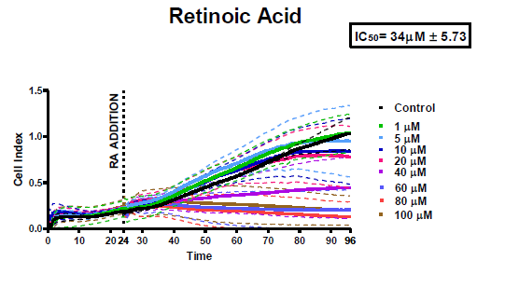
B

Fig S1: Retinoic acid-induced cytotoxicity in the SH-SY5Y cell line is dose- and time-dependent. The IC₅₀ (half-maximal inhibition) was calculated from (A) real-time data collected from the xCELLigence RTCA SP. (B)The IC₅₀ value was determined using the xCelligence developed graph of Cell Index (CI) vs. log of concentration (M), where a sigmoidal dose-response curve (variable slope) was generated. The time period consisted of 72 hours, from the point of compound addition (depicted by dotted line shown in A); this excluded the initial 24-hour time period allowed for cell settling. The IC₅₀ (µM) was calculated and is shown above, with the average ± SD (n =2) and average R² value of 0.98.

