Supporting Information

Size is not everything: Nuanced effects of female multiple mating and annual litter number on testes size in terrestrial mammals

Annemarie van der Marel^{a,b}, Miyako H. Warrington^{b,c}, Jane M. Waterman^{b,d}

a- Departamento de Ecología, Pontificia Universidad Católica de Chile, Santiago, Chile
b- Department of Biological Sciences, University of Manitoba, Winnipeg, MB, Canada
c- Department of Biological and Medical Sciences, Oxford Brookes University, Oxford, UK
d- Mammal Research Institute, Department of Zoology and Entomology, University of Pretoria, Pretoria 0002, South Africa

Figure S1. The relationship of log-transformed testes mass on log-transformed body mass for 571 terrestrial mammal species.
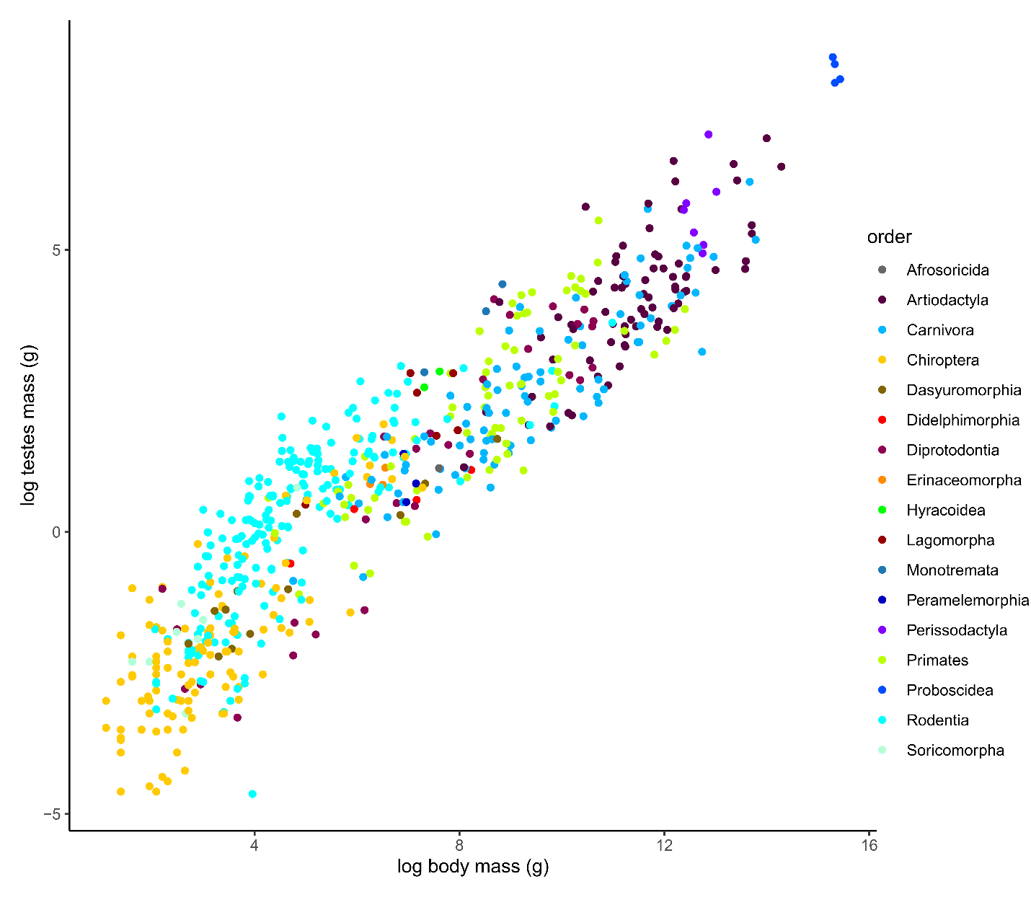

Supporting information 2. Results of the models that showed higher LooIC values
Table S1. Full summary of the intercept-only model (M1) describing relative testes size in terrestrial mammals. All estimates are summarized by the mean and 95% credible interval (“lwr95CI” – “upr95CI”) of the posterior distribution of the model ran across 100 sampled phylogenetic trees. The factors highlighted in bold represent the variable that has an influential effect on relative testes size.
Parameter | Mean | lwr95CI | upr95CI
Intercept | -0.51 | -1.56 | 0.4
Phylo SD | 0.38 | 0.05 | 0.63
Species SD | 0.07 | 0.03 | 0.11

Table S2. Full summary of the factors affecting relative testes size in terrestrial mammals (global model, M2). All estimates are on the log-odds scale and summarized by the mean and 95% credible interval (“lwr95CI” – “upr95CI”) of the posterior distribution of the model ran across 100 sampled phylogenetic trees. The factors highlighted in bold represent the variable that has an influential effect on relative testes size.
Parameter | Mean | lwr95CI | upr95CI
Intercept | -1.16 | -2.24 | -0.17
Litter size | 0.08 | -0.09 | 0.25
Litters per year | 0.04 | -0.13 | 0.23
Mating system (polygynous) | 0.43 | -0.01 | 0.87
Mating system (promiscuous) | 0.76 | 0.32 | 1.18
Longevity | 0.02 | -0.17 | 0.20
Paternal care present | -0.23 | -0.57 | 0.10
Phylo SD | 0.33 | 0.02 | 0.57
Species SD | 0.07 | 0.03 | 0.11

We had one potential outlier in our full dataset of 224 species as the tenrec has a litter size of 16, therefore we decided to rerun our interaction model without this species. We found similar results as our main interaction model, where litters per year and mating system influenced relative testes size but not litter size (Table SM2.3).

Table S3. Full summary of the factors affecting relative testes size in terrestrial mammals excluding the potential outlier the tenrec (interaction model with LooIC of 317.6). All estimates are on the log-odds scale and summarized by the mean and 95% credible interval (“lwr95CI” – “upr95CI”) of the posterior distribution of the model ran across 100 sampled phylogenetic trees. The factors highlighted in bold represent the variable that has an influential effect on relative testes size.
Parameter | Mean | lwr95CI | upr95CI
Intercept | -1.09 | -2.08 | -0.07
Litter size | 0.13 | -0.34 | 0.62
Litters per year | -0.94 | -1.4 | -0.48
Mating system (polygynous) | 0.42 | -0.04 | 0.84
Mating system (promiscuous) | 0.72 | 0.31 | 1.16
Longevity | -0.02 | -0.21 | 0.17
Paternal care present | -0.13 | -0.48 | 0.2
Litter size:litters/year | 0.3 | -0.4 | 1.03
Litter size:polygynous mating system | -0.05 | -0.52 | 0.48
Litter size:promiscuous mating system | -0.1 | -0.59 | 0.38
Litters/year:polygynous mating system | 1.1 | 0.6 | 1.62
Litters/year:promiscuous mating system | 0.98 | 0.49 | 1.44
Litter size:litters/year:polygynous mating system | -0.35 | -1.13 | 0.41
Litter size:litters/year:promiscuous mating system | -0.33 | -1.07 | 0.41
Phylo SD | 0.3 | 0.01 | 0.53
Species SD | 0.07 | 0.03 | 0.1

Table S4. Full summary of the factors affecting relative testes size in a subset of terrestrial mammals with a litter size ≤ 1 (interaction model, M5). All estimates are summarized by the mean and 95% credible interval (“lwr95CI” – “upr95CI”) of the posterior distribution of the model ran across 100 sampled phylogenetic trees. The factors highlighted in bold represent the variable that has an influential effect on relative testes size.
Parameter | Mean | lwr95CI | upr95CI
Intercept | -1.01 | -1.53 | -0.45
Litters per year | 0.11 | -0.09 | 0.3
Longevity | 0.12 | -0.10 | 0.33
Female multiple mating present | 0.51 | 0.16 | 0.83
Litters per year X females multiple mating present | -0.2 | -0.59 | 0.20
Phylo SD | 0.33 | 0.00 | 0.58
Species SD | 0.03 | 0.00 | 0.07

Table S5. Full summary of the factors affecting relative testes size calculated as testes divided by body mass (interaction model, M6, with LooIC of 596.1 [592.2 – 600.5]). All estimates are summarized by the mean and 95% credible interval (“lwr95CI” – “upr95CI”) of the posterior distribution of the model ran across 100 sampled phylogenetic trees. The factors highlighted in bold represent the variable that has an influential effect on relative testes size.

Parameter | Mean | lwr95CI | upr95CI
Intercept | -0.6 | -1.58 | 0.42
Litter size | 0.12 | -0.38 | 0.64
Litters per year | -0.95 | -1.41 | -0.51
Mating system (polygynous) | 0.43 | -0.01 | 0.88
Mating system (promiscuous) | 0.71 | 0.28 | 1.12
Longevity | 0.01 | -0.18 | 0.19
Paternal care present | -0.16 | -0.51 | 0.15
Litter size:litters/year | 0.32 | -0.42 | 1.11
Litter size:polygynous mating system | -0.06 | -0.57 | 0.51
Litter size:promiscuous mating system | -0.14 | -0.66 | 0.38
Litters/year:polygynous mating system | 1.1 | 0.61 | 1.59
Litters/year:promiscuous mating system | 0.97 | 0.52 | 1.43
Litter size:litters/year:polygynous mating system | -0.37 | -1.16 | 0.46
Litter size:litters/year:promiscuous mating system | -0.33 | -1.07 | 0.48
Phylo SD | 0.28 | 0 | 0.5
Species SD | 0.07 | 0.04 | 0.1

