Supplementary Information:
Dispersal potential does not predict recent range expansions of sub-Antarctic plant species

Nompilo Mazibuko, Michelle Greve and Peter C. le Roux
University of Pretoria, Department of Plant and Soil Sciences, Pretoria, Gauteng, South Africa

Correspondence
Nompilo Mazibuko, Department of Plant and Soil Sciences, University of Pretoria, Pretoria, South Africa.
Email: nompilomazibuko94@gmail.com

ORCID
Nompilo Mazibuko: 0000-0003-1161-0149
Michelle Greve: 0000-0002-6229-8506
Peter C. le Roux: 0000-0002-7941-7444

Online Resource 1 The mean height and seed weight of plant species included in this study (mean plant height obtained from Mathakutha et al. 2019)

Species name | Mean plant height (mm) | Mean weight of the diaspore (mg) |  | Mean diaspore release height (mm)
Acaena magellanica | 136.1 | 196.4 |  | 120
Agrostis stolonifera | 188.1 | 77.4 |  | 190
Azorella selago | 157.8 | 1.2 |  | 160
Callitriche antarctica | 76.3 | 1.4 |  | 80
Cerastium fontanum | 100.8 | 0.2 |  | 100
Colobanthus kerguelensis | 7.7 | 0.1 |  | 10
Cotula plumosa | 60.9 | 0.4 |  | 60
Crassula moschata | 19.3 | 0.5 |  | 20
Juncus scheuchzerioides | 52.8 | 5.3 |  | 50
Montia fontana | 31.3 | 0.5 |  | 30
Poa annua | 82.3 | 42.9 |  | 80
Poa cookii | 362.0 | 629.7 |  | 360
Poa pratensis | 205.5 | 45.1 |  | 210
Polypogon magellanicus | 143.4 | 88.7 |  | 140
Pringlea antiscorbutica | 151.7 | 3.8 |  | 150
Ranunculus biternatus | 18.1 | 2.2 |  | 20
Uncinia compacta | 109.0 | 58.7 |  | 110
Sagina procumbens | 25.7 | 0.02 |  | 30

Online Resource 2 Variety in the shape and texture of diaspores from the island's species. (a) Polypogon magellanicus (c.4 mm), (b) Colobanthus kerguelensis (c. 1 mm), (c) Juncus scheuchzerioides (c. 3 mm), (d) Poa cookii (c. 5 mm), (e) Poa annua (c. 4.5 mm), (f) Agrostis stolonifera (c.3.5 mm), (g) Poa pratensis (c. 5 mm), (h) Crassula moschata (c. 4 mm)
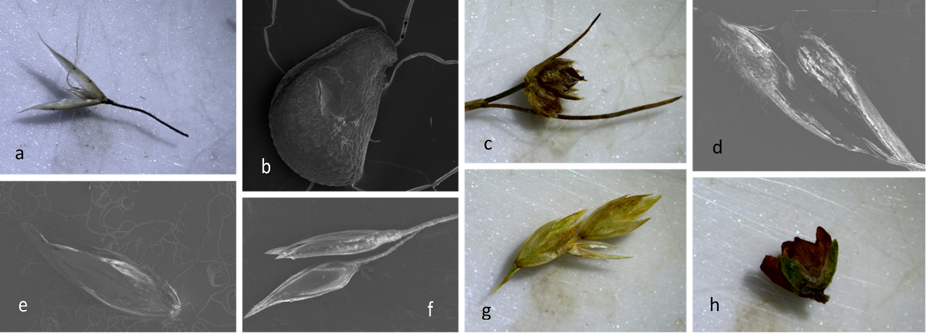

Online Resource 3 Results from the buoyancy and viability tests (PD_{thala} = dispersal potential via thalassochory). The cumulative number of sunken diaspores was recorded at eight different time intervals (1 min. = number of sunken diaspores after 1 minute; 5 min. = number of sunken diaspores 5 minutes after the previous observation; etc.). Viability was also recorded for control samples that were not exposed to artificial seawater (PD_{thala} for control sample %)
Species | 1 min | 5 min | 15 min | 30 min | 1 hr | 1 day | 2 days | 3 days | # of buoyant diaspores after 6 days | Buoyancy after 6 days % | # of viable diaspore after buoyancy test | Viability % | PD_{thala} % | PD_{thala} for control sample %
Acaena magellanica | 0 | 0 | 0 | 0 | 0 | 0 | 7 | 19 | 1 | 5 | 0 | 0 | 2.5 | 30
Agrostis stolonifera | 0 | 0 | 0 | 0 | 0 | 0 | 0 | 2 | 18 | 90 | 0 | 0 | 45.0 | 70
Azorella selago | 2 | 2 | 3 | 4 | 4 | 4 | 9 | 12 | 8 | 40 | 1 | 12.5 | 26.3 | 0
Callitriche antarctica | 3 | 4 | 4 | 4 | 4 | 6 | 19 | 19 | 1 | 5 | 0 | 0 | 2.5 | 60
Cerastium fontanum | 20 | 20 | 20 | 20 | 20 | 20 | 20 | 20 | 0 | 0 | 0 | 0 | 0.0 | 0
Colobanthus kerguelensis | 9 | 18 | 20 | 20 | 20 | 20 | 20 | 20 | 0 | 0 | 0 | 0 | 0.0 | 0
Cotula plumosa | 0 | 0 | 0 | 0 | 0 | 0 | 2 | 2 | 18 | 90 | 6 | 33 | 61.5 | 90
Crassula moschata | 0 | 0 | 0 | 0 | 0 | 0 | 2 | 13 | 7 | 35 | 0 | 0 | 17.5 | 30
Juncus scheuchzerioides | 0 | 0 | 0 | 0 | 0 | 3 | 8 | 8 | 12 | 60 | 0 | 0 | 30.0 | 50
Montia fontana | 0 | 1 | 1 | 1 | 3 | 4 | 12 | 12 | 8 | 40 | 6 | 75 | 57.5 | 90
Poa annua | 0 | 1 | 0 | 0 | 0 | 4 | 11 | 13 | 7 | 35 | 3 | 43 | 39.0 | 10
Poa cookii | 1 | 1 | 1 | 1 | 1 | 2 | 5 | 10 | 10 | 50 | 0 | 0 | 25.0 | 40
Poa pratensis | 0 | 0 | 0 | 0 | 0 | 0 | 5 | 20 | 0 | 0 | 0 | 0 | 0.0 | 0
Polypogon magellanicus | 0 | 0 | 0 | 0 | 0 | 0 | 1 | 15 | 5 | 25 | 1 | 20 | 22.5 | 80
Pringlea antiscorbutica | 0 | 0 | 0 | 0 | 0 | 0 | 1 | 7 | 13 | 65 | 10 | 77 | 71.0 | 100
Ranunculus biternatus | 0 | 0 | 0 | 0 | 0 | 0 | 0 | 1 | 19 | 95 | 13 | 68 | 81.5 | 80
Uncinia compacta | 0 | 0 | 0 | 0 | 0 | 0 | 1 | 3 | 17 | 85 | 0 | 0 | 42.5 | 50
Sagina procumbens | 4 | 20 | 20 | 20 | 20 | 20 | 20 | 20 | 0 | 0 | 0 | 0 | 0.0 | 0

Online Resource 4 Results from simple linear models, which assess dispersal capacity (across all considered dispersal syndromes), the range expansion of native species, and the spread rate of alien species as functions of morphological traits. All alien species had the same texture (specialised str = specialised structure)

Native Species | Morphological trait | F | p
PD_{ane} | Size | 1.332 | 0.273
 | Shape | 3.006 | 0.087
 | Texture | 0.710 | 0.393
 | Specialised str. | 9.518 | 0.005
PD_{zoo} | Size | 1.346 | 0.271
 | Shape | 1.973 | 0.189
 | Texture | 1.213 | 0.294
 | Specialised str. | 2.242 | 0.157
PD_{anthro} | Size | 1.391 | 0.263
 | Shape | 43.973 | < 0.001
 | Texture | 1391 | 0.263
 | Specialised str. | 0.072 | 0.931
PD_{thala} | Size | 0.090 | 0.770
 | Shape | 0.875 | 0.490
 | Texture | 5.809 | 0.035
 | Specialised str. | 0.167 | 0.849
Range expansion | Size | 0.045 | 0.837
 | Shape | 0.356 | 0.786
 | Texture | 2.121 | 0.173
 | Specialised str. | 0.344 | 0.717
Alien Species
PD_{ane} | Size | 4.242 | 0.132
 | Shape | 4.242 | 0.132
 | Specialised str. | 4.242 | 0.132
PD_{zoo} | Size | 0.206 | 0.687
 | Shape | 0.206 | 0.687
 | Specialised str. | 0.206 | 0.687
PD_{anthro} | Size | 0.032 | 0.869
 | Shape | 0.032 | 0.869
 | Specialised str. | 0.032 | 0.869
PD_{thala} | Size | 2.364 | 0.222
 | Shape | 2.364 | 0.222
 | Specialised str. | 2.364 | 0.222
Spread rate | Size | 0.579 | 0.502
 | Shape | 0.579 | 0.502
 | Specialised str. | 0.579 | 0.502

Online Resource 5 The number of plant habitats in which each of Marion Island's vascular plant species are recorded (extracted from Gremmen 1981) and the upslope range shifts of native plant species (extracted from le Roux and McGeoch 2008) and range expansion rates of alien plant species (extracted from le Roux et al. 2013)
Native species | Number of habitats recorded from | Upslope shift over 40 years (m)
Acaena magellanica | 28 | 22
Azorella selago | 20 | 75
Blechnum penna-marina | 3 | 146
Callitriche antarctica | 12 | 0
Colobanthus kerguelensis | 5 | 275
Cotula plumosa | 9 | -16
Crassula moschata | 5 | -25
Grammitis kerguelensis | 3 | 257
Hymenophyllum peltatum | 3 | -146
Juncus scheuchzerioides | 23 | 116
Lycopodium magellanicum | 5 | 388
Lycopodium Saururus | 2 | -126
Montia fontana | 37 | 27
Poa cookii | 23 | 69
Polypogon magellanicus | 38 | 158
Pringlea antiscorbutica | 2 | 234
Ranunculus biternatus | 41 | 24
Uncinia compacta | 13 | 89
Alien species | Number of habitats recorded from | Rate of spread since discovery (km².yr⁻¹)
Agrostis stolonifera | 5 | 0.56
Cerastium fontanum | 3 | 0.68
Festuca rubra | 1 | 0.00
Poa annua | 11 | 1.48
Poa pratensis | 1 | 0.29
Sagina procumbens | 1 | 1.84
Stellaria media | 4 | 0.13
Rumex acetosella | 1 | 0.01

