Table 6: Effect of compositing maize flour with orange-fleshed sweet potato flour (OFSP) on the starch content and soluble solids of their flours and their extrusion made pasta samples
Sample | Composites | Starch % (db) | Soluble solids (ºbrix)
Flour | 100 % Maize | 88.7 ± 5.12^{d} | 0.23 ± 0.06ª
 | 80 % Maize: 20 % OFSP | 81.5 ± 2.78^{cd} | 1.23 ± 0.06^{c}
 | 70 % Maize: 30 % OFSP | 80.7 ± 3.35^{c} | 1.53 ± 0.06^{d}
 | 50 % Maize: 50 % OFSP | 69.7 ± 1.36^{b} | 2.50 ± 0.00^{f}
Pasta | 100 % Maize | 81.5 ± 2.35^{cd} | 0.60 ± 0.00^{b}
 | 80 % Maize: 20 % OFSP | 78.3 ± 2.47^{c} | 1.30 ± 0.00^{c}
 | 70 % Maize: 30 % OFSP | 82.6 ± 4.14^{cd} | 1.90 ± 0.00e
 | 50 % Maize: 50 % OFSP | 68.6 ± 1.79^{b} | 2.93 ± 0.06^{g}
Commercial pasta |  | 77.1 ± 0.96^{c} | 0.23 ± 0.06^{s}
100 % OFSP flour |  | 56.8 ± 1.42ª | 4.00 ± 0.10^{h}
Means within a column with different letters are significantly different (p<0.05)
Standard deviations are given in parenthesis
Commercial gluten-free pasta made from maize and rice

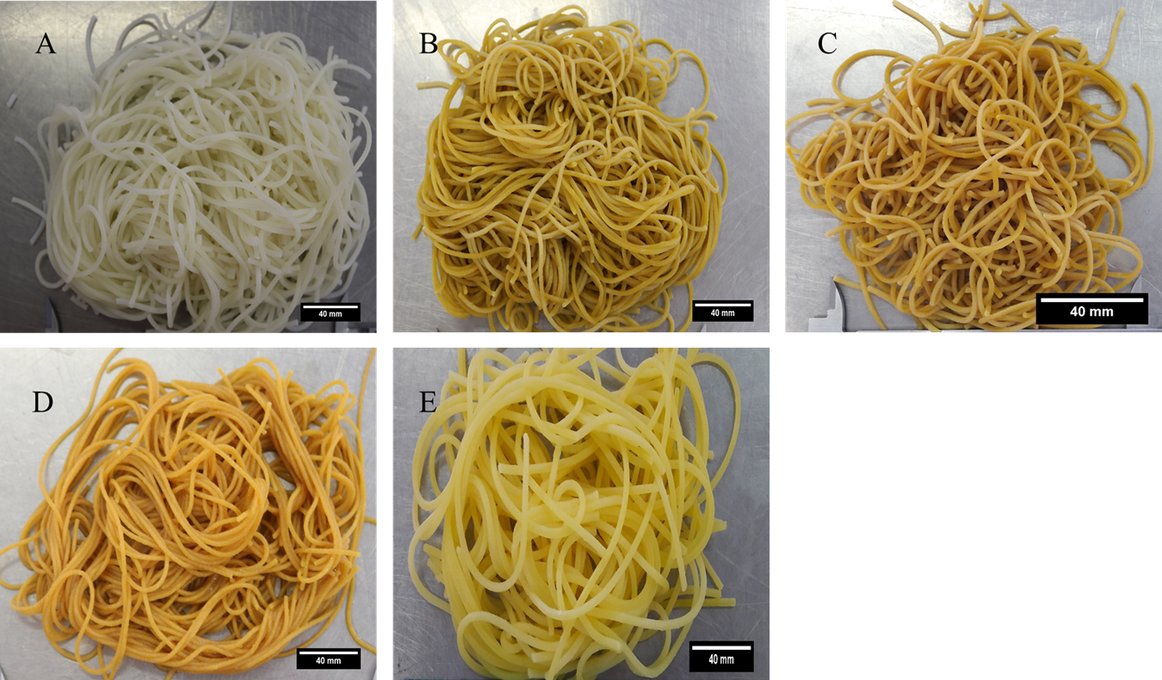
Figure 6: Images of extruded and cooked pasta samples.
A: 100 % Maize pasta, B: 80 % Maize: 20 % OFSP pasta, C: 70 % Maize: 30 % OFSP pasta, D: 50 % Maize: 50 % OFSP pasta, E: Commercial pasta

