Supplementary Digital Content:

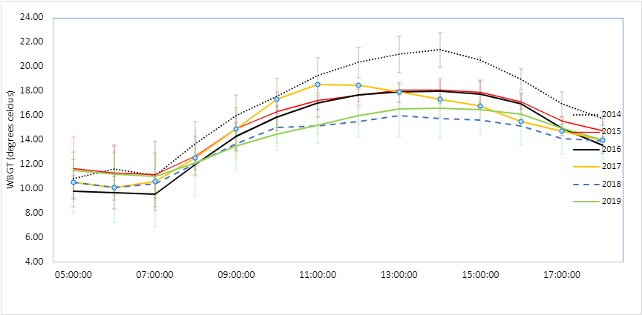
Supplementary Figure 1: Wet-Bulb Globe Temperature (WBGT) over race day from 2014-2019

Table 1: Environmental data over the six years during the event (average from 4 weather stations)
 | WBGT
Hourly time of day | 2014 | 2015 | 2016 | 2017 | 2018 | 2019
05:00:00 | 10.8 (1.6) | 11.7 (2.5) | 9.8 (1.3) | 10.5 (2.1) | 10.5 (2.5) | 11.5 (1.5)
06:00:00 | 11.6 (1.8) | 11.3 (2.3) | 9.7 (1.4) | 10.1 (2.2) | 10.1 (2.9) | 11.2 (1.8)
07:00:00 | 11.1 (1.8) | 11.2 (2.7) | 9.5 (1.3) | 10.6 (2.3) | 10.4 (3.5) | 11.0 (2.0)
08:00:00 | 13.7 (1.8) | 12.7 (1.6) | 12.0 (0.4) | 12.5 (1.7) | 12.0 (2.7) | 12.1 (1.1)
09:00:00 | 16.0 (1.7) | 14.9 (1.7) | 14.2 (1.2) | 14.9 (2.2) | 13.7 (2.2) | 13.5 (1.0)
10:00:00 | 17.6 (1.4) | 16.3 (1.6) | 15.9 (0.9) | 17.3 (1.6) | 15.0 (1.9) | 14.4 (0.7)
11:00:00 | 19.2 (1.5) | 17.2 (1.4) | 17.0 (0.6) | 18.5 (0.9) | 15.1 (1.4) | 15.2 (0.7)
12:00:00 | 20.3 (1.3) | 17.6 (0.9) | 17.7 (0.5) | 18.5 (0.7) | 15.5 (1.2) | 16.0 (0.7)
13:00:00 | 21.0 (1.5) | 18.1 (0.4) | 17.9 (0.8) | 17.9 (0.6) | 16.0 (1.7) | 16.5 (0.6)
14:00:00 | 21.4 (1.4) | 18.1 (0.6) | 18.0 (1.1) | 17.3 (0.0) | 15.7 (1.6) | 16.6 (0.8)
15:00:00 | 20.5 (0.2) | 17.9 (0.9) | 17.7 (1.2) | 16.8 (0.5) | 15.6 (1.2) | 16.5 (0.7)
16:00:00 | 18.9 (0.8) | 17.1 (0.6) | 16.9 (0.9) | 15.5 (0.8) | 15.1 (1.6) | 16.1 (0.7)
17:00:00 | 16.9 (1.0) | 15.6 (0.3) | 15.0 (0.6) | 14.7 (0.9) | 14.1 (1.3) | 14.9 (0.2)
18:00:00 | 15.7 (0.6) | 14.7 (1.0) | 13.6 (0.7) | 14.0 (1.0) | 13.9 (1.5) | 14.0 (0.9)
*Wet-Bulb Globe Temperature index¹
Values are mean (SD)

Example of a cumulative exposure measure for athlete starting at 05:30:03 and finishing at 11:58:37 in 2014:
Total run time: 5:28:34
Total cumulative exposure = (average wbgt index between 05:00-06:00*time spent in this period + … + average wbgt index between 11:00-12:00*time spent in this period) / total run time
Total cumulative exposure = 10.82*0.077 + 11.63*0.154 + 11.06*0.154 + 13.67*0.154 + 15.95*0.154 + 17.57*0.154 +19.2*0.151;

Table 2: Demographics of all race starters and finishers (by sex, age categories and year of participation)

 |  |  | 2014 |  | 2015 |  | 2016 |  | 2017 |  | 2018 |  | 2019 |  | All years
 |  |  | n | % | n | % | n | % | n | % | n | % | n | % | n | %
Total starters | All |  | 14341 | 100 | 16579 | 100 | 16846 | 100 | 17092 | 100 | 19106 | 100 | 19167 | 100 | 103131 | 100
 | Males | All | 11333 | 79 | 13122 | 79.1 | 13286 | 78.9 | 13541 | 79.2 | 14924 | 78.1 | 15374 | 80.2 | 81580 | 79.1
 |  | < 30 yrs | 1167 | 8.1 | 1252 | 7.6 | 1189 | 7.1 | 1136 | 6.6 | 1054 | 5.5 | 1030 | 5.4 | 6828 | 6.6
 |  | 31-40 yrs | 4100 | 28.6 | 4673 | 28.2 | 4793 | 28.5 | 4985 | 29.2 | 5644 | 29.5 | 5689 | 29.7 | 29884 | 29
 |  | 41-50 yrs | 3972 | 27.7 | 4629 | 27.9 | 4740 | 28.1 | 4912 | 28.7 | 5442 | 28.5 | 5813 | 30.3 | 29508 | 28.6
 |  | >50 yrs | 2094 | 14.6 | 2568 | 15.5 | 2564 | 15.2 | 2508 | 14.7 | 2784 | 14.6 | 2842 | 14.8 | 15360 | 14.9
 | Females | All | 3008 | 21 | 3457 | 20.9 | 3560 | 21.1 | 3551 | 20.8 | 4182 | 21.9 | 3793 | 19.8 | 21551 | 20.9
 |  | < 30 yrs | 343 | 2.4 | 372 | 2.2 | 371 | 2.2 | 371 | 2.2 | 399 | 2.1 | 348 | 1.8 | 2204 | 2.1
 |  | 31-40 yrs | 1159 | 8.1 | 1306 | 7.9 | 1395 | 8.3 | 1463 | 8.6 | 1724 | 9 | 1590 | 8.3 | 8637 | 8.4
 |  | 41-50 yrs | 1109 | 7.7 | 1271 | 7.7 | 1297 | 7.7 | 1263 | 7.4 | 1486 | 7.8 | 1346 | 7 | 7772 | 7.5
 |  | >50 yrs | 397 | 2.8 | 508 | 3.1 | 497 | 3 | 454 | 2.7 | 573 | 3 | 509 | 2.7 | 2938 | 2.8
Total finishers | All |  | 11917 | 100 | 13000 | 100 | 14594 | 100 | 13852 | 100 | 16482 | 100 | 16439 | 100 | 86284 | 100
 | Males | All | 9491 | 79.6 | 10433 | 80.3 | 11587 | 79.4 | 11151 | 80.5 | 13110 | 79.5 | 13384 | 81.4 | 69156 | 80.1
 |  | < 30 yrs | 1026 | 8.6 | 1045 | 8 | 1070 | 7.3 | 981 | 7.1 | 956 | 5.8 | 922 | 5.6 | 6000 | 7
 |  | 31-40 yrs | 3597 | 30.2 | 3984 | 30.6 | 4338 | 29.7 | 4299 | 31 | 5118 | 31.1 | 5124 | 31.2 | 26460 | 30.7
 |  | 41-50 yrs | 3307 | 27.8 | 3662 | 28.2 | 4159 | 28.5 | 4069 | 29.4 | 4824 | 29.3 | 5102 | 31 | 25123 | 29.1
 |  | >50 yrs | 1561 | 13.1 | 1742 | 13.4 | 2020 | 13.8 | 1802 | 13 | 2212 | 13.4 | 2236 | 13.6 | 11573 | 13.4
 | Females | All | 2426 | 20.4 | 2567 | 19.7 | 3007 | 20.6 | 2701 | 19.5 | 3372 | 20.5 | 3055 | 18.6 | 17128 | 19.9
 |  | < 30 yrs | 289 | 2.4 | 284 | 2.2 | 314 | 2.2 | 286 | 2.1 | 334 | 2 | 289 | 1.8 | 1796 | 2.1
 |  | 31-40 yrs | 966 | 8.1 | 1023 | 7.9 | 1218 | 8.3 | 1165 | 8.4 | 1437 | 8.7 | 1327 | 8.1 | 7136 | 8.3
 |  | 41-50 yrs | 902 | 7.6 | 964 | 7.4 | 1116 | 7.6 | 950 | 6.9 | 1194 | 7.2 | 1074 | 6.5 | 6200 | 7.2
 |  | >50 yrs | 269 | 2.3 | 296 | 2.3 | 359 | 2.5 | 300 | 2.2 | 407 | 2.5 | 365 | 2.2 | 1996 | 2.3

Table 3. Number of medical events (MEs) per year (2014-2019)
Year | Any ME (n; incidence per 1000) | Serious life-threatening ME (n; incidence per 1000)
2014 | 339 (23.79) | 26 (1.81)
2015 | 295 (17.99) | 18 (1.09)
2016 | 374 (22.45) | 27 (1.60)
2017 | 350 (20.82) | 24 (1.41)
2018 | 331 (17.53) | 54 (2.83)
2019 | 336 (17.88) | 40 (2.10)
2015-2019 | 1686 | 163
2014-2019 | 2025 | 189

1. Grundstein A, Cooper E. Assessment of the Australian Bureau of Meteorology wet bulb globe temperature model using weather station data. International Journal of Biometeorology. 2018;62(12):2205-2213.

