Appendix

Table 1: Demographic and clinical characteristics of the included and excluded cases-patients with carbapenem-resistant Enterobacterales bacteremia at GERM-SA sentinel sites by treatment regimen, South Africa, January 2015 – December 2020.
Characteristics |  | All  N=3 432 |  | Included case-patients  n=1 607 |  | Excluded case-patients  n=1 825 | p-value
 |  | n (%)
Age group in years |  | 3 432 |  | 1 607 |  | 1 825 | <0.001
1-9 |  | 1076 (31) |  | 570(36) |  | 506 (28)
10-20 |  | 173 (5) |  | 96 (6) |  | 77 (4)
21-30 |  | 347 (10) |  | 166 (10) |  | 181 (10)
31-40 |  | 473 (14) |  | 223 (14) |  | 250 (14)
41-50 |  | 390 (11) |  | 160 (10) |  | 230 (13)
>50 |  | 973 (28) |  | 392 (24) |  | 581 (32)
Sex |  | 3400 |  | 1607 |  | 1793 | 0.44
Male (vs. female) |  | 1837 (54) |  | 857 (53) |  | 980 (55)
Provinceª |  | 3 432 |  | 1 607 |  | 1 825 | <0.001
Gauteng |  | 2376 (69) |  | 1034 (64) |  | 1342 (74)
KwaZulu Natal |  | 624 (18) |  | 327 (20) |  | 297 (16)
Western Cape |  | 371 (11) |  | 223 (14) |  | 148 (8)
Free State |  | 61 (2) |  | 23 (1) |  | 38 (2)
CPE^{b} genes |  | 1 708 |  | 909 |  | 799 | <0.001
bla_{OXA-48-like} |  | 1155 (68) |  | 551 (61%) |  | 604 (76)
bla_{NDM} |  | 510 (30) |  | 333 (37%) |  | 177 (22)
bla_{VIM} |  | 36 (2) |  | 22 (2%) |  | 14 (2)
bla_{GES} |  | 3 (0) |  | 2 (0%) |  | 1 (0)
bla_{KPC} |  | 4 (0) |  | 1 (0%) |  | 3 (0)
Antibiotic exposure (prio 6 months) |  | 1 902 |  | 1 435 |  | 467 | 0.094
Yes (vs. no) |  | 877 (46) |  | 646 (45) |  | 231 (50)
Any underlying conditions^{c} |  | 2 017 |  | 1 521 |  | 496 | 0.65
Yes (vs. no) |  | 1079 (54) |  | 818 (54) |  | 261 (53)
HIV status |  | 1 720 |  | 1 202 |  | 518 | <0.001
Positive (vs. negative) |  | 467 (27) |  | 285 (24) |  | 182 (35)
CD4 cell count | 341 |  | 207 |  | 134 |  |  | 0.13
≥200 cells/mm3 | 73 (37) |  | 74 (36) |  | 59 (44)
<200 cells/mm3 | 125 (63) |  | 133 (64) |  | 75 (56)
Glasgow coma scale |  | 1 894 |  | 1 424 |  | 470 | 0.68
15 |  | 981 (52) |  | 743 (52) |  | 240 (51)
<15 |  | 911 (48) |  | 681 (48) |  | 230 (49)
Medical device^{d} |  | 2 118 |  | 1 595 |  | 523 | <0.001
Yes |  | 2055 (97) |  | 1559 (98) |  | 496 (95)
ICU^{e} admission |  | 2 197 |  | 1 418 |  | 779 | <0.001
Yes |  | 606 (28) |  | 435 (31) |  | 171 (22)
Mechanically ventilated |  | 2 127 |  | 1 598 |  | 529 | 0.13
Yes |  | 697 (33) |  | 538 (34) |  | 159 (30)
Outcome |  | 2 317 |  | 1 607 |  | 710 | <0.001
Alive |  | 1452 (63) |  | 1103 (69) |  | 349 (49)
Dead |  | 865 (37) |  | 504 (31) |  | 361 (51)
Days to outcome^{f} |  | 1 036 |  | 619 |  | 417 | <0.001
Median days (Interquartile range) |  | 7 (2-19) |  | 9 (3-21) |  | 4 (1-14)
a, Number of sentinel sites in each province; KwaZulu-Natal (n=5), Gauteng (n=5), Free State (n=1) and Western Cape (n=2).
b, Carbapenemase-producing Enterobacterales
c, Underlying conditions included malignancy, cardiovascular disease, renal failure, and diabetes mellitus
d, Medical devices included intravenous lines, central venous lines, urinary catheters, drainage ports, and/or intra-arterial lines
e, Intensive care unit
f, From specimen collection to death

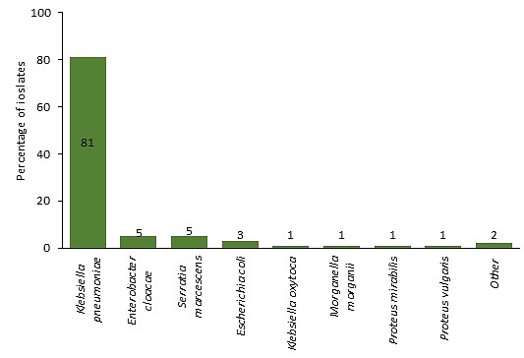

Figure 1: Distribution of pathogens among patients with carbapenem-resistant Enterobactereles bacteremia identified through the GERMS-SA enhanced sentinel site, South Africa, January 2015–December 2020. (Other= Citrobacter freundii, Citrobacter koseri, Citrobacter sedlakii, Enterobacter aerogenes, Enterobacter kobei, Enterobacter asburia, Klebsiella aerogenes, Proteus penneri, Salmonella non-Typhi).

