Additional file
Fig. S1: A flowchart depicting gathering and screening of global studies for the meta-analysis. The plus (+) and minus (-) signs indicate studies that were qualified and disqualified for the meta-analysis, respectively
Fig. S2: The relationship between J_{max} and V_{cmax} of woody plants grown at elevated CO₂

Fig. S3: The relationships between root biomass and shoot biomass (a), and LAI (b) of the woody plants grown at eCO₂. The relationships were conducted on the actual natural log response ratios
Fig. S4: Percentage change (±95% CI) in carbon:nitrogen ratio (C:N) of woody plants grown at eCO₂. The whiskers denote 95% CI and the circles denote mean percentage change (MPC) between aCO₂ and eCO₂. The numbers above the major ticks of the X-axis denote number of observations. The area fill () shows the trends and the magnitude of differences between the eCO₂ concentrations. The wider the area the bigger the difference between MPCs

Fig. S5: Percentage change in leaf area index and height of woody plants over different duration (years) of exposure to eCO₂. The whiskers denote 95% CI and the circles denote mean percentage change (MPC) between aCO₂ and eCO₂. The numbers above the major ticks of the X-axis denote number of observations. The area fill () shows the trends and the magnitude of differences between the eCO₂ concentrations. The wider the area the bigger the difference between MPCs. Key to period of exposure: 0.5 years denotes half of a year (6 months). There were no observations reported for a period >2-3 years for these parameters
Fig. S6: Percentage change (±95% CI) in leaf N and C:N of woody plants with different N-fixation ability (a, d and g), leaf phenology (b, e and h) and leaf types (c, f and i) grown at eCO₂. The whiskers denote 95% CI and the circles denote mean percentage change. The numbers above the major ticks of the X-axis denote number of observations. Key to leaf types: Compound-small = compound leaves with small leaflets and Needle-like = needle-like leaves

A
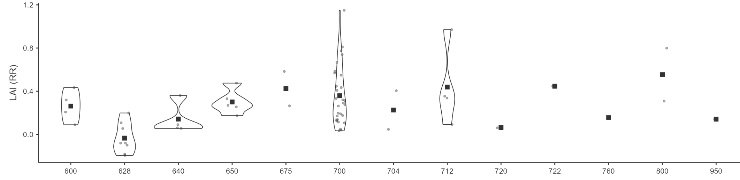
B
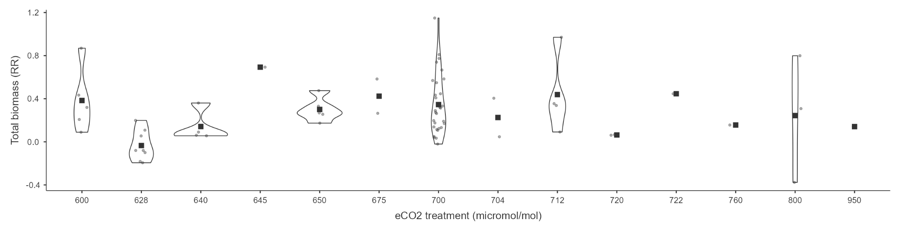
Fig. S7: Leaf area index (A) and total biomass (B) of woody plants grown at eCO₂. RR = response ratio. The grey dots indicate the data points or observations and the black square is the mean RR.
A
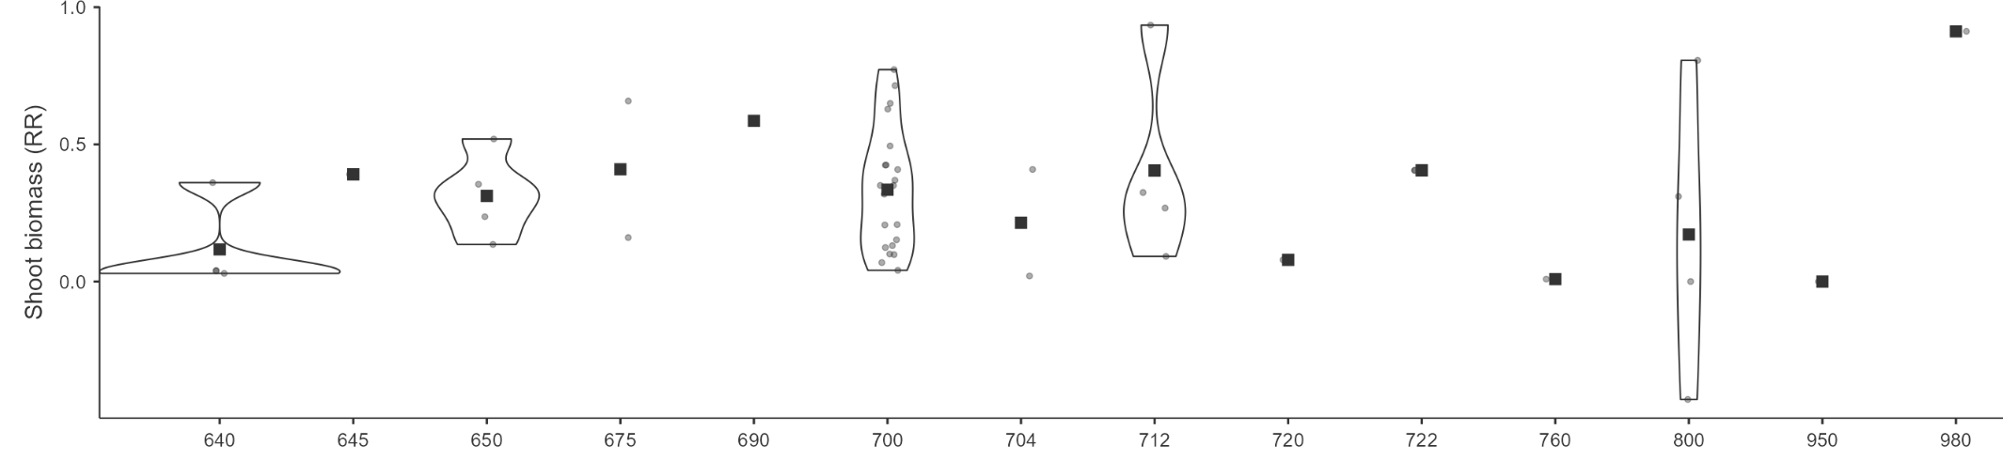
B
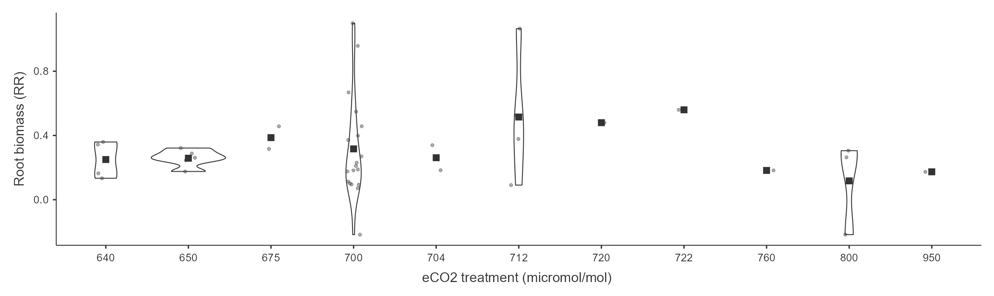
Fig. S8: Shoot (A) and root biomass (B) of woody plants grown at eCO₂. RR = response ratio. The grey dots indicate the data points or observations and the black square is the mean RR.
A
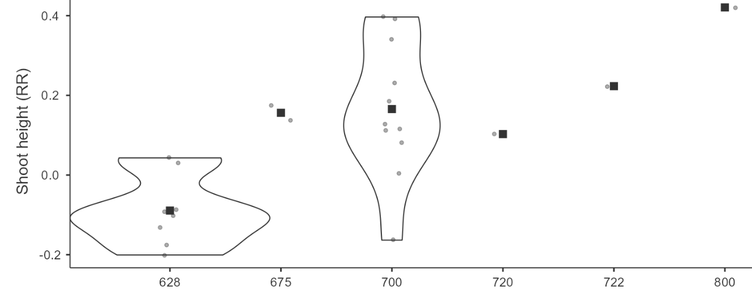
B
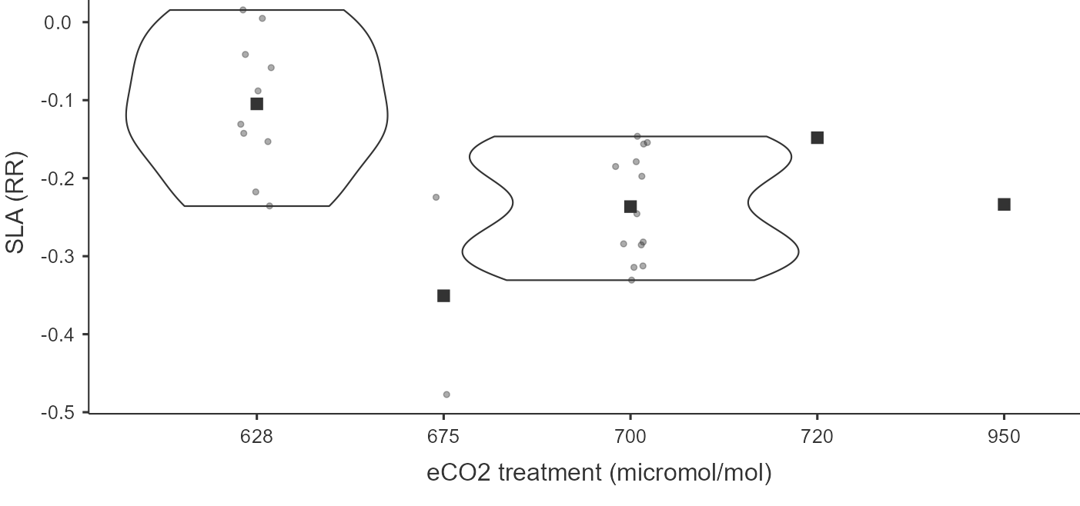
Fig. S9: Shoot height (A) and specific leaf area (B) of woody plants grown at eCO₂. RR = response ratio. The grey dots indicate the data points or observations and the black square is the mean RR.
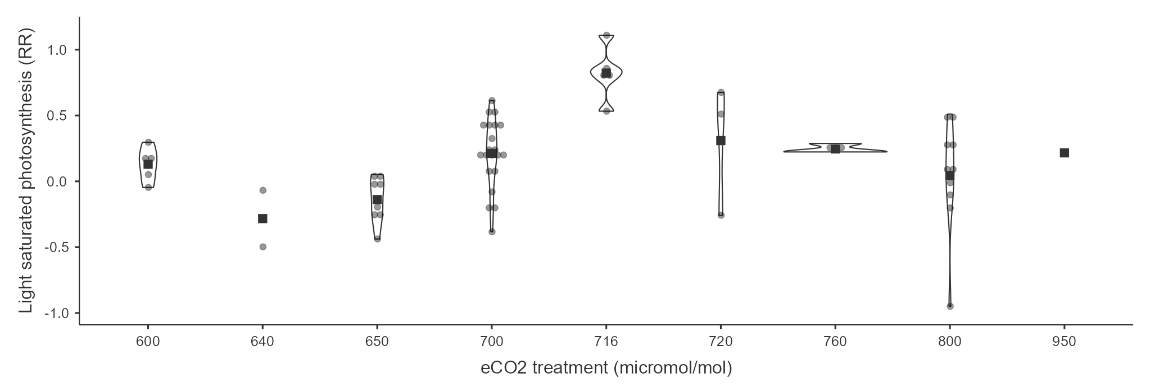
Fig. S10: Light saturated photosynthesis (A_{max}) of woody plants grown at eCO₂. RR = response ratio. The grey dots indicate the data points or observations and the black square is the mean RR.

A
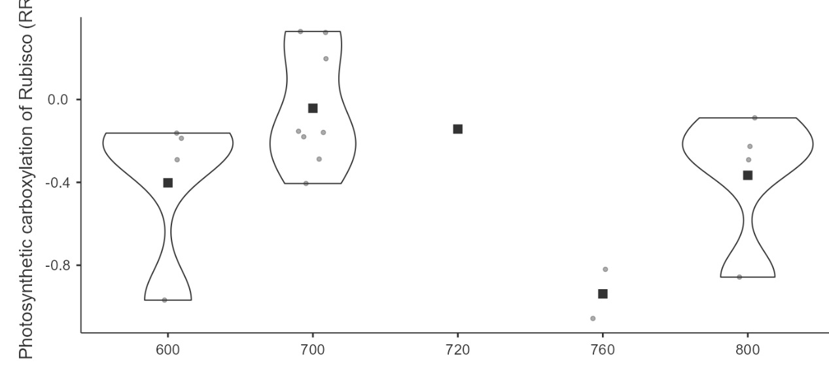
B
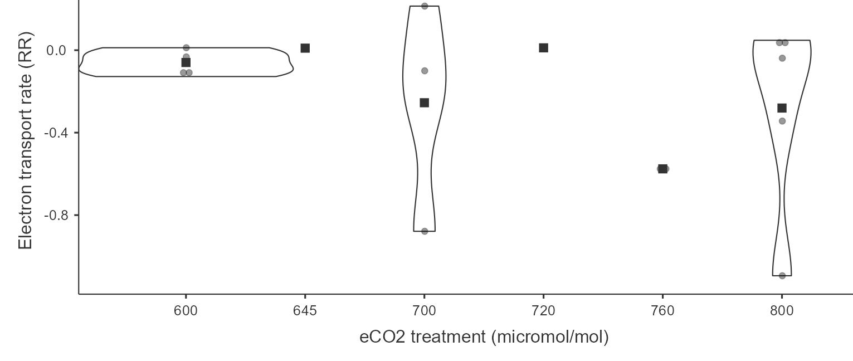
Fig. S11: Photosynthetic carboxylation of Rubisco (V_{cmax}; A) and electron transport rate (J_{max}; B) of woody plants grown at eCO₂. RR = response ratio. The grey dots indicate the data points or observations and the black square is the mean RR.
A
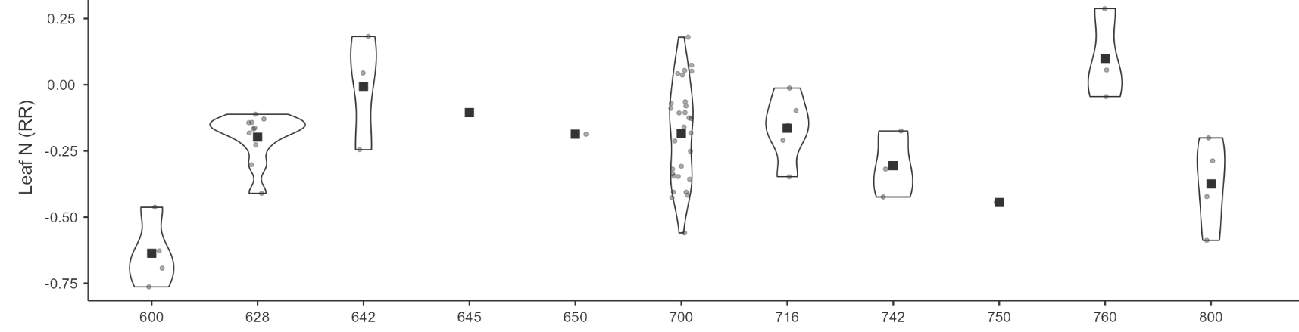
B
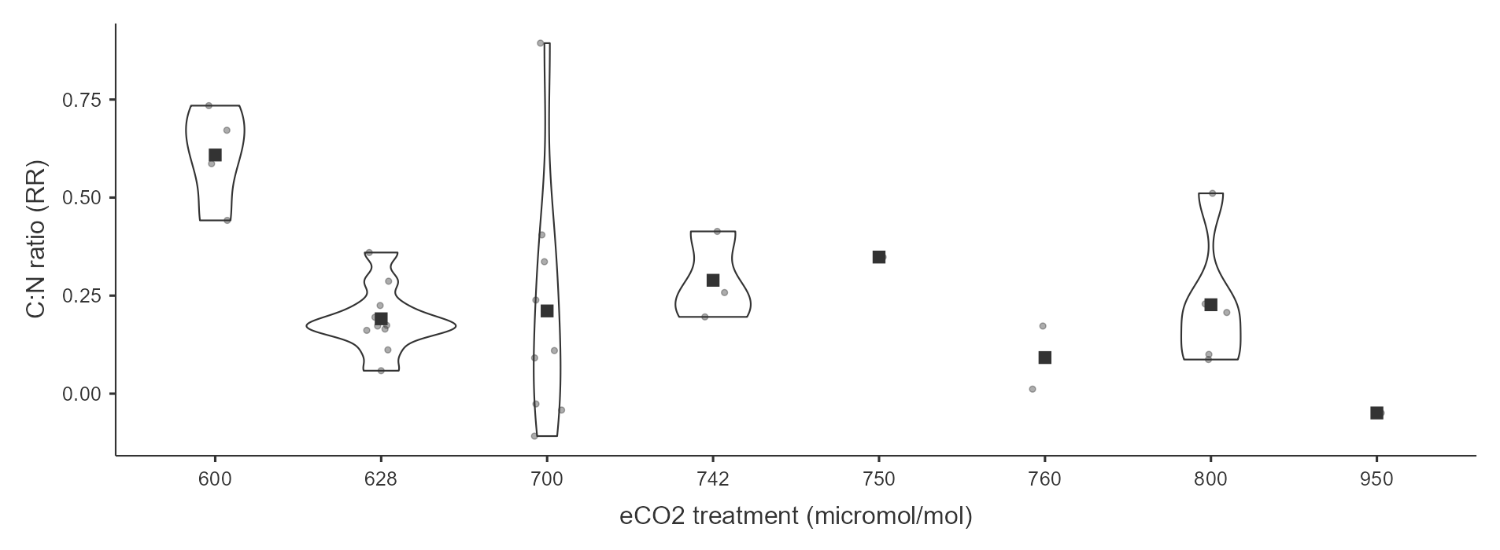
Fig. S12: Leaf N (A) and C:N ratio (B) of woody plants grown at eCO₂. RR = response ratio. The grey dots indicate the data points or observations and the black square is the mean RR.
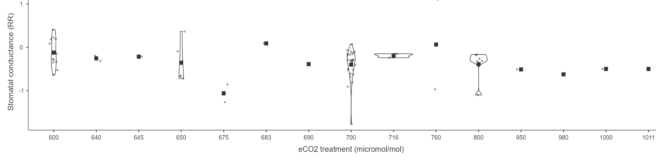
Fig. S13: Stomatal conductance (g_{s}) of woody plants grown at eCO₂. RR = response ratio. The grey dots indicate the data points or observations and the black square is the mean RR.

A
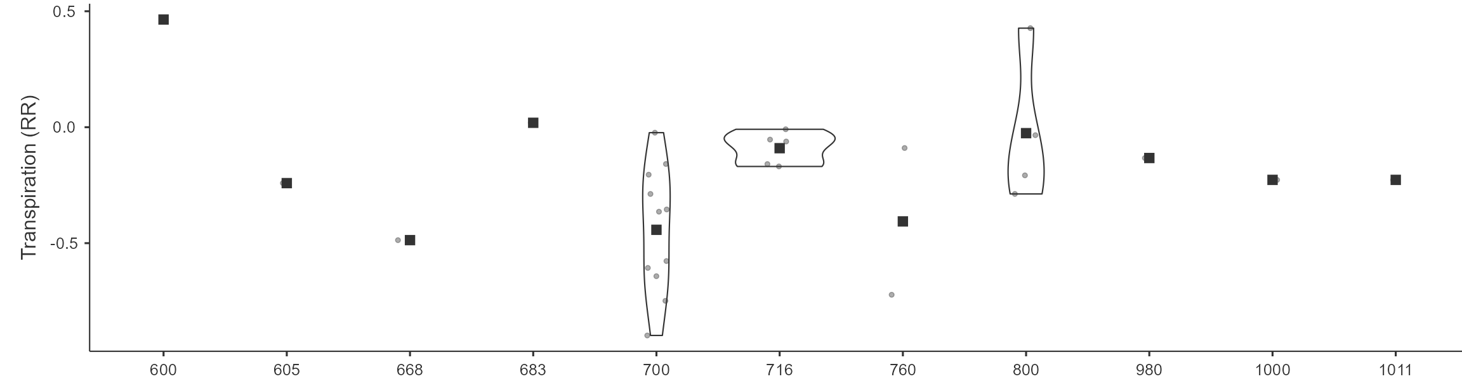
B
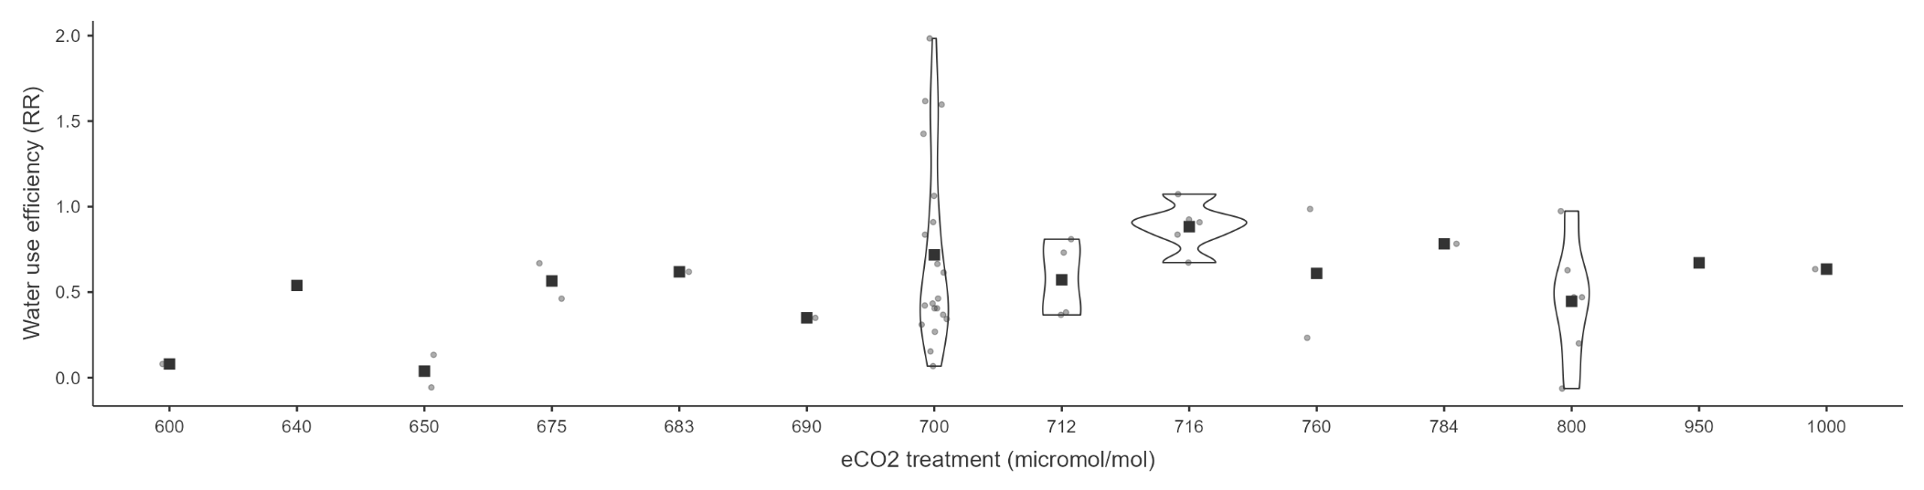
Fig. S14: Transpiration (Tr; A) and water use efficiency (WUE; B) of woody plants grown at eCO₂. RR = response ratio. The grey dots indicate the data points or observations and the black square is the mean RR.

A | 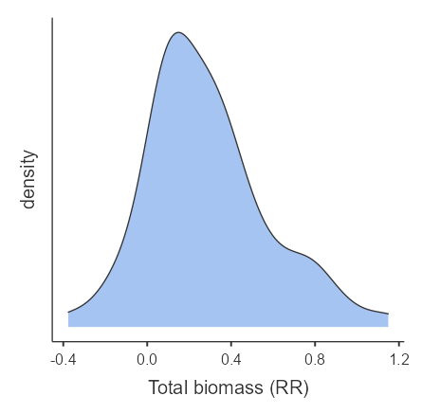 | 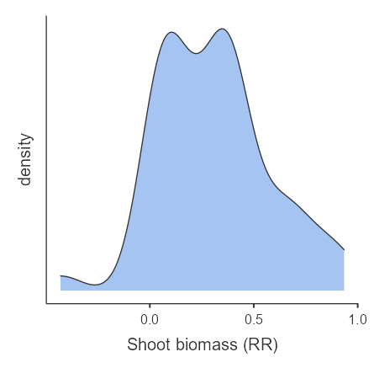 | 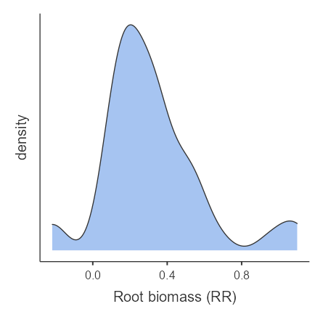
B | 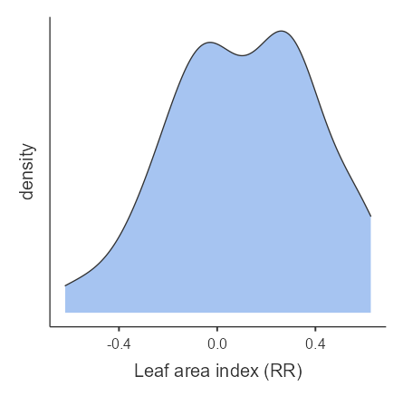 | 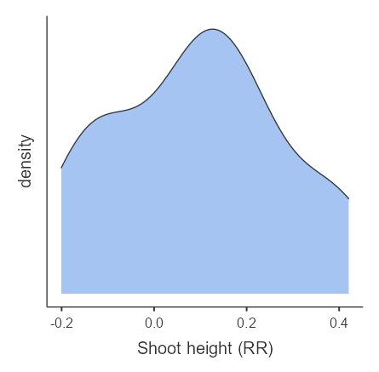 | 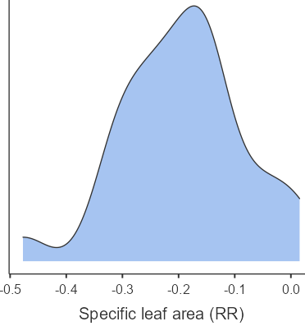
C | 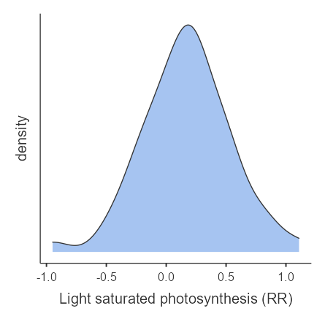 | 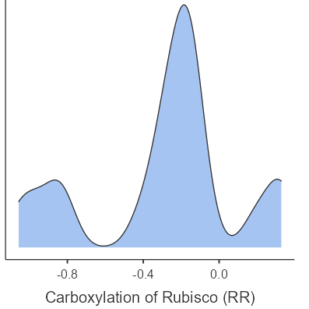 | 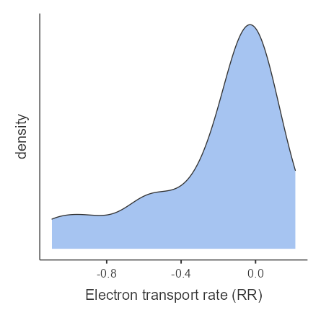
D | 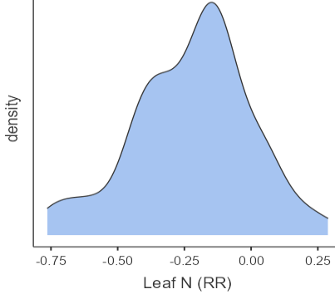 | 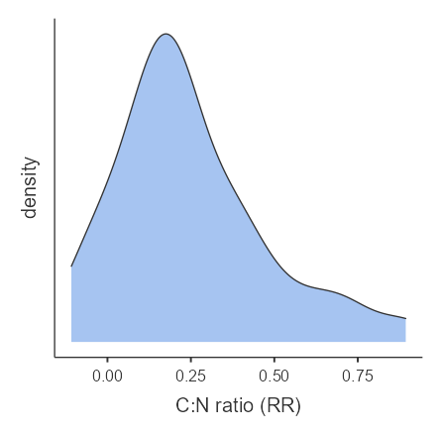
E | 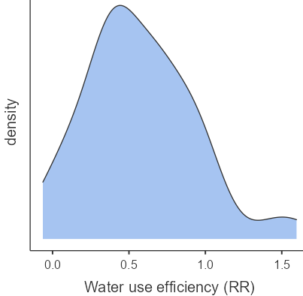 | 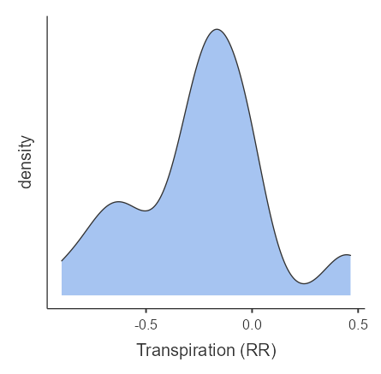 | 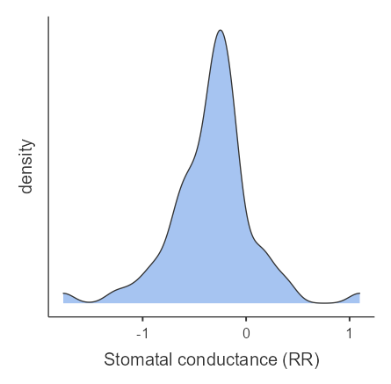
Fig. S15: Density plots indicating data dispersion of biomass (A), growth (B), photosynthetic (C) and water related parameters of woody plants grown at eCO₂. RR = response ratio

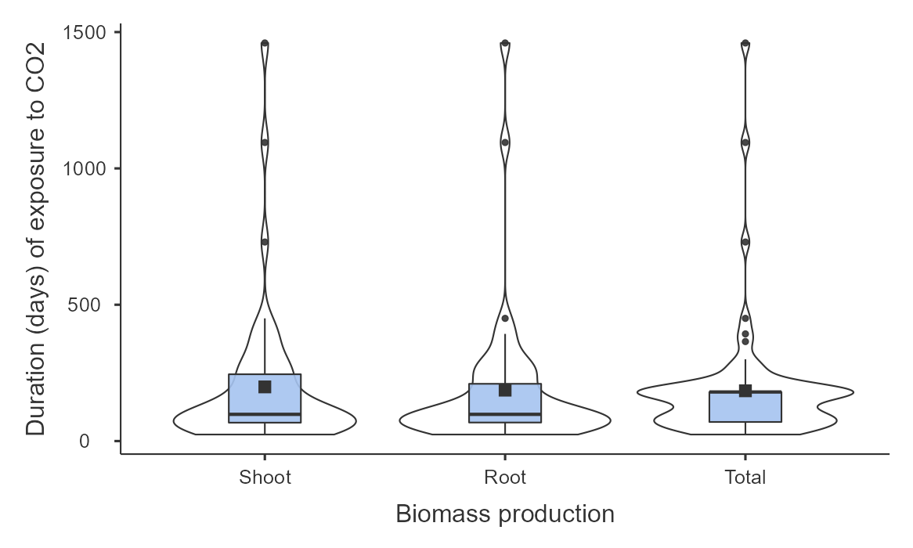
Fig. S16: The experimental length (days) of woody plant exposure to eCO₂ for biomass assessment. The violin indiacates the distribution of data. The bold horizontal line denotes a median time and the black square inside the box denotes mean (X̄) duration of the exposure to eCO₂. The upper and lower vertical whiskers are 25th and 75th quartiles, respectively. The upper and lower edges of the box denote maximum and minimum duration (days) of woody plant exposure to eCO₂.
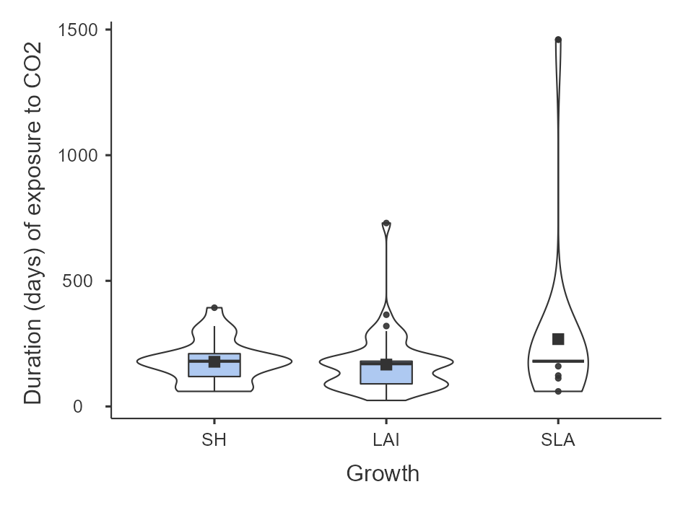
Fig. S17: Length (days) of woody plant exposure to eCO₂ for assessment of leaf area index (LAI), specific leaf area (SLA) and shoot height (SH). The violin indiacates the distribution of data. The bold horizontal line denotes a median duration and the black square inside the box plots denotes mean (X̄) duration of the exposure to eCO₂. The upper and lower vertical whiskers are 25th and 75th quartiles, respectively. The upper and lower edges of the box denote maximum and minimum duration (days) of woody plant exposure to eCO₂.

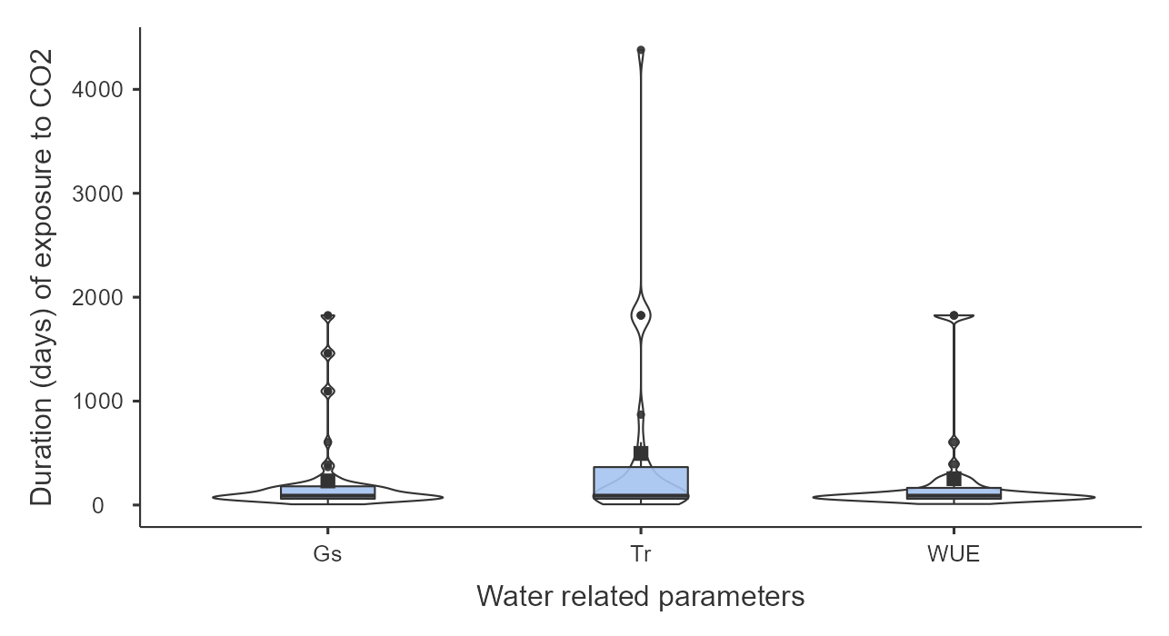
Fig. S18: Length (days) of woody plant exposure to eCO₂ for assessment of stomatal conductance (g_{s}), transpiration (Tr) and water use efficiency (WUE). The violin indiacates the distribution of data. The bold horizontal line denotes a median duration and the black square inside the box plots denotes mean (X̄) durationof the exposure to eCO₂. The upper and lower vertical whiskers are 25th and 75th quartiles, respectively. The upper and lower edges of the box denote maximum and minimum duration (days) of woody plant exposure to eCO₂.

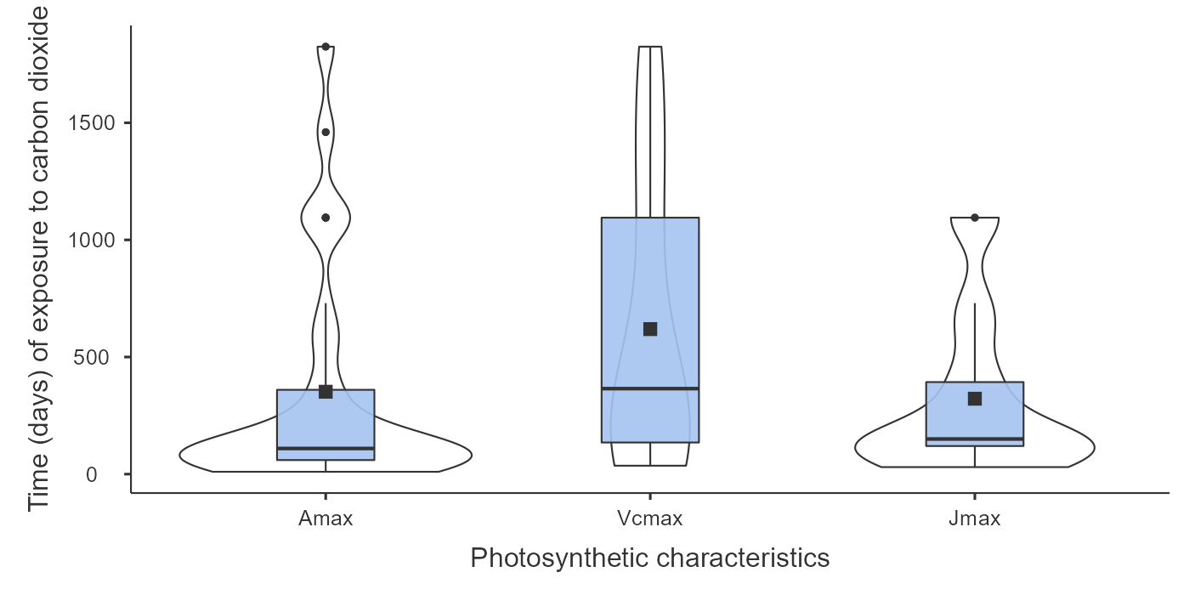
Fig. S19: Length (days) of woody plant exposure to eCO₂ for assessment of light saturated photosynthesis (A_{max}), carboxylation of Rubisco (V_{cmax}) and electron transport rate (J_{max}). The violin indiacates the distribution of data. The bold horizontal line denotes a median duration and the black square inside the box plots denotes mean (X̄) duration of the exposure to eCO₂. The upper and lower vertical whiskers are 25th and 75th quartiles, respectively. The upper and lower edges of the box denote maximum and minimum duration (days) of woody plant exposure to eCO₂. Dots indicate outlier observations. The few extreme outliers (mostly studies spanning over 5 years) were removed from the graphs
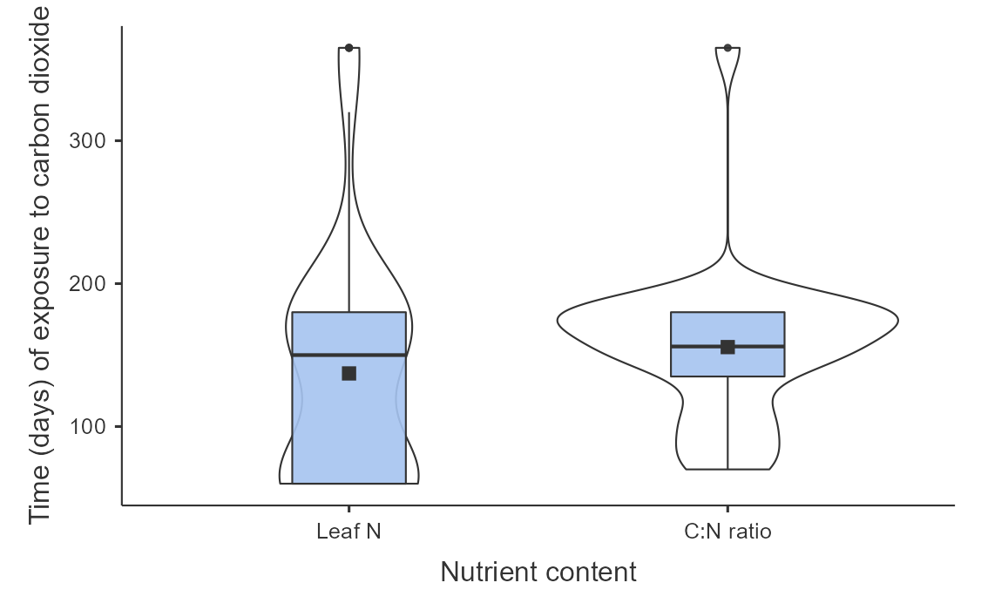
Fig. S20: Length (days) of woody plant exposure to eCO₂ for assessment of leaf N and C:N ratio. The violin indiacates the distribution of data. The bold horizontal line denotes a median durationand the black square inside the box plots denotes mean (X̄) duration of the exposure to eCO₂. The upper and lower vertical whiskers are 25th and 75th quartiles, respectively. The upper and lower edges of the box denote maximum and minimum duration (days) of woody plant exposure to eCO₂.

