Cichlidae
Figure 1: Maximum likelihood consensus tree, derived from the COI sequences, using the Kimura 2-parameter model and 1,000 bootstrap replicates. All positions below 95% site coverage were removed, with incomplete deletion option. Analysis involved nine Tylochromis and Thoracochromis nucleotide sequences, with 651 positions in the final dataset. The tree was rooted with C. citharinus as an outgroup taxon (Sogbesan et al., 2017).

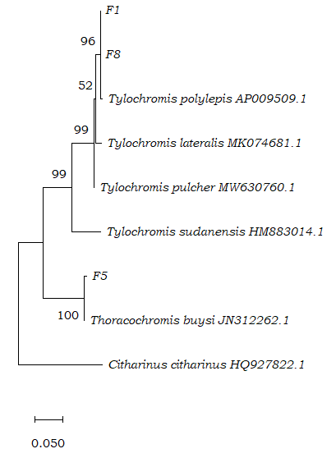

Table 1. Pairwise genetic distance (%) based on COI sequence data of Tylochromis and Thoracochromis of the Mweru-Luapula fishery using the Kimura-2-parameter model. C. citharinus was used as an outgroup
S/NO | Species | 1 | 2 | 3 | 4 | 5 | 6 | 7 | 8
1 | F1
2 | F8 | 0.000
3 | Tylochromis lateralis | 2.100 | 2.100
4 | Tylochromis sudanensis | 11.900 | 11.900 | 11.700
5 | Tylochromis pulcher | 1.400 | 1.400 | 1.600 | 10.700
6 | F5 | 19.900 | 19.900 | 21.000 | 19.900 | 19.100
7 | Thoracochromis buysi | 19.100 | 19.100 | 20.100 | 19.100 | 18.200 | 0.800
8 | Citharinus citharinus | 29.500 | 29.500 | 29.100 | 33.900 | 29.100 | 31.100 | 30.800
9 | Tylochromis polylepis | 0.500 | 0.500 | 2.600 | 12.100 | 1.600 | 20.200 | 19.300 | 29.100

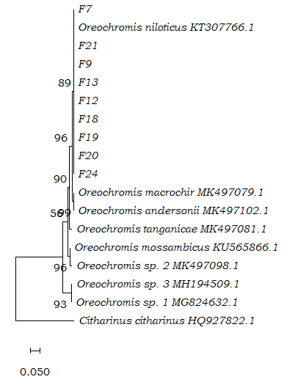
Figure 2: Maximum likelihood analysis, showing the phylogenetic tree with the highest log likelihood. Consensus tree of 19 Oreochromis and Citharinus COI nucleotide sequences, using the Kimura 2-parameter model and 1,000 bootstrap replicates. All positions below 95% site coverage were removed, with the incomplete deletion option. The alignment had 735 positions in the final dataset and the tree was rooted with C. citharinus as an outgroup taxon (Sogbesan et al., 2017).

Table 2. Pairwise genetic distance (%) based on COI sequence data of Oreochromis of the Mweru-Luapula fishery using the Kimura-2-parameter model. C. citharinus was used as an outgroup
S/NO | Species | 1 | 2 | 3 | 4 | 5 | 6 | 7 | 8 | 9 | 10 | 11 | 12 | 13 | 14 | 15 | 16 | 17 | 18
1 | F7
2 | F9 | 0.200
3 | F12 | 0.100 | 0.300
4 | F13 | 0.000 | 0.200 | 0.100
5 | F18 | 0.100 | 0.300 | 0.000 | 0.100
6 | F19 | 0.100 | 0.300 | 0.000 | 0.100 | 0.000
7 | F20 | 0.100 | 0.300 | 0.300 | 0.100 | 0.300 | 0.300
8 | F21 | 0.100 | 0.300 | 0.300 | 0.100 | 0.300 | 0.300 | 0.300
9 | F24 | 0.100 | 0.300 | 0.300 | 0.100 | 0.300 | 0.300 | 0.000 | 0.300
10 | Oreochromis niloticus | 0.000 | 0.200 | 0.200 | 0.000 | 0.200 | 0.200 | 0.200 | 0.200 | 0.200
11 | Oreochromis mossambicus | 4.600 | 5.000 | 4.800 | 4.600 | 4.800 | 4.800 | 4.400 | 4.600 | 4.400 | 4.200
12 | Oreochromis macrochir | 1.600 | 1.900 | 1.800 | 1.700 | 1.800 | 1.800 | 1.800 | 1.700 | 1.800 | 1.400 | 3.800
13 | Oreochromis andersonii | 1.600 | 1.900 | 1.800 | 1.700 | 1.800 | 1.800 | 1.800 | 1.700 | 1.800 | 1.400 | 3.800 | 0.000
14 | Oreochromis tanganicae | 3.400 | 4.100 | 3.200 | 3.400 | 3.200 | 3.200 | 3.200 | 3.600 | 3.200 | 3.400 | 3.800 | 3.700 | 3.700
15 | Sarotherodon galilaeus | 9.300 | 9.900 | 9.400 | 9.200 | 9.400 | 9.400 | 9.000 | 9.200 | 9.000 | 9.200 | 8.000 | 9.000 | 9.000 | 9.500
16 | Oreochromis species 2 | 5.500 | 6.100 | 5.600 | 5.400 | 5.600 | 5.600 | 5.200 | 5.400 | 0.200 | 5.300 | 1.100 | 4.700 | 4.700 | 4.700 | 8.800
17 | Oreochromis species 3 | 9.200 | 10.2000 | 9.400 | 9.200 | 9.400 | 9.400 | 9.000 | 9.200 | 9.000 | 9.400 | 8.000 | 9.200 | 9.200 | 9.700 | 0.800 | 9.000
18 | Oreochromis species 1 | 9.300 | 9.400 | 9.600 | 9.300 | 9.600 | 9.600 | 9.100 | 9.300 | 9.100 | 9.300 | 7.900 | 9.100 | 9.100 | 10.400 | 0.600 | 9.100 | 0.400
19 | Citharinus citharinus | 28.000 | 29.000 | 28.400 | 28.100 | 28.400 | 28.400 | 28.100 | 27.800 | 28.100 | 28.100 | 27.500 | 27.500 | 27.500 | 27.800 | 28.800 | 28.700 | 29.200 | 2.900
Oreochromis species 1 is Oreochromis species LMN, Oreochromis species 2 is Oreochromis species SAIAB and Oreochromis species 3 is Oreochromis species SF88

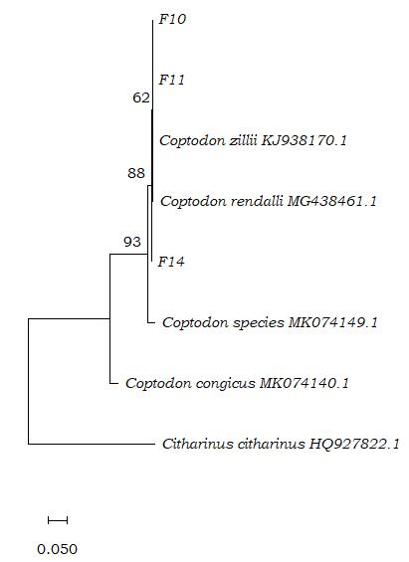
Figure 3: Maximum likelihood analysis, showing the tree with the highest log likelihood, the consensus tree of eight Coptodon and Citharinus COI nucleotide sequences, using the Kimura 2-parameter model and 1,000 bootstrap replicates. All positions below 95% site coverage were removed, with the incomplete deletion option. The alignment had 651 positions in the final dataset and the tree was rooted with C. citharinus as an outgroup taxon (Sogbesan et al., 2017).

Table 3. Pairwise genetic distance (%) based on COI sequence data of Coptodon of the Mweru-Luapula fishery using the Kimura-2-parameter model. C. citharinus was used as an outgroup
S/NO | Species | 1 | 2 | 3 | 4 | 5 | 6 | 7
1 | F10
2 | F11 | 0.000
3 | F14 | 0.200 | 0.200
4 | Coptodon species | 3.100 | 3.100 | 2.900
5 | Coptodon congicus | 11.600 | 11.600 | 11.400 | 11.500
6 | Coptodon rendalli | 0.300 | 0.300 | 0.500 | 3.400 | 11.600
7 | Citharinus citharinus | 28.300 | 28.300 | 28.300 | 28.000 | 26.200 | 28.300
8 | Coptodon zilli | 0.000 | 0.000 | 0.200 | 3.100 | 11.600 | 0.300 | 28.300
Alestidae
Figure 4: Consensus tree of six Hydrocynus and Hepsetus nucleotide sequences, derived from the COI sequences, using the Kimura 2-parameter model and 1,000 bootstrap replicates. All positions with less than 95% site coverage were eliminated, with partial deletion option. The alignment had a total of 742 positions in the final dataset and the tree was rooted with H. odoe as an outgroup taxon (Kurikova et al., 2016).
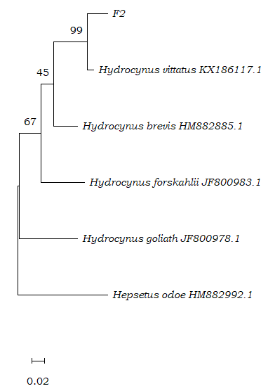

Table 4. Pairwise genetic distance (%) based on COI sequence data of Hydrocynus of the Mweru-Luapula fishery using the Kimura-2-parameter model. H. odoe was used as an outgroup

S/NO | Species | 1 | 2 | 3 | 4 | 5
1 | F2
2 | Hydrocynus forskahlii | 16.500
3 | Hydrocynus vittatus | 4.800 | 15.900
4 | Hydrocynus brevis | 14.500 | 12.900 | 12.100
5 | Hydrocynus goliath | 21.800 | 19.000 | 19.400 | 18.900
6 | Hepsetus odoe | 27.700 | 25.500 | 24.900 | 21.500 | 26.700

Figure 5: Maximum likelihood consensus tree, derived from the COI sequences, using the Kimura 2-parameter model and 1,000 bootstrap replicates. All positions below 95% site coverage were removed, with the incomplete deletion option. Analysis involved four Auchenoglanis and Bagrus nucleotide sequences. The alignment had 720 positions in the final dataset and the tree was rooted with B. bajad as an outgroup taxon (Okwiri et al., 2018).
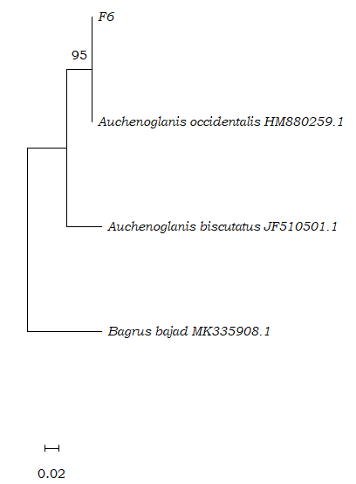
Table 5. Pairwise genetic distance (%) based on COI sequence data of Auchenoglanis of the Mweru-Luapula fishery using Kimura-2-parameter model. B. bajad was used as an outgroup
S/NO | Species | 1 | 2 | 3
1 | F6
2 | Auchenoglanis occidentalis | 0.400
3 | Auchenoglanis biscutatus | 10.000 | 10.000
4 | Bagrus bajad | 21.900 | 21.900 | 23.500

Claroteidae
Figure 6: Consensus tree of nine Chrysichthys and Bagrus nucleotide sequences, derived from the COI sequences, using the Kimura 2-parameter model and 1,000 bootstrap replicates. All positions below 95% site coverage were removed, with incomplete deletion option. The alignment had a total of 717 positions in the final dataset and the tree was rooted with B. bajad as an outgroup taxon (Okwiri et al., 2018).

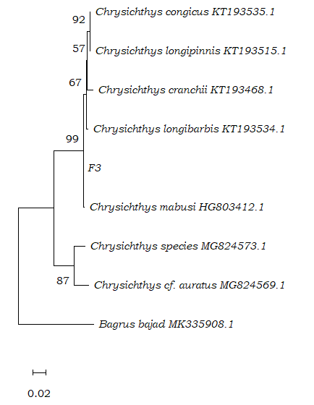
Table 6. Pairwise genetic distance (%) based on COI sequence data of Chrysichthys of the Mweru-Luapula fishery using the Kimura-2-parameter model. B. bajad was used as an outgroup
S/NO | Species | 1 | 2 | 3 | 4 | 5 | 6 | 7 | 8
1 | F3
2 | Chrysichthys mabusi | 0.200
3 | Chrysichthys congicus | 0.900 | 1.100
4 | Chrysichthys longibarbis | 0.400 | 0.600 | 0.900
5 | Chrysichthys longipinnis | 0.800 | 0.900 | 0.200 | 0.800
6 | Chrysichthys cranchii | 1.100 | 1.300 | 1.300 | 1.100 | 1.100
7 | Chrysichthys species | 10.000 | 10.300 | 11.300 | 10.500 | 11.100 | 11.100
8 | Chrysichthys cf auratus | 10.500 | 10.700 | 11.200 | 11.000 | 11.000 | 11.500 | 4.200
9 | Bagrus bajad | 23.400 | 23.700 | 23.700 | 23.400 | 23.400 | 24.800 | 22.700 | 22.000

Mormyridae
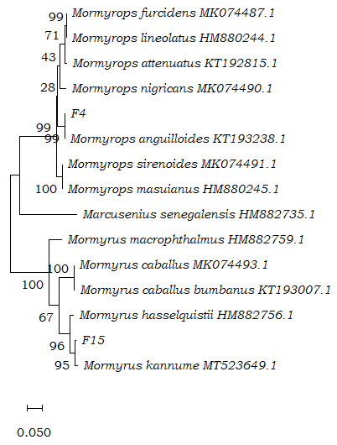
Figure 7: Maximum likelihood consensus tree, derived from the COI sequences, using the Kimura 2-parameter model and 1,000 bootstrap replicates. All positions below 95% site coverage were removed, with the incomplete deletion option. Analysis involved 14 Mormyrids and Marcusenius nucleotide sequences, with 651 positions in the final dataset. The tree was rooted with M. senegalensis as an outgroup taxon (Prié et al., 2021).

Table 7: Pairwise genetic distance (%) based on COI sequence data of Mormyrids species of the Mweru-Luapula fishery using the Kimura-2-parameter model. M. senegalensis was used as an outgroup
S/NO | Species | 1 | 2 | 3 | 4 | 5 | 6 | 7 | 8 | 9 | 10 | 11 | 12 | 13 | 14
1 | F4
2 | F15 | 0.204
3 | Mormyrops anguilloides | 0.003 | 0.199
4 | Mormyrops sirenoides | 0.053 | 0.202 | 0.049
5 | Mormyrops nigricans | 0.053 | 0.190 | 0.049 | 0.057
6 | Mormyrops furcidens | 0.061 | 0.176 | 0.061 | 0.053 | 0.047
7 | Mormyrops masuianus | 0.053 | 0.202 | 0.049 | 0.000 | 0.057 | 0.053
8 | Mormyrops lineolatus | 0.061 | 0.176 | 0.061 | 0.053 | 0.047 | 0.000 | 0.053
9 | Mormyrops attenuatus | 0.059 | 0.193 | 0.059 | 0.055 | 0.045 | 0.015 | 0.055 | 0.015
10 | Mormyrus caballus | 0.219 | 0.090 | 0.213 | 0.210 | 0.220 | 0.205 | 0.210 | 0.205 | 0.0217
11 | Mormyrus macrophthalmus | 0.165 | 0.111 | 0.160 | 0.159 | 0.184 | 0.171 | 0.159 | 0.171 | 0.188 | 0.109
12 | Mormyrus hasselquistii | 0.190 | 0.037 | 0.184 | 0.194 | 0.182 | 0.168 | 0.194 | 0.168 | 0.185 | 0.088 | 0.109
13 | Mormyrus caballus bumbanus | 0.216 | 0.094 | 0.210 | 0.207 | 0.216 | 0.202 | 0.207 | 0.202 | 0.214 | 0.003 | 0.109 | 0.088
14 | Mormyrus kannume | 0.196 | 0.017 | 0.191 | 0.188 | 0.182 | 0.163 | 0.188 | 0.163 | 0.180 | 0.090 | 0.121 | 0.041 | 0.094
15 | Marcusenius senegalensis | 0.203 | 0.207 | 0.204 | 0.188 | 0.213 | 0.201 | 0.188 | 0.201 | 0.211 | 0.193 | 0.187 | 0.205 | 0.190 | 0.211

Channidae
Figure 8: Maximum likelihood consensus tree, derived from the COI sequences, using the Kimura 2-parameter model and 1,000 bootstrap replicates. All positions below 95% site coverage were removed, with incomplete deletion option. Analysis involved 11 Parachanna and Pristolepis nucleotide sequences, with 717 positions in the final dataset. The tree was rooted with Pristolepis fasciata as an outgroup taxon (Britz et al., 2020).

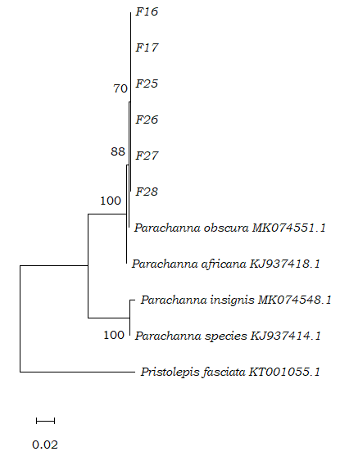
Table 8. Pairwise genetic distance (%) based on COI sequence data of Parachanna of the Mweru-Luapula fishery using the Kimura-2-parameter model. P. fasciata was used as an outgroup
S/NO | Species | 1 | 2 | 3 | 4 | 5 | 6 | 7 | 8 | 9 | 10
1 | F16
2 | F17 | 0.000
3 | F25 | 0.000 | 0.000
4 | F26 | 0.000 | 0.000 | 0.000
5 | F27 | 0.000 | 0.000 | 0.000 | 0.000
6 | F28 | 0.000 | 0.000 | 0.000 | 0.000 | 0.000
7 | Parachanna obscura | 0.200 | 0.200 | 0.200 | 0.200 | 0.200 | 0.200
8 | Pristolepis fasciata | 30.200 | 30.200 | 30.200 | 30.200 | 30.200 | 30.200 | 29.900
9 | Parachanna insignis | 11.200 | 11.200 | 11.200 | 11.200 | 11.200 | 11.200 | 11.000 | 28.500
10 | Parachanna africana | 0.500 | 0.500 | 0.500 | 0.500 | 0.500 | 0.500 | 0.300 | 29.100 | 10.500
11 | Parachanna species | 10.700 | 10.700 | 10.700 | 10.700 | 10.700 | 10.700 | 10.500 | 28.900 | 0.700 | 10.000
Mochokidae
Figure 9: Maximum likelihood consensus tree, derived from the COI sequences, using the Kimura 2-parameter model and 1,000 bootstrap replicates. All positions below 95% site coverage were removed, with incomplete deletion option. Analysis involved seven Synodontis nucleotide sequences, with a total of 619 positions in the final dataset. The tree was rooted with A. chapini as an outgroup taxon (Schedel et al., 2021).
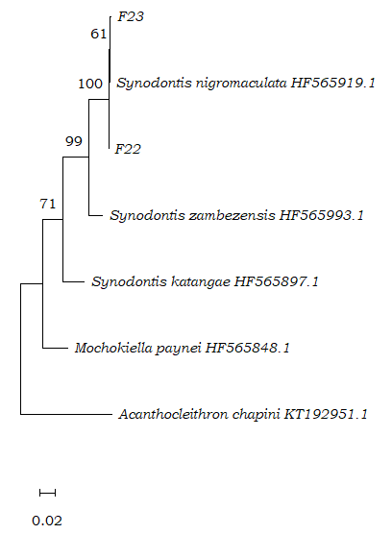
Table 9. Pairwise genetic distance (%) based on COI sequence data of Synodontis of the Mweru-Luapula fishery using the Kimura-2-parameter model. A. chapini was used as an outgroup
S/NO | Species | 1 | 2 | 3 | 4 | 5 | 6
1 | F22
2 | F23 | 0.300
3 | Synodontis nigromaculata | 0.200 | 0.200
4 | Mochokiella paynei | 13.600 | 13.500 | 13.800
5 | Acanthocleithron chapini | 24.400 | 24.700 | 24.400 | 20.900
6 | Synodontis zambezensis | 4.900 | 4.900 | 5.100 | 11.400 | 22.100
7 | Synodontis katangae | 10.000 | 10.400 | 10.200 | 9.300 | 21.200 | 8.900

References
Britz R, Dahanukar N, Anoop VK, et al. Aenigmachannidae, a new family of snakehead fishes (Teleostei: Channoidei) from subterranean waters of South India. Scientific reports. 2020;10(1):16081-16081. doi:10.1038/s41598-020-73129-6
Kimura M. A simple method for estimating evolutionary rates of base substitutions through comparative studies of nucleotide sequences. Journal of molecular evolution. 1980;16(2):111-120. doi:10.1007/BF01731581
Kuříková P, Patoka J, Kalous L. Female Morphometric and Genetic Analysis of Potential new Brycinus species (Teleostei: Characiformes: Alestiidae) From Cuanza (Quanza, Kwanza) 2016; River Catchment, Bié, Angola. Corpus ID:90881794. MendelNet, 23, Article 319-324.
Okwiri B, Cao L, Nyingi DW, Zhang E. Molecular phylogenetic analysis of the catfish species Auchenoglanis occidentalis (Valenciennes, 1840) (Pisces: Claroteidae) from Lake Turkana in East Africa: taxonomic implications. Zootaxa. 2018;4450(1):115-124. doi:10.11646/zootaxa.4450.1.8
Prié V, Adam B, Melki F. From fin rays to DNA: supplementary morphological and molecular data to identify Mormyrus subundulatus Roberts, 1989 (Pisces: Mormyridae) from the Bandama River in Côte d’Ivoire. Zoosystema. 2021;43(27):649-658. doi:10.5252/zoosystema2021v43a27
Schedel FDB, Chakona A, Sidlauskas BL, et al. New phylogenetic insights into the African catfish families Mochokidae and Austroglanididae. Journal of fish biology. 2022;100(5):1171-1186. doi:10.1111/jfb.15014
Sogbesan OA, Sanda MK, Ja’afar JN, Adedeji HA. DNA Barcoding of Tilapia Species (Pisces: Cichlidae) from North-Eastern Nigeria. J Biotechnol Biomater 2017;7: 277. doi: 10.4172/2155-952X.1000277
Tamura K, Stecher G, Kumar S. MEGA11: Molecular Evolutionary Genetics Analysis Version 11. Molecular biology and evolution. 2021;38(7):3022-3027. doi:10.1093/molbev/msab120

