SUPPLEMENTARY MATERIAL: Correlating the density and refractive index of ternary liquid mixtures
Journal of Solution Chemistry
Pethile Dzingai,^{1,2} Walter W Focke,^{1,2,*} Shatish Ramjee,² Pretty Khosa,² Ripfumelo A. Nobunga²
¹UP Institute for Sustainable Malaria Control & MRC Collaborating Centre for Malaria Research, University of Pretoria, Private Bag X20, Hatfield 0028, Pretoria, South Africa, Pretoria, South Africa.
²Department of Chemical Engineering, University of Pretoria, Private Bag X20, Hatfield 0028, Pretoria, South Africa, Pretoria, South Africa.

The ability of the proposed models to represent or predict the variation of property with composition was tested using the literature-sourced data for the ternary systems listed in Table 1 in the main text. The mixture models listed in Table 2 in the main text were explored for the liquid density, molar refraction and Lorentz-Lorenz parameter. First, the full data set for each ternary was used to fix the model parameters using least squares regression. The Akaike information criterion (AIC) (Akaike, 1983) was used to rank the relative performance of the models as follows:
$AIC=n ln\left({{SSE}_{ideal}}/{{SSE}_{model}}\right)+2df$ (20)
Where n is the number of data points, SSE is the sum of the square errors defined as the difference between the predicted and measure property values, and df represents the degrees of freedom, i.e. the number of adjustable constants in the model determined via the regression process. The subscript “model” refers to the mixture model under investigation and the subscript “ideal” refers to the equation presumed to hold for an ideal solution. Note that the Lorentz-Lorenz parameter (N) acts as a surrogate for the refractive index (n) as the latter can be determined from:
$$n=\sqrt{{\left(1+N\right)}/{\left(1-N\right)}}$$

Next, the model parameters were determined on the basis of the binary data alone. The Akaike information criterion was applied using the squares errors summed over all the data, i.e. the binary and the ternary data, in order to quantify the binary-predictive power of the model. The outcomes of these exercises are presented in Table S-1 through Table S-3 for the density, Lorentz-Lorenz parameter, and the molar refraction respectively.

Model parameters are given in the Excel spreadsheets that can be obtained by request from the corresponding author.
Table S1. Model performance for density
 |  | Full correlation |  |  |  |  | Binary Predictive
No. parameters |  | 0 | 3 | 6 | 9 | 12 | 3 | 6 | 9 | 12
System | Model | K₁/K₁ | K₂/K₁ | K₂/K₂ | K₃/K₂ | K₃/K₃ | K₂/K₁ | K₂/K₂ | K₃/K₂ | K₃/K₃
T0 | ΔAIC | 0 | 529 | 802 | 918 | 914 | 504 | 528 | 858 | 794
T0 | MAD (%) | 3.462 | 0.743 | 0.560 | 0.321 | 0.327 | 0.797 | 1.801 | 0.500 | 0.679
T0 | AAD (%) | 1.718 | 0.270 | 0.088 | 0.061 | 0.060 | 0.273 | 0.120 | 0.057 | 0.060
T1 | ΔAIC | 0 | 733 | 827 | 829 | 825 | 312 | 327 | 335 | 317
T1 | MAD (%) | 1.036 | 0.089 | 0.057 | 0.055 | 0.054 | 0.089 | 0.094 | 0.083 | 0.082
T1 | AAD (%) | 0.516 | 0.030 | 0.021 | 0.020 | 0.020 | 0.030 | 0.021 | 0.020 | 0.023
T2 | ΔAIC | 0.000 | 185 | 222 | 216 | 294 | 71 | 48 | 40 | 78
T2 | MAD (%) | 0.302 | 0.085 | 0.060 | 0.060 | 0.037 | 0.124 | 0.166 | 0.171 | 0.092
T2 | AAD (%) | 0.103 | 0.029 | 0.022 | 0.022 | 0.011 | 0.030 | 0.033 | 0.035 | 0.018
T3 | ΔAIC | 0.000 | 221 | 221 | 294 | 305 | 80 | 44 | 63 | -191
T3 | MAD (%) | 0.160 | 0.038 | 0.044 | 0.022 | 0.022 | 0.059 | 0.094 | 0.084 | 2.555
T3 | AAD (%) | 0.076 | 0.016 | 0.015 | 0.008 | 0.008 | 0.020 | 0.027 | 0.017 | 0.660
T4 | ΔAIC | 0 | 531 | 538 | 538 | 532 | 768 | 180 | 245 | 235
T4 | MAD (%) | 0.709 | 0.074 | 0.065 | 0.052 | 0.052 | 0.070 | 0.179 | 0.061 | 0.069
T4 | AAD (%) | 0.419 | 0.024 | 0.022 | 0.022 | 0.022 | 0.028 | 0.041 | 0.024 | 0.023
T5 | ΔAIC | 0 | 329 | 329 | 361 | 354 | 118 | 21 | -42 | -44
T5 | MAD (%) | 1.553 | 0.362 | 0.340 | 0.204 | 0.202 | 0.503 | 1.084 | 2.930 | 2.761
T5 | AAD (%) | 0.739 | 0.062 | 0.057 | 0.048 | 0.047 | 0.059 | 0.349 | 0.926 | 0.872
T6 | ΔAIC | 0 | 432 | 509 | 490 | 539 | 125 | 125 | 107 | 145
T6 | MAD (%) | 0.289 | 0.024 | 0.016 | 0.020 | 0.013 | 0.031 | 0.025 | 0.029 | 0.016
T6 | AAD (%) | 0.091 | 0.007 | 0.004 | 0.004 | 0.003 | 0.008 | 0.008 | 0.010 | 0.004
T7 | ΔAIC | 0 | 158 | 253 | 336 | 329 | 53 | -38 | 81 | 78
T7 | MAD (%) | 0.196 | 0.092 | 0.056 | 0.025 | 0.026 | 0.297 | 1.177 | 0.105 | 0.096
T7 | AAD (%) | 0.065 | 0.022 | 0.012 | 0.007 | 0.007 | 0.084 | 0.359 | 0.045 | 0.042
T8 | ΔAIC | 0 | 194 | 292 | 308 | 304 | 97 | 125 | 133 | 130
T8 | MAD (%) | 0.923 | 0.198 | 0.099 | 0.076 | 0.076 | 0.213 | 0.163 | 0.114 | 0.113
T8 | AAD (%) | 0.391 | 0.066 | 0.025 | 0.020 | 0.020 | 0.071 | 0.038 | 0.030 | 0.029
T9 | ΔAIC | 0 | 223 | 297 | 328 | 323 | 113 | 131 | 166 | 164
T9 | MAD (%) | 1.004 | 0.201 | 0.096 | 0.077 | 0.075 | 0.200 | 0.159 | 0.076 | 0.074
T9 | AAD (%) | 0.415 | 0.059 | 0.030 | 0.020 | 0.020 | 0.062 | 0.040 | 0.022 | 0.020
T10 | ΔAIC | 0 | 202 | 306 | 329 | 322 | 98 | 136 | 159 | 135
T10 | MAD (%) | 0.960 | 0.169 | 0.095 | 0.074 | 0.066 | 0.191 | 0.109 | 0.071 | 0.099
T10 | AAD (%) | 0.420 | 0.067 | 0.025 | 0.018 | 0.018 | 0.072 | 0.032 | 0.021 | 0.026
T11 | ΔAIC | 0 | 570 | 565 | 579 | 573 | 269 | 263 | 260 | 196
T11 | MAD (%) | 0.659 | 0.092 | 0.094 | 0.078 | 0.077 | 0.091 | 0.094 | 0.099 | 0.095
T11 | AAD (%) | 0.207 | 0.016 | 0.015 | 0.014 | 0.014 | 0.016 | 0.016 | 0.016 | 0.028
T12 | ΔAIC | 0 | 215 | 272 | 242 | 256 | 104 | 102 | -20 | 86
T12 | MAD (%) | 1.000 | 0.159 | 0.106 | 0.128 | 0.132 | 0.182 | 0.226 | 1.717 | 0.251
T12 | AAD (%) | 0.431 | 0.062 | 0.037 | 0.045 | 0.036 | 0.065 | 0.052 | 0.304 | 0.053
T13 | ΔAIC | 0 | 559 | 1013 | 995 | 1023 | 233 | 422 | 333 | 326
T13 | MAD (%) | 4.128 | 0.771 | 0.201 | 0.216 | 0.191 | 0.771 | 0.201 | 0.271 | 0.274
T13 | AAD (%) | 2.138 | 0.254 | 0.043 | 0.045 | 0.040 | 0.254 | 0.043 | 0.098 | 0.099
T14 | ΔAIC | 0 | 424 | 440 | 467 | 461 | 176 | 181 | 186 | 180
T14 | MAD (%) | 0.659 | 0.102 | 0.101 | 0.072 | 0.071 | 0.091 | 0.092 | 0.068 | 0.068
T14 | AAD (%) | 0.152 | 0.018 | 0.016 | 0.014 | 0.014 | 0.021 | 0.017 | 0.016 | 0.016

Table S2. Model performance for Lorentz-Lorenz parameter
 |  | Full correlation |  |  |  |  | Binary Predictive
No. parameters |  | 0 | 3 | 6 | 9 | 12 | 3 | 6 | 9 | 12
System | Model | K₁/K₁ | K₂/K₁ | K₂/K₂ | K₃/K₂ | K₃/K₃ | K₂/K₁ | K₂/K₂ | K₃/K₂ | K₃/K₃
T0 | ΔAIC | 0 | 811 | 1004 | 1184 | 1223 | 667 | 825 | 679 | 1025
T0 | MAD (%) | 1.029 | 0.198 | 0.163 | 0.070 | 0.077 | 0.254 | 0.201 | 0.285 | 0.063
T0 | AAD (%) | 0.532 | 0.053 | 0.030 | 0.019 | 0.016 | 0.054 | 0.032 | 0.038 | 0.017
T1 | ΔAIC | 0 | 741 | 834 | 891 | 885 | 302 | 347 | 354 | 126
T1 | MAD (%) | 0.284 | 0.025 | 0.018 | 0.017 | 0.016 | 0.023 | 0.018 | 0.018 | 0.117
T1 | AAD (%) | 0.145 | 0.008 | 0.005 | 0.004 | 0.004 | 0.009 | 0.005 | 0.005 | 0.028
T2 | ΔAIC | 0 | 157 | 197 | 220 | 218 | 67 | 74 | -30 | 72
T2 | MAD (%) | 0.152 | 0.057 | 0.044 | 0.031 | 0.031 | 0.055 | 0.039 | 0.161 | 0.032
T2 | AAD (%) | 0.046 | 0.012 | 0.010 | 0.009 | 0.009 | 0.015 | 0.013 | 0.047 | 0.011
T3 | ΔAIC | 0 | 152 | 186 | 163 | 203 | 63 | 73 | 55 | 72
T3 | MAD (%) | 0.149 | 0.059 | 0.042 | 0.048 | 0.035 | 0.058 | 0.045 | 0.058 | 0.047
T3 | AAD (%) | 0.050 | 0.016 | 0.013 | 0.015 | 0.011 | 0.018 | 0.015 | 0.017 | 0.011
T4 | ΔAIC | 0 | 375 | 401 | 394 | 401 | 177 | 126 | 121 | 134
T4 | MAD (%) | 0.270 | 0.081 | 0.081 | 0.065 | 0.066 | 0.091 | 0.128 | 0.128 | 0.097
T4 | AAD (%) | 0.114 | 0.014 | 0.011 | 0.011 | 0.011 | 0.015 | 0.019 | 0.019 | 0.016
T5 | ΔAIC | 0 | 346 | 434 | 476 | 498 | 123 | 126 | 153 | 155
T5 | MAD (%) | 0.487 | 0.062 | 0.030 | 0.028 | 0.027 | 0.102 | 0.066 | 0.045 | 0.041
T5 | AAD (%) | 0.236 | 0.019 | 0.010 | 0.007 | 0.006 | 0.021 | 0.019 | 0.011 | 0.010
T6 | ΔAIC | 0 | 213 | 255 | 302 | 271 | 64 | 72 | 78 | 7
T6 | MAD (%) | 0.065 | 0.028 | 0.028 | 0.017 | 0.018 | 0.026 | 0.024 | 0.018 | 0.047
T6 | AAD (%) | 0.027 | 0.006 | 0.005 | 0.004 | 0.004 | 0.007 | 0.006 | 0.004 | 0.014
T7 | ΔAIC | 0 | 158 | 253 | 336 | 329 | 50 | 78 | 101 | 96
T7 | MAD (%) | 0.196 | 0.092 | 0.056 | 0.025 | 0.026 | 0.090 | 0.054 | 0.027 | 0.027
T7 | AAD (%) | 0.065 | 0.022 | 0.012 | 0.007 | 0.007 | 0.022 | 0.012 | 0.008 | 0.007
T8 | ΔAIC | 0 | 113 | 152 | 154 | 163 | 48 | 50 | 38 | 8
T8 | MAD (%) | 0.197 | 0.123 | 0.063 | 0.054 | 0.064 | 0.141 | 0.093 | 0.113 | 0.177
T8 | AAD (%) | 0.082 | 0.024 | 0.018 | 0.018 | 0.015 | 0.030 | 0.025 | 0.026 | 0.037
T9 | ΔAIC | 0 | 131 | 145 | 150 | 150 | 50 | 43 | 35 | -50
T9 | MAD (%) | 0.456 | 0.209 | 0.207 | 0.191 | 0.175 | 0.167 | 0.175 | 0.176 | 0.527
T9 | AAD (%) | 0.102 | 0.028 | 0.019 | 0.019 | 0.019 | 0.036 | 0.037 | 0.038 | 0.119
T10 | ΔAIC | 0 | 111 | 176 | 172 | 175 | 44 | 61 | 53 | 72
T10 | MAD (%) | 0.220 | 0.088 | 0.049 | 0.050 | 0.048 | 0.105 | 0.082 | 0.083 | 0.071
T10 | AAD (%) | 0.081 | 0.028 | 0.015 | 0.015 | 0.013 | 0.033 | 0.019 | 0.019 | 0.014
T11 | ΔAIC | 0 | 255 | 259 | 265 | 262 | 118 | 115 | 115 | 112
T11 | MAD (%) | 0.165 | 0.153 | 0.152 | 0.154 | 0.151 | 0.155 | 0.145 | 0.163 | 0.154
T11 | AAD (%) | 0.044 | 0.011 | 0.010 | 0.009 | 0.009 | 0.011 | 0.011 | 0.009 | 0.009
T12 | ΔAIC | 0 | 110 | 166 | 162 | 164 | 36 | 40 | 54 | 29
T12 | MAD (%) | 0.220 | 0.131 | 0.074 | 0.074 | 0.073 | 0.184 | 0.137 | 0.125 | 0.158
T12 | AAD (%) | 0.090 | 0.029 | 0.018 | 0.017 | 0.016 | 0.035 | 0.030 | 0.020 | 0.029
T13 | ΔAIC | 0 | 645 | 706 | 889 | 976 | 270 | 292 | 366 | 397
T13 | MAD (%) | 1.093 | 0.150 | 0.120 | 0.058 | 0.066 | 0.150 | 0.120 | 0.058 | 0.062
T13 | AAD (%) | 0.544 | 0.045 | 0.037 | 0.018 | 0.012 | 0.045 | 0.037 | 0.018 | 0.013
T14 | ΔAIC | 0 | 354 | 393 | 393 | 420 | 144 | 130 | -31 | 169
T14 | MAD (%) | 0.165 | 0.028 | 0.019 | 0.017 | 0.020 | 0.033 | 0.034 | 0.183 | 0.018
T14 | AAD (%) | 0.046 | 0.008 | 0.006 | 0.006 | 0.005 | 0.008 | 0.009 | 0.049 | 0.005

Table S3. Model performance for molar refraction
 |  | Full correlation |  |  |  |  |  |  | Binary Predictive
No. parameters |  | 0 | 3 | 6 | 6 | 9 | 9 | 12 | 3 | 6 | 6 | 9 | 9 | 12
System | Model | K₁ | K₂ | K₃ | K₂*K₂ | K₃*K₂ | K₂*K₃ | K₃*K₃ | K₂ | K₃ | K₂*K₂ | K₃*K₂ | K₂*K₃ | K₃*K₃
T0 | ΔAIC | 0 | 510 | 531 | 802 | 799 | 802 | 803 | 468 | 498 | 605 | 749 | 614 | 705
T0 | MAD (%) | 3.226 | 0.603 | 0.570 | 0.292 | 0.292 | 0.310 | 0.311 | 0.587 | 0.570 | 0.507 | 0.292 | 0.411 | 0.312
T0 | AAD (%) | 1.794 | 0.191 | 0.168 | 0.053 | 0.053 | 0.051 | 0.049 | 0.190 | 0.168 | 0.073 | 0.052 | 0.069 | 0.057
T1 | ΔAIC | 0 | 727 | 440 | 823 | 839 | 830 | 839 | 297 | 172 | 346 | 340 | 206 | 298
T1 | MAD (%) | 0.96 | 0.080 | 0.287 | 0.082 | 0.064 | 0.063 | 0.066 | 0.081 | 0.309 | 0.071 | 0.071 | 0.212 | 0.088
T1 | AAD (%) | 0.48 | 0.028 | 0.085 | 0.018 | 0.017 | 0.017 | 0.016 | 0.030 | 0.077 | 0.018 | 0.017 | 0.055 | 0.024
T2 | ΔAIC | 0.000 | 133 | 127 | 175 | 183 | 169 | 180 | 54 | 48 | 61 | 64 | 56 | 0
T2 | MAD (%) | 0.455 | 0.142 | 0.142 | 0.105 | 0.098 | 0.105 | 0.109 | 0.164 | 0.163 | 0.147 | 0.117 | 0.138 | 0.258
T2 | AAD (%) | 0.140 | 0.040 | 0.040 | 0.034 | 0.030 | 0.034 | 0.028 | 0.050 | 0.051 | 0.047 | 0.040 | 0.045 | 0.079
T3 | ΔAIC | 0 | 128 | 122 | 161 | 159 | 156 | 154 | 51 | 45 | 16 | 17 | 55 | 2
T3 | MAD (%) | 0.464 | 0.167 | 0.167 | 0.132 | 0.106 | 0.131 | 0.110 | 0.212 | 0.212 | 0.346 | 0.237 | 0.143 | 0.272
T3 | AAD (%) | 0.153 | 0.048 | 0.048 | 0.038 | 0.036 | 0.038 | 0.037 | 0.058 | 0.058 | 0.084 | 0.070 | 0.043 | 0.080
T4 | ΔAIC | 0 | 347 | 360 | 364 | 359 | 349 | 347 | 176 | 192 | 66 | 154 | 155 | 182
T4 | MAD (%) | 0.780 | 0.222 | 0.201 | 0.188 | 0.179 | 0.149 | 0.178 | 0.266 | 0.209 | 0.553 | 0.199 | 0.195 | 0.163
T4 | AAD (%) | 0.333 | 0.045 | 0.042 | 0.035 | 0.038 | 0.042 | 0.037 | 0.045 | 0.035 | 0.106 | 0.040 | 0.040 | 0.030
T5 | ΔAIC | 0 | 359 | 422 | 397 | 477 | 468 | 504 | 134 | 107 | 89 | 134 | 6 | 44
T5 | MAD (%) | 1.529 | 0.238 | 0.135 | 0.127 | 0.070 | 0.074 | 0.088 | 0.248 | 0.301 | 0.449 | 0.211 | 1.450 | 0.668
T5 | AAD (%) | 0.761 | 0.066 | 0.035 | 0.047 | 0.023 | 0.027 | 0.021 | 0.063 | 0.093 | 0.132 | 0.059 | 0.464 | 0.220
T6 | ΔAIC | 0 | 232 | 297 | 277 | 299 | 261 | 295 | 71 | 86 | 67 | 85 | 54 | 79
T6 | MAD (%) | 0.221 | 0.108 | 0.102 | 0.097 | 0.100 | 0.095 | 0.102 | 0.097 | 0.094 | 0.091 | 0.092 | 0.092 | 0.093
T6 | AAD (%) | 0.093 | 0.023 | 0.015 | 0.017 | 0.014 | 0.018 | 0.014 | 0.023 | 0.016 | 0.024 | 0.015 | 0.027 | 0.015
T7 | ΔAIC | 0 | 167 | 306 | 271 | 332 | 364 | 358 | 53 | 99 | 74 | 73 | 98 | 93
T7 | MAD (%) | 1 | 0.266 | 0.110 | 0.139 | 0.125 | 0.088 | 0.089 | 0.286 | 0.110 | 0.171 | 0.171 | 0.108 | 0.108
T7 | AAD (%) | 0 | 0.079 | 0.035 | 0.042 | 0.028 | 0.020 | 0.020 | 0.083 | 0.035 | 0.051 | 0.051 | 0.031 | 0.031
T8 | ΔAIC | 0 | 101 | 121 | 123 | 119 | 123 | 139 | 24 | 40 | 33 | 19 | 34 | 25
T8 | MAD (%) | 0.646 | 0.429 | 0.324 | 0.236 | 0.195 | 0.269 | 0.179 | 0.537 | 0.489 | 0.296 | 0.452 | 0.275 | 0.350
T8 | AAD (%) | 0.270 | 0.093 | 0.072 | 0.063 | 0.062 | 0.072 | 0.054 | 0.158 | 0.104 | 0.082 | 0.112 | 0.076 | 0.089
T9 | ΔAIC | 0 | 124 | 130 | 130 | 132 | 127 | 128 | 50 | 60 | 38 | -77 | -91 | -97
T9 | MAD (%) | 1.462 | 0.658 | 0.632 | 0.658 | 0.628 | 0.646 | 0.600 | 0.560 | 0.562 | 0.574 | 4.982 | 4.403 | 4.404
T9 | AAD (%) | 0.340 | 0.102 | 0.098 | 0.075 | 0.076 | 0.080 | 0.080 | 0.105 | 0.078 | 0.128 | 0.756 | 0.909 | 0.909
T10 | ΔAIC | 0 | 113 | 135 | 152 | 147 | 147 | 155 | 49 | -12 | 51 | -101 | -97 | -130
T10 | MAD (%) | 0.703 | 0.386 | 0.242 | 0.170 | 0.167 | 0.171 | 0.141 | 0.407 | 0.843 | 0.253 | 6.011 | 3.619 | 7.394
T10 | AAD (%) | 0.271 | 0.105 | 0.086 | 0.051 | 0.047 | 0.052 | 0.052 | 0.099 | 0.178 | 0.058 | 0.811 | 0.641 | 1.154
T11 | ΔAIC | 0 | 266 | 263 | 265 | 259 | 259 | 253 | 123 | 108 | 115 | 109 | 108 | 102
T11 | MAD (%) | 0.583 | 0.523 | 0.524 | 0.518 | 0.518 | 0.518 | 0.518 | 0.534 | 0.494 | 0.495 | 0.494 | 0.494 | 0.492
T11 | AAD (%) | 0.150 | 0.038 | 0.036 | 0.035 | 0.035 | 0.035 | 0.035 | 0.037 | 0.044 | 0.039 | 0.040 | 0.040 | 0.040
T12 | ΔAIC | 0 | 97 | 125 | 129 | 124 | 134 | 129 | 34 | -93 | 29 | -39 | 23 | -67
T12 | MAD (%) | 0.710 | 0.359 | 0.219 | 0.229 | 0.225 | 0.215 | 0.214 | 0.456 | 3.989 | 0.421 | 1.938 | 0.427 | 2.505
T12 | AAD (%) | 0.299 | 0.121 | 0.085 | 0.060 | 0.066 | 0.055 | 0.055 | 0.097 | 0.822 | 0.093 | 0.349 | 0.090 | 0.489
T13 | ΔAIC | 0 | 606 | 609 | 867 | 1085 | 875 | 1081 | 253 | 251 | 360 | 449 | 360 | 294
T13 | MAD (%) | 3.730 | 0.699 | 0.677 | 0.327 | 0.096 | 0.361 | 0.097 | 0.699 | 0.677 | 0.327 | 0.096 | 0.361 | 0.296
T13 | AAD (%) | 1.897 | 0.164 | 0.158 | 0.075 | 0.024 | 0.070 | 0.025 | 0.164 | 0.158 | 0.075 | 0.024 | 0.070 | 0.086
T14 | ΔAIC | 0 | 329 | 190 | 347 | 396 | 371 | 390 | 134 | -138 | 95 | 153 | 89 | 127
T14 | MAD (%) | 0.583 | 0.102 | 0.167 | 0.071 | 0.061 | 0.065 | 0.061 | 0.101 | 1.960 | 0.154 | 0.064 | 0.154 | 0.089
T14 | AAD (%) | 0.158 | 0.026 | 0.056 | 0.023 | 0.016 | 0.020 | 0.017 | 0.027 | 0.540 | 0.041 | 0.020 | 0.041 | 0.026

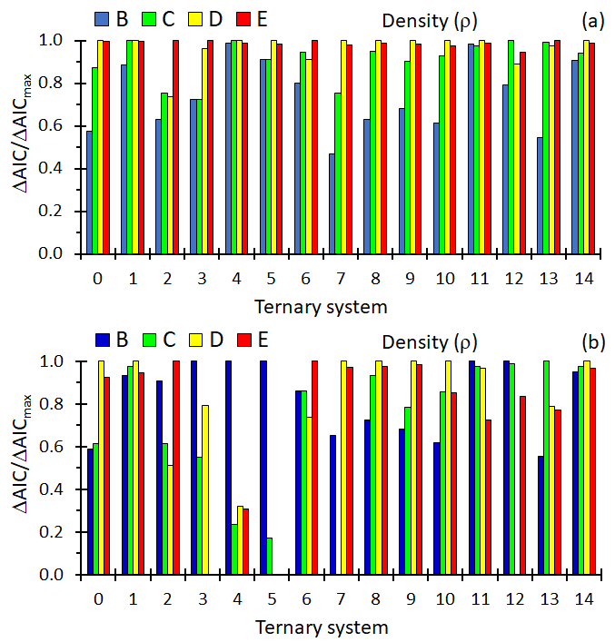
Figure S1. Plots of the ΔAIC/ΔAIC_{max} for the models used to correlate the density data. (a) Model parameters fitted using the full data sets. (b) Model parameters fitted using only the binary data. In both cases the AIC values were calculated using the sum of square errors for the full data sets.

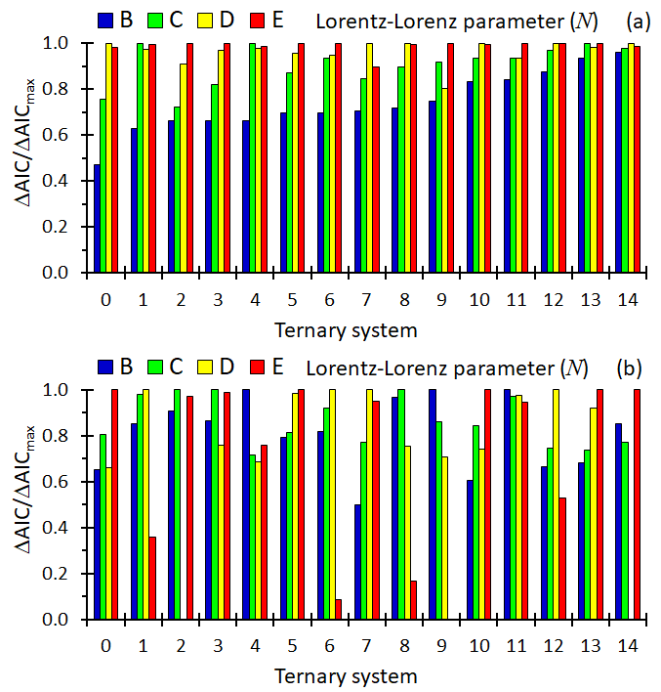

Figure S2. Plots of the ΔAIC/ΔAIC_{max} for the models used to correlate the data for the Lorentz-Lorenz parameter. (a) Model parameters fitted using the full data sets. (b) Model parameters fitted using only the binary data. In both cases the AIC values were calculated using the sum of square errors for the full data sets.

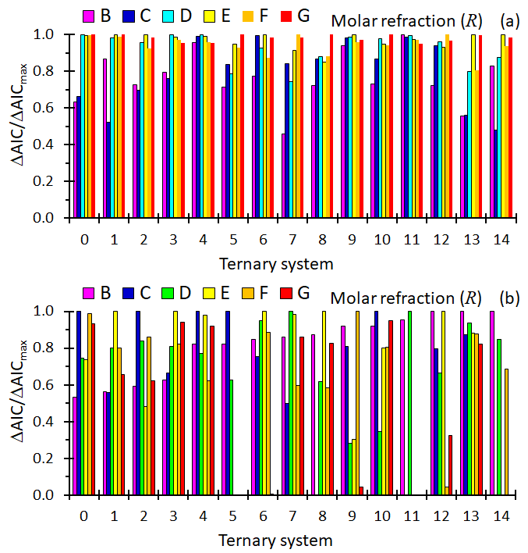
Figure S3. Plots of the ΔAIC/ΔAIC_{max} for the models used to correlate the molar refraction data. (a) Model parameters fitted using the full data sets. (b) Model parameters fitted using only the binary data. In both cases the AIC values were calculated using the sum of square errors for the full data sets.

