Appendix
Supplementary Table 1: Outcome of two-step cluster analysis among patients with Ménière’s disease. Cluster names, number and percentage of subjects with MD are given as also distribution/scores of factors belonging to each cluster. The statistical significance (p-values) in ANOVA test is given for each complaint.
Complaints | Cluster 1: Mixed MD  (n=389, 46.4%) | Cluster 2: Sporodic MD  (n=153, 18.3%) | Cluster 3  Migraine MD  (n=66, 7.9%) | Cluster 4  Familial MD  (n=104, 12.4%) | Cluster 5:  Thyroid associated MD  (n=126, 15%) |  | ANOVA p-value
Migraine | 5.6% | 0% | 100% | 0% |  | 30.4%
Thyroid disorder | 7,8% | 0% | 32.9% | 0% |  | 100%
Familiar MD | 37.8% | 0% | 32.9% | 100% |  | 35.5%
Impact of vertigo | 2.12 | 1.12 | 1.69 | 1.08 |  | 1.48 | 0.024
Impact of gait problems | 1.78 | 0.35 | 0.88 | 0.49 |  | 0.78 | 0.049
Severity of VDA | 2.01 | 1.03 | 1.80 | 1.05 |  | 1.37 | 0.003
Energy | 1.78 | 0.82 | 1.42 | 0.69 |  | 1.23 | <0.001
SOC | 58.9 | 64.68 | 58 | 73.44 |  | 66.43 | <0.001
HRQoL | 0.81 | 0.86 | 0.71 | 0.85 |  | 0.74 | <0.001
Arise from chair | 0.82 | 0.08 | 0-45 | 0.26 |  | 0.46 | <0.001
Unsteadiness between attacks | 2.39 | 0.74 | 1.42 | 0.79 |  | 1.04 | 0.002
Use of anti-depressive medication (%) | 0.37 | 0.10 | 0.10 | 0.35 |  | 0.05 | 0.002
Use of analgesic medication (%) | 1.02 | 0.52 | 0.51 | 0.64 |  | 0.43 | <0.001

Supplementary Figure 1: Intensity of vertigo on daily activities in Ménière’s disease in non-defined, hereditary, thyroid and migraine groups. The impact of vertigo was rated as: 0= not applicable, 1 = weakly (affects but can continue to work normally), 2 = moderately (have to stop working), 3 = strongly (must rest), 4 = very strongly (I can't do my daily chores). Stars indicate statistically significant difference between non-defined and selected phenotype group.

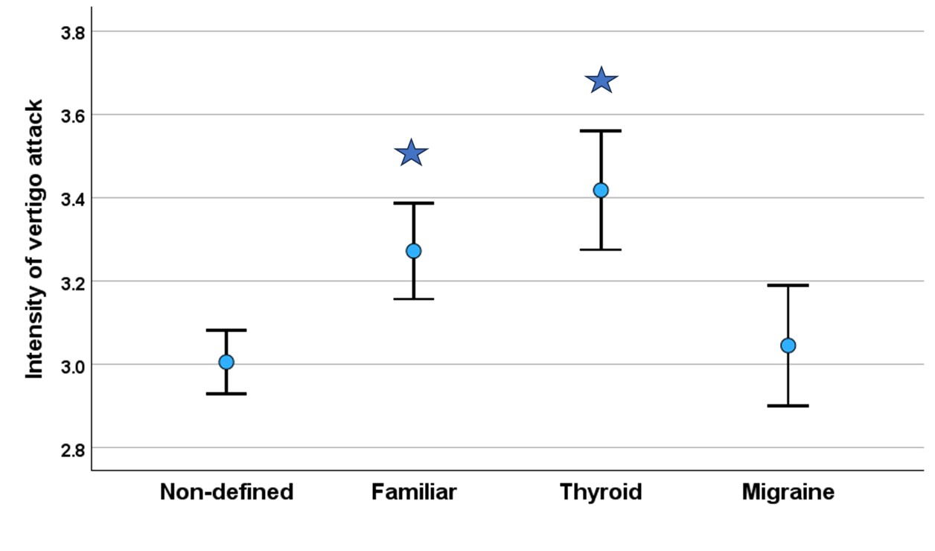
Supplementary Figure 2: Frequency of vertigo attacks among non-defined, familiar, thyroid and migraneous patients with Ménière’s disease. The frequency is scored by mean of replies on question: How often do stronger episodes of vertigo occur? 1 = less than once a year, 2 = less than once a month, 3 = monthly, 4 = weekly. 5 = daily. The higher scores indicate more frequent vertigo attacks. The difference between the groups were not statistically significant (Kruskal-Wallis test, H=2.5, p=0.470)
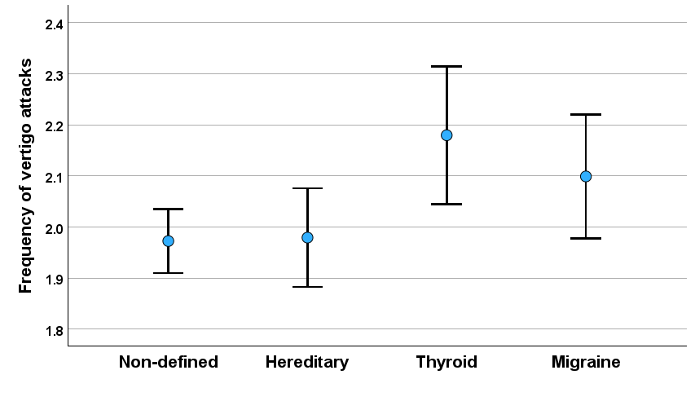
Supplementary Figure 3. Duration of vertigo attacks among non-defined, familiar, thyroid and migraneous patients with Ménière’s disease. The duration is scored by mean of replies on question: How long do the stronger vertigo attacks last? 1 = less than 1 minute, 2 = 1 - 10 minutes, 3 = 20 minutes - 4 hours, 4 = 4 hours - 24 hours, 5 = more than a day. The higher scores indicate longer duration of vertigo attacks. The difference between the groups were not statistically significant (Kruskal-Wallis test, H=4.2, p=0.241)

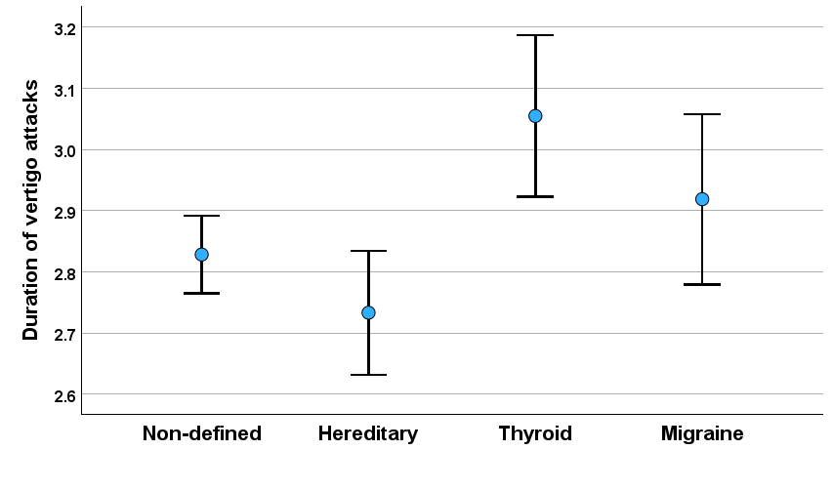

Supplementary Figure 4. Severity of anxiety among non-defined, familiar, thyroid and migraneous patients with Ménière’s disease. The frequency is scored by mean of replies on question: 0 = I feel healthy, 1 = I'm a little anxious or nervous, 2 = I feel fairly moderately anxious or nervous 3 = I feel severity anxious or nervous, 4 = I feel totally anxious or nervous. Stars indicate statistical significant difference between non-defined and selected phenotype group.

