Electronic Supplementary Information (ESI)

for

Natural acids as catalysts for the continuous flow production of the green solvent 2,2,5,5-tetramethyltetrahydrofuran
Bernice M. Currieª, Estefan van Vuurenª, Jaimee Jugmohan^{b}, Jenny-Lee Panayides^{b}, and Darren L. Riley^{a*}
- Department Chemistry, University of Pretoria, Pretoria, 0028, South Africa;
- Pharmaceutical Technologies, Chemicals cluster, CSIR, Pretoria campus, Pretoria, 0001, South Africa;
- Correspondence: Darren.riley@up.ac.za; Tel.: +2712-420-3097
Table of contents
1. Experimental 2
1.1 General experimental detail 2
1.2 Flow reactors and equipment 2
1.3 Characterisation and purification 3
1.4 Setup for synthesis of TMTHF 5
1.5 Space-time yield and throughput calculations 5
2. Additional data related to main article 5
2.1 GC-FID conversions for catalyst screening of various natural acids, showing byproduct percentage 5
2.2 DoE results using citric acid monohydrate 6
2.3 Results for co-catalyst approach 8
2.4 Results for further optimization at various temperatures and residence times 8
2.5 Cost analysis details 9
2.6 Summary of CHEM21 Metrics toolkit (Please refer to Excel spreadsheet for full calculations) 10
2.7 TMTHF Price commercially available 10
3. Experimental section 16
3.1 2,5-Dimethyl-2,5-hexanediol 2 (Starting Material) 16
3.2 2,2,5,5-tetramethyltetrahydrofuran (TMTHF) 1: 16
4. GC-FID Method Information 19
4.1 GC-FID method details 19
4.2 GC-FID standard curve 20
5. Characterization data 24
5.1 Byproduct formation according to Byrne and co-workers^{1–5} 24
5.2 Nuclear magnetic resonance spectra 25
5.3 Fourier transform infrared spectra 31
5.4 HRMS Spectra 33
6. References 33

Experimental

General experimental detail
All batch reactions were carried out using traditional chemistry methods, glassware and apparatus found in a standard synthetic laboratory. Batch distillations were performed using a Dean-Stark apparatus. Before use, all glassware was oven- or flame-dried. Ethyl acetate was used for GC analysis and distilled from calcium hydride. Water was obtained from the tap and filtered using gravity filtration. 2,5-Dimethyl-2,5-hexanediol was purchased from Sigma-Merck and Fluorochem, and a H-Beta Zeolite sample was supplied from Clariant. All starting materials and solvents were used without purification. The solvent removal was performed under reduced pressure (approximately 20 mmHg) using a standard Heidolph rotary evaporator at temperatures between 40 °C and 90 °C, when using ethyl acetate.

Flow reactors and equipment
- Flow reactor:
  - UniqsisTM Binary Pump Module (BPM) reactor equipped with 10 mL HPLC pump heads
  - The reactor was fitted with standard 1.0 mm inner diameter or 1.5 mm inner diameter PTFE or SS tubing.
- Coil reactors:
  - Stainless-steel coil reactors had a maximum operating temperature of 260 °C and maximum pressure of 1000-psi (70 bar) with volumes of 2.5, 5, and 20 mL (1.0 mm inner diameter) and 40 mL (2.1 mm inner diameter)
- The coil reactors were heated using a UniqsisTM HotCoil flow module with an operational temperature range from ambient temperature to 260 °C. A UniqsisTM Polar Bear PLUS flow module, which has an operational temperature range of -40 °C to 150 °C, was used for cooling.
- Static mixer:
  - A 0.5 mL (3.2 mm internal diameter) VapourtecTM static mixer with a maximum pressure rating of 362-psi (25 bar) was used.
- Cartridge-based back-pressure regulators (BPR) were used, with pressures set to 10 bar based on application. They were fitted with chemically resistant perfluoro polymer components.

Characterisation and purification
- Purification: Isolated yields were obtained from distillation using Dean-Stark, insulated with cotton wool and foil.
- Nuclear Magnetic Resonance (NMR)was performed using a Bruker Ultrashield AVANCE-III spectrometer.
  - Splitting and multiplicity patterns are reported as singlet (s), doublet (d), doublet of doublet (dd), triplet (t), doublet of triplet (dt), quartet (q), multiplet (m), and broad singlet (bs). Coupling constants, J, were reported in Hertz (Hz). Chemical shifts δ are reported in parts per million (ppm).
  - ¹H NMR spectra were recorded at 300 and 400 MHz, and chemical shifts were reported in the following order: chemical shift (δH, ppm); coupling constants (J, Hz); multiplicity; number of protons; proton assignment, and all signals are referenced relative to deuterated chloroform (CDCl₃) at 7.27 ppm.
  - ¹³C NMR were recorded at 75MHz and 101 MHz and chemical shifts were reported in the following order: chemical shift (δC, ppm); assignment and all signals are referenced relative to CDCl₃ at 77.36 ppm.
  - Both ¹H NMR and ¹³C NMR were processed using MestreNova 12.0 as follows:
    - Apodization: 0.10 Hz
    - Zero Filling and LP: 262144 (256 K)
    - Auto Baseline Correction: Polynomial fit (5th order)
  - qHNMR calculations:
    - QNMR samples were prepared using anisole (99%) as internal standard (I.S) and the targeted compound (T) dissolved in 600 µL deuterated chloroform, and the conversion was calculated as follows:
$$\text{\% Conversion=}\frac{\text{I.S }\left(\text{protons}\right)\text{×T }\left(\text{ Integral}\right)\text{×T }\left(\text{MW}\right)\text{×I.S (Mass)}}{\text{T }\left(\text{protons}\right)\text{×I.S }\left(\text{Integral}\right)\text{×I.S }\left(\text{MW}\right)\text{×T }\left(\text{Mass}\right)}\text{ ×\% I.S Purity Percentage}$$

- Fourier-transform Infrared (FTIR) spectroscopy was performed on a JASCO FT/IR-4X spectrometer instrument.
  - Functional group signals were reported as wavenumbers (cm⁻¹) ranging from 400 – 3000 cm⁻¹.
- GC-FIC was performed with a Shimadzu GC-2010 instrument, which has an FID detector and an InertCap5MS column (0.25 um (film thickness), 30 m (column length), 0.25 mm ID, and a max temperature of 320 °C).
  - The injection volume was set to 1.0 µL with injection mode using split ratio of 30:1 and Helium as carrier gas
  - Samples were prepared using distilled ethyl acetate to approximate concentrations relating to each method.
- High-resolution mass spectra (HRMS) were recorded on a Waters Synapt G2 Mass Spectrometer at 70 eV and 200 mA.
  - For analysis, the instrument was operated under the following conditions: a capillary voltage of 2.8 kV (positive mode), a sampling cone (ramped from 20 V – 40 V), an extraction cone of 4 V, a source temperature of 100 °C, a desolvation temperature of 200 °C, cone gas of 100 L.h⁻¹, desolvation gas of 500 L.h⁻¹, inert gas source: nitrogen.
  - Samples were prepared in analytical grade acetonitrile to an approximate concentration of 10 μg.mL⁻¹.
- Nomenclature
  - The compounds were named according to IUPAC nomenclature, using ChemDraw Ultra 12.0. Numbering was chosen as a matter of convenience.
- Referencing
  - All sources were cited with Mendeley Reference Manager, using the Royal Society of Chemistry (with titles) citation style.

Setup for synthesis of TMTHF
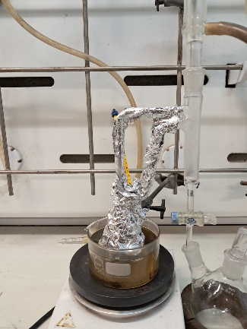 | 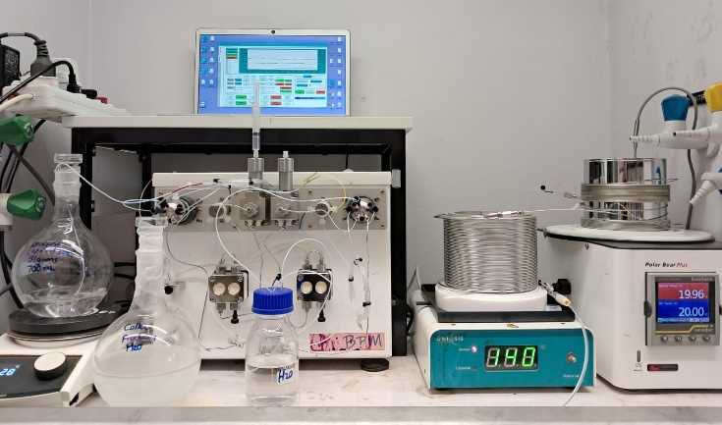
Figure 1: Batch setup using Dean-Stark apparatus | Figure 2: Flow setup for the 200-gram scale
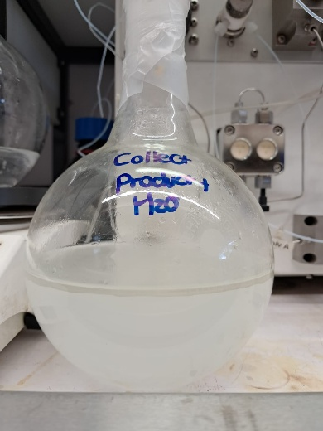 | 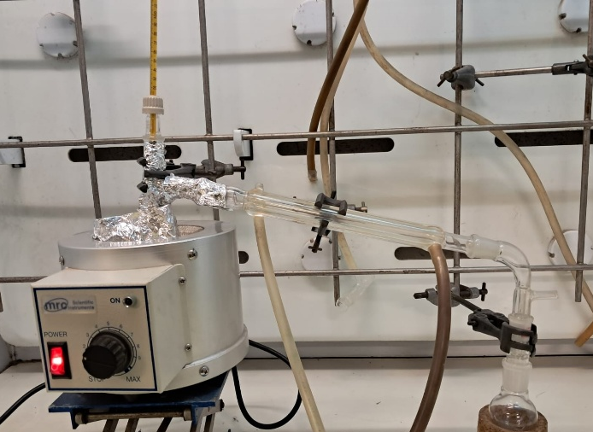
Figure 3: Flow collection flask showing separation prior to liquid-liquid extraction (TMTHF at the top) | Figure 4: Distillation setup for the 200-gram scale

Space-time yield and throughput calculations
Yield | Residence time | Coil volume | Collection time
125.697 grams  = 0.125697 kg | 20 min  = 0.333 hours | 40 mL  = 0.040 L | 15 hours 15 min  = 15.25 hours
Formula |  | Calculation | Answer
Throughput (g.h⁻¹) | $$\frac{\text{yield (grams)}}{\text{collection time (hours)}}$$ | $$\frac{\text{125.697 grams}}{\text{15.25 hours}}$$ | 8.2424 g h⁻¹
Space-time yield  (kg h⁻¹ L⁻¹) | $$\frac{\text{yield (grams)}}{\text{residence time }\left(\text{hours}\right)\text{×reactor volume (L)}}$$ | $$\frac{\text{0.125697 kg}}{\text{0.333 hours ×0.04 L}}$$ | 9.4272 kg h⁻¹ L⁻¹

Additional data related to main article

TMTHF Price commercially available
Supplier | Purity | Quantity | Price | Last updated date
- Accel Scientific S.L.  (Spain) | 95% | 100 mg | 52 EUR | 2025-06-10
- Accel Scientific S.L.  (Spain) | 95% | 250 mg | 77 EUR | 2025-06-10
- Accel Scientific S.L.  (Spain) | 99% | 500 mg | 97 EUR | 2025-06-10
- Accel Scientific S.L.  (Spain) | 95% | 1 g | 155 EUR | 2025-06-10
- Accel Scientific S.L.  (Spain) | 95% | 5 g | 372 EUR | 2025-06-10
- Bio-Farma Ltd.  (United Kingdom) | Not specified | 1 g | 452 GBP | 2025-06-05
- Bio-Farma Ltd.  (United Kingdom) | Not specified | 5 g | 1093 GBP | 2025-06-05
- Bio-Farma Ltd.  (United Kingdom) | Not specified | 10 g | 1595 GBP | 2025-06-05
- Sigma Aldrich, Inc.  (USA) | 95% | 100 mg | 166.25 AUD | 2025-06-02
- Sigma Aldrich, Inc.  (USA) | 95% | 100 mg | 18200 JPY | 2025-06-02
- Sigma Aldrich, Inc.  (USA) | 95% | 100 mg | 52.9 USD | 2025-06-02
- Sigma Aldrich, Inc.  (USA) | 95% | 100 mg | 91.98 GBP | 2025-02-21
- Sigma Aldrich, Inc.  (USA) | 95% | 100 mg | 94.05 CHF | 2025-02-21
- Sigma Aldrich, Inc.  (USA) | 95% | 100 mg | 2351.25 CZK | 2025-02-21
- Sigma Aldrich, Inc.  (USA) | 95% | 100 mg | 705.38 DKK | 2025-02-21
- Sigma Aldrich, Inc.  (USA) | 95% | 100 mg | 94.05 EUR | 2025-02-21
- Sigma Aldrich, Inc.  (USA) | 95% | 100 mg | 35739 HUF | 2025-02-21
- Sigma Aldrich, Inc.  (USA) | 95% | 100 mg | 1081.58 NOK | 2025-02-21
- Sigma Aldrich, Inc.  (USA) | 95% | 100 mg | 423.23 PLN | 2025-02-21
- Sigma Aldrich, Inc.  (USA) | 95% | 100 mg | 1072.17 SEK | 2025-02-21
- Sigma Aldrich, Inc.  (USA) | 95% | 250 mg | 211.88 AUD | 2025-06-02
- Sigma Aldrich, Inc.  (USA) | 95% | 250 mg | 23200 JPY | 2025-06-02
- Sigma Aldrich, Inc.  (USA) | 95% | 250 mg | 79.35 USD | 2025-06-02
- Sigma Aldrich, Inc.  (USA) | 95% | 250 mg | 113.04 GBP | 2025-02-21
- Sigma Aldrich, Inc.  (USA) | 95% | 250 mg | 121.65 CHF | 2025-02-21
- Sigma Aldrich, Inc.  (USA) | 95% | 250 mg | 3041.25 CZK | 2025-02-21
- Sigma Aldrich, Inc.  (USA) | 95% | 250 mg | 912.38 DKK | 2025-02-21
- Sigma Aldrich, Inc.  (USA) | 95% | 250 mg | 121.65 EUR | 2025-02-21
- Sigma Aldrich, Inc.  (USA) | 95% | 250 mg | 46227 HUF | 2025-02-21
- Sigma Aldrich, Inc.  (USA) | 95% | 250 mg | 1398.98 NOK | 2025-02-21
- Sigma Aldrich, Inc.  (USA) | 95% | 250 mg | 547.43 PLN | 2025-02-21
- Sigma Aldrich, Inc.  (USA) | 95% | 250 mg | 1386.81 SEK | 2025-02-21
- Sigma Aldrich, Inc.  (USA) | 95% | 500 mg | 155.16 GBP | 2025-02-21
- Sigma Aldrich, Inc.  (USA) | 95% | 1 g | 358.68 AUD | 2025-06-02
- Sigma Aldrich, Inc.  (USA) | 95% | 1 g | 39600 JPY | 2025-02-21
- Sigma Aldrich, Inc.  (USA) | 95% | 1 g | 164.45 USD | 2025-02-21
- Sigma Aldrich, Inc.  (USA) | 95% | 1 g | 187.92 GBP | 2025-02-21
- Sigma Aldrich, Inc.  (USA) | 95% | 1 g | 206.75 CHF | 2025-02-21
- Sigma Aldrich, Inc.  (USA) | 95% | 1 g | 5168.75 CZK | 2025-02-21
- Sigma Aldrich, Inc.  (USA) | 95% | 1 g | 1550.63 DKK | 2025-02-21
- Sigma Aldrich, Inc.  (USA) | 95% | 1 g | 206.75 EUR | 2025-02-21
- Sigma Aldrich, Inc.  (USA) | 95% | 1 g | 78565 HUF | 2025-02-21
- Sigma Aldrich, Inc.  (USA) | 95% | 1 g | 2377.63 NOK | 2025-02-21
- Sigma Aldrich, Inc.  (USA) | 95% | 1 g | 930.38 PLN | 2025-02-21
- Sigma Aldrich, Inc.  (USA) | 95% | 1 g | 2356.95 SEK | 2025-02-21
- Sigma Aldrich, Inc.  (USA) | 95% | 2.5 g | 266.31 GBP | 2025-02-21
- Sigma Aldrich, Inc.  (USA) | 95% | 5 g | 795.1 AUD | 2025-06-02
- Sigma Aldrich, Inc.  (USA) | 95% | 5 g | 88200 JPY | 2025-06-02
- Sigma Aldrich, Inc.  (USA) | 95% | 5 g | 417.45 USD | 2025-06-02
- Sigma Aldrich, Inc.  (USA) | 95% | 5 g | 396.18 GBP | 2025-02-21
- Sigma Aldrich, Inc.  (USA) | 95% | 5 g | 443.65 CHF | 2025-02-21
- Sigma Aldrich, Inc.  (USA) | 95% | 5 g | 11091.2 CZK | 2025-02-21
- Sigma Aldrich, Inc.  (USA) | 95% | 5 g | 3327.38 DKK | 2025-02-21
- Sigma Aldrich, Inc.  (USA) | 95% | 5 g | 443.65 EUR | 2025-02-21
- Sigma Aldrich, Inc.  (USA) | 95% | 5 g | 168587 HUF | 2025-02-21
- Sigma Aldrich, Inc.  (USA) | 95% | 5 g | 5101.98 NOK | 2025-02-21
- Sigma Aldrich, Inc.  (USA) | 95% | 5 g | 1996.43 PLN | 2025-02-21
- Sigma Aldrich, Inc.  (USA) | 95% | 5 g | 5057.61 SEK | 2025-02-21
- Sigma Aldrich, Inc.  (USA) | 95% | 10 g | 657.09 GBP | 2025-02-21
- AA Blocks LLC  (USA) | 95% | 100 mg | 37 USD | 2025-05-31
- AA Blocks LLC  (USA) | 95% | 250 mg | 55 USD | 2025-05-31
- AA Blocks LLC  (USA) | 95% | 1 g | 113 USD | 2025-05-31
- AA Blocks LLC  (USA) | 95% | 5 g | 287 USD | 2025-05-31
- Ambeed Inc. (USA) | 95% | 100 mg | 100 mg | 2025-05-28
- Ambeed Inc. (USA) | 95% | 250 mg | 60 USD | 2025-05-28
- Ambeed Inc. (USA) | 95% | 1 g | 120 USD | 2025-05-28
- Ambeed Inc. (USA) | 95% | 5 g | 290 USD | 2025-05-28
- AK Scientific Inc. | 95% | 100 mg | 169 USD | 2025-05-08
- AK Scientific Inc. | 95% | 250 mg | 285 USD | 2025-05-08
- AK Scientific Inc. | 95% | 1 g | 766 USD | 2025-05-08
- AK Scientific Inc. | 95% | 5 g | 2684 USD | 2025-05-08
- Apollo Scientific Ltd. (United Kingdom) | 99% | 100 mg | 60 GBP | 2025-05-08
- Apollo Scientific Ltd. (United Kingdom) | 99% | 250 mg | 89 GBP | 2025-05-08
- Apollo Scientific Ltd. (United Kingdom) | 99% | 1 g | 183 GBP | 2025-05-08
- Apollo Scientific Ltd. (United Kingdom) | 99% | 5 g | 663 GBP | 2025-05-08
- Envigen Pharmaceuticals Inc. (USA) | 97% | 100 mg | 167 USD | 2025-05-05
- Envigen Pharmaceuticals Inc. (USA) | 95% | 100 mg | 167 USD | 2025-03-10
- Envigen Pharmaceuticals Inc. (USA) | 97% | 250 mg | 249 USD | 2025-05-05
- Envigen Pharmaceuticals Inc. (USA) | 95% | 250 mg | 249 USD | 2025-03-10
- Envigen Pharmaceuticals Inc. (USA) | 97% | 1 g | 577 USD | 2025-05-05
- Envigen Pharmaceuticals Inc. (USA) | 95% | 1 g | 577 USD | 2025-03-10
- Key Organics Ltd. (United Kingdom) | >95percent | 100 mg | 235 GBP | 2025-05-01
- Key Organics Ltd. (United Kingdom) | >95percent | 250 mg | 328 GBP | 2025-05-01
- Key Organics Ltd. (United Kingdom) | >95percent | 1 g | 698 GBP | 2025-05-01
- Aladdin Scientific Corporation (USA) | >=95percent | 100 mg | 363.9 USD | 2025-04-29
- Aladdin Scientific Corporation (USA) | >=95percent | 100 mg | 349.34 EUR | 2025-04-29
- Aladdin Scientific Corporation (USA) | >=95percent | 250 mg | 576.9 USD | 2025-04-29
- Aladdin Scientific Corporation (USA) | >=95percent | 250 mg | 553.82 EUR | 2025-04-29
- Aladdin Scientific Corporation (USA) | >=95percent | 500 mg | 390.9 USD | 2025-04-29
- Aladdin Scientific Corporation (USA) | >=95percent | 500 mg | 375.26 EUR | 2025-04-29
- Aladdin Scientific Corporation (USA) | >=95percent | 1 g | 692.9 USD | 2025-04-29
- Aladdin Scientific Corporation (USA) | >=95percent | 1 g | 665.18 EUR | 2025-04-29
- Aladdin Scientific Corporation (USA) | >=90percent | 1 g | 650.9 USD | 2025-04-29
- Aladdin Scientific Corporation (USA) | >=90percent |  | 624.86 EUR | 2025-04-29
- Aladdin Scientific Corporation (USA) | >=95percent | 5 g | 2251.9 USD | 2025-04-29
- Aladdin Scientific Corporation (USA) | >=95percent | 5 g | 2161.82 EUR | 2025-04-29
- Aladdin Scientific Corporation (USA) | >=90percent | 5 g | 2149.9 USD | 2025-04-29
- Aladdin Scientific Corporation (USA) | >=90percent | 5 g | 2063.9 EUR | 2025-04-29
- ChemScene LLC (USA) | 98% | 100 mg | 148 USD | 2024-09-09
- ChemScene LLC (USA) | 98% | 250 mg | 64 USD | 2025-04-23
- ChemScene LLC (USA) | 98% | 1 g | 131 USD | 2025-04-23
- ChemScene LLC (USA) | 98% | 5 g | 318 USD | 2025-04-23
- Advanced ChemBlocks Inc | 95% | 1 g | 120 USD | 2025-04-22
- Advanced ChemBlocks Inc | 95% | 5 g | 290 USD | 2025-04-22
- Advanced ChemBlocks Inc | 95% | 25 g | 780 USD | 2025-04-22
- AstaTech Inc. (USA) | 95% | 100 mg | 214 USD | 2025-04-17
- AstaTech Inc. (USA) | 95% | 250 mg | 365 USD | 2025-04-17
- AstaTech Inc. (USA) | 95% | 1 g | 730 USD | 2025-04-17
- Georganics Ltd.  (Europe) | 97% | 200 g | price on demand | 2025-04-11
- Chemenu Inc. (China) | 95% | 100 mg | 154 USD | 2025-04-09
- Chemenu Inc. (China) | 95% | 250 mg | 259 USD | 2025-04-09
- Chemenu Inc. (China) | 95% | 1 g | 697 USD | 2025-04-09
- Chemenu Inc. (China) | 95% | 5 g | 2441 USD | 2025-04-09
- SynHet (Lithuania) | >96percent+ | upon inquiry | upon inquiry | 2025-04-04
- Combi-Blocks Inc.  (USA) | 97% | 100 mg | 40 USD | 2025-04-02
- Combi-Blocks Inc.  (USA) | 97% | 250 mg | 60 USD | 2025-04-02
- Combi-Blocks Inc.  (USA) | 97% | 1 g | 290 USD | 2025-04-02
- Combi-Blocks Inc.  (USA) | 97% | 10 g | 550 USD | 2025-04-02
- Biosynth  (United Kingdom) | >=95percent | 50 mg | 217 USD | 2025-04-01
- Biosynth  (United Kingdom) | >=95percent | 100 mg | 369 USD | 2025-04-01
- Biosynth  (United Kingdom) | >=95percent | 250 mg | 740 USD | 2025-04-01
- 1Click Chemistry Inc  (USA) | 96% | 100 mg | 44.16 USD | 2025-03-25
- 1Click Chemistry Inc  (USA) | 96% | 250 mg | 62.4 USD | 2025-03-25
- 1Click Chemistry Inc  (USA) | 96% | 500 mg | 98.88 USD | 2025-03-25
- 1Click Chemistry Inc  (USA) | 96% | 1 g | 126.72 USD | 2025-03-25
- 1Click Chemistry Inc  (USA) | 96% | 2.5 g | 194.88 USD | 2025-03-25
- 1Click Chemistry Inc  (USA) | 96% | 5 g | 306.24 USD | 2025-03-25
- 1Click Chemistry Inc  (USA) | 96% | 10 g | 530.88 USD | 2025-03-25
- 1Click Chemistry Inc  (USA) | 96% | 25 g | 1134.45 USD | 2025-03-25
- Aurum Pharmatech LLC  (USA) | 96% | 100 mg | 43.7 USD | 2025-03-25
- Aurum Pharmatech LLC  (USA) | 96% | 250 mg | 61.75 USD | 2025-03-25
- Aurum Pharmatech LLC  (USA) | 96% | 500 mg | 97.85 USD | 2025-03-25
- Aurum Pharmatech LLC  (USA) | 96% | 1 g | 125.4 USD | 2025-03-25
- Aurum Pharmatech LLC  (USA) | 96% | 2.5 g | 192.85 USD | 2025-03-25
- Aurum Pharmatech LLC  (USA) | 96% | 5 g | 303.05 USD | 2025-03-25
- Aurum Pharmatech LLC  (USA) | 96% | 10 g | 525.35 USD | 2025-03-25
- Aurum Pharmatech LLC  (USA) | 96% | 25 g | 1122.63 USD | 2025-03-25
- Aurum Pharmatech LLC  (USA) | 96% | 50 g | 2163.25 USD | 2025-03-25
- Aurum Pharmatech LLC  (USA) | 96% | 100 g | 4199.33 USD | 2025-03-25
- AAA Chemistry (USA) | 95% | upon inquiry | upon inquiry | 2025-03-20
- BLD Pharmatech Ltd. (China) | 95% | 100 mg | 46 USD | 2025-03-20
- BLD Pharmatech Ltd. (China) | 95% | 100 mg | 46 EUR | 2025-03-20
- BLD Pharmatech Ltd. (China) | 95% | 250 mg | 69 USD | 2025-03-20
- BLD Pharmatech Ltd. (China) | 95% | 250 mg | 68 EUR | 2025-03-20
- BLD Pharmatech Ltd. (China) | 95% | 1 g | 143 USD | 2025-03-20
- BLD Pharmatech Ltd. (China) | 95% | 1 g | 139 EUR | 2025-03-20
- BLD Pharmatech Ltd. (China) | 95% | 5 g | 363 USD | 2025-03-20
- BLD Pharmatech Ltd. (China) | 95% | 5 g | 337 EUR | 2025-03-20
- ChemPUR Feinchemikalien und Forschungsbedarf GmbH (Germany) | 95% | upon inquiry | upon inquiry | 2025-03-04
- RR SCIENTIFIC LLC | 97percent+ | 100 mg | 168 USD | 2025-03-03
- RR SCIENTIFIC LLC | 97percent+ | 250 mg | 250 USD | 2025-03-03
- RR SCIENTIFIC LLC | 97percent+ | 1 g | 562 USD | 2025-03-03
- RR SCIENTIFIC LLC | 98% | 1 g | 2167.66 USD | 2024-07-11
- RR SCIENTIFIC LLC | 95% | 1 g | 132 USD | 2025-03-03
- Enamine (Ukraine) | 95% | 5 g | 319 USD | 2025-03-01
- Enamine (Ukraine) | 95% | 10 g | 553 USD | 2025-03-01
- Appchem  (Hong Kong) | 99% | 100 mg | 50 USD | 2025-02-15
- Appchem  (Hong Kong) | 95% | 250 mg | 79 USD | 2025-02-15
- Appchem  (Hong Kong) | 99% | 500 mg | 110 USD | 2025-02-15
- Appchem  (Hong Kong) | 99% | 1 g | 146 USD | 2025-02-15
- Appchem  (Hong Kong) | 99% | 5 g | 361 USD | 2025-02-15
- Ambinter (France) | >90percent | upon inquiry | upon inquiry | 2025-02-13
- XtalpI Inc. (USA) | 95% | 100 mg | upon inquiry | 2025-02-11
- 1Pluschem LLC (USA) | 97% | 100 mg | 71 USD | 2025-01-23
- 1Pluschem LLC (USA) | 97% | 250 mg | 156 USD | 2025-01-23
- 1Pluschem LLC (USA) | 97% | 5 g | 229 USD | 2025-01-23
- Activate Scientific (Germany) | 95% | 250 mg | 185 USD | BOC Sciences
- Activate Scientific (Germany) | 95% | 1 g | 404 USD | BOC Sciences
- Activate Scientific (Germany) | 95% | 5 g | 1248 USD | BOC Sciences
- BOC Sciences | 98% | upon inquiry | upon inquiry | 2024-12-18
- Hangzhou Yuhao Chemical Technology Co., Ltd. (China) | Not specified | upon inquiry | price on askingv | 2024-10-24
- 10X CHEM (USA) | 97% | 100 mg | 70 USD | 2024-09-06
- 10X CHEM (USA) | 97% | 250 mg | 99 USD | 2024-09-06
- 10X CHEM (USA) | 97% | 1 g | 276 USD | 2024-09-06
- 10X CHEM (USA) | 97% | 5 g | 810 USD | 2024-09-06
- 10X CHEM (USA) | 97% | 10 g | 1198 USD | 2024-09-06
- Aaron Chemicals LLC (USA) | 95% | 100 mg | 27 USD | 2024-08-08
- Aaron Chemicals LLC (USA) | 95% | 250 mg | 61 USD | 2024-08-08
- Aaron Chemicals LLC (USA) | 95% | 1 g | 189 USD | 2024-08-08
- Aaron Chemicals LLC (USA) | 95% | 5 g | 712 USD | 2024-08-08
- Angene International Ltd. (China) | 95% | 100 mg | 27 USD | 2024-07-26
- Angene International Ltd. (China) | 95% | 250 mg | 59 USD | 2024-07-26
- Angene International Ltd. (China) | 95% | 1 g | 194 USD | 2024-07-26
- Angene International Ltd. (China) | 99percent;RG | 5 g | 762 USD | 2024-07-26
- Manchester Organics Ltd. (United Kingdom) | Not specified | upon inquiry | upon inquiry | 2024-07-25
- Shanghai Sunway Pharmaceutical Technology Co., Ltd. (China) | 97% | 1 g | 645 USD | 2024-05-08
- eMolecules, Advanced ChemBlocks Inc. (USA) | 95% | 1 g | 168 USD | 2024-02-01
- eMolecules, Advanced ChemBlocks Inc. (USA) | 95% | 5 g | 406 USD | 2024-02-01
- eMolecules, Advanced ChemBlocks Inc. (USA) | 95% | 25 g | 1092 USD | 2024-02-01
eMolecules, Ambeed Inc. (USA) | 95% | 100 mg | 198 USD | 2024-02-01
eMolecules, Ambeed Inc. (USA) | 95% | 250 mg | 334 USD | 2024-02-01
eMolecules, Ambeed Inc. (USA) | 95% | 1 g | 895 USD | 2024-02-01
eMolecules, Ambeed Inc. (USA) | 95% | 5 g | 3132 USD | 2024-02-01
eMolecules, AstaTech Inc. (USA) | 95% | 100 mg | 275 USD | 2024-02-01
eMolecules, AstaTech Inc. (USA) | 95% | 250 mg | 426 USD | 2024-02-01
eMolecules, AstaTech Inc. (USA) | 95% | 1 g | 852 USD | 2024-02-01
eMolecules, Bio-Farma Ltd. (USA) | Not specified | 1 g | 631 USD | 2024-02-01
eMolecules, Bio-Farma Ltd. (USA) | Not specified | 5 g | 1520 USD | 2024-02-01
eMolecules, Bio-Farma Ltd. (USA) | Not specified | 10 g | 2161 USD | 2024-02-01
eMolecules, Biosynth (USA) | Not specified | 50 mg | 187 USD | 2024-02-01
eMolecules, Biosynth (USA) | Not specified | 100 mg | 317 USD | 2024-02-01
eMolecules, Biosynth (USA) | Not specified | 250 mg | 634 USD | 2024-02-01
eMolecules, BLD Pharmatech GmbH (USA) | 95% | 100 mg | 166 USD | 2024-02-01
eMolecules, BLD Pharmatech GmbH (USA) | 95% | 250 mg | 280 USD | 2024-02-01
eMolecules, BLD Pharmatech GmbH (USA) | 95% | 1 g | 754 USD | 2024-02-01
eMolecules, BLD Pharmatech GmbH (USA) | 95% | 5 g | 2636 USD | 2024-02-01
eMolecules, BLD Pharmatech Ltd. (USA) | 95% | 100 mg | 202 USD | 2024-02-01
eMolecules, BLD Pharmatech Ltd. (USA) | 95% | 250 mg | 341 USD | 2024-02-01
eMolecules, BLD Pharmatech Ltd. (USA) | 95% | 1 g | 917 USD | 2024-02-01
eMolecules, BLD Pharmatech Ltd. (USA) | 95% | 5 g | 3209 USD | 2024-02-01
eMolecules, Combi-Blocks Inc. (USA) | 97% | 100 mg | 98 USD | 2024-02-01
eMolecules, Combi-Blocks Inc. (USA) | 97% | 250 mg | 140 USD | 2024-02-01
eMolecules, Combi-Blocks Inc. (USA) | 97% | 1 g | 392 USD | 2024-02-01
eMolecules, Combi-Blocks Inc. (USA) | 97% | 5 g | 1155 USD | 2024-02-01
eMolecules, Combi-Blocks Inc. (USA) | 97% | 10 g | 1708 USD | 2024-02-01
eMolecules, Key Organics Ltd. (USA) | 95% | 100 mg | 553 USD | 2024-02-01
eMolecules, Key Organics Ltd. (USA) | 95% | 250 mg | 771 USD | 2024-02-01
eMolecules, Key Organics Ltd. (USA) | 95% | 1 g | 1644 USD | 2024-02-01
eMolecules, Toronto Research Chemicals (USA) | Not specified | 50 mg | 132 USD | 2024-02-01
eMolecules, Toronto Research Chemicals (USA) | Not specified | 100 mg | 175 USD | 2024-02-01
eMolecules, Toronto Research Chemicals (USA) | Not specified | 500 mg | 696 USD | 2024-02-01
eMolecules, WuXi AppTec (USA) | Not specified | 100 mg | 181 USD | 2024-02-01
eMolecules, WuXi AppTec (USA) | Not specified | 250 mg | 287 USD | 2024-02-01
- ArrakisTek Inc. (USA) | 95% | upon inquiry | price on demand | 2024-01-17
- Fluorochem Ltd. (United Kingdom) | 95% | upon inquiry | upon inquiry | 2023-10-02
- Chemieliva Pharmaceutical Co., Ltd. | 98% | 1 g – 50 kg | Not specified | 2023-07-19
- Hong Kong Chemhere Co., Ltd. (China) | Not specified | Not specified | Not specified | 2021-05-11
- Aurora Fine Chemicals LLC (USA, Austria) | 95-98percent | upon inquiry | Price on request | 2021-04-20
- Debye Scientific Co., Ltd. | 95% | 5 g – 500 g | POA | 2020-01-17
CAS no: 15045-43-9 all prices on the 11th of August 2025 from Reaxys https://www-reaxys-com.uplib.idm.oclc.org/#/results/substances/20/RX001_1107353758479105994/UlgwMDE9Uw==/list/1f46ad0c-210b-4494-9b9c-3a060d6bec87/1/asc/IDE.RCSID

GC-FID conversions for catalyst screening of various natural acids, showing byproduct percentage
Table 1: Screening of initial flow experiments of various natural acid catalysts showing byproduct formation
Catalyst Name | GC-FID Conversions (%)
Catalyst Name | 100 °C |  | 140 °C
Catalyst Name | 20 minutes | 40 minutes | 20 minutes | Byproduct % | 40 minutes | Byproduct %
Acetic acid | 0.17 | 0.27 | 2.88 | 26.90 | 7.44 | 5.30
Ascorbic acid | 0.10 | 0.35 | 11.11 | 5.10 | 22.70 | 0.28
CAM | 0.77 | 1.10 | 35.34 | 1.34 | 28.22 | 1.73
Formic acid | 0.75 | 1.71 | 32.49 | 6.65 | 22.54 | 8.73
Gallic acid | 0.21 | 0.36 | 4.00 | 13.46 | 4.46 | -
Lactic acid * | 0.54 | 0.35 | 21.41 | 8.50 | 19.63 | 1.63
_{L}-Mandelic acid | 0.57 | 0.47 | 25.68 | 2.97 | 35.62 | 0.08
Maleic acid | 3.73 | 6.93 | 37.30 | 2.47 | 27.60 | 1.50
Malonic acid | 1.43 | 2.72 | 9.00 | 5.01 | 30.08 | 5.75
Nicotinic acid | 0.21 | 0.39 | 7.93 | - | 18.46 | 10.52
Oxalic acid | 6.75ª | 7.46^{b} | 41.81 | 2.25 | 33.06 | 6.2
Picolinic acid | 0.22 | 0.15 | 9.39 | 10.26 | 9.49 | 8.72
Succinic acid | 0.31 | 1.29 | 19.83 | 4.90 | 20.62 | 5.15
_{D}-tartaric acid salt | 0.28 | 0.22 | 2.10 | - | 1.40 | -
_{DL}-Tartaric acid | 1.73 | 3.55 | 35.03 | 0 | 28.87 | 0.05
ª byproduct: 1.37% ; ^{b} byproduct: 1.41%. Byproduct percentage determined by GC-FID conversions based on standard curve; * 90 % Lactic acid solution

DoE results using citric acid monohydrate
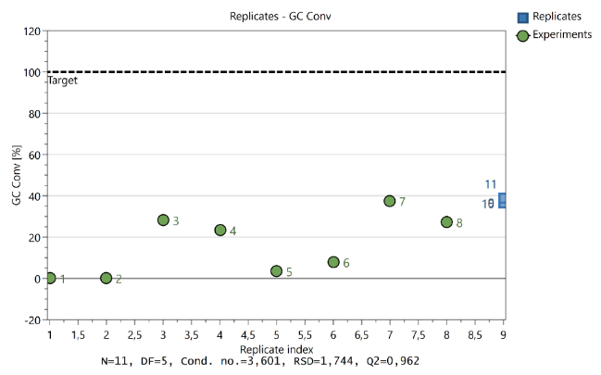 | 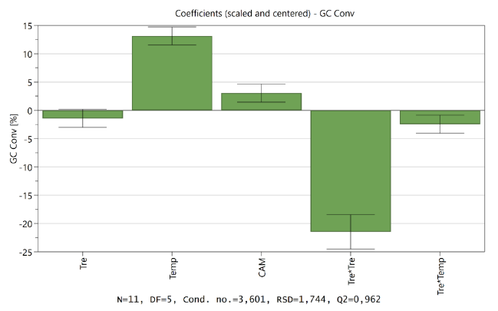
Figure 5: Representation of replicate plot that demonstrates the variation between results within the experimental limits | Figure 6: Representation of a coefficient plot illustrating essential terms and their interactions
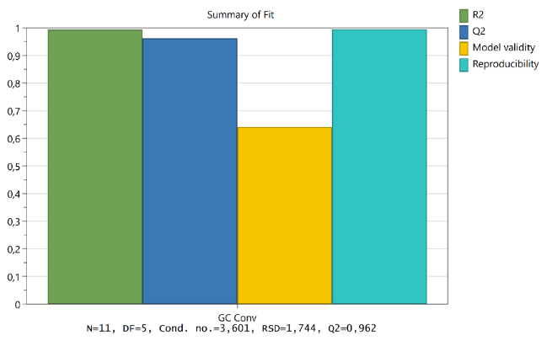 | 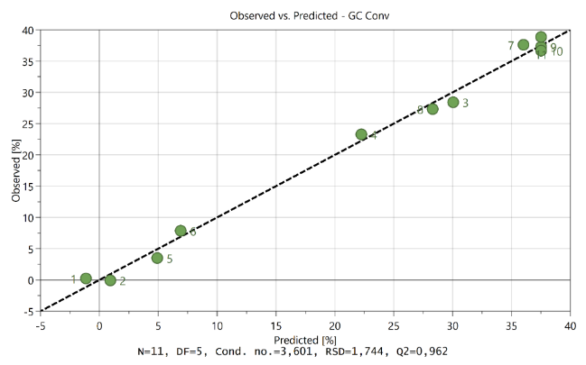
Figure 7: Representation of a summary of fit plot demonstrating the reliability and validity of the model | Figure 8: Representation of the observed vs. predicted plot for the results based on a line of best fit

Results for co-catalyst approach
Table 2: Co-catalyst reactions using CAM (0.10 equiv.) at 0.50 M concentration using a 316L Stainless steel coil (40 mL) and cooling coil (2.5 mL) at 15°C.
Entry no | Catalyst combination with CAM (0.10 equivalents) | Cat Equiv. | Tres. (min) | Temp. (°C) | GC-FID Conv.
1 | Tartaric acid | 0.10 | 10 | 120 | 9.32
2 | Tartaric acid | 0.10 | 10 | 120 | 8.64
3 | Oxalic acid | 0.05 | 20 | 140 | 25.73
4 | Oxalic acid | 0.05 | 20 | 160 | 33.19
5 | Oxalic acid | 0.05 | 15 | 140 | 28.41
6 | Oxalic acid | 0.05 | 15 | 160 | 31.16
7 | Tri-sodium citrate | 0.10 | 20 | 140 | 1.09
8 | Ammonium acetate | 0.10 | 20 | 140 | 2.15
9 | Tri-ammonium citrate | 0.10 | 20 | 140 | 0.62

Results for further optimization at various temperatures and residence times
Table 3: GC-FID conversions using citric acid monohydrate (0.10 equiv.) at 0.50 M concentration and screening coil volume, residence times and temperature
Entry no | Tres. (min) | Coil Volume (mL) | Temp. (°C) | GC-FID Conv.
1 | 10 | 20 | 100 | 1.23
2 | 20 | 20 | 100 | 2.35
3 | 10 | 20 | 120 | 13.06
4 | 20 | 20 | 120 | 15.52
5ª | 15 | 20 | 100 | 1.93
6ª | 30 | 20 | 100 | 6.22
7ª | 15 | 20 | 120 | 8.55
8ª | 30 | 20 | 120 | 5.64
9 | 10 | 20 | 140 | 24.06
10 | 20 | 20 | 140 | 21.87
11 | 10 | 20 | 160 | 18.28
12 | 20 | 20 | 160 | 8.49
13 | 20 | 40 | 120 | 12.91
14 | 40 | 40 | 120 | 22.31
15 | 15 | 40 | 140 | 24.9
16^{b} | 20 | 40 | 140 | 33.44
17^{c} | 20 | 40 | 140 | 34.17
18 | 30 | 40 | 140 | 31.7
19 | 60 | 40 | 140 | 7.44
20 | 5 | 5 | 180 | 37.88
21 | 5 | 5 | 200 | 33.29
ª Performed Vapourtec Rapid Mixing coil (20 mL, 3.2 mm I.D); ^{b} recycled once; ^{c} recycled twice.

Cost analysis details
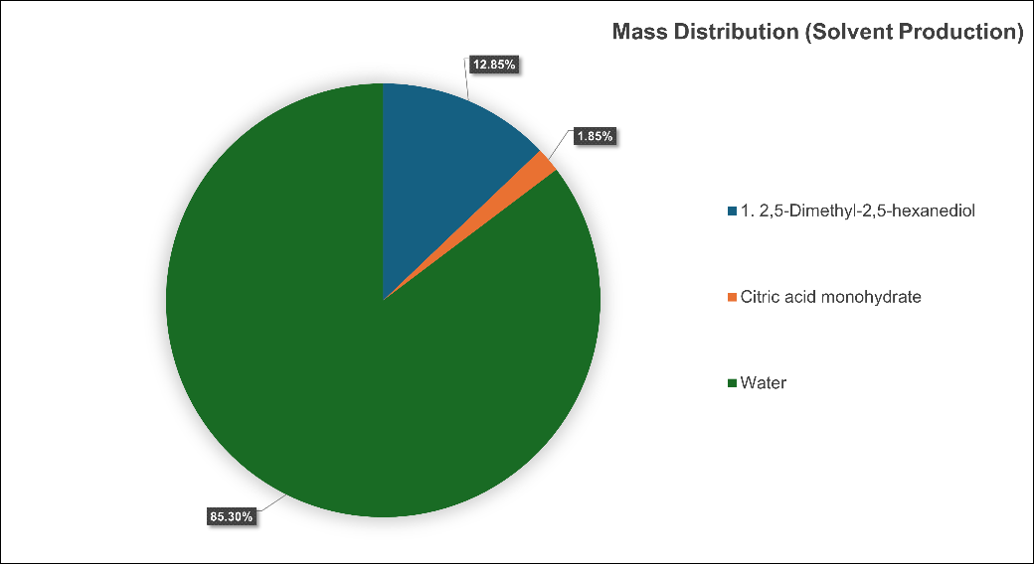
Figure 9: Diagrammatic representation of the mass distribution when producing TMTHF using citric acid monohydrate
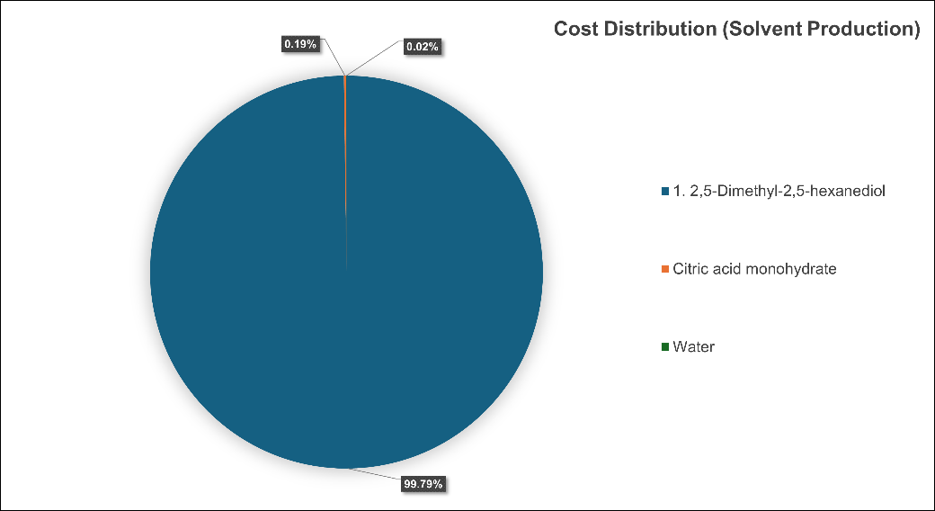
Figure 10: Diagrammatic representation of the cost distribution when producing TMTHF using citric acid monohydrate

Summary of CHEM21 Metrics toolkit (Please refer to Excel spreadsheet for full calculations)
Table 4: Additional assessment by CHEM21 metric toolkit and techno economics for zeolite and citric acid monohydrate approaches to synthesize TMTHF 1
Category | Zeolite approach¹ | Citric acid monohydrate approach
Solvent | No solvent | Water
Catalyst/Enzyme/  Stoichiometric reagent | Catalyst | Catalyst
Catalyst/Enzyme recovery | Recoverable | Recoverable and biodegradable
Critical elements | Al (Zeolite) | None (citric acid monohydrate)
Reaction temperature | 130 | 140
Reflux/>5 °C below reflux | n/a | n/a
Work up | Distillation (115 °C) | Distillation (115 °C)
EHS (worst) | None | H319, H335

Experimental section

2,5-Dimethyl-2,5-hexanediol 2 (Starting Material)
GC-FID retention time: 5.59 min, ¹H NMR (400 MHz, Chloroform-d) δ 2.67 – 2.50 (m, 2H, H₃ & H₇), 1.53 (s, 4H,H₄ & H₅ ), 1.19 (s, 12H, H₁ & H₈₋₁₀), ¹³C NMR (101 MHz, CDCl₃) δ 77.38, 77.06, 76.74, 70.57 (C₂ & C₆), 37.76 (C₄₋₅), 29.40 (C_{1 &} C₈₋₁₀); IR V_{max}/cm⁻¹ 3270.68 (O-H stretch), 2967.9 (C-H stretch), 2869.56, 1470.46 (C-H bend), 1414.53, 1285.32, 1246.75, 1199.51, 1140.69, 1096.33, 965.198(C-O bond), 905.415, 752.102, 680.749.

2,2,5,5-tetramethyltetrahydrofuran (TMTHF) 1:

Batch method using H-beta Zeolite
2,5-Dimethyl-2,5-hexanediol 2 (10.00 g, 68.41 mmol, 1.0 equiv.) was heated and stirred until molten (100 °C ). H-Beta zeolite (22.8 mg, 0.14 mmol, 0.002 equiv., 0.21 mol %) was added and heated for 4 hours at 130 °C using a Dean-Stark apparatus. The product formed as two layers, the top organic layer was dried over magnesium sulphate and distilled again to obtain 95.0 % isolated yield (8.33 grams, 64.99 mmol, >99% GC-FID conversion, 97,02 % qNMR) of 2,2,5,5-tetramethyltetrahydrofuran (TMTHF) 1 as a clear liquid. GC-FID retention time: 3.06 min ¹H NMR (400 MHz, Chloroform-d) δ 1.77 (s, 4H, H₂ & H₃), 1.18 (s, 9H, H₅₋₈), ¹³C NMR (101 MHz, CDCl₃) δ 80.91(C₁ & C₄), 77.48, 77.16, 76.84, 38.80 (C₂ & C₃), 29.77 (C₅₋₈)., IR V_{max}/cm⁻¹ 2967.91(C-H stretch), 2930.31, 2897.52, 1458.89 (C-H bend), 1375.96, 1364.39, 1308.46, 1264.11, 1205.29, 1142.62, 1078.01, 984.482 (C-O bond), 886.131, 848.525.

Batch method using citric acid monohydrate
2,5-Dimethyl-2,5-hexanediol 2 (10.00 g, 68.41 mmol, 1.0 equiv.) was added to water (1.0 M) heated and stirred until molten (100 °C). Citric acid monohydrate (1.44 mg, 6.84 mmol, 0.1 equiv., 10 mol %) was added and heated for 8 hours at 115 °C using a Dean-Stark apparatus. The matrix separated as two layers, the top organic layer was dried over magnesium sulphate and distilled again to obtain 41.8 % isolated yield (3.67 grams, 28.60 mmol, 47.72% GC-FID conversion, 49.03% qNMR ) of 2,2,5,5-tetramethyltetrahydrofuran (TMTHF) 1 as a clear liquid. GC-FID retention time: 3.05 min.

Flow method using citric acid monohydrate

Preparation of stock solution using citric acid monohydrate
Main article (Table 3, Entry 17): 0.75 M stock solution was prepared by dissolving 2,5-dimethyl-2,5-hexanediol 2 (54.7084 g, 374.13 mmol, 1.0 equiv.) and citric acid monohydrate 3 (7.8746 g, 0.037 mmol, 0.10 equiv.) in water to a total volume of 500 mL. For the 200-gram scale, a 0.75 M stock solution was prepared by dissolving 2,5-dimethyl-2,5-hexanediol 2 (200.356 g, 1370,14 mmol, 1.0 equiv.) and citric acid monohydrate 3 (28.79 g, 137,03 mmol, 0.10 equiv.) in water to a total volume of 1830 mL.

UniqsisTM binary pump reactor setup and description for 200-gram scale (Main article: Scheme 3)
The UniqsisTM binary pump reactor was used with a 40 mL (2.10 mm inner diameter) coil. A total flow rate of 2.00 mL min⁻¹ was used to introduce 1830 mL of the stock reservoir into the flow system. Water was used as a pushing solvent. The solution was pumped through a static mixer at room temperature, a coil reactor held at 140 °C (T_{Res} = 20 min), and a 7.5 mL cooling coil held at 20 °C with a 10-bar BPR. The solution was collected and directly extracted using liquid-liquid extraction, after which GC-FID analysis was performed. The TMTHF was isolated via distillation to obtain a 71.6% isolated yield (125.70 grams, 980.40 mmol, >99% GC-FID conversion, 94.16% qNMR ) of 2,2,5,5-tetramethyltetrahydrofuran (TMTHF) 1 as a clear liquid. GC-FID retention time: 3.07 min, ¹H NMR (400 MHz, Chloroform-d) δ 1.77 (s, 4H, H₂ & H₃), 1.17 (s, 12H, H₅₋₈), ¹³C NMR (101 MHz, CDCl₃) δ 80.90 (C₁ & C₄), 77.48, 77.16, 76.84, 38.79 (C₂ & C₃), 29.76(C₅₋₈),IR V_{max}/cm⁻¹ 2967.91 (C-H stretch), 2930.3, 2872.45, 1458.89 (C-H bend), 1375.96, 1364.39, 1308.46, 1264.11, 1205.29, 1142.62, 1078.01, 984.482 (C-O bond), 886.131, 848.525, 767.53, 489.831, HRMS m/z (ES+) 128.1210 [M]⁺ (C₈H₁₆O requires 128.2120 g/mol).
Analysis of TMTHF 1 corresponded with literature results obtained F. Patrick Byrne and co-workers.¹⁻²

GC-FID Method Information

GC-FID method details
Parameter | Setting
Instrument | Shimadzu GC-2010 instrument with a FID detector
Column | InertCap5MS , 0.25 um (film thickness), 30 m (column length), 0.25 mm ID, max temperature 320 °C
Carrier Gas | Helium
Injection Mode | split ratio was 30:1
Injector Temperature | 250 °C
Injection Volume | 1.0 ul
Oven Temperature Program | 60 °C for 0.30 minute, 20 °C/min ramp to 140 °C, hold for 1 minute, 50 °C/min ramp to 250 °C, hold for 0.30 minute
FID Temperature | 250 °C
Air Flow | 400 mL/min
Hydrogen Flow | 40 mL/min
Sampling rate | 40 msec
Makeup Gas (Helium) | Helium (30 mL/min)
Run Time | 7.80 min
Retention time | TMTHF 1 (3.05 min), Decane (4.81 min), 2,5-Dimethyl-2,5-hexanediol 2 (5.59 min)
Internal Standard | Decane (>99%)
GC-FID standard curve equation (conducted in triplicates) | y=112.26x
R² value for standard curve | 0.9996

GC-FID standard curve

General procedure for preparing concentrations for standard curve
Purified TMTHF (97,02 % conversion using qNMR) was used and several concentrations were prepared in triplicates with the addition of Decane (Density:0.73, 5840 ppm) as an internal standard. A 8 µl aliquot of decane was dispensed directly into an GC vial and diluted with ethyl acetate.

Raw data for standard curve
TMTHF (ppm) | Retention time (min) | Area | Average Area | Decane (ppm) | retention time (min) | Average Decane
1622 | 3,094 | 207752,9 | 205612,6 | 5840 | 4,83 | 1076746
1622 | 3,094 | 203030,8 | 205612,6 | 5840 | 4,829 | 1076746
1622 | 3,101 | 206054,1 | 205612,6 | 5840 | 4,788 | 1076746
3244 | 3,068 | 373856,8 | 352406,2 | 5840 | 4,84 | 1003245
3244 | 3,072 | 343289,6 | 352406,2 | 5840 | 4,833 | 1003245
3244 | 3,076 | 340072,2 | 352406,2 | 5840 | 4,796 | 1003245
4866 | 3,039 | 563245,6 | 531417,7 | 5840 | 4,824 | 1075662
4866 | 3,055 | 498578,9 | 531417,7 | 5840 | 4,805 | 1075662
4866 | 3,059 | 532428,5 | 531417,7 | 5840 | 4,791 | 1075662
6488 | 3,02 | 779654,8 | 721617,3 | 5840 | 4,837 | 1067472
6488 | 3,039 | 698409,7 | 721617,3 | 5840 | 4,806 | 1067472
6488 | 3,041 | 686787,5 | 721617,3 | 5840 | 4,789 | 1067472
8110 | 3,016 | 939434,3 | 906225,2 | 5840 | 4,829 | 1068905
8110 | 3,016 | 907274,1 | 906225,2 | 5840 | 4,806 | 1068905
8110 | 3,022 | 871967,1 | 906225,2 | 5840 | 4,789 | 1068905
9732 | 3,001 | 1164111 | 1107938 | 5840 | 4,827 | 1156844
9732 | 3,004 | 1070845 | 1107938 | 5840 | 4,824 | 1156844
9732 | 3,01 | 1088859 | 1107938 | 5840 | 4,782 | 1156844

GC-FID standard curve

GC-FID Conversions calculations
Table 5: Example of descriptions and letters used for calculation of GC-FID conversions for TMTHF 1
Letter | Description
A | Starting material mass (2,5-Dimethyl-2,5-hexanediol 2 ) in grams
B | Concentration in 50-100 mL sample
C | Concentration in 1 mL LC vail sample
D | Dilution factor
E | Area of product from GC-FID
F | Area/ Equation of product
G | F × Dilution factor
H | G / 1000
I | H × Collected volume
J | % Conversion (I/ Expected product × 100 )

GC-FID Chromatograms
Starting material: 2,5-Dimethyl-2,5-hexanediol 2 | 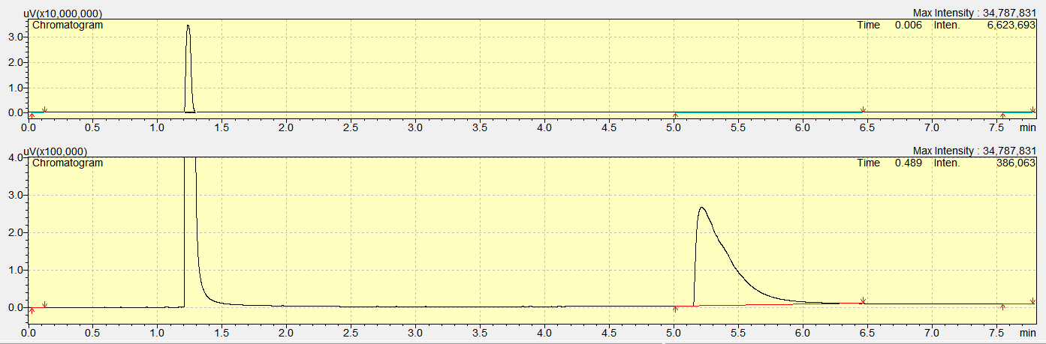
Decane (Internal standard) and Starting material 2 | 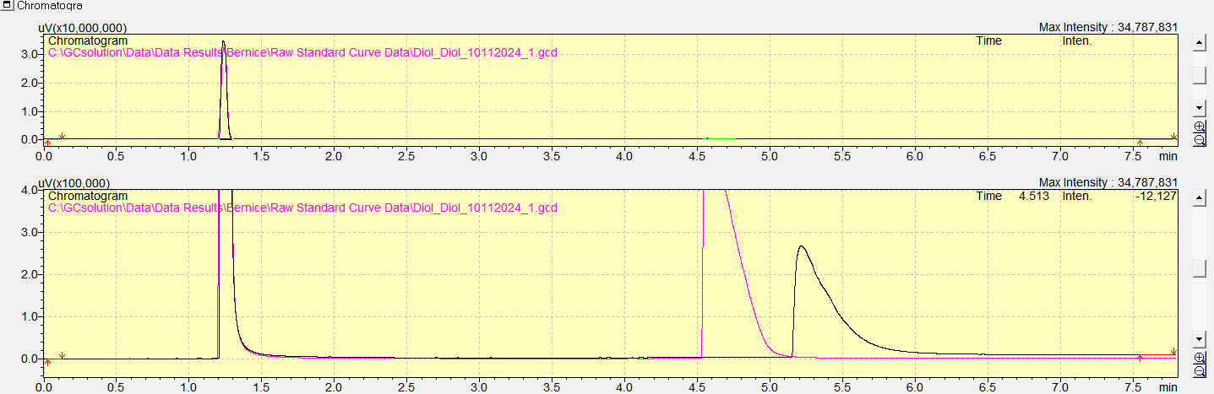
TMTHF 1 and Decane | 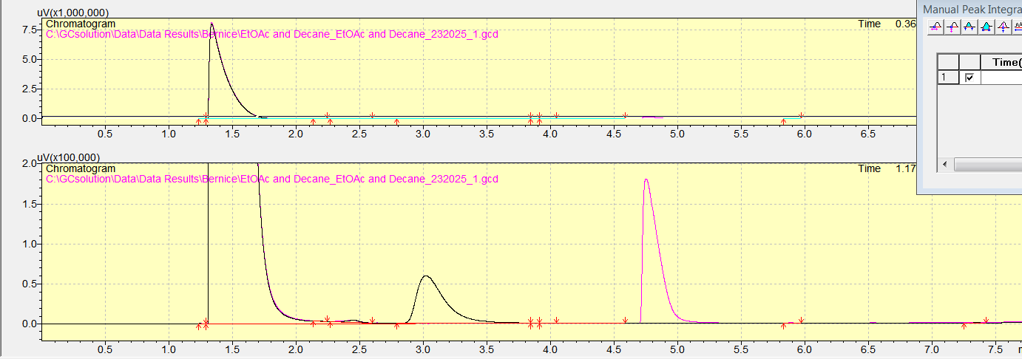
TMTHF 1 (Zeolite batch product) used for standard curve generation | 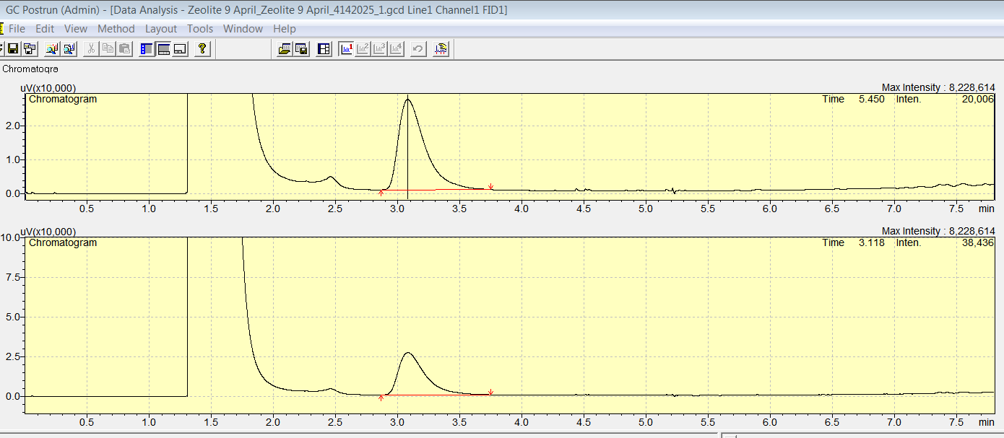
TMTHF 1 (200 gram before distillation) (90,8969% conversion, 9,1031% byproduct) | 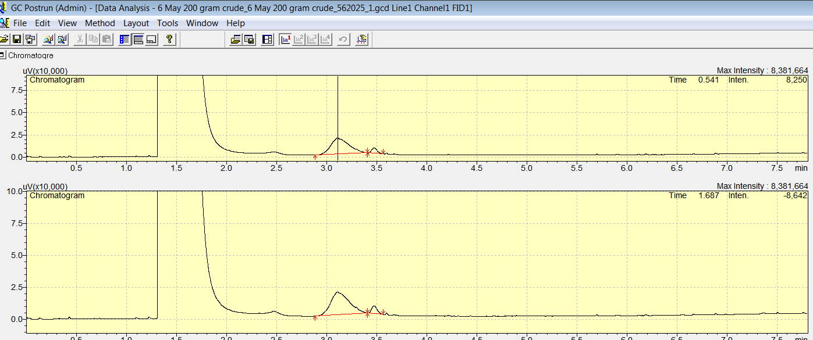
TMTHF 1 (200 gram after distillation) (99,9248% conversion, 0,0752% byproduct) | 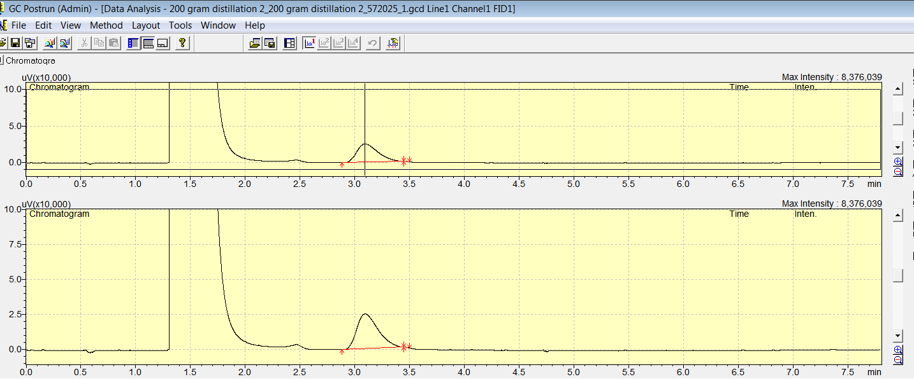
TMTHF 1 (Zeolite batch product and 200 gram flow reaction) | 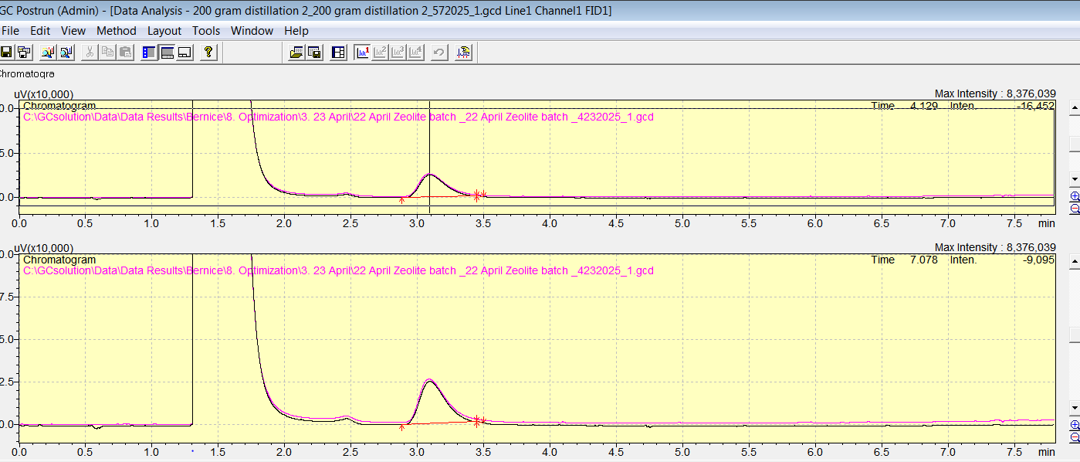
Byproducts | 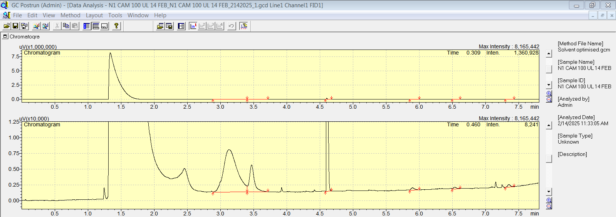

Characterization data

Byproduct formation according to Byrne and co-workers^{1–5}
Byproduct (DHN) 2,5-dimethylhexa-2,4-diene 4 | Byproduct (DHN2) 2,5-dimethylhexa-1,5-diene 5 | Byproduct (DHN3) 2,5-dimethylhexa-1,4-diene 6 | Byproduct (HNL) 2,5-dimethylhex-4-en-2-ol 7
Figure 11: Predicted ¹H-NMR spectra by Mestrenova of byproducts

Nuclear magnetic resonance spectra
NMR 1: qNMR of batch reaction using H-beta zeolite as catalyst (97.02 % conversion using anisole as internal standard )
NMR 2: qNMR of batch reaction using citric acid monohydrate as catalyst (49.03 % conversion using anisole as internal standard)
NMR 3: qNMR of 200 gram flow reaction using citric acid monohydrate (94.16% conversion using anisole as internal standard)
NMR 4: ¹H-NMR of batch reaction using H-beta zeolite as catalyst
NMR 5: ¹³C-NMR of batch reaction using H-beta zeolite as catalyst
NMR 6: DEPT 135 spectra of batch reaction using H-beta zeolite as catalyst
NMR 7: ¹H-NMR of 200-gram flow reaction using citric acid monohydrate
NMR 8: ¹³C-NMR of 200-gram flow reaction using citric acid monohydrate
NMR 9: DEPT 135 spectra of 200-gram flow reaction using citric acid monohydrate
NMR 10: ¹H-NMR of 2,5-Dimethyl-2,5-hexanediol 2 (Starting Material)
NMR 11: ¹³C-NMR of 2,5-Dimethyl-2,5-hexanediol 2 (Starting Material)
NMR 12: DEPT 135 spectra of 2,5-Dimethyl-2,5-hexanediol 2 (Starting Material)

Fourier transform infrared spectra
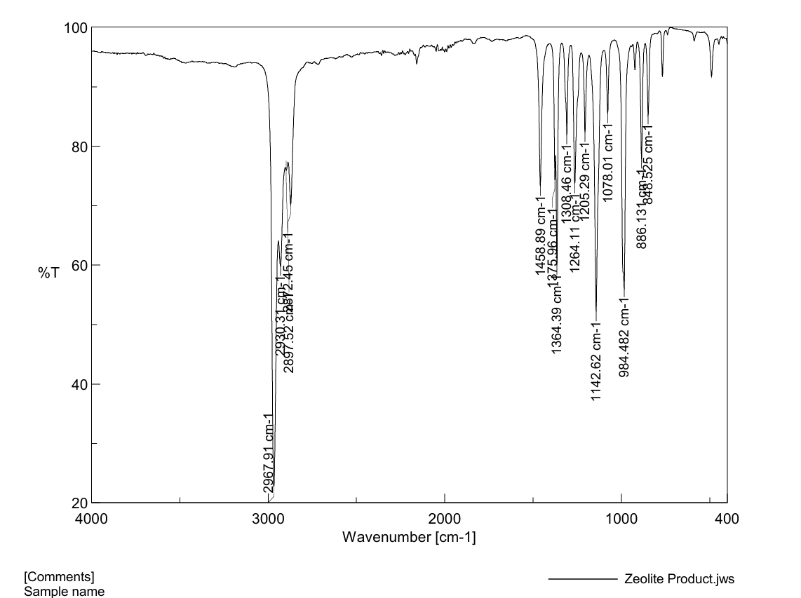
Figure 12: IR spectrum of batch reaction using H-beta zeolite as catalyst
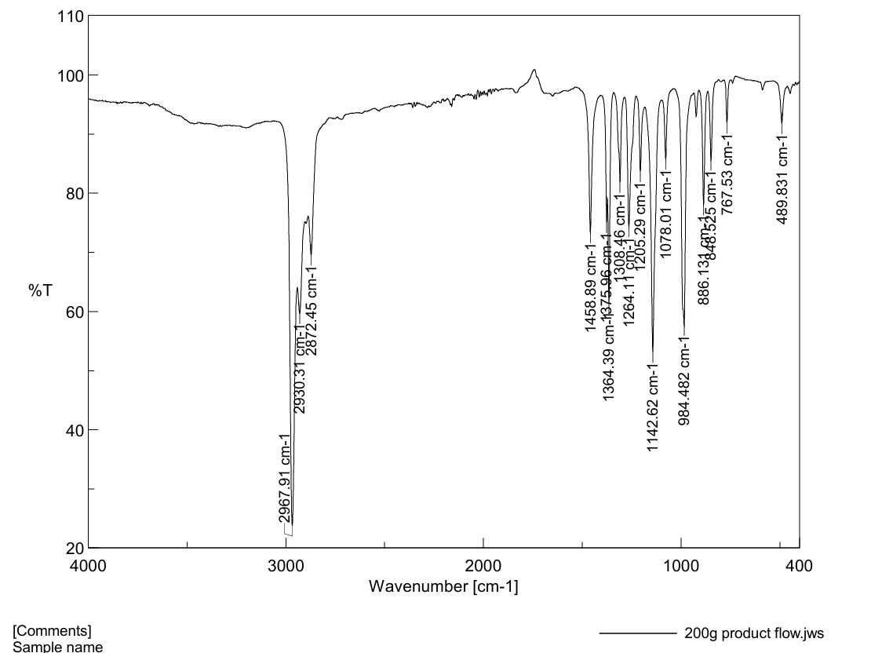
Figure 13: IR spectrum of 200-gram flow reaction using citric acid monohydrate
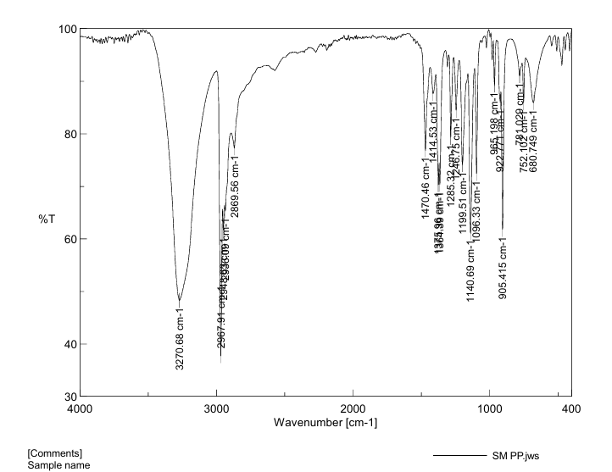
Figure 14: IR spectrum of 2,5-Dimethyl-2,5-hexanediol 2 (Starting Material)

HRMS Spectra

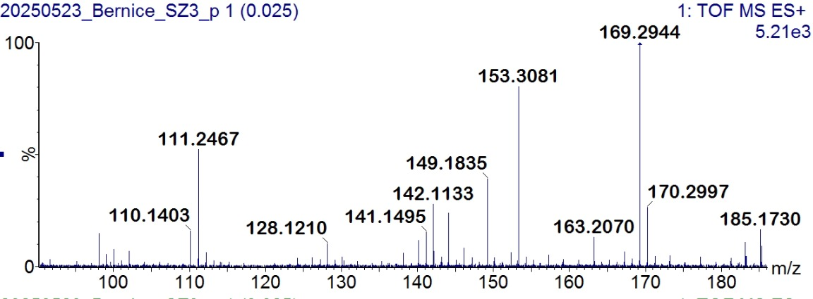
Figure 15: HRMS spectrum of the 200-gram flow reaction using citric acid monohydrate

References
1. F. Patrick Byrne, Greener solvents to replace toluene in the polymerisation and coating industry, PhD thesis, University of York (2017).
2. F. Byrne, B. Forier, G. Bossaert, C. Hoebers, T. J. Farmer, J. H. Clark and A. J. Hunt, 2,2,5,5-Tetramethyltetrahydrofuran (TMTHF): A non-polar, non-peroxide forming ether replacement for hazardous hydrocarbon solvents, Green Chem. 19 (2017) 3671–3678. DOI: 10.1039/C7GC01392B.

