Supplementary results:
Table S1: Neutralising titres of serum elicited in hamsters prime boost vaccinated (days 0 and 21) with plant-produced SARS-CoV-2 Beta VLPs and formulated with two different adjuvants namely SEPIVAC SWETM, or DCA NADA. ID₅₀ values are the inhibitory dilutions at which 50% neutralisation is attained. Values smaller than the limit of detection (LOD) are stated as 50.

 |  |  | Day 14 |  |  | Day 44
Male or female |  | Test item groups | Beta B.1.351 | Delta B.1.617.2 | Omicron BA.1 | Beta B.1.351 | Delta B.1.617.2 | Omicron BA.1
M |  | Group 1  Vaccine/ SEPIVAC SWE | 112 | 115 | 128 | 50 | 50 | 50
M |  | Group 1  Vaccine/ SEPIVAC SWE | 103 | 50 | 50 | 117 | 50 | 50
M |  | Group 1  Vaccine/ SEPIVAC SWE | 89 | 50 | 50 | 725 | 182 | 203
F |  | Group 1  Vaccine/ SEPIVAC SWE | 87 | 50 | 50 | 4037 | 1757 | 172
F |  | Group 1  Vaccine/ SEPIVAC SWE | 263 | 50 | 50 | 1056 | 91 | 51
F |  | Group 1  Vaccine/ SEPIVAC SWE | 367 | 50 | 50 | 2186 | 394 | 50
 |  | GMT | 143±117 | 57 ±26 | 58 ±31 | 583 ±1523 | 175±667 | 78±71
M |  | Group 2  Vaccine/ DCA NADA | 50 | 50 | 50 | 531 | 50 | 50
M |  | Group 2  Vaccine/ DCA NADA | 55 | 50 | 50 | 876 | 111 | 50
M |  | Group 2  Vaccine/ DCA NADA | 50 | 50 | 50 | 639 | 50 | 50
F |  | Group 2  Vaccine/ DCA NADA | 207 | 50 | 50 | 4388 | 469 | 112
F |  | Group 2  Vaccine/ DCA NADA | 819 | 50 | 50 | 2246 | 109 | 102
F |  | Group 2  Vaccine/ DCA NADA | 108 | 50 | 50 | 1187 | 116 | 250
 |  | GMT | 117±302 | 50±0 | 50±0 | 1231±1479 | 109±159 | 84±77
M |  | Group 3 Unvaccinated/unchallenged | 50 | 50 | 50 | 50 | 50 | 50
M |  | Group 3 Unvaccinated/unchallenged | 50 | 50 | 50 | 50 | 50 | 50
F |  | Group 3 Unvaccinated/unchallenged | 50 | 50 | 50 | 50 | 50 | 50
F |  | Group 3 Unvaccinated/unchallenged | 50 | 50 | 50 | 50 | 50 | 50
 |  | GMT | 50±0 | 50±0 | 50±0 | 50±0 | 50±0 | 50±0
M |  | Group 4 PBS/SEPIVAC SWE | 50 | 50 | 50 | 50 | 50 | 50
M |  | Group 4 PBS/SEPIVAC SWE | 50 | 50 | 50 | 50 | 50 | 50
F |  | Group 4 PBS/SEPIVAC SWE | 50 | 50 | 50 | 50 | 50 | 50
 |  | GMT | 50±0 | 50±0 | 50±0 | 50±0 | 50±0 | 50±0
M |  | Group 5  PBS/ DCA NADA | 50 | 50 | 50 | 50 | 50 | 50
M |  | Group 5  PBS/ DCA NADA | 50 | 50 | 50 | 50 | 50 | 50
F |  | Group 5  PBS/ DCA NADA | 50 | 50 | 50 | 50 | 50 | 50
 |  | GMT | 50±0 | 50±0 | 50±0 | 50±0 | 50±0 | 50±0

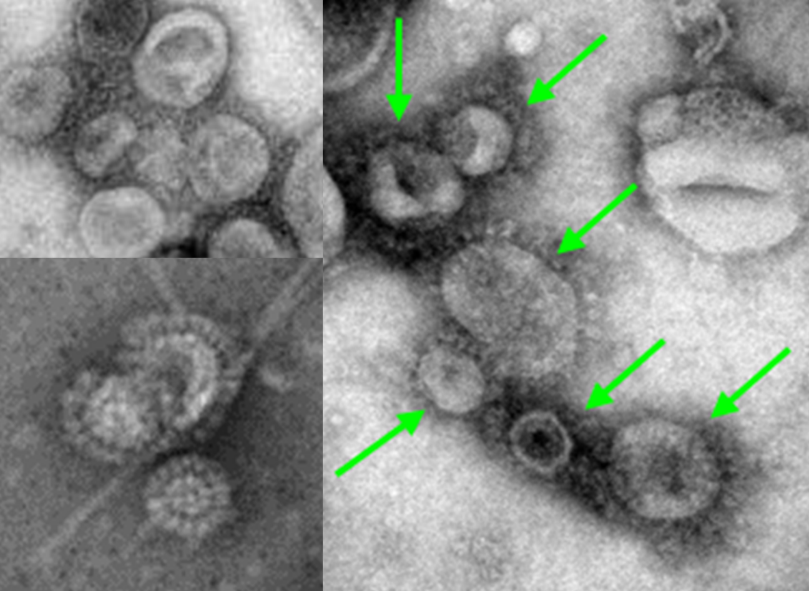

Figure S1: Negatively stained transmission electron microscopy (TEM) images of plant-produced and density gradient purified Coronavirus rSARS-CoV-2 Beta S protein VLPs.

