Target-specific Rhenium(I) Tricarbonyl Complexes as Prospective Pharmacological Agents: Synthesis, X-ray Crystallography, and In Vitro Anticancer Evaluation

Lesetja V. Ramobaª, Lucy W. Macharia^{b}, Suparna Chakraborty^{b}, Sharon Prince^{b}, Frederick P. Malan^{c}, Orbett T. Alexander^{d}, Amanda-Lee E. Manicumª*
ª Department of Chemistry, Tshwane University of Technology, P.O. Box X680, Pretoria, 0001, South Africa
^{b} Department of Human Biology, University of Cape Town, Anzio Road Observatory 7925, Cape Town, South Africa
^{c} Department of Chemistry, University of Pretoria, 02 Lynnwood Road, Hatfield, Pretoria 0001, South Africa
^{d} Department of Chemistry, University of the Western Cape, Bellville, Cape Town, 7535, South Africa
*Corresponding author: Amanda-Lee Manicum (ManicumAE@tut.ac.za)

- Hydrogen bonding tables of complexes 1-4 (Table SI 1 to 4)
- Crystal packing and intermolecular forces of complexes 1-4 (Figure SI 1a to 1d)
- ¹H NMR and ¹³C NMR spectra of complexes 1-4 (Figure SI 2a to Figure SI 4b)
- UV-Vis spectra of complexes 1-4 (Figure SI 3a-d)
- IR spectra of complexes 1-4 (Figure SI 4a-d)
- Graphical representation of the half-maximal effective concentration of complex 3 in various cancer cell lines and normal human cells (Figure SI 5)

Table SI 1: Summary of the hydrogen interactions (distances (Å) and angles (°)) observed in the structure of (1).
D—H···A | Symmetry | D—H (Å) | H···A (Å) | D···A (Å) | D—H···A (°)
C7-H7···O1 | #1 | 0.95 | 2.48 | 3.371(7) | 157
C10-H10A···O5 | #2 | 0.98 | 2.60 | 3.514(6) | 156
Symmetry transformation used to generate equivalent atoms: #1 ½ + x, 3/2 – y, ½ + z; #2 1 - x, 1 - y, 1 – z;
Table SI 2: Summary of the hydrogen interactions (distances (Å) and angles (°)) observed in the structure of (2).
D—H···A | Symmetry | D—H (Å) | H···A (Å) | D···A (Å) | D—H···A (°)
N3-H17···O5 | #1 | 0.88 | 1.93(4) | 2.759(5) | 156
Symmetry transformation used to generate equivalent atoms: #1 1 - x, 2 - y, 1 – z

Table SI 3: Summary of the hydrogen interactions (distances (Å) and angles (°)) observed in the structure of (3).
D—H···A | Symmetry | D—H (Å) | H···A (Å) | D···A (Å) | D—H···A (°)
N2-H2···O5 | #1 | 0.88 | 1.97 | 2.804(7) | 157
C7-H7···O2 | #2 | 0.87 | 1.94 | 2.791(4) | 167
C12-H12···O1 | #3 | 0.95 | 2.44 | 3.264(5) | 145
Symmetry transformation used to generate equivalent atoms: #1 x, y, – 1 + z; #2 1/2 - x, 1/2 + y, ½ + z
: #3 1/2 + x, 1/2 – y, z
Table SI 4: Summary of the hydrogen interactions (distances (Å) and angles (°)) observed in the structure of (4).
D—H···A | Symmetry | D—H (Å) | H···A (Å) | D···A (Å) | D—H···A (°)
N3-H3A···O6 | #1 | 0.88 | 1.98 | 2.837(5) | 165
O6-H6B···O5 | #2 | 0.87 | 1.94 | 2.791(4) | 167
C12-H12···F1 | #3 | 0.95 | 2.44 | 3.264(5) | 145
C21-H21···O6 | #1 | 0.95 | 2.50 | 3.405(6) | 159
Symmetry transformation used to generate equivalent atoms: #1 x, 1/2 – y, 1/2 + z; #2 1 - x, -1/2 + y, 1/2 – z
: #3 1 – x, 1 – y, 1 – z

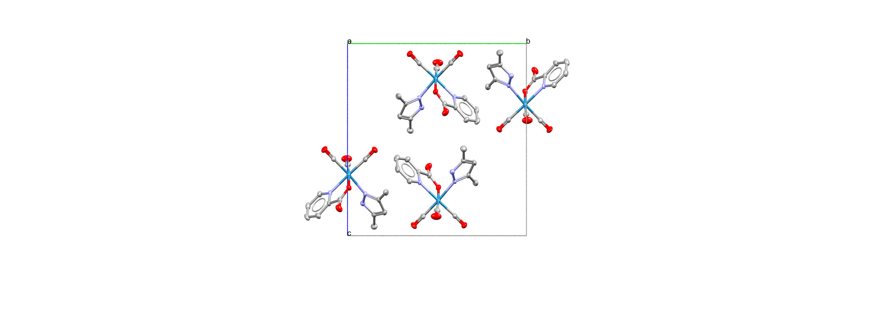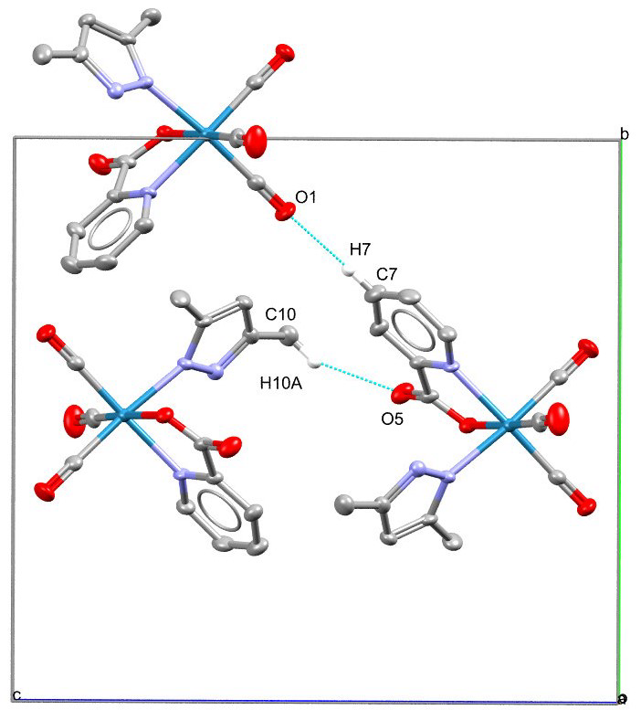
Figure SI 1a: Molecular packing (left) and intermolecular hydrogen interactions (right) of 1.
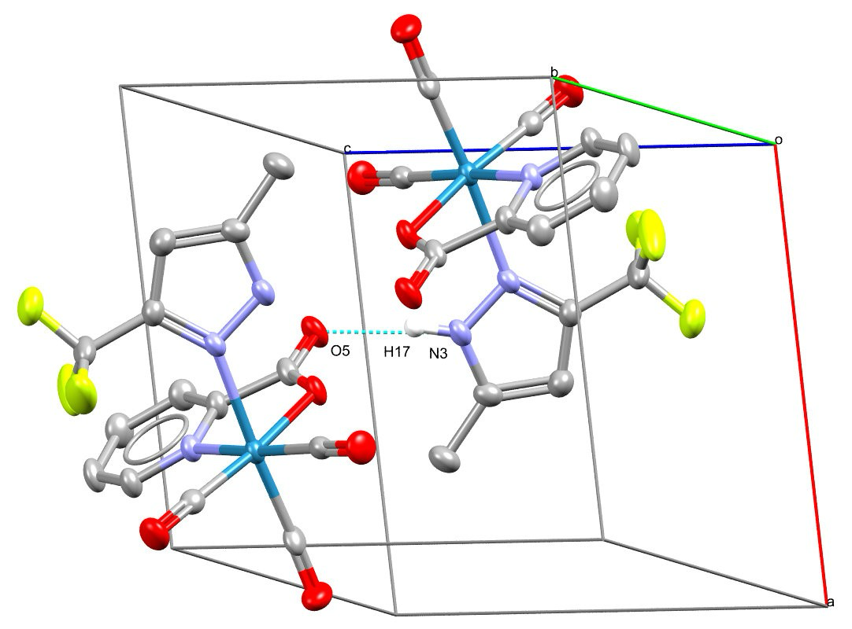
Figure SI 1b: Molecular packing (left) and intermolecular hydrogen interactions (right) of 2.

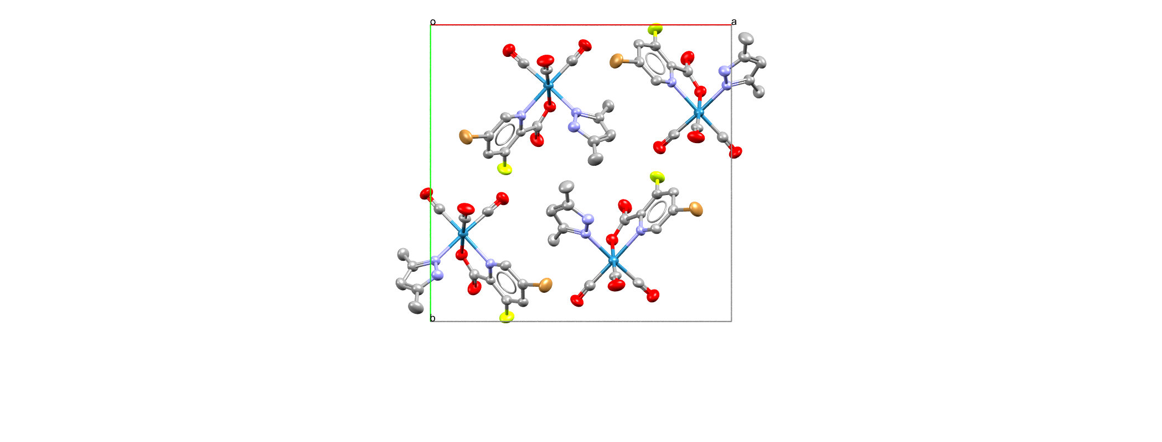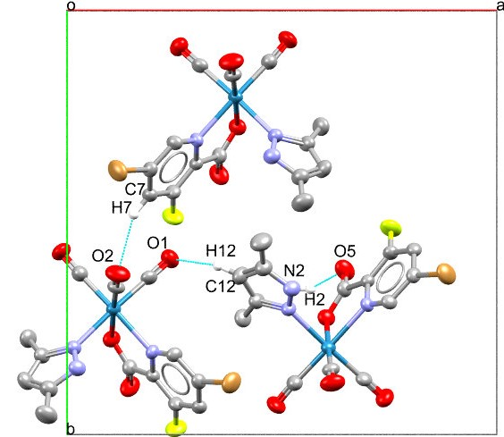
Figure SI 1c: Molecular packing (left) and intermolecular hydrogen interactions (right) of 3.
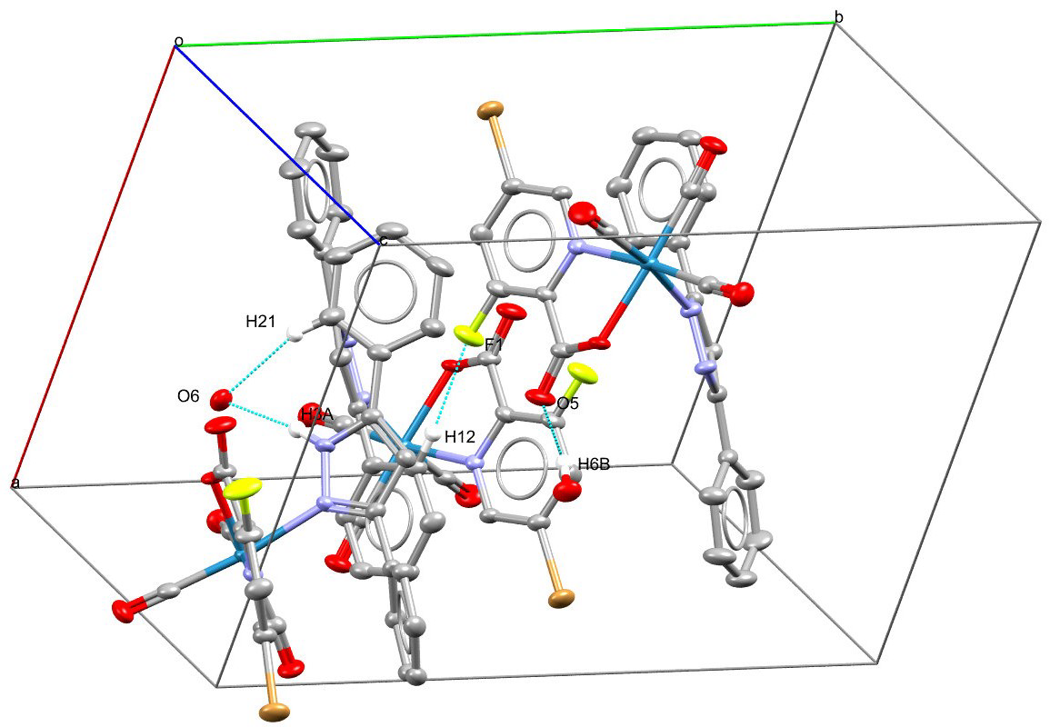
4

Figure SI 1d: Molecular packing and intermolecular hydrogen interactions of complex 4.

¹H NMR and ¹³C NMR spectra for 1-4. spectrum for 1-4.
Figure SI 2a: ¹H NMR spectrum of fac-[Re(Pico)(CO)₃L1], 1 (solvent: CDCl₃).

Figure SI 2b: ¹³C NMR spectrum of fac-[Re(Pico)(CO)₃L1], 1 (solvent: CDCl₃)Figure SI 2a: ¹H NMR spectrum of fac-[Re(Pico)(CO)₃L4], 2 (solvent: DMSO-d₆).
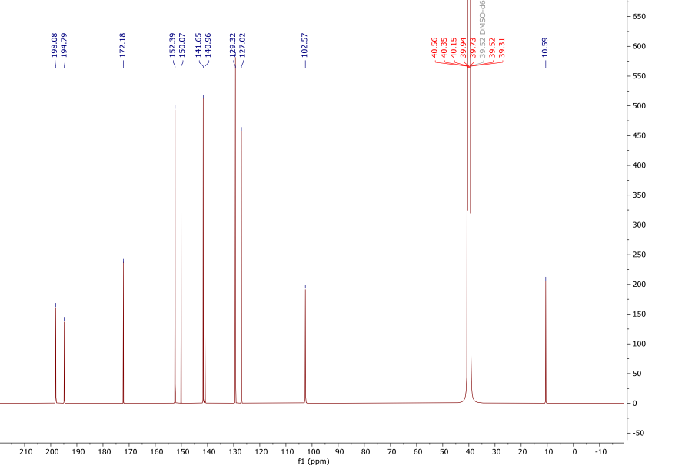
Figure SI 2b: ¹³C NMR spectrum of fac-[Re(Pico)(CO)₃L4], 2 (solvent: DMSO-d₆).
Figure SI 2a: ¹H NMR spectrum of fac-[Re(I)(CO)₃(5Br-3-F-pico)L1], 3 (solvent: DMSO-d₆).
Figure SI 2b: ¹³C NMR spectrum of fac-[Re(I)(CO)₃(5Br-3-F-pico)L1], 3 (solvent: DMSO-d₆).
Figure SI 2a: ¹H NMR spectrum of fac-[Re(I)(CO)₃(5-Br-3-F-pico)L2], 4 (solvent: DMSO-d₆).
Figure SI 2b: ¹³C NMR spectrum of fac-[Re(I)(CO)₃(5-Br-3-F-pico)L2], 4 (solvent: DMSO-d₆).

UV-Vis spectra for 1-4.
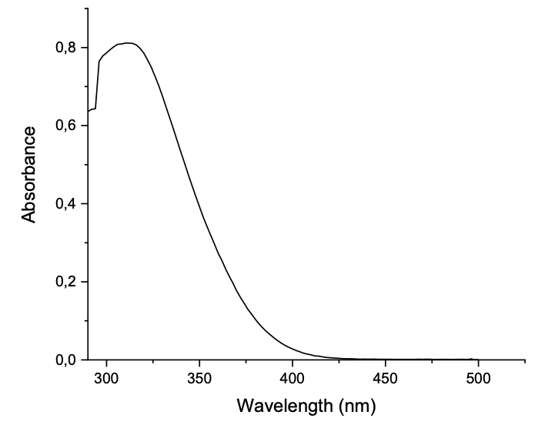
312 nm
Figure SI 3a: UV-Vis spectrum of complex 1 (solvent: Methanol).
292 nm
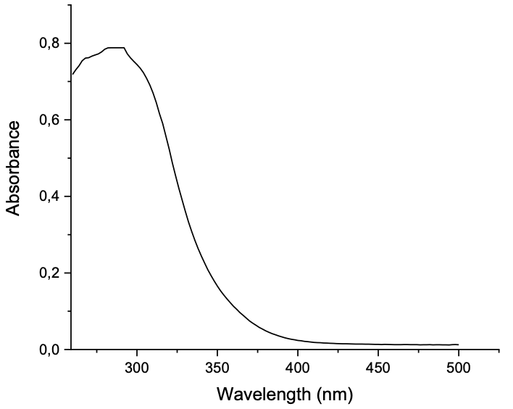
Figure SI 3b: UV-Vis spectrum of complex 2 (solvent: Methanol).

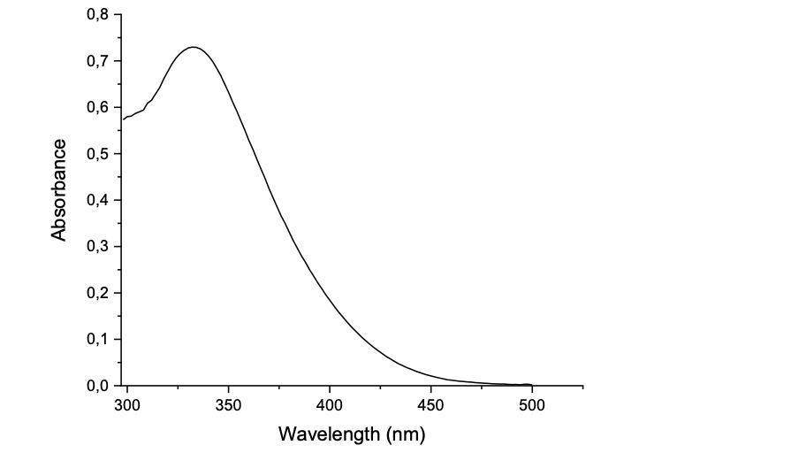Figure SI 3c: UV-Vis spectrum of complex 3 (solvent: Methanol).
332 nm
344 nm
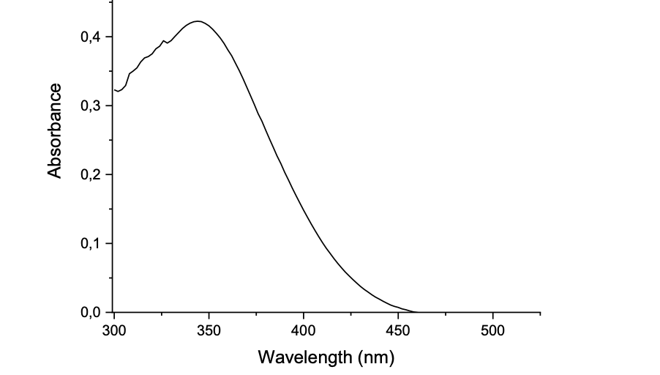Figure SI 3d: UV-Vis spectrum of complex 4 (solvent: Methanol).

IR spectra for 1-4.
Figure SI 4a: IR spectrum of complex 1.
1550 cm⁻¹
2019, 1929, 1903 cm⁻¹
-C=N-

-CO _{(tricarbonyl)}
1600 cm⁻¹
2025, 1933, 1891cm⁻¹
-C=N-

-CO _{(tricarbonyl)}
Figure SI 4b: IR spectrum of complex 2.
2022, 1907 cm⁻¹
1590 cm⁻¹
-CO _{(tricarbonyl)}
-C=N-

Figure SI 4c: IR spectrum of complex 3.
2031, 1912 cm⁻¹
1600 cm⁻¹
-CO _{(tricarbonyl)}
-C=N-

Figure SI 4d: IR spectrum of complex 4.

Half-maximal effective concentrations (EC₅₀) of complex 3 in various cancerous and normal lung fibroblast cell lines (N=2)

Figure SI 5: Graphical representation of Half-maximal effective concentrations of complex 3 in various cancerous and normal lung fibroblast cell lines (N = 2).

