Supporting Information: Performance of protected areas in conserving African elephants. Correa et al.

Table S1: Elephant population and funding data sources for each protected area used in the analysis.

Protected area data |  |  |  | Elephant population data |  |  |  | Funding data
Region | Country | Name | Designation | Year | Elephant numbers | Survey reliability | Source | Year | Notes | Source
Central | Cameroon | Bayang- Mbo | Wildlife Sanctuary | 2001 | 457 | D | AESR 2007 | 2012 | Assessment ID 25788. | METT
 |  |  |  | 2007 | 153 | C | AESR 2016 | 2012 | Salaries not included | METT
Central | Cameroon | Boumba Bek | National Park | 2004 | 318 | D | AESR 2007 | 2014 | Assessment ID 19157. | METT
 |  |  |  | 2015 | 143 | B | AESR 2016 | 2014 | Salaries not included | METT
Central | Cameroon | Campo Ma'an | National Park | 2001 | 548 | C | AESR 2007 | 2010 | Assessment ID 19158. | METT
 |  |  |  | 2014 | 539 | B | AESR 2016 | 2010 | Assessment ID 19158. | METT
Central | Cameroon | Dja | Faunal Reserve | 1995 | 1,500 | E | AESR 2007 | 2010 |  | PAPACO
 |  |  |  | 2015 | 420 | C | AESR 2016 | 2010 |  | PAPACO
Central | Cameroon | Lobeke | National Park | 1993 | 3,719 | E | AESR 2007 | 2010 |  | PAPACO
 |  |  |  | 2015 | 1,029 | B | AESR 2016 | 2010 |  | PAPACO
Central | Cameroon | Mt Cameroon | National Park | 2003 | 178 | C | AESR 2007 | 2012 | Assessment ID 25789. | METT
 |  |  |  | 2013 | 118 | D | AESR 2016 | 2012 | Salaries not included | METT
Central | Cameroon | Nki | National Park | 1998 | 2178 | D | AESR 2007 | Not available
 |  |  |  | 2015 | 565 | B | AESR 2016
Central | Cameroon | Waza | National Park | 2002 | 475 | D | AESR 2007 | 2011 | Assessment ID 19166 | METT
 |  |  |  | 2007 | 246 | A | AESR 2016 | 2011 | Assessment ID 19166 | METT
Central | Central African Republic | Bamingui-Bangoran | National Park | 2005 | 708 | N/A | Bouché et al 2011 | 2011-2017 | AID.DEC. | EU AID
 |  |  |  |  |  |  |  |  | 021447.01.1; | EU AID
 |  |  |  | 2010 | 61 | N/A | Bouché et al 2011 | 2011-2017 | State budget not reported | EU AID
Central | Central African Republic | Dzanga Ndoki-Sangha | National Park | 2005 | 869 | C | AESR 2007 | 2010 |  | PAPACO
 |  |  |  | 2012 | 631 | B | AESR 2016 | 2010 |  | PAPACO
Central | Central African Republic | Manovo Gounda | National Park | 2005 | 74 | N/A | Bouché et al 2011 | 2011-2017 | AID.DEC. | EU AID
 |  |  |  |  |  |  |  |  | 021447.01.1; | .
 |  |  |  | 2010 | 7 | N/A | Bouché et al 2011 | 2011-2017 | State budget not reported
Central | Chad | Zakouma | National Park | 2009 | 617 | N/A | AESR 2007 | 2015-2016 |  | Lindsey et al 2018
 |  |  |  | 2014 | 443 | A | AESR | 2015-2016 |  | Lindsey et al 2018
 |  |  |  |  |  |  | 2016 | 2015-2016 |  | Lindsey et al 2018
Central | Democratic Republic of the Congo | Garamba | National Park | 2004 | 6,354 | B | AESR 2007 | 2007-2011 | Project ID 2100 | GEF
 |  |  |  | 2014 | 1,924 | A | AESR 2016 | 2007-2011 | Project ID 2100 | GEF
Central | Democratic Republic of the Congo | Maiko | National Park | 2005 | 3,000 | E | AESR 2007 | 2006 | Project ID 2100. | .GEF
 |  |  |  | 2015 | 100 | E | AESR 2016 | 2006 | State budget not reported | .GEF
Central | Democratic Republic of the Congo | Okapi | Faunal Reserve | 2006 | 2,688 | C | AESR 2007 | 2010 |  | PAPACO
 |  |  |  | 2011 | 1,701 | C | AESR 2016 | 2010 |  | PAPACO
Central | Democratic Republic of the Congo | Upemba | National Park | 2005 | 145 | E | AESR 2007 | 2007-2011 | Project ID 2100. | GEF
 |  |  |  | 2011 | 40 | E | AESR 2016 | 2007-2011 | State budget not reported | GEF
Central | Democratic Republic of the Congo | Virunga | National Park | 2006 | 348 | B | AESR 2007 | 2007-2011 | Project ID 2100 | GEF
 |  |  |  | 2014 | 35 | B | AESR 2016 | 2007-2011 | Project ID 2100 | GEF
Central | Republic of the Congo | Conkouati Douli † | National Park | 2005 | 772 | B | AESR 2007 | 2010 |  | PAPACO
 |  |  |  | 2013 | 947 | B | AESR 2016 | 2010 |  | PAPACO
Central | Republic of the Congo | Nouabale Ndoki | National Park | 2003 | 3,032 | C | AESR 2007 | 2011 |  | PAPACO
 |  |  |  | 2011 | 2,324 | B | AESR 2016 | 2011 |  | PAPACO
Central | Republic of the Congo | Odzala | National Park | 2005 | 13,545 | C | AESR 2007 | 2010 | Project ID 1095 | GEF
 |  |  |  | 2012 | 9,292 | C | AESR 2016 | 2010 | Project ID 1095 | GEF
Central | Gabon | Ivindo ª | National Park | 2005 | 1,216 | C | AESR 2007 | 2004-2005 | Project ID 1095 | GEF
 |  |  |  | 2009 | 3,489 | C | AESR 2016 | 2004-2005 | Project ID 1095 | GEF
Central | Gabon | Lope ª | National Park | 2005 | 2,350 | B | AESR 2007 | 2010 |  | PAPACO
 |  |  |  | 2009 | 4,142 | B | AESR 2016 | 2010 |  | PAPACO
Central | Gabon | Minkebe | National Park | 2004 | 21,070 | C | AESR 2007 | 2004-2005 | Project ID 1095 | GEF
 |  |  |  | 2013 | 6,875 | C | AESR 2016 | 2004-2005 | Project ID 1095 | GEF
Central | Gabon | Mwange | National Park | 2001 | 2,483 | D | AESR 2007 | 2004-2005 | Project ID 1095 | GEF
 |  |  |  | 2012 | 1,680 | C | AESR 2016 | 2004-2005 | Project ID 1095 | GEF
Eastern | Ethiopia | Babille | Elephant Sanctuary | 2005 | 264 | D | AESR 2007 | 2015-2016 |  | Lindsey et al 2018
 |  |  |  | 2015 | 250 | D | AESR 2016 | 2015-2016 |  | Lindsey et al 2018
Eastern | Ethiopia | Chebera ª | Wildlife Reserve | 2014 | 60 | D | AESR 2007 | 2015-2016 |  | Lindsey et al 2018
 |  |  |  | 2015 | 420 | D | AESR 2016 | 2015-2016 |  | Lindsey et al 2018
Eastern | Ethiopia | Gambella † | National Park | 2002 | 200 | D | AESR 2007 | 2015-2016 |  | Lindsey et al 2018
 |  |  |  | 2015 | 606 | D | AESR 2016 | 2015-2016 |  | Lindsey et al 2018
Eastern | Ethiopia | Omo † | National Park | 2002 | 324 | D | AESR 2007 | 2015-2016 |  | Lindsey et al 2018
 |  |  |  | 2015 | 491 | D | AESR 2016 | 2015-2016 |  | Lindsey et al 2018
Eastern | Kenya | Amboseli | National Park | 2005 | 1,417 | A | AESR 2007 | 2015-2016 |  | Lindsey et al 2018
 |  |  |  | 2015 | 1,656 | A | AESR 2016 | 2015-2016 |  | Lindsey et al 2018
Eastern | Kenya | Masai Mara†† | National Reserve | 2002 | 1,655 | A | AESR 2007 | 2015-2016 |  | Lindsey et al 2018
 |  |  |  | 2014 | 876 | A | AESR 2016 | 2015-2016 |  | Lindsey et al 2018
Eastern | Kenya | Meru | National Park | 2002 | 272 | A | AESR 2007 | 2015-2016 |  | Lindsey et al 2018
 |  |  |  | 2015 | 659 | A | AESR 2016 | 2015-2016 |  | Lindsey et al 2018
Eastern | Kenya | Mt Elgon | National Park | 2002 | 139 | D | AESR 2007 | Not available
 |  |  |  | 2015 | 200 | D | AESR 2016
Eastern | Kenya | Tsavo East † | National Park | 2005 | 6,395 | A | AESR 2007 | 2015-2016 |  | Lindsey et al 2018
 |  |  |  | 2014 | 8,394 | A | AESR 2016 | 2015-2016 |  | Lindsey et al 2018
Eastern | Kenya | Tsavo West † | National Park | 2005 | 2,626 | A | AESR 2007 | 2015-2016 |  | Lindsey et al 2018
 |  |  |  | 2014 | 2,724 | A | AESR 2016 | 2015-2016 |  | Lindsey et al 2018
Eastern | Rwanda | Akagera | National Park | 2002 | 34 | D | AESR 2007 | 2015-2016 |  | Lindsey et al 2018
 |  |  |  | 2013 | 88 | A | AESR 2016 | 2015-2016 |  | Lindsey et al 2018
Eastern | South Sudan | Nimule | National Park | 2002 | 300 | D | AESR 2007 | 2016-2019 | Project ID 9551 | GEF
 |  |  |  | 2012 | 118 | B | AESR 2016 | 2016-2019 | Project ID 9551 | GEF
Eastern | Tanzania | Burigi | National Park | 2009 | 1,295 | N/A | TAWIRI 2009 | Not available
 |  |  |  | 2014 | 402 | N/A | TAWIRI 2015
Eastern | Tanzania | Katavi | National Park | 2009 | 3,235 | N/A | TAWIRI 2009 | 2015-2016 | Estimates of the total projected expenditure | Lindsey et al 2018
 |  |  |  | 2014 | 3,128 | N/A | TAWIRI 2015 | 2015-2016 | Estimates of the total projected expenditure | Lindsey et al 2018
Eastern | Tanzania | Mikumi | National Park | 2009 | 1,570 | N/A | TAWIRI 2009 | Not available
 |  |  |  | 2014 | 885 | N/A | TAWIRI 2015
Eastern | Tanzania | Moyowosi- Kigosi | Game Reserve | 2006 | 9,541 | B | TAWIRI 2009 | 2015-2016 | Estimates of the total projected expenditure. | Lindsey et al 2018
 |  |  |  | 2014 | 1,645 | B | TAWIRI 2015 | 2015-2016 | Estimates of the total projected expenditure. | Lindsey et al 2018
Eastern | Tanzania | Ruaha | National Park | 2009 | 9,885 | N/A | TAWIRI 2009 | 2015-2016 | Estimates of the total projected expenditure. | Lindsey et al 2018
 |  |  |  | 2014 | 4,210 | N/A | TAWIRI 2015 | 2015-2016 | Estimates of the total projected expenditure. | Lindsey et al 2018
Eastern | Tanzania | Rukwa ª | Game Reserve | 2009 | 2,124 | N/A | TAWIRI 2009 | 2015-2016 | Estimates of the total projected expenditure. | Lindsey et al 2018
 |  |  |  | 2014 | 122 | N/A | TAWIRI 2015 | 2015-2016 | Estimates of the total projected expenditure. | Lindsey et al 2018
Eastern | Tanzania | Rungwa | Game Reserve | 2009 | 13,869 | N/A | TAWIRI 2009 | 2015-2016 | Estimates of the total projected expenditure. | Lindsey et al 2018
 |  |  |  | 2014 | 2,801 | N/A | TAWIRI 2015 | 2015-2016 | Estimates of the total projected expenditure. | Lindsey et al 2018
Eastern | Tanzania | Selous | Game Reserve | 2009 | 30,088 | N/A | TAWIRI 2009 | 2015-2016 | Estimates of the total projected expenditure. | Lindsey et al 2018
 |  |  |  | 2014 | 11,419 | N/A | TAWIRI 2015 | 2015-2016 | Estimates of the total projected expenditure. | Lindsey et al 2018
Eastern | Tanzania | Serengeti † | National Park | 2009 | 2,941 | N/A | TAWIRI 2009 | 2015-2016 | Estimates of the total projected expenditure. | Lindsey et al 2018
 |  |  |  | 2014 | 5,160 | N/A | TAWIRI 2015 | 2015-2016 | Estimates of the total projected expenditure. | Lindsey et al 2018
Eastern | Tanzania | Tarangire † | National Park | 2009 | 2,193 | N/A | TAWIRI 2009 | 2015-2016 | Estimates of the total projected expenditure. | Lindsey et al 2018
 |  |  |  | 2014 | 3,282 | N/A | TAWIRI 2015 | 2015-2016 | Estimates of the total projected expenditure. | Lindsey et al 2018
Eastern | Tanzania | Ugalla | Game Reserve | 2006 | 4,133 | B | TAWIRI 2009 | 2015-2016 | Estimates of the total projected expenditure. | Lindsey et al 2018
 |  |  |  | 2014 | 659 | B | TAWIRI 2015 | 2015-2016 | Estimates of the total projected expenditure. | Lindsey et al 2018
Eastern | Uganda | Kibale | National Park | 2005 | 393 | C | AESR 2007 | 2010 |  | WCS
 |  |  |  | 2010 | 487 | D | AESR 2016 | 2010 |  | WCS
Eastern | Uganda | Kidepo Valley | National Park | 2005 | 454 | A | AESR 2007 | 2010 |  | WCS
 |  |  |  | 2014 | 621 | A | AESR 2016 | 2010 |  | WCS
Eastern | Uganda | Murchison Falls † | National Park | 2005 | 516 | B | AESR 2007 | 2010 |  | WCS
 |  |  |  | 2014 | 1,352 | B | AESR 2016 | 2010 |  | WCS
Eastern | Uganda | Queen Elizabeth | National Park | 2006 | 2,959 | B | AESR 2007 | 2010 |  | WCS
 |  |  |  | 2014 | 2,904 | B | AESR 2016 | 2010 |  | WCS
Southern | Angola | Luiana | National Park | 2005 | 1,827 | B | AESR 2007 | 2015-2016 | State budget not reported. | Lindsey et al 2018
 |  |  |  | 2015 | 1,437 | B | AESR 2016 | 2015-2016 | State budget not reported. | Lindsey et al 2018
Southern | Botswana | Chobe | National Park | 2010 | 29,539 | N/A | Chase et al 2011 | 2013 | Assessment ID 19202. | METT
 |  |  |  | 2014 | 17,212 | N/A | Chase et al 2015 | 2013 | Salaries not included | METT
Southern | Botswana | Moremi | Game Reserve | 2010 | 8,947 | N/A | Chase et al 2011 | Not available
 |  |  |  | 2014 | 10,027 | N/A | Chase et al 2015
Southern | Eswanti | Hlane | National Park | 2005 | 13 | A | AESR 2007 | 2014 | Project ID 5065. | GEF
 |  |  |  | 2015 | 25 | A | AESR 2016 | 2014 | Spend was divided by the total PA area | GEF
Southern | Eswanti | Malolotja | Nature Reserve | 2005 | 3 | D | AESR 2007 | 2014 | Project ID 5065. | GEF
 |  |  |  | 2015 | 3 | D | AESR 2016 | 2014 | Spend was divided by the total PA area | GEF
Southern | Malawi | Kasungu | National Park | 2005 | 58 | B | AESR 2007 | 2015-2016 |  | Lindsey et al 2018
 |  |  |  | 2014 | 40 | A | AESR 2016 | 2015-2016 |  | Lindsey et al 2018
Southern | Malawi | Liwonde | National Park | 2006 | 530 | E | AESR 2007 | 2015-2016 |  | Lindsey et al 2018
 |  |  |  | 2014 | 777 | A | AESR 2016 | 2015-2016 |  | Lindsey et al 2018
Southern | Malawi | Majeteª | Wildlife Reserve | 2006 | 70 | D | AESR 2007 | 2015-2016 |  | Lindsey et al 2018
 |  |  |  | 2015 | 300 | D | AESR 2016 | 2015-2016 |  | Lindsey et al 2018
Southern | Malawi | Nkhotakota | Wildlife Reserve | 1995 | 1,037 | E | AESR 2007 | Not available
 |  |  |  | 2013 | 92 | D | AESR 2016
Southern | Malawi | Nyika | National Park | 1997 | 339 | B | AESR 2007 | Not available
 |  |  |  | 2013 | 47 | A | AESR 2016
Southern | Malawi | Vwaza Marsh † | Wildlife Reserve | 2005 | 270 | D | AESR 2007 | 2015-2016 |  | Lindsey et al 2018
 |  |  |  | 2013 | 310 | A | AESR 2016 | 2015-2016 |  | Lindsey et al 2018
Southern | Mozambique | Gile † | National Reserve | 2002 | 15 | D | AESR 2007 | 2015-2016 |  | Lindsey et al 2018
 |  |  |  | 2012 | 21 | D | AESR 2016 | 2015-2016 |  | Lindsey et al 2018
Southern | Mozambique | Gorongosaª | National Park | 2004 | 22 | D | AESR 2007 | 2015-2016 |  | Lindsey et al 2018
 |  |  |  | 2014 | 535 | A | AESR 2016 | 2015-2016 |  | Lindsey et al 2018
Southern | Mozambique | Limpopo † | National Park | 2006 | 630 | A | AESR 2007 | 2015-2016 |  | Lindsey et al 2018
 |  |  |  | 2014 | 1,081 | B | AESR 2016 | 2015-2016 |  | Lindsey et al 2018
Southern | Mozambique | Marromeu | Game Reserve | 2008 | 267 | N/A | AESR 2007 | Not available
 |  |  |  | 2014 | 606 | B | AESR 2016
Southern | Mozambique | Niassa | National Reserve | 2004 | 12,477 | B | AESR 2007 | 2015-2016 |  | Lindsey et al 2018
 |  |  |  | 2014 | 4,441 | B | AESR 2016 | 2015-2016 |  | Lindsey et al 2018
Southern | Mozambique | Quirimbas | National Park | 2005 | 2,000 | E | AESR 2007 | 2015-2016 |  | Lindsey et al 2018
 |  |  |  | 2014 | 328 | B | AESR 2016 | 2015-2016 |  | Lindsey et al 2018
Southern | Namibia | Etosha | National Park | 2004 | 2,057 | B | AESR 2007 | 2015-2016 |  | Lindsey et al 2018
 |  |  |  | 2015 | 2,911 | B | AESR 2016 | 2015-2016 |  | Lindsey et al 2018
Southern | Namibia | Khaudum | National Park | 2004 | 3,848 | B | AESR 2007 | 2015-2016 | Government spend was divided by the total PA area | Lindsey et al 2018
 |  |  |  | 2015 | 4,149 | B | AESR 2016 | 2015-2016 | Government spend was divided by the total PA area | Lindsey et al 2018
Southern | Namibia | Nyae ^{b} | Communal Conservancy | 2004 | 967 | B | AESR 2007 | Not available
 |  |  |  | 2015 | 2,264 | B | AESR 2016
Southern | South Africa | Addo | National Park | 2005 | 459 | A | AESR 2007 | 2016 |  | SANParks
 |  |  |  | 2012 | 595 | A | AESR 2016 | 2016 |  | SANParks
Southern | South Africa | Hluhluwe- Imfolozi | Game Reserve | 2004 | 346 | D | AESR 2007 | 2010 |  | KZN
 |  |  |  | 2015 | 700 | D | AESR 2016 | 2010 |  | KZN
Southern | South Africa | Kruger | National Park | 2006 | 12,467 | A | AESR 2007 | 2018 |  | SANParks
 |  |  |  | 2015 | 17,086 | A | AESR 2016 | 2018 |  | SANParks
Southern | South Africa | Madikwe | Nature Reserve | 2005 | 455 | A | AESR 2007 | Not available
 |  |  |  | 2015 | 1,006 | D | AESR 2016
Southern | South Africa | Marakele | National Park | 2005 | 110 | A | AESR 2007 | 2015 |  | SANParks
 |  |  |  | 2012 | 171 | A | AESR 2016 | 2015 |  | SANParks
Southern | South Africa | Tembe | Elephant Park | 2005 | 167 | A | AESR 2007 | 2018 |  | KZN
 |  |  |  | 2015 | 220 | D | AESR 2016 | 2018 |  | KZN
Southern | Zambia | Kafue | National Park | 2004 | 6,306 | B | AESR 2007 | 2015-2016 | Government spend was divided by the total PA area | Lindsey et al 2018
 |  |  |  | 2015 | 4,813 | B | AESR 2016 | 2015-2016 | Government spend was divided by the total PA area | Lindsey et al 2018
Southern | Zambia | Lower Zambezi | National Park | 2003 | 1,477 | B | AESR 2007 | 2015-2016 | Government spend was divided by the total PA area | Lindsey et al 2018
 |  |  |  | 2015 | 973 | B | AESR 2016 | 2015-2016 | Government spend was divided by the total PA area | Lindsey et al 2018
Southern | Zambia | North Luangwa | National Park | 2003 | 3,235 | B | AESR 2007 | 2015-2016 | Government spend was divided by the total PA area | Lindsey et al 2018
 |  |  |  | 2015 | 4,673 | B | AESR 2016 | 2015-2016 | Government spend was divided by the total PA area | Lindsey et al 2018
Southern | Zambia | Sioma Ngwezi | National Park | 2005 | 385 | B | AESR 2007 | 2015-2016 | Government spend was divided by the total PA area | Lindsey et al 2018
 |  |  |  | 2015 | 48 | B | AESR 2016 | 2015-2016 | Government spend was divided by the total PA area | Lindsey et al 2018
Southern | Zambia | South Luangwa † | National Park | 2002 | 4,459 | B | AESR 2007 | 2015-2016 | Government spend was divided by the total PA area | Lindsey et al 2018
 |  |  |  | 2015 | 3,302 | B | AESR 2016 | 2015-2016 | Government spend was divided by the total PA area | Lindsey et al 2018
Southern | Zimbabwe | Chete | Safari Area | 2006 | 971 | B | AESR 2007 | 2015-2016 | Government spend was divided by the total PA area | Lindsey et al 2018
 |  |  |  | 2014 | 278 | B | AESR 2016 | 2015-2016 | Government spend was divided by the total PA area | Lindsey et al 2018
Southern | Zimbabwe | Chirisa | Safari Area | 2006 | 4,231 | B | AESR 2007 | 2015-2016 | Government spend was divided by the total PA area | Lindsey et al 2018
 |  |  |  | 2014 | 1,200 | B | AESR 2016 | 2015-2016 | Government spend was divided by the total PA area | Lindsey et al 2018
Southern | Zimbabwe | Chizarira | National Park | 2006 | 3,071 | B | AESR 2007 | 2015-2016 | Government spend was divided by the total PA area | Lindsey et al 2018
 |  |  |  | 2014 | 747 | B | AESR 2016 | 2015-2016 | Government spend was divided by the total PA area | Lindsey et al 2018
Southern | Zimbabwe | Doma | Safari Area | 2001 | 336 | B | AESR 2007 | 2015-2016 | Government spend was divided by the total PA area | Lindsey et al 2018
 |  |  |  | 2014 | 153 | B | AESR 2016 | 2015-2016 | Government spend was divided by the total PA area | Lindsey et al 2018
Southern | Zimbabwe | Gonarezho† | National Park | 2001 | 4,987 | B | AESR 2007 | 2015-2016 | Government spend was divided by the total PA area | Lindsey et al 2018
 |  |  |  | 2014 | 11,120 | B | AESR 2016 | 2015-2016 | Government spend was divided by the total PA area | Lindsey et al 2018
Southern | Zimbabwe | Hwange † | National Park | 2001 | 44,492 | B | AESR 2007 | 2015-2016 | Government spend was divided by the total PA area | Lindsey et al 2018
 |  |  |  | 2014 | 45,846 | B | AESR 2016 | 2015-2016 | Government spend was divided by the total PA area | Lindsey et al 2018
Southern | Zimbabwe | Matetsi † | Safari Area | 2001 | 4,201 | B | AESR 2007 | 2015-2016 | Government spend was divided by the total PA area | Lindsey et al 2018
 |  |  |  | 2014 | 4,843 | B | AESR 2016 | 2015-2016 | Government spend was divided by the total PA area | Lindsey et al 2018
Southern | Zimbabwe | Matusadona | National Park | 2006 | 1,925 | B | AESR 2007 | 2015-2016 | Government spend was divided by the total PA area | Lindsey et al 2018
 |  |  |  | 2014 | 669 | B | AESR 2016 | 2015-2016 | Government spend was divided by the total PA area | Lindsey et al 2018
Southern | Zimbabwe | Save Conservancy | Sanctuary | 2003 | 527 | B | AESR 2007 | Not available
 |  |  |  | 2014 | 1,585 | B | AESR 2016
Western | Benin | Pendjari†† | National Park | 2006 | 1,808 | A | AESR 2007 | 2015-2016 |  | Lindsey et al 2018
 |  |  |  | 2015 | 1,632 | B | AESR 2016 | 2015-2016 |  | Lindsey et al 2018
Western | Benin | W du Beninª | National Park | 2003 | 56 | A | AESR 2007 | 2015-2016 |  | Lindsey et al 2018
 |  |  |  | 2015 | 462 | B | AESR 2016 | 2015-2016 |  | Lindsey et al 2018
Western | Burkina Faso | Arly | National Park | 2003 | 422 | A | AESR 2007 | 2015-2016 |  | Lindsey et al 2018
 |  |  |  | 2015 | 985 | B | AESR 2016 | 2015-2016 |  | Lindsey et al 2018
Western | Burkina Faso | W du Burkina † | National Park | 2003 | 740 | A | AESR 2007 | 2015-2016 |  | Lindsey et al 2018
 |  |  |  | 2015 | 1,099 | B | AESR 2016 | 2015-2016 |  | Lindsey et al 2018
Western | Cote d'Ivoire | Comoe ª | National Park | 2002 | 10 | D | AESR 2007 | 2009-2013 | Project ID 3533. | GEF
 |  |  |  | 2015 | 100 | D | AESR 2016 | 2009-2013 | Spend was divided by the total PA areas | GEF
Western | Cote d'Ivoire | Tai ª | National Park | 2002 | 53 | C | AESR 2007 | 2011-2015 | State budget not reported | EU AID
 |  |  |  | 2010 | 189 | B | AESR 2016 | 2011-2015 | State budget not reported | EU AID
Western | Liberia | Gola | National Park | 1990 | 500 | E | AESR 2007 | 2007-2012 | Project ID 3284 | GEF
 |  |  |  | 2015 | 400 | E | AESR 2016 | 2007-2012 | Project ID 3284 | GEF
Western | Liberia | Sapo | National Park | 1989 | 313 | E | AESR 2007 | 2011-2015 | Project ID 1475 | GEF
 |  |  |  | 2015 | 124 | E | AESR 2016 | 2011-2015 | Project ID 1475 | GEF
Western | Niger | W du Niger | National Park | 2003 | 85 | A | AESR 2007 | 2015-2016 |  | Lindsey et al 2018
 |  |  |  | 2013 | 380 | B | AESR 2016 | 2015-2016 |  | Lindsey et al 2018
Western | Nigeria | Yankari | National Park | 2006 | 348 | A | AESR 2007 | 2015-2016 |  | Lindsey et al 2018
 |  |  |  | 2011 | 82 | D | AESR 2016 | 2015-2016 |  | Lindsey et al 2018

ª Sites excluded from the analysis because the annual rate of change was greater than 12%. † Sites where the model estimated additional funding required to stabilise the population, but the existing census data suggested a stable or increasing population (blue outline Figure 2C). †† Sites estimated to be sufficiently financed (stable or increasing elephant population) but the most recent census data suggested the population was decreasing (red outline Figure 2C). Source acronyms: AESR, IUCN African Elephant Status Report; TAWIRI, Tanzania Wildlife Research Institute; GEF, Global Environment Facility https://www.thegef.org/projects-operations/database; KZN, KwaZulu-Natal Parks; WCS, Wildlife Conservation Society. Survey reliability described in Table S2 and available at https://africanelephantdatabase.org/reliability
Table S2: AESR Survey Reliability: Categorization of elephant population estimates according to survey type and contribution of each to the four categories of elephant numbers.
Survey Reliability | Survey type(s) | Categorization of estimates
A | * INDIVIDUAL REGISTRATIONS (IR)  * AERIAL TOTAL COUNTS (AT)  * GROUND TOTAL COUNTS (GT) | DEFINITE = the population estimate.  PROBABLE = none.  POSSIBLE = none.  SPECULATIVE = none.
B | * AERIAL SAMPLE COUNTS (AS)or GROUND SAMPLE COUNTS (GS) with 95% confidence limits  * DUNG COUNTS (DC) with 95% confidence limits and an estimate of dung decay rate obtained on site | DEFINITE = the lower 95% confidence limit of the population estimate (there are at least this number of elephants) or the number actually seen, whichever is greater.  PROBABLE = the differencea between the estimate and the lower confidence limit, or between the estimate and the actual number seen or between the estimate and zero, if the lower confidence limit is negativeb.  POSSIBLE = the difference between the upper confidence limit and the estimate.  SPECULATIVE = none.
C | * DUNG COUNTS (DC) with 95% confidence limits but no on-site measurement of dung decay rate  * GENETIC DUNG COUNTS (GD) | DEFINITE = none, or the number actually seen, if givenc.  PROBABLE = the population estimate.  POSSIBLE = the difference between the upper confidence limit and the estimate.  SPECULATIVE = none.
D | * AERIAL SAMPLE COUNTS (AS), GROUND SAMPLE COUNTS (GS) and DUNG COUNTS (DC) without 95% confidence limits  * INFORMED GUESSES (IG) | DEFINITE = the number actually seen, if given.  PROBABLE = none.  POSSIBLE = the population estimate or the lower estimate if a range is given, minus the actual number seen, if given.  SPECULATIVE = the difference between upper and lower estimates, if given
E | * OTHER GUESSES (OG)  * Any of the above survey types in which the estimate is over 10 years old | DEFINITE = the number actually seen, if given.  PROBABLE = none.  POSSIBLE = none.  SPECULATIVE = the estimate, or the mean of the upper and lower limit, minus the actual number seen, if given.

Additional data details
Budget data
Obtaining protected area budget data is notoriously difficult (Lindsey et al., 2018). Tracking funding from a variety of sources at a continental spatial scale presented several challenges that require consideration. (i) There is no established and consistent definition of what constitutes the costs of a protected-area system (Bruner, Gullison and Balmford, 2004). We were specifically interested in the recurrent management costs because they are related to the success or failure of conservation interventions (Geldmann et al., 2018). We excluded spending allocated towards social and economic development surrounding the PAs. Although these investments could potentially have an indirect long-term effect on biodiversity conservation, the effect of such spending remains largely unquantified. (ii) There are several sources of funding, including national governments, foreign aid agencies and nongovernmental organisations (NGOs), which makes collation of financial information and its attribution to a PA(s) challenging (James, Gaston and Balmford, 2001; Waldron et al., 2013). It is largely infeasible to collect data on all financial flows, consequently our estimates are likely to underestimate the actual total amount of funding PAs receive. (iii) The level of reporting can vary substantially. For instance, wildlife authorities and aid agencies often report funding levels for an aggregate of PAs. This lumping could hide or dilute the effects of explanatory variables – particularly PA size, which has been shown to have a negative relationship with spend per unit area (Balmford et al., 2003). (iv) The amount of funding a PA receives will vary over time. Overall, the amount of funding allocated to conservation in Africa has increased over time (Brockington and Scholfield, 2010). Therefore, more recent estimates of funding are likely to be higher. It is also important to note that many foreign aid agencies operate in a 3 to 5-year project time frame. Initial stages of the project may include one-off capital investments, which would inflate the levels of funding. The funding data did also not include contributions from trophy hunting operators, who often provide significant contributions to protected area management.

Table S3: Description of covariates, other than expenditure, considered in the models. Variables are organised into four groups. (i) protected-area attributes, (ii) local human impacts, (iii) socio-economic context and (iv) governance. The scale of the variable: (PA) individual protected area, (Nat) national.

Group | Variable | Scale | Description
Protected area attributes | Protected area size | PA | Total reported area (km²) of each protected area.
Local human impacts | Human population density | PA | Mean of the cell values for human population density (km⁻²) in a 5km buffer surrounding the protected area.
Local human impacts | Accessibility | PA | Lowest cell values for travel time (minutes) to nearest city (50,000 individuals) within the protected area.
Local human impacts | Agricultural land use | PA | Percentage of agricultural land in a 5km buffer surrounding the protected area
Socio- economic context | Per capita Gross Domestic Product | Nat. | Per capita gross domestic product (2015 US$)
Socio- economic context | Human Development Index | Nat. | Average achievement in key dimensions of human development: GDP, life expectancy and literacy rate
Socio- economic context | Rule of Law | Nat. | Extent to which agents have confidence in and abide by the rules of society
Socio- economic context | Political Stability | Nat. | Likelihood of political instability and/or politically motivated violence
Socio- economic context | Control of Corruption | Nat. | Extent to which public power is exercised for private gain
Socio- economic context | Government effectiveness | Nat. | Quality of public and civil service, and the degree of its independence from political pressures

Protected area attributes
For protected area attributes, we used the size of each protected area. Where available, we used the protected area size reported in the spend data source (n=28). Where the size of the protected area was not reported, we used the WDPA (n=53) which provides the most comprehensive data set on protected areas globally (UNEP-WCMC and IUCN, 2020), except for protected areas in Kenya, Tanzania and Uganda which had very different measurements and for which we instead used size as reported by the corresponding management authorities (n=21).

Local human impacts
For local human impacts, we tested (i) human population density, extracted from the Gridded Population of the World dataset for the 2015, estimated at a 2.5 arc-minute resolution (CIESIN, 2018) in a 5km buffer around each protected area; (ii) accessibility, extracted from the Accessibility to Cities dataset for 2015 at a spatial resolution of 1km (Weiss et al, 2018); and (iii) agricultural land use was taken from the 100m resolution Soils4Africa map of agricultural land of continental Africa, (https://www.soils4africa-h2020.eu/s4a-maps-agricultural-land-in-africa), calculated as the percentage of agricultural land in a 5km buffer around each protected area.

Socio-economic context
For socio-economic context, we used per capita GDP, given that poverty is associated with increased risk of elephant poaching (Hauenstein et al., 2019). These data were taken from the World Development Indicators (World Bank 2020a). We also included the HDI obtained from the Human Development Data Center for the year 2015, which incorporates some non-economic aspects of development as well (UNDP, 2020). We used four of the six Worldwide Governance Indicators (World bank 2020b) that have a strong hypothetical linkage to the spending decision process in conservation: “government effectiveness”, “control of corruption”, “rule of law”, and “political stability and absence of violence” (Eklund et al., 2011; Waldron et al., 2013). Variables chosen to represent aspects of governance and socio-economic context were only consistently available at the national scale and on a yearly basis. We used the mean of each indicator across the elephant population time series of each protected area.
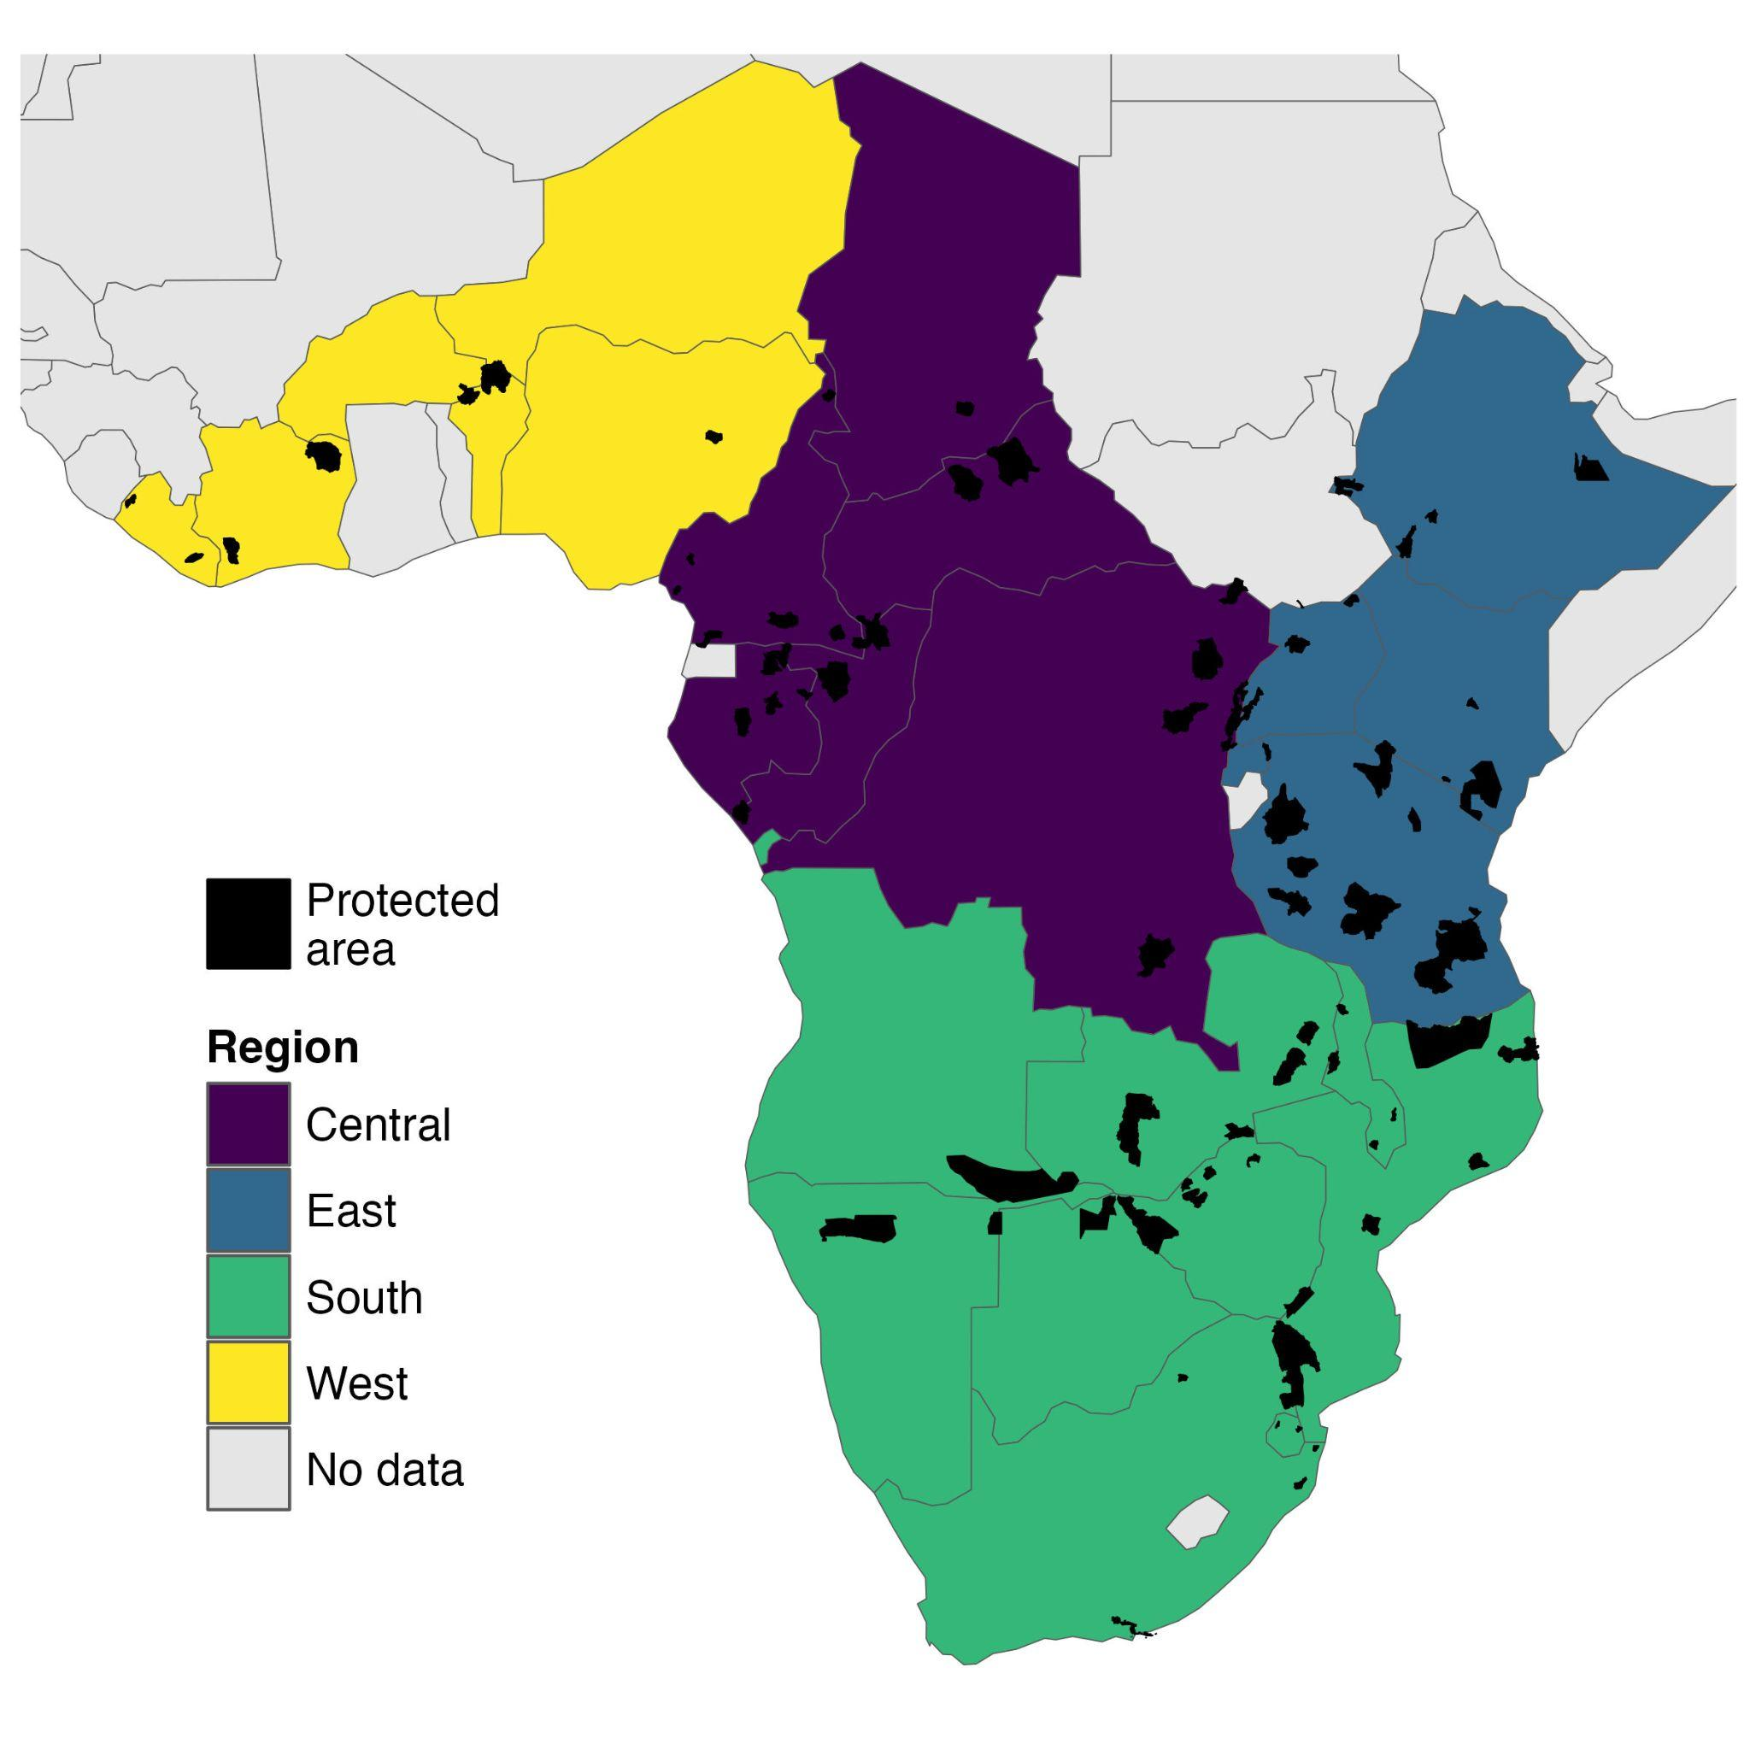
Figure S1: Distribution of the 80 protected areas that had funding information and were included in the models and their assigned African region.

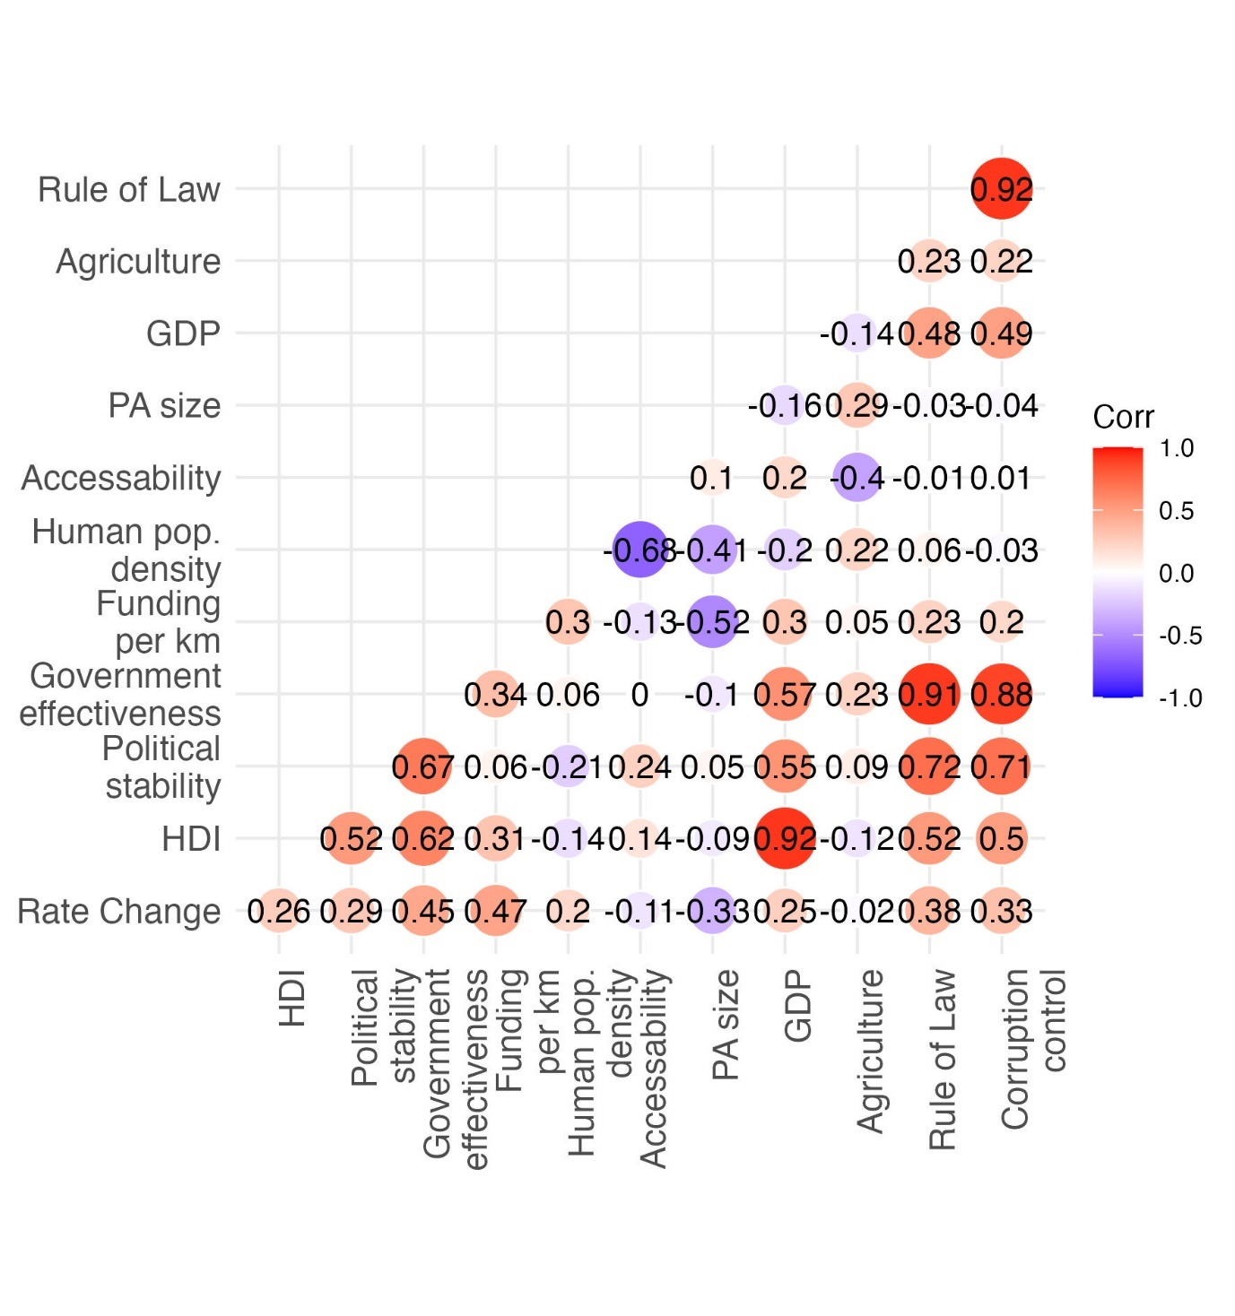
Figure S2: Pearson’s correlation coefficients of the key explanatory variables used in the models. Colours of text and circles indicate negative (red) and positive (blue) correlations between individual variable pairs. Circles and text show the same data; circle size illustrates the strength of correlation.
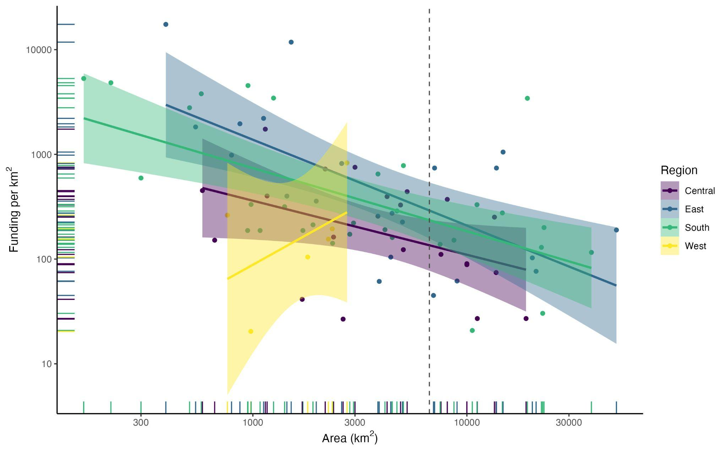
Figure S3: Relationship between the logarithm of the protected area size and the logarithm of the funding per square kilometre. In most of Africa, larger sites receive lower funding per unit area indicating that managers either struggle to raise sufficient funding for large sites or that there is an economy of scale effect. Approximately 80% of the sites have an area of less than 10,000 km² and the mean protected area size of the 80 sites was 6,600 km² (vertical dashed line). In West Africa the trend was for relatively larger sites to receive more funding per unit area.
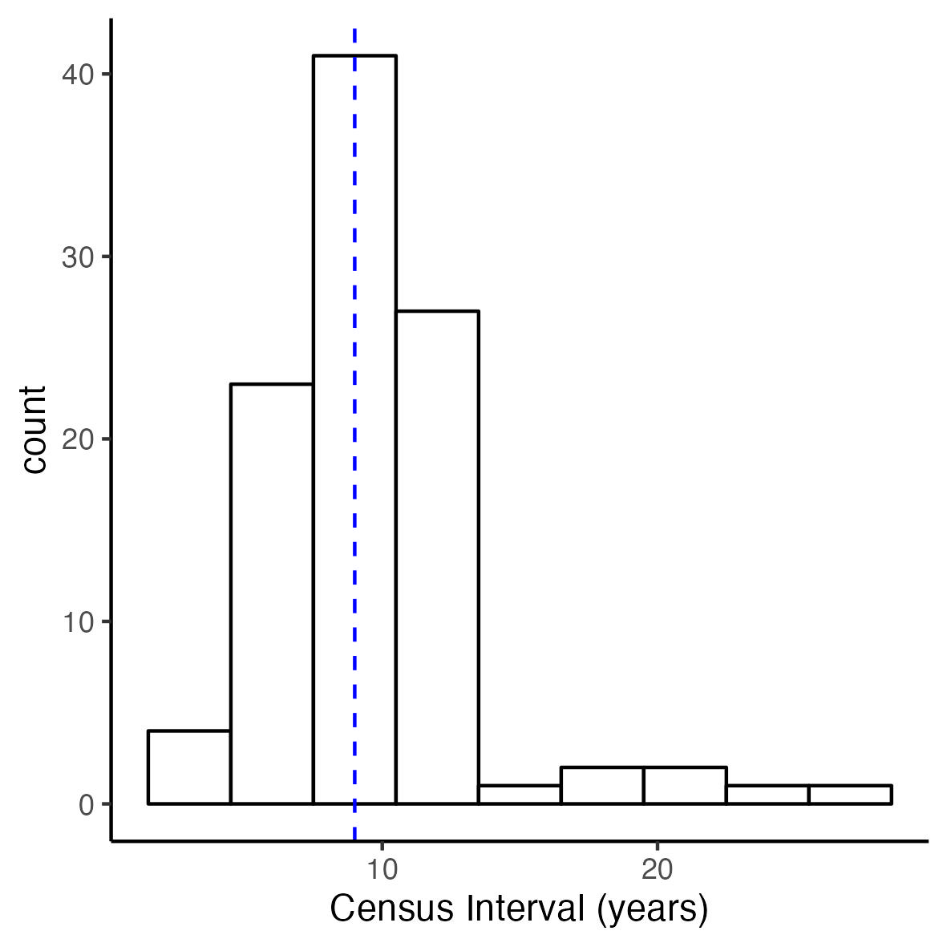
Figure S4: Distribution population census interval used across all 102 protected areas. Blue dashed line show the median census interval (9 years).
SUPPORTING INFORMATION REFERENCES
- Balmford, A. et al. (2003) ‘Global variation in terrestrial conservation costs, conservation benefits, and unmet conservation needs’, Proceedings of the National Academy of Sciences of the United States of America, 100(3), pp. 1046–1050. doi: 10.1073/pnas.0236945100.
- Blanc, J.J., et al. (2007). African Elephant Status Report 2007 : an update from the African Elephant Database. Occasional Paper series of the IUCN Species Survival Commission, No. 33. IUCN/SSC African Elephant Specialist Group. IUCN, Gland, Switzerland. vi + 276 pp.
- Bouché P, et al. (2011) Will elephants soon disappear from West African savannahs? PLoS One, e20619. Pmid:21731620
- Brockington, D. and Scholfield, K. (2010) ‘Expenditure by conservation nongovernmental organizations in sub-Saharan Africa’, Conservation Letters, 3(2), pp. 106–113. doi: 10.1111/j.1755-263X.2010.00094.x.
- Bruner, A. G., Gullison, R. E. and Balmford, A. (2004) ‘Financial Costs and Shortfalls of Managing and Expanding Protected-Area Systems in Developing Countries’, BioScience, 54(12), pp. 1119–1126. doi: 10.1641/0006-3568(2004)054[1119:fcasom]2.0.co;2.
- Center for International Earth Science Information Network, CIESIN. (2018). Gridded Population of the World, Version 4 (GPWv4): Population Density, Revision 11. Plaisades, NY: NASA Socioeconomic Data and Applications Center (SEDAC). Available at: https://doi.org/10.7927/H49C6VHW
- Chase, M. J. et al. (2016) ‘Continent-wide survey reveals massive decline in African savannah elephants’, PeerJ, 4, p. e2354. doi: 10.7717/peerj.2354.
- Chase M.J. (2011). Dry Season fixed-wing aerial survey of elephants and wildlife in northern Botswana. Elephants Without Borders, Kasane, Botswana
- Chase M., et al. (2015). Dry Season aerial survey of elephants and wildlife in Northern Botswana. Elephants Without Borders, Kasane, Botswana
- Coad, L. et al. (2015) ‘Measuring impact of protected area management interventions: Current and future use of the global database of protected area management effectiveness’, Philosophical Transactions of the Royal Society B: Biological Sciences, 370, pp. 1–10. doi: 10.1098/rstb.2014.0281.
- Doumenge, C. et al. (2015). Aires protégées d’Afrique central – Etat 2015. OFAC, Kinshasa, République Démocratique du Congo et Yaounde, Cameroun : 256p.
- Eklund, J. and Cabeza, M. (2017) ‘Quality of governance and effectiveness of protected areas: crucial concepts for conservation planning’, Annals of the New York Academy of Sciences, 1399(1), pp. 27–41. doi: 10.1111/nyas.13284.
- European Commission, EC. (2021). EU Aid Explorer. Available at : https://euaidexplorer.ec.europa.eu/
- Geldmann, J. et al. (2018) ‘A global analysis of management capacity and ecological outcomes in terrestrial protected areas’, Conservation Letters, 11(3), pp. 1–10. doi: 10.1111/conl.12434.
- Global Environment Facility, GEF. (2021). Projects. Available at: https://www.thegef.org/projects
- Hauenstein, S. et al. (2019) ‘African elephant poaching rates correlate with local poverty, national corruption and global ivory price’, Nature Communications, 10(2242), pp. 1–9. doi: 10.1038/s41467-019-09993-2.
- James, A., Gaston, K. J. and Balmford, A. (2001) ‘Can We Afford to Conserve Biodiversity?’, BioScience, 51(1), pp. 43–52. doi: 10.1641/0006-3568(2001)051[0043:cwatcb]2.0.co;2
- Jane Good Institute, JGI. (2018). Report and financial statements for the year ended 31 December 2018.
- Lindsey, P. A. et al. (2018) ‘More than $1 billion needed annually to secure Africa’s protected areas with lions’, Proceedings of the National Academy of Sciences of the United States of America, 115(45), pp. E10788–E10796. doi: 10.1073/pnas.1805048115.
- Program on African Protected Areas & Conservation, PAPACO. (2021). METT. Available at: https://papaco.org/286-2/
- South African National Parks, SANParks. (2021). Approved plans. Available at: https://www.sanparks.org/conservation/park_man/approved_plans.php
- Tanzania Wildlife Research Institute, TAWIRI. (2009). Elephant population estimate in Tanzania dry season, 2009. Conservation Information and Monitoring Unit.
- Tanzania Wildlife Research Institute, TAWIRI. (2015). Population status of African elephant in Tanzania Dry and Wet Season 2014. Conservation Information and Monitoring Unit.
- Thouless, C.R., et al. (2016). African Elephant Status Report 2016: an update from the African Elephant Database. Occasional Paper Series of the IUCN Species Survival Commission, No. 60 IUCN/SSC African Elephant Specialist Group. IUCN, Gland, Switzerland. vi + 309pp.
- UICN/PACO. (2010). Parcs et réserves du Niger : évaluation de l’efficacité de gestion des aires protégés. Ouagadougou, BF : UICN/PACO
- United Nations Development Programme, UNDP. (2020). Human Development Data (1995-2015). Available at: http://hdr.undp.org/en/data
- UNEP-WCMC and IUCN (2020). Protected Planet: [The World Database on Protected Areas (WDPA)/The Global Database on Protected Areas Management Effectiveness (GD-PAME)] [On-line], [08/2020], Cambridge, UK: UNEP-WCMC and IUCN. Available at: www.protectedplanet.net
- Waldron, A. et al. (2013) ‘Targeting global conservation funding to limit immediate biodiversity declines’, Proceedings of the National Academy of Sciences of the United States of America, 110(29), pp. 12144–12148. doi: 10.1073/pnas.1221370110.
- Weiss DJ., et al. (2018). A global map of travel time to cities to assess inequalities in accessibility in 2015. Nature. 553: 333–336. Available at: http://doi.org/10.1038/nature25181
- Wildlife Conservation Society. (2010). Uganda Wildlife Authority expenditure per protected area.
- World Bank (2020a). GDP per capita (current US$). Available at: https://data.worldbank.org/indicator/NY.GDP.PCAP.CD
World Bank (2020b). Worldwide Governance Indicators. Available at: http://info.worldbank.org/governance/wgi/#home

