Supplementary information for
Within-group sex ratios predict growth of social mole-rats
Corresponding author: H Bensch hanna.bensch@lnu.se

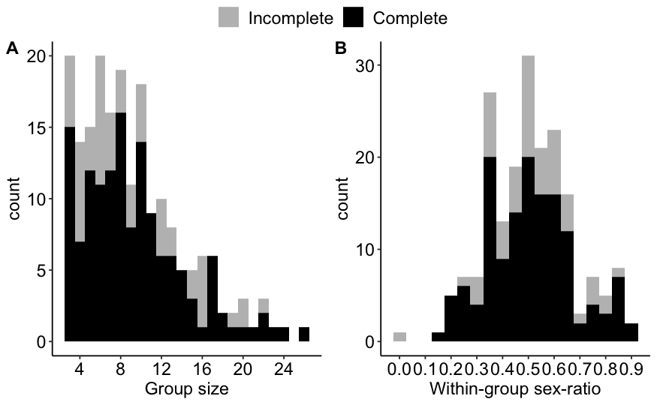
Figure S1. Histogram of number of our group captures (N = 196) used in this study of different A) group sizes and B) within-group sex ratios (as proportion of males). Black bars denote complete captures and grey incomplete (less than 24 H inactivity at traps).

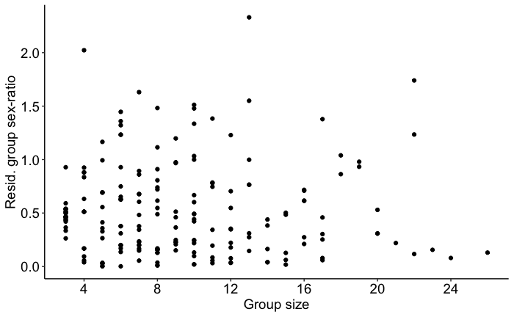
Figure S2. Residual variation of within-group sex ratio (as proportion of males) ~ group size. Each point is a group capture.
Table S1. Overview of models and datasets used in this study. Only group captures with >= 3 individuals included.
Test/Question | Response variable | Explanatory variables | Random effects | Data overview | Model type
Any overall sex ratio bias on the group level? | sex ratio group capture | 1 | GroupID | 196 group captures from 47 groups | Intercept only model, GLMM binomial
Is group sex ratio associated with group size? | sex ratio group capture | group size | GroupID | 196 group captures from 47 groups | GLMM binomial
Does variation in sex ratio of groups increase with group size? | Absolute value residual sex ratio ~ group size of group capture | group size |  | 196 group captures from 47 groups | LM Gaussian
Does group sex ratio have an effect on the number of recruits to the next capture? | N recruits standardised/ 6 month between 2 group captures | sex ratio + group size + TimeToNextCapture + BreederAge | GroupID | 89 group captures with recruitment data | LMM Gaussian
Does sex ratio of recruits even out existing sex ratio biases? | sex ratio of recruits standardised/ 6 month between 2 group captures | sex ratio + group size + TimeToNextCapture + BreederAge | GroupID | 67 group captures with recruitment data | GLMM binomial
Is growth of the non-breeders influenced by within-group sex ratio? | Body mass change between two captures | weight + sex * sex ratio + group size + TimeBetweenCaptures | GroupID+ AnimalID +  GroupCapID | 999 animal captures, 605 growth measures from 344 unique individuals and 34 groups and 167 group captures | LMM Gaussian
Is body condition of non-breeders influenced by group sex ratio? | Body condition non-breeders | sex + sex ratio + group size + weight | GroupID+ AnimalID +  GroupCapID | 858 body mass indexes from 334 individuals, 34 groups and 151 group captures | LMM Gaussian
Does group sex ratio have an effect on time of disappearance of non-breeders? | Stay or disappear to next capture | sex * sex ratio (scaled) + weight + rainfall |  | 1051 animal captures of 486 individuals | MSM
sex ratio = proportion of males
group size = number of individuals within group
sex = sex of the individual (male or female)
weight = weight in g scaled within each sex separately
rainfall = rainfall in the three months prior to capture, scaled
TimeToNextCapture = Days between group captures, scaled
TimeBetweenCaptures = Days between animal captures, scaled
BreederAge = Age of breeder female in days, scaled
* = interaction between factors
GroupID = Group identifier
AnimalID = Animal Identifier
GroupCapID = Group capture identifier
GLMM = generalised linear mixed models
LMM = linear mixed model
LM = linear model
MSM = multi-state Markov model
Table S2. Predictors of the number of recruits to the next capture standardised to per 6 months from a linear mixed model assuming Gaussian error structure. Table provides estimates, standard errors, t-values and p-values. Sex ratio is the proportion of males within a group.
Factor | Estimate | Std.Error | t-value | p-value
(Intercept) | 0.744 | 0.711 | 1.046 | 0.302
Sex ratio | 1.800 | 1.276 | 1.411 | 0.168
Group size | 0.063 | 0.039 | 1.627 | 0.111
Time to next cap | 0.088 | 0.182 | 0.485 | 0.629
Breeder female age | -0.413 | 0.200 | -2.066 | 0.043

Table S3. Predictors of the male-bias of recruits to the next capture standardised to per 6 months from a generalised linear mixed model with binomial error structure as sex ratio of recruits, bound between 0 and 1. Table provides estimates, standard errors, z-values and p-values. sex ratio is the proportion of males within a group.
Factor | Estimate | Std.Error | z-value | p-value
(Intercept) | -0.385 | 0.631 | -0.610 | 0.542
Sex ratio | -0.022 | 1.089 | -0.021 | 0.984
Group size | 0.021 | 0.026 | 0.832 | 0.405
Time to next cap | -0.195 | 0.137 | -1.418 | 0.156
Breeder female age | -0.280 | 0.150 | -1.870 | 0.061

Table S4. Hazard covariates MSM-model time of philopatry non-breeders including rainfall and body mass.
Covariate | HR | L | U
Sex (male) | 1.234 | 0.907 | 1.679
sex ratio | 0.610 | 0.132 | 2.812
Body mass | 1.401 | 1.222 | 1.606
Rainfall | 1.331 | 1.179 | 1.503
Sex * sex ratio | 1.672 | 0.250 | 11.189

Number and sex ratio of recruits calculations
Because our group captures were done opportunistically within two field seasons per year and not at fixed intervals within groups, we calculated the number and sex ratio of recruits only for group captures where the breeding female was present, the initial capture was complete and the time to the recapture was between 100 and 365 days (N = 89 group captures). We defined new recruits as all individuals not captured at the previous capture with a body size small enough to indicate the individual was younger than the time since the previous capture of the group. To be able to compare between captures, the number of recruits and sex ratio of recruits were standardised for each group capture as the number of recruits within a six-month period by dividing the number of recruits by the number of days in between captures and multiplying by 180. Only group captures with at least one recruitment were included for the sex ratio of recruits analysis (N = 67), as zero recruitment would otherwise give the false sex ratio of 0 (which would reflect 100% females).

Age estimation of breeders for recruitment analysis
For breeding females that we had captured as non-breeding individuals, we estimated the age of the individual based on the first capture weight, sex of the individual (in this case, all were females) and group size from a von Bertalanffy growth model (see Thorley and Clutton-Brock 2019 for further details). For breeding females that were already reproductively active on their first capture, and hence had already dispersed from their birth group and reached an adult body mass, we could not assign age with as high precision. Instead, we used the group size of their first capture as an indicator of how old the female was at that capture, based on the fact that most non-breeders disperse around 2 years of age, and a mean litter size of 3 pups and a maximum of 4 litters produced within a year. We made the following estimations of female breeder ages:
- group size < 5 individuals = assigned to be 3 years
- group size < 10 and 5 >= individuals = assigned to be 4 years
- group size > 10 individuals = assigned to be 5 years

Calculating body mass index/body condition
We performed standardised major axis regression to scale body mass on tooth-width measures and estimate body condition of wild caught non-breeding mole-rats. This method was proposed by Peig and Green (Peig and Green 2009) as a superior method to estimate body condition and has since been widely used on research of mammals, including in our recent study where we showed that single-females did not differ in body condition from group living non-breeding females (Thorley et al. 2023). The body condition scaling was done using the smatr-package (Warton et al. 2012), assuming that non-breeding females and males had the same scaling relationship. We used the average of two tooth-width measures taken by two observers of the upper incisors (1.00 mm precision) and the capture weight (1 gram precision) to calculate the scaled body mass index (body condition).

References
Peig J, Green AJ. 2009. New perspectives for estimating body condition from mass/length data: The scaled mass index as an alternative method. Oikos. 118(12):1883–1891. doi:10.1111/j.1600-0706.2009.17643.x.
Thorley J, Bensch HM, Finn K, Clutton-brock T, Zöttl M. 2023. Damaraland mole-rats do not rely on helpers for reproduction or survival. Evol Lett. 7(4):203–215. doi:10.1093/evlett/qrad023.
Thorley J, Clutton-Brock TH. 2019. A unified-models analysis of the development of sexual size dimorphism in Damaraland mole-rats, Fukomys damarensis. J Mammal. 100(4):1374–1386. doi:10.1093/jmammal/gyz082.
Warton DI, Duursma RA, Falster DS, Taskinen S. 2012. smatr 3- an R package for estimation and inference about allometric lines. Methods Ecol Evol. 3(2):257–259. doi:10.1111/j.2041-210X.2011.00153.x.

