Supplemental Material 5a. Sensitivity analysis for DLC as removing studies with 200 voxel size
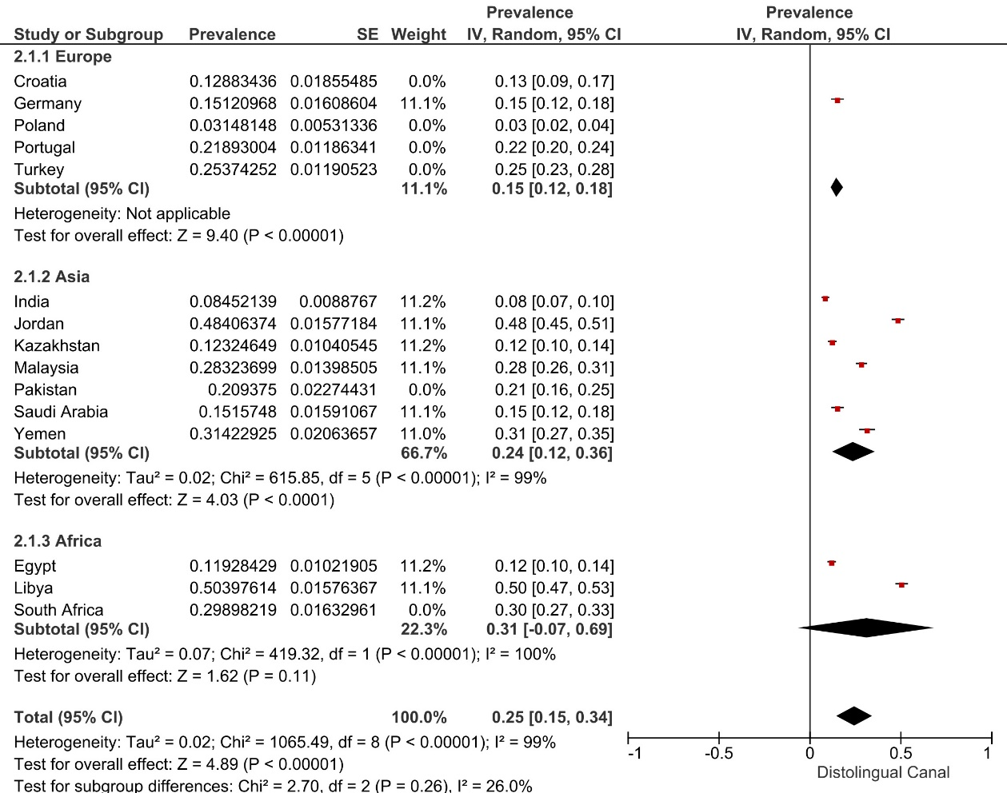

Supplemental Material 5b. Sensitivity analysis for DLC as removing studies with 170 and 200 voxel sizes
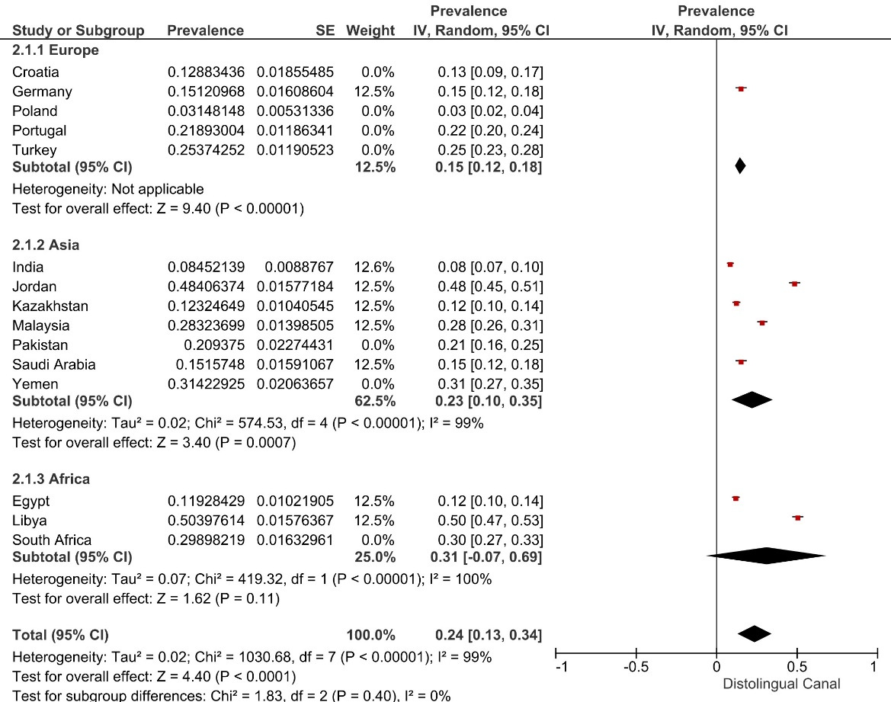

Supplemental Material 5c. Sensitivity analysis for DLC as removing studies with 160, 170 and 200 voxel sizes
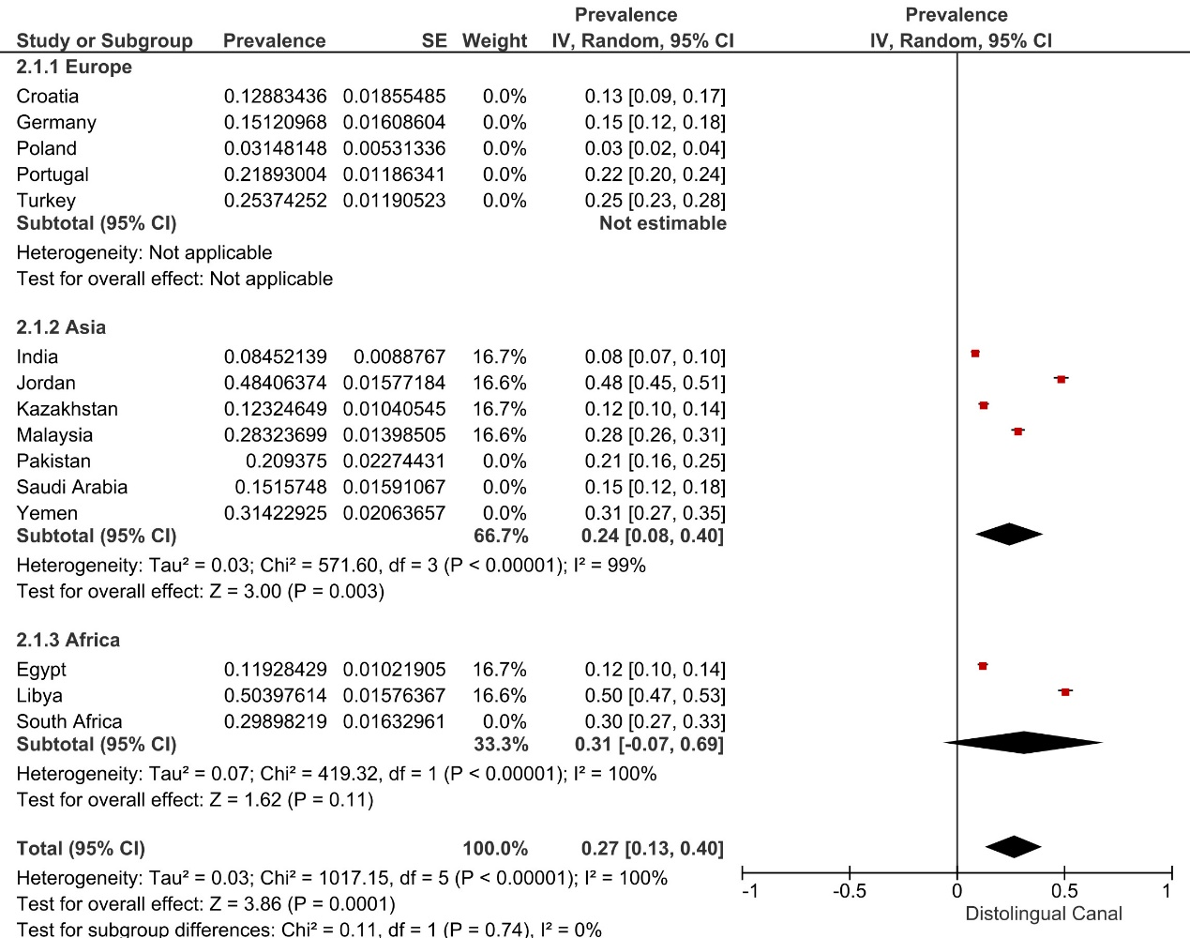

Supplemental Material 5d. Sensitivity analysis for RE as removing studies with 200 voxel sizes
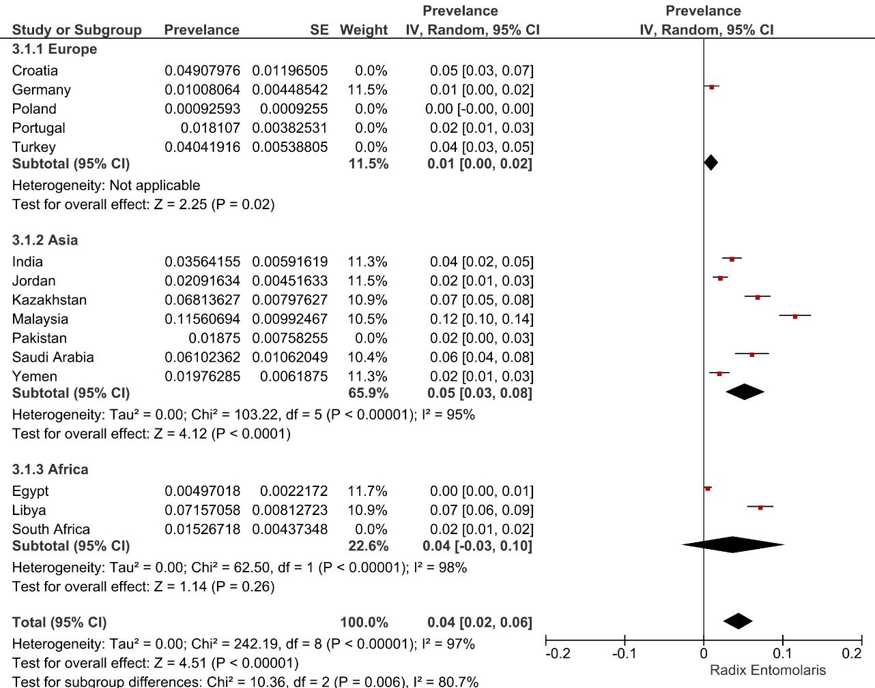
Supplemental Material 5e. Sensitivity analysis for RE as removing studies with 170 and 200 voxel sizes
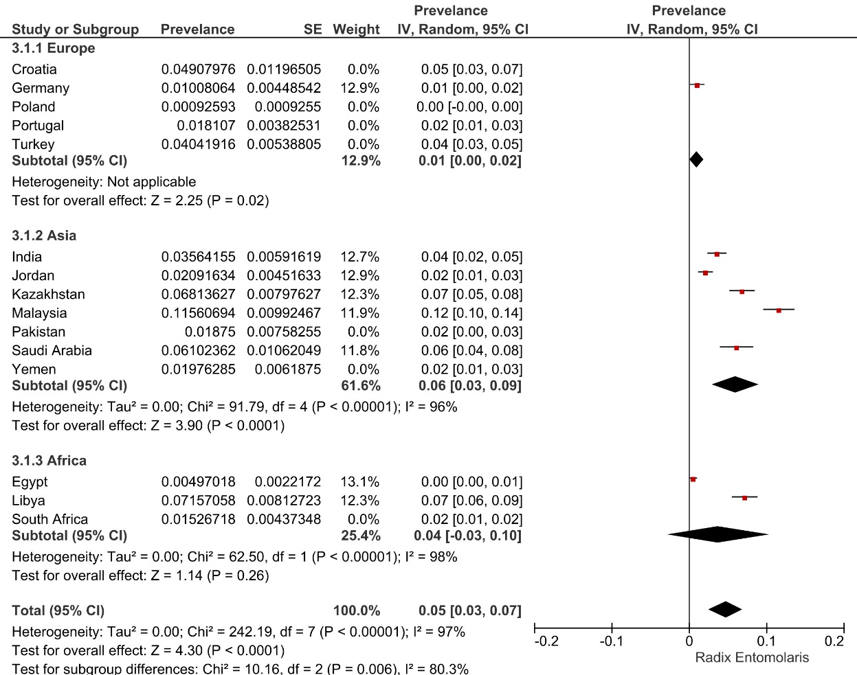

Supplemental Material 5f. Sensitivity analysis for RE as removing studies with 160, 170 and 200 voxel sizes
