Supplementary information
Intensive Feeding Modifies Nutrient Patterns in a Strictly Protected Area

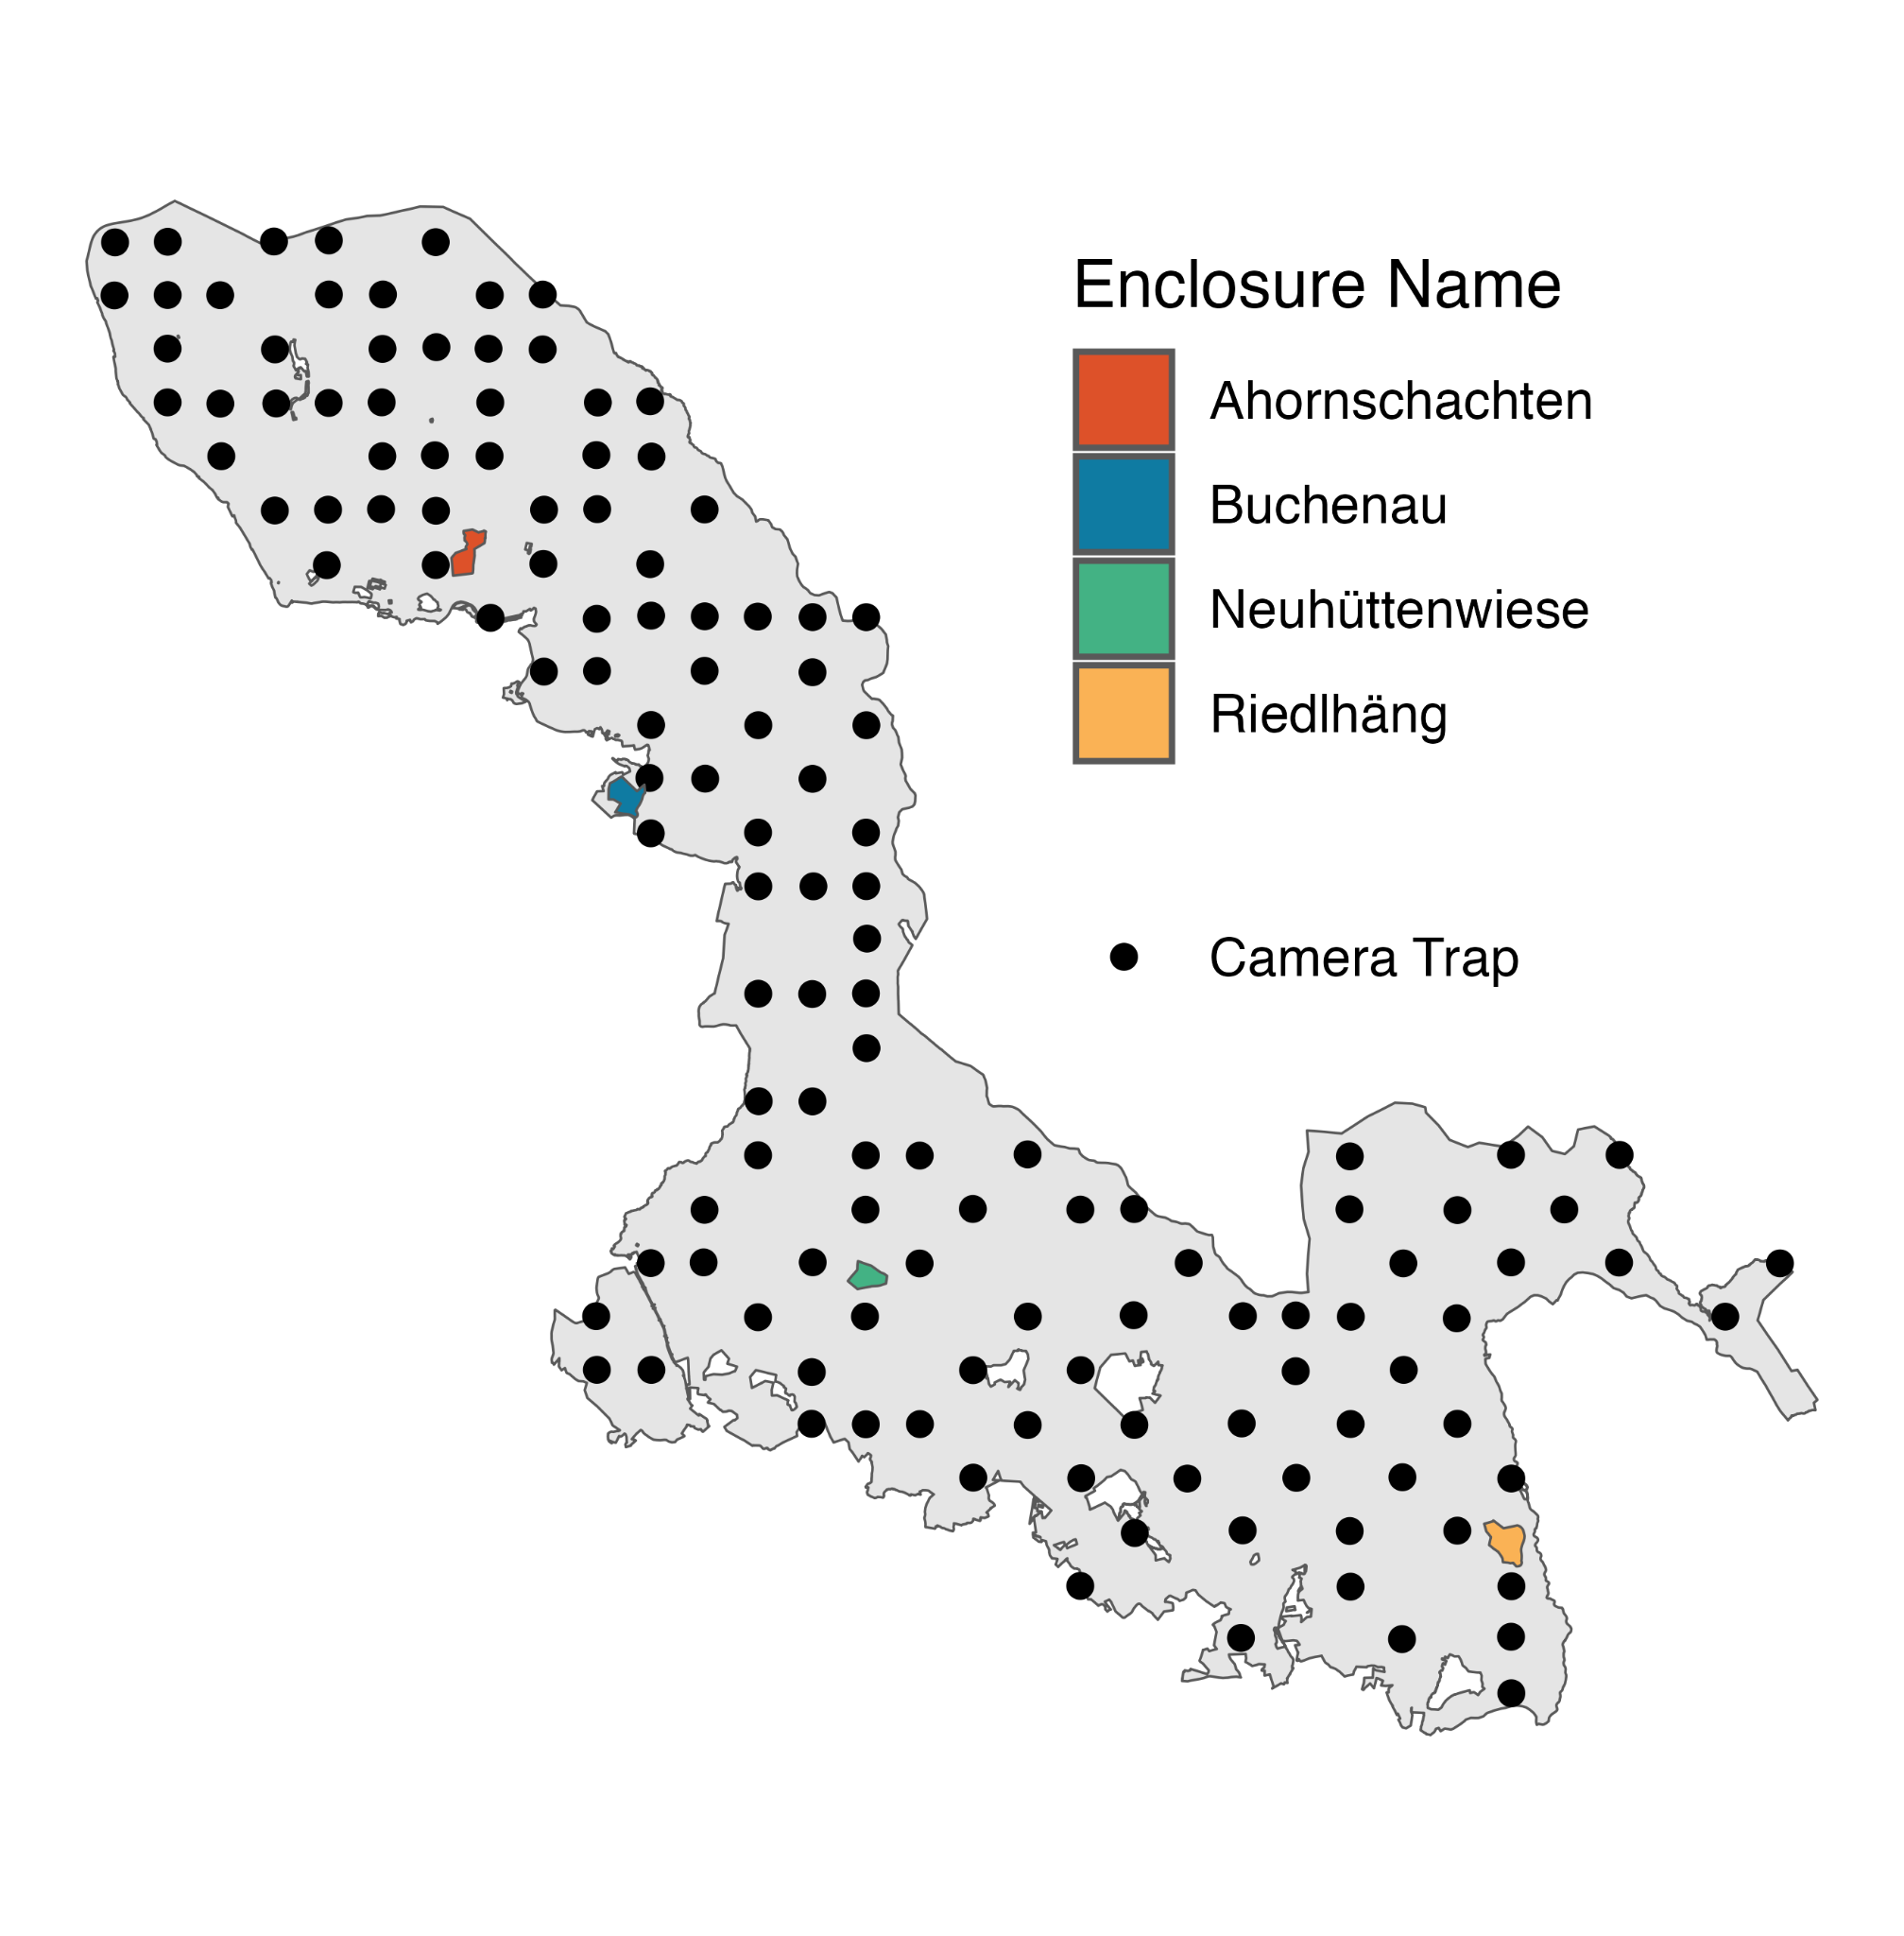
Fig. S1: Distribution of camera traps across the Bavarian Forest National Park. Cameras have been active between Oct 2023 and March 2024.
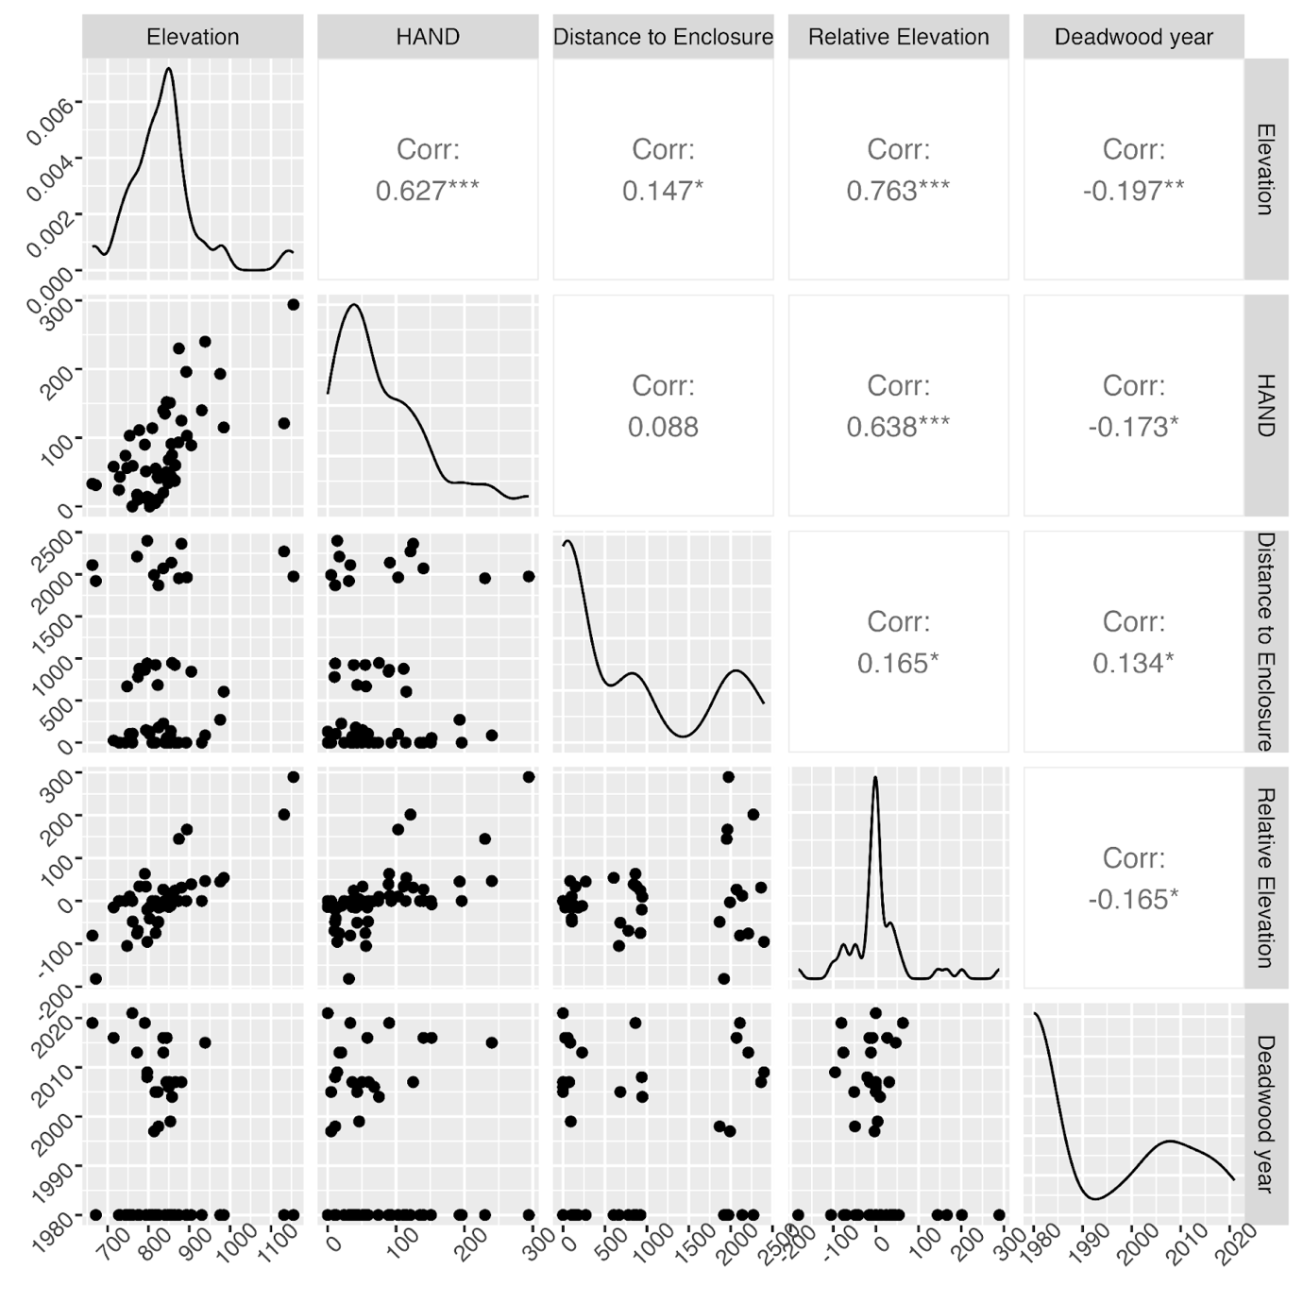
Fig. S2: Variable correlation. All units are meters, except for “Deadwood year”.
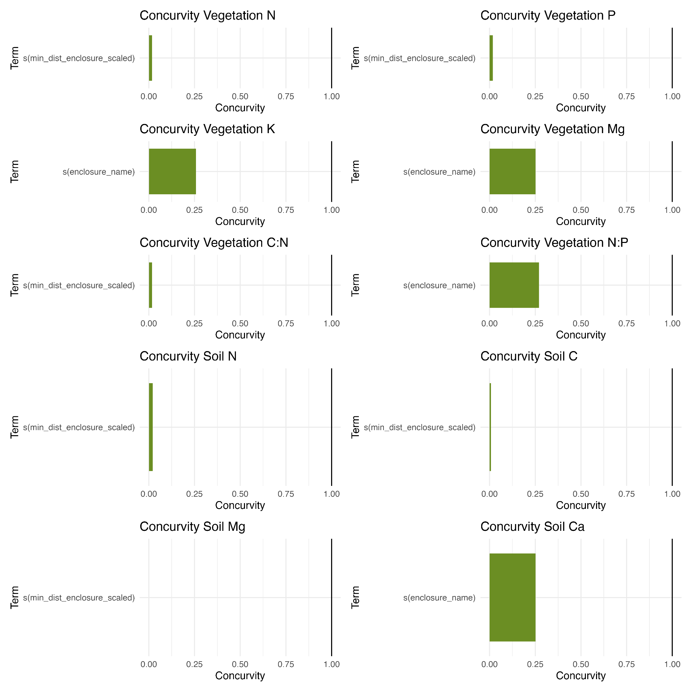
Fig. S3: Concurvity values of models with smoothed predictors. Concurvity occurs when the value of one smoothed variable can be predicted by the value of another smoothed term. Here, all models show a concurvity of well below critical values.

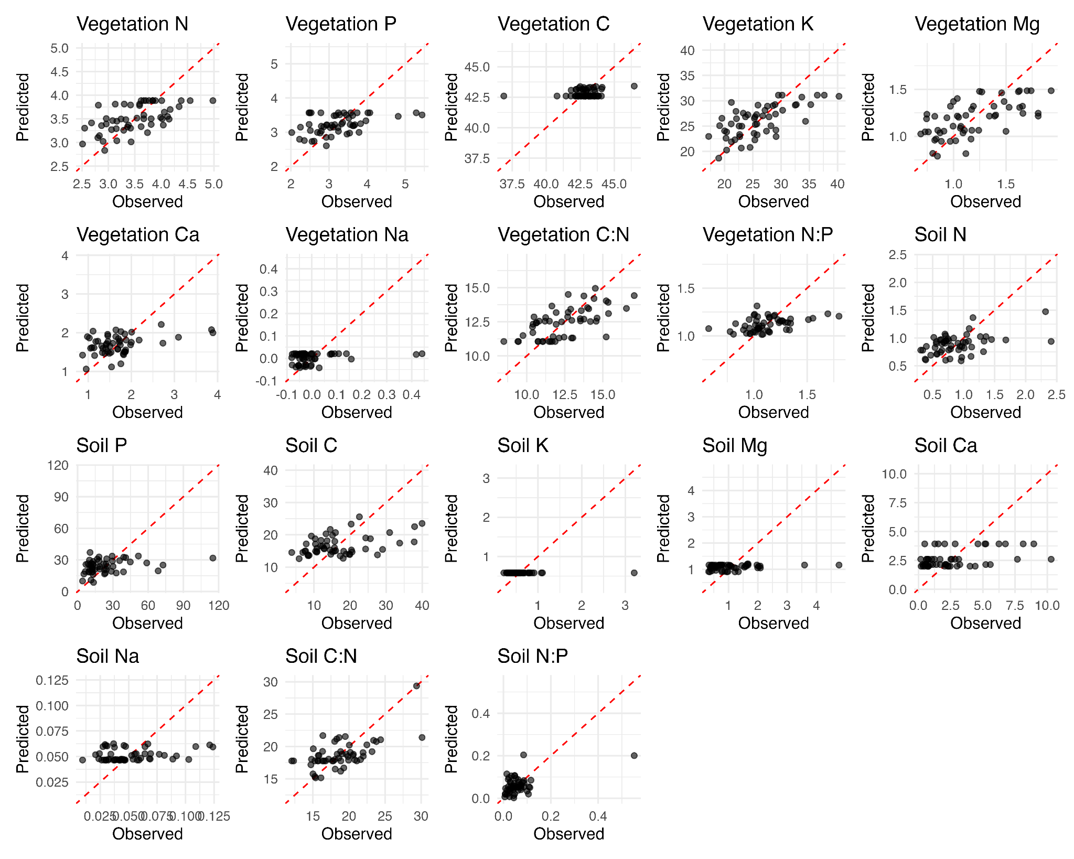
Fig. S4: Observed vs predicted values. Predictive capacity is higher for models with higher R² values (Table 1) but overall moderate. This is expected since nutrient dynamics are influenced by a variety of drivers, often interacting, of which we investigated only a few in this study.
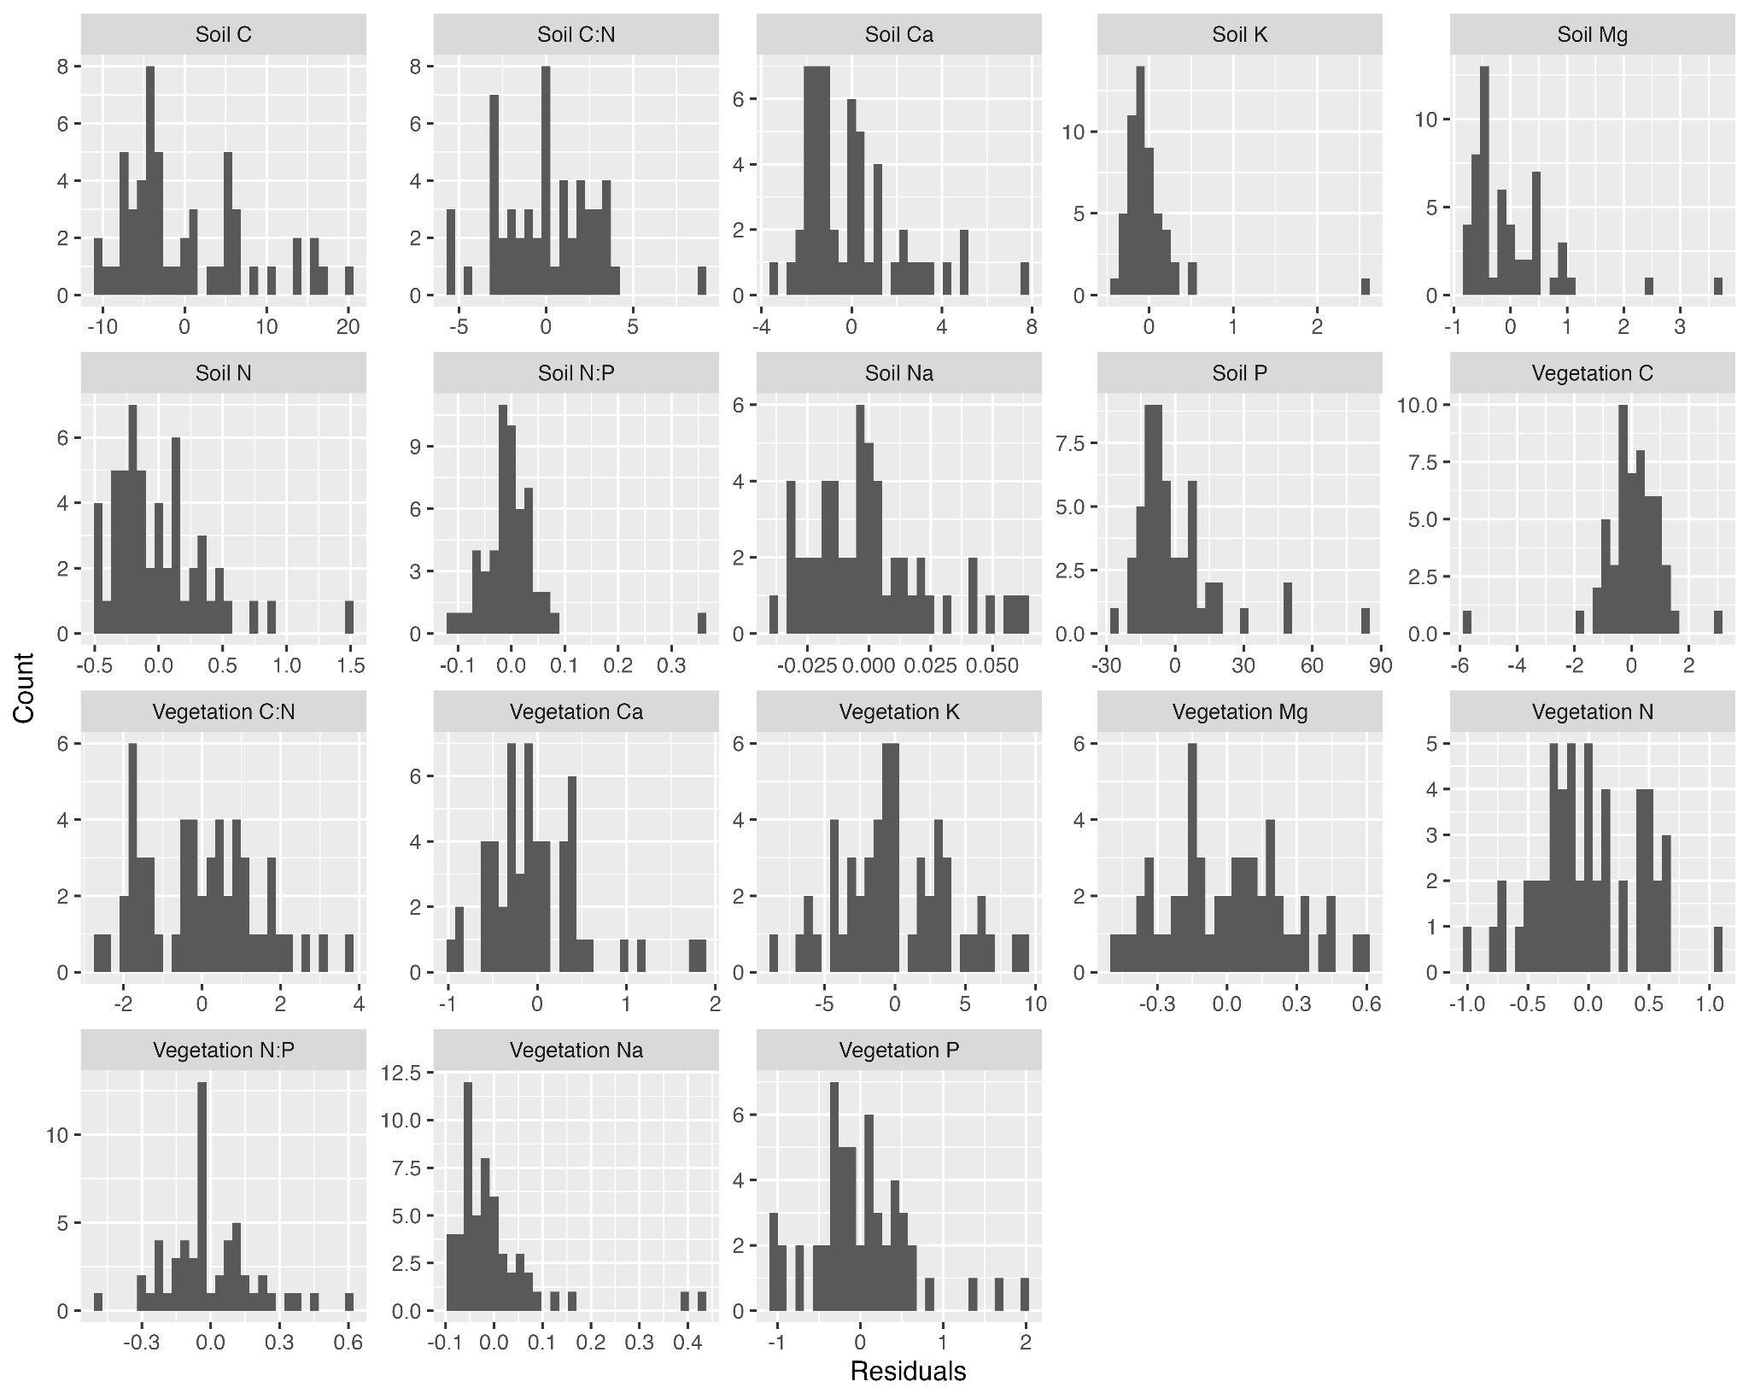
Fig. S5: Residual distribution of the best models. All models have approximately normal distributed residuals.
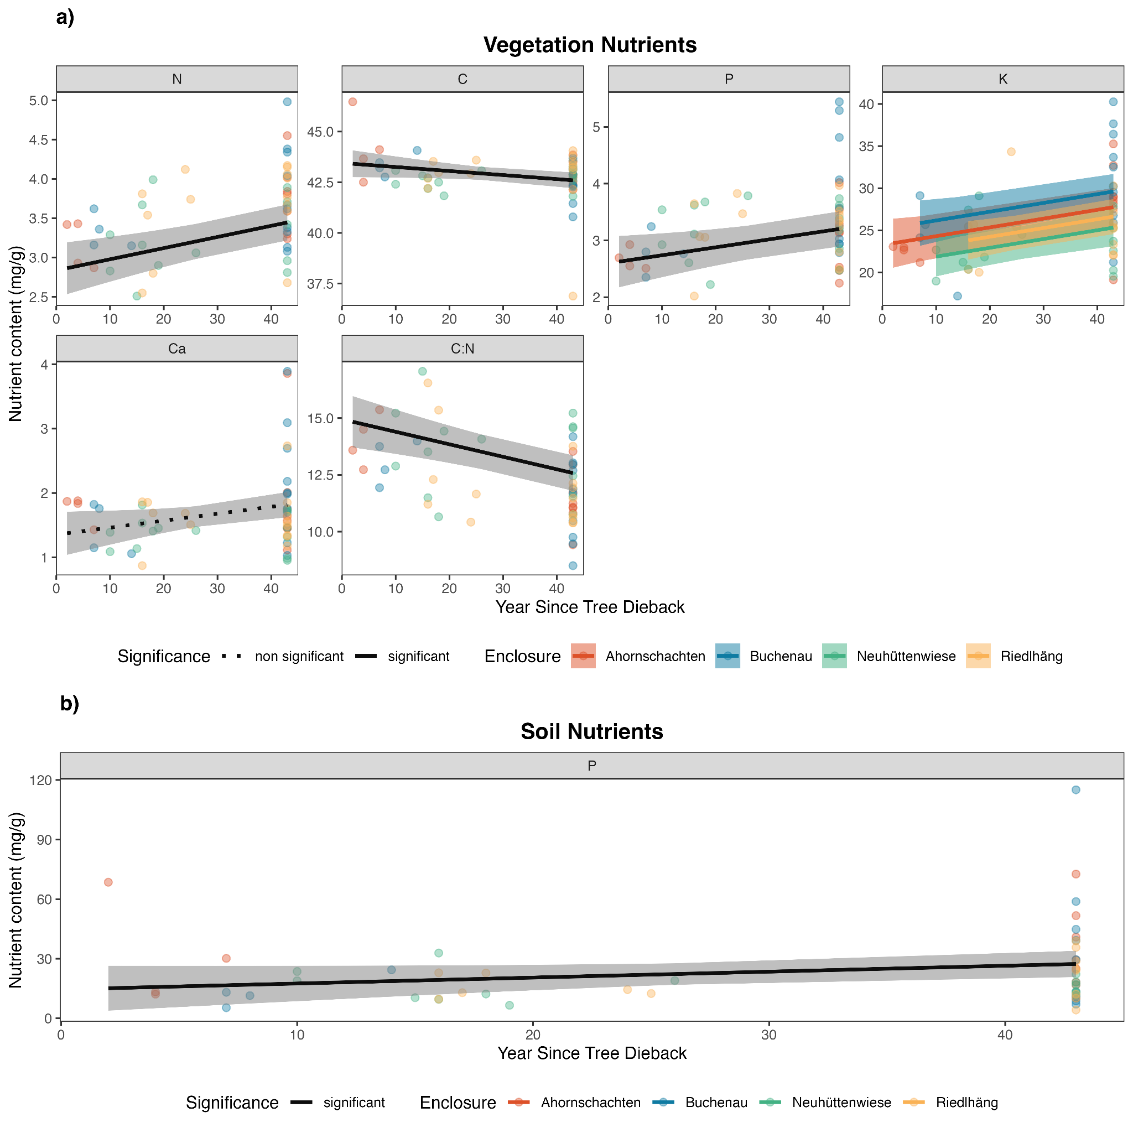
Fig. S6: Predictions for the nutrient contents in relation to the year the tree cover turned into deadwood (i.e., year of bark beetle outbreak). All points which haven’t experienced a change to deadwood since 1988 (earliest detected change in the NP) were set to 1980. X axis values have been transformed to year since tree dieback for ease of interpretation.

Table S1: N-mixture model estimates. CI refers to the 95 % confidence interval, SE is the standard error and p is the p-value. Standard errors (and therefore confidence intervals) and p value have been adjusted for the moderate overdispersion using a quasi-likelihood approach.
Component | Term | Estimate (CI) | SE | z | p
Detection | Intercept | -3.627 (-3.936; -3.317) | 0.158 | -37.599 | 0
Detection | Sampling Effort | 0.143 (0.002; 0.284) | 0.072 | 3.267 | 0.047
Detection | Vegetation Density | 0.008 (-0.38; 0.364) | 0.19 | -0.068 | 0.967
Abundance | Habitat: Coniferous | 1.156 (0.628; 1.683) | 0.269 | 7.048 | 0
Abundance | Habitat: Deadwood | 0.599 (0.021; 1.178) | 0.295 | 3.337 | 0.042
Abundance | Habitat: Deciduous Stand | 0.576 (0.011; 1.14) | 0.288 | 3.286 | 0.046
Abundance | Habitat: Mixed Stand | 0.294 (-0.278; 0.867) | 0.292 | 1.656 | 0.313
Abundance | Habitat: Open Habitat | 0.86 (0.131; 1.589) | 0.372 | 3.798 | 0.021
Abundance | Canopy Cover | -0.267 (-0.493; -0.042) | 0.115 | -3.808 | 0.02
Abundance | Elevation | -0.215 (-0.399; -0.031) | 0.094 | -3.775 | 0.022
Abundance | Vegetation Density | -0.438 (0.046; 0.83) | 0.2 | 3.601 | 0.029
Abundance | Distance to Enclosure | -0.202 (-0.376; -0.027) | 0.089 | -3.707 | 0.023

