Supplementary Material
A diagnostic biomarker profile for Fibromyalgia Syndrome based on an NMR metabolomics study of selected patients and controls
Bontle G. Malatji¹, Helgard Meyer², Shayne Mason¹, Udo F.H. Engelke³, Ron A. Wevers³, Mari van Reenen¹ and Carolus J. Reinecke¹
¹Centre for Human Metabonomics, Faculty of Natural Sciences, North-West University (Potchefstroom Campus), Private Bag X6001, Potchefstroom, South Africa,
²Department of Family Medicine, Kalafong Hospital, University of Pretoria, Private Bag X396, Pretoria, South Africa
³Radboud University Nijmegen Medical Centre, Translational Metabolic Laboratory, Department of Laboratory Medicine, PO Box 9101, 6500 HB Nijmegen, The Netherlands,

Contents
S1: Experimental subjects symptom assessment questionnaire 2
A - Fibromyalgia Impact Questionnaire (FIQR) 2
B - Clinical Questionnaire 3
S2: Comparison of FMS symptom severity with a published reference group 8
S3: Correlation table based on the FIQR questionnaire 10
S4: Normalized data of the original NMR spectral bins 16
S5: Outlier identification 17
S6: PCA Analysis 18
S7: N-acetyl aspartic acid (NAA) verification 19
Overview 19
Reagents 19
Sample preparation and analysis 19
Results and discussion 19
References: 21

S1: Experimental subjects symptom assessment questionnaire
The Fibromyalgia Impact Questionnaire (FIQR) is an internationally derived questionnaire developed by Burckhardt and co-workers [1]. It was developed with the aim to evaluate and understand the effects of therapy on the broad range of symptoms that manifest in FMS. As such, the questionnaire has routinely been used, since its official release in 1991, as a means to assess the progression of the disorder and any therapeutic interventions applied [2].
Questionnaire A in Table S1 shows this FIQR questionnaire that was voluntarily completed by the FMS patients who took part in this study. The in-house clinical questionnaire, Table S1B, was drawn up to identify secondary data about the patients for use in conjunction with the FIQR questionnaire.
Table S1: Fibromyalgia Impact Questionnaire (FIQR) (A) and Clinical questionnaire (B). Questionnaire A was used by the clinicians to assess the severity of the symptoms experienced by the FMS patients. Questionnaire B was used to gather supplementary information on the FMS patients

A - Fibromyalgia Impact Questionnaire (FIQR)
- Function domain
Directions: For each question, place an “X” in the box that best indicates how much your fibromyalgia made it difficult to do each of the following activities during the past 7 days
Brush or comb your hair | No difficulty | 0 1 2 3 4 5 6 7 8 9 10 | Very difficult
Walk continuously for 20 minutes | No difficulty | 0 1 2 3 4 5 6 7 8 9 10 | Very difficult
Prepare a homemade meal | No difficulty | 0 1 2 3 4 5 6 7 8 9 10 | Very difficult
Vacuum, scrub or sweep floors | No difficulty | 0 1 2 3 4 5 6 7 8 9 10 | Very difficult
Lift and carry a bag full of groceries | No difficulty | 0 1 2 3 4 5 6 7 8 9 10 | Very difficult
Climb one flight of stairs | No difficulty | 0 1 2 3 4 5 6 7 8 9 10 | Very difficult
Change bed sheets | No difficulty | 0 1 2 3 4 5 6 7 8 9 10 | Very difficult
Sit in a chair for 45 minutes | No difficulty | 0 1 2 3 4 5 6 7 8 9 10 | Very difficult
Go shopping for groceries | No difficulty | 0 1 2 3 4 5 6 7 8 9 10 | Very difficult

- Overall impact domain:
Directions: For each question, check the one box that best describes the overall impact of your fibromyalgia over the last 7 days:

Fibromyalgia prevented me from accomplishing goals for the week | Never | 0 1 2 3 4 5 6 7 8 9 10 | Always
I was completely overwhelmed by my fibromyalgia symptoms | Never | 0 1 2 3 4 5 6 7 8 9 10 | Always

- Symptoms domain:
Directions: For each of the following 10 questions, select the one circle that best indicates the intensity of your fibromyalgia symptoms over the past 7 days

Please rate your level of pain | No pain | 0 1 2 3 4 5 6 7 8 9 10 | Unbearable pain
Please rate your level of energy | Lots of energy | 0 1 2 3 4 5 6 7 8 9 10 | No energy
Please rate your level of stiffness | No stiffness | 0 1 2 3 4 5 6 7 8 9 10 | Severe stiffness
Please rate the quality of your sleep | Awoke well rested | 0 1 2 3 4 5 6 7 8 9 10 | Awoke very tired
Please rate your level of depression | No depression | 0 1 2 3 4 5 6 7 8 9 10 | Very depressed
Please rate your level of memory problems | Good memory | 0 1 2 3 4 5 6 7 8 9 10 | Very poor memory
Please rate your level of anxiety | Not anxious | 0 1 2 3 4 5 6 7 8 9 10 | Very anxious
Please rate your level of tenderness to touch | No tenderness | 0 1 2 3 4 5 6 7 8 9 10 | Very tender
Please rate your level of balance problems | No imbalance | 0 1 2 3 4 5 6 7 8 9 10 | Severe imbalance
Please rate your level of sensitivity to loud noises, bright lights, odors and cold | No sensitivity | 0 1 2 3 4 5 6 7 8 9 10 | Extreme sensitivity

B - Clinical Questionnaire

- Age: |  |  |  |  | Years |  |  |  |  | Months
- Relationship status: |  | 1. Married |  | 2. Engaged |  |  | 3. In a relationship, but not married or engaged |  |  |  | 4. Single
- Current employment status | 1. Fulltime employed |  | 2. Part-time employed |  |  | 3. Home executive (housewife) |  |  | 4. Retired |  |  | 5. Disabled

- How long ago did your fibromyalgia symptoms start (e.g. widespread muscle pain, poor sleep, fatigue, headaches, etc.) |  |  |  |  | Years |  | Months
- How long ago were you diagnosed with fibromyalgia? |  |  |  |  | Years |  | Months
- (a) Were your fibromyalgia symptoms triggered by? Please tick (√)  (you may tick more than one block) |  |  | 1. Neck injury
 |  |  | 2. Other injuries
 |  |  | 3. After surgical procedure
 |  |  | 4. Severe emotional stress
 |  |  | 5. Acute infection
 |  |  | 6. Spontaneous onset
 |  |  | 7. Uncertain
(b) | Length
(b) | Bodyweight

- Please rate your pain by circling the one number that best describes you pain at its worst in the last month. (A rating of 10 would indicate pain so severe as to prohibit all activity; the worst pain you can imagine.)
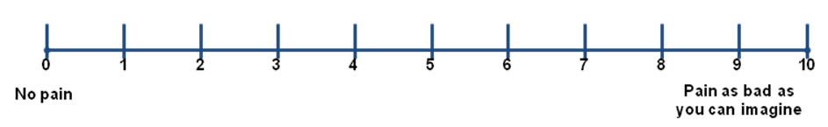
- Please rate your pain by circling the one number that best describes you pain on the average in the last month. (A rating of 10 would indicate pain so severe as to prohibit all activity; the worst pain you can imagine.)

- (i) Which medications are you receiving for your pain?
Please tick
Trepeline |  | Lyrica
Cymbalta |  | Syndol
Tramal (Tramahexal) |  | Myprodol
Tenston |  | Mypaid
Stilpayne |  | Cataflam
Other

(ii) How often do you take pain killers (e.g. Tramal, Tramahexal, Tramacet, Panado, Syndol., Mypaid, Cataflam, Voltaren, etc.)
± Once a week
± Twice a week
± Three days a week
± Every second day
± Daily

10. | During the past week how much did the state of your health, including any pain, interfere with the following things: choose the one number, from 0 to 4 below, that best describes your state and write them in the appropriate box (I to vi).  - Not at all  - A little bit  - Moderately  - Quite a bit  - Extremely
- Mood
- Relations with other people
- Walking ability
- Sleep
- Normal Work (includes both work outside the home and housework)
- Enjoyment of life
- Have you ever been diagnosed and treated for depression |  | Yes |  |  | No
- Do you suffer from regular headaches? |  |  | Yes |  | No
- Irritable bowel syndrome (IBS) is known to commonly affect patients with fibromyalgia. It is characterized by abdominal pain and cramps as well as bloating, flatulence, diarrhea and/or constipation
Have you ever been diagnosed with IBS? |  |  | Yes |  | No

- Restless leg syndrome (RLS) is characterized by uncomfortable sensations in the lower legs and an uncontrollable urge to move them so as to provide relief. Some of the sensations felt in RLS include burning, creeping or a crawling feeling inside the legs.
Have you ever experienced symptoms of RLS? |  |  |  |  | Yes |  |  |  | No
15. Have you suffered from anxiety since being diagnosed with fibromyalgia or thereafter? (Symptoms such as feeling nervous most of the time, not able to control worrying, etc.) |  |  | Yes |  |  |  |  |  | No
16. If yes, have you been diagnosed and treated for anxiety? |  |  | Yes |  |  |  |  |  | No
- Have you ever suffered from a sleep disturbance? |  |  | Yes |  |  |  |  |  | No
If yes, please tick the appropriate block(s)  (you may tick more than one block) | Problem with sleep initiation
 | Problem with maintaining sleep
 | Early morning awakening
 | Waking up feeling unrefreshed
- Dysmenorrhoea is defined as painful menstruation often associated with cramps for mostly 1–3 days after beginning of menstruation.
Were you treated before or are you currently being treated for dysmenorrhoea? |  |  |  |  | Yes
 |  |  |  |  | No

Table S2: Summary of the supplementary data collected based on the in-house questionnaire (Table S1B) completed by the FMS patient group.
Variable | Mean  (SD) | %
1. Socio-demographic information
Age (years) | 45.5 | n/a
Marital status  Single  Separated/Divorced/Widow  In permanent relationship  Married | 2  0  2  15 | 11  0  11  78
Employment  Disabled/Retired  Housewife  Part-time  Full-time | 2  6  1  10 | 11  32  5  52
2. Pain experience
Worst pain experience | 7,7 | n/a
Recent past pain average | 5,7 | n/a
Pain specific medication  Trepiline (antidepressant for neuropathic pain)  Cymbalta (antidepressant for chronic pain)  Tramal (analgesic for moderate to severe pain)  Myprodol (relief of pain of inflammatory origin)  Patients using also other medication against pain | 12  10  9  6  11 | 63  52  47  32  58
3. Levels of emotional experiences affected by FMS  Mood  Relations with other people  Enjoyment of life  Normal work | 2.3  2.2  2.1  2.4 | n/a
0 = Not at all 1 = A little bit 2 = Moderately 3 = Quite a bit 4 = Extremely

S2: Comparison of FMS symptom severity with a published reference group
The mean scores of FMS patients’ symptoms based on severity in relation to the published reference group [3] are shown in Table S3.
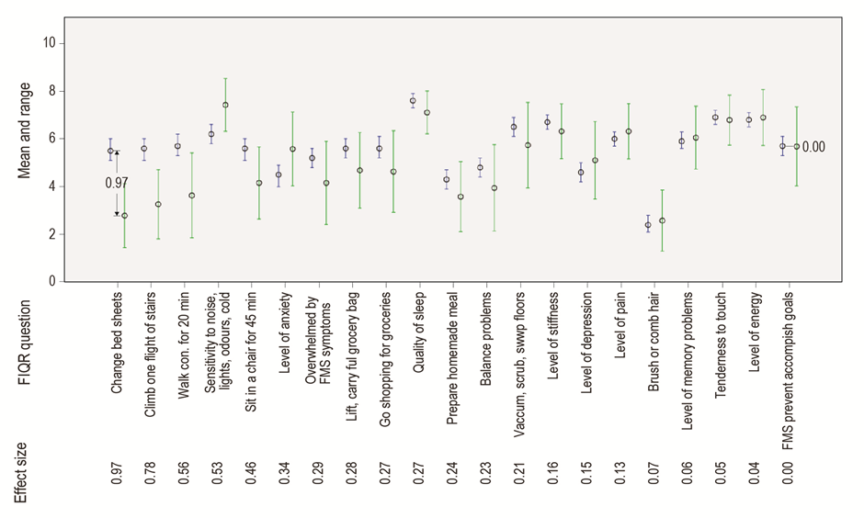
Figure S1: Comparison of minimum, mean and maximum scores of fibromyalgia patients’ symptoms based on severity in relation to a published reference group. Every FIQR question is compared with the data from a reference group, presented for the revised FIQR. The questions are ranked according to the difference between the effect sizes (ES) ranked from high to low (1.0 ≥ ES ≥ 0.00), with the mean values shown as a circular point in the figure. The range of points scored for the reference group is shown in blue and for the present FMS group by green vertical bars.

Higher scores are indicative of greater dysfunction or symptom severity, while differences between the blue (previously published study) and green (current study) observed ranges show how the current patient group differs from another patient group. These differences were also quantified using Cohen’s d-value as a measure of practical significance of differences (i.e. effect size). Effect sizes exceeding 0.5 are considered practically visible, whereas those exceeding 0.8 are considered practically significant [4]. The six highest scores reported for the reference group were: sleep quality (mean 7.61 ± 2.4 (standard deviation)), tenderness to touch (6.86 ± 2.5), energy level (6.80 ± 2.4), stiffness (6.72 ± 2.2), sensitivity to the environment (6.19 ± 2.9), and pain (6.01 ± 2.1). The mean values of the highest scores obtained for the present FMS group remarkably resemble the published observations: sensitivity to the environment > sleep quality > energy level > tenderness to touch > stiffness and pain. Likewise, ‘difficulty with combing hair' had the lowest score in both groups. The scores for the three FIQR domains did, however, indicate some clear differences between the two groups: Reliability was assessed using Cronbach’s alpha coefficient (α) and indicated reliability for all domains. The mean values (reference group vs present group) obtained were 18 vs 36 for the ‘Function domain’ (α = 0.94 and mean inter-item correlation = 0.62); 11 vs 10 for the ‘Impact domain’ (α = 0.89 and mean inter-item correlation = 0.8) and 30 vs 60 for the ‘Symptoms domain’ (α = 0.88 and mean inter-item correlation = 0.44). The total scores (α = 0.95 and mean inter-item correlation = 0.5) were comparable: 55 vs 50. It is important, finally, to notice that the difference between the minimum and maximum scores obtained for all 21 questions involving the present group mostly exceeded the values for the reference group, clearly suggesting a greater diversity between the present FMS patients group than in the reference group.

S3: Correlation table based on the FIQR questionnaire
Table S3: Correlation table data, as based on the FIQR questionnaire, used to draw up Fig. 1 in the main article.
Comparison | Correlation coefficient | Correlation coefficient | p-value
(As quoted in Fig. 1
of main article)
Hair correlation with Walk | 0.466454 | 0.5 | 0.012
Hair correlation with Meals | 0.418437 | 0.4 | 0.024
Hair correlation with Clean | 0.460269 | 0.5 | 0.014
Hair correlation with Carry | 0.421214 | 0.4 | 0.022
Hair correlation with Stairs | 0.216187 | 0.2 | 0.247
Hair correlation with Make bed | 0.177345 | 0.2 | 0.345
Hair correlation with Sit | 0.307686 | 0.3 | 0.095
Hair correlation with Shop | 0.269565 | 0.3 | 0.154
Hair correlation with Goals | 0.335035 | 0.3 | 0.070
Hair correlation with Symptoms | 0.195924 | 0.2 | 0.296
Hair correlation with Pain | 0.261516 | 0.3 | 0.159
Hair correlation with Energy | 0.068820 | 0.1 | 0.710
Hair correlation with Stiffness | 0.497131 | 0.5 | 0.007
Hair correlation with Sleep | 0.157715 | 0.2 | 0.407
Hair correlation with Depression | 0.014139 | 0.0 | 0.940
Hair correlation with Memory | 0.048174 | 0.0 | 0.795
Hair correlation with Anxiety | -0.151901 | -0.2 | 0.414
Hair correlation with Tenderness | 0.202921 | 0.2 | 0.279
Hair correlation with Balance | 0.079710 | 0.1 | 0.676
Hair correlation with Environment | 0.020921 | 0.0 | 0.911
Walk correlation with Meals | 0.538961 | 0.5 | 0.003
Walk correlation with Clean | 0.719570 | 0.7 | 0.000
Walk correlation with Carry | 0.636686 | 0.6 | 0.000
Walk correlation with Stairs | 0.646953 | 0.6 | 0.000
Walk correlation with Make bed | 0.483494 | 0.5 | 0.008
Walk correlation with Sit | 0.614890 | 0.6 | 0.001
Walk correlation with Shop | 0.557361 | 0.6 | 0.002
Walk correlation with Goals | 0.550165 | 0.6 | 0.002
Walk correlation with Symptoms | 0.609392 | 0.6 | 0.001
Walk correlation with Pain | 0.553749 | 0.6 | 0.002
Walk correlation with Energy | 0.403911 | 0.4 | 0.025
Walk correlation with Stiffness | 0.620928 | 0.6 | 0.001
Walk correlation with Sleep | 0.149298 | 0.1 | 0.420
Walk correlation with Depression | 0.281064 | 0.3 | 0.124
Walk correlation with Memory | 0.312705 | 0.3 | 0.083
Walk correlation with Anxiety | 0.078433 | 0.1 | 0.665
Walk correlation with Tenderness | 0.549777 | 0.5 | 0.003
Walk correlation with Balance | 0.342981 | 0.3 | 0.065
Walk correlation with Environment | 0.389492 | 0.4 | 0.033
Meals correlation with Clean | 0.666757 | 0.7 | 0.000
Meals correlation with Carry | 0.546649 | 0.5 | 0.002
Meals correlation with Stairs | 0.448906 | 0.4 | 0.014
Meals correlation with Make bed | 0.718525 | 0.7 | 0.000
Meals correlation with Sit | 0.569582 | 0.6 | 0.002
Meals correlation with Shop | 0.443203 | 0.4 | 0.016
Meals correlation with Goals | 0.563110 | 0.6 | 0.002
Meals correlation with Symptoms | 0.563025 | 0.6 | 0.002
Meals correlation with Pain | 0.508146 | 0.5 | 0.005
Meals correlation with Energy | 0.469058 | 0.5 | 0.009
Meals correlation with Stiffness | 0.411774 | 0.4 | 0.023
Meals correlation with Sleep | 0.278236 | 0.3 | 0.133
Meals correlation with Depression | 0.267680 | 0.3 | 0.143
Meals correlation with Memory | 0.175897 | 0.2 | 0.331
Meals correlation with Anxiety | 0.176474 | 0.2 | 0.330
Meals correlation with Tenderness | 0.245081 | 0.2 | 0.180
Meals correlation with Balance | 0.377279 | 0.4 | 0.042
Meals correlation with Environment | 0.237656 | 0.2 | 0.193
Clean correlation with Carry | 0.778044 | 0.8 | 0.000
Clean correlation with Stairs | 0.416107 | 0.4 | 0.024
Clean correlation with Make bed | 0.505193 | 0.5 | 0.006
Clean correlation with Sit | 0.723825 | 0.7 | 0.000
Clean correlation with Shop | 0.716828 | 0.7 | 0.000
Clean correlation with Goals | 0.684344 | 0.7 | 0.000
Clean correlation with Symptoms | 0.653202 | 0.7 | 0.000
Clean correlation with Pain | 0.695425 | 0.7 | 0.000
Clean correlation with Energy | 0.456994 | 0.5 | 0.012
Clean correlation with Stiffness | 0.578102 | 0.6 | 0.002
Clean correlation with Sleep | 0.241471 | 0.2 | 0.198
Clean correlation with Depression | 0.326561 | 0.3 | 0.078
Clean correlation with Memory | 0.377517 | 0.4 | 0.039
Clean correlation with Anxiety | 0.186056 | 0.2 | 0.310
Clean correlation with Tenderness | 0.316500 | 0.3 | 0.087
Clean correlation with Balance | 0.474216 | 0.5 | 0.012
Clean correlation with Environment | 0.248322 | 0.2 | 0.178
Carry correlation with Stairs | 0.424982 | 0.4 | 0.019
Carry correlation with Make bed | 0.399043 | 0.4 | 0.029
Carry correlation with Sit | 0.576935 | 0.6 | 0.001
Carry correlation with Shop | 0.645120 | 0.6 | 0.000
Carry correlation with Goals | 0.685912 | 0.7 | 0.000
Carry correlation with Symptoms | 0.656023 | 0.7 | 0.000
Carry correlation with Pain | 0.703284 | 0.7 | 0.000
Carry correlation with Energy | 0.541981 | 0.5 | 0.003
Carry correlation with Stiffness | 0.543761 | 0.5 | 0.003
Carry correlation with Sleep | 0.396545 | 0.4 | 0.031
Carry correlation with Depression | 0.192205 | 0.2 | 0.290
Carry correlation with Memory | 0.322608 | 0.3 | 0.073
Carry correlation with Anxiety | 0.110047 | 0.1 | 0.541
Carry correlation with Tenderness | 0.380494 | 0.4 | 0.036
Carry correlation with Balance | 0.353276 | 0.4 | 0.056
Carry correlation with Environment | 0.241913 | 0.2 | 0.182
Stairs correlation with Make bed | 0.539328 | 0.5 | 0.004
Stairs correlation with Sit | 0.473776 | 0.5 | 0.009
Stairs correlation with Shop | 0.512020 | 0.5 | 0.006
Stairs correlation with Goals | 0.421135 | 0.4 | 0.020
Stairs correlation with Symptoms | 0.478117 | 0.5 | 0.010
Stairs correlation with Pain | 0.344401 | 0.3 | 0.059
Stairs correlation with Energy | 0.357647 | 0.4 | 0.050
Stairs correlation with Stiffness | 0.598036 | 0.6 | 0.001
Stairs correlation with Sleep | 0.075891 | 0.1 | 0.685
Stairs correlation with Depression | 0.197297 | 0.2 | 0.285
Stairs correlation with Memory | 0.245055 | 0.2 | 0.179
Stairs correlation with Anxiety | 0.079738 | 0.1 | 0.663
Stairs correlation with Tenderness | 0.397309 | 0.4 | 0.031
Stairs correlation with Balance | 0.488164 | 0.5 | 0.009
Stairs correlation with Environment | 0.382550 | 0.4 | 0.038
Make bed correlation with Sit | 0.522093 | 0.5 | 0.004
Make bed correlation with Shop | 0.437500 | 0.4 | 0.020
Make bed correlation with Goals | 0.428384 | 0.4 | 0.019
Make bed correlation with Symptoms | 0.561697 | 0.6 | 0.003
Make bed correlation with Pain | 0.464860 | 0.5 | 0.011
Make bed correlation with Energy | 0.410963 | 0.4 | 0.025
Make bed correlation with Stiffness | 0.310924 | 0.3 | 0.092
Make bed correlation with Sleep | 0.189484 | 0.2 | 0.315
Make bed correlation with Depression | 0.304500 | 0.3 | 0.101
Make bed correlation with Memory | 0.276221 | 0.3 | 0.133
Make bed correlation with Anxiety | 0.202777 | 0.2 | 0.271
Make bed correlation with Tenderness | 0.363048 | 0.4 | 0.051
Make bed correlation with Balance | 0.581692 | 0.6 | 0.002
Make bed correlation with Environment | 0.423270 | 0.4 | 0.022
Sit correlation with Shop | 0.716204 | 0.7 | 0.000
Sit correlation with Goals | 0.425806 | 0.4 | 0.018
Sit correlation with Symptoms | 0.561206 | 0.6 | 0.002
Sit correlation with Pain | 0.571441 | 0.6 | 0.002
Sit correlation with Energy | 0.324682 | 0.3 | 0.072
Sit correlation with Stiffness | 0.605892 | 0.6 | 0.001
Sit correlation with Sleep | 0.142051 | 0.1 | 0.442
Sit correlation with Depression | 0.466926 | 0.5 | 0.011
Sit correlation with Memory | 0.266239 | 0.3 | 0.140
Sit correlation with Anxiety | 0.293174 | 0.3 | 0.105
Sit correlation with Tenderness | 0.297109 | 0.3 | 0.103
Sit correlation with Balance | 0.369223 | 0.4 | 0.046
Sit correlation with Environment | 0.401394 | 0.4 | 0.027
Shop correlation with Goals | 0.602414 | 0.6 | 0.001
Shop correlation with Symptoms | 0.568546 | 0.6 | 0.002
Shop correlation with Pain | 0.633287 | 0.6 | 0.001
Shop correlation with Energy | 0.384015 | 0.4 | 0.038
Shop correlation with Stiffness | 0.567775 | 0.6 | 0.002
Shop correlation with Sleep | 0.287735 | 0.3 | 0.129
Shop correlation with Depression | 0.346023 | 0.3 | 0.064
Shop correlation with Memory | 0.498545 | 0.5 | 0.007
Shop correlation with Anxiety | 0.297406 | 0.3 | 0.108
Shop correlation with Tenderness | 0.287698 | 0.3 | 0.124
Shop correlation with Balance | 0.560411 | 0.6 | 0.003
Shop correlation with Environment | 0.307212 | 0.3 | 0.099
Goals correlation with Symptoms | 0.680049 | 0.7 | 0.000
Goals correlation with Pain | 0.727288 | 0.7 | 0.000
Goals correlation with Energy | 0.538972 | 0.5 | 0.003
Goals correlation with Stiffness | 0.553772 | 0.6 | 0.002
Goals correlation with Sleep | 0.473503 | 0.5 | 0.011
Goals correlation with Depression | 0.266815 | 0.3 | 0.144
Goals correlation with Memory | 0.311695 | 0.3 | 0.084
Goals correlation with Anxiety | 0.234539 | 0.2 | 0.195
Goals correlation with Tenderness | 0.343326 | 0.3 | 0.060
Goals correlation with Balance | 0.376060 | 0.4 | 0.043
Goals correlation with Environment | 0.144765 | 0.1 | 0.427
Symptoms correlation with Pain | 0.817389 | 0.8 | 0.000
Symptoms correlation with Energy | 0.651253 | 0.7 | 0.000
Symptoms correlation with Stiffness | 0.360032 | 0.4 | 0.050
Symptoms correlation with Sleep | 0.470726 | 0.5 | 0.012
Symptoms correlation with Depression | 0.409578 | 0.4 | 0.027
Symptoms correlation with Memory | 0.465180 | 0.5 | 0.011
Symptoms correlation with Anxiety | 0.380034 | 0.4 | 0.039
Symptoms correlation with Tenderness | 0.459459 | 0.5 | 0.013
Symptoms correlation with Balance | 0.510802 | 0.5 | 0.007
Symptoms correlation with Environment | 0.417511 | 0.4 | 0.024
Pain correlation with Energy | 0.562092 | 0.6 | 0.002
Pain correlation with Stiffness | 0.452461 | 0.5 | 0.013
Pain correlation with Sleep | 0.510630 | 0.5 | 0.006
Pain correlation with Depression | 0.443113 | 0.4 | 0.016
Pain correlation with Memory | 0.411765 | 0.4 | 0.023
Pain correlation with Anxiety | 0.400002 | 0.4 | 0.028
Pain correlation with Tenderness | 0.365499 | 0.4 | 0.046
Pain correlation with Balance | 0.392274 | 0.4 | 0.035
Pain correlation with Environment | 0.251678 | 0.3 | 0.169
Energy correlation with Stiffness | 0.288526 | 0.3 | 0.112
Energy correlation with Sleep | 0.510630 | 0.5 | 0.006
Energy correlation with Depression | 0.416257 | 0.4 | 0.023
Energy correlation with Memory | 0.503268 | 0.5 | 0.005
Energy correlation with Anxiety | 0.419674 | 0.4 | 0.021
Energy correlation with Tenderness | 0.159490 | 0.2 | 0.384
Energy correlation with Balance | 0.385392 | 0.4 | 0.038
Energy correlation with Environment | 0.304662 | 0.3 | 0.095
Stiffness correlation with Sleep | 0.136615 | 0.1 | 0.463
Stiffness correlation with Depression | 0.303115 | 0.3 | 0.099
Stiffness correlation with Memory | 0.078689 | 0.1 | 0.665
Stiffness correlation with Anxiety | 0.118421 | 0.1 | 0.516
Stiffness correlation with Tenderness | 0.313361 | 0.3 | 0.088
Stiffness correlation with Balance | 0.138092 | 0.1 | 0.460
Stiffness correlation with Environment | 0.179411 | 0.2 | 0.328
Sleep correlation with Depression | 0.293735 | 0.3 | 0.118
Sleep correlation with Memory | 0.299569 | 0.3 | 0.107
Sleep correlation with Anxiety | 0.396184 | 0.4 | 0.033
Sleep correlation with Tenderness | 0.083069 | 0.1 | 0.658
Sleep correlation with Balance | 0.229404 | 0.2 | 0.230
Sleep correlation with Environment | 0.055193 | 0.1 | 0.768
Depression correlation with Memory | 0.416257 | 0.4 | 0.023
Depression correlation with Anxiety | 0.734211 | 0.7 | 0.000
Depression correlation with Tenderness | 0.157005 | 0.2 | 0.397
Depression correlation with Balance | 0.219148 | 0.2 | 0.245
Depression correlation with Environment | 0.380988 | 0.4 | 0.039
Memory correlation with Anxiety | 0.386887 | 0.4 | 0.033
Memory correlation with Tenderness | 0.166136 | 0.2 | 0.364
Memory correlation with Balance | 0.536796 | 0.5 | 0.004
Memory correlation with Environment | 0.344401 | 0.3 | 0.059
Anxiety correlation with Tenderness | -0.026669 | 0.0 | 0.885
Anxiety correlation with Balance | 0.227852 | 0.2 | 0.222
Anxiety correlation with Environment | 0.292373 | 0.3 | 0.110
Tenderness correlation with Balance | 0.104959 | 0.1 | 0.578
Tenderness correlation with Environment | 0.457915 | 0.5 | 0.013
Balance correlation with Environment | 0.299872 | 0.3 | 0.111

Table S3 shows the correlation coefficient and associated p-value (rounded to 1 and 3 decimals, respectively, for display purposes) for each question with the remaining questions, as summarized in Fig. 1 in the main paper. We made use of Kendall’s tau correlation coefficient as it is a non-parametric method better suited to small groups with multiple tied values [4]. Coefficients range between –1 and 1 are considered practically visible if above 0.3 or below –0.3 (indicating an inverse relationship) and as practically significant is above 0.5 or below –0.5. Since we did not have a truly randomised sample, we focus more on practical significance than statistical significance; however, we also report the associated p-values indicating statistically significant associations if less than 0.05.

S4: Normalized data of the original NMR spectral bins
Division of the original ¹H NMR spectrum of each analysed urine sample into 0.02 ppm equal-sized bins, between 0.5 ppm and 10 ppm, yielded 468 bins with spectral data, excluding the region of the water peak (4.66–4.90 ppm). To account for dilution differences common to urine samples, each spectral bin was made relative to the CH₃ singlet of creatinine at 3.13 ppm. The raw, normalized spectral data matrix of every analysed sample in this study is given as an electronic file (Excel format) in Table S4.
Table S4: Raw NMR spectral data (Excel format) normalized relative to the CH₃ singlet of creatinine at 3.13 ppm, given as an electronic file (See Additional File S2 – Raw data matrix) attached online as part of the SI.

S5: Outlier identification
Outliers were detected using equidistant binning data to identify cases with undue influences on the predictor models. This was done by assessing the principal components analysis (PCA) score plots for each of the experimental groups as shown in Fig S2(e–h). Cases presenting outside of the confidence interval boundary are classified as outliers. Similarly, a Hotelling’s T² (Fig S2 a–d) analysis was also applied to the same data for supplementary outlier detection. Cases presenting above the solid horizontal line are classified as outliers. These two methods were then used in conjunction to identify outliers. Cases identified by either method were excluded from further analysis.
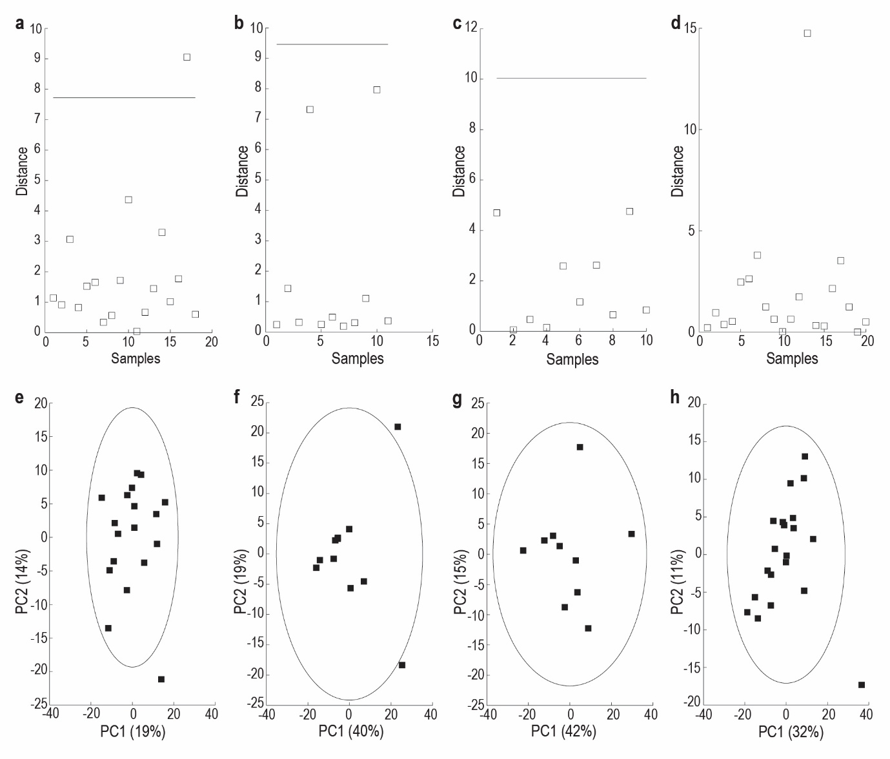
Figure S2: Outlier detection by means of a Hotelling’s T² distance plot (a–d) and PCA scores plot (e–h) for each of the four experimental groups. Cases appearing above the red line (Hotelling’s T² plot) or outside the blue confidence interval boundary (PCA scores plot) were earmarked as outliers.

S6: PCA Analysis
Principal component analysis (PCA) was also performed on the entire scaled dataset, including all four groups. This provides a more holistic view of the variation in the data relative to the groups.
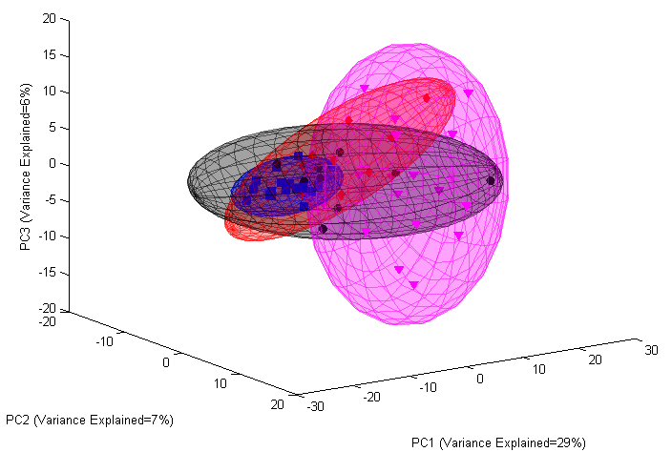
Figure S3: PCA of FMS (magenta); CF (black); CN (blue) and CO (red) groups

S7: N-acetyl aspartic acid (NAA) verification

Overview
Peak 9 in Fig. 2 of the main article was initially labelled as N-acetylaspatic acid. However, this peak is a characteristic moiety of most N-acetyl compounds and thus this result necessitated more detailed NMR analyses, by means of two-dimensional (2D) NMR, for verification. Of these 2D analyses we opted for correlation spectroscopy (COSY) and J-resolved spectroscopy (JRES).

Reagents
The reagents used for this analysis were three of the study’s experimental subjects’ urine, namely, two Pre patient samples (Pre 1 and Pre 2) and one control sample from the CN group. A 1 mM sample of pure NAA compound (Sigma-Aldrich) was prepared in MilliQ-water. The samples were then spiked with this pure compound for analysis.

Sample preparation and analysis
The two patients’ urine samples and the pure NAA compound were prepared as per the protocol described in the main article. Only the CN sample was spiked with the pure NAA compound as the aim of this analysis was to identify and verify NAA in the patient samples; we also required a urine control to see where the spiked NAA peak would present in urine. As such, the preparation protocol was adjusted for the CN sample, to take into account the addition of the pure NAA, by adding 630 µl of the centrifuged urine supernatant, 70 µl pure 1 mM NAA compound and 70 µl of internal standard (IS), which was TSP. the samples were adjusted to pH 2.5. All four samples were then analysed on ¹H NMR, COSY and JRES. For the purposes of verification, the ¹H NMR analysis was done at 512 scans to reduce the noise peaks to a minimum. The results of this analysis are shown in Fig. S4.

Results and discussion
Fig. S4 shows the 1H NMR overlay of the four analysed samples. Red indicates the pure NAA compound, green indicates the spiked CN urine sample, and orange and light blue indicate the non-spiked Pre samples. The circled areas show the regions of interest where the pure NAA compound and NAA+ urine (spiked CN urine) peaks appear. Within the blue circled area in Fig. S4A, we can see that all the samples present with a singlet peak, which is characteristic of any N-acetyl compound, as also identified in the JRES (Fig. S4B) analysis shown in the corresponding blue area. In the yellow circled area we can see that all samples peak in this area, with the red sample being the highest. This peak depicts the characteristic multiplet peak of NAA. In the JRES picture we see that only the red and green samples present with this multiplet peak as the peak patterns correlate. All other peaks presenting in this area of the other samples can be concluded as not including the characteristic NAA peak as the peak patterns do not match those of the CN (green) and pure NAA (red) peaks.
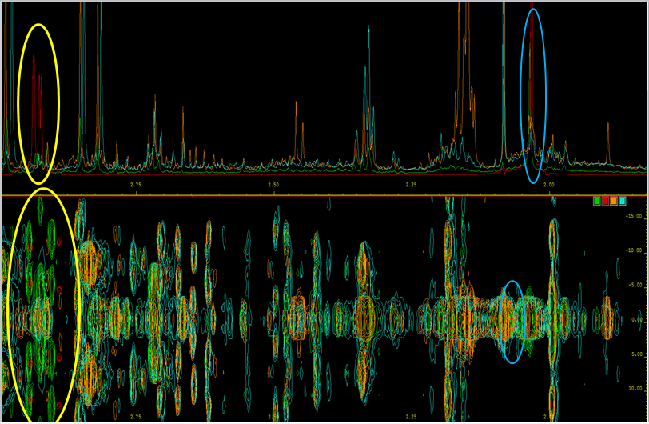
B
A
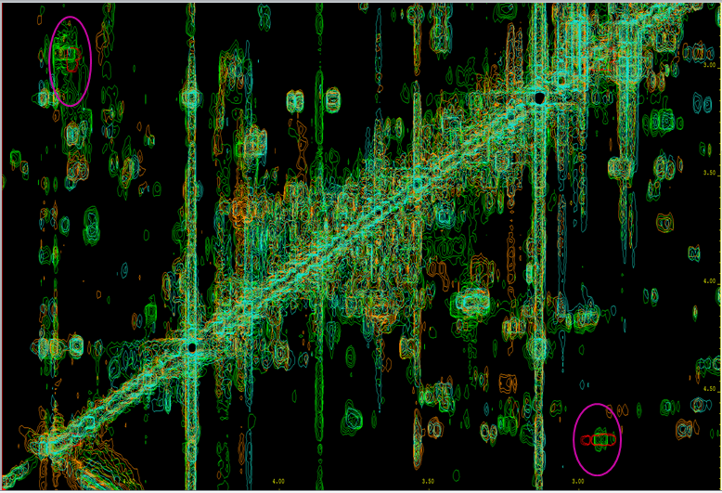
C
Figure S4: ¹H NMR overlay of three urine samples, namely, two PRE patient samples (orange and blue) and a CN control group sample (green) spiked with pure N-acetyl aspartic acid. Red indicates the pure NAA compound dissolved in MilliQ water. Picture A shows the one-dimensional NMR analysis whereas B and C show the two-dimensional JRES and COSY analyses, respectively. The circled areas show the regions of interest for the verification of the presence of NAA.

References:
- Burckhardt CS, Clark SR, Bennett RM. The Fibromyalgia Impact Questionnaire: development and validation. J Rheumatol. 1991;18:728 733.
- The overview of the FIQR and SIQR. http://fiqrinfo.ipage.com/index.html. Accessed on 22 January 2016.
- Bennett RM, Friend R, Jones KD, Ward R, Han BK, Ross RL. The Revised Fibromyalgia Impact Questionnaire (FIQR): validation and psychometric properties. Arthritis Res Ther. 2009; 11(5):415.
- Field, AP. Discovering statistics using IBM SPSS Statistics: and sex and drugs and rock 'n' roll. 3rd ed. London: Sage Publications; 2009.

