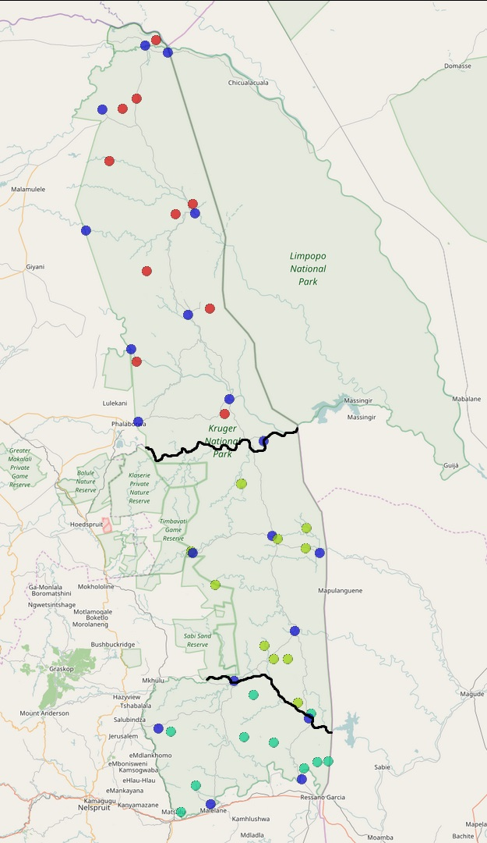
Figure S1: Map with locations of the rainfall stations and the sampled herds. Blue circles: rainfall stations, red circles: herds from northern Kruger, green circles: herds from southern Kruger north of the Sabie River, turquoise circles: herds from southern Kruger south of the Sabie River. The Olifants River in the centre and the Sabie River in the south are denoted in black.
© OpenStreetMap contributors. The data is available under the Open Database License, and the cartography is licensed as CC BY-SA.

