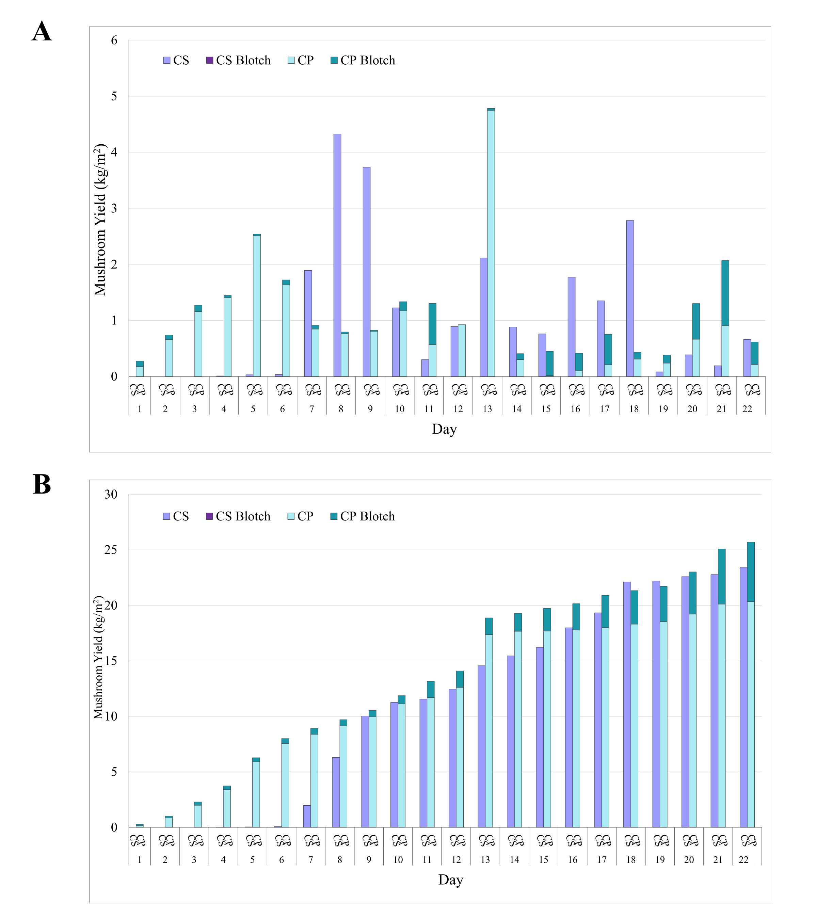
Figure S1. Mushroom yield (kg/m²) in standard casing (CS) and passaged casing (CP) including mushrooms with mild blotch disease expression in the standard (CS Blotch) and passaged treatment (CP Blotch). A – Yield by day over a 22-day period. B – Cumulative yield over a 22-day period. Note that there were no mushrooms recorded for CS Blotch.

