Lung microbiome of stable and exacerbated COPD patients in Tshwane, South Africa

Goolam Mahomed T¹, Peters RPH^{1,2}, Allam M³, Ismail A³, Mtshali S³, Goolam Mahomed A⁴, Ueckermann V⁵, Kock MM^{1,6}, and Ehlers MM^{1,6*}

- Department of Medical Microbiology, University of Pretoria
- Foundation for Professional Development, Research Unit, East London, South Africa
- National Institute for Communicable Diseases, of the National Health Laboratory Service, Johannesburg, South Africa
- Louis Pasteur Private Hospital
- Department of Internal Medicine, University of Pretoria
- Department of Medical Microbiology, Tshwane Academic Division, National Health Laboratory Service

*Corresponding author: marthie.ehlers@up.ac.za

Supplementary Materials and Results

Table S1: Inclusion and exclusion criteria for COPD patients in this study
Stable state
Inclusion criteria | Exclusion criteria
HIV patients on antiviral therapy (ART) | Active tuberculosis infection (receiving treatment)
Over 40 years of age | Receiving immunosuppressants
Able to provide informed consent | Cancer
 | Lung surgery within the last six months
 | Unable to answer questionnaire (CDQ)
 | Antibiotics within last month
Exacerbated state
Inclusion criteria | Exclusion criteria
HIV patients on antiviral therapy (ART) | Active tuberculosis infection (receiving treatment)
Over 40 years of age | Receiving immunosuppressants
Able to provide informed consent | Cancer
Increased/worsening of respiratory symptoms 48 h prior to visit | Lung surgery within the last six months
 | Unable to answer questionnaire (CDQ)
 | Unable to give informed consent
 | Antibiotics therapy 24 h prior to admission
 | Antibiotic therapy administered for more than 12 h after admission
FEV1% - The ratio of FEV₁ (forced expiratory volume in 1 second, the amount of air that can be blown out after a second) to FVC (forced vital capacity, the amount of air that can be blown out after a full inspiration)

Prevalence of different species
The most abundant species in the 22% of the OTUs that could be classified to species level were: i) Haemophilus influenzae (detected in 21/24 samples, with abundance ranging from 0.01% to 61%), ii) Haemophilus parainfluenzae (detected in 22/24 samples, with abundance ranging from 0.01% to 16%), Prevotella melaninogenica (detected in all 24 samples, with abundance ranging from 0.08% to 15%), Veillonella dispar (detected in 21/24 samples, with abundance ranging from 0.02% to 9%) and Veillonella parvula (detected in 23/24 samples, with abundance ranging from 0.07% to 9%). Additionally, sample M20 showed a high abundance of Serratia marcescens (41%), sample M4 showed a high abundance of Pseudomonas spp. (49%) (was not classified to a species level) and sample M26 showed a high abundance of Staphylococcus aureus (13%).

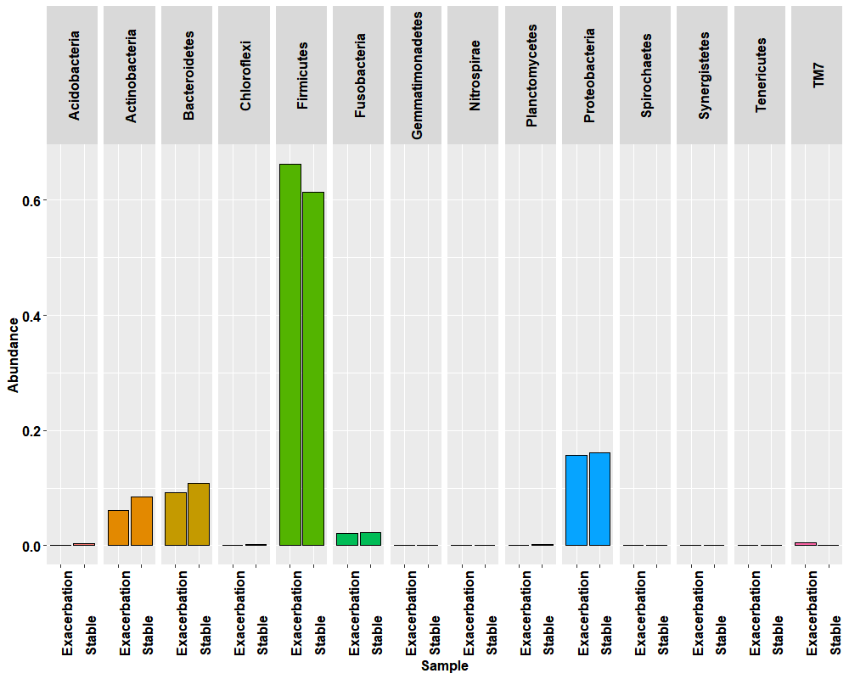
Figure S1: Bar plots showing the relative abundance of the different phyla in the sputum microbiome of COPD participants as determined by targeted metagenomics compared across exacerbated state (n=6) and stable state (n=18).

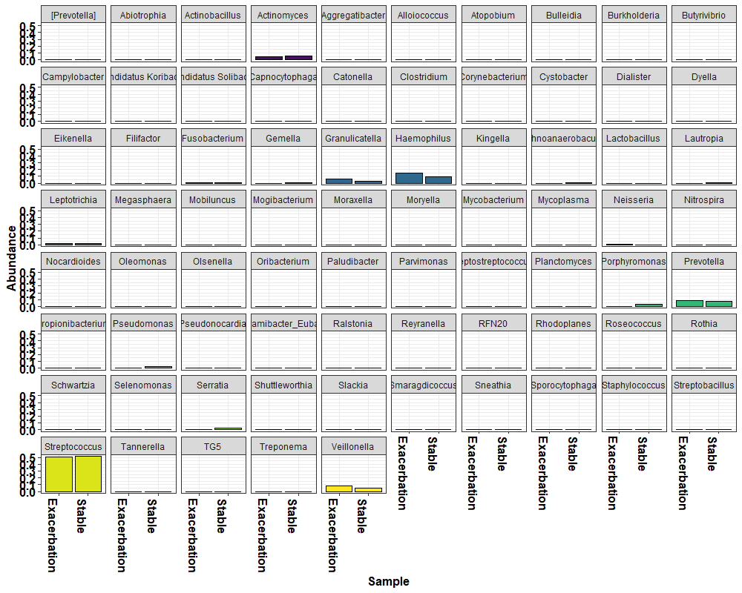
Figure S2: Bar plots showing the relative abundance of the genera in the sputum microbiome of COPD participants by disease state.

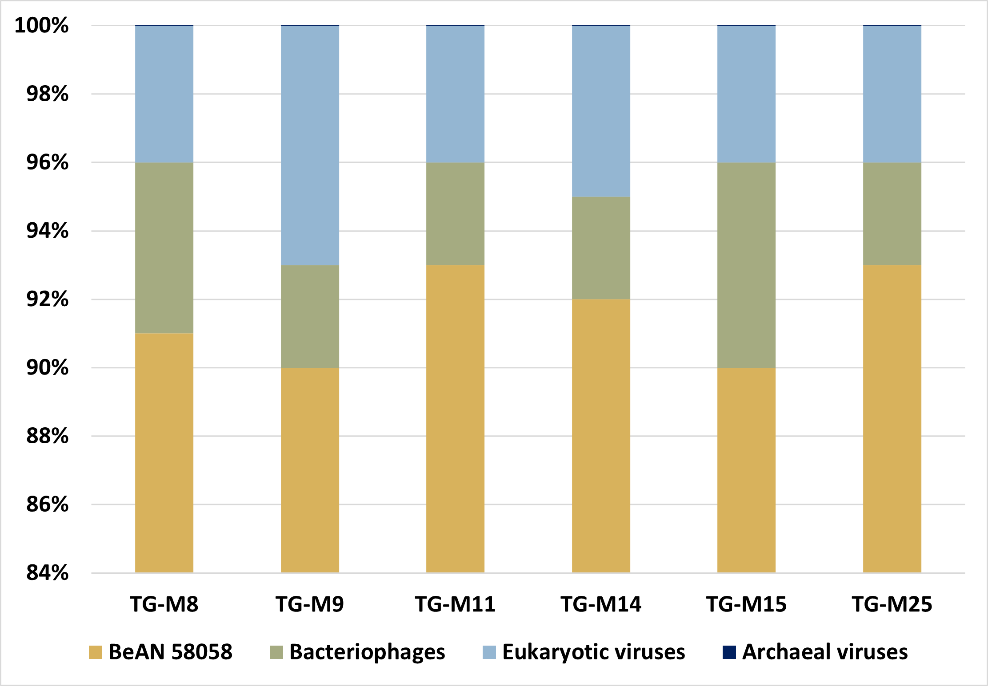
Figure S3: Bar plot showing the distribution of viruses (obtained from shotgun metagenomic sequencing using the Kraken 2 virome database) across the different samples (n=6) of the sputum virome of COPD participants based on their hosts.

