Soil ingestion: a primary contamination pathway for toxic element exposure in wild herbivores

Running: Soil ingestion and wild herbivores

Contents

Supplementary tables
Table S1 – Median, range and SD for toxic elements assessed in soil, vegetation, faeces and fur in this study
Table S2 – Instrument and method limits of detection for elements in soil, vegetation, faeces and fur
Table S3 – Species-specific characteristics for herbivores assessed at Tswalu
Table S4 – Outputs from linear model checks assessed using the R ‘performance’ package

Supplementary figures
Figure S1 – Al concentration gradient map of Tswalu Kalahari Reserve
Figure S2 – Species-specific dispersal probability curves and Soil ingestion buffers
Figure S3 – Output Kaiser-Meye-Olkin test and Mahalanobis Distance of PCA scores for faeces
Figure S4 – Output Kaiser-Meye-Olkin test and Mahalanobis Distance of PCA scores for hair
Figure S5 – Element and species-specific relationships for faeces and fur

References

Supplementary tables

Table S1. Range, median and standard deviation ($σ)$ values for toxic elements assessed in the environment and free-ranging African wildlife 2019. Environmental values for paired sediment and vegetation samples are provided only for elements assessed in biological matrices (Al, As, Co, Cr, Pb, Sn and V). Al values in soil represent the full dataset of measurements (n=24; Webster et al. 2021 and n=233; Abraham et al. 2023). Biological values are provided for toxic element concentrations in faeces and fur. Note faecal Al values are representative of the full faecal dataset (n=594) and values given as mg/kg dry weight. All other elements are represented at µg/kg dry weight (Webster et al. 2021).

Element | Al (mg/kg) |  | As (µg/kg) |  |  | Co (µg/kg) |  | Cr (µg/kg) |  | Pb (µg/kg) |  |  | Sn (µg/kg) |  | V (µg/kg)
Environmental values | Soil | Vegetation | Soil | Vegetation |  | Soil | Vegetation | Soil | Vegetation | Soil |  | Vegetation | Soil | Vegetation | Soil | Vegetation
Range | 2000-43000 | 223-1770 | 292-3714 | 44-443 |  | 594-112269 | 285-852 | 8592-58071 | 681-3673 | 1236-12146 |  | 114-624 | 228-1237 | 15-64 | 7044-84928 | 413-3673
Median  (Std Dev) | 1894  (2357) | 604  (470.6) | 1267  (977.1) | 145  (86) |  | 2607  (3082.2) | 262  (187.4) | 21604  (15886.6) | 1354  (859.4) | 4233  (2085.6) |  | 239  (196.9) | 416  (336.5) | 27  (18.8) | 21573 (20113) | 1042  (913.5)
Biological values | Faeces | Fur | Faeces | Fur |  | Faeces | Fur | Faeces | Fur | Faeces |  | Fur | Faeces | Fur | Faeces | Hair
Range | 110-34960 | 21070-4151179 | 98-654 | 8-529 |  | 694-2206 | 33-2372 | 519-4407 | 410-13309 | 220-3092 |  | 40-1775 | 15-221 | 25-2920 | 501-13614 | 107-8419
Median  (Std Dev) | 1941  (1254) | 514868 (867064) | 261  (150.5) | 61  (106.3) |  | 846  (485.6) | 154  (390.8) | 4407  (2674.1) | 1788  (2333.7) | 917  (505.8) |  | 235  (385.6) | 86  (64.3) | 113  (440.7) | 4583  (2656.1) | 977  (1930.3)

Table S2. Inductively Coupled Plasma Mass Spectrometry Instrument and method limits of quantification for all elements assessed in sediment, vegetation and faeces and fur. Detailed parameters for method optimisation, quantification, adjustments and validation are outlined in Webster et al. (2020).

 | Sediment |  | Veg & faeces |  | Hair
 | Instrument LOQ | Method LOQ | instrument LOQ | Method LOQ | Instrument LOQ | Method LOQ
Element | ug/kg | ug/kg | ug/kg | ug/kg | ug/kg | ug/kg
V | 0.004 | 5.7 | 0.005 | 2.7 | 1.46 | 0.01
Al | 0.59 | 940.0 | 0.69 | 290.0 | 449.00 | 1.80
Pb | 0.012 | 18.7 | 0.006 | 3.2 | 7.72 | 0.03
Cr | 0.028 | 44.4 | 0.051 | 28.3 | 12.10 | 0.05
Sn | 0.006 | 10.2 | 0.002 | 5.2 | 3.55 | 0.01
Co | 0.005 | 7.7 | 0.005 | 2.2 | 9.61 | 0.04
As | 0.013 | 20.9 | 0.014 | 9.1 | 5.99 | 0.02
Ni | 0.177 | 450.2 | 0.044 | 239.7 | 229.77 | 0.92
Cu | 0.177 | 187.1 | 0.152 | 73.0 | 348.09 | 1.39
Ba | 0.014 | 23.0 | 0.019 | 11.0 | 4.94 | 0.02
Mo | 0.042 | 67.4 | 0.042 | 40.1 | 15.72 | 0.06
Zn | 0.783 | 1252.9 | 0.016 | 70.4 | 64.86 | 0.26
Se | 0.032 | 50.6 | 0.034 | 23.5 | 4.20 | 0.02
Cd | 0.011 | 5.5 | 0.002 | 1.9 | 0.56 | 0.00
Sr | 0.016 | 25.8 | 0.007 | 10.0 | 1.62 | 0.01
B | 1.37 | 2186.5 | 1.26 | 1587.2 | 262.69 | 1.05

Elements in soil, vegetation, faeces and fur were quantified at Stellenbosch University’s Central Analytical Facilities ICP-MS Laboratory. An Agilent 7900 quadrupole Inductively Coupled Plasma-Mass Spectrometer (ICP-MS) equipped with a high matrix Introduction system and Agilent Mass Hunter software (version 4.4) for instrument control and data processing was used. Optimization for sensitivity and low oxide ratios (CeO/Ce<0.3%) were performed daily.

Table S3. Species-specific characteristics for herbivore faecal material assessed at Tswalu Kalahari Reserve. Dietary information taken from Kingdon et al., (2013), digestive physiology from Stevens and Hume (1995), gut passage time and associated percentiles from Abraham et al. 2021, foraging height broadly classified from field observations 2019-2024.
Species | Body mass | Digestive physiology | Gut passage time (hrs) | 5th percentile (m) | median percentile (m) | 95th percentile (m) | Diet | Feeding height group | Samples/ species | Group total
Giraffe  (Giraffa camelopardalis) | 1117,5 | Ruminant | 46.65 | 454 | 1984 | 6350 | Browser | High browser | 48 | 140
Kudu  (Tragelaphus strepsiceros) | 202.3 | Ruminant | 48.60 | 280 | 1203 | 3838 | Browser | High browser | 39 | 140
Eland  (Taurotragus oryx) | 511.2 | Ruminant | 56.79 | 440 | 1815 | 5571 | Mixed – mostly browse | High browser | 53 | 140
Black rhino  (Diceros bicornis) | 999.9 | Non-ruminant | 43.21 | 394 | 1767 | 5889 | Browser | Low browser | 10 | 21
Duiker  (Sylvicapra grimmia) | 16.9 | Ruminant | 32.86 | 72 | 411 | 1534 | Seasonal mixed feeder  Mostly browse | Low browser | 11 | 21
Springbok  (Antidorcas marsupialis) | 35.3 | Ruminant | 34.56 | 99 | 537 | 1928 | Seasonal mixed feeder | Mixed feeder | 60 | 109
Impala  (Aepyceros melampus) | 49.1 | Ruminant | 36.01 | 120 | 613 | 2168 | Seasonal mixed feeder | Mixed feeder | 49 | 109
Plains zebra; Mountain zebra  (Equus quagga); (Equus zebra) | 280.4 | Non-ruminant | 41.46 | 255 | 1158 | 3885 | Grazer | High grazer | 43 | 95
Red hartebeest  (Alcelaphus buselaphus caama) | 150.3 | Ruminant | 52.02 | 277 | 1153 | 3661 | Mixed – mostly graze | High grazer | 30 | 95
Buffalo  (Syncerus caffer) | 486.3 | Ruminant | 50.32 | 375 | 1614 | 5104 | Grazer | High grazer | 22 | 95
Gemsbok  (Oryx gazella) | 203.7 | Ruminant | 50.33 | 295 | 1249 | 3874 | Mixed – mostly graze | Low grazer | 60 | 174
Blue wildebeest  (Connochaetes taurinus) | 220.1 | Ruminant | 48.21 | 285 | 1228 | 3905 | Grazer | Low grazer | 77 | 174
White Rhino  (Ceratotherium simum simum) | 2195.8 | Non-ruminant | 44.55 | 517 | 2296 | 7494 | Grazer | Low grazer | 24 | 174
Scrub hare  (Lepus saxatilis) | 3.5 | Non-ruminant | 18.82 | 20 | 122 | 723 | Grazer | Low grazer | 13 | 174
Warthog  (Phacochoerus africanus) | 75.9 | Non-ruminant | 45.15 | 190 | 842 | 2806 | Mixed feeder (grass, roots, shoot, tubers) | Fossorial | 20 | 55
Porcupine  (Hystrix africaeaustralis) | 18 | Non-ruminant | 31.52 | 65 | 401 | 1519 | Mixed feeder (roots, tubers, bulbs, bark) | Fossorial | 35 | 55

Table S4 – Outputs from linear model checks assessed using the R ‘performance’ package

Model | Model results |  |  |  | Model checks
Model | Adjusted R² | Estimate | t-value | P-value | Normality | Heteroscedasticity | Residuals
lm(Soil ingestion ~ feeding height) | 0.418 | -0.5819 | -3.432 | 0.004 | Data are normally distributed  (p = 0.813) | Error variance is homoscedastic  (p=0.122) | Simulated residuals are uniformly distributed  (p=0.840)
lm(Soil ingestion ~ hypsodonty) | 0.105 | 0.3679 | 1.552 | 0.149 | Data are normally distributed  (p = 0.246) | Error variance is homoscedastic  (p=0.741) | Simulated residuals are uniformly distributed  (p=0.680)
lm(Hypsodonty ~ aridity, data=grazers) | 0.300 | -0.00036 | -3.607 | 0.001 | Data are normally distributed  (p = 0.226) | Heteroscedasticity detected  (p<0.001) | Simulated residuals are uniformly distributed  (p=0.656)
lm(Hypsodonty ~ aridity, data=mixed feeders) | 0.352 | -1.839e-04 | -2.934 | 0.011 | Data are normally distributed  (p = 0.222) | Error variance is homoscedastic  (p=0.206) | Simulated residuals are uniformly distributed  (p=0.522)
lm(Hypsodonty ~ aridity, data=browser) | 0.099 | -8.083e-05 | -1.735 | 0.099 | Data are normally distributed  (p = 0.629) | Error variance is homoscedastic  (p=0.286) | Simulated residuals are uniformly distributed  (p=0.904)

Supplementary figures

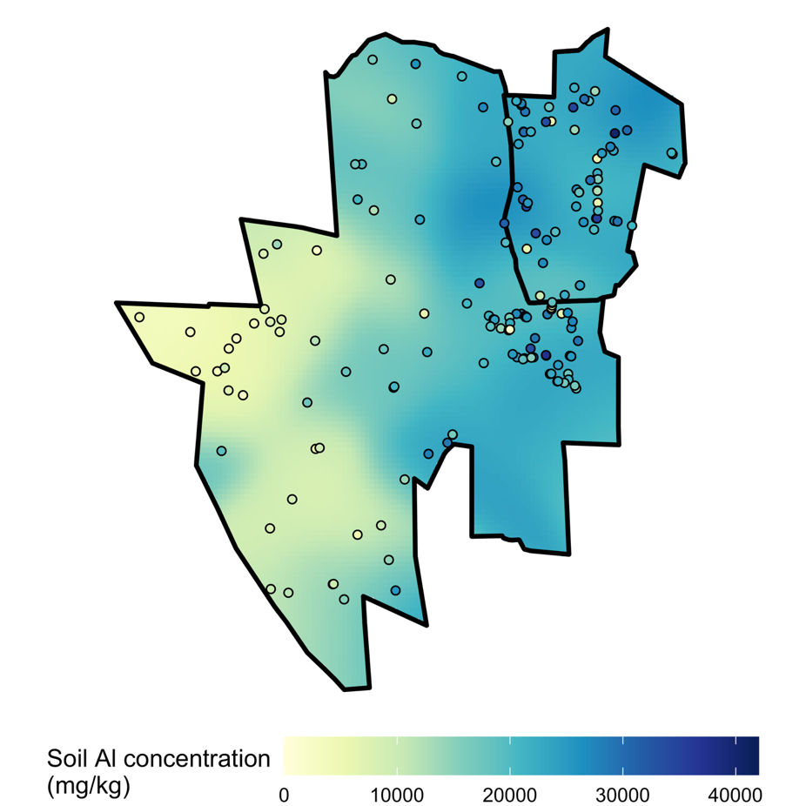
Figure S1. Map of Tswalu Kalahari Reserve showing east to west gradient of aluminium with lowest concentrations (2,000mg/kg) in the western salt pans and highest concentrations (43,000mg/kg) in the east around the Korannaberg mountain range

Species-specific buffers were generated around each faecal sample collected in our database. The size of the buffer was estimated using a published dung dispersal model (Pires et al. 2018), that integrates species-specific parameters of daily dispersal (in meters/day; approximated from allometric body mass scaling relationships) and gut passage time (estimated using species traits and a database of mean particle retention times; Abraham et al. 2021). Our modelling approach generated a dung dispersal kernel for each species. From this, we calculated the 95th percentile distance that individual species may have travelled from when soil was ingested to when faecal sample was actually collected. We then calculated the mean soil Al concentration within this circular buffered region for each faecal sampled and have correspondingly updated our estimates of soil ingestion using these values. See Pires et al. 2018 and Abraham et al. 2021 for related methodological details.

Figure S2. A) Species-specific dispersal probability curves capture short range deposition and long range events. The top panel shows a mean close to zero (consistent with most limited dispersal from the source) with a long tail extending to ~5000m reflecting long distance dispersal events. The bottom panel is flatter and more spread out, indicating a mean further from zero. The circle represents the mean predicted dispersal distance in meters; the horizontal line is the confidence interval with uncertainty around the central estimate. B) Species- specific soil ingestion buffers calculated around each faecal sample used

Figure S3. Kaiser-Meye-Olkin test results for corelation between PCA in herbivore faeces (left). Six outliers identified using Mahalanobis Distance of PCA scores with an outlier cutoff at 99% quantile of Chi-squared (right).

Figure S4. Kaiser-Meye-Olkin test results for corelation between PCA in herbivore fur (left). Six outliers identified using Mahalanobis Distance of PCA scores with an outlier cutoff at 99% quantile of Chi-squared (right).
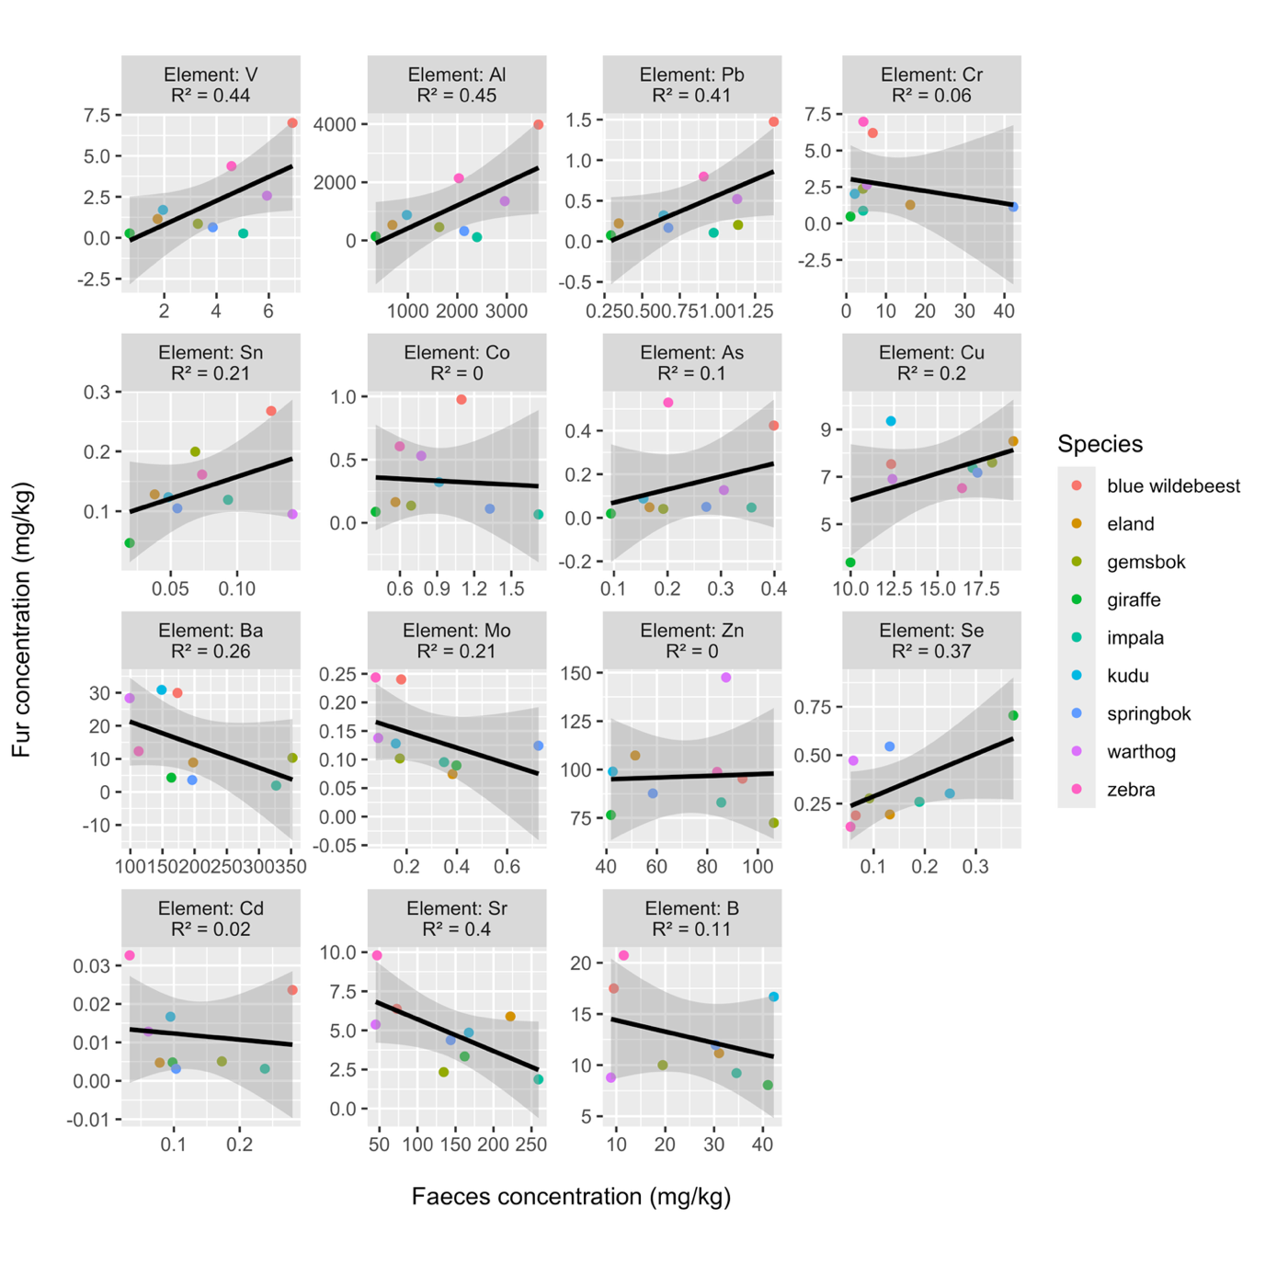
Figure S5. Regression analysis highlights the relationship between faecal element concentrations on the x axis and fur concentrations on the y axis measured in mg/kg in 9 of the sixteen species and for fifteen elements assessed in this study. Positive relationship (R²>0.4) between faeces and fur for high intake elements V, Al, Pb and Se, through soil ingestion. No correlation or negative correlation for remaining elements

References
Abraham, A.J., Prys-Jones, T.O., De Cuyper, A., Ridnour, C., Hempson, G.P., Hocking, T., Clauss, M., Doughty, C.E. (2021). Improved estimation of gut passage time considerably affects trait-based dispersal models. Functional Ecology 35: 860–869.https://doi.org/10.1111/1365-2435.13726
Kingdon, J., Happold, D., Butynski, T., Hoffmann, M., Meredith H., Kalina, J., (2013). Mammals of Africa: Volumes i-vi. Bloomsbury.
Stevens, C.E., Hume, I.D., (1995). Comparative Physiology of the Vertebrate Digestive System, Cambridge University Press.
Webster, A.B., Abraham, A.J., (2021). An assessment of large herbivore dynamics at Tswalu Kalahari Reserve 2008-2021. Management Report.
Webster, A.B., Ganswindt, A., Small, C., and Rossouw, R. (2021). Optimised ICP-MS quantification method for using animal faeces as a measure of protected area ecosystem health. MethodsX 8:101441.
Webster, A.B., Callealta, J., Bennett, N.C., and Ganswindt. A. (2022). Non-lethal assessment of potentially toxic elements across mammalian trophic levels in African savannahs. Frontiers in Environmental Science: Toxicology, Pollution and the Environment 9:794487.

