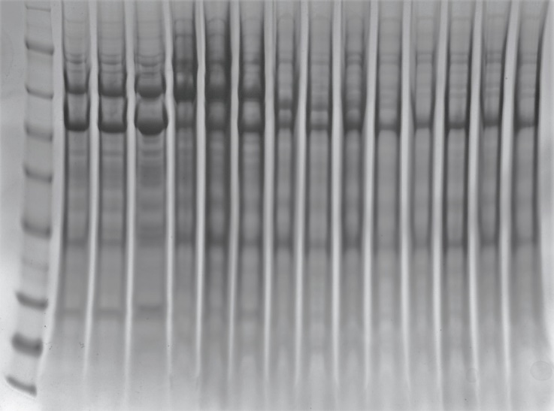

Figure. S1(a). Uncropped SDS PAGE image for figure 1(a). Lane 1: SeeBlue Plus2 molecular weight marker (Invitrogen, Thermo Fisher Scientific); Lane 2: H6 VLP iodixanol fraction 10; Lane 3: H6 VLP iodixanol fraction 11; Lane 4: H6 VLP iodixanol fraction 12; Lane 5: H6 VLP sucrose fraction 4; Lane 6: H6 VLP sucrose fraction 5; Lane 7: H6 VLP sucrose fraction 6. Lanes 8-15: sucrose fractions for paramyxovirus or coronavirus VLPs (not part of this study).

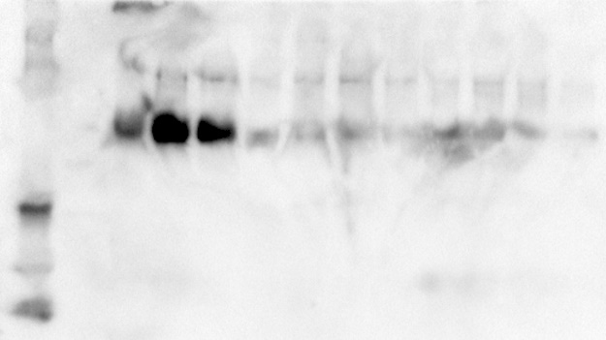

Figure S1(b). Uncropped Western blot image for figure 1(b). Lane 1: Precision Plus Protein Western C molecular weight marker (Bio-Rad). Lane 2: empty; Lanes 3-5: iodixanol fractions of a 2016 strain H6 VLP (not part of this study). Lane 6: H6 VLP iodixanol fraction 10; Lane 7: H6 VLP iodixanol fraction 11; Lane 8: H6 VLP iodixanol fraction 12; Lane 9: H6 VLP iodixanol pooled dialyzed fractions 10-12; Lane 10: H6 VLP sucrose fraction 4; Lane 11: H6 VLP sucrose fraction 5; Lane 12: H6 VLP sucrose fraction 6; Lane 13: H6 VLP sucrose pooled dialyzed fractions 4-6.

