Africa’s drylands in a changing world: Challenges for wildlife conservation under climate and land-use changes in the Greater Etosha Landscape

Wendy C. Turner, Stéphanie Périquet, Claire E. Goelst, Kimberlie B. Vera, Elissa Z. Cameron, Kathleen A. Alexander, Jerrold L. Belant, Claudine C. Cloete, Pierre du Preez, Wayne M. Getz, Robyn S. Hetem, Pauline L. Kamath, Marthin K. Kasaona, Monique Mackenzie, John Mendelsohn, John K.E. Mfune, Jeff R. Muntifering, Ruben Portas, H. Ann Scott, W. Maartin Strauss, Wilferd Versfeld, Bettina Wachter, George Wittemyer, and J. Werner Kilian

Appendix - Literature review
We conducted structured literature searches for relevant references on Scopus and Web of Science (WoS) using “Etosha” as a single keyword search within titles, keywords and abstracts. Since these two databases do not consistently include references from local or low impact factor journals, we ran a second search on SABINET (https://journals.co.za) using “Etosha” as a single keyword within the whole reference. These three searches were conducted on 10th June 2021 with no exclusion criteria regarding the year of publication. Finally, we added any references missing from the above search results but known to the authors to be relevant to this review. Only peer-reviewed references were considered in the next steps. Our inclusion criteria for references were the following: the work presented was conducted within Etosha National Park or on adjacent lands. In case of review or synthesis in which only a few samples or data points were coming from the focus area, inclusion was based on the overall relevance of the study to the Etosha region. For a flowchart showing how references were selected, see Figure A1.
Publications were classified into three mutually exclusive research types: empirical, review/synthesis and theoretical (see Table A1 for detailed definitions; results in Figure A2). For each publication, we recorded one or two main focal research areas into six categories: abiotic environment, animals, human impacts, microparasites, plants and others. Publications focusing on animals were further classified into taxonomic categories: arthropods, birds, carnivores, megaherbivores, other mammals (except ungulates), other ungulates, parasites, reptiles, and others (see Table A1 for detailed definitions). For publications on subjects that included ecology, evolution, environmental biology, behavior and/or conservation, we recorded the highest level of biological complexity they focused on as follows: molecular, organismal, population, species interactions, community, ecosystem (see Table A1 for detailed definitions).
For references satisfying the inclusion criteria and that were referenced in Google Scholar (n = 429 out of 448 references satisfying the inclusion criteria), we extracted their total number of citations (between the 13 Jul and 25 Aug 2021) since their publication. For references published between 1960-2019 (n = 410, one reference from before 1960 and 18 from after 2019 were removed), we presented their number of citations per year as their total number of citations divided by the number of years elapsed between 2021 and their year of publication. We tested for a significant effect of decade of publication on the number of citations per year using Yuen’s trimmed means test in the R package ‘ggstatsplot’ (Patil, 2021 v. 0.8.0). We used a Chi square test and Pearson’s correlation tests to test for the effect of decade of publication on the distribution of the number of publications focusing on each biological level. Since biological levels were not mutually exclusive, we used the higher level of interest for this analysis. All statistical analyses were conducted in R (R Core Team, 2020, v. 4.0.3).
The vast majority of references presented empirical research (n = 410, 91.5 %), while only 6.5% (n=29) were reviews or syntheses and 2% (n = 9) presented theoretical work (Figure S2). Most of the references had a single focal research area (n = 305, 68.1%) while 31.9% (n = 143) references were attributed to two foci of interest.

References
Patil, I. (2021). Visualizations with statistical details: The “ggstatsplot” approach. Journal of Open Source Software, 6(61), 3167. https://doi.org/10.21105/joss.03167
R Core Team. (2020). R: A language and environment for statistical computing. R Foundation for Statistical Computing (4.0.3) [Computer software].

Table A1: Definitions of terms for the literature review
 | Criteria for inclusion
Research type
Empirical | Any study with at least some empirical data collected/presented
Review/synthesis | Study purely based on data or findings from the literature
Theoretical | Study focusing on theoretical development
Research focal area
Abiotic environment | Water, wind, air, dust, geology, climate, fire, soil, rainfall
Animals | Includes ectoparasites and endoparasites  Arthropods: insects and arachnids  Birds, including bird of prey and vultures  Carnivores  Mega-herbivores: elephant, black and white rhinoceros and giraffe  Other mammals, includes bats and undescribed mammals, excluding ungulates  Other ungulates, includes smaller species and livestock  Parasites: ectoparasites (e.g. tick, lice)  Reptiles  Others includes amphibians, fish and undescribed vertebrates and invertebrates
Human impacts | Socio-ecological studies, human-wildlife conflict
Microparasite | Bacteria, virus and protozoa
Plants | Plant description, vegetation mapping
Other | Paleontology, microfauna and microscopic organisms, remote sensing, methods development
Biological levels
Molecular | e.g., genetic analysis
Organismal | e.g., behavior, movement, breeding, morphology
Population | e.g., growth or reproduction rates, population size, structure, composition, distribution, survey of single species
Species interactions | e.g., parasitology, predation (interactions between two species)
Community | e.g., species diversity, survey or ecology including multiple species
Ecosystem | e.g., vegetation mapping, water quality, climate
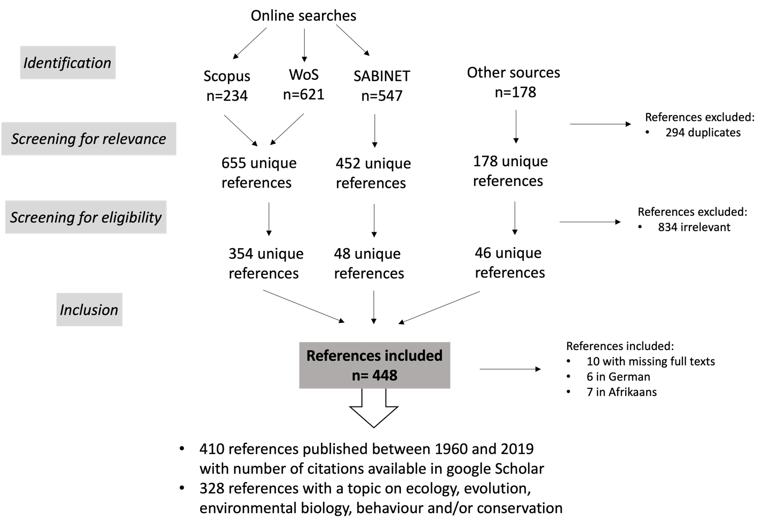
Figure A1. Flow chart showing how references were selected.
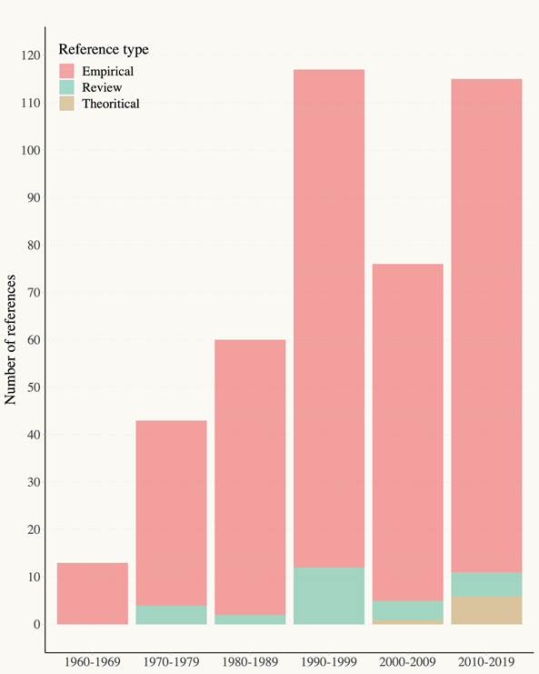
Figure A2: Distribution of research type through decades of publication.

