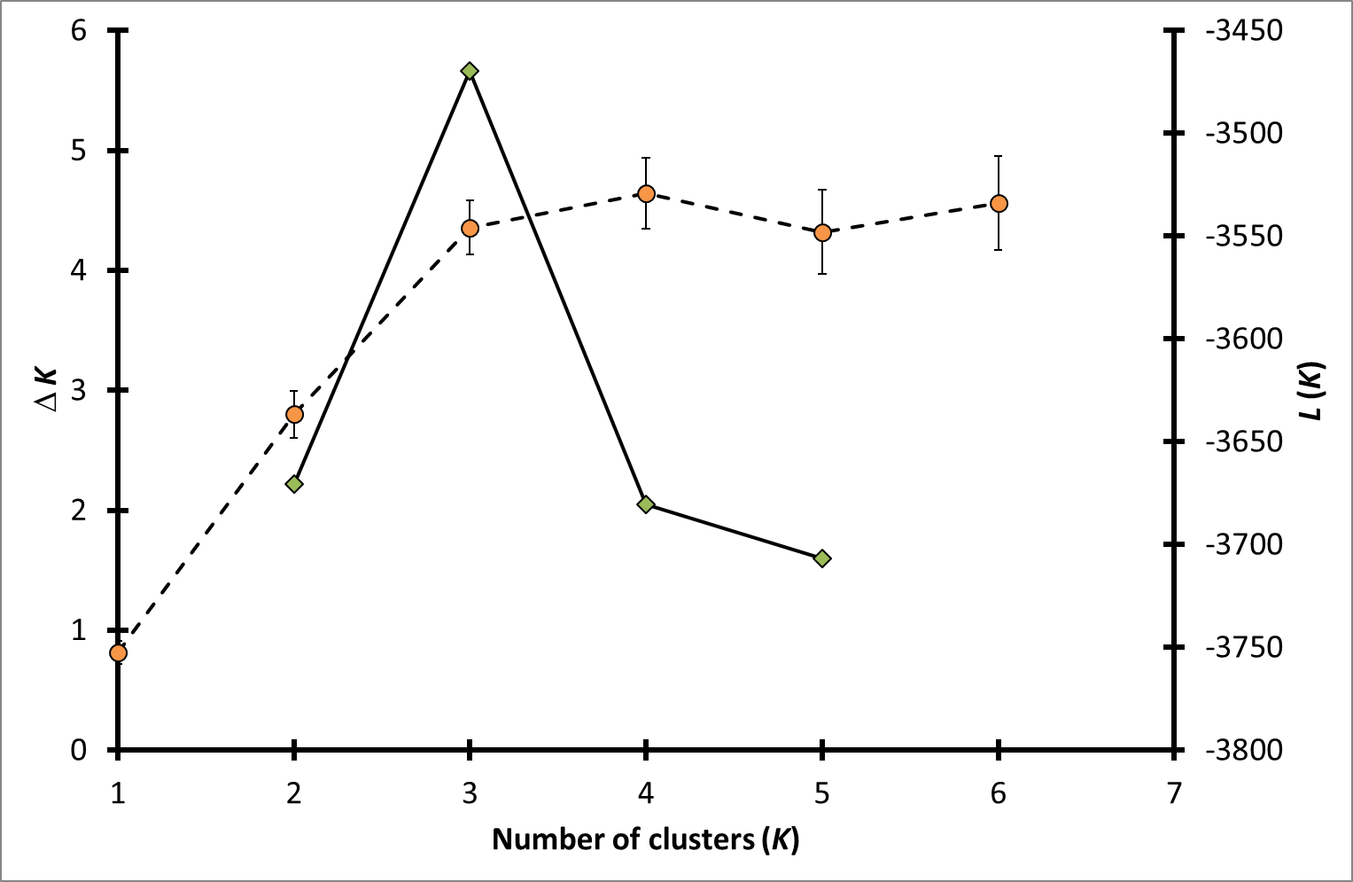
Number of microsatellite clusters based on the software Structure using the method of Evanno et al. 2005 [1].
Orange circles: mean L(K) (± SD) over 10 runs for each K value, green diamonds: ∆K. The peak of ∆K denotes the most likely number of clusters, here three.

References
1. Evanno G, Regnaut S, Goudet J: Detecting the number of clusters of individuals using the software STRUCTURE: a simulation study. Mol Ecol 2005, 14(8):2611-2620.

