APPENDIX
Supplementary Figure 1 : CMNN and NCD combined mortality rates
These results report the death rates, per 100 000, for CMNN and NCD. The results include all ages but are split by gender when reported

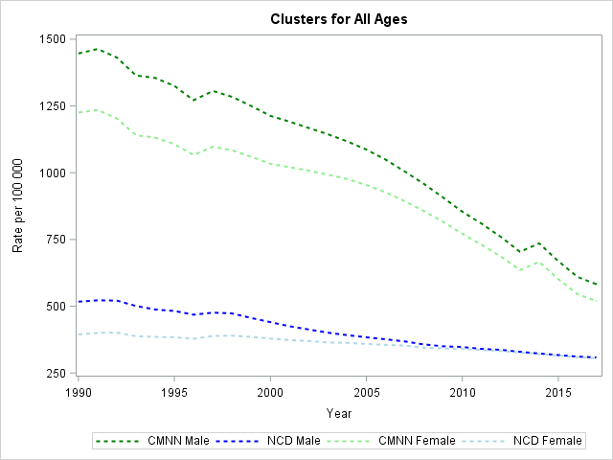

Supplementary Figure 2: Top 10 Diseases for CMNN and NCD combined
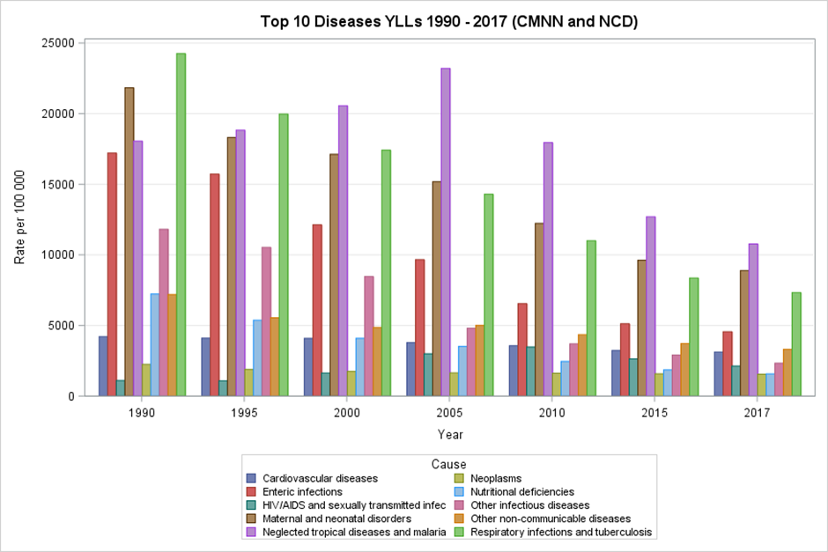

Figure 2: The following results reports on the top 10 diseases for CMNN and NCD combined, for all ages and both genders, reported in YLL rate per 100 000. The top 10 was determined by considering the average rank of each disease across all years and selecting the top 10 ranked.

Risk factors for NCD and CMNN Combined

The following results report the risk factors, for all ages both genders, measured in YLL rate per 100 000 for all NCD and CMNNN causes. The data downloads allow for a split in the two or a combination or NCD, CMNN and Injuries
Supplementary Table 1: CMNNs risk factors
 | Rank
Risk | 1990 | 1995 | 2000 | 2005 | 2010 | 2015 | 2016 | 2017
High systolic blood pressure | 1 | 1 | 1 | 1 | 1 | 1 | 1 | 1
Dietary risks | 2 | 2 | 2 | 2 | 2 | 2 | 2 | 2
High fasting plasma glucose | 6 | 6 | 3 | 3 | 3 | 3 | 3 | 3
Air pollution | 5 | 4 | 4 | 4 | 4 | 4 | 4 | 5
Tobacco | 3 | 3 | 5 | 5 | 5 | 6 | 6 | 6
Impaired kidney function | 4 | 5 | 6 | 6 | 6 | 7 | 7 | 7
Alcohol use | 7 | 7 | 7 | 7 | 7 | 9 | 9 | 9
High body-mass index | 9 | 9 | 9 | 9 | 8 | 5 | 5 | 4
High LDL cholesterol | 8 | 8 | 8 | 8 | 9 | 8 | 8 | 8
Other environmental risks | 10 | 10 | 10 | 10 | 10 | 10 | 10 | 10
Unsafe sex | 11 | 11 | 11 | 11 | 11 | 11 | 11 | 11
Low physical activity | 12 | 12 | 12 | 12 | 12 | 12 | 12 | 12
Occupational risks | 13 | 13 | 13 | 13 | 13 | 13 | 13 | 13
Drug use | 14 | 14 | 14 | 14 | 14 | 14 | 14 | 14
Child and maternal malnutrition | 15 | 15 | 15 | 15 | 15 | 15 | 15 | 15
Childhood maltreatment | 16 | 16 | 16 | 16 | 16 | 16 | 16 | 16

Supplementary Table 2: NCD Risk factors
 | Rank
Risk | 1990 | 1995 | 2000 | 2005 | 2010 | 2015 | 2016 | 2017
Child and maternal malnutrition | 1 | 1 | 1 | 1 | 1 | 1 | 1 | 1
Unsafe water, sanitation, and handwashing | 2 | 2 | 2 | 2 | 2 | 2 | 2 | 2
Air pollution | 3 | 3 | 3 | 3 | 3 | 3 | 3 | 3
Alcohol use | 5 | 5 | 5 | 5 | 5 | 5 | 5 | 5
Tobacco | 4 | 4 | 4 | 6 | 6 | 6 | 6 | 6
Unsafe sex | 7 | 7 | 6 | 4 | 4 | 4 | 4 | 4
High fasting plasma glucose | 6 | 6 | 7 | 8 | 8 | 8 | 8 | 7
Intimate partner violence | 8 | 8 | 8 | 7 | 7 | 7 | 7 | 8
Drug use | 9 | 9 | 9 | 9 | 9 | 9 | 9 | 9

