Supplementary Figures: Mobile application screens for self-iniated reporting listening experiences

Supplementary Figure a) Screenshot of the first screen of the EMA survey used by the hearing aid wearers.



Supplementary Figure b) Screenshot of the second screen of the EMA survey used by the hearing aid wearers.

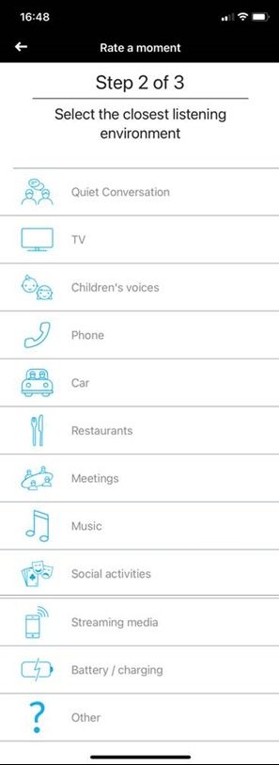

Supplementary Figure c) Screenshot of the third screen of the EMA survey used by the hearing aid wearers.

