Supplementary Table 1 - Composite forest plots of the sensitivities and specificities of antigen and antibody rapid diagnostic tests for all participants
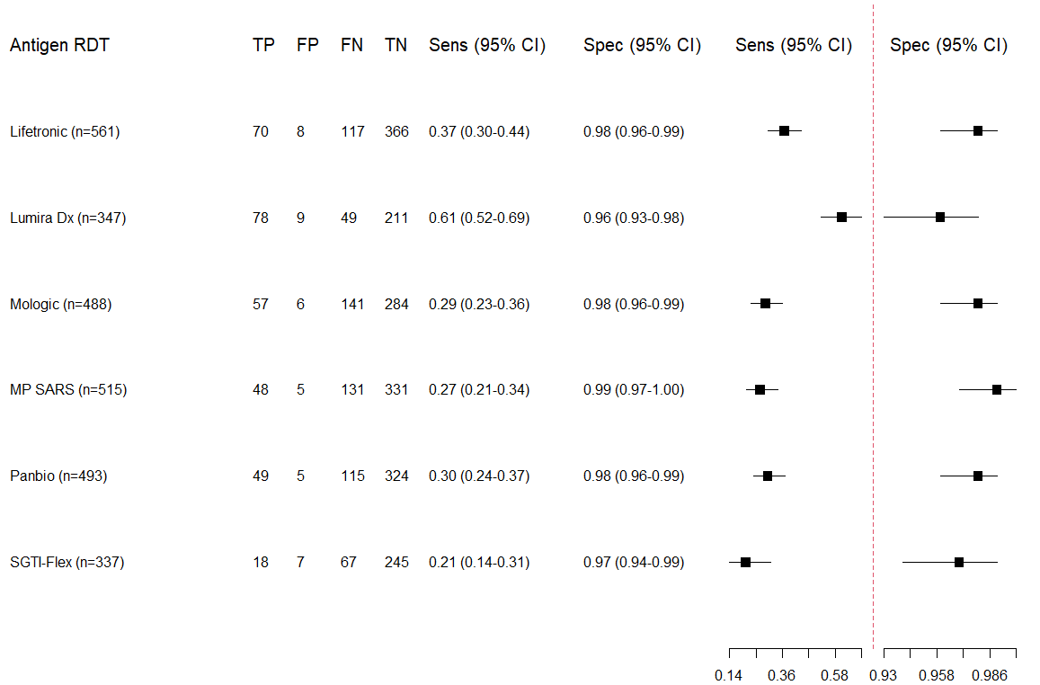

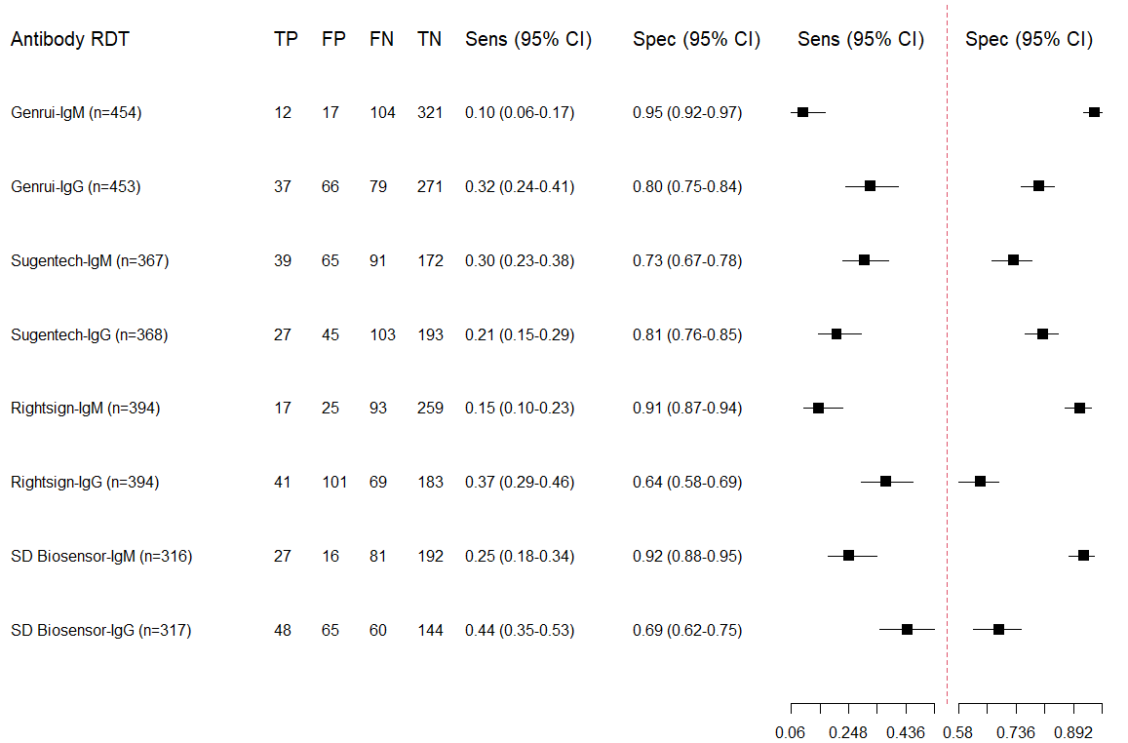

Symptomatic Participants
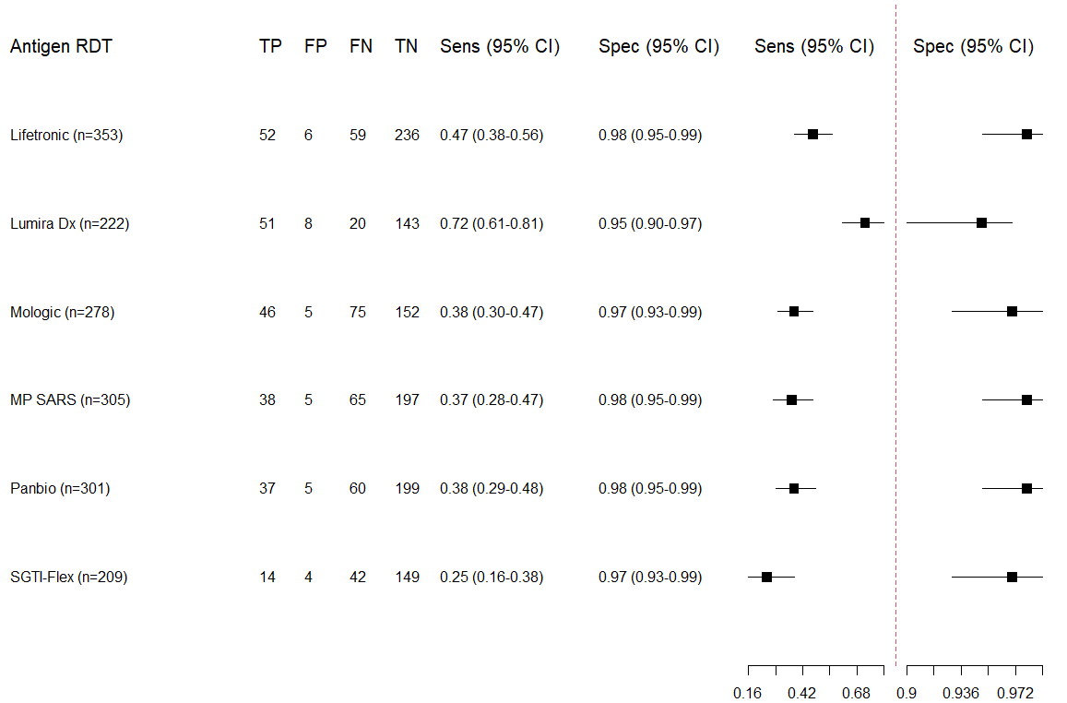

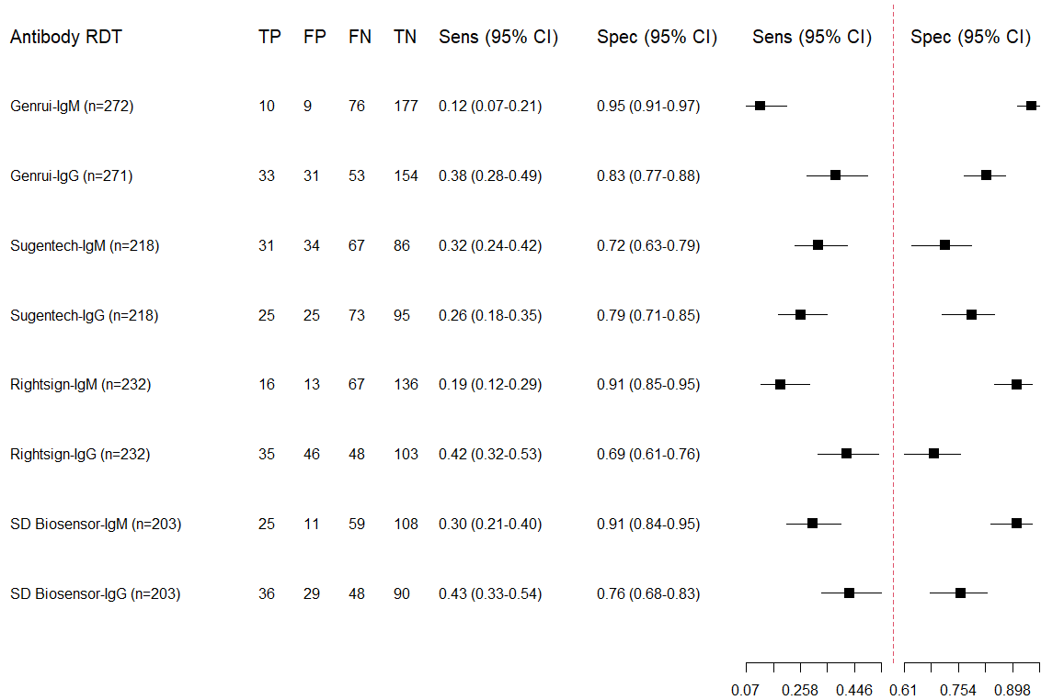

Asymptomatic Participants
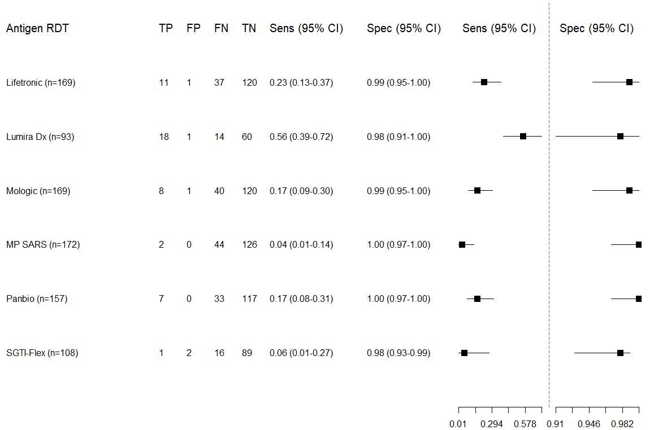
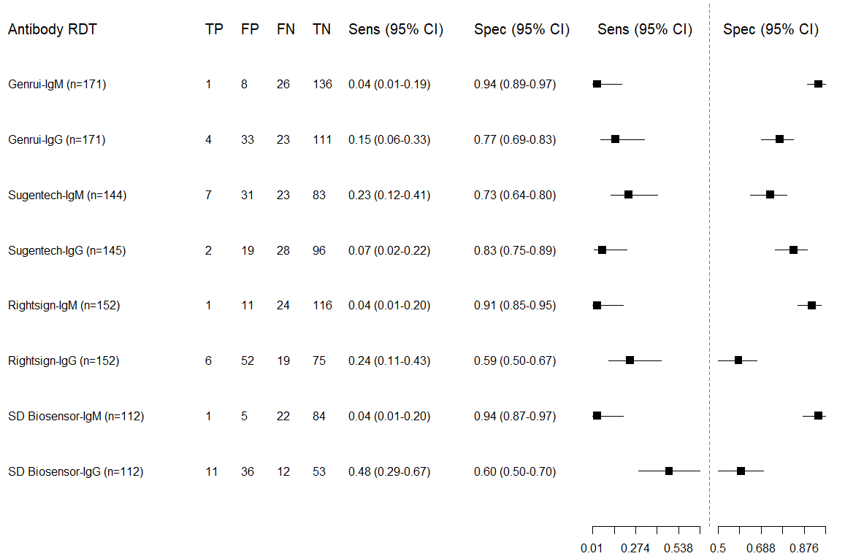

TP – True positive; FP - False positive; FN - False negative, TN - True negative; Sens-Sensitivity; Spec-Specificity

