MOVEMENTS OF THE WHOLE ARM

Free fall and Float off movements
The aim is to concentrate on the basic movements in piano playing to enable the pupils to develop an injury-free, advanced piano technique that will serve them in the years to come.
Seat the pupil properly at the piano.
The first movement is taught in different stages and is called the "free-fall and float-off” movement.
Although this movement is described in many different ways, these all refer to the use of the relaxed arm weight which in the end is controlled or absorbed by the fingers and wrist.
In the first stage the movement can be practised away from the piano by the teacher and pupil: The teacher should pick up the pupil’s arm at the sides of the wrist (it should be possible to move the arm up, down and sideways without any resistance) and let the total weight of the arm fall into his or her other hand. (See photo.)
This is the uncontrolled “free fall” movement”
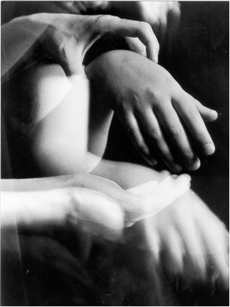

Photo 1 (Author and pupil’s hand)
This can be followed by the “Pick up - drop” exercise. This uncontrolled, relaxed movement can be performed at the piano. The teacher should ensure that the movement is completely relaxed by picking up the pupil's hand on beats 3 and 4 and letting it fall on beats 1 and 2 in the next bar.

Look at photo 1 in motion and the simple “Pick up - drop” exercise below.
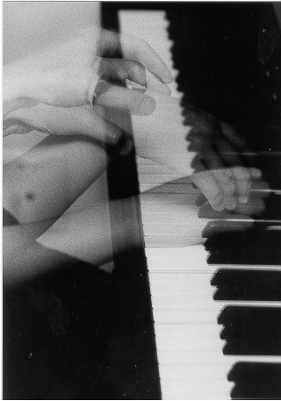

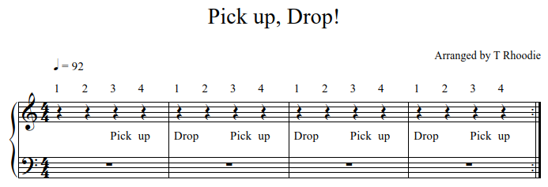
Photo 2 (Author and pupil’s hand)

In the second stage the pupil can do the movement on his/her own, letting the lower part of the wrist fall freely on a cluster of notes not controlling the movement and 'floating-off' afterwards. I call this exercise “Cluster”. An important aspect to look out for is a forced movement which often appears when young pupils want to produce a big sound and hit the piano forcibly in order to do this. The dead weight of their arms is usually not enough to produce a big sound. The teacher should always make sure that a relaxed fall is the objective and not a big sound.

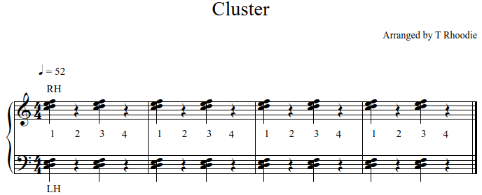

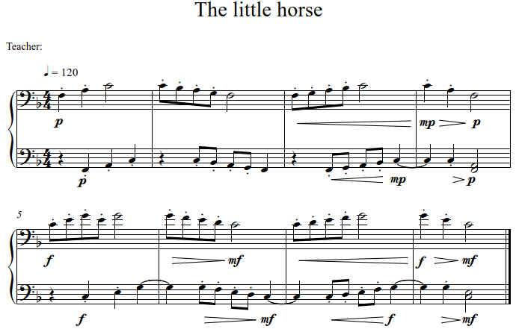
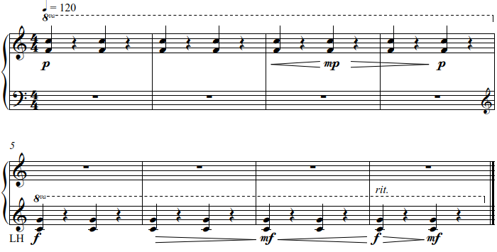
When reaching the third stage, the pupil can “fall” onto a comfortable fifth for a small hand. This is a free-falling, relaxed movement. The aim is to control or absorb the weight of the arm with the fingers and wrist, not letting the arm fall but continuing into a “float-off” movement. Here, teachers should again be aware of a relaxed falling movement without a sharp and percussive sound. The completed position of the “float off” movement is the position of the wrist when picked up by the teacher before letting it fall (see photo 2). In this forward/up movement the weight of the arm is taken off the hand and fingers through a supple wrist not falling through, but moving forward and up allowing a smooth, stroking finger touch. “The little horse” is a beginner duet for the teacher and pupil, encouraging a comfortable position for both the right and left hands.

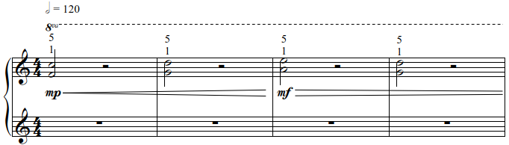

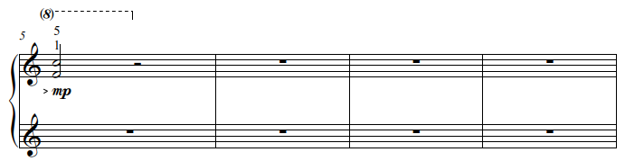

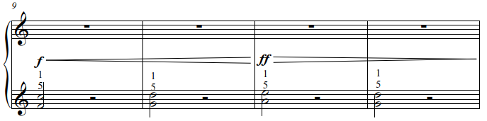

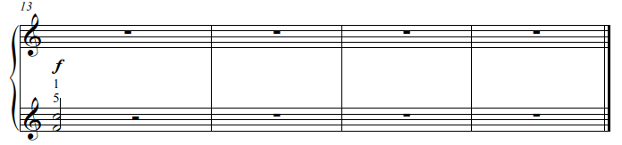
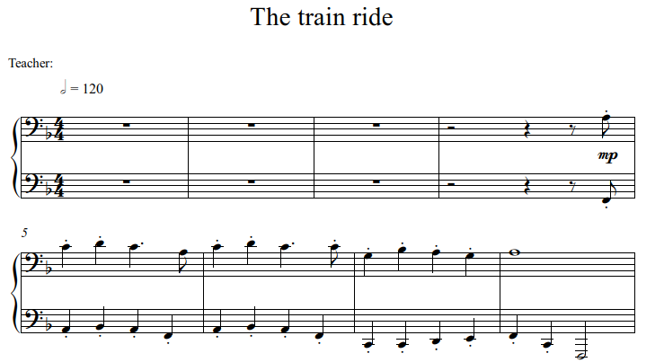

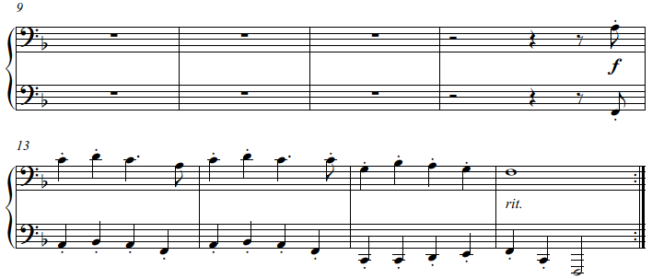

“The train ride” duet requires controlled free-fall and float-off movements, ascending and descending, hands separately.

The fourth stage is a sigh motive often heard in the Classical period. This uses a falling movement on the third finger and a float-off movement on the second. Timing is important here because the weight of the arm should be taken off in time for the float-off movement (and correlated sound) to be without arm weight.
The correlating sound will be loud on the free-fall and soft on the float-off. This exercise should be done with both hands separately at first, followed by both hands doing the movement together. Listen attentively and take note of the difference in sound that is produced on the “free-fall” and “float-off” movements respectively.

The following duets, “The hiding bunny” and “On my little horse”, include sigh motive exercises and use the three middle fingers of both hands. Their approximate evenness in length simplifies the exercise for beginners. Concentrate on the timing of the float-off movement to correlate the loud and soft sounds as explained previously.

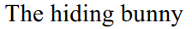
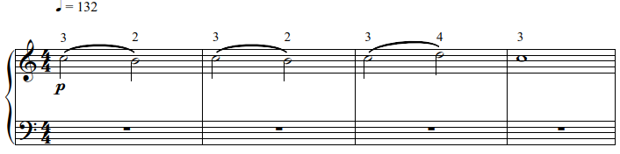
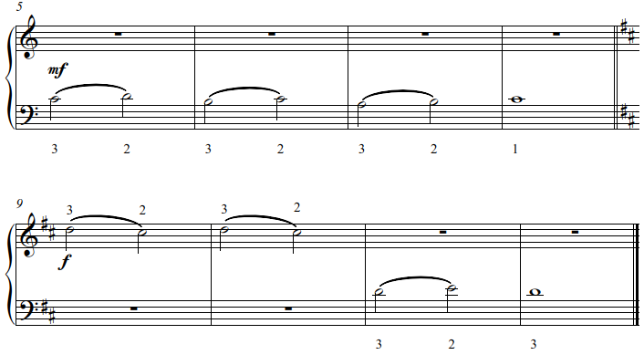

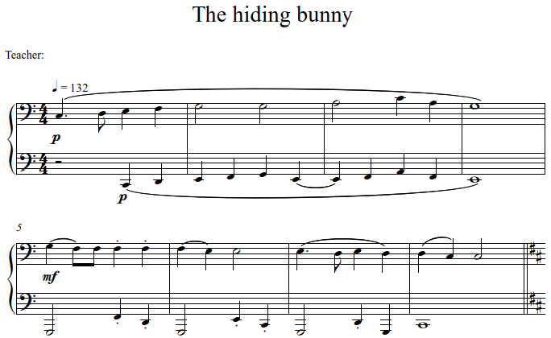
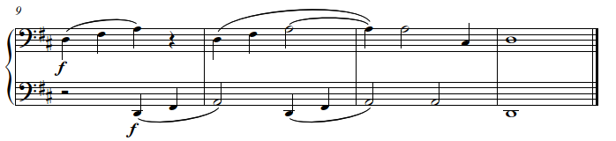
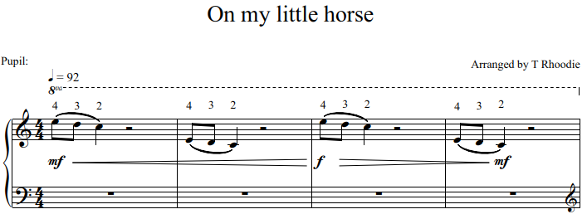
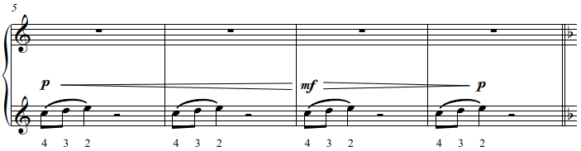
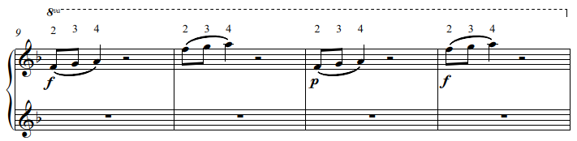

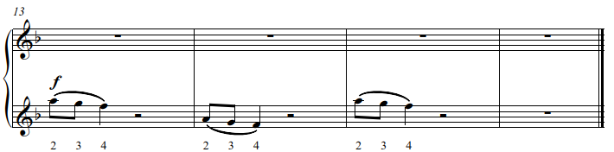

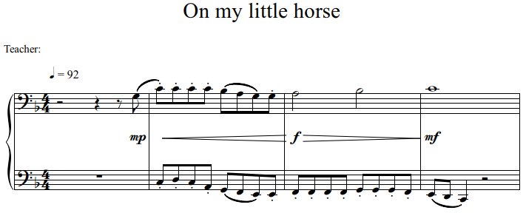

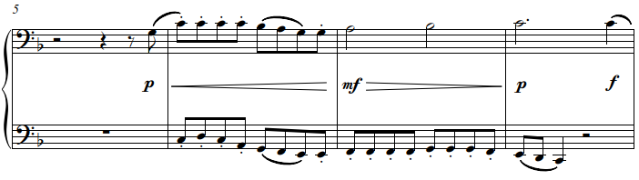

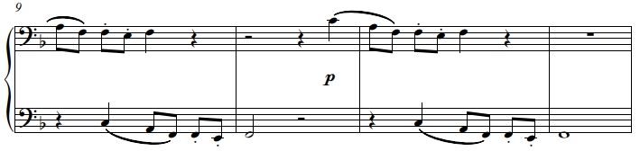

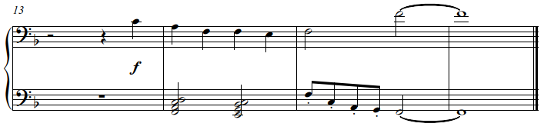

A few simple solo exercises follow:
“A Christmas song”, “Grandpa’s snuff-box”, “Come little duck” and “The little duckling”.
These highlight the correlated movements and sounds of the “free-fall” and “float-off” in both hands. They also introduce independent movements of the hands when playing together.

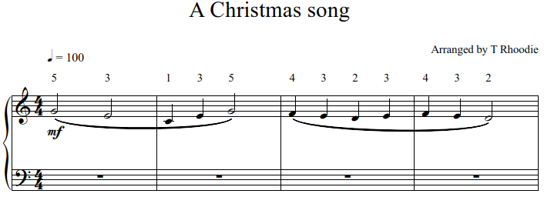

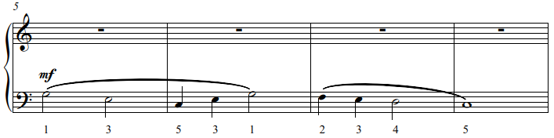

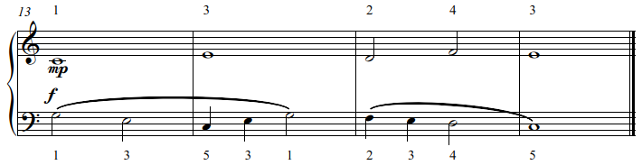
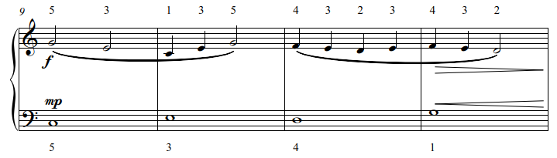
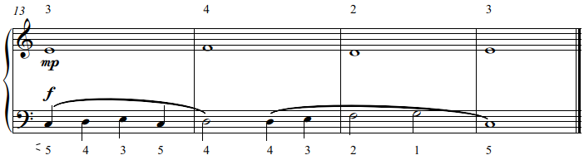
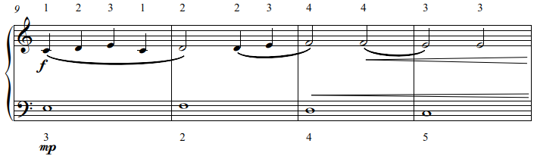
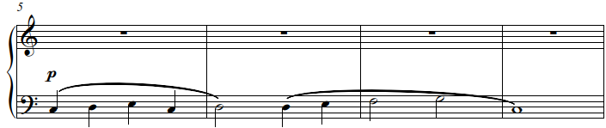
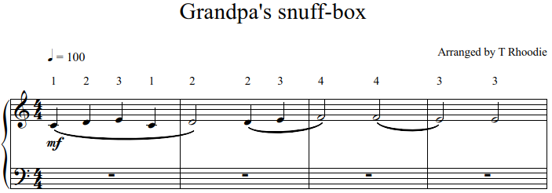
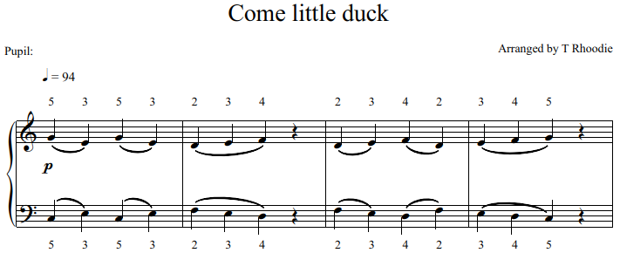
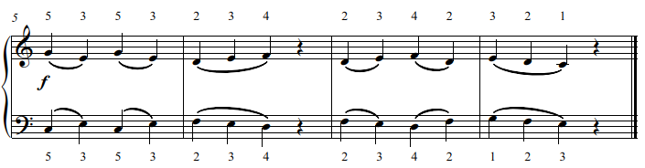
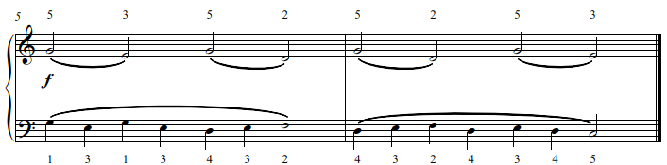
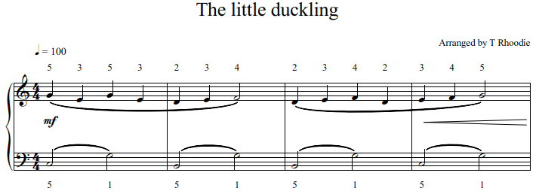
The free-fall and float-off movements and the correlation in sound are frequently underestimated, but form the basis of many intricate combinations of movements in an advanced technique. When mastered successfully, they will prevent many muscle injuries.

2.1.2 The thumb-under movement

This movement can either hamper or enhance the performance of scales and both simple and more advanced technical passages in pieces.
The thumb’s position alongside the hand puts it in a different category to the other four fingers. The only position where the thumb is agile and able to move in any direction is alongside the hand. For this reason, the wrist, as the initiator of the “thumb-under” movement, leads the (whole) arm and hand to the appropriate position.
A general problem with this movement is the interference of the forearm and elbow. This is usually the result of the thumb being placed underneath the palm where no independent movement is possible. With the thumb in this position, the arm is forced to move down or the elbow forced to move up, resulting in clumsy accents and uneven playing.

The solution is to let the wrist initiate and control the movement and to keep the arm, and especially the elbow, relaxed. When the left wrist moves laterally to the left, pulling the forearm, elbow and hand with it, space is created for the thumb to move independently up and down.
A practical, simple exercise is the following: In a descending E major scale position, the left hand should play and hold the C sharp with the third finger. The thumb, led by the wrist is able to sway horizontally to the right and left respectively, when playing E, B and back to E. This can be performed within a regular beat and the thumb stays independent and agile next to the hand.
This exercise for the right hand uses an ascending E major scale position. Play and hold the G sharp with the third finger whilst the thumb, led by the wrist sways to the left and right respectively, when playing E to A and back to E.
Concentrate on achieving an agile thumb to prevent unwanted unevenness or accents when performing the “thumb-under" movement. The movement can be seen in photo number 3.
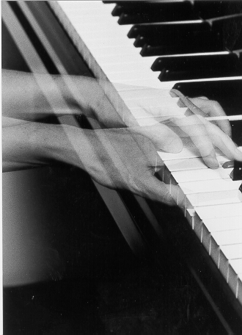
Photo 3 (Author”s hand)

“Humpty Dumpty” and “I love Humpty Dumpty” are exercises for the “thumb under” movement in the right and left hands in two new keys: The D major ascending and B major descending positions, respectively.

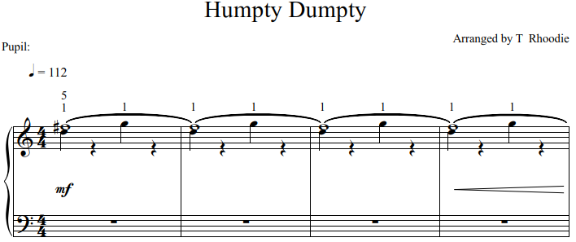
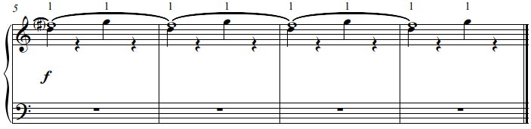
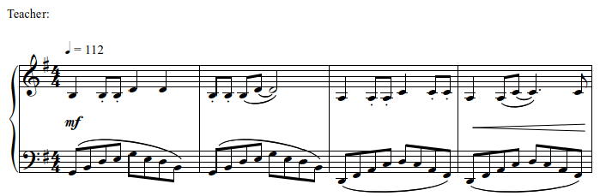

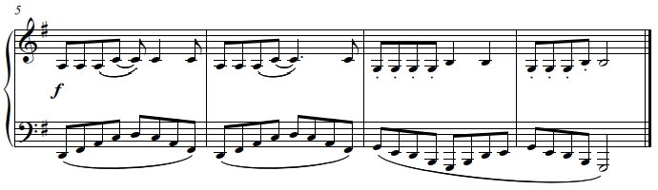
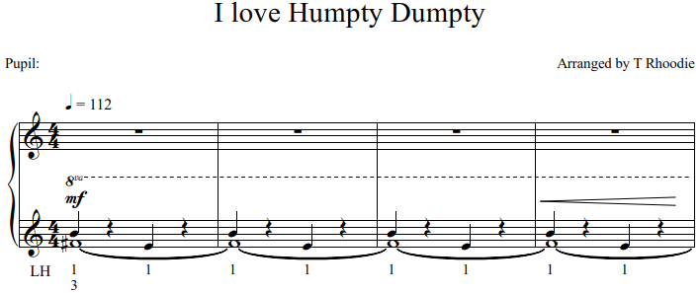

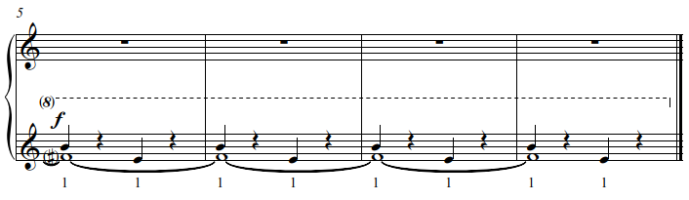

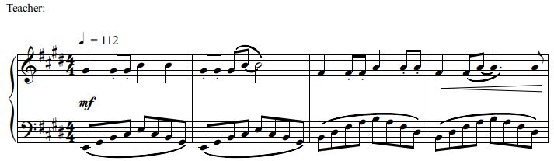

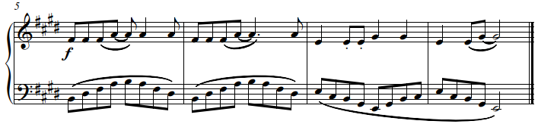
“On my birthday” is a combination of two movements: a “thumb under” movement in the position of an ascending and descending E major arpeggio in contrary motion and a “free fall, float off” movement in a B major arpeggio in first inversion position, ascending and descending.

