Supplementary Material for
Soft range limits shape sensitivity to forest cover more strongly than hard range limits
Authors: Natasha R. Granville*; Alex L. Pigot; Benjamin Howes; Luiz dos Anjos; Victor Arroyo-Rodriguez; Luc Barbaro; Jos Barlow; Matthew G. Betts; Alexis Cerezo; Pedro F. Develey; Jack H. Hatfield; Hervé Jactel; Jordan Karubian; Urs G. Kormann; Jesse R. Lasky; Charles J. Marsh; Luiz A.M. Mestre; José Carlos Morante-Filho; Pieter Olivier; Anna Pidgeon; Hugh Possingham; Vânia Proença; Julien Terraube; Alexandre Uezu; Eric M. Wood; Cristina Banks-Leite
* Author for correspondence: natasha.granville19@imperial.ac.uk
Contents
Appendix 1: List of studies 2
Table S1: List of studies
Appendix 2: Map of sites included in analysis of hard vs. soft range limits 5
Figure S1: Map of sites included in analysis of hard vs. soft range limits
Appendix 3: Model coefficients 6
Table S2: Model coefficients from analysis of hard vs. soft range limits
Table S3: Model coefficients from analysis of equatorward vs. poleward range limits
Appendix 4: Poleward vs. equatorward halves of species’ ranges 8
Figure S2: Heatmap from model testing how position in equatorward vs. poleward half of range affects response to forest cover
Table S4: Coefficients from model testing how position in equatorward vs. poleward half of range affects response to forest cover
Appendix 5: Controlling for range size 10
Figure S3: Heatmap from model testing how distance to soft range limit affects sensitivity to forest cover, when accounting for range size
Table S5: Coefficients from model testing how distance to soft range limit affects sensitivity to forest cover, when accounting for range size
Appendix 6: Sensitivity test for buffer sizes used to calculate forest cover proportions in the landscape surrounding each site 12
Table S6: Coefficients from model using 400m buffer to calculate forest cover
Table S7: Coefficients from model using 800m buffer to calculate forest cover
Appendix 7: AIC comparison for fixed effects ……………………………………………........ 13
Table S8: AIC scores of models reported in main text, compared to models with simpler fixed effects
Appendix 8: Test for correlation between forest cover and distance to range limit 14
Appendix 9: Test for phylogenetic signal in random effects 14
Appendix 10: Verification of assumptions underlying statistical models 15
Figure S4: Distribution of residuals for hard limit model
Figure S5: Distribution of residuals for soft limit model
Figure S6: Distribution of residuals for equatorward vs. poleward model
References 17

Appendix 1: List of studies
Table S1. List of studies included in analyses. Studies were compiled from three databases (Hasui et al. 2018; Hudson et al. 2017; Pfeifer et al. 2014). We also sourced four additional studies from the relevant literature (Orme et al. 2019).
 | Database | Author | Year | Biogeographic realm | Method | Number of sites | Number of species surveyed
1 | BIOFRAG | Phalan | 2007 | Afrotropical | Point count | 25 | 145
2 | BIOFRAG | Marsh | 2008 | Afrotropical | Point count | 45 | 21
3 | BIOFRAG | Banks-Leite | 2005-2007 | Neotropical | Mist net | 17 | 118
4 | BIOFRAG | Banks-Leite | 2005-2007 | Neotropical | Mist net | 21 | 119
5 | BIOFRAG | Banks-Leite | 2005-2007 | Neotropical | Mist net | 19 | 119
6 | BIOFRAG | Stouffer | 2007 | Neotropical | Mist net | 11 | 105
7 | BIOFRAG | Wood | 2007-2009 | Nearctic | Point count | 238 | 63
8 | BIOFRAG | Cerezo | 1998-2001 | Neotropical | Point count | 120 | 172
9 | BIOFRAG | Richard | 2001-2006 | Australasian | Point count | 48 | 45
10 | BIOFRAG | Kormann | 2008-2012 | Neotropical | Point count | 40 | 151
11 | BIOFRAG | Barlow | 2005 | Neotropical | Mist net | 15 | 212
12 | BIOFRAG | Betts | 2000-2002 | Nearctic | Point count | 743 | 28
13 | BIOFRAG | Arroyo-Rodriguez | 2010-2012 | Neotropical | Point count | 20 | 65
14 | BIOFRAG | Possingham | 2001 | Australasian | Point count | 164 | 64
15 | BIOFRAG | Morante-Filho | 2013-2014 | Neotropical | Point count | 40 | 154
16 | BIOFRAG | Olivier | 2012-2015 | Afrotropical | Point count | 754 | 106
17 | BIOFRAG | Barabaro | 2011 | Palearctic | Point count | 12 | 19
18 | BIOFRAG | Lasky | 2005 | Neotropical | Point count | 113 | 51
19 | BIOFRAG | Karubian | 2014-2016 | Neotropical | Mist net | 32 | 94
20 | BIOFRAG | Karubian | 2004 | Neotropical | Mist net | 15 | 88
21 | BIOFRAG | Proença | 2005 | Palearctic | Point count | 26 | 30
22 | BIOFRAG | Raman | 2002-2003 | Indo-Malay | Point count | 13 | 87
23 | BIOFRAG | Jactel | 2012-2013 | Palearctic | Various | 28 | 31
24 | BIOFRAG | Jactel | 2012-2013 | Palearctic | Various | 38 | 29
25 | BIOFRAG | Jactel | 2012-2013 | Palearctic | Various | 36 | 17
26 | BIOFRAG | Jactel | 2012-2013 | Palearctic | Various | 43 | 24
27 | BIOFRAG | Jactel | 2012-2013 | Palearctic | Various | 28 | 26
28 | BIOFRAG | Jactel | 2012-2013 | Palearctic | Various | 35 | 23
29 | BIOFRAG | Terraube | 2011 | Palearctic | Line transect | 33 | 30
30 | BIOFRAG | Terraube | 2011 | Palearctic | Line transect | 21 | 14
31 | BIOFRAG | Terraube | 2011 | Palearctic | Line transect | 22 | 29
32 | Addition | Hatfield | 2015-2017 | Neotropical | Point count | 24 | 171
33 | Addition | dosAnjos | 1997-2000 | Neotropical | Point count | 14 | 158
34 | Addition | Uezu | 2002-2004 | Neotropical | Point count | 28 | 90
35 | Addition | Develey | 2000-2003 | Neotropical | Point count | 32 | 144
36 | ATLANTIC | Alexandrino | 2011-2012 | Neotropical | Point count | 8 | 128
37 | ATLANTIC | Athiê | 2007-2009 | Neotropical | Point count | 2 | 69
38 | ATLANTIC | Coelho | 2007-2011 | Neotropical | Point count | 6 | 72
39 | ATLANTIC | Gussoni | 2006-2007 | Neotropical | Point count | 2 | 117
40 | ATLANTIC | Hasui | 1999-2002 | Neotropical | Mist net | 3 | 97
41 | ATLANTIC | Lobo-Araújo | 2003-2008 | Neotropical | Point count | 3 | 104
42 | ATLANTIC | Longo | 2005-2006 | Neotropical | Mist net | 2 | 30
43 | ATLANTIC | Luz | 2011-2012 | Neotropical | Mist net | 8 | 62
44 | ATLANTIC | Piratelli | 2000-2001 | Neotropical | Mist net | 4 | 5
45 | ATLANTIC | Ribon | 1996-2000 | Neotropical | Point count | 41 | 59
46 | ATLANTIC | Roos | 2001 | Neotropical | Mist net | 5 | 41
47 | ATLANTIC | Sebaio | 2000-2001 | Neotropical | Mist net | 6 | 68
48 | ATLANTIC | Silveira | 2001 | Neotropical | Line transect | 14 | 146
49 | PREDICTS | Alvarez | 2014-2015 | Neotropical | Point count | 40 | 77
50 | PREDICTS | Azhar | 2009 | Indo-Malay | Line transect | 74 | 151
51 | PREDICTS | Azman | 2009 | Indo-Malay | Various | 3 | 90
52 | PREDICTS | Bartolommei | 2008 | Palearctic | Point count | 123 | 4
53 | PREDICTS | Barzan | 2012-2013 | Neotropical | Point count | 59 | 97
54 | PREDICTS | Borges | 2003 | Neotropical | Visual encounter survey | 12 | 111
55 | PREDICTS | Bouam | 2014-2015 | Palearctic | Point count | 3 | 10
56 | PREDICTS | Brandt | 2010 | Palearctic | Point count | 62 | 58
57 | PREDICTS | Báldi | 2003 | Palearctic | Line transect | 42 | 35
58 | PREDICTS | Cabral | 2017-2019 | Neotropical | Point count | 8 | 88
59 | PREDICTS | Chapman | 2000 | Nearctic | Point count | 300 | 67
60 | PREDICTS | Chiawo | 2012-2013 | Afrotropical | Point count | 3 | 74
61 | PREDICTS | Cockle | 2001-2002 | Neotropical | Line transect | 2 | 163
62 | PREDICTS | Dayananda | 2015-2018 | Indo-Malay | Point count | 32 | 42
63 | PREDICTS | Doulton | 2005 | Afrotropical | Point count | 121 | 20
64 | PREDICTS | Dures | 2008-2009 | Afrotropical | Point count | 39 | 27
65 | PREDICTS | Edenius | 2010 | Palearctic | Point count | 30 | 22
66 | PREDICTS | Farwig | 2005-2006 | Afrotropical | Point count | 15 | 96
67 | PREDICTS | Flaspohler | 2006 | Oceania | Systematic searching | 2 | 6
68 | PREDICTS | Gomes | 2003-2004 | Neotropical | Line transect | 9 | 75
69 | PREDICTS | Gove | 2007 | Afrotropical | Point count | 38 | 76
70 | PREDICTS | Hassan | 2010-2011 | Afrotropical | Point count | 32 | 77
71 | PREDICTS | Hayward | 2003 | Afrotropical | Line transect | 84 | 15
72 | PREDICTS | Kajtoch | 2014 | Palearctic | Point count | 66 | 37
73 | PREDICTS | Karp | 2016 | Neotropical | Point count | 118 | 89
74 | PREDICTS | Kessler | 2007 | Australasian | Various | 15 | 66
75 | PREDICTS | Kitazawa | 2015-2016 | Palearctic | Line transect | 17 | 15
76 | PREDICTS | Latta | 2006-2007 | Neotropical | Point count | 2 | 30
77 | PREDICTS | Le | 2018 | Palearctic | Point count | 100 | 39
78 | PREDICTS | Mallari | 2006 | Indo-Malay | Line transect | 70 | 46
79 | PREDICTS | Mandal | 2014 | Indo-Malay | Line transect | 100 | 88
80 | PREDICTS | Martin | 2017-2018 | Afrotropical | Point count | 80 | 43
81 | PREDICTS | Milder | 2008-2009 | Neotropical | Point count | 79 | 121
82 | PREDICTS | Miranda | 2006-2007 | Neotropical | Mist net | 2 | 23
83 | PREDICTS | Moreno | 2005-2007 | Palearctic | Point count | 65 | 4
84 | PREDICTS | Morgado | 2014-2016 | Palearctic | Point count | 191 | 16
85 | PREDICTS | Munyekenye | 2004-2005 | Afrotropical | Point count | 208 | 108
86 | PREDICTS | Munyekenye | 2005 | Afrotropical | Point count | 64 | 108
87 | PREDICTS | Naithani | 2005-2007 | Indo-Malay | Line transect | 6 | 70
88 | PREDICTS | Ndang | 2010-2011 | Afrotropical | Point count | 337 | 40
89 | PREDICTS | O'Dea | 2003 | Neotropical | Point count | 150 | 172
90 | PREDICTS | Otto | 2010 | Nearctic | Point count | 143 | 19
91 | PREDICTS | Otto | 2011 | Nearctic | Point count | 79 | 19
92 | PREDICTS | Palomino | 2001-2003 | Palearctic | Point count | 317 | 50
93 | PREDICTS | Politi | 2005-2006 | Neotropical | Point count | 4 | 85
94 | PREDICTS | Ranganathan | 2002 | Neotropical | Point count | 67 | 126
95 | PREDICTS | Ranganathan | 2004 | Indo-Malay | Line transect | 30 | 79
96 | PREDICTS | Reid | 2007 | Neotropical | Point count | 27 | 143
97 | PREDICTS | Rey | 2008 | Palearctic | Point count | 95 | 33
98 | PREDICTS | Rey | 2009 | Palearctic | Point count | 111 | 33
99 | PREDICTS | Rosselli | 2009-2010 | Neotropical | Point count | 19 | 66
100 | PREDICTS | Sam | 2010-2011 | Australasian | Point count | 4 | 93
101 | PREDICTS | Santana | 2005-2006 | Palearctic | Point count | 48 | 32
102 | PREDICTS | Shahabuddin | 2002 | Indo-Malay | Point count | 30 | 49
103 | PREDICTS | Sheldon | 2005 | Indo-Malay | Point count | 33 | 111
104 | PREDICTS | Sodhi | 2007 | Indo-Malay | Visual encounter survey | 6 | 68
105 | PREDICTS | Song | 2016 | Palearctic | Line transect | 16 | 37
106 | PREDICTS | St-Laurent | 2004 | Nearctic | Point count | 60 | 19
107 | PREDICTS | Suarez | 2006 | Nearctic | Point count | 6 | 37
108 | PREDICTS | Tanalgo | 2010 | Indo-Malay | Mist net | 4 | 36
109 | PREDICTS | Tanalgo | 2014 | Indo-Malay | Point count | 3 | 21
110 | PREDICTS | Van | 2004 | Neotropical | Point count | 200 | 147
111 | PREDICTS | Wang | 2006 | Palearctic | Line transect | 42 | 60
112 | PREDICTS | Wunderle | 2000-2001 | Neotropical | Mist net | 39 | 104
113 | PREDICTS | Yamaura | 2009 | Palearctic | Line transect | 6 | 34
114 | PREDICTS | Zhang | 2017-2018 | Palearctic | Point count | 33 | 98
115 | PREDICTS | daSilva | 2013-2014 | Palearctic | Point count | 40 | 22
116 | PREDICTS | deLima | 2009-2010 | Afrotropical | Point count | 300 | 22

Appendix 2: Map of sites included in analysis of hard vs. soft range limits
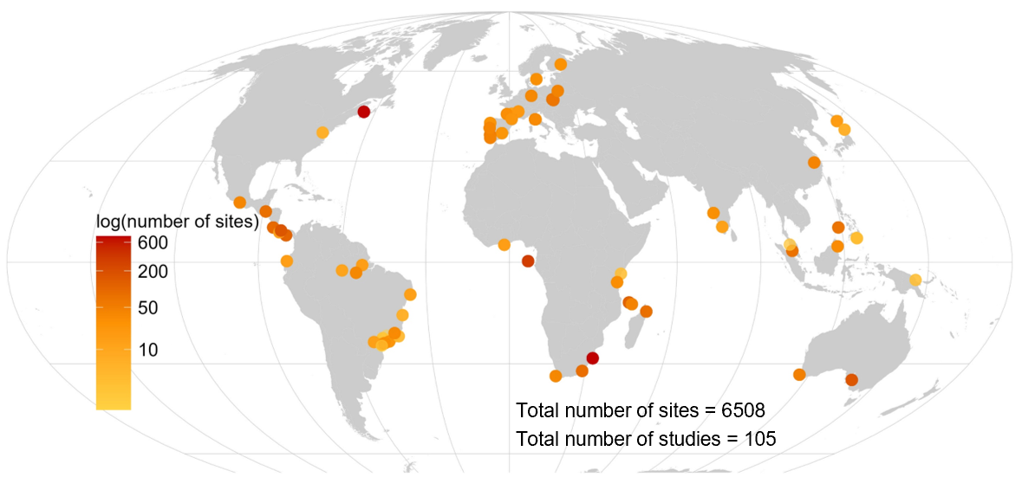
Figure S1. Spatial distribution of sites included in the comparison of hard vs. soft range limits. Each point represents the location of one study, and points are coloured according to the number of sites in the study on a logarithmic scale.

Appendix 3: Model coefficients
In the model formula, the * operator is a shorthand for including all main effects and their interactions, so Incidence ~ distance to range limit * forest cover is equivalent to Incidence ~ distance to range limit + forest cover + distance to range limit: forest cover
Model formula: Incidence ~ distance to range limit * forest cover + (1 | Study/ Site) + (distance to range limit * forest cover | Species)
Table S2. Binomial GLMM results for models testing how distance to range limit, forest cover and their interaction affect probability of incidence. Two separate models were fitted, one using distance to the hard (coastal) limit and another using distance to the soft (inland) limits.
 | Hard limits |  |  |  | Soft limits
Predictors | Log-Odds | std. Error | z | p | Log-Odds | std. Error | z | p
Distance to hard range limit (square-root) | 0.08 | 0.02 | 4.04 | <0.001
Forest cover proportion | 0.91 | 0.17 | 5.33 | <0.001 | 1.87 | 0.21 | 8.71 | <0.001
Interaction between distance to hard limit and forest cover | 0.01 | 0.02 | 0.27 | 0.786
Distance to soft range limit (square-root) |  |  |  |  | 0.06 | 0.01 | 5.74 | <0.001
Interaction between distance to soft limit and forest cover |  |  |  |  | -0.07 | 0.01 | -5.51 | <0.001
N _{Site} | 6508 |  |  |  | 6506
N _{Study} | 105 |  |  |  | 104
N _{Species} | 1708 |  |  |  | 1664
Observations | 230837 |  |  |  | 230837
Marginal R² / Conditional R² | 0.03 / 0.71 |  |  |  | 0.01 / 0.69

Table S3. Binomial GLMM results for model testing how distance to range limit, forest cover, direction of the range limit (equatorward- or poleward- facing) and their pairwise interactions affect probability of incidence.
Predictors | Log-Odds | std. Error | z | p
Distance to soft range limit (square-root) [reference level = equatorward] | 0.07 | 0.01 | 7.77 | <0.001
Forest cover proportion [reference level = equatorward] | 1.59 | 0.16 | 9.96 | <0.001
Interaction between distance to soft limit and forest cover [reference level = equatorward] | -0.05 | 0.01 | -5.02 | <0.001
Interaction between distance to soft limit and edge direction [poleward] | -0.00 | 0.01 | -0.20 | 0.845
Interaction between forest cover and edge direction [poleward] | 0.07 | 0.21 | 0.34 | 0.734
Interaction between distance to soft limit, forest cover and edge direction [poleward] | 0.01 | 0.01 | 0.93 | 0.350
N _{Site} | 7634
N _{Study} | 114
N _{Species} | 2414
Observations | 426685
Marginal R² / Conditional R² | 0.03 / 0.70

Appendix 4: Poleward vs. equatorward halves of species’ ranges
Due to the complex shapes of some species’ ranges, it was possible for a site to be closest to a poleward-facing range limit while being in the equatorward half of the species’ range, and vice versa. We therefore also classified site-by-species combinations based on whether they were in the poleward or equatorward halves of their species’ ranges. To do this, we found the centroid of the range (using the st_centroid function in the ‘sf’ package (Pebesma et al. 2024) in R) and compared the latitude of the sample site with the latitude of the range centroid.
Of the 171,187 site-by-species combinations that were closer to a poleward-facing range limit, 70% of them (n = 119,652) were also in the poleward half of their range. Of the 255,928 site-by-species combinations that were closer to an equatorward-facing range limit, 27% of them (n = 69,937) were also in the equatorward half of their range.
To test how the relationship between distance to soft range limit and sensitivity to forest cover varies depending on whether the population is in the poleward or equatorward half of the species’ range, we considered all combinations of site and species for which it was possible to measure distance to the soft range limit. This excluded species with no soft limits to their ranges (e.g. species endemic to small islands, where all range limits are coastal). We fitted a single model with a three-way interaction term; in addition to forest cover and distance to the nearest soft range limit as interacting predictors, the model included a binary term describing whether the sample site was located in the equatorward- or poleward- half of the species’ range. Sensitivity to forest cover increased with distance to the soft range limit similarly for both populations located in the equatorward half of their species’ range, and those in the poleward half of their species’ range.
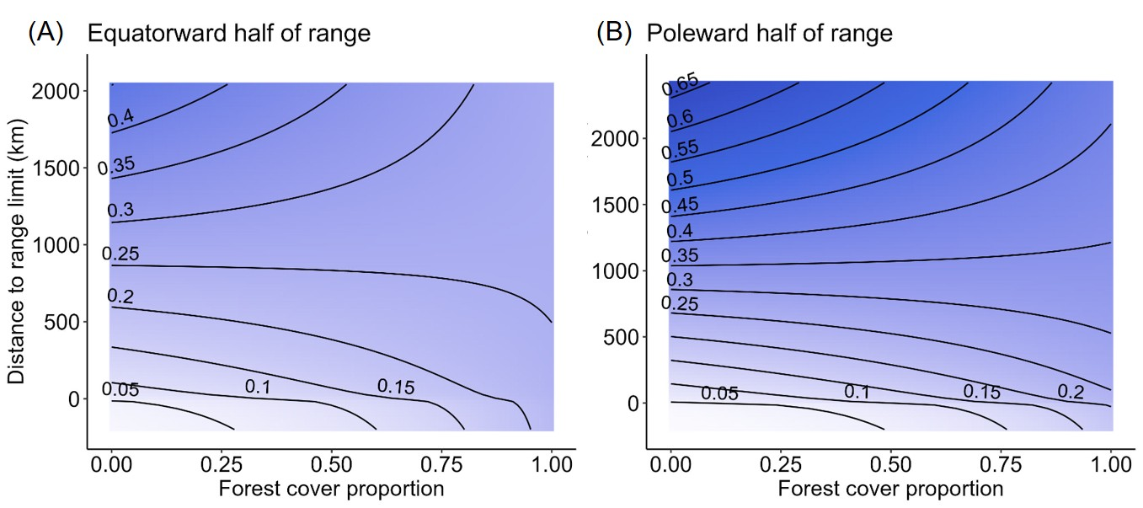Figure S2. Probability of species incidence (contour lines and colour hue) predicted by forest cover (x axis) and distance to range limit (y axis) for sites in the equatorward (A) and poleward (B) halves of species’ ranges.
Table S4. Results from a binomial GLMM examining the probability of species incidence. The model includes a three-way interaction among distance to soft range limit, forest cover and a binary term indicating whether the site was in the equatorward or poleward half of the species’ range, as well as all lower order interactions and fixed effects.
Predictors | Log-Odds | std. Error | z | p
Distance to soft range limit (square-root) [reference level = equatorward] | 0.06 | 0.01 | 5.53 | <0.001
Forest cover proportion [reference level = equatorward] | 1.58 | 0.17 | 9.35 | <0.001
Interaction between distance to soft limit and forest cover [reference level = equatorward] | -0.05 | 0.01 | -4.43 | <0.001
Interaction between distance to soft limit and latitude half [poleward] | 0.02 | 0.01 | 1.65 | 0.100
Interaction between forest cover proportion and latitude half [poleward] | 0.28 | 0.20 | 1.36 | 0.173
Interaction between distance to soft limit, forest cover and latitude half [poleward] | -0.01 | 0.01 | -0.46 | 0.648
N _{Site} | 7634
N _{Study} | 114
N _{Species} | 2491
Observations | 501362
Marginal R² / Conditional R² | 0.03 / 0.70

Appendix 5: Controlling for range size
To account for range size, we first calculated the area of the range using the st_area function from the sf package (Pebesma et al. 2024) in R. We then included log-transformed range area as an additional fixed effect in the binomial GLMM which we described in the main text, which tests how distance to range limit, forest cover and their interaction affect incidence.
Species with larger ranges had higher probability of incidence (effect size on log-odds scale = -0.1, se = 0.02, p < 0.001). Accounting for range size did not alter the significance of distance to range limit, forest cover and their interaction, as predictors of incidence. Species with small ranges are negatively affected by forest loss throughout their range because they are always close to the range limit, while species with larger ranges show more variation.
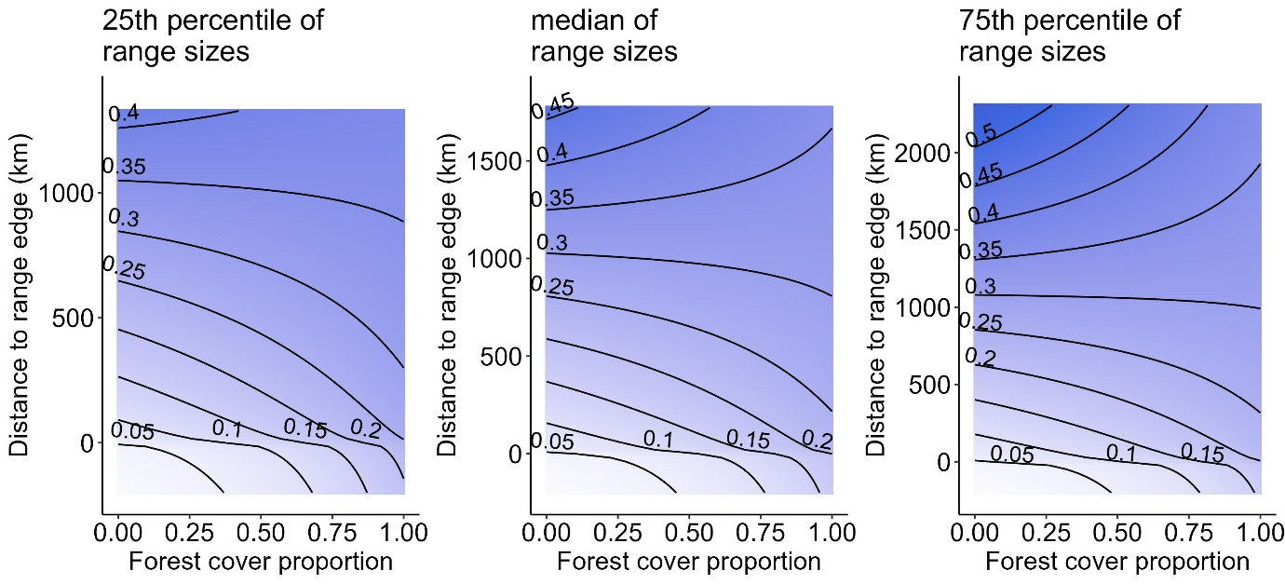
Figure S3. Probability of species incidence (contour lines and colour hue) predicted by forest cover (x axis) and distance to range limit (y axis) at three different range sizes (panels)

Table S5. Binomial GLMM results for model testing how distance to range limit, forest cover and their interaction affect probability of incidence, when accounting for range size.
Predictors | Log-Odds | std. Error | z | p
Distance to soft range limit (square-root) | 0.07 | 0.01 | 10.37 | <0.001
Forest cover proportion | 1.69 | 0.12 | 14.19 | <0.001
Range size (log-transformed) | -0.13 | 0.02 | -6.14 | <0.001
Interaction between distance to soft limit and forest cover | -0.05 | 0.01 | -6.42 | <0.001
N _{Site} | 7634
N _{Study} | 114
N _{Species} | 2491
Observations | 501362
Marginal R² / Conditional R² | 0.03 / 0.68

Appendix 6: Sensitivity test for buffer sizes used to calculate forest cover proportions in the landscape surrounding each site
We calculated the proportion of forest pixels within a 600m buffer around each site. We tested sensitivity of our results to the buffer size using two alternative values often used in studies of the effects of forest cover on bird communities (Arroyo-Rodríguez et al. 2023). Varying the buffer size did not affect the overall results.
Table S6. Model coefficients testing effects of distance to soft range limit, forest cover proportion (400m buffer) and their interaction on species incidence.
Buffer radius = 400m
Predictors | Log-Odds | std. Error | z | p
Distance to soft range limit (square-root) | 0.06 | 0.01 | 9.45 | <0.001
Forest cover proportion | 1.64 | 0.11 | 14.38 | <0.001
Interaction between distance to soft range limit and forest cover proportion | -0.05 | 0.01 | -6.08 | <0.001
N _{Site} | 7634
N _{Study} | 114
N _{Species} | 2491
Observations | 501362
Marginal R² / Conditional R² | 0.03 / 0.69
Table S7. Model coefficients testing effects of distance to soft range limit, forest cover proportion (800m buffer) and their interaction on species incidence.
Buffer radius = 800m
Predictors | Log-Odds | std. Error | z | p
Distance to soft range limit (square-root) | 0.07 | 0.01 | 9.94 | <0.001
Forest cover proportion | 1.76 | 0.12 | 14.20 | <0.001
Interaction between distance to soft range limit and forest cover proportion | -0.05 | 0.01 | -6.61 | <0.001
N _{Site} | 7634
N _{Study} | 114
N _{Species} | 2491
Observations | 501362
Marginal R² / Conditional R² | 0.03 / 0.69

Appendix 7: AIC comparison for fixed effects
Table S8. AIC scores of models reported in main text, compared to models with simpler fixed effects. For this comparison, we fitted binomial GLMMs to the full dataset. The response variable was species incidence, and the predictor variables are shown in the table. All models included the same random effects: (1/Study/Site) + (distance to soft range limit * forest cover | Species). Including both forest cover and distance to the nearest soft range limit, along with their interaction, substantially improved model fit compared to simpler models. Adding a fixed effect for edge direction (i.e., whether the nearest soft range limit faced equatorward or poleward) did not significantly change the model fit. This suggests support for the conclusion that distance to soft range limits mediates the effect of incidence of forest cover, regardless of whether the soft range limit faces equatorward or poleward.
Fixed effect predictors | AIC | ΔAIC
1 | 266899.7 | 226
Distance to soft range limit | 266844.4 | 170
Forest cover | 266764.7 | 90
Distance to soft range limit + Forest cover | 266699.7 | 26
Distance to soft range limit + Forest cover + Distance to soft range limit:Forest cover | 266674.2 | 0
Distance to soft range limit + Forest cover + Distance to soft range limit:Forest cover + Edge direction | 266674.6 | 0.4
Distance to soft range limit + Forest cover + Distance to soft range limit:Forest cover + Distance to soft range limit:Edge direction + Forest cover:Edge direction +  Distance to soft range limit:Forest cover:Edge direction | 266675.0 | 0.8

Appendix 8: Test for correlation between forest cover and distance to range limit
We tested for a correlation between the two predictors in our GLMMs: forest cover and distance to range limit and found no correlation. The Pearson’s correlation coefficient between distance to soft range limit and forest cover was -0.067 (95% CI = -0.070, -0.064). For the subset of data consisting of sites closer to a hard range limit than a soft range limit, the Pearson’s correlation coefficient between distance to hard range limit and forest cover was -0.025 (95% CI = -0.029, -0.021).

Appendix 9: Test for phylogenetic signal in random effects
We used random slopes in our statistical models to account for variation in the fixed effects across species. To test whether these slopes were phylogenetically correlated, we used phylogenetic generalised least squares (PGLS) to estimate λ, a measure of phylogenetic signal.
First, we fitted a binomial GLMM, as described in the main text, using the full dataset. The model included distance to the soft range limit and forest cover proportion as interacting predictors of incidence (presence or absence of each species at each site). We then extracted the random effect slopes and intercepts for each species for each model coefficient. We then used these slopes and intercepts as response variables in separate PGLS models. We used null PGLS models (coefficient ~ 1) and estimated λ by maximum likelihood using the ‘caper’ R package (Orme et al. 2023).
There was no phylogenetic signal in the distance to soft range limit coefficients (λ = 0. 95% CI = 0 – 0.016) or in the interaction coefficients (λ = 0, 95% CI = 0 – 0.011). There was very weak phylogenetic signal in the forest cover coefficients (λ = 0.15, 95% CI = 0.067 – 0.26) and intercepts (λ = 0.13, 95% CI = 0.052 – 0.236).

Appendix 10: Verification of assumptions underlying statistical models
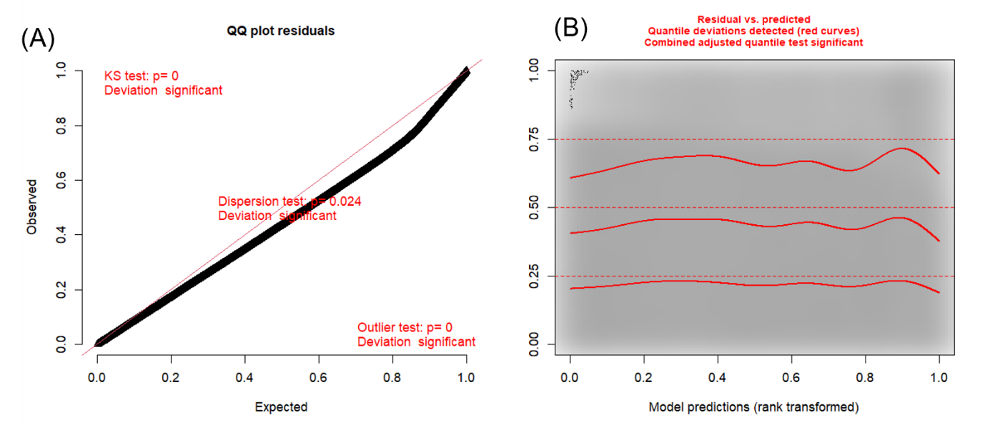

Figure S4. Distribution of residuals for model testing how forest cover and distance to hard range limit affect incidence (model shown in Table S2 and Figure 2A). (A) Q-Q plot showing observed vs expected scaled residuals. (B) Distribution of quantiles of scaled residuals vs predicted values. Plots were constructed using the DHARMa package (Hartig & Lohse 2022). Visual inspection of both plots indicates uniformity of residuals for our large dataset.
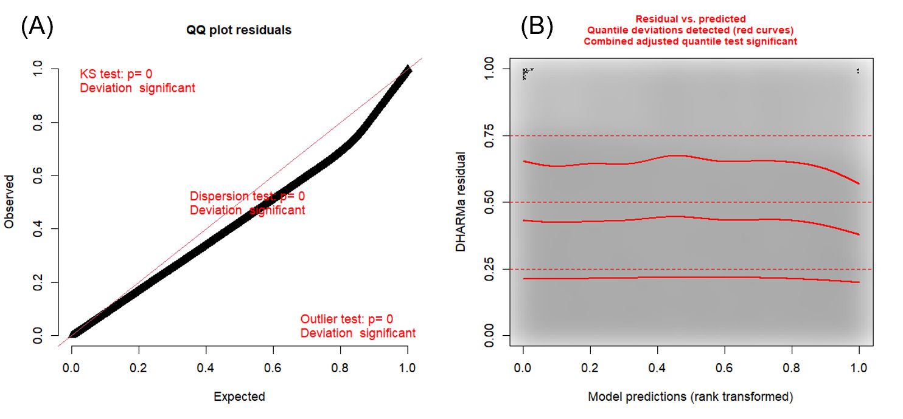Figure S5. Distribution of residuals for model testing how forest cover and distance to soft range limit affect incidence (model shown in Table S2 and Figure 2B. (A) Q-Q plot showing observed vs expected scaled residuals. (B) Distribution of quantiles of scaled residuals vs predicted values. Plots were constructed using the DHARMa package (Hartig & Lohse 2022). Visual inspection of both plots indicates uniformity of residuals for our large dataset.
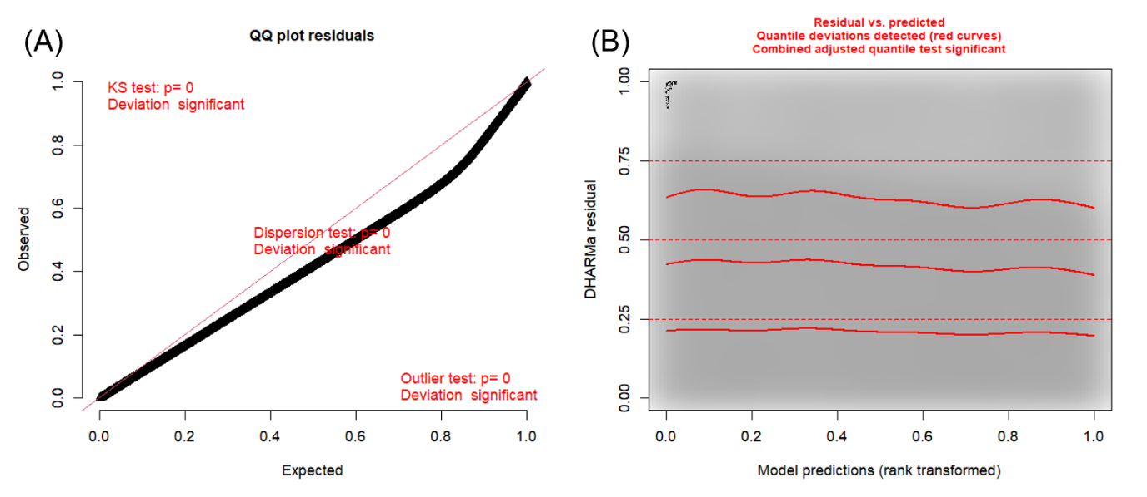
Figure S6. Distribution of residuals for model testing how forest cover, distance to soft range limit and direction of the range limit (poleward or equatorward) affect incidence (model shown in Table S3 and Figure 3). (A) Q-Q plot showing observed vs expected scaled residuals. (B) Distribution of quantiles of scaled residuals vs predicted values. Plots were constructed using the DHARMa package (Hartig & Lohse 2022). Visual inspection of both plots indicates uniformity of residuals for our large dataset.

References
Arroyo-Rodríguez, V., Martínez-Ruiz, M., Bezerra, J.S., Galán-Acedo, C., San-José, M. & Fahrig, L. (2023). Does a Species’ Mobility Determine the Scale at Which It Is Influenced by the Surrounding Landscape Pattern? Curr Landscape Ecol Rep, 8, 23–33.
Hartig, F. & Lohse, L. (2022). DHARMa: Residual Diagnostics for Hierarchical (Multi-Level / Mixed) Regression Models.
Hasui, É., Metzger, J.P., Pimentel, R.G., Silveira, L.F., Bovo, A.A. d. A., Martensen, A.C., et al. (2018). ATLANTIC BIRDS: a data set of bird species from the Brazilian Atlantic Forest. Ecology, 99, 497–497.
Hudson, L.N., Newbold, T., Contu, S., Hill, S.L.L., Lysenko, I., De Palma, A., et al. (2017). The database of the PREDICTS (Projecting Responses of Ecological Diversity In Changing Terrestrial Systems) project. Ecol Evol, 7, 145–188.
Orme, C.D.L., Mayor, S., dos Anjos, L., Develey, P.F., Hatfield, J.H., Morante-Filho, J.C., et al. (2019). Distance to range edge determines sensitivity to deforestation. Nat Ecol Evol, 3, 886–891.
Orme, D., cre, Freckleton, R., Thomas, G., Petzoldt, T., Fritz, S., et al. (2023). caper: Comparative Analyses of Phylogenetics and Evolution in R.
Pebesma, E., Bivand, R., Racine, E., Sumner, M., Cook, I., Keitt, T., et al. (2024). sf: Simple Features for R.
Pfeifer, M., Lefebvre, V., Gardner, T.A., Arroyo-Rodriguez, V., Baeten, L., Banks-Leite, C., et al. (2014). BIOFRAG – a new database for analyzing BIOdiversity responses to forest FRAGmentation. Ecol Evol, 4, 1524–1537.

