Electronic Supplementary Materials:

The costs of keeping cool: behavioural trade-offs between foraging and thermoregulation are associated with significant mass loss in an arid-zone bird

Oecologia

T.M.F.N. van de Ven¹
A.E. McKechnie^{2,3}
S.J. Cunningham^{1*}

¹FitzPatrick Institute of African Ornithology, DST-NRF Centre of Excellence, Private Bag X3, University of Cape Town, Rondebosch 7701, South Africa
²DST-NRF Centre of Excellence at the FitzPatrick Institute, Department of Zoology and Entomology, University of Pretoria, Pretoria 0002, South Africa
³South African Research Chair in Conservation Physiology, National Zoological Garden, South African National Biodiversity Institute, Pretoria, South Africa

*susie.j.c@gmail.com; sj.cunningham@uct.ac.za

Construction of taxidermic models and black bulb calibration
Operative temperature (T_{e}) experienced by live hornbills would be best approximated with a taxidermic model covered by a skin and pelage of a hornbill, in order to mimic the thermal properties of the species (Bakken 1992). However, because it was impractical to obtain a large number of hornbill skins, we mapped the hornbills’ thermal environment using 36 blackbulb thermometers instead, and calibrated these against two taxidermic models of Southern Yellow-billed Hornbills (Bakken 1980).
The blackbulbs were constructed according to Bakken’s (1985) black globe thermometer, ‘rugged model’, and each comprised a copper sphere (painted matt black) with internally mounted temperature logger (Thermochron iButton, DS1923, Maxim, Sunnyvale, CA, USA, resolution = 0.0625 °C, hereafter “iButtons”) (Figure S1A). The diameter of each blackbulb approximated mean thoracic depth of an adult male Southern Yellow-billed Hornbill (60 mm), which was estimated from museum specimen measurements (mean 60.1 ± SD 5.6 mm, n = 15). The two taxidermic models were each made of a hollow copper spheroid and copper sheeting shaped to resemble the hornbill body shape and covered with a hornbill skin (following Wathes and Clark 1981; Figure S1B). An iButton was placed in each of the taxidermic models and calibration carried out as described in the main text.
More than 95% of the variation in taxidermic model T_{e} could be explained by the blackbulb T_{e} in all microsite categories, and the relationship between the taxidermic model temperature and the blackbulb temperature was linear in all 12 microsite categories (Figure S2). Corrected blackbulb temperatures used in all analyses in the main manuscript were obtained by adding the intercept value of the regression of taxidermic model temperatures against blackbulb temperatures for each microsite to the blackbulb temperature value and multiplying it by the slope estimate (intercepts and slopes presented in Figure S2).

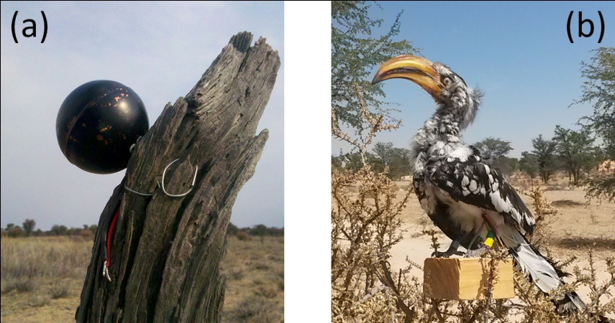

Figure S1 (a) A blackbulb and (bB) a Southern Yellow-billed Hornbill taxidermic model placed in an 'exposed' microsite at a height between 0 and 1 m.

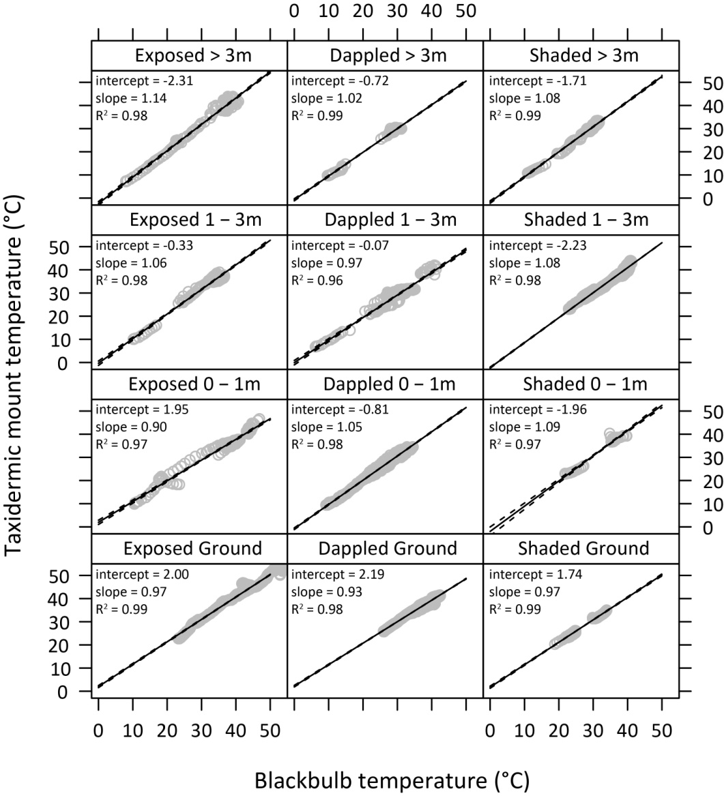

Figure S2 Calibration curves of taxidermic model temperature from blackbulb temperature in the 12 microsite categories. Data were obtained from the calibration of blackbulbs (n = 3) with taxidermic models (n = 2) over 27 days. The data are represented as grey symbols, the black line represents the model fit and the dotted line represents the upper and lower 95% CI. Estimates of the intercept, the slope and the multiple r² value of the linear relationship are presented in each panel. The slope estimate refers to the change in taxidermic model temperature per 1 °C increase in blackbulb temperature.
Calculation of prey biomass

Biomass per prey item type was calculated as the average live mass of at least five specimens of each prey taxa, drawn from a reference collection (Table S1). Prey items for this reference collection were collected during summer between 2012 and 2015 and match the spectrum of the hornbills’ diet as observed from the focal observations. Prey item sizes observed during focal observations were classified as an estimate relative to beak size and recorded as categories: 'tiny', '< 1/3 of the beak’,’1/3 of the beak’, '2/3 of the beak', 'same size as the beak' and '> than beak'. Some items were unavoidably missing from the reference collection due to difficulty of catching these. The biomass of the missing prey items was estimated from a prey reference collection for meerkats (Suricata suricatta) at the Kuruman River Reserve (T. Chalikonda, unpubl. data).

Table S1 Prey items captured by male Southern Yellow-billed Hornbills as recorded during focal observations and classified by order, common name (as noted during focal data collection), size class and average wet biomass of the prey item (g). The avian eggs that were observed in the diet were acquired from Southern Pied Babbler (Turdoides bicolor), Fork-tailed Drongo (Dicrurus adsimilis) White-browed Sparrow Weaver (Plocepasser mahali) and Cape Turtle Dove (Streptopelia capicola) nests. The mass estimate of the avian egg is taken from an average of two Southern Pied Babbler eggs and three Fork-tailed Drongo eggs acquired from abandoned nests (< 2 days after abandonment) at the study site.

Estimating minimum foraging bout length required for reliable estimation of foraging efficiency

The number of prey captures per minute foraging was calculated as a function of foraging bout length to assess minimum bout length required for reliable estimations of foraging efficiency. Foraging bouts with a duration < 2.5 min had high variability in the number of prey captures per minute, but this stabilised once bouts exceeded ~2.5 minutes in length (Figure S). Foraging attempts shorter than 2.5-min were therefore excluded from subsequent analyses of foraging efficiency.

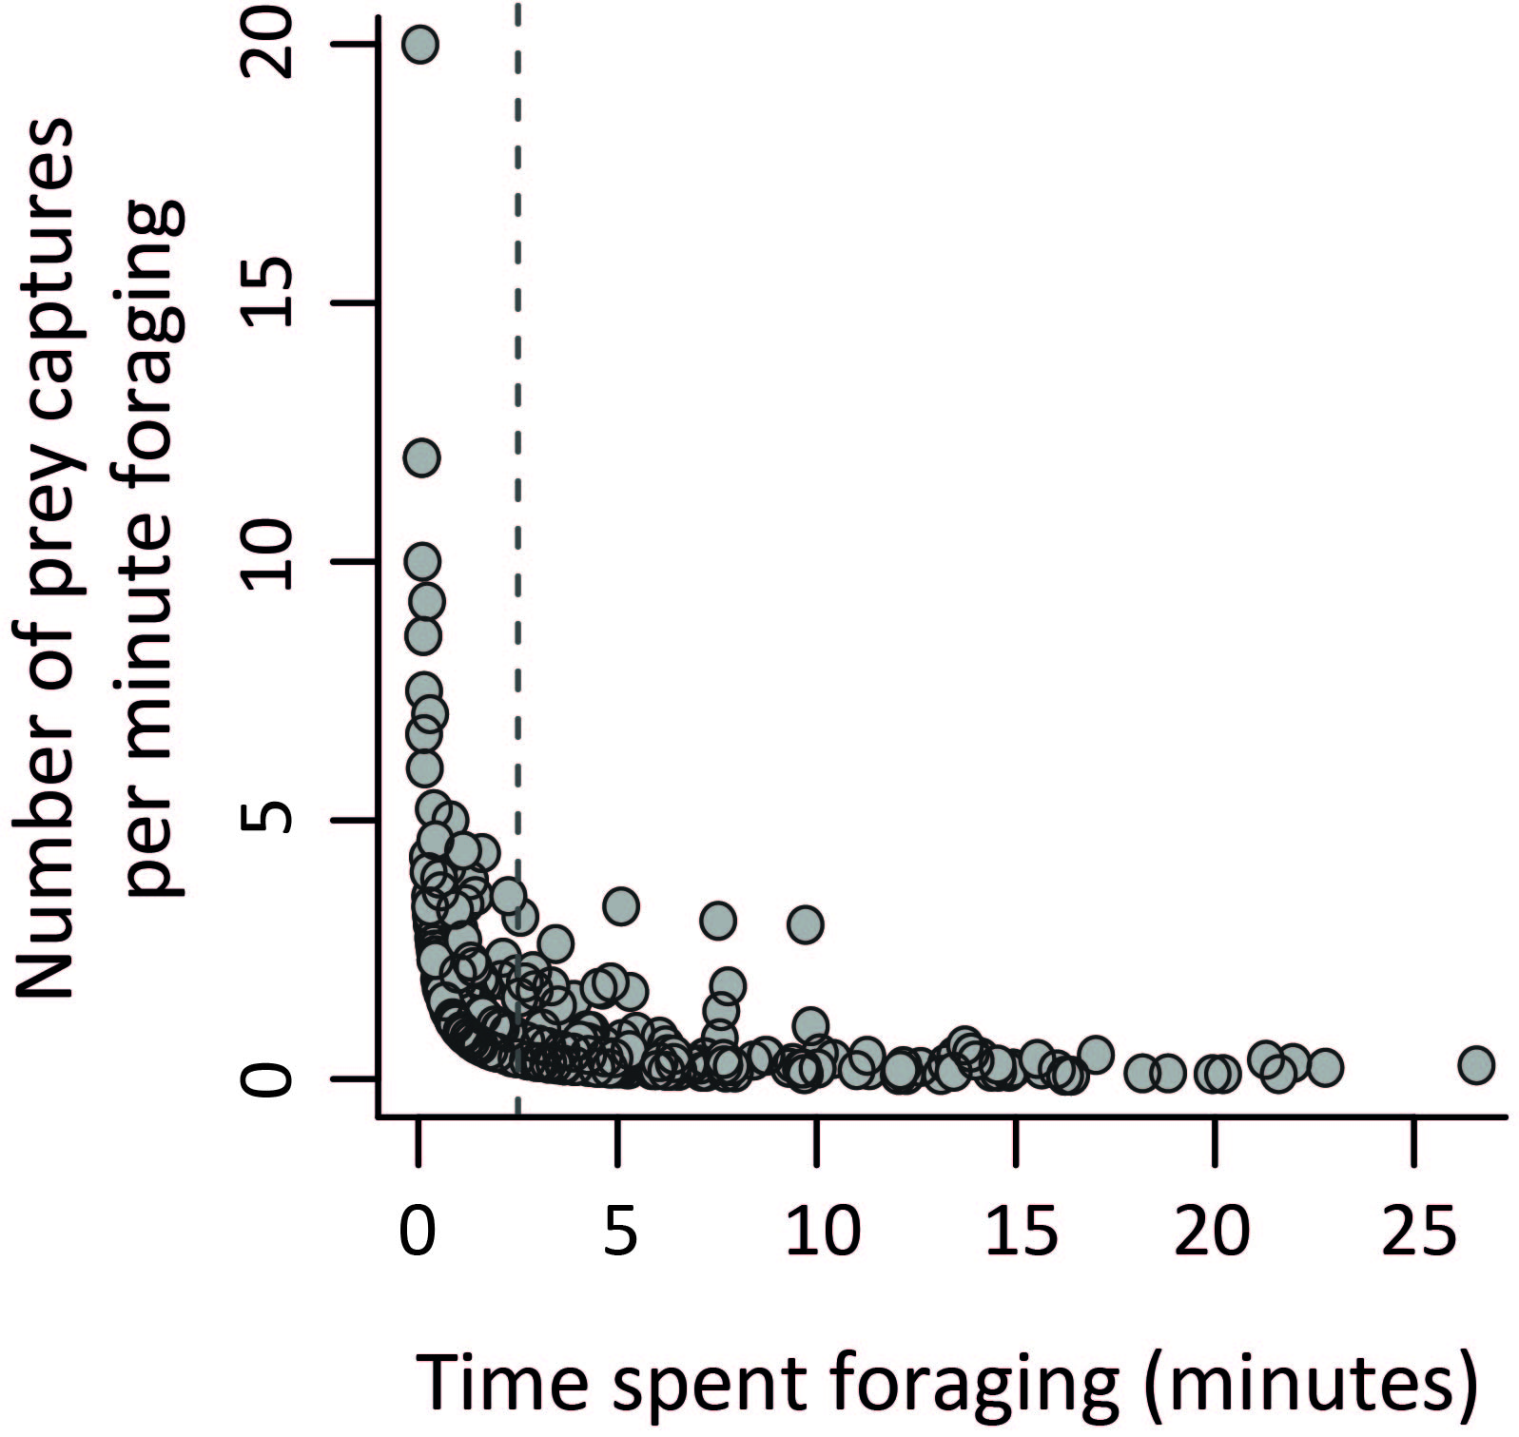

Figure S3: The relationship between foraging bout length and reliability of foraging efficiency (prey captures per minute foraging) estimates. Data plotted are the number of prey captures per minute foraging by Southern Yellow-billed Hornbills (y-axis) against foraging bout length (time spent foraging in minutes; x-axis). The vertical dashed line indicates foraging bout length of 2.5-min; above which variation in prey capture rate stabilises.

Foraging efficiency (prey captures per minute) in different microsites

Table S2: Paired Wilcoxon tests for foraging efficiency (prey captures per minute foraging) within the same focal observation period (therefore presumably under the same T_{a} and prey availability conditions) for eight breeding male Southern Yellow-billed Hornbills. Foraging efficiency was always higher on the ground, regardless of exposure of the microsite to the sun.

Microsite comparison |  |  | Effect size | Z-statistic | p-value
Off-ground shade | VS | Off-ground sun | 0.00 | 0.00 | 1.000
Off-ground shade | VS | Ground shade | 0.94 | 2.66 | 0.008
Off-ground shade | VS | Ground sun | 0.81 | 2.28 | 0.022
Off-ground sun | VS | Ground shade | 0.94 | 2.66 | 0.008
Off-ground sun | VS | Ground sun | 0.81 | 2.28 | 0.022
Ground shade | VS | Ground sun | 0.17 | 0.47 | 0.641

Illustration of perch scale used to collect M_{b} data

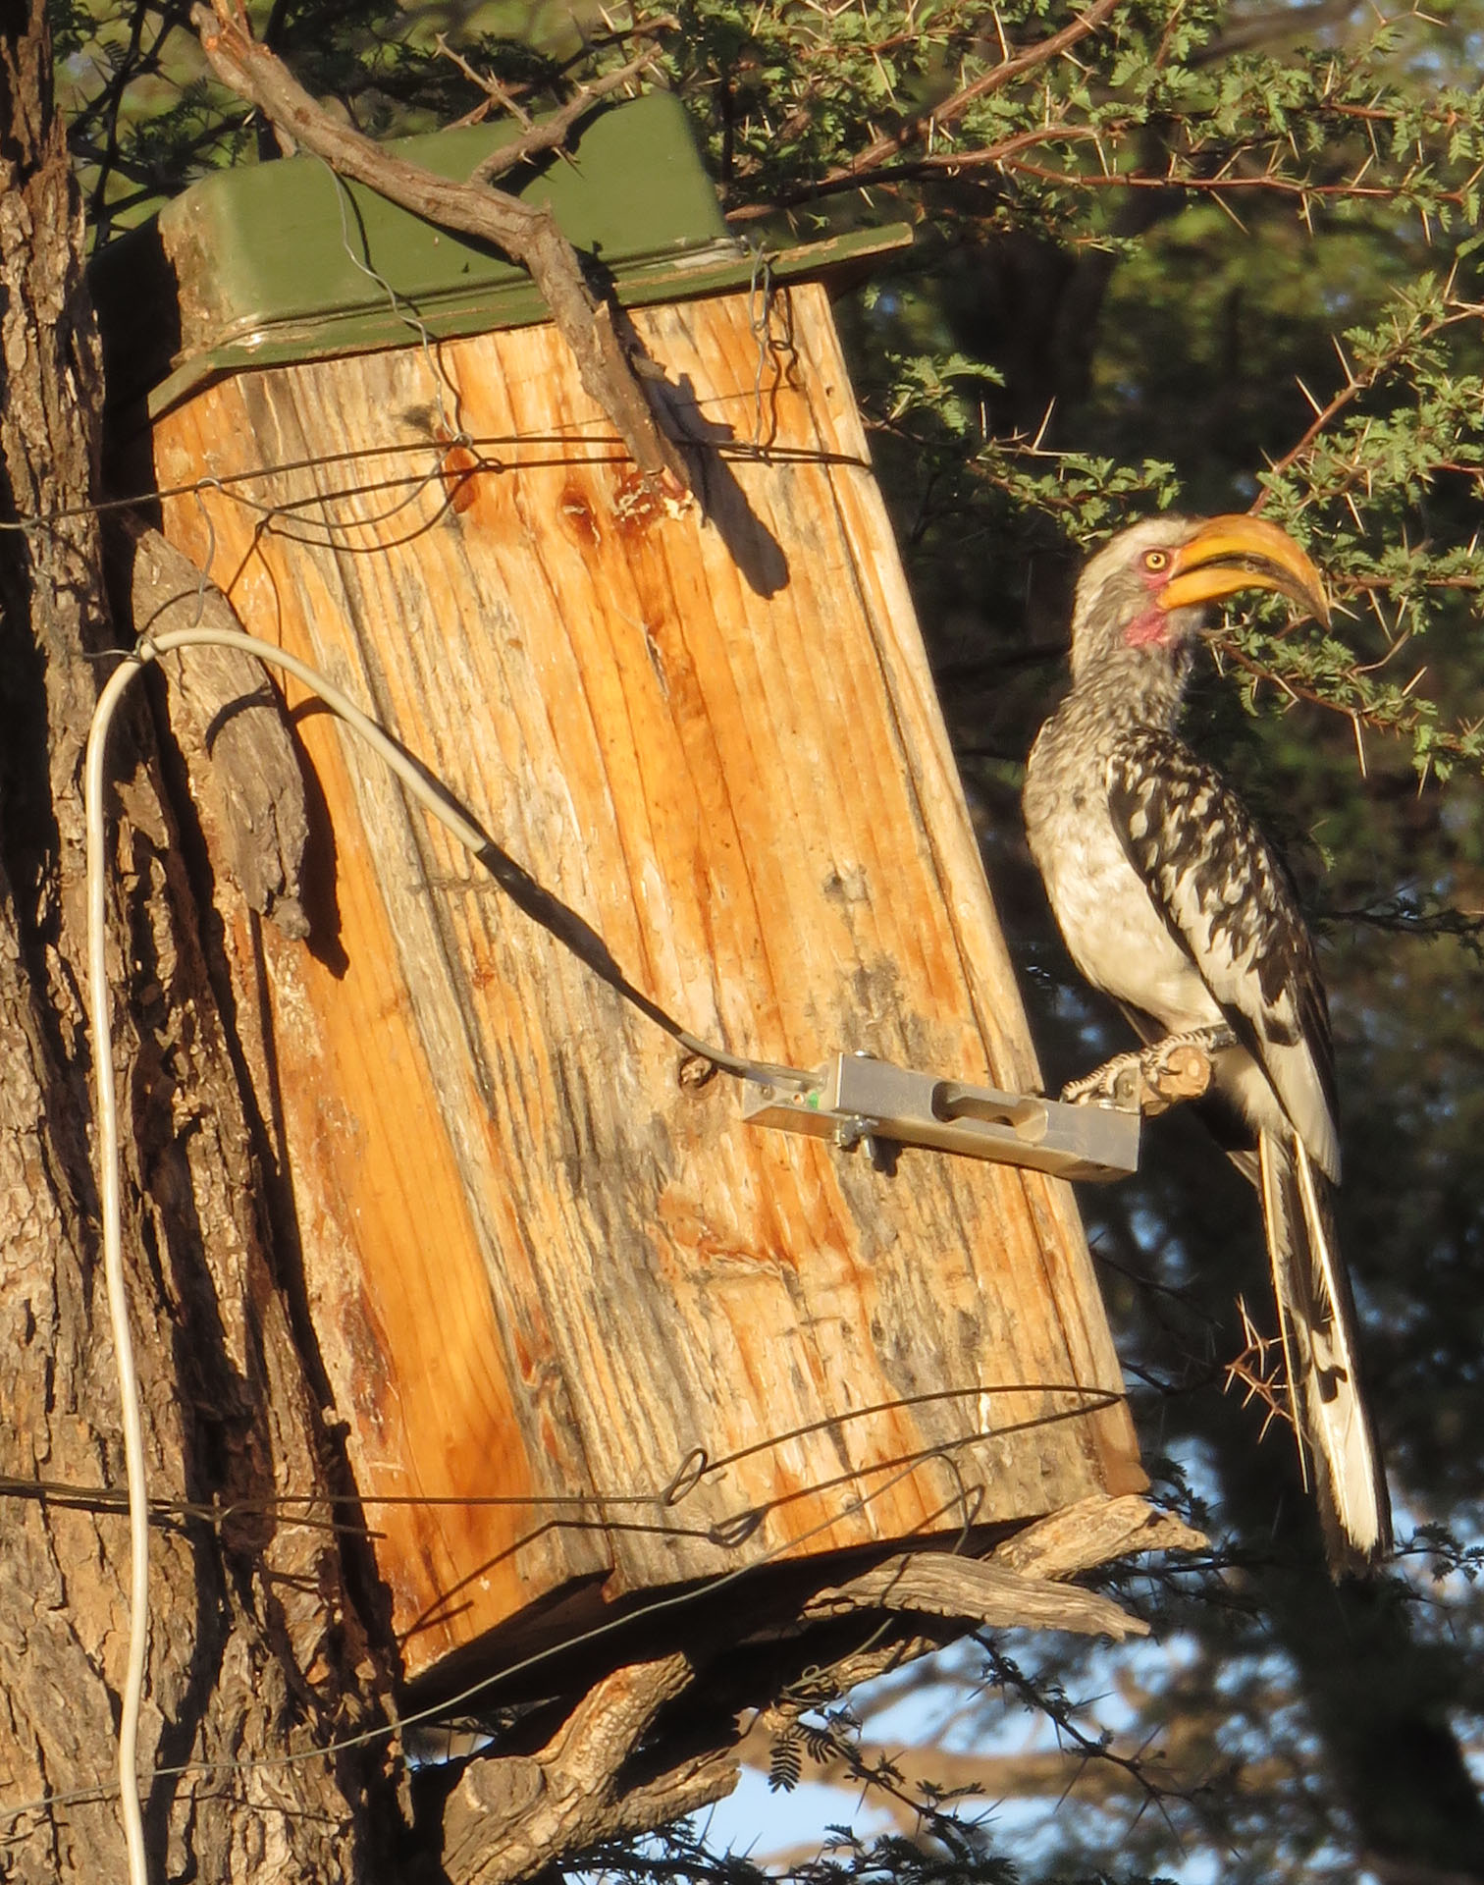

Figure S4. A male Southern Yellow-billed Hornbill (individual ID: GMOR of nest ID: LEA05) correctly using a perch scale mounted to a nest box. Note both feet on the perch and no body parts touching the nest box or other parts of the scale, ensuring a correct M_{b} reading (photo credit: Dean Portelli).

References

Bakken GS (1980) The use of standard operative temperature in the study of the thermal energetics of birds. Physiological Zoology 53:108-119.
Bakken GS (1992) Measurement and application of operative and standard operative temperatures in ecology. American Zoologist 32:194-216.
Bakken GS, Santee WR, Erskine DJ (1985) Operative and standard operative temperature: Tools for thermal energetics studies. Integrative and Comparative Biology 25:933-943.
Wathes GM, Clark JA (1981) Sensible heat transfer from the fowl: thermal resistance of the pelt. British Poultry Science 22:175-183.

