The Saururus chinensis genome provides insights into the evolution of pollination strategies and herbaceousness in magnoliids

Jia-Yu Xue^{1,2,#}, Zhen Li^{3,#}, Shuai-Ya Hu^{1,#}, Shu-Min Kao^{3,#}, Tao Zhao^{4,#}, Jie-Yu Wang^{5,#}, Hai-Yun Fan¹, Yichun Qiu⁶, Yue Wang², Min Chen², Yang Liu^{7,*}, Zhu-Qing Shao^{8,*},Yves Van de Peer^{1,3,9,*}

¹College of Horticulture, Academy for Advanced Interdisciplinary Studies, Nanjing Agricultural University, Nanjing 210095, China
²Center for Plant Diversity and Systematics, Institute of Botany, Jiangsu Province and Chinese Academy of Sciences, Nanjing 210014, China
³Department of Plant Biotechnology and Bioinformatics, Ghent University, VIB-UGent Center for Plant Systems Biology, B-9052 Ghent, Belgium
⁴State Key Laboratory of Crop Stress Biology for Arid Areas/Shaanxi Key Laboratory of Apple, College of Horticulture, Northwest A&F University, Yangling 712100, China
⁵Key Laboratory of Plant Resources Conservation and Sustainable Utilization, South China Botanical Garden, Chinese Academy of Sciences, Guangzhou 510650, China
⁶Max Planck Institute of Molecular Plant Physiology, Potsdam Science Park, Am Mühlenberg 1, 14476 Potsdam-Golm, Germany
⁷Fairy Lake Botanical Garden, Shenzhen & Chinese Academy of Sciences, Shenzhen 518004, Guangdong, China
⁸State Key Laboratory of Pharmaceutical Biotechnology, School of Life Sciences, Nanjing University, Nanjing, 210023, China
⁹Department of Biochemistry, Genetics and Microbiology, University of Pretoria, Pretoria 0028, South Africa

#These authors contributed equally to this work.
*To whom correspondence should be addressed: yang.liu0508@gmail.com (Y.L.), zhuqingshao@nju.edu.cn (Z.Q.S) or yves.vandepeer@psb.ugent.be (Y.V.d.P.)

Supplementary Note 1. The Karyotype analysis of S. chinensis
Young root tips were pretreated in 0.1% colchicine solution for four hours, and were then fixed in Carnoy's Fluid (glacial acetic acid: anhydrous ethanol = 1:3) for 20 hours. Afterword, plant materials were moved into 10% hydrochloric acid at 60 ℃ for five minutes. Rinse with water when each change of solution. The meristem was cut off and put on the glass slide, then a drop of Carbol fuchsin solution was added. Roast the glass slide over an alcohol lamp, covered with a cover glass. Tap gently with the tip of your pencil until foggy and give it two hard knocks then press it hardly with the thumb. Examine it under a microscope and take photos (Supplementary Fig. S1).

Supplementary Note 2. Sample collection, DNA and RNA extraction
One individual of cultivated S. chinensis in at Institute of Botany, Jiangsu Province and Chinese Academy of Sciences, Nanjing, was chosen for genome sequencing. Its fresh leaf tissues were collected for Illumina, PacBio and HiC sequencing; and its green leaves, white leaves, fruits, inflorescence, roots and stems were used for transcriptomes sequencing. Green leaves and white leaves of two other individuals in the same population were also collected for transcriptomes sequencing.

Supplementary Note 3. Genome size estimation of S. chinensis
Flow cytometric analysis. A young leaf (about 0.2g) collected and put into the petri dish, and 500μL 1ml/L LB01 nucleic acid extraction solution (15 mmol/L Tris (Hydroxymethyl) Aminomethane Hydrochloride (PH=7~8); 2 mmol/L Disodium ethylenediamine tetraacetic acid; 0.5 mmol/L Speramine tetrachloride; 80 mmol/L potassium chloride; 15 mmol/Lβ-mercaptoethanol; 0.1% (V/V) polyethylene glycol octylphenol ether) was added. The leaf was chopped with a razor blade in vertical direction. After incubation under dark conditions for 5 min, leaf residue was filtered out by three hundred mesh nylon screen to obtain the nuclear suspension of Saururus chinensis. All the above operations were carried out on the ice. After that, 0.5 ml propidium iodide staining solution (45 mg/L RNase A, 10ug/L PI) was added into the nuclear suspension, then was placed in a 4 ℃ refrigerator for half an hour after mixing by shaking. The nuclear suspension of Oryza sativa (2C=1.00) (Bennett and Smith 1991) and Nicotiana tabacum (2C=10.36) (Leitch, et al. 2008) were prepared in the same way and used as internal standards. According to the conversion factor that 1 pg DNA equals 978 Mbp (Dolezel, et al. 2003), the genome size of S. chinensis was estimated to be 553 and 523 Mb (Supplementary Fig. S2, Table S1 and S2), respectively.
K-mer assessment. We performed k-mer analysis to assess the genome size from 89 Gb short Illumina reads. K-mer frequencies were calculated using Jellyfish version 2.2.6 with k-mer size 21 (Marcais and Kingsford 2011), and the resulting data was sent to GenomeScope version 1.0 for the estimation (Vurture, et al. 2017). The genome size was calculated with the following formula: genome size = k-mer number/peak depth. The 21-kmer analysis captured a k-mer number of 1.8 x 10⁷ and highest peak depth of 25 in a plot of the frequency distribution of k-mer numbers, suggesting that S. chinensis has a genome of approximately 502 Mb. The secondary peak that has just half of the average sequencing depth of the primary peak reveals a moderate level of heterozygosity (0.821%), and the percentage of k-mer numbers after the homozygous peak at 1.8 of the total number of k-mers shows a repetitive sequence ratio of 66.8% (Supplementary Fig. S3).

Supplementary Note 4. Genome assembly of S. chinensis
Contig assembly and polishing. We used Canu version 1.8 to correct and assemble the raw PacBio reads with default parameters except for parameters: “genomeSize=550m correctedErrorRate=0.040” (Koren, et al. 2017). Following Canu, we polished the long-read assembled contigs using Pilon version 1.23 for eight iterative rounds (Walker, et al. 2014). In total, 244 Gb of Illumina short reads were mapped to the contigs using Bowtie version 2.3.4.3 with parameter: “--sensitive-local” (Langmead and Salzberg 2012), followed by Pilon polishing with parameter: “--fix bases” for four iterative rounds (Walker, et al. 2014). Another four iterative rounds of polishing with parameters: “--fix all” (bases, gaps, and local) were further performed to fix all the variants. The final polished contigs contain 3,919 sequences with a total length of 698 Mbp and an N50 of 1.0 Mbp.
Haplotigs purging. After mapping and estimating the read coverage using short Illumina reads, we observed two peaks: 44x and 88x (Supplementary Fig. S4), indicating that there were unresolved homologous contigs (the peak with 44x). Hence, we further used Purge haplotigs version 1.1.0 (Roach, et al. 2018) with parameters: -l 10 -m 63 -h 195 for purge_haplotigs contigcov (purge_haplotigs hist and purge_haplotigs purge were with default parameters) to refine the assembly and collapse the homologous regions. After the elimination of heterozygotic sequences, the assembly reduced to 537 Mb with 842 contigs.
Scaffolding with Hi-C data. In total, we used 60 Gb of clean Hi-C reads for the scaffolding. S. chinensis was reported to be a diploid (2n = 22) plant, the polished and haplotigs-purged contigs were scaffolded into 11 pseudomolecules chromosome-scale assembly using AllHiC pipeline (Zhang, et al. 2019).

Supplementary Note 5. Identification of transposable elements and repetitive DNA
We used both de novo and homology-based predictions to identify the repetitive elements in the S. chinensis genome. We built a de novo repeat library by RepeatModeler version 2.0 with the support of LTRStruct by adding parameter: “-LTRStruct” (McCarthy and McDonald 2003). Additionally, we used TransposonPSI to detect (retro-) transposon ORF. We merged the libraries from RepeatModeler and TransposonPSI by USEARCH with 80% identity as the minimum threshold for combining similar sequences in the de novo libraries (Edgar 2010). The resulting non-redundant de novo repeat library was further scanned to remove potential plant protein-coding sequences. Finally, we used RepeatMasker version 4-1-0 with parameter: “-e rmblast -a -s -norna -no_is -xsmall -gff -html -lib” to identify and classify repeats in the genome assembly. The soft-masked genome sequence was used for downstream gene prediction and RNA-Seq mapping analysis. The S. chinensis genome has the highest proportion of repetitive sequences (66.8%) among all sequenced magnoliids, despite that it has the smallest genome (Supplementary Table S6). Compared with P. nigrum from the same order Piperales, S. chinensis has less LTRs, only about a half (136 Mb) of that of P. nigrum (282 Mb), while has more DNA transposons (128 Mb) than P. nigrum (79 Mb) (Hu, et al. 2019).

Supplementary Figures

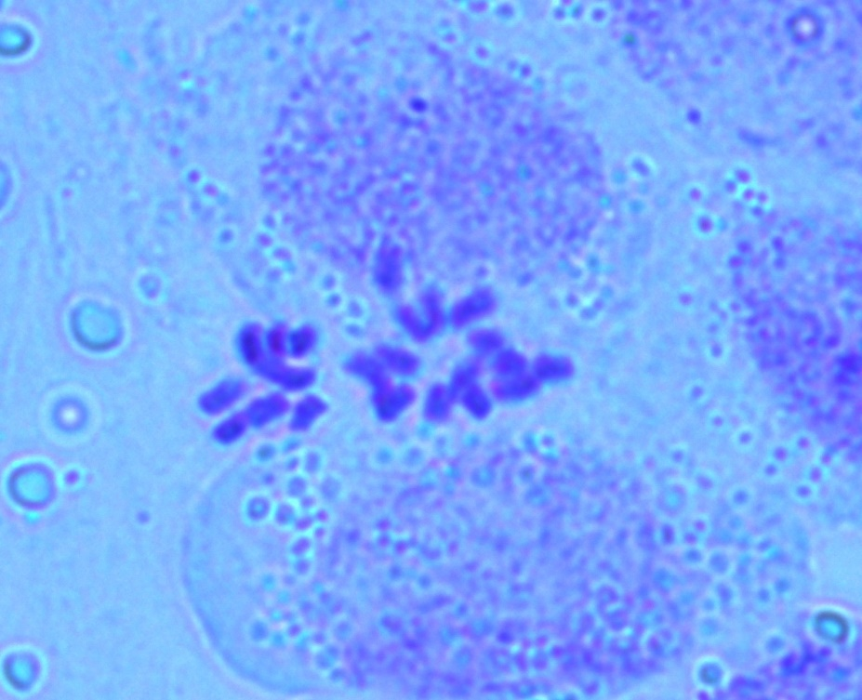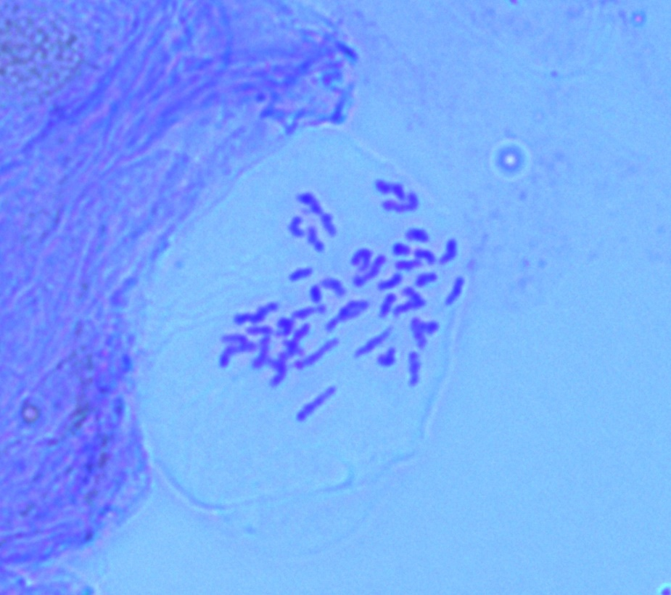
a
b

Supplementary Fig. S1. Karyotype of Saururus chinensis.
a) metaphase; b) anaphase. The basic root-tip metaphase cells show the number of chromosomes number (2n = 22).

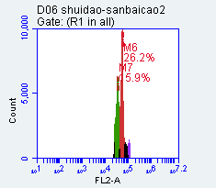
Supplementary Fig. 2.1. The flow cytometry peak diagram of S. chinensis (Red) and O. sativa (Greeen)

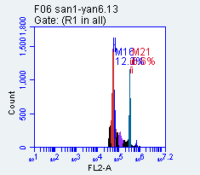

Supplementary Fig. 2. The flow cytometry peak diagram of S. chinensis (Red) and N. tabacum (Blue).

Supplementary Fig. S3. Saururus chinensis genome size estimation using Jellyfish and GenomeScope with k-mer size 21.

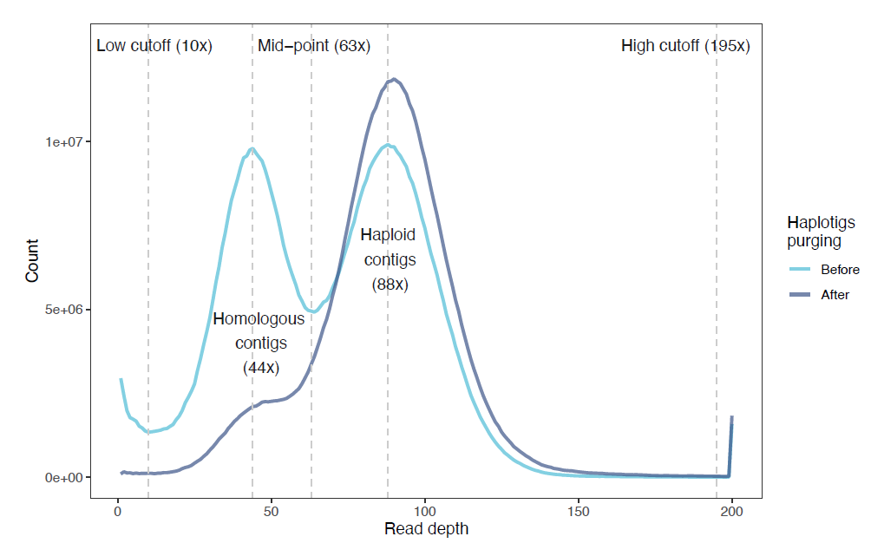
Supplementary Fig. S4. Read coverage of raw PacBio reads on Canu assembly before and after purging haplotigs.

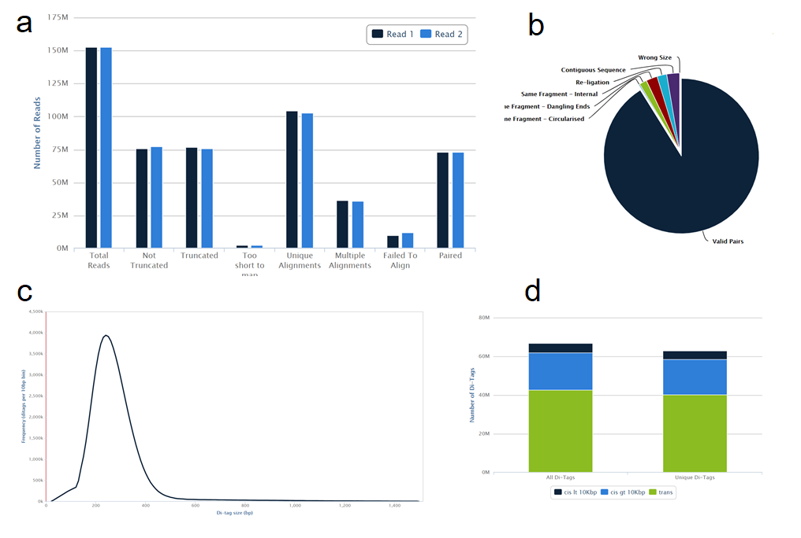
Supplementary Fig. S5. Report of Hi-C data.
(a) Statistics of truncated and mapped reads. (b) Statistics of reads after filtering. (c) Di-tag length distribution. (d) De-duplicated reads.

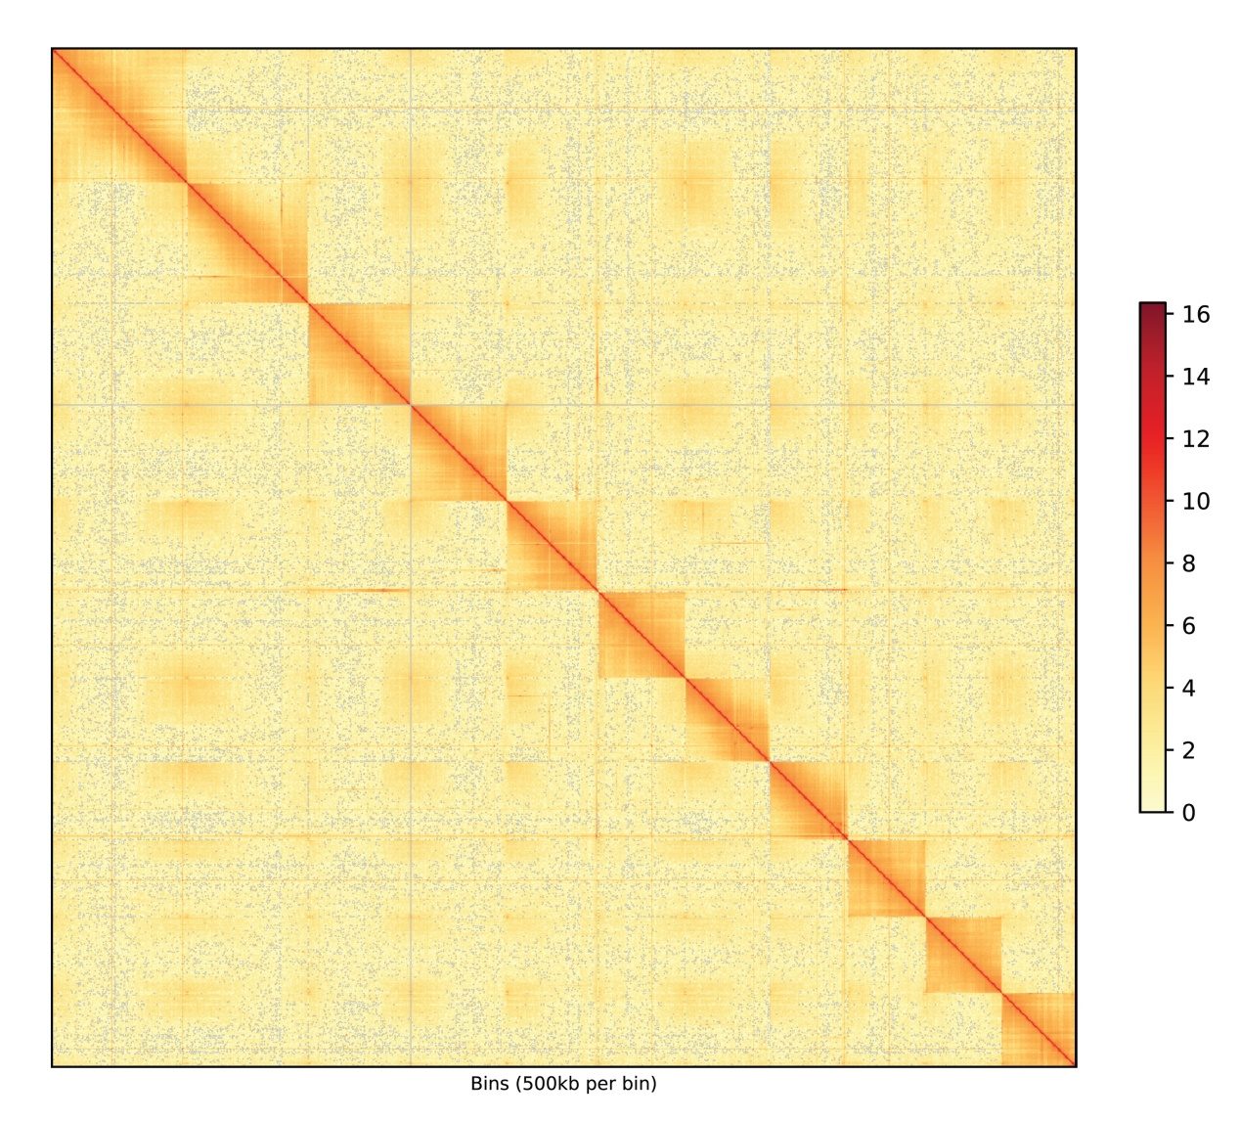
Supplementary Fig. S6. Genome-wide chromatin interaction heatmap of the Saururus chinensis genome.
The intensity of each pixel represents the number of Hi-C links of 500 kb resolution in the chromosomes. Darker red pixels denote higher contact probabilities.

Supplementary Fig. S7. Assessment of gene space completeness using BUSCO.
Species are sorted by the number of complete and duplicated complete BUSCOs from top to bottom. Species within magnoliids are in bold. *: Current study.

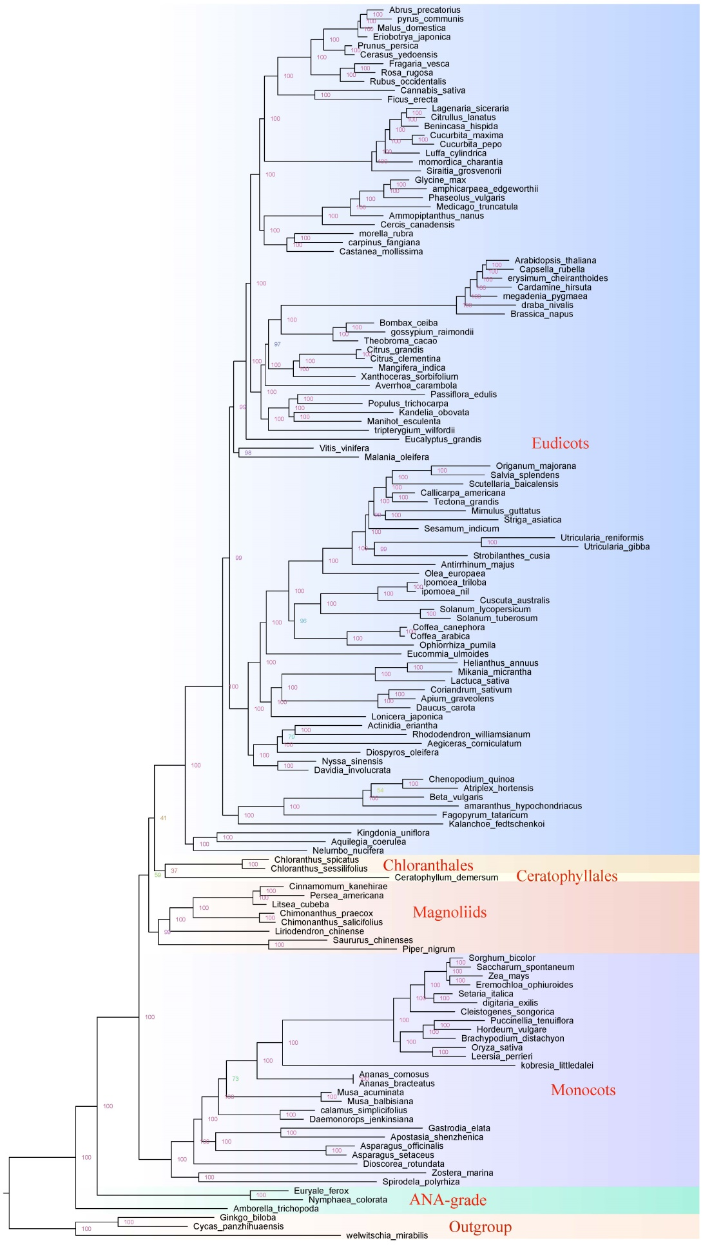
Supplementary Fig. S8. Phylogenetic relationships from concatenated CDS of 473 BUSCO genes based on RAxML analysis. Numbers on branches are bootstrap values.
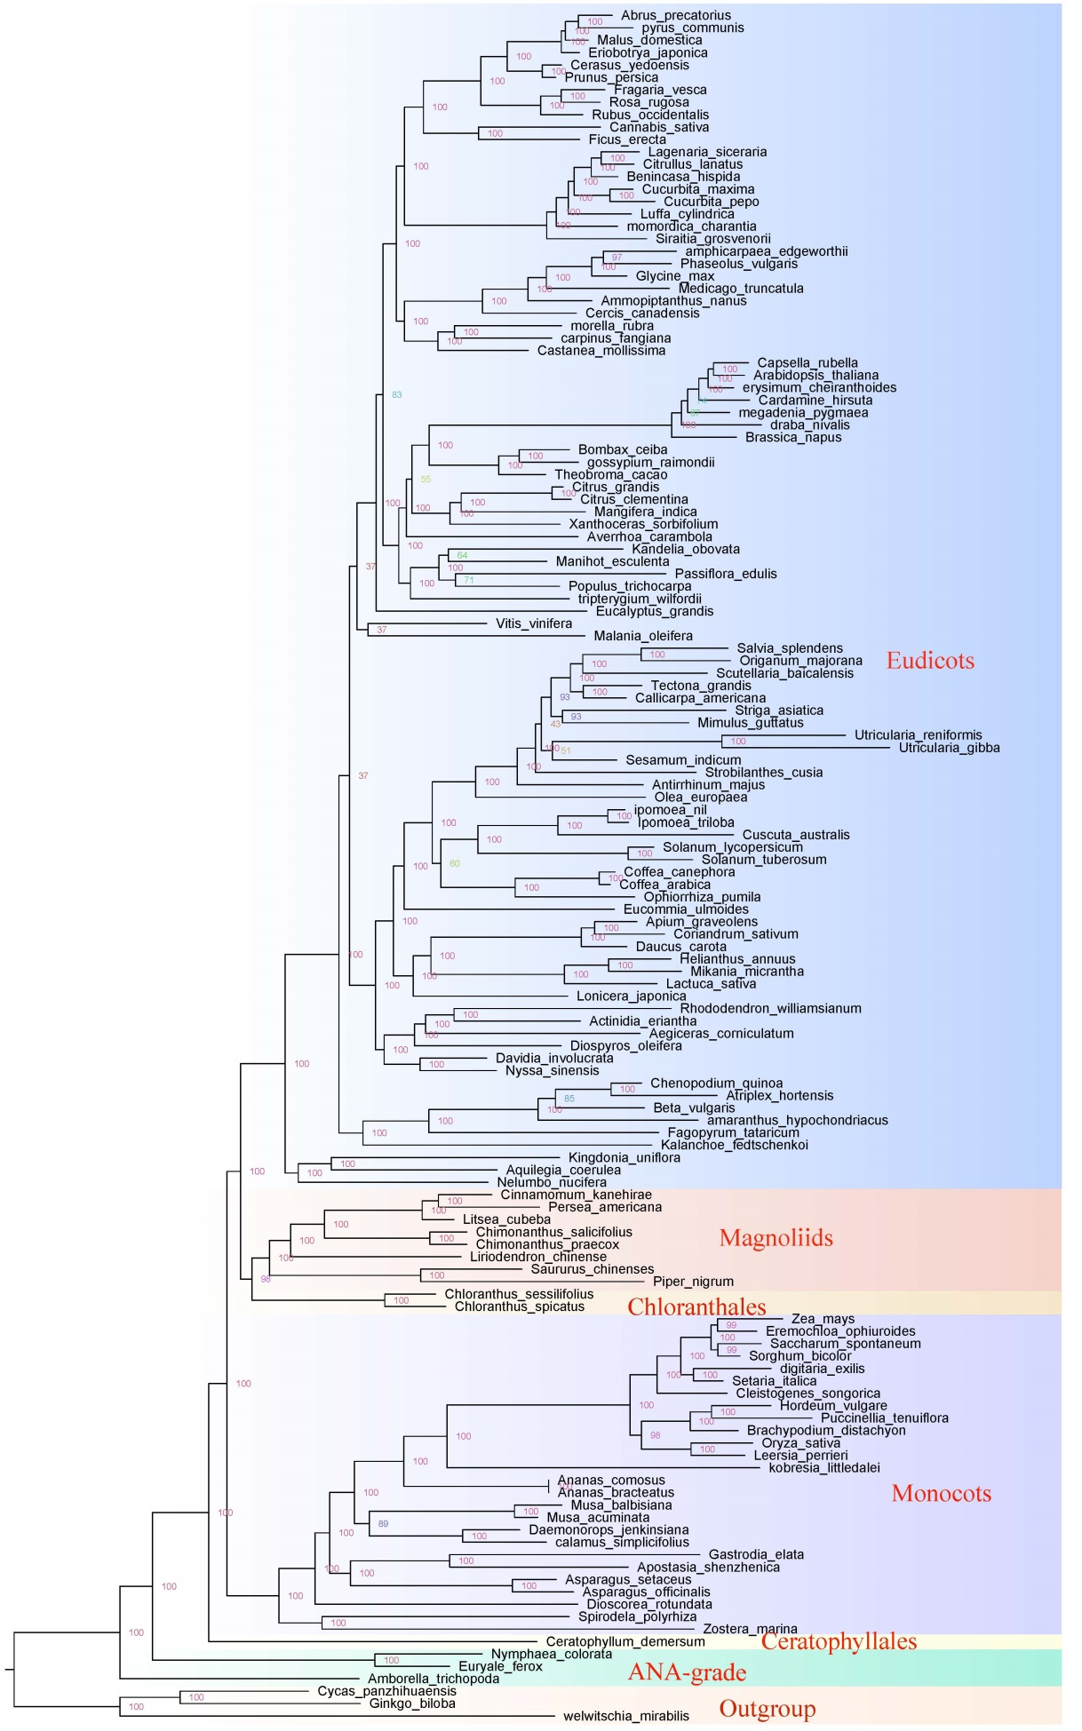
Supplementary Fig. S9. Phylogenetic relationships from concatenated amino acid sequences of 473 BUSCO genes based on RAxML analysis. Numbers on branches are bootstrap values.
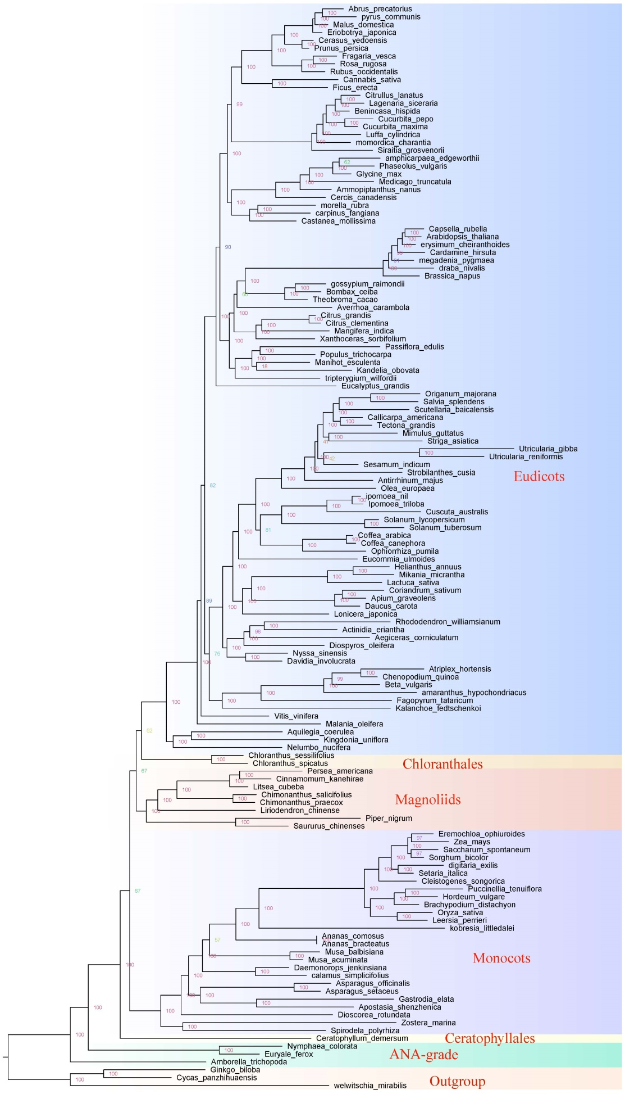
Supplementary Fig. S10. Phylogenetic relationships from concatenated combined first and second codon positions of 473 BUSCO genes based on RAxML analysis. Numbers on branches are support values.
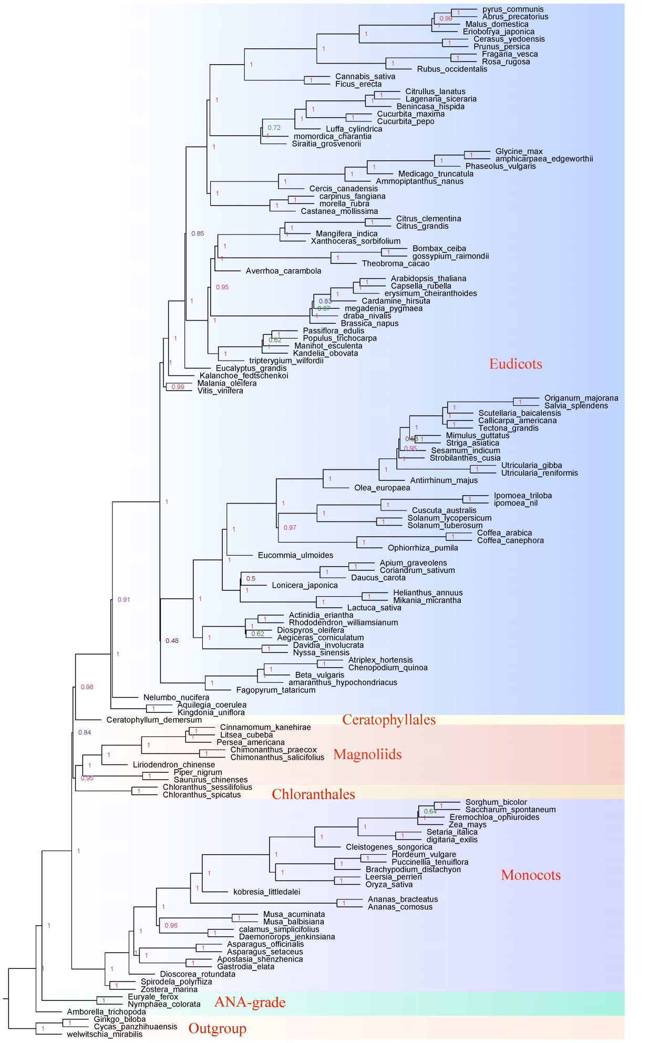
Supplementary Fig. S11. Phylogenetic relationships by coalescence-based inferences of CDS of 473 BUSCO genes. Numbers on branches are support values.

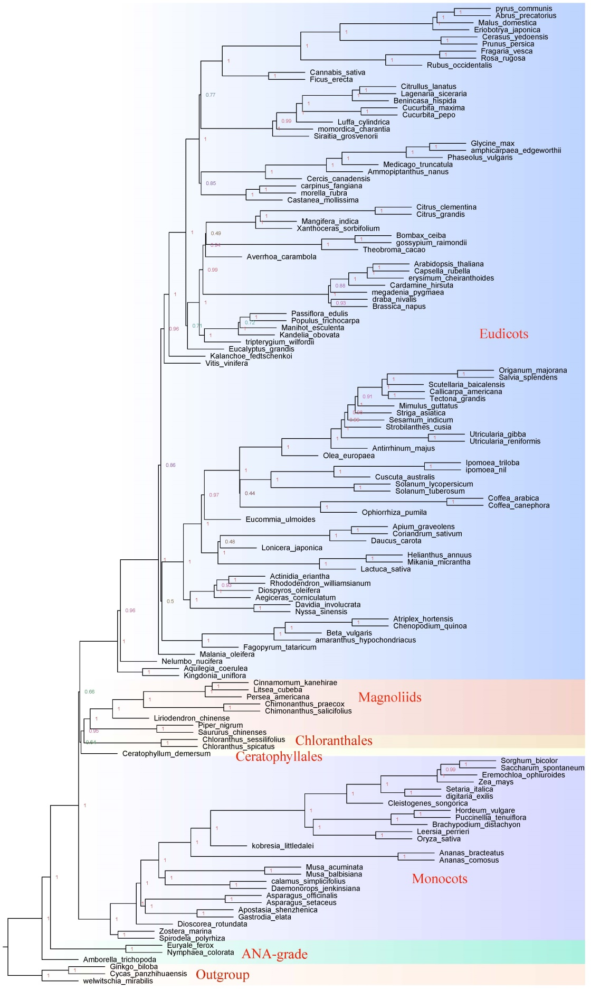 Supplementary Fig. S12. Phylogenetic relationships by coalescence-based inferences of amino acid sequences of 473 BUSCO genes. Numbers on branches are support values.
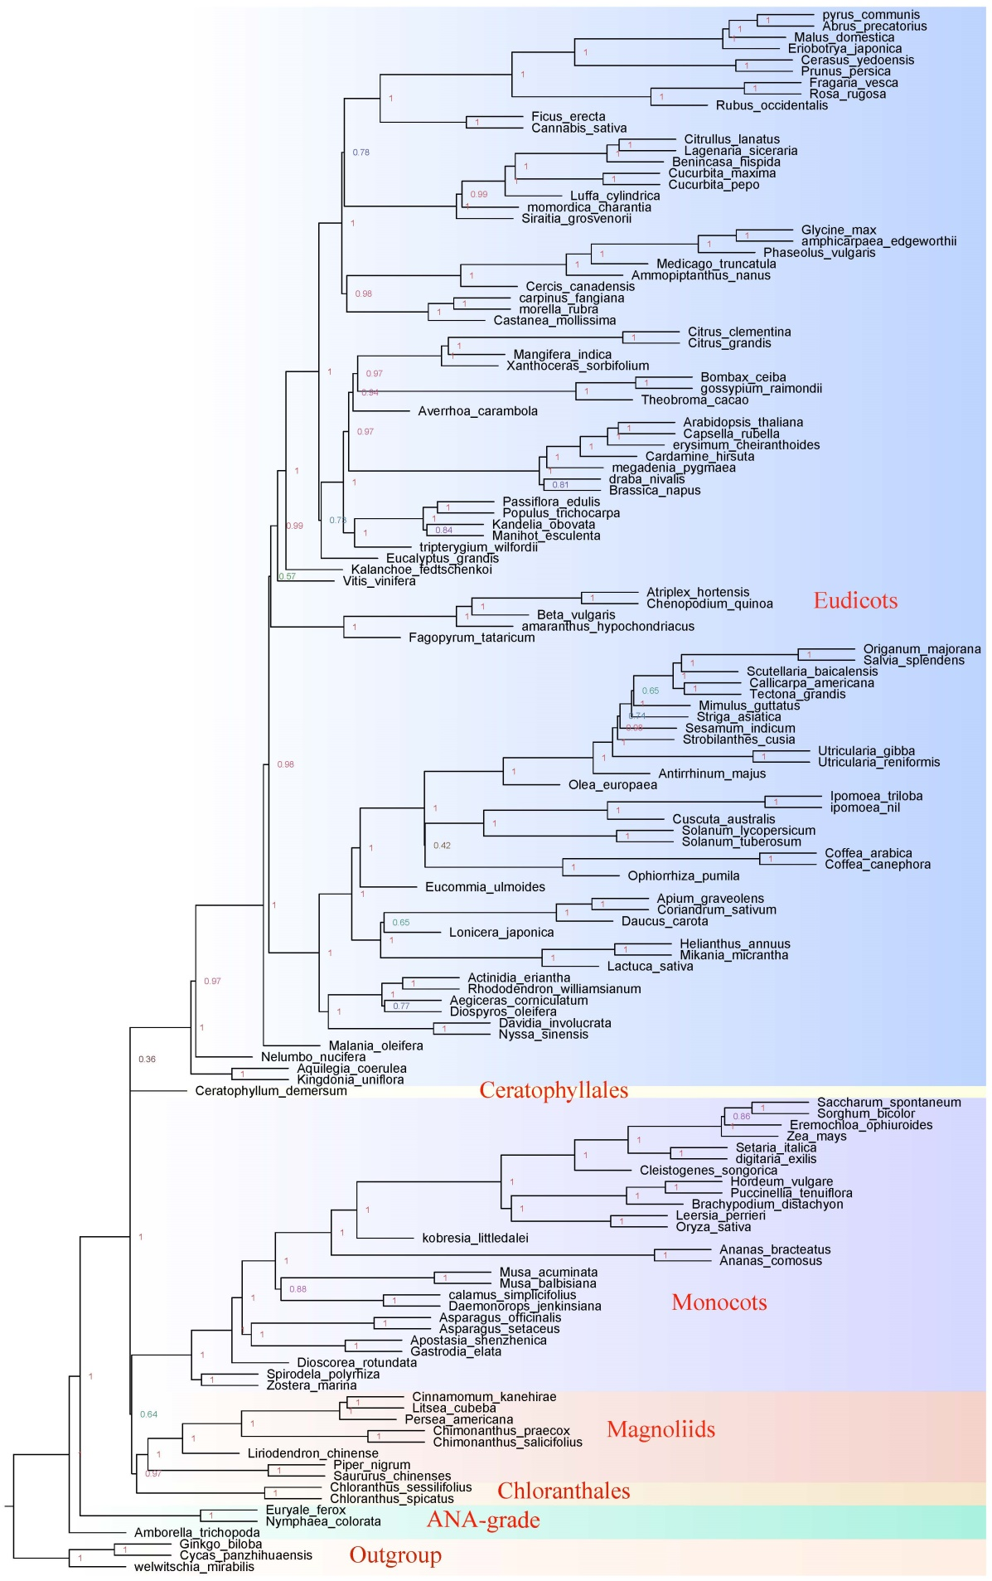
Supplementary Fig. S13. Phylogenetic relationships by coalescence-based inferences of combined first and second codon positions of 500 BUSCO genes. Numbers on branches are support values.
a
Mono
Eudi-Chlo-Mag
Cera
Gym-ANA
Toplogy1
Cera
Eudi-Chlo-Mag
Mono
Gym-ANA
Toplogy2
Mono
Cera
Eudi-Chlo-Mag
Gym-ANA
Toplogy3

Node Ⅰ

 | q1(ratio/number) | q2(ratio/number) | q3(ratio/number) | total(ratio/number)
NT | 36%/149 | 37%/150 | 27%/112 | 100%/411
NT12 | 33.4%/137 | 33.5%/137 | 33.1%/135 | 100%/409
AA | 33.4%/137 | 33.2%/135 | 33.4%/137 | 100%/409

Eudi
Chlo-Mag
Mono
Gym-ANA-Cera
Mono
Chlo-Mag
Eudi
Gym-ANA-Cera

Mono
Eudi

Chlo-Mag

Gym-ANA-Cera

Toplogy1
Toplogy2
Toplogy3
b

NodeⅡ

 | q1(ratio/number) | q2(ratio/number) | q3(ratio/number) | total(ratio/number)
NT | 36%/170 | 34%/160 | 30%/142 | 100%/472
NT12 | 32.8%/154 | 35.7%/168 | 31.5%/148 | 100%/470
AA | 35.5%/167 | 31.8%/149 | 32.7%/154 | 100%/470

Chlo
Mag
Eudi
Gym-ANA-Cera-Mono
Toplogy1
Mag
Eudi
Chlo
Gym-ANA-Cera-Mono

Toplogy2
Chlo
Eudi
Mag
Gym-ANA-Cera-Mono
Toplogy3
c

Node Ⅲ

 | q1(ratio/number) | q2(ratio/number) | q3(ratio/number) | total(ratio/number)
NT | 40%/187 | 24%/112 | 36%/170 | 100%/469
NT12 | 39%/183 | 27.2%/127 | 33.8%/158 | 100%/468
AA | 42.7%/199 | 26.8%/125 | 30.5%/143 | 100%/467

Supplementary Fig. S14. Gene tree incongruences and quartet supports for the three important nodes/clades (Fig. 2) for nucleotide (NT), Codon1+2 (NT12), and amino acid (AA) trees for 15-taxa (upper) and 90-taxa (below) datasets, respectively.
Supplementary Fig. S15. GO analysis of shared gene families in magnoliids and eudicots (90% species in either lineage).
Supplementary Fig. S16. K_{S} age distributions for the whole paranome (upper) and anchor pairs (lower) in S. chinensis.
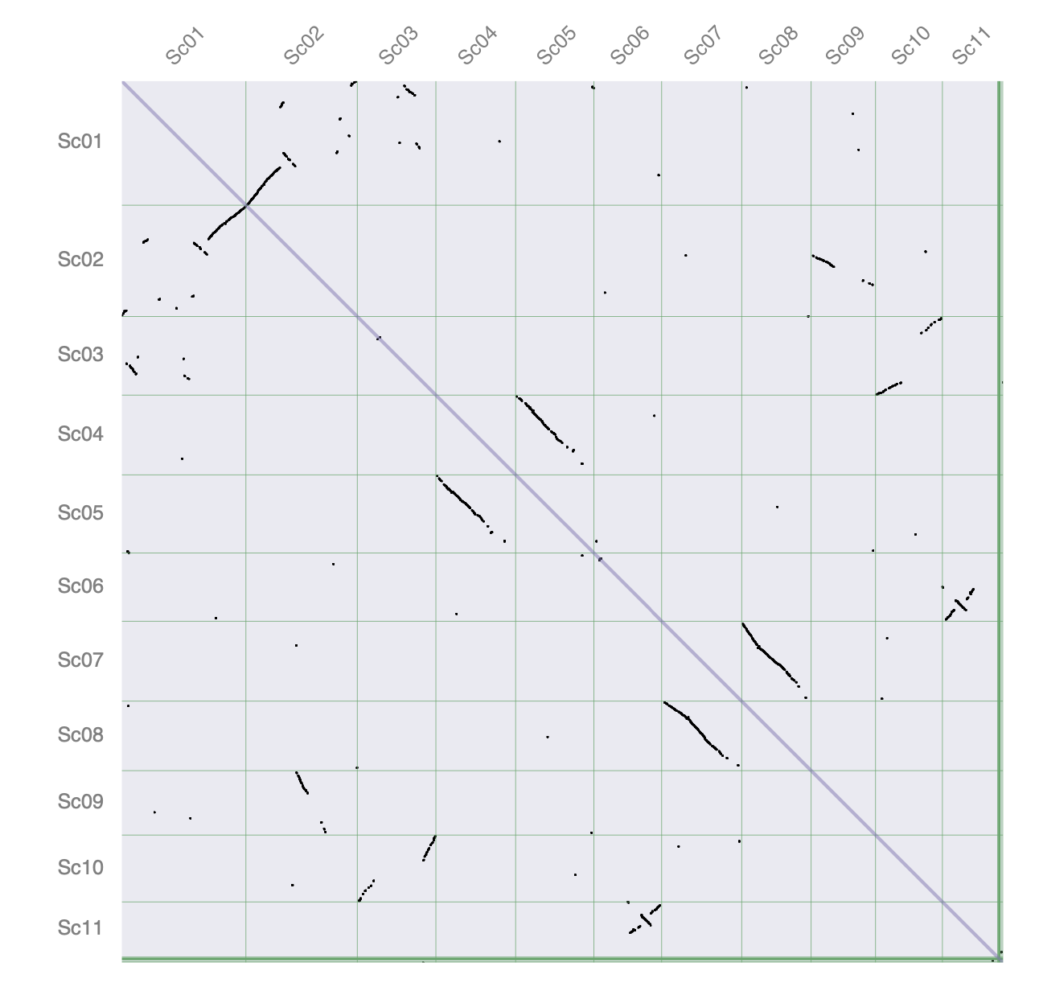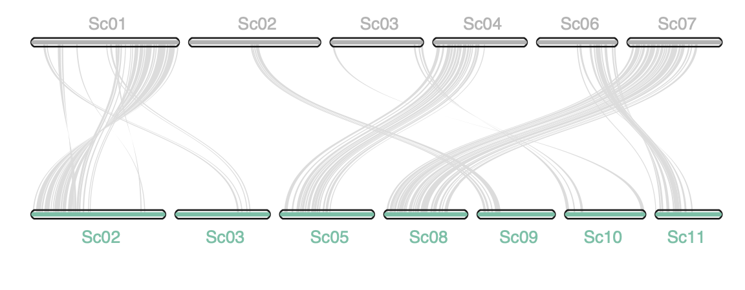
Supplementary Fig. 17. Syntenic dotplot (upper) and macrosynteny (lower) within the Saururus chinensis genome.

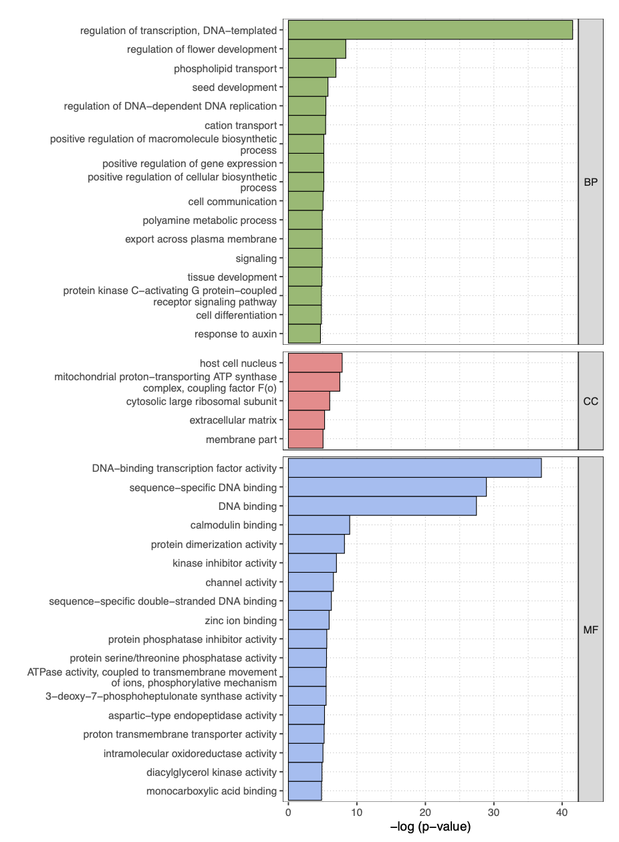
Supplementary Fig. 18. Enriched GO terms for duplicates retained after the WGD. BP: Biological process; CC: Cellular component; MF: Molecular function.
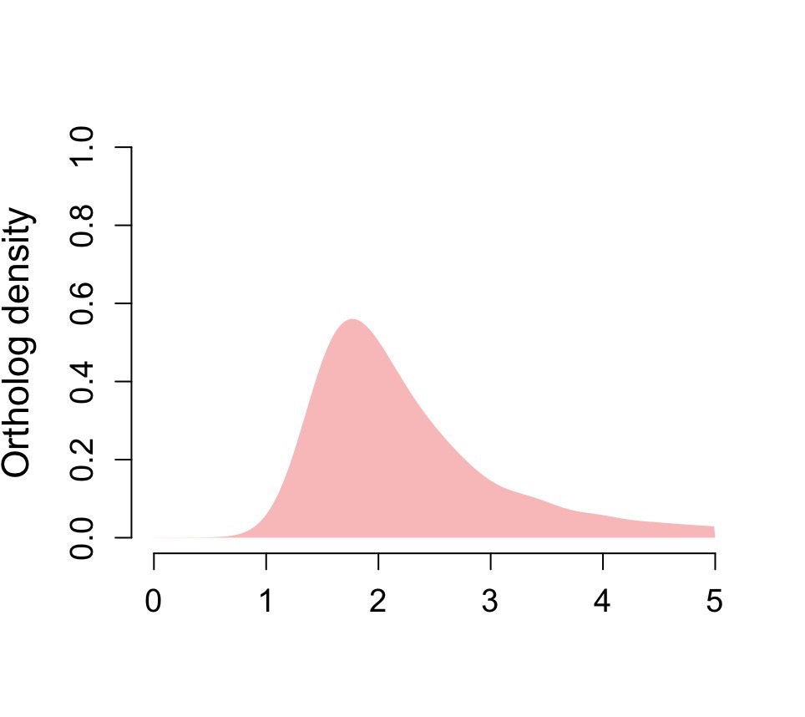
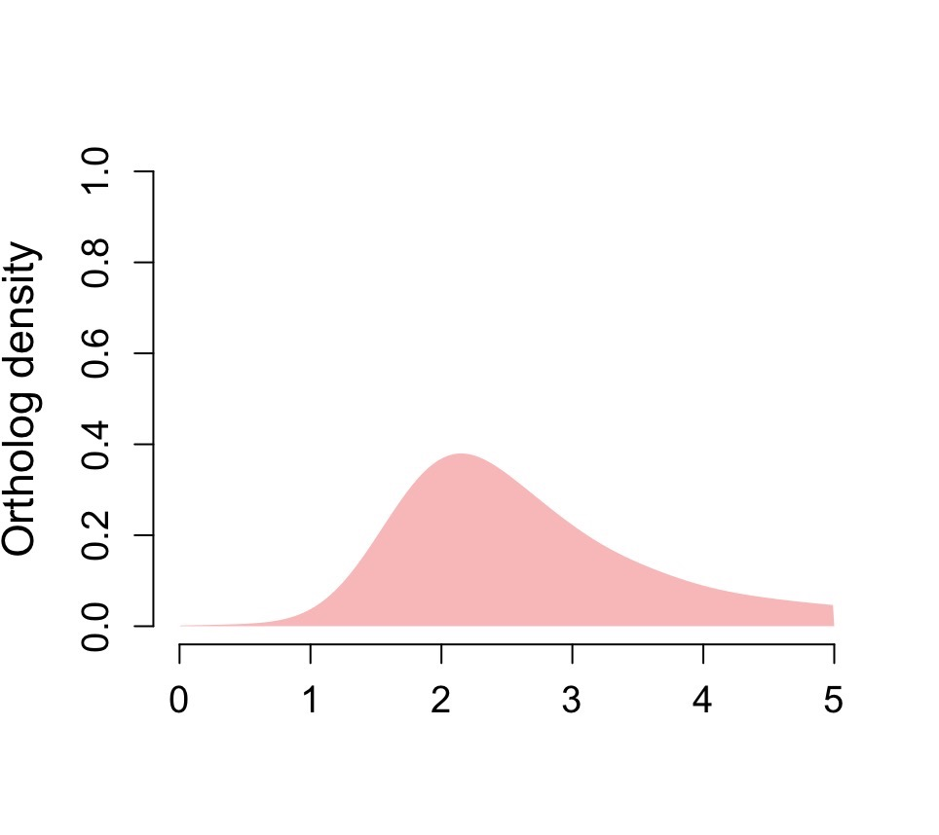
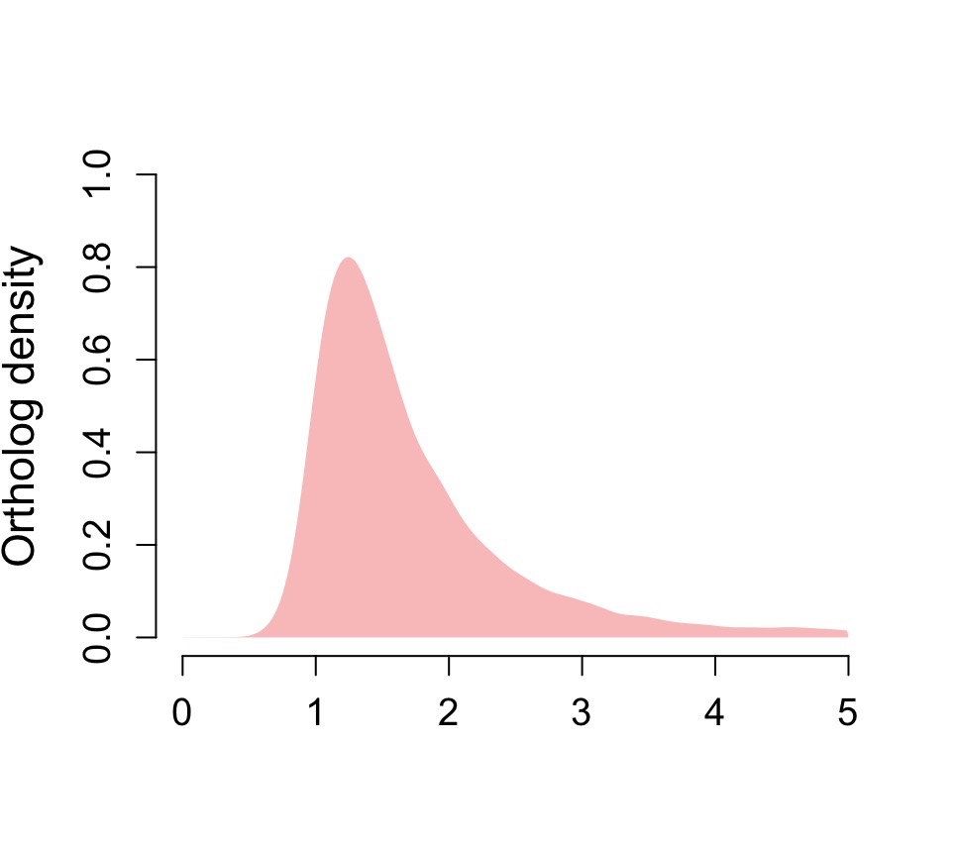
Supplementary Fig. 19. One-to-one orthologous K_{S} distributions between V. vinifera and Saururus chinensis (up), Piper nigrum (middle), and Liriodendron chinense (bottom).

Supplementary Fig. S20. Syntenic dot plot of the intragenomic comparison of P. nigrum.

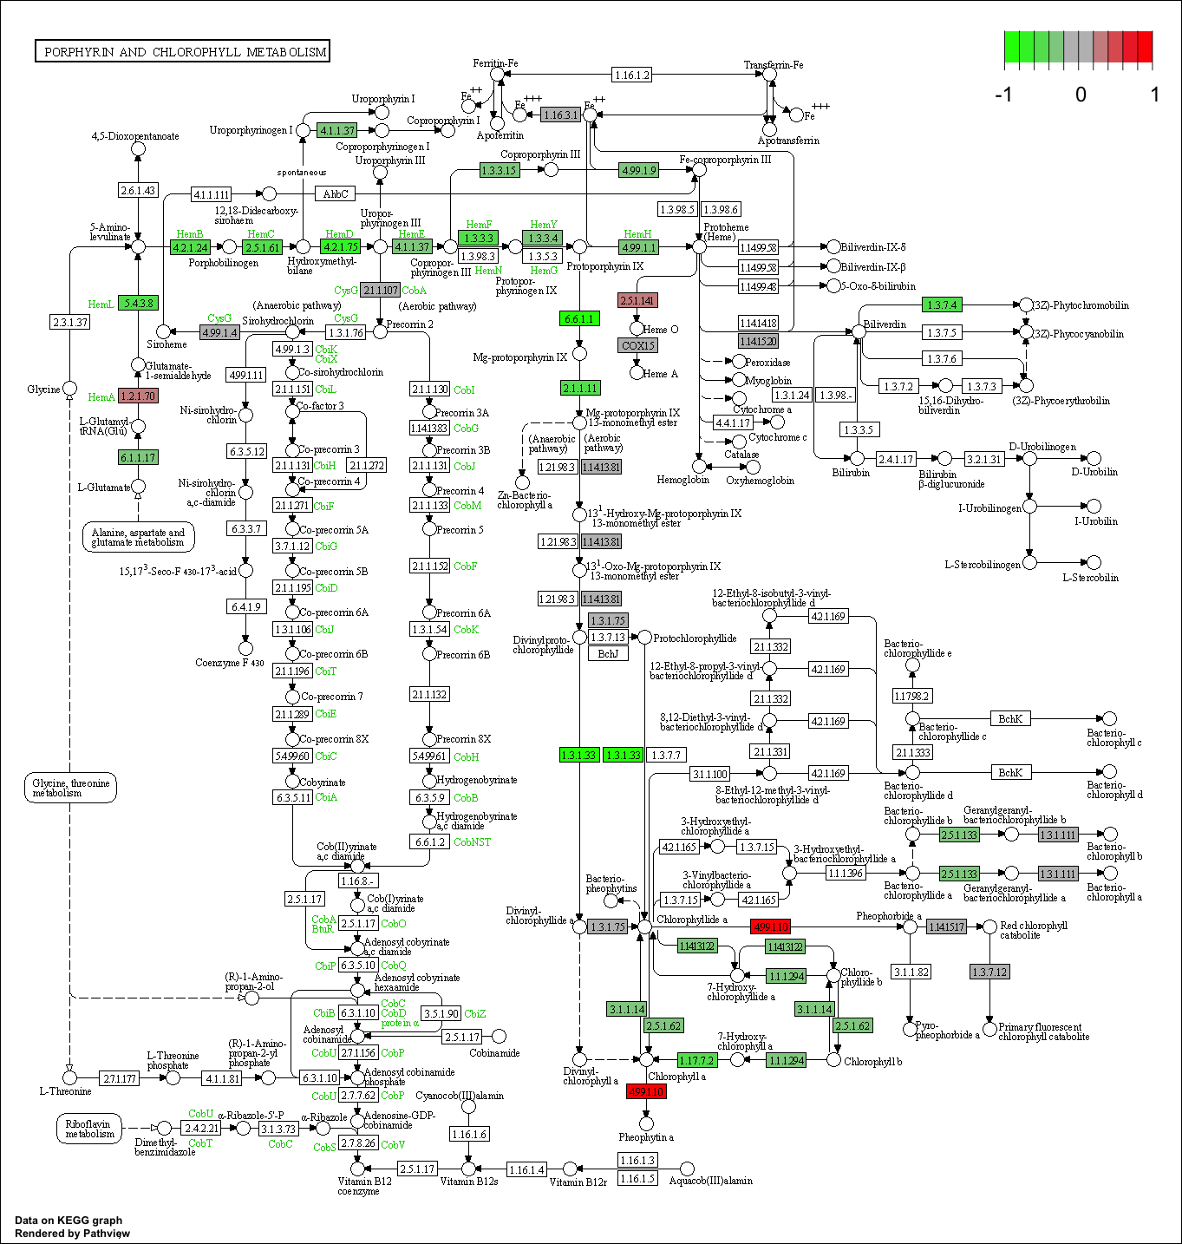
Supplementary Fig. S21. Differentially expressed genes in porphyrin and chlorophyll metabolism pathway (ko00860).

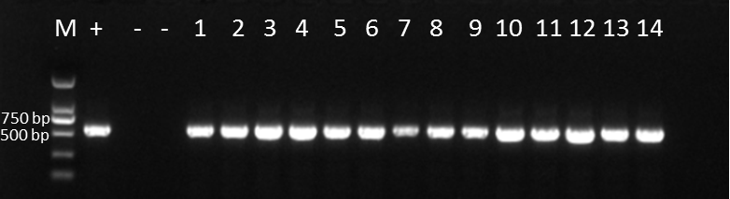
Supplementary Fig. S22. Positive identification of transformants by PCR.

b
ScPEL
AtUBQ5
WT OE-10 OE-11 OE-12
a
Supplementary Fig. S23. QRT-PCR (a) and RT-PCR (b) analysis of ScPEL transcript levels in overexpressing lines and the WT (Col-0). AtUBQ5 was used as a normalization control. Asterisks represent significant differences compared with the WT (Col-0), **P < 0.01.

Supplementary Table S1.The genome size of Saururus chinensis using Oryza sativa as the internal reference
Mean of O. sativa | Mean of S. chinensis | Genome size of O. sativa (Mb) | Genome size of S. chinensis (Mb)
34748 | 55891.96 | 389 | 625.7042834
43138.5 | 58416.49 | 389 | 526.7687706
40429.83 | 55313.35 | 389 | 532.203404
40239.06 | 55779.32 | 389 | 539.2311719
42368.07 | 59339.43 | 389 | 544.8215666
The average genome size of S. chinensis |  |  | 553.7458393

Supplementary Table S2.The genome size of Saururus chinensis using Nicotiana tabacum as the internal reference
Mean of N. tabacum | Mean of S. chinensis | Genome size of N. tabacum | Genome size of S. chinensis
363930.37 | 62801.23 | 3072 | 530.1161828
354790.3 | 58082.15 | 3072 | 502.9121845
376399.29 | 65818.88 | 3072 | 537.1837959
The average genome size of S. chinensis |  |  | 523.4040544

Supplementary Table S3. Statistics of S. chinensis sequencing data.
Pair-end libraries | Insert size (bp) | Total data (Gb) | Read length (bp) | Sequence coverage (X)
Illumina reads | 350 | 244 | 150 | 455
Pacbio reads | - | 50 | 7,949 (mean) | 93
Total | - | 294 | - | 548

Supplementary Table S4. Assembly metrics of Saururus genome compared with Piper genome
 | Saururus scaffolds | Saururus contigs | Piper scaffolds | Piper  contigs
# sequences (>= 0 bp) | 38.00 | 842.00 | 45.00 | 1300.00
# sequences (>= 5 bp) | 23.00 | 824.00 | 45.00 | 1295.00
# sequences (>= 10 bp) | 20.00 | 814.00 | 45.00 | 1285.00
# sequences (>= 25 bp) | 18.00 | 783.00 | 45.00 | 1253.00
# sequences (>=5 0 bp) | 16.00 | 733.00 | 29.00 | 1168.00
Total length (>= 0 bp) | 539018180.00 | 538937780.00 | 761218309.00 | 756720420.00
Total length (>= 5 bp) | 538984785.00 | 538895531.00 | 761218309.00 | 756710666.00
Total length (>= 10 bp) | 538959967.00 | 538819763.00 | 761218309.00 | 756627069.00
Total length (>= 25 bp) | 538929424.00 | 538288746.00 | 761218309.00 | 756032061.00
Total length (>= 50 bp) | 538853891.00 | 536345851.00 | 760618609.00 | 752968007.00
Largest contig | 70783412.00 | 5467227.00 | 48451882.00 | 5646249.00
Total length | 539018180.00 | 538937780.00 | 761218309.00 | 756720420.00
GC (%) | 37.74 | 37.74 | 38.23 | 38.23
N50 | 47843222.00 | 1428727.00 | 29812524.00 | 1092847.00
N75 | 41191273.00 | 721661.00 | 25555373.00 | 592712.00
L50 | 5.00 | 110.00 | 11.00 | 198.00
L75 | 8.00 | 240.00 | 18.00 | 436.00
# N’s per 100 kbp | 14.92 | 0.00 | 590.88 | 0.00

Supplementary Table S5. Statistics of TE in the S. chinensis genome
Type |  | Length (bp) | Percentage of sequence (%)
DNA transposons |  | 127,920,818 | 23.73
LINEs |  | 5,884,293 | 1.09
SINEs |  | 0 | 0
LTR | Copia | 32,063,601 | 5.95
LTR | Gypsy | 136,576,649 | 25.34
LTR | Retroviral | 7,306,440 | 1.36
Rolling-circles |  | 2,292,183 | 0.43
Small RNA |  | 0 | 0
Satellites |  | 4,065,798 | 0.75
Simple repeats |  | 2,522,182 | 0.47
Low complexity |  | 760,121 | 0.14
unknown |  | 33,350,447 | 6.19
Total |  | 355,999,916 | 66.05

Supplementary Table S6. Comparison of repetitive sequences in the S. chinensis and other magnoliids genomes
Species | Length of repetitive sequences (Mb) | Proportion of genome (%)
Liriodendron chinense | 1,072 | 61.6
Cinnamomum kanehirae | 351 | 48.0
Litsea cubeba | 735 | 55.5
Chimonanthus praecox | 318 | 45.7
Piper nigrum | 417 | 54.9
Saururus chinensis | 360 | 66.8
Data collected from (Chaw, et al. 2019; Chen, et al. 2019; Hu, et al. 2019; Rendon-Anaya, et al. 2019; Chen, et al. 2020; Shang, et al. 2020).

Supplementary Table S7. Statistics on the annotation of the S. chinensis genome
Database |  | Number annotated |  | Percent annotated(%)
NR |  | 24,605 |  | 68.08
Swiss-Prot |  | 23,649 |  | 65.44
KEGG |  | 23,693 |  | 65.56
InterPro | All | 19,340 |  | 53.51
InterPro | Pfam | 18,878 |  | 52.24
InterPro | Go | 11,840 |  | 32.76
Annotated |  | 27,123 |  | 74.05
Total |  | 36,140

Supplementary Table S8. Sequenced genomes used for phylogenomic analyses in this study
Species | Download resource
Ginkgo biloba | http://gigadb.org/dataset/100613
Ceratophyllum demersum | https://genomevolution.org/CoGe/GenomeInfo.pl?gid=56574
Amborella trichopoda | https://genome.jgi.doe.gov/portal/pages/dynamicOrganismDownload.jsf?organism=Atrichopoda
Euryale ferox | https://genomevolution.org/CoGe/GenomeInfo.pl?gid=56574
Nymphaea colorata | https://bigd.big.ac.cn/search/?dbId=gwh&q=Nymphaea_colorata&page=1
Piper nigrum | http://cotton.hzau.edu.cn/EN/download.php
Liriodendron chinense | https://hardwoodgenomics.org/Genome-assembly/2630420
Chimonanthus salicifolius | http://xhhuanglab.cn/data/Chimonanthus_salicifolius.html
Cinnamomum kanehirae | https://www.ncbi.nlm.nih.gov/assembly/GCA_003546025.1/
Litsea cubeba | https://ftp.ncbi.nlm.nih.gov/genomes/all/GCA/012/931/725/GCA_012931725.1_ASM1293172v1/
Persea americana | https://genomevolution.org/coge/SearchResults.pl?s=29302&p=genome
Spirodela polyrhiza | https://genome.jgi.doe.gov/portal/pages/dynamicOrganismDownload.jsf?organism=Spolyrhiza
Zostera marina | https://genome.jgi.doe.gov/portal/pages/dynamicOrganismDownload.jsf?organism=Zmarina
Asparagus officinalis | https://genome.jgi.doe.gov/portal/pages/dynamicOrganismDownload.jsf?organism=Aofficinalis
Asparagus setaceus | https://datadryad.org/stash/dataset/doi:10.5061/dryad.1c59zw3rm
Apostasia shenzhenica | https://www.ncbi.nlm.nih.gov/assembly/GCA_002786265.1
Gastrodia elata | ftp://download.big.ac.cn/gwh/Plants/
Calamus simplicifolius | http://gigadb.org/dataset/101052
Daemonorops jenkinsiana | http://gigadb.org/search/new?keyword=Daemonorops+jenkinsiana
Ananas bracteatus | ftp://download.big.ac.cn/gwh/Plants/
Ananas comosus | https://genome.jgi.doe.gov/portal/pages/dynamicOrganismDownload.jsf?organism=Acomosus
Kobresia littledalei | https://ftp.ncbi.nlm.nih.gov/genomes/all/GCA/011/114/355/GCA_011114355.1_ASM1111435v1/
Leersia perrieri | http://plants.ensembl.org/info/website/ftp/index.html
Oryza sativa | https://genome.jgi.doe.gov/portal/pages/dynamicOrganismDownload.jsf?organism=Osativa
Puccinellia tenuiflora | http://xhhuanglab.cn/data/alkaligrass.html
Brachypodium distachyon | https://genome.jgi.doe.gov/portal/pages/dynamicOrganismDownload.jsf?organism=Bdistachyon
Hordeum vulgare | https://genome.jgi.doe.gov/portal/pages/dynamicOrganismDownload.jsf?organism=Hvulgare
Saccharum spontaneum | http://www.life.illinois.edu/ming/downloads/Spontaneum_genome/
Sorghum bicolor | https://genome.jgi.doe.gov/portal/pages/dynamicOrganismDownload.jsf?organism=SbicolorRio
Zea mays | https://genome.jgi.doe.gov/portal/pages/dynamicOrganismDownload.jsf?organism=ZmaysPH207
Musa acuminata | https://genome.jgi.doe.gov/portal/pages/dynamicOrganismDownload.jsf?organism=Macuminata
Musa balbisiana | https://banana-genome-hub.southgreen.fr/organism/Musa/balbisiana
Dioscorea rotundata | http://plants.ensembl.org/info/website/ftp/index.html
Cleistogenes songorica | https://ngdc.cncb.ac.cn/search/?dbId=gwh&q=PRJCA002752&page=1
Setaria italica | https://genome.jgi.doe.gov/portal/pages/dynamicOrganismDownload.jsf?organism=Sitalica
Digitaria exilis21.3.12 | https://bioinformatics.psb.ugent.be/orcae/aocc/overview/Digex
Nelumbo nucifera | https://genomevolution.org/CoGe/SearchResults.pl?s=Nelumbo%20nucifera&p=genome
Apium graveolens | http://celerydb.bio2db.com/
Coriandrum sativum | http://cgdb.bio2db.com/Download/Index
Daucus carota | https://genome.jgi.doe.gov
Mikania micrantha | https://www.ncbi.nlm.nih.gov/assembly/GCA_009363875.1/
Helianthus annuus | https://genome.jgi.doe.gov
Lactuca sativa | PhytozomeV13
Lonicera japonica | ftp://download.big.ac.cn/gwh/Plants/Lonicera_japonica_jyh_GWHAAZE00000000/
Nyssa sinensis | https://genomevolution.org/coge/SearchResults.pl?s=Nyssa%20sinensis&p=genome
Actinidia eriantha | http://gigadb.org/dataset/100568
Diospyros oleifera | http://gigadb.org/dataset/100687
Rhododendron williamsianum | https://genomevolution.org/CoGe/SearchResults.pl?s=Rhododendron%20williamsianum&p=genome
Eucommia ulmoides | ftp://download.big.ac.cn/gwh/Plants/Eucommia_ulmoides_hardy_rubberv0_GWHAAAL00000000/
Coffea arabica | https://www.ncbi.nlm.nih.gov/assembly/GCF_003713225.1/
Coffea canephora | http://coffee-genome.org/download
Salvia splendens | https://www.ebi.ac.uk/ena/data/view/PRJNA422035
Tectona grandis | http://aspera.gigadb.org/
Utricularia gibba | https://genomevolution.org/coge/GenomeInfo.pl?gid=29027
Utricularia reniformis | https://zenodo.org/record/3268745#.XpG5yT--uM8
Olea europaea | https://genome.jgi.doe.gov
Striga asiatica | https://datadryad.org/stash/dataset/doi:10.5061/dryad.53t3574
Sesamum indicum | http://www.ocri-genomics.org/Sinbase/login.htm
Mimulus guttatus | https://genome.jgi.doe.gov
Antirrhinum majus | http://bioinfo.sibs.ac.cn/Am/download_v3.php
Cuscuta australis | http://groups.english.kib.cas.cn/epb/dgd/Download/201711/t20171101_386248.html
Ipomoea nil | https://ftp.ncbi.nlm.nih.gov/genomes/all/GCA/001/879/475/GCA_001879475.1_Asagao_1.1/
Ipomoea triloba | https://ftp.ncbi.nlm.nih.gov/genomes/all/GCA/003/576/645/GCA_003576645.1_ASM357664v1/
Solanum lycopersicum | https://genome.jgi.doe.gov/portal/pages/dynamicOrganismDownload.jsf?organism=Slycopersicum
Solanum tuberosum | https://genome.jgi.doe.gov/portal/pages/dynamicOrganismDownload.jsf?organism=Stuberosum
Amaranthus hypochondriacus | https://genome.jgi.doe.gov
Beta vulgaris | http://bvseq.molgen.mpg.de/index.shtml
Chenopodium quinoa | https://genome.jgi.doe.gov
Fagopyrum tataricum | http://mbkbase.org/Pinku1/
Benincasa hispida | ftp://download.big.ac.cn/gwh/Plants/Benincasa_hispida_ALLPATHS-LG_PBJelly_GWHAAAR00000000/
Citrullus lanatus | ftp://cucurbitgenomics.org/pub/cucurbit/genome/watermelon/97103/v2/
Lagenaria siceraria | ftp://cucurbitgenomics.org/pub/cucurbit/genome/Lagenaria_siceraria/
Cucurbita maxima | ftp://cucurbitgenomics.org/pub/cucurbit/genome/Cucurbita_maxima/v1.1/
Cucurbita pepo | ftp://cucurbitgenomics.org/pub/cucurbit/genome/Cucurbita_pepo/
Momordica charantia | ftp://download.big.ac.cn/Genome/Plants/Momordica_charantia/
Luffa cylindrica | https://ftp.cngb.org/pub/CNSA/data2/CNP0000780/CNS0139036/CNA0007250/
Siraitia grosvenorii | http://gigadb.org/dataset/100452
Cercis canadensis | http://gigadb.org/dataset/101044
Abrus precatorius | https://ftp.ncbi.nlm.nih.gov/genomes/all/GCF/003/935/025/GCF_003935025.1_Abrus_2018/
Ammopiptanthus nanus | http://gigadb.org/dataset/100466
Glycine max | https://genome.jgi.doe.gov/portal/pages/dynamicOrganismDownload.jsf?organism=Gmax
Medicago truncatula | https://genome.jgi.doe.gov/portal/pages/dynamicOrganismDownload.jsf?organism=Mtruncatula
Phaseolus vulgaris | ftp://ftp.ensemblgenomes.org/pub/plants/release-46/
Castanea mollissima | http://gigadb.org/dataset/view/id/100643
Manihot esculenta | https://genome.jgi.doe.gov/portal/pages/dynamicOrganismDownload.jsf?organism=Mesculenta
Passiflora edulis | https://db.cngb.org/search/?q=+CNA0017758
Kandelia obovata | https://bigd.big.ac.cn/search/?dbId=gwh&q=GWHACBH00000000
Populus trichocarpa | https://genome.jgi.doe.gov/portal/pages/dynamicOrganismDownload.jsf?organism=Ptrichocarpa
Averrhoa carambola | https://bigd.big.ac.cn/search/?dbId=gwh&q=GWHABKE00000000
Cannabis sativa | https://plantgarden.jp/en/list/t3483
Ficus erecta | https://plantgarden.jp/en/list/t66383/genome/t66383.G001
Prunus persica | https://genome.jgi.doe.gov/portal/pages/dynamicOrganismDownload.jsf?organism=Ppersica
Cerasus yedoensis | ftp://ftp.kazusa.or.jp/pub/cherry/Cerasus_x_yedoensis/
Malus domestica | https://genome.jgi.doe.gov/portal/pages/dynamicOrganismDownload.jsf?organism=Mdomestica
Pyrus communis | ftp://ftp.bioinfo.wsu.edu/species/Pyrus_communis/Pcommunis_DH_genome.v2.0/genes/
Eriobotrya japonica | http://gigadb.org/dataset/100711
Fragaria vesca | https://genome.jgi.doe.gov/portal/pages/dynamicOrganismDownload.jsf?organism=Fvesca
Rubus occidentalis | http://gigadb.org/dataset/100465
Brassica napus | http://brassicadb.org/brad/datasets/pub/BrassicaceaeGenome/Brassica_napus/
Arabidopsis thaliana | https://genome.jgi.doe.gov/portal/pages/dynamicOrganismDownload.jsf?organism=Athaliana
Capsella rubella | https://genome.jgi.doe.gov/portal/pages/dynamicOrganismDownload.jsf?organism=Crubella
Cardamine hirsuta | http://chi.mpipz.mpg.de/assembly.html
Bombax ceiba | http://gigadb.org/dataset/100445
Theobroma cacao | https://genome.jgi.doe.gov/portal/pages/dynamicOrganismDownload.jsf?organism=Tcacao
Gossypium raimondii | ftp://ftp.bioinfo.wsu.edu/species/Gossypium_raimondii/BYU-Improved_G.raimondii/assembly/
Eucalyptus grandis | https://genome.jgi.doe.gov/portal/pages/dynamicOrganismDownload.jsf?organism=Egrandis
Mangifera indica | ftp://download.big.ac.cn/gwh/Plants/Mangifera_indica_mangoV1_GWHABLA00000000/
Citrus clementina | https://genome.jgi.doe.gov/portal/pages/dynamicOrganismDownload.jsf?organism=Cclementina
Citrus grandis | http://citrus.hzau.edu.cn/orange/download/index.php
Xanthoceras sorbifolium | http://gigadb.org/dataset/view/id/100606/File_page/3
Vitis vinifera | https://genome.jgi.doe.gov/portal/pages/dynamicOrganismDownload.jsf?organism=Vvinifera
Malania oleifera | http://gigadb.org/dataset/100549
Kalanchoe fedtschenkoi | https://genome.jgi.doe.gov/portal/pages/dynamicOrganismDownload.jsf?organism=Kfedtschenkoi
Kingdonia uniflora | https://ftp.ncbi.nlm.nih.gov/genomes/all/GCA/014/058/105/GCA_014058105.1_ASM1405810v1/
Aquilegia coerulea | https://genome.jgi.doe.gov/portal/pages/dynamicOrganismDownload.jsf?organism=Acoerulea
Atriplex hortensis | https://genomevolution.org/coge/SearchResults.pl?s=56906&p=genome
Davidia involucrata | https://bigd.big.ac.cn/search/?dbId=&q=PRJCA001721
Ophiorrhiza pumila | http://pumila.kazusa.or.jp/
Strobilanthes cusia | http://indigoid-plant.iflora.cn/
Callicarpa americana | GIGADB
Origanum majorana | https://datadryad.org/stash/dataset/doi:10.5061/dryad.jwstqjq6t
Scutellaria baicalensis | https://ngdc.cncb.ac.cn/search/?dbId=gwh&q=GWHAOTO00000000
Aegiceras corniculatum | https://db.cngb.org/search/assembly/CNA0017738/
Draba nivalis | https://datadryad.org/stash/dataset/doi:10.5061/dryad.pg4f4qrm4
Erysimum cheiranthoides | ftp://erysimum.org/genomes/ECHE1.2/
Megadenia pygmaea | https://bigd.big.ac.cn/search/?dbId=gwh&q=PRJCA002905&page=1
Tripterygium wilfordii | https://ftp.ncbi.nlm.nih.gov/genomes/all/GCF/013/401/445/GCF_013401445.1_ASM1340144v1/
Amphicarpaea edgeworthii | https://figshare.com/s/565549fb2611c26c229f
Morella rubra | https://ftp.ncbi.nlm.nih.gov/genomes/all/GCA/003/952/965/GCA_003952965.2_Mru_ZJU_2/
Cycas panzhihuaensis | obtained from authors
Welwitschia mirabilis | obtained from authors
Carpinus fangiana | obtained from authors
Chimonanthus praecox | obtained from authors
Rosa rugosa | http://eplantftp.njau.edu.cn/
Eremochloa ophiuroides | obtained from authors
Chloranthus spicatus | https://ngdc.cncb.ac.cn/gwh/Assembly/23169/show
Chloranthus sessilifolius | https://github.com/yongzhiyang2012/Chloranthus-sessilifolius-genome/tree/main/Annotation
Saururus chinensis | https://bioinformatics.psb.ugent.be/orcae/overview/Sauch

Supplementary Table S9. Fossil calibrations used for divergence time estimates in this study
Node | Clade | Fossil type | Age  (Million-year) | References
F1 | Crown group seed plants |  | 308.14–365.629 | (Morris, et al. 2018)
F2 | Crown group Arcogymnospermae | Cones | >290 | Mapes et al. (1984)
F3 | Crown group angiosperms  Crown group Mesangiosperms |  | 125~247.2  125~247.2 | (Morris, et al. 2018)
 |  |  |  | (Morris, et al. 2018)
F4 | Crown group Nymphaeaceae | flowers | >113 | Else et al. (2009)
F5 | Stem group Magnoliales | Flower | >108.8 | Crane et al. (1994)
F6 | Crown group Eudicots | pollen | <128.63 | Doyle et al. (1977)
F7 | Crown group angiosperms |  | 125~247.2 | Doyle and Hotton et al. (1991)
F8 | Crown group Alismatales |  | 102~128 | www.timetree.org
F9 | Crown group Poales | Pollen | >68.1 | Muller et al. (1981)
F10 | Crown group Laurales | flowers | >108.8 | Crane et al. (1994)
F11 | Crown group Ranunculales |  | 89~118 | www.timetree.org
F12 | Crown group Caryophyllales | Seeds | >83.5 | Collinson et al. (1993)
F13 | Crown group Cornales | fruits | >85.8 | Takahashi et al. (2002)
F14 | Crown group Ericales |  | 64~121 | www.timetree.org
F15 | Crown group Asterales |  | 32~41 | Www.timetree.org
F16 | Crown group Apiales |  | 21~44 | Www.timetree.org
F17 | Crown group Garryales+Solanales+Lamiales+Gentianales |  | 85~102 | Www.timetree.org
F18 | Crown group Gentianales |  | 66~87 | Www.timetree.org
F19 | Crown group Solanales |  | 51~80 | www.timetree.org
F20 | Crown group Lamiales | fruits | >44.3 | Call et al. (1992)
F21 | Crown group Malvales |  | 32~99 | Www.timetree.org
F22 | Crown group Brassicales |  | 29~32 | Www.timetree.org
F23 | Crown group Fagales |  | 47~89 | Www.timetree.org
F24 | Crown group Fabales |  | 59~77 | Www.timetree.org
F25 | Crown group Cucurbieales |  | 51~60 | Www.timetree.org

Supplementary Table S10. Differentially expressed genes in white leaves relative to green leaves
Gene | BaseMean | log2FoldChange | lfcSE | stat | pvalue | padj | GO
Sc004_1478.1 | 6.59E+14 | 9.15E+14 | 0.788419 | 1.16E+14 | 4.01E-17 | 9.34E-13 | NA
Sc007_0170.1 | 6.44E+14 | 9.36E+13 | 0.824462 | 1.13E+14 | 7.44E-16 | 8.66E-12 | GO:0003677
Sc003_3384.1 | 4.41E+13 | 6.21E+14 | 0.549746 | 1.13E+14 | 1.33E-15 | 1.03E-11 | GO:0005634, GO:0003677, GO:0006355, GO:0046983, GO:0045944, GO:0000977, GO:0003700
Sc006_2552.1 | 1.39E+14 | 4.24E+14 | 0.434128 | 9.77E+14 | 1.58E-08 | 9.21E-05 | NA
Sc002_3677.1 | 1.77E+14 | 3.58E+14 | 0.381113 | 9.39E+12 | 5.88E-07 | 2.74E-03 | NA
Sc002_5002.1 | 1.41E+14 | 1.06E+12 | 1.25E+14 | 8.51E+13 | 1.81E-03 | 7.045733 | NA
Sc005_0043.1 | 8.97E+14 | -2.23E+14 | 0.300264 | -7.44E+14 | 1.038706 | 34571.11 | GO:0016020, GO:0055085, GO:0006811, GO:0005216
Sc006_3060.1 | 1.27E+13 | 6.18E+14 | 0.876863 | 7.05E+14 | 182.4794 | 531425.7 | GO:0055114, GO:0016491
Sc006_1334.1 | 6.82E+14 | 4.27E+13 | 0.610725 | 7.00E+14 | 256.5379 | 664091.2 | GO:0055085, GO:0016021
Sc004_3220.1 | 1.40E+14 | 5.35E+14 | 0.778823 | 6.87E+14 | 6.212955 | 1447494 | NA
Sc007_0689.1 | 8.16E+14 | 5.50E+14 | 0.809474 | 6.80E+14 | 1079.138 | 2285614 | NA
Sc001_2598.1 | 1.47E+14 | 5.30E+14 | 0.81205 | 6.53E+14 | 6681.038 | 12971236 | GO:0046983
Sc005_0274.1 | 1.58E+14 | -3.39E+14 | 0.554011 | -6.12E+14 | 92101.66 | 1.65E+08 | GO:0055085, GO:0006816, GO:0006812, GO:0015369, GO:0016021, GO:0008324
Sc002_2259.1 | 3.93E+14 | 8.76E+13 | 1.47E+14 | 5.95E+14 | 264765 | 4.41E+08 | GO:0004190, GO:0006508
Sc001_3720.1 | 2.44E+14 | 1.60E+14 | 0.276703 | 5.80E+14 | 67700.66 | 1.05E+09 | NA
Sc003_2944.1 | 4.31E+14 | 5.77E+14 | 0.99867 | 5.77E+14 | 772519.5 | 1.12E+09 | GO:0005524, GO:0006468, GO:0030246, GO:0004672
Sc005_1051.1 | 1.60E+14 | 4.95E+14 | 0.861869 | 5.75E+14 | 90875.62 | 1.25E+09 | NA
Sc005_3452.1 | 8.42E+14 | 2.05E+14 | 0.361282 | 5.68E+14 | 1358057 | 1.76E+09 | GO:0004869
Sc011_0619.1 | 3.97E+14 | 3.43E+14 | 0.606043 | 5.67E+14 | 1459405 | 1.79E+09 | NA
Sc006_0675.1 | 3.65E+14 | 4.33E+14 | 0.767583 | 5.64E+13 | 1731781 | 2.02E+09 | NA
Sc003_1187.1 | 2.74E+14 | 4.78E+14 | 0.852337 | 5.61E+14 | 2065095 | 2.29E+09 | GO:0009269
Sc001_4039.1 | 2.21E+14 | 2.06E+14 | 0.371693 | 5.54E+13 | 2940086 | 3.11E+09 | GO:0055114, GO:0016491
Sc007_0688.1 | 5.14E+14 | 4.42E+14 | 0.803004 | 5.51E+14 | 3622520 | 3.67E+09 | NA
Sc001_0101.1 | 1.18E+14 | 4.73E+14 | 0.86798 | 5.45E+14 | 4959944 | 4.81E+09 | NA
Sc002_3267.1 | 3.69E+14 | 4.47E+14 | 0.835239 | 5.35E+14 | 8701826 | 8.11E+09 | GO:0016020, GO:0042546, GO:0008107
Sc004_2664.1 | 1.46E+14 | 7.34E+14 | 1.37E+14 | 5.34E+14 | 9289495 | 8.32E+09 | NA
Sc008_2629.1 | 2.22E+13 | -4.70E+14 | 0.881747 | -5.33E+14 | 9840677 | 8.49E+09 | GO:0005515
Sc011_1445.1 | 3.92E+14 | 4.01E+14 | 0.756333 | 5.30E+14 | 11540630 | 9.6E+09 | GO:0009055
Sc002_1615.1 | 9.04E+14 | 1.80E+14 | 0.341579 | 5.27E+14 | 13919656 | 0.000112 | GO:0008289
Sc001_5743.1 | 1.68E+14 | 2.63E+14 | 0.505764 | 5.20E+14 | 20226694 | 0.000157 | GO:0046983
Sc009_2021.1 | 1.43E+13 | 2.32E+14 | 0.452475 | 5.13E+14 | 28270377 | 0.000212 | GO:0020037, GO:0005506, GO:0055114, GO:0016705
Sc007_3535.1 | 3.86E+14 | 3.16E+14 | 0.620207 | 5.09E+14 | 3499583 | 0.00025 | GO:0055114, GO:0004097, GO:0016491
Sc011_2038.1 | 6.77E+14 | -2.06E+14 | 0.404393 | -5.09E+14 | 35384315 | 0.00025 | NA
Sc007_1129.1 | 9.23E+14 | 3.28E+14 | 0.660198 | 4.97E+13 | 67402352 | 0.000436 | GO:0030247, GO:0005509
Sc009_0697.1 | 6.39E+14 | -2.84E+14 | 0.572756 | -4.97E+14 | 68036249 | 0.000436 | NA
Sc005_1411.1 | 3.02E+14 | -4.72E+14 | 0.950329 | -4.96E+14 | 69037413 | 0.000436 | NA
Sc006_1868.1 | 6.12E+14 | -3.48E+14 | 0.701863 | -4.96E+14 | 69307927 | 0.000436 | GO:0005509
Sc010_0095.1 | 5.95E+14 | 2.27E+14 | 0.459257 | 4.94E+14 | 76995453 | 0.000472 | GO:0005515
Sc002_0635.1 | 1.45E+14 | 2.67E+14 | 0.540614 | 4.94E+14 | 79481982 | 0.000475 | GO:0003993, GO:0016787
Sc001_5023.1 | 1.87E+13 | 6.70E+14 | 1.36E+14 | 4.93E+14 | 81620839 | 0.000475 | GO:0003700
Sc004_1986.1 | 2.77E+13 | 2.23E+14 | 0.456455 | 4.89E+12 | 1E+08 | 0.000569 | NA
Sc004_0982.1 | 1.30E+14 | 1.56E+14 | 0.319853 | 4.87E+14 | 1.1E+08 | 0.000611 | NA
Sc002_2614.1 | 8.74E+13 | 2.04E+14 | 0.427539 | 4.76E+14 | 1.92E+08 | 0.001042 | NA
Sc002_2056.1 | 1.07E+14 | 1.30E+14 | 0.273346 | 4.75E+14 | 2.08E+08 | 0.0011 | GO:0016491
Sc003_3065.1 | 2.39E+13 | 1.65E+14 | 0.348736 | 4.74E+13 | 2.17E+08 | 0.001124 | GO:0016757
Sc007_1391.1 | 3.03E+14 | 1.69E+14 | 0.359824 | 4.70E+14 | 2.57E+08 | 0.001303 | GO:0003677
Sc008_2508.1 | 3.41E+14 | 2.25E+14 | 0.47936 | 4.69E+14 | 2.71E+08 | 0.001343 | GO:0030286, GO:0007017
Sc007_1272.1 | 8.19E+14 | -3.86E+14 | 0.824422 | -4.68E+14 | 2.92E+08 | 0.00142 | GO:0008270
Sc006_0691.1 | 1.52E+14 | 4.53E+14 | 0.983318 | 4.61E+14 | 4.08E+08 | 0.001941 | NA
Sc004_1049.1 | 4.16E+13 | 4.10E+14 | 0.895522 | 4.58E+14 | 4.75E+08 | 0.002212 | GO:0020037, GO:0005506, GO:0055114, GO:0016705
Sc008_2256.1 | 3.44E+14 | 2.01E+14 | 0.440473 | 4.56E+14 | 5.14E+08 | 0.002347 | GO:0030599, GO:0004857, GO:0042545
Sc011_1342.1 | 2.89E+12 | 2.66E+14 | 0.584679 | 4.54E+14 | 5.54E+08 | 0.002482 | NA
Sc010_2631.1 | 1.10E+14 | 6.93E+14 | 1.53E+14 | 4.52E+13 | 6.06E+08 | 0.002665 | GO:0016747
Sc006_2962.1 | 5.00E+14 | 1.58E+14 | 0.351579 | 4.48E+14 | 7.35E+08 | 0.00317 | GO:0005524, GO:0006468, GO:0005515, GO:0004672
Sc008_2225.1 | 2.33E+14 | -3.39E+14 | 0.757739 | -4.47E+13 | 7.86E+08 | 0.003328 | NA
Sc005_1703.1 | 8.85E+13 | 2.08E+14 | 0.467465 | 4.46E+14 | 8.29E+08 | 0.003451 | GO:0003677, GO:0006355, GO:0003700
Sc006_0696.1 | 1.69E+14 | 2.96E+14 | 0.665242 | 4.45E+14 | 8.49E+08 | 0.003471 | NA
Sc002_2064.1 | 1.92E+14 | 1.18E+14 | 0.266827 | 4.42E+14 | 9.73E+08 | 0.003907 | GO:0016491
Sc001_5035.1 | 3.79E+14 | -2.82E+14 | 0.642234 | -4.38E+14 | 1.16E+09 | 0.004585 | NA
Sc003_1706.1 | 2.09E+14 | 1.80E+14 | 0.413406 | 4.34E+14 | 1.41E+09 | 0.005472 | NA
Sc001_2736.1 | 5.78E+13 | 1.04E+14 | 0.239477 | 4.33E+14 | 1.5E+09 | 0.005726 | NA
Sc002_2577.1 | 4.93E+14 | 3.00E+14 | 0.695668 | 4.32E+14 | 1.57E+09 | 0.005918 | GO:0046983
Sc009_0895.1 | 1.85E+14 | 1.13E+14 | 0.263345 | 4.30E+14 | 1.71E+09 | 0.006327 | GO:0003824, GO:0008792, GO:0008295, GO:0006527
Sc002_2551.1 | 3.29E+14 | -5.63E+14 | 1.32E+14 | -4.28E+14 | 1.88E+09 | 0.00685 | NA
Sc001_2023.1 | 2.39E+14 | -1.88E+14 | 0.441045 | -4.27E+14 | 1.95E+09 | 0.006989 | GO:0016787
Sc007_0496.1 | 2.56E+14 | 2.96E+14 | 0.705507 | 4.19E+14 | 2.76E+09 | 0.009744 | GO:0008083
Sc004_3133.1 | 4.56E+14 | 1.38E+14 | 0.330053 | 4.17E+14 | 2.99E+09 | 0.010409 | GO:0009055
Sc005_2689.1 | 2.03E+14 | 3.54E+13 | 0.850215 | 4.17E+13 | 3.06E+09 | 0.010468 | NA
Sc002_0864.1 | 1.18E+14 | 2.69E+14 | 0.645958 | 4.16E+14 | 3.15E+09 | 0.010647 | NA
Sc008_0691.1 | 8.47E+14 | 1.33E+14 | 0.318836 | 4.16E+13 | 3.22E+09 | 0.010661 | GO:0005515
Sc010_0096.1 | 2.79E+13 | 1.53E+13 | 0.368385 | 4.16E+14 | 3.25E+09 | 0.010661 | GO:0016020, GO:0055085, GO:0022857
Sc007_0544.1 | 3.78E+14 | 2.15E+14 | 0.520674 | 4.14E+14 | 3.53E+09 | 0.011419 | NA
Sc008_0684.1 | 2.46E+14 | 2.34E+14 | 0.565916 | 4.13E+14 | 3.59E+09 | 0.011472 | GO:0055114, GO:0016717, GO:0006629
Sc007_0863.1 | 6.77E+14 | 2.48E+14 | 0.602716 | 4.11E+14 | 3.89E+09 | 0.012236 | NA
Sc007_0306.1 | 2.76E+14 | 3.20E+14 | 0.778413 | 4.11E+14 | 3.99E+09 | 0.012389 | GO:0005524, GO:0006468, GO:0005515, GO:0004672
Sc008_1739.1 | 3.50E+14 | -7.63E+14 | 1.88E+14 | -4.07E+14 | 4.76E+09 | 0.014602 | NA
Sc011_0744.1 | 2.75E+14 | -4.00E+14 | 0.984078 | -4.06E+14 | 4.91E+09 | 0.014863 | GO:0055114, GO:0008131, GO:0005507, GO:0048038, GO:0009308
Sc010_3299.1 | 1.60E+14 | 2.23E+14 | 0.551457 | 4.05E+14 | 5.11E+09 | 0.015252 | NA
Sc001_3003.1 | 4.83E+14 | -2.12E+14 | 0.526577 | -4.03E+14 | 5.51E+09 | 0.016263 | NA
Sc007_3078.1 | 2.04E+14 | 3.19E+14 | 0.793539 | 4.02E+14 | 5.74E+09 | 0.016525 | GO:0006355, GO:0046983
Sc002_0596.1 | 1.08E+14 | 2.48E+14 | 0.615468 | 4.02E+14 | 5.75E+09 | 0.016525 | GO:0009627, GO:0005504
Sc008_2574.1 | 1.66E+14 | 3.36E+14 | 0.837443 | 4.01E+14 | 6E+09 | 0.01695 | GO:0020037, GO:0055114, GO:0006979, GO:0004601, GO:0042744
Sc001_0782.1 | 9.79E+14 | -1.38E+12 | 0.342795 | -4.01E+14 | 6.04E+09 | 0.01695 | GO:0005515
Sc006_2635.1 | 5.59E+14 | 1.45E+14 | 0.362828 | 4.00E+14 | 6.23E+09 | 0.017283 | NA
Sc006_0987.1 | 3.75E+13 | -1.28E+14 | 0.321357 | -3.98E+14 | 6.77E+09 | 0.018557 | GO:0042025, GO:0006355, GO:0043565, GO:0003700
Sc008_0432.1 | 2.51E+14 | 1.65E+14 | 0.413912 | 3.98E+14 | 6.94E+09 | 0.018792 | GO:0016758
Sc001_3016.1 | 2.83E+14 | 1.01E+14 | 0.253305 | 3.97E+13 | 7.14E+08 | 0.018997 | NA
Sc008_1399.1 | 1.84E+14 | 1.47E+14 | 0.370379 | 3.97E+13 | 7.18E+09 | 0.018997 | NA
Sc009_0501.1 | 2.45E+14 | 1.28E+14 | 0.324335 | 3.95E+14 | 7.77E+09 | 0.020341 | GO:0055085, GO:0016021
Sc001_0301.1 | 1.61E+14 | -2.57E+13 | 0.651483 | -3.94E+14 | 8.03E+09 | 0.020787 | GO:0005515
Sc002_0388.1 | 3.44E+14 | 2.33E+14 | 0.595257 | 3.91E+14 | 9.33E+08 | 0.023893 | NA
Sc010_1674.1 | 3.73E+14 | 1.27E+14 | 0.32643 | 3.89E+14 | 9.93E+09 | 0.025141 | GO:0003824
Sc010_1640.1 | 3.26E+14 | 1.39E+14 | 0.356351 | 3.89E+14 | 0.000101 | 0.025389 | NA
Sc005_0023.1 | 1.95E+14 | 5.30E+14 | 1.37E+13 | 3.86E+14 | 0.000114 | 0.028284 | GO:0004553, GO:0005975
Sc002_0591.1 | 4.17E+14 | 2.68E+14 | 0.698566 | 3.83E+14 | 0.000128 | 0.031281 | GO:0004351, GO:0003824, GO:0019752, GO:0016831, GO:0006536, GO:0030170
Sc001_3423.1 | 4.03E+14 | 2.47E+14 | 0.646691 | 3.82E+14 | 0.000131 | 0.031787 | NA
Sc009_0326.1 | 8.06E+14 | -3.23E+14 | 0.844591 | -3.82E+14 | 0.000132 | 0.031787 | GO:0003677
Sc009_2876.1 | 5.64E+14 | 5.96E+14 | 1.57E+14 | 3.80E+13 | 0.000146 | 0.034721 | NA
Sc003_0550.1 | 3.12E+14 | -1.24E+14 | 0.326681 | -3.79E+14 | 0.000149 | 0.034808 | GO:0006508, GO:0004185
Sc004_2724.1 | 1.75E+14 | 4.48E+14 | 1.18E+14 | 3.79E+14 | 0.000149 | 0.034808 | GO:0006571, GO:0008977, GO:0055114, GO:0004665
Sc003_2995.1 | 4.27E+14 | 1.62E+14 | 0.426488 | 3.79E+14 | 0.000153 | 0.035182 | NA
Sc001_3832.1 | 9.12E+14 | 2.09E+14 | 0.553659 | 3.77E+13 | 0.000163 | 0.037163 | NA
Sc005_0123.1 | 2.32E+14 | 3.35E+14 | 0.891906 | 3.76E+14 | 0.000171 | 0.038716 | GO:0055085, GO:0016021, GO:0022857
Sc001_1962.1 | 7.22E+14 | 1.88E+14 | 0.500736 | 3.75E+14 | 0.000179 | 0.040129 | NA
Sc004_1669.1 | 7.00E+14 | 2.88E+14 | 0.770502 | 3.74E+13 | 0.000185 | 0.041039 | GO:0046983
Sc002_1878.1 | 5.97E+14 | -5.24E+12 | 1.40E+14 | -3.73E+14 | 0.00019 | 0.041652 | NA
Sc001_2065.1 | 7.46E+14 | 6.37E+13 | 1.71E+14 | 3.72E+14 | 0.0002 | 0.043644 | GO:0005515
Sc002_2505.1 | 7.45E+14 | 1.71E+14 | 0.461808 | 3.71E+14 | 0.000206 | 0.044544 | NA
Sc009_0040.1 | 3.98E+14 | 1.45E+14 | 0.390847 | 3.71E+14 | 0.000211 | 0.045093 | NA
Sc007_1128.1 | 6.03E+14 | 3.44E+14 | 0.929831 | 3.70E+14 | 0.000219 | 0.046474 | NA
Sc003_3391.1 | 1.15E+14 | 2.99E+14 | 0.809557 | 3.69E+14 | 0.000224 | 0.046908 | NA
Sc010_0080.1 | 4.93E+14 | 2.10E+14 | 0.569666 | 3.69E+14 | 0.000227 | 0.046908 | NA
Sc003_3095.1 | 6.75E+14 | 6.22E+14 | 1.69E+14 | 3.69E+14 | 0.000228 | 0.046908 | GO:0055114, GO:0004097, GO:0016491
Sc007_2303.1 | 2.53E+14 | 1.48E+14 | 0.400819 | 3.68E+14 | 0.00023 | 0.046915 | GO:0005524, GO:0006468, GO:0005515, GO:0004672
Sc005_0257.1 | 2.33E+14 | -3.67E+14 | 0.997987 | -3.68E+14 | 0.000235 | 0.047551 | NA
Sc009_2024.1 | 7.80E+14 | 5.44E+14 | 1.49E+14 | 3.65E+14 | 0.000257 | 0.051702 | NA
Sc003_0261.1 | 9.38E+13 | 2.72E+14 | 0.745942 | 3.65E+14 | 0.000261 | 0.052042 | GO:0016787
Sc008_0981.1 | 7.00E+14 | -1.04E+14 | 0.286388 | -3.65E+14 | 0.000264 | 0.052127 | GO:0008270
Sc005_3069.1 | 2.10E+14 | 3.08E+14 | 0.845764 | 3.64E+14 | 0.000272 | 0.053257 | GO:0000287, GO:0016616, GO:0051287, GO:0055114, GO:0004450, GO:0006102
Sc001_5560.1 | 1.56E+14 | 1.13E+13 | 0.312476 | 3.62E+14 | 0.000293 | 0.056956 | GO:0003677, GO:0006355, GO:0003700
Sc006_0690.1 | 2.14E+14 | 4.07E+14 | 1.13E+14 | 3.62E+14 | 0.000297 | 0.057093 | NA
Sc010_3038.1 | 2.06E+13 | 3.43E+14 | 0.950796 | 3.60E+14 | 0.000312 | 0.059614 | NA
Sc005_2085.1 | 3.56E+14 | -1.78E+14 | 0.495654 | -3.60E+14 | 0.000323 | 0.061222 | NA
Sc007_1530.1 | 8.04E+14 | 1.33E+14 | 0.370055 | 3.59E+14 | 0.000327 | 0.061435 | GO:0016020, GO:0055085, GO:0015267
Sc005_1387.1 | 1.16E+14 | -1.22E+14 | 0.339475 | -3.58E+14 | 0.000337 | 0.062857 | NA
Sc001_5086.1 | 5.08E+14 | -0.823000572 | 0.229778 | -3.58E+14 | 0.000341 | 0.06295 | GO:0003676
Sc003_1081.1 | 5.94E+14 | -3.98E+14 | 1.11E+14 | -3.58E+14 | 0.000343 | 0.06295 | GO:0003677
Sc006_1348.1 | 1.18E+14 | 1.62E+14 | 0.454568 | 3.56E+13 | 0.000367 | 0.066795 | NA
Sc003_0919.1 | 1.19E+14 | -2.47E+14 | 0.694586 | -3.56E+14 | 0.00037 | 0.066874 | GO:0055085
Sc010_2647.1 | 7.01E+14 | -1.77E+14 | 0.502835 | -3.51E+14 | 0.000446 | 0.079438 | GO:0032502, GO:0005634, GO:0005524, GO:0006355, GO:0006351
Sc005_2982.1 | 1.10E+14 | 2.71E+13 | 0.7724 | 3.51E+14 | 0.000447 | 0.079438 | GO:0005524, GO:0006468, GO:0003676, GO:0004672, GO:0008270
Sc004_0825.1 | 1.23E+14 | -1.21E+14 | 0.346082 | -3.50E+14 | 0.000461 | 0.081363 | NA
Sc007_0277.1 | 8.71E+13 | -2.73E+14 | 0.78486 | -3.48E+14 | 0.000496 | 0.086595 | GO:0055085
Sc004_2462.1 | 5.84E+14 | 3.66E+14 | 1.05E+14 | 3.48E+14 | 0.000498 | 0.086595 | NA
Sc002_2008.1 | 1.84E+14 | 2.57E+14 | 0.739198 | 3.48E+14 | 0.000508 | 0.087586 | NA
Sc001_0423.1 | 4.97E+13 | -2.02E+13 | 0.582536 | -3.47E+14 | 0.000527 | 0.089939 | NA
Sc008_1782.1 | 6.94E+14 | 3.13E+14 | 0.902581 | 3.46E+14 | 0.000532 | 0.089939 | GO:0016567, GO:0004842, GO:0005515
Sc006_2636.1 | 2.62E+14 | 1.42E+14 | 0.410155 | 3.46E+14 | 0.00054 | 0.089939 | NA
Sc001_0199.1 | 2.35E+14 | 1.66E+14 | 0.48066 | 3.46E+13 | 0.00054 | 0.089939 | GO:0016020, GO:0055085, GO:0015267
Sc011_0494.1 | 4.59E+14 | 1.82E+14 | 0.524742 | 3.46E+14 | 0.00054 | 0.089939 | GO:0005634, GO:0003677, GO:0006355, GO:0043565, GO:0003700
Sc002_4414.1 | 7.53E+13 | 1.77E+14 | 0.511213 | 3.45E+14 | 0.000551 | 0.091053 | NA
Sc008_0532.1 | 2.71E+14 | 1.51E+14 | 0.438578 | 3.45E+14 | 0.000558 | 0.091529 | NA
Sc011_0700.1 | 1.61E+14 | -1.54E+14 | 0.448229 | -3.43E+14 | 0.000594 | 0.096759 | GO:0005992, GO:0003824
Sc007_1984.1 | 7.85E+14 | 4.40E+14 | 1.28E+14 | 3.43E+14 | 0.0006 | 0.097093 | NA
Sc010_0755.1 | 3.25E+14 | 2.33E+13 | 0.679446 | 3.43E+14 | 0.000611 | 0.098138 | GO:0005634, GO:0006355, GO:0003700
Sc005_1386.1 | 3.00E+14 | -1.15E+14 | 0.337228 | -3.42E+14 | 0.000615 | 0.09821 | NA
Genes with adjusted p-value < 0.01 are shown here. Expressions of green leaves are used as reference-level. log2FC: log2FoldChange.

Supplementary Table S11. Primers for amplification of ScPEL coding sequence
Primer name | Primer sequence
ScPEL-F1 | GAACAACACCGCCATCTCA
ScPEL-R1 | TGTGCGTCACCATCATCAG
ScPEL-F2 | TTCCTGTTCCTCCCCCCATT
ScPEL-R2 | CTATTTGGCTGACCGTGGA

Supplementary Table S12. Chlorophyll content of wild type and transgenic Arabidopsis thaliana lines
Type | Name | Fresh weight (g) | Content (mmol.g-1）
wild | WT-1 | 0.108 | 6.64716
wild | WT-2 | 0.1096 | 6.27255
Transgenic | 10-1 | 0.1086 | 2.94163
Transgenic | 10-2 | 0.1087 | 2.53281
Transgenic | 11-1 | 0.109 | 1.71884
Transgenic | 11-2 | 0.1114 | 1.21912
Transgenic | 12-1 | 0.1075 | 1.42779
Transgenic | 12-2 | 0.1079 | 1.42779
Transgenic | 14-1 | 0.1097 | 1.90798
Transgenic | 14-2 | 0.108 | 2.00255
WT-1 and WT-2 are wild type of Col, and 10-1 to 14-2 are all transgenic lines.
Supplementary Table S13. Copy number of genes involved in the lignin biosynthesis pathway in 135 angiosperm genomes.
Lineage | Species |  | Gene
Lineage | Species |  | PALs | C4H | C3H | CAD1 | CAD9 | CAD4 | CCoAOMT | F5H | COMT | CCR
Gymnospermae | Cycas panzhihuaensis | W | 11 | 11 | 0 | 1 | 16 | 3 | 4 | 0 | 18 | 17
Gymnospermae | Ginkgo biloba | W | 10 | 10 | 3 | 1 | 5 | 0 | 9 | 0 | 22 | 10
Gymnospermae | Welwitschia mirabilis | W | 1 | 2 | 2 | 1 | 11 | 2 | 3 | 0 | 15 | 6
ANA grade | Amborella trichopoda | W | 5 | 2 | 2 | 1 | 8 | 1 | 5 | 1 | 3 | 1
ANA grade | Euryale ferox | H | 15 | 7 | 3 | 3 | 1 | 2 | 8 | 4 | 18 | 6
ANA grade | Nymphaea colorata | H | 5 | 3 | 1 | 1 | 0 | 1 | 6 | 2 | 13 | 2
Ceratophyllales | Ceratophyllum demersum | H | 10 | 7 | 1 | 1 | 8 | 1 | 9 | 2 | 3 | 2
Magnoliids | Chimonanthus salicifolius | W | 6 | 2 | 2 | 4 | 11 | 6 | 6 | 4 | 17 | 6
Magnoliids | Cinnamomum kanehirae | W | 3 | 3 | 2 | 1 | 7 | 3 | 8 | 3 | 26 | 2
Magnoliids | Litsea cubeba | W | 5 | 4 | 2 | 1 | 9 | 3 | 5 | 3 | 21 | 2
Magnoliids | Persea americana | W | 3 | 3 | 0 | 1 | 2 | 2 | 9 | 5 | 12 | 2
Magnoliids | Liriodendron chinense | W | 6 | 3 | 8 | 2 | 16 | 2 | 7 | 4 | 24 | 5
Magnoliids | Chimonanthus praecox | W | 6 | 3 | 1 | 1 | 10 | 2 | 5 | 3 | 9 | 5
Magnoliids | Saururus chinenses | H | 7 | 2 | 3 | 1 | 4 | 1 | 12 | 8 | 28 | 4
Magnoliids | Piper nigrum | W | 9 | 4 | 2 | 1 | 9 | 5 | 18 | 7 | 26 | 3
Chloranthales | Chloranthus sessilifolius | H | 10 | 1 | 2 | 1 | 6 | 2 | 2 | 4 | 3 | 1
Chloranthales | Chloranthus spicatus | H | 4 | 1 | 2 | 0 | 7 | 2 | 3 | 2 | 3 | 1
Monocots | Spirodela polyrhiza | H | 3 | 3 | 1 | 1 | 2 | 1 | 0 | 1 | 7 | 3
Monocots | Zostera marina | H | 4 | 4 | 1 | 2 | 2 | 1 | 2 | 2 | 21 | 2
Monocots | Asparagus officinalis | H | 6 | 2 | 1 | 1 | 7 | 1 | 6 | 2 | 5 | 4
Monocots | Asparagus setaceus | H | 7 | 2 | 1 | 1 | 7 | 1 | 8 | 2 | 14 | 4
Monocots | Apostasia shenzhenica | H | 5 | 2 | 0 | 1 | 6 | 1 | 4 | 1 | 5 | 1
Monocots | Gastrodia elata | H | 4 | 1 | 1 | 1 | 6 | 1 | 5 | 2 | 2 | 2
Monocots | Calamus simplicifolius | H | 5 | 10 | 3 | 11 | 24 | 3 | 19 | 6 | 39 | 5
Monocots | Daemonorops jenkinsiana | W | 8 | 9 | 4 | 18 | 33 | 3 | 16 | 13 | 52 | 5
Monocots | Ananas bracteatus | H | 6 | 5 | 1 | 2 | 3 | 1 | 6 | 2 | 1 | 3
Monocots | Ananas comosus | H | 6 | 4 | 1 | 2 | 3 | 1 | 6 | 2 | 1 | 3
Monocots | Kobresia littledalei | H | 3 | 3 | 2 | 2 | 6 | 2 | 4 | 1 | 10 | 4
Monocots | Leersia perrieri | H | 11 | 3 | 2 | 5 | 9 | 1 | 7 | 5 | 7 | 11
Monocots | Oryza sativa | H | 13 | 4 | 3 | 4 | 10 | 1 | 9 | 4 | 12 | 15
Monocots | Puccinellia tenuiflora | H | 14 | 5 | 4 | 4 | 4 | 2 | 7 | 5 | 12 | 20
Monocots | Brachypodium distachyon | H | 16 | 5 | 1 | 6 | 11 | 2 | 10 | 5 | 4 | 12
Monocots | Hordeum vulgare | H | 48 | 20 | 12 | 13 | 71 | 6 | 29 | 20 | 39 | 66
Monocots | Saccharum spontaneum | H | 28 | 12 | 8 | 8 | 19 | 3 | 22 | 9 | 4 | 28
Monocots | Sorghum bicolor | H | 7 | 3 | 2 | 8 | 8 | 1 | 7 | 3 | 7 | 11
Monocots | Zea mays | H | 13 | 4 | 3 | 2 | 6 | 1 | 5 | 2 | 2 | 9
Monocots | Musa acuminata | H | 8 | 7 | 2 | 2 | 6 | 2 | 7 | 4 | 38 | 3
Monocots | Musa balbisiana | H | 8 | 8 | 1 | 2 | 6 | 2 | 6 | 3 | 31 | 3
Monocots | Dioscorea rotundata | H | 2 | 3 | 1 | 4 | 3 | 2 | 7 | 1 | 23 | 6
Monocots | Cleistogenes songorica | H | 13 | 6 | 4 | 2 | 13 | 5 | 8 | 3 | 7 | 13
Monocots | Eremochloa ophiuroides | H | 6 | 2 | 4 | 1 | 5 | 1 | 7 | 1 | 13 | 8
Monocots | Setaria italica | H | 10 | 4 | 1 | 3 | 11 | 2 | 6 | 1 | 7 | 14
Monocots | Digitaria exilis | H | 11 | 6 | 5 | 6 | 22 | 4 | 10 | 4 | 11 | 18
Eudicots | Nelumbo nucifera | H | 8 | 3 | 1 | 1 | 4 | 2 | 6 | 3 | 13 | 3
Eudicots | Daucus carota | H | 4 | 2 | 2 | 1 | 17 | 2 | 11 | 3 | 19 | 6
Eudicots | Lactuca sativa | H | 5 | 2 | 5 | 1 | 10 | 3 | 13 | 2 | 5 | 1
Eudicots | Sesamum indicum | H | 3 | 7 | 2 | 1 | 12 | 1 | 13 | 3 | 15 | 2
Eudicots | Mimulus guttatus | H | 3 | 5 | 6 | 1 | 6 | 1 | 13 | 2 | 9 | 1
Eudicots | Cuscuta australis | H | 3 | 1 | 1 | 1 | 4 | 1 | 2 | 1 | 2 | 1
Eudicots | Ipomoea nil | H | 7 | 3 | 1 | 7 | 25 | 1 | 12 | 3 | 8 | 5
Eudicots | Ipomoea triloba | H | 6 | 4 | 2 | 8 | 25 | 1 | 10 | 3 | 9 | 5
Eudicots | Solanum lycopersicum | H | 12 | 2 | 7 | 2 | 14 | 1 | 15 | 1 | 7 | 2
Eudicots | Solanum tuberosum | H | 9 | 3 | 9 | 2 | 30 | 2 | 13 | 2 | 16 | 4
Eudicots | Beta vulgaris | H | 1 | 2 | 4 | 1 | 2 | 1 | 4 | 2 | 14 | 1
Eudicots | Chenopodium quinoa | H | 2 | 5 | 7 | 6 | 15 | 2 | 17 | 3 | 20 | 2
Eudicots | Glycine max | H | 11 | 4 | 2 | 3 | 15 | 2 | 22 | 4 | 22 | 4
Eudicots | Medicago truncatula | H | 6 | 3 | 0 | 2 | 17 | 2 | 12 | 4 | 37 | 4
Eudicots | Phaseolus vulgaris | H | 7 | 3 | 1 | 3 | 10 | 1 | 8 | 3 | 19 | 2
Eudicots | Fragaria vesca | H | 2 | 2 | 2 | 2 | 19 | 5 | 27 | 2 | 9 | 2
Eudicots | Brassica napus | H | 13 | 10 | 8 | 2 | 13 | 6 | 18 | 10 | 60 | 8
Eudicots | Arabidopsis thaliana | H | 5 | 1 | 3 | 1 | 8 | 3 | 8 | 2 | 17 | 3
Eudicots | Capsella rubella | H | 3 | 1 | 3 | 1 | 6 | 2 | 5 | 2 | 14 | 2
Eudicots | Kalanchoe fedtschenkoi | H | 7 | 3 | 2 | 1 | 8 | 1 | 12 | 1 | 29 | 3
Eudicots | Aquilegia coerulea | H | 2 | 1 | 3 | 2 | 10 | 3 | 5 | 3 | 29 | 1
Eudicots | Apium graveolens | H | 4 | 2 | 2 | 1 | 12 | 3 | 7 | 4 | 3 | 8
Eudicots | Coriandrum sativum | H | 6 | 3 | 2 | 2 | 14 | 2 | 9 | 6 | 20 | 7
Eudicots | Mikania micrantha | H | 9 | 4 | 3 | 2 | 14 | 3 | 31 | 3 | 14 | 3
Eudicots | Helianthus annuus | H | 9 | 3 | 3 | 1 | 15 | 3 | 20 | 10 | 22 | 3
Eudicots | Salvia splendens | H | 6 | 7 | 9 | 2 | 25 | 6 | 13 | 5 | 6 | 2
Eudicots | Utricularia gibba | H | 5 | 4 | 1 | 1 | 8 | 1 | 2 | 3 | 5 | 0
Eudicots | Utricularia reniformis | H | 3 | 7 | 2 | 4 | 23 | 3 | 9 | 6 | 5 | 3
Eudicots | Striga asiatica | H | 3 | 5 | 3 | 1 | 20 | 2 | 6 | 4 | 7 | 2
Eudicots | Antirrhinum majus | H | 2 | 5 | 8 | 1 | 36 | 6 | 15 | 3 | 31 | 1
Eudicots | Amaranthus hypochondriacus | H | 2 | 5 | 3 | 1 | 8 | 1 | 6 | 3 | 11 | 1
Eudicots | Fagopyrum tataricum | H | 5 | 9 | 3 | 4 | 11 | 2 | 6 | 5 | 17 | 5
Eudicots | Benincasa hispida | H | 11 | 5 | 1 | 1 | 4 | 2 | 5 | 2 | 6 | 5
Eudicots | Citrullus lanatus | H | 12 | 5 | 1 | 1 | 4 | 2 | 6 | 3 | 3 | 6
Eudicots | Lagenaria siceraria | H | 14 | 5 | 2 | 1 | 5 | 2 | 4 | 3 | 4 | 2
Eudicots | Cucurbita maxima | H | 13 | 5 | 1 | 1 | 4 | 3 | 6 | 2 | 4 | 6
Eudicots | Cucurbita pepo | H | 0 | 6 | 1 | 1 | 3 | 4 | 3 | 2 | 2 | 6
Eudicots | Momordica charantia | H | 13 | 3 | 1 | 6 | 2 | 2 | 4 | 1 | 5 | 4
Eudicots | Luffa cylindrica | H | 19 | 6 | 1 | 1 | 5 | 2 | 6 | 3 | 4 | 5
Eudicots | Siraitia grosvenorii | H | 16 | 4 | 1 | 1 | 6 | 2 | 4 | 3 | 5 | 7
Eudicots | Passiflora edulis | H | 4 | 2 | 2 | 5 | 7 | 6 | 3 | 2 | 15 | 1
Eudicots | Cannabis sativa | H | 7 | 2 | 2 | 2 | 6 | 4 | 5 | 1 | 21 | 1
Eudicots | Cardamine hirsuta | H | 3 | 1 | 3 | 1 | 4 | 3 | 6 | 4 | 23 | 2
Eudicots | Gossypium raimondii | H | 7 | 2 | 3 | 3 | 23 | 8 | 19 | 4 | 27 | 4
Eudicots | Kingdonia uniflora | H | 9 | 2 | 3 | 24 | 9 | 1 | 4 | 1 | 21 | 2
Eudicots | Atriplex hortensis | H | 1 | 2 | 8 | 3 | 8 | 1 | 7 | 0 | 9 | 1
Eudicots | Ophiorrhiza pumila | H | 4 | 3 | 2 | 1 | 17 | 1 | 5 | 2 | 27 | 1
Eudicots | Strobilanthes cusia | H | 6 | 4 | 2 | 1 | 10 | 2 | 6 | 2 | 3 | 2
Eudicots | Origanum majorana | H | 3 | 6 | 5 | 3 | 7 | 2 | 6 | 3 | 9 | 1
Eudicots | Scutellaria baicalensis | H | 4 | 3 | 2 | 2 | 9 | 1 | 6 | 3 | 13 | 2
Eudicots | Draba nivalis | H | 4 | 2 | 5 | 1 | 4 | 2 | 4 | 3 | 13 | 2
Eudicots | Erysimum cheiranthoides | H | 3 | 1 | 2 | 1 | 4 | 2 | 4 | 3 | 10 | 2
Eudicots | Megadenia pygmaea | H | 6 | 1 | 3 | 2 | 4 | 2 | 4 | 3 | 12 | 2
Eudicots | Amphicarpaea edgeworthii | H | 5 | 3 | 1 | 2 | 2 | 1 | 10 | 3 | 15 | 2
Eudicots | Carpinus fangiana | W | 6 | 2 | 3 | 5 | 17 | 2 | 9 | 1 | 22 | 1
Eudicots | Rosa rugosa | W | 4 | 1 | 1 | 7 | 16 | 3 | 12 | 2 | 16 | 3
Eudicots | Lonicera japonica | W | 5 | 5 | 2 | 5 | 28 | 3 | 6 | 2 | 16 | 3
Eudicots | Nyssa sinensis | W | 9 | 4 | 4 | 7 | 34 | 2 | 16 | 3 | 12 | 7
Eudicots | Actinidia eriantha | W | 8 | 4 | 4 | 2 | 14 | 3 | 7 | 4 | 10 | 1
Eudicots | Diospyros oleifera | W | 5 | 2 | 1 | 1 | 8 | 2 | 9 | 1 | 6 | 1
Eudicots | Rhododendron williamsianum | W | 0 | 1 | 3 | 3 | 9 | 2 | 6 | 2 | 7 | 1
Eudicots | Eucommia ulmoides | W | 5 | 2 | 2 | 2 | 18 | 3 | 3 | 1 | 7 | 1
Eudicots | Coffea arabica | W | 6 | 7 | 5 | 11 | 28 | 2 | 10 | 3 | 25 | 2
Eudicots | Coffea canephora | W | 4 | 4 | 2 | 3 | 15 | 1 | 4 | 2 | 16 | 1
Eudicots | Tectona grandis | W | 7 | 4 | 3 | 8 | 23 | 4 | 16 | 3 | 7 | 3
Eudicots | Olea europaea | W | 6 | 3 | 3 | 1 | 19 | 4 | 6 | 5 | 6 | 3
Eudicots | Cercis canadensis | W | 4 | 2 | 2 | 2 | 11 | 1 | 9 | 3 | 37 | 1
Eudicots | Abrus precatorius | W | 2 | 4 | 7 | 11 | 13 | 3 | 9 | 4 | 19 | 5
Eudicots | Ammopiptanthus nanus | W | 5 | 2 | 1 | 2 | 4 | 1 | 6 | 3 | 9 | 2
Eudicots | Castanea mollissima | W | 7 | 4 | 3 | 6 | 13 | 2 | 6 | 4 | 24 | 1
Eudicots | Manihot esculenta | W | 7 | 2 | 1 | 14 | 19 | 3 | 19 | 4 | 19 | 3
Eudicots | Kandelia obovata | W | 3 | 3 | 2 | 1 | 6 | 2 | 3 | 2 | 7 | 2
Eudicots | Populus trichocarpa | W | 7 | 4 | 4 | 11 | 10 | 1 | 6 | 4 | 16 | 12
Eudicots | Averrhoa carambola | W | 4 | 2 | 2 | 4 | 12 | 1 | 7 | 2 | 19 | 1
Eudicots | Ficus erecta | W | 12 | 6 | 3 | 5 | 11 | 4 | 4 | 3 | 58 | 2
Eudicots | Prunus persica | W | 5 | 2 | 5 | 10 | 29 | 5 | 17 | 2 | 18 | 4
Eudicots | Cerasus yedoensis | W | 6 | 4 | 2 | 9 | 19 | 4 | 9 | 5 | 29 | 9
Eudicots | Malus domestica | W | 6 | 7 | 5 | 5 | 29 | 6 | 11 | 3 | 34 | 2
Eudicots | Pyrus communis | W | 4 | 6 | 4 | 4 | 19 | 3 | 9 | 4 | 22 | 5
Eudicots | Eriobotrya japonica | W | 5 | 12 | 8 | 5 | 21 | 4 | 10 | 3 | 27 | 2
Eudicots | Rubus occidentalis | W | 2 | 2 | 2 | 5 | 8 | 2 | 8 | 2 | 7 | 1
Eudicots | Bombax ceiba | W | 13 | 5 | 4 | 2 | 14 | 6 | 17 | 2 | 27 | 3
Eudicots | Theobroma cacao | W | 5 | 3 | 1 | 4 | 15 | 4 | 9 | 3 | 19 | 1
Eudicots | Eucalyptus grandis | W | 10 | 2 | 6 | 28 | 38 | 2 | 21 | 2 | 29 | 2
Eudicots | Mangifera indica | W | 10 | 2 | 2 | 2 | 13 | 3 | 6 | 3 | 4 | 3
Eudicots | Citrus clementina | W | 6 | 2 | 4 | 3 | 7 | 4 | 21 | 2 | 62 | 3
Eudicots | Citrus grandis | W | 5 | 2 | 2 | 2 | 8 | 1 | 9 | 2 | 15 | 4
Eudicots | Xanthoceras sorbifolium | W | 5 | 2 | 2 | 2 | 14 | 3 | 5 | 3 | 15 | 1
Eudicots | Vitis vinifera | W | 16 | 3 | 1 | 10 | 38 | 5 | 22 | 3 | 18 | 1
Eudicots | Malania oleifera | W | 5 | 2 | 2 | 2 | 14 | 2 | 4 | 2 | 2 | 1
Eudicots | Davidia involucrata | W | 7 | 3 | 4 | 5 | 21 | 3 | 9 | 3 | 18 | 6
Eudicots | Callicarpa americana | W | 6 | 6 | 3 | 1 | 23 | 5 | 19 | 4 | 19 | 3
Eudicots | Aegiceras corniculatum | W | 5 | 3 | 1 | 3 | 12 | 2 | 9 | 2 | 24 | 2
Eudicots | Tripterygium wilfordii | W | 6 | 4 | 1 | 7 | 16 | 3 | 11 | 4 | 17 | 1
Eudicots | Morella rubra | W | 5 | 3 | 1 | 4 | 16 | 1 | 2 | 3 | 13 | 1
“W”, woody; “H”, herbaceous.

Supplementary Table S14. Expression of CCR genes in different organs of 10 angiosperm species.
 | Species | Gene |  | root | stem | leaf | flower
CAD1 | Vitis vinifera | VIT_02S0025G03100 | 557.16 |  | 102.00 | 50.43 | 103.84
CAD1 | Populus trichocarpa | POTRI.011G148100.1 | 122.03 |  | 260.87 | 32.31 | 156.77
CAD1 | Populus trichocarpa | POTRI.011G148200.7 | 62.03 |  | 85.33 | 15.35 | 56.63
CAD1 | Camellia lanceoleosa | LG05_G01594.t1 | 150.06 |  | 216.43 | 80.90 | 17.94
CAD1 | Camellia lanceoleosa | LG05_G01596.t1 | 424.30 |  | 41.18 | 212.38 | 28.93
CAD1 | Camellia lanceoleosa | LG05_G01599.t1 | 78.91 |  | 22.47 | 33.86 | 10.08
CAD1 | Camellia lanceoleosa | LG05_G01601.t1 | 220.37 |  | 41.02 | 105.50 | 17.73
CAD1 | Actinidia chinensis | Actinidia22238.t1 | 46.06 |  | 35.49 | 33.27 | 31.62
CAD1 | Actinidia chinensis | Actinidia32510.t1 | 0.78 |  | 0.43 | 0.39 | 0.00
CAD1 | Nelumbo nucifera | Nn8g40604.2 | 12.20 |  | 0.56 | 11.42 | 10.96
CAD1 | Solanum lycopersicum | SolyMTch12g348310.1 | 2.91 |  | 2.78 | 1.43 | 1.40
CAD1 | Solanum lycopersicum | SolyMTch12g348310.2 | 3.72 |  | 10.18 | 3.55 | 7.12
CAD1 | Arabidopsis thalina | AT1G72680 | 132.97 |  | 105.80 | 180.98 | 273.90
CAD1 | Medicago truncatula | MEDTR2G009810 | 10.21 |  | 7.74 | 8.03 | 8.23
CAD1 | Glycine max | Glyma.13G255300 | 18.07 |  | 3.12 | 6.66 | 4.48
CAD1 | Glycine max | Glyma.15G059500 | 7.25 |  | 4.94 | 13.94 | 10.80
CAD1 | Saururus chinenses | Sc011_1025.1 | 63.56 |  | 58.29 | 69.75 | 46.61
CAD4 | Vitis vinifera | VIT_03S0180G00260 | 750.41 |  | 698.94 | 263.34 | 526.55
CAD4 | Populus trichocarpa | POTRI.009G095800.1 | 17973.23 |  | 45144.53 | 738.46 | 4057.30
CAD4 | Camellia lanceoleosa | LG02_G03424.t1 | 309.18 |  | 9.02 | 2.89 | 40.10
CAD4 | Camellia lanceoleosa | LG12_G00440.t1 | 1191.33 |  | 974.12 | 513.76 | 347.71
CAD4 | Camellia lanceoleosa | LG12_G00451.t1 | 0.38 |  | 0.15 | 0.00 | 0.18
CAD4 | Actinidia chinensis | Actinidia00408.t1 | 76.09 |  | 165.74 | 36.17 | 105.65
CAD4 | Actinidia chinensis | Actinidia17482.t2 | 234.71 |  | 245.75 | 42.38 | 133.54
CAD4 | Nelumbo nucifera | Nn1g04696.1 | 244.71 |  | 4.50 | 8.55 | 0.18
CAD4 | Nelumbo nucifera | Nn5g30425.1 | 483.44 |  | 89.92 | 283.96 | 889.88
CAD4 | Nymphaea candida | Isoform0021844 | - |  | 2.85 | 15.64 | -
CAD4 | Nymphaea candida | Isoform0036653 | - |  | 19.52 | 1.25 | -
CAD4 | Nymphaea candida | Isoform0038510 | - |  | 5.74 | 35.14 | -
CAD4 | Nymphaea candida | Isoform0038554 | - |  | 69.73 | 3.29 | -
CAD4 | Nymphaea candida | Isoform0038564 | - |  | 76.22 | 178.67 | -
CAD4 | Solanum lycopersicum | SolyMTch01g021300.1 | 114.06 |  | 62.77 | 21.68 | 20.68
CAD4 | Arabidopsis thalina | AT3G19450 | 230.65 |  | 337.33 | 104.08 | 64.45
CAD4 | Glycine max | Glyma.10G262400 | 51.83 |  | 84.87 | 47.14 | 56.84
CAD4 | Glycine max | Glyma.20G128600 | 83.53 |  | 34.07 | 44.24 | 32.33
CAD4 | Saururus chinenses | Sc010_2992.1 | 90.48 |  | 55.81 | 38.52 | 27.97
CAD9 | Vitis vinifera | VIT_04S0044G00190 | 15.19 |  | 102.89 | 11.19 | 438.65
CAD9 | Populus trichocarpa | POTRI.001G307200.1 | 400.63 |  | 3508.63 | 529.60 | 6538.20
CAD9 | Camellia lanceoleosa | LG01_G02591.t1 | 83.48 |  | 3.24 | 0.09 | 0.78
CAD9 | Camellia lanceoleosa | LG01_G02602.t1 | 168.71 |  | 6.00 | 5.37 | 1.05
CAD9 | Camellia lanceoleosa | LG01_G02604.t1 | 45.53 |  | 26.79 | 94.19 | 16.09
CAD9 | Camellia lanceoleosa | LG02_G00935.t1 | 54.69 |  | 0.36 | 4.84 | 0.56
CAD9 | Camellia lanceoleosa | LG02_G00937.t1 | 44.41 |  | 2.57 | 0.63 | 0.18
CAD9 | Camellia lanceoleosa | LG07_G02993.t1 | 76.14 |  | 30.73 | 165.09 | 53.51
CAD9 | Camellia lanceoleosa | LG07_G02995.t1 | 26.25 |  | 14.20 | 12.02 | 16.47
CAD9 | Camellia lanceoleosa | LG07_G03000.t1 | 40.53 |  | 6.60 | 4.97 | 11.74
CAD9 | Actinidia chinensis | Actinidia06503 | 191.77 |  | 169.63 | 224.29 | 41.74
CAD9 | Actinidia chinensis | Actinidia28817 | 89.32 |  | 6.67 | 30.81 | 11.93
CAD9 | Nelumbo nucifera | Nn1g06070 | 1.01 |  | 6.29 | 53.76 | 13.15
CAD9 |  | Nn7g37447 | 5.40 |  | 0.05 | 0.04 | 0.52
CAD9 | Nymphaea candida | Isoform0038682 | - |  | 8.50 | 34.69 | -
CAD9 | Nymphaea candida | Isoform0039141 | - |  | 0.48 | 1.79 | -
CAD9 | Nymphaea candida | Isoform0039732 | - |  | 0.23 | 0.98 | -
CAD9 | Solanum lycopersicum | SolyMTch11g316610.1 | 0.16 |  | 38.18 | 29.94 | 120.40
CAD9 | Solanum lycopersicum | SolyMTch11g304990.2 | 73.70 |  | 0.23 | 0.04 | 0.76
CAD9 | Solanum lycopersicum | SolyMTch11g304990.3 | 221.89 |  | 0.04 | 0.00 | 0.06
CAD9 | Solanum lycopersicum | SolyMTch11g305000.1 | 2.05 |  | 0.08 | 0.42 | 0.34
CAD9 | Solanum lycopersicum | SolyMTch03g086970.1 | 0.00 |  | 0.05 | 0.20 | 1.06
CAD9 | Arabidopsis thalina | AT4G39330 | 64.83 |  | 211.82 | 307.03 | 1610.25
CAD9 | Medicago truncatula | MEDTR8G092630 | 2.22 |  | 2.22 | 2.31 | 2.39
CAD9 | Glycine max | Glyma.01G020900 | 5.53 |  | 271.45 | 14.26 | 3.25
CAD9 | Glycine max | Glyma.05G187700 | 2.43 |  | 5.58 | 2.72 | 37.31
CAD9 | Glycine max | Glyma.01G021000 | 0.69 |  | 0.00 | 1.43 | 2.61
CAD9 | Glycine max | Glyma.08G145900 | 7.43 |  | 8.15 | 8.39 | 27.47
CAD9 | Glycine max | Glyma.17G260100 | 0.44 |  | 0.53 | 0.10 | 6.89
CAD9 | Saururus chinenses | Sc003_0962.1 | 16.24 |  | 427.06 | 203.45 | 526.56
CAD9 | Saururus chinenses | Sc009_0746.1 | 7.78 |  | 57.53 | 68.01 | 148.62
CAD9 | Saururus chinenses | Sc010_0104.1 | 0.05 |  | 0.26 | 0.04 | 0.18

Note: Woody plants were marked as blue. Herbaceous plants were marked as green. Saururus chinenses was marked as pink. “-” indicates no data available.

Supplementary Table S15. Expression of CAD genes in different organs of 10 angiosperm species.
Species | Gene | root | stem | leaf | flower
Vitis vinifera | VIT_09S0070G00240 | 466.72 | 692.66 | 79.51 | 204.74
Populus trichocarpa | POTRI.003G181400.1 | 7693.10 | 22917.13 | 841.43 | 1826.67
Populus trichocarpa | POTRI.001G045500.1 | 45.45 | 70.37 | 4.57 | 64.00
Populus trichocarpa | POTRI.001G045100.1 | 7.17 | 51.03 | 1.92 | 99.60
Populus trichocarpa | POTRI.001G046100.1 | 50.97 | 24.97 | 2.92 | 145.47
Camellia lanceoleosa | LG04_G02433.t1 | 62.97 | 177.11 | 125.02 | 112.77
Camellia lanceoleosa | LG14_G01522.t1 | 0.00 | 5.28 | 8.17 | 24.69
Camellia lanceoleosa | LG14_G01524.t1 | 0.00 | 2.35 | 1.16 | 6.48
Camellia lanceoleosa | LG14_G01534.t1 | 0.47 | 5.72 | 7.26 | 23.75
Actinidia chinensis | Actinidia18245 | 119.85 | 332.78 | 23.31 | 1361.67
Actinidia chinensis | Actinidia26957 | 21.52 | 17.09 | 15.67 | 3.89
Nelumbo nucifera | Nn2g12330 | 71.94 | 14.86 | 0.17 | 0.00
Nelumbo nucifera | Nn2g13791 | 0.00 | 0.13 | 0.00 | 0.18
Nelumbo nucifera | Nn3g17650 | 33.05 | 16.12 | 38.05 | 2.38
Nelumbo nucifera | Nn8g39845 | 157.74 | 65.66 | 78.36 | 218.08
Nymphaea candida | Isoform0024756 | - | 9.60 | 15.05 | -
Nymphaea candida | Isoform0028047 | - | 15.37 | 23.87 | -
Nymphaea candida | Isoform0028239 | - | 51.15 | 44.94 | -
Nymphaea candida | Isoform0028885 | - | 11.97 | 12.64 | -
Nymphaea candida | Isoform0029027 | - | 10.42 | 17.33 | -
Solanum lycopersicum | SolyMTch06g178370.1 | 58.36 | 32.08 | 22.48 | 18.71
Arabidopsis thalina | AT1G80820 | 47.72 | 85.75 | 103.03 | 85.20
Arabidopsis thalina | AT1G15950 | 228.55 | 1009.60 | 393.68 | 267.78
Medicago truncatula | MEDTR4G006940 | 10.24 | 9.11 | 6.49 | 6.53
Glycine max | Glyma.07G023700 | 11.11 | 5.27 | 3.90 | 5.78
Glycine max | Glyma.08G218100 | 7.35 | 4.87 | 7.04 | 5.98
Glycine max | Glyma.13G369800 | 46.11 | 30.86 | 15.37 | 52.80
Glycine max | Glyma.15G003600 | 76.75 | 64.25 | 43.54 | 35.19
Saururus chinenses | Sc003_1121.1 | 1.62 | 0.11 | 0.06 | 0
Saururus chinenses | Sc006_0704.1 | 3.25 | 0 | 0 | 0
Saururus chinenses | Sc007_0582.1 | 47.72 | 111.57 | 28.63 | 38.24
Note: Woody plants were marked as blue. Herbaceous plants were marked as green. Saururus chinenses was marked as pink. “-” indicates no data available.

Data source:
Populus trichocarpa: http://bar.utoronto.ca/efp_Populus_trichocarpa/cgi-bin/efpWeb.cgi?dataSource=Populus_trichocarpa&primaryGene=POTRI.009G095800.1&modeInput=Absolute
Arabidopsis thalina:
http://bar.utoronto.ca/eplant/
Medicago truncatula: http://bar.utoronto.ca/efp_medicago/cgi-bin/efpWeb.cgi?dataSource=medicago_rma&mode=Absolute&primaryGene=MEDTR8G092630&secondaryGene=Medtr4g132360&useThreshold=&threshold=31.49&grey_low=None&grey_stddev=None
Vitis vinifera:
http://bar.utoronto.ca/efp_Vitis vinifera/cgi-bin/efpWeb.cgi?dataSource=Vitis vinifera_developmental&modeInput=Absolute&primaryGene=VIT_10S0003G02030
Nelumbo nucifera: Li, H., Yang, X., Zhang, Y. et al. Nelumbo genome database, an integrative resource for gene expression and variants of Nelumbo nucifera. Sci Data 8, 38 (2021)
Camellia lanceoleosa: unpublished data
Actinidia chinensis: unpublished data
Nymphaea candida: unpublished data
Solanum lycopersicum: unpublished data

References
Bennett MD, Smith JB. 1991. Nuclear-DNA Amounts in Angiosperms. Philosophical Transactions of the Royal Society B-Biological Sciences 334:309-345.
Chaw SM, Liu YC, Wu YW, Wang HY, Lin CYI, Wu CS, Ke HM, Chang LY, Hsu CY, Yang HT, et al. 2019. Stout camphor tree genome fills gaps in understanding of flowering plant genome evolution. Nature Plants 5:63-73.
Chen JH, Hao ZD, Guang XM, Zhao CX, Wang PK, Xue LJ, Zhu QH, Yang LF, Sheng Y, Zhou YW, et al. 2019. Liriodendron genome sheds light on angiosperm phylogeny and species-pair differentiation. Nature Plants 5:18-25.
Chen YC, Li Z, Zhao YX, Gao M, Wang JY, Liu KW, Wang X, Wu LW, Jiao YL, Xu ZL, et al. 2020. The Litsea genome and the evolution of the laurel family. Nature Communications 11.
Dolezel J, Bartos J, Voglmayr H, Greilhuber J. 2003. Nuclear DNA content and genome size of trout and human. Cytometry Part A 51a:127-128.
Edgar RC. 2010. Search and clustering orders of magnitude faster than BLAST. Bioinformatics 26:2460-2461.
Hu LS, Xu ZP, Wang MJ, Fan R, Yuan DJ, Wu BD, Wu HS, Qin XW, Yan L, Tan LH, et al. 2019. The chromosome-scale reference genome of black pepper provides insight into piperine biosynthesis. Nature Communications 10.
Koren S, Walenz BP, Berlin K, Miller JR, Bergman NH, Phillippy AM. 2017. Canu: scalable and accurate long-read assembly via adaptive k-mer weighting and repeat separation. Genome Res 27:722-736.
Langmead B, Salzberg SL. 2012. Fast gapped-read alignment with Bowtie 2. Nat Methods 9:357-359.
Leitch IJ, Hanson L, Lim KY, Kovarik A, Chase MW, Clarkson JJ, Leitch AR. 2008. The ups and downs of genome size evolution in polyploid species of Nicotiana (Solanaceae). Annals of Botany 101:805-814.
Marcais G, Kingsford C. 2011. A fast, lock-free approach for efficient parallel counting of occurrences of k-mers. Bioinformatics 27:764-770.
McCarthy EM, McDonald JF. 2003. LTR_STRUC: a novel search and identification program for LTR retrotransposons. Bioinformatics 19:362-367.
Morris JL, Puttick MN, Clark JW, Edwards D, Kenrick P, Pressel S, Wellman CH, Yang Z, Schneider H, Donoghue PCJ. 2018. The timescale of early land plant evolution. Proc Natl Acad Sci U S A 115:E2274-E2283.
Rendon-Anaya M, Ibarra-Laclette E, Mendez-Bravo A, Lan TY, Zheng CF, Carretero-Paulet L, Perez-Torres CA, Chacon-Lopez A, Hernandez-Guzman G, Chang TH, et al. 2019. The avocado genome informs deep angiosperm phylogeny, highlights introgressive hybridization, and reveals pathogen-influenced gene space adaptation. Proceedings of the National Academy of Sciences of the United States of America 116:17081-17089.
Roach MJ, Schmidt SA, Borneman AR. 2018. Purge Haplotigs: allelic contig reassignment for third-gen diploid genome assemblies. BMC Bioinformatics 19:460.
Shang JZ, Tian JP, Cheng HH, Yan QM, Li L, Jamal A, Xu ZP, Xiang L, Saski CA, Jin SX, et al. 2020. The chromosome-level wintersweet (Chimonanthus praecox) genome provides insights into floral scent biosynthesis and flowering in winter. Genome Biology 21.
Vurture GW, Sedlazeck FJ, Nattestad M, Underwood CJ, Fang H, Gurtowski J, Schatz MC. 2017. GenomeScope: fast reference-free genome profiling from short reads. Bioinformatics 33:2202-2204.
Walker BJ, Abeel T, Shea T, Priest M, Abouelliel A, Sakthikumar S, Cuomo CA, Zeng Q, Wortman J, Young SK, et al. 2014. Pilon: an integrated tool for comprehensive microbial variant detection and genome assembly improvement. PLoS One 9:e112963.
Zhang X, Zhang S, Zhao Q, Ming R, Tang H. 2019. Assembly of allele-aware, chromosomal-scale autopolyploid genomes based on Hi-C data. Nat Plants 5:833-845.

