Figure S1:
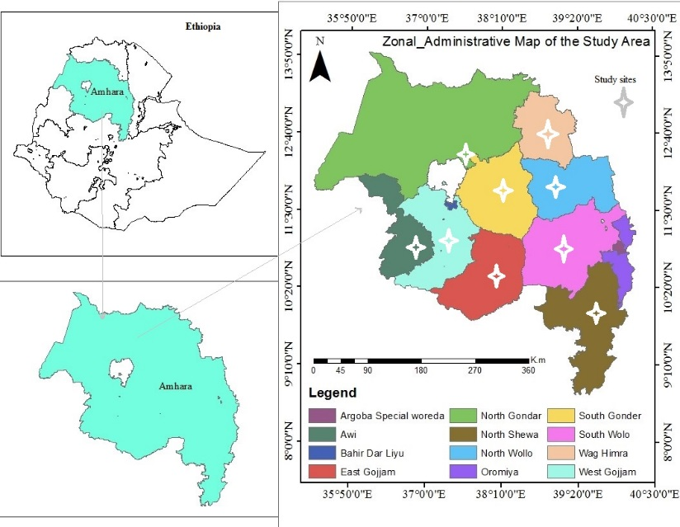

Table S1: The proportion of drug-resistant TB isolates and characteristics of study participants (N=122).
Characteristics |  | N | Anti-TB drug resistance patterns
 |  | N | Any drug resistance  n (%) | INHr  n (%) | RIFr  n (%) | MDR  n (%) | FLQr  n (%)
Sex | Male | 67 | 14 (20.9) | 14 (20.9) | 9 (13.4) | 9 (13.4) | 2 (3.0)
Sex | Female | 55 | 6 (10.9) | 6 (10.9) | 6 (10.9) | 6 (10.9) | 3 (5.5)
Age group (year) | 18-33 | 75 | 17 (22.7) | 17 (22.7) | 12 (16.0) | 12 (16.0) | 5 (6.7)
Age group (year) | 34-49 | 31 | 0 (0.0) | 0 (0.0) | 0 (0.0) | 0 (0.0) | 0 (0.0)
Age group (year) | ≥ 50 | 16 | 3 (18.8) | 3 (18.8) | 3 (18.8) | 3 (18.8) | 0 (0.0)
Residence | Urban | 46 | 10 (21.7) | 10 (21.7) | 7 (15.2) | 7 (15.2) | 2 (4.3)
Residence | Rural | 76 | 10 (13.2) | 10 (13.2) | 8 (10.5) | 8 (10.5) | 3 (3.9)
Marital status | Married | 85 | 11 (12.9) | 11 (12.9) | 7 (8.2) | 7 (8.2) | 2 (2.4)
Marital status | Single* | 37 | 9 (24.3) | 9 (24.3) | 8 (21.6) | 8 (21.6) | 3 (8.1)
Educational status | Can’t read & write | 59 | 6 (10.2) | 6 (10.2) | 4 (6.8) | 4 (6.8) | 0 (0.0)
Educational status | Primary school | 30 | 8 (26.7) | 8 (26.7) | 7 (23.3) | 7 (23.3) | 4 (13.3)
Educational status | Secondary school & above | 33 | 6 (18.2) | 6 (18.2) | 4 (12.1) | 4 (12.1) | 1 (3.0)
Family size | 1-5 | 57 | 13 (22.8) | 13 (22.8) | 9 (15.8) | 9 (15.8) | 3 (5.3)
Family size | > 5 | 65 | 7 (10.8) | 7 (10.8) | 6 (9.2) | 6 (9.2) | 2 (3.1)
Occupation | Farmer | 45 | 4 (8.9) | 4 (8.9) | 2 (4.4) | 2 (4.4) | 1 (2.2)
Occupation | Employed | 6 | 3 (50.0) | 3 (50.0) | 2 (33.3) | 2 (33.3) | 1 (16.7)
Occupation | Unemployed | 23 | 5 (21.7) | 5 (21.7) | 3 (13.0) | 3 (13.0) | 1 (4.3)
Occupation | Housewife | 24 | 1 (4.2) | 1 (4.2) | 1 (4.2) | 1 (4.2) | 0 (0.0)
Occupation | Students & others** | 24 | 7 (29.2) | 7 (29.2) | 7 (29.2) | 7 (29.2) | 2 (8.3)
Study area (zone) | North Wello | 22 | 1 (4.5) | 1 (4.5) | 1 (4.5) | 1 (4.5) | 0 (0.0)
Study area (zone) | South Wello | 22 | 9 (40.9) | 9 (40.9) | 8 (36.4) | 8 (36.4) | 5 (22.7)
Study area (zone) | North Shewa | 33 | 3 (9.1) | 3 (9.1) | 3 (9.1) | 3 (9.1) | 0 (0.0)
Study area (zone) | South Gondar | 28 | 6 (21.4) | 6 (21.4) | 2 (7.1) | 2 (7.1) | 0 (0.0)
Study area (zone) | Central Gondar & others*** | 17 | 1 (5.9) | 1 (5.9) | 1 (5.9) | 1 (5.9) | 0 (0.0)
Note: *Single, divorced & widowed; **Others: religious leaders & deacons; ***Others: Awi zone, West Gojjam, East Gojjam, and Wag-Hamra. Abbreviation: FLQr: Fluoroquinolone resistance; HWS: Holy water sites; INHr: Isoniazid resistance; MDR: Multidrug-resistant; N: Total number of culture-positive cases; PTB: Pulmonary tuberculosis; RIFr: Rifampicin resistance.

