Effects of the physisorption properties of activated carbon derived from human hair as a potential electrode for symmetric supercapacitors
Rashed A. M. Adam, Delvina J. Tarimo, Vusani M. Maphiri, Abdulmajid A. Mirghni, Oladepo Fasakin, and Ncholu Manyala*
Department of Physics, University of Pretoria, Pretoria 0002, South Africa
*Corresponding author email: ncholu.manyala@up.ac.za, Tel.: + (27)12 420 3549
Supporting information

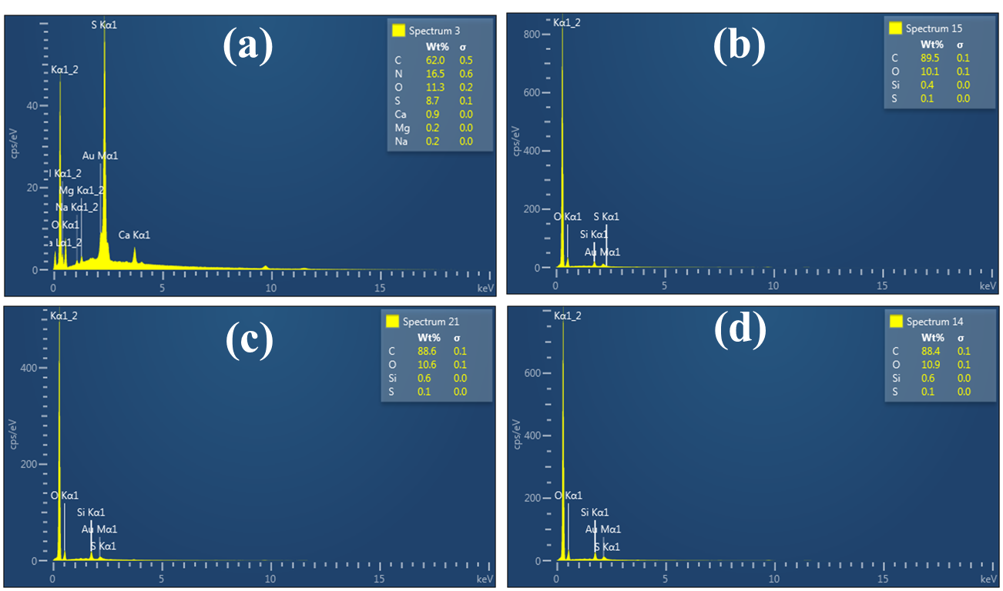
Fig. S1: EDX elemental analysis of (a) Human hair, (b) HH-AC(11), (C) HH-AC(12), and (d) HH-AC(13)

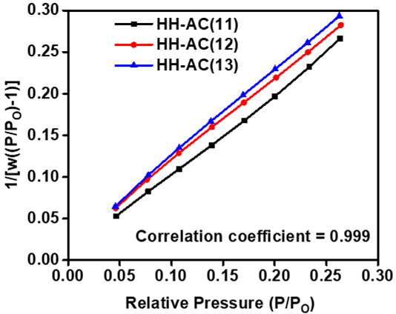
Fig. S2: The BET plot of HH-ACs samples
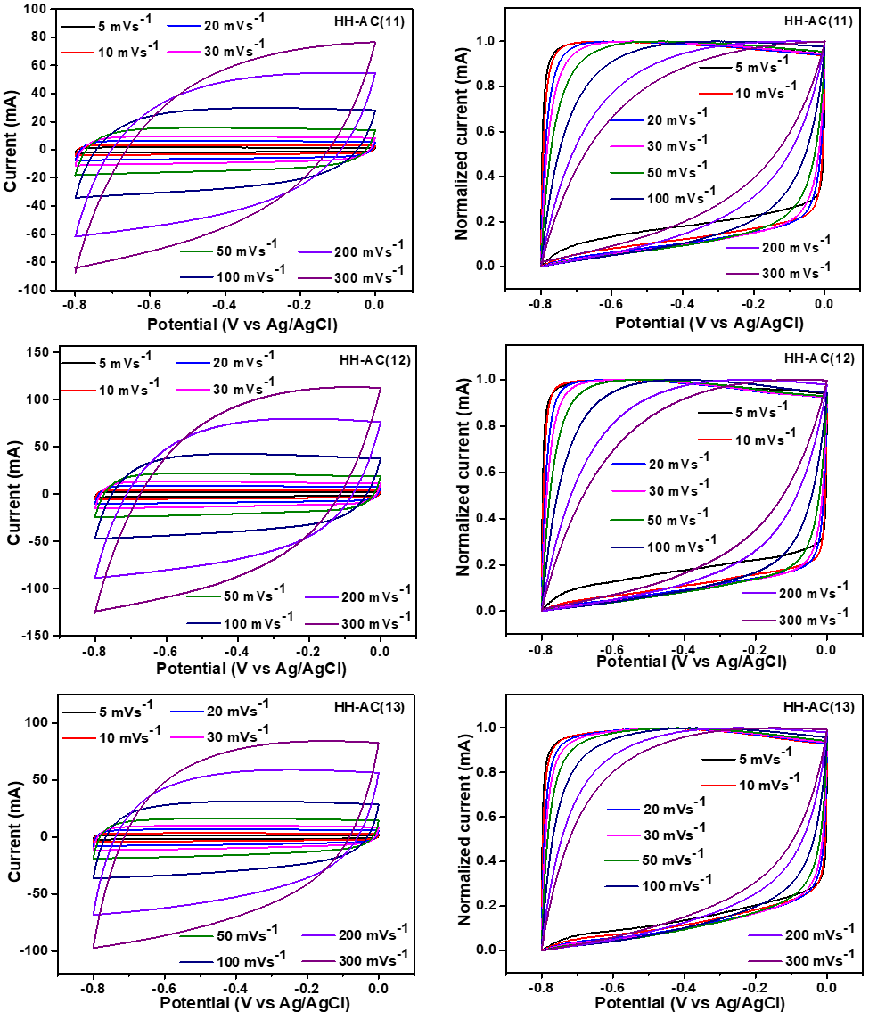
Fig. S3: CV curves at a scan rate in the range of $5-300 mV s^{-1}$ for HH-ACs samples.
The total capacitance ($C_{T}$) is given by:
$C_{T}=C_{o}+C_{diffu}$ (S1)
Where: $C_{o}$ and $C_{diffu}$ are non-diffusion and diffusion capacitance, respectively.
To clarify charge storage process on the electrode structure, Trasatti’s method was employed to differentiate non-diffusion (surface-controlled reaction, EDLC) contribution and diffusion contribution using equation (S2) and (S3).
$C_{S}=k_{1} v^{{-1}/2}+C_{o}$ (S2)
$C_{S}^{-1}=k_{2} v^{1/2}+C_{T}^{-1}$ (S3)
Where $v$ ~ scan rate, $k_{1}$and $k_{2}$ ~ constants, $C_{S}$ ~ specific capacitance depends on $v$.
The charge stored at the surface of the electrode and the total amount of charge stored at the structure of the electrode can be calculated by linear fit and extrapolate the graph of $C_{S}$ versus $\frac{1}{v^{1/2}}$ at $v$ → ∞ (y-intercept gives $C_{o}$) and $C_{S}^{-1}$versus $v^{1/2}$ at $v$ → 0 (y-intercept gives the reciprocal of $C_{T}$) respectively [1,2].
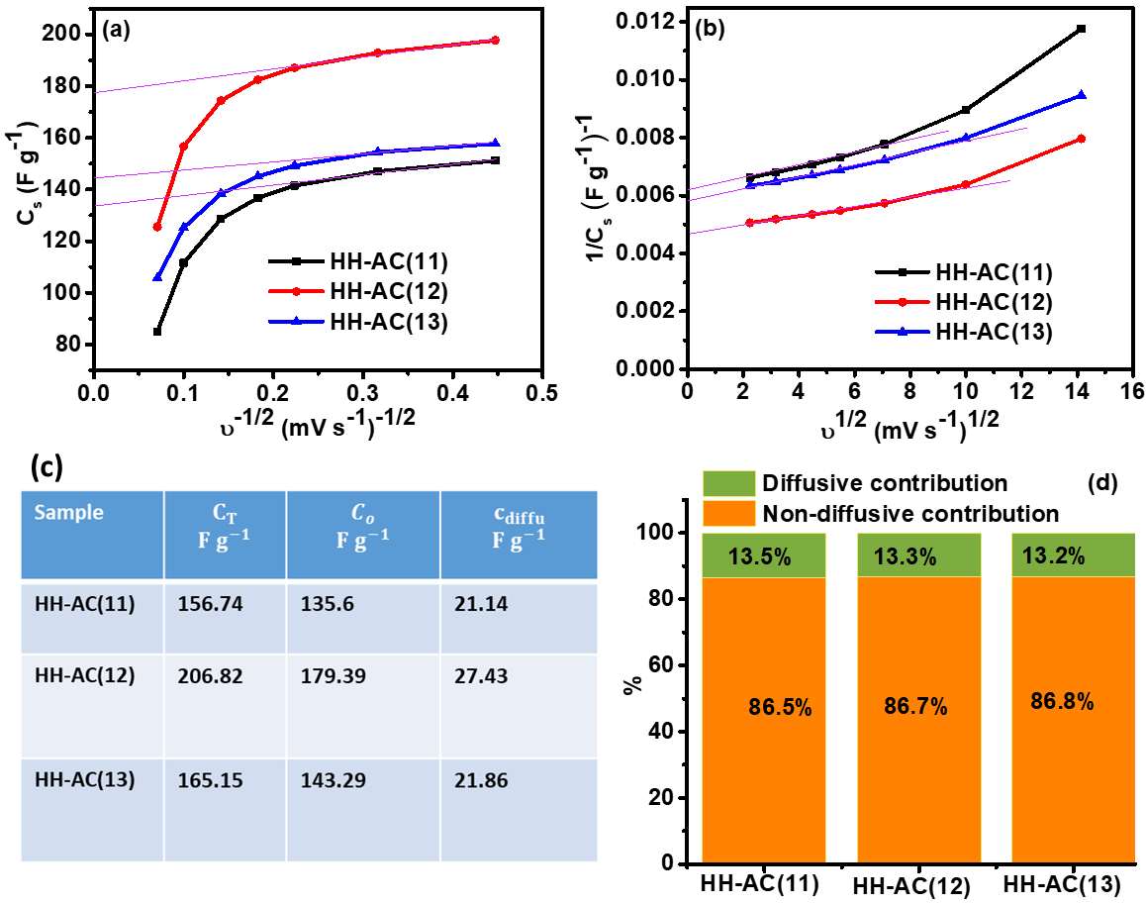
Fig. S4: The capacitance contribution rate of HH-ACs samples using the Trasatti’s method: (a) $C_{S}$ versus $\frac{1}{v^{1/2}}$ , (b) $C_{S}^{-1}$versus $v^{1/2}$, (c) table of difference capacitance values, and (d) histogram of non-diffusive and diffusive capacitance contribution to the total capacitance.
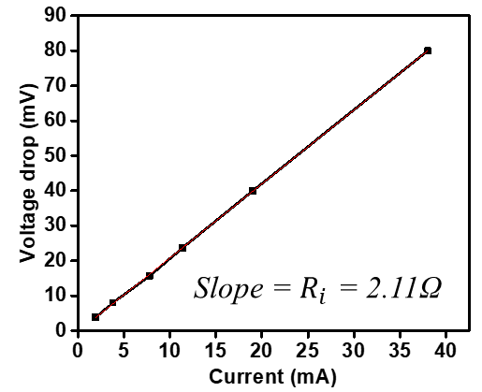
Fig. S5: Voltage drop vs applied currents of HH-AC(12) symmetric supercapacitor device.
Table S1
Sample | $$ρ {(g cm}^{-3})$$ | $$C_{S}^{+} {(F g}^{-1})$$ | $$C_{S}^{-} ({F g}^{-1})$$ | $$C_{V}^{+} {( F cm}^{-3})$$ | $$C_{V}^{-} ({F cm}^{-3})$$
HH-AC(11) | 0.42 | 83 | 114 | 35 | 48
HH-AC(12) | 0.40 | 125.8 | 215 | 50 | 86
HH-AC(13) | 0.38 | 104 | 161 | 40 | 61
Where $ρ$ is the density of the sample $ρ= 1/(V_{t}+1/ρ_{carbon} )$, $V_{t}$ is the total pore volume, and $ρ_{carbon}$ is the actual density of carbon ${(2 g cm}^{-3})$ . $C_{V}$ is the volumetric capacitance in ${F cm}^{-3}$ ( $C_{V}$ = $ρ C_{s}$). $C_{S}^{+}$, $C_{S}^{-}$, $C_{V}^{+}$, and $C_{V}^{-}$ are specific capacitance and volumetric capacitance calculated at positive and negative potentials, respectively [3,4].

Reference
[1] Z.H. Huang, T.Y. Liu, Y. Song, Y. Li, X.X. Liu, Balancing the electrical double layer capacitance and pseudocapacitance of hetero-atom doped carbon, Nanoscale 9 (2017) 13119–13127. https://doi.org/10.1039/c7nr04234e.
[2] G. Maheshwaran, M. Pardha Saradhi, S. Sambasivam, R. Ranjith Kumar, S. Dhinesh, G. Ramalingam, S. Sudhahar, A.A.A. Mohammed, Enhanced electrochemical activity of two dimensional layered bismuthene-MWCNT heterostructures based electrodes for the fabrication of high energy density hybrid supercapacitors, Inorg Chem Commun 158 (2023) 111724. https://doi.org/10.1016/j.inoche.2023.111724.
[3] L. Gao, Z. Chen, H. Zhao, Y. Zou, C. Yu, W. Zhong, Controllable preparation of nitrogen-doped hierarchical and honeycomb-like porous carbon/graphene based on composites of graphene oxide and polyaniline nanorod arrays for high performance supercapacitors, J Energy Storage 36 (2021) 102314. https://doi.org/10.1016/J.EST.2021.102314.
[4] Y. Tao, X. Xie, W. Lv, D.M. Tang, D. Kong, Z. Huang, H. Nishihara, T. Ishii, B. Li, D. Golberg, F. Kang, T. Kyotani, Q.H. Yang, Towards ultrahigh volumetric capacitance: graphene derived highly dense but porous carbons for supercapacitors, Scientific Reports 2013 3:1 3 (2013) 1–8. https://doi.org/10.1038/srep02975.

