Supplementary tables

Table S1: Demographic features, clinical characteristics and molecular findings of 15 Southern African patients, with clinically diagnosed NF1, with a disease-causing variant identified in the NF1 gene.
Clinical features | Patient number
Clinical features | 1 | 2 | 3 | 4 | 5 | 6 | 7 | 9 | 10 | 11ª | 12 | 13 | 14 | 15 | 16
Demographic information
Sex | F | F | M | F | M | M | M | M | F | M | M | F | M | M | F
Age at recruitment | 1y11m | 13y11m | 8y8m | 6y6m | 28y0m | 13y4m | 4y10m | 9y9m | 42y9m | 5y8m | 0y6m | 2y4m | 6y6m | 12y3m | 12y2m
Ethnolinguistic group | Zulu/ Seswati | NA | Zulu | NA | Shona | Sotho/ Venda | NA | Tswana | Tswana | NA | NA | Sotho | Xhosa | NA | Zulu
NIH NF1 criteria met | + | + | + | + | + | + | + | - | + | - | + | + | + | + | +
Growth centiles (SDS)
Weight | 3rd-10th (-1.86) | 10th-25th (-0.78) | 10th-25th (-0.97) | NA | NA | 90th-97th (1.47) | 10th-25th (-1.17) | 10th (-1.56) | 50th (-0.29) | <3rd (-2.05) | <3rd (-2.36) | 25th (-0.53) | 50th (0.20) | 10th-25th (-1.19) | 50th-75th (0.25)
Length/height | <3rd (-2.14) | 3rd-10th (-1.67) | 25th-50th (0.27) | 50th-75th (0.30) | NA | >97th (>3.00) | 3rd-10th (-1.62) | 10th (-1.92) | <3rd (-2.75) | 3rd-10th (-1.44) | <3rd (>-3) | 3rd-25th (-1.33) | 25th-50th (-0.29) | 10th-25th (-1.23) | 90th-97th (1.49)
Head circumference | >97th (2.84) | >97th (>4) | >97th (2.64) | 75th (1.17) | 90th-97th (1.36) | >97th (3.70) | 75th-90th (1.15) | 10th-25th (-1.00) | 75th (1.18) | 50th-75th (0.54) | 75th-90th (0.55) | >97th (2.08) | >97th (2.29) | 50th-75th (0.00) | >97th (3.84)
Ectodermal
CAL (number) | + (>6) | + (>6) | + (>6) | + (>6) | + (>6) | + (>6) | + (>6) | + (3) | - | + (>6) | + (>6) | + (>6) | + (>6) | + (>6) | + (>6)
Axillary/inguinal freckling | + | + | + | + | + | + | - | + | - | - | + | - | + | + | +
Cutaneous neurofibromas (number) | - | + (>2) | + (>2) | + | + (>2) | + | + (>2) | - | + (>2) | - | - | - | + (>2) | + (>2) | + (>2)
Other | Hyperkeratosis, dry skin | - | - | Deep palmar creases | - | - | Hypopigmentation | - | - | - | - | - | - | - | Hyperpigmented patches
Ocular
Lisch nodules (number) | - | - | - | NA | NA | - | NA | - | NA | NA | NA | + (NA) | - | + (NA) | NA
Optic glioma (number) | - | - | - | NA | NA | - | NA | - | NA | NA | NA | - | - | - | NA
Tumours/ malignancies
Plexiform neurofibroma (number) | - | + (1) | - | + (1) | + (1) | + (3) | - | - | - | - | - | - | - | + (1) | -
MPNST | - | - | - | - | - | - | - | - | - | - | - | - | - | - | -
Other | - | Cerebellar glioma | - | - | Ampulla of Vater neuroendocrine tumour | Brainstem glioma | - | - | - | - | - | - | - | - | -
Neurological
Headaches/ migraines | - | + | - | - | - | - | - | - | - | - | - | - | - | + | -
Developmental/ intellectual delay (degree) | + (mild) | + (mod) | - | - | - | - | - | + (NA) | - | + (mild to mod) | - | - | + (NA) | - | + (mild)
Learning disability | + | + | - | - | - | + | - | + | - | + | - | - | + | + | +
Behavioural problems | - | - | - | - | - | - | - | + (ADHD) | - | - | - | - | - | - | -
MRI brain scan | + | + | NA | NA | NA | + | NA | + | NA | NA | + | + | NA | + | NA
FASI | - | - | NA | NA | NA | + | NA | + | NA | NA | - | + | NA | + | NA
Other | - | Chronic hydrocephalus | - | - | - | - | - | - | - | - | - | - | Arachnoid cyst, hydrocephalus | - | -
Musculoskeletal
Long bone or sphenoid wing dysplasia | - | - | - | - | - | - | - | - | - | - | - | - | - | - | -
Scoliosis | - | + | - | - | - | + | - | - | - | - | - | - | - | - | +
Other | Pectus carinatum, joint hyperlaxity | - | - | Short 5th metacarpal | - | - | - | - | - | Clinodactyly | - | Genu valgum | - | - | Genu valgum, overlapping toes
CVS/chest
Hypertension | - | - | - | - | - | - | - | - | - | - | - | - | - | - | -
History of CVA | - | - | - | - | - | - | - | - | - | - | - | - | - | - | -
Other | - | - | - | - | - | - | - | - | - | Broad chest, widely spaced nipples | - | - | - | - | -
Craniofacial
Ocular hypertelorism | - | - | + | - | - | - | - | - | - | + | - | - | - | - | +
DSPF | + | - | + | + | - | - | - | - | - | + | - | - | - | - | -
Low-set ears | + | - | - | - | - | - | - | - | - | + | - | - | - | - | -
Webbed neck | - | - | - | - | - | - | - | - | - | + | - | - | - | - | -
Other | Frontal bossing, full lips, high-arched palate, Widow’s peak | - | Epicanthic folds | Laterally sparse eyebrows, broad nasal tip, short philtrum | Mildly coarse face | - | - | - | Long face, malar hypoplasia | Ptosis, micrognathia | - | - | Micrognathia, full upper lip | - | Broad nasal root
FDR meeting NHI NF1 criteria | - | - | + | - | - | - | - | - | + | - | + | - | NA | - | -
Clinically significant variant identified  NF1 gene: NM_001042492.3 | c.1658A>G (p.His553Arg) | c.6772C>T (p.Arg2258Ter) | c.496_497del (p.Val166Leufs) | c.3721C>T (p.Arg1241Ter) | c.569T>G p.Leu190Ter | c.5267_5268del (p.Lys1756Serfs) | c.27G>A (p.Trp9Ter) | c.5991G>A (p.Trp1997Ter) | c.2540T>C (p.Leu847Pro) | c.1A>C (p.Met1?) | c.5609G>A (p.Arg1870Gln) | c.616A>T (p.Lys206Ter) | Heterozygous NF1 gene deletion (Type 3) | Exon 19 and 20 deletion | Heterozygous NF1 gene deletion and flanking genes (Type 1)
Type | Missense | Nonsense | Frame-shift | Nonsense | Nonsense | Frame-shift | Nonsense | Nonsense | Missense | Start-loss | Missense | Nonsense | Type 3 deletion | Two exon deletion | Type 1 deletion
Interpretation | Pathogenic | Pathogenic | Pathogenic | Pathogenic | Pathogenic | Pathogenic | Pathogenic | Pathogenic | Pathogenic | Likely Pathogenic | Pathogenic | Pathogenic | Pathogenic | Pathogenic | :Pathogenic
ClinVar ID | 420076 | 230389 | 431562 | 361 | 431974 | 1072614 | 1459748 | 233869 | 68323 | 694505 | 185354 | 2443302* | NA | NA | NA
Abbreviations
NF1 (neurofibromatosis type 1), F (female), M (male), y (year), m (month), NA (not available), NIH (National Institutes of Health), NF1 (neurofibromatosis type 1), + (yes/present), - (no/absent), SDS (standard deviation score), CAL (café-au-lait macule), MPNST (malignant peripheral nerve sheath tumour), mod (moderate), ADHD (attention deficit hyperactivity disorder), MRI (magnetic resonance imaging), FASI (focal area of signal intensity), CVS (cardiovascular system), CVA (cerebral vascular accident), DSPF (down slanted palpebral fissures), FDR (first degree relative).
Key
CNV positive cases are shaded in grey. Absent/unavailable clinical information is indicated by NA (not available).ª Patient 11 was noted to have a Noonan syndrome / NF1 phenotype. ClinVar ID (*) identified only in the current study and submitted to ClinVar. Patients shaded in grey were found to have deletion variants; these do not have ClinVar IDs, as the exact variation could not be determined using MLPA analysis.

Table S2: Demographic features, clinical characteristics and molecular results of 10 Southern African patients, with clinically diagnosed NF1, with no identified disease-causing SNV/CNV in NF1 or SPRED1.

Clinical features | Patient number
Clinical features | 17 | 18 | 19 | 20 | 21 | 22 | 23 | 24 | 25 | 26
Demographic information
Sex | M | M | F | M | M | M | M | F | F | F
Age | 12y8m | 33y5m | 7y3m | 2y2m | 6y7m | 27y6m | 18y9m | 6y8m | 29y8m | 33y
Ancestry | African | African | African | African | African | African | African | African | African | African
Ethnolinguistic group | Sesotho | Zulu | NA | NA | NA | NA | NA | NA | Sesotho | NA
NIH NF1 criteria met | + | + | + | + | + | + | + | + | + | +
Growth centiles (SDS)
Weight | 10th-25th (-0.87) | 3rd-97th (-0.82) | 10th-25th (-1.19) | 25th-50th (0.00) | 10th-25th (-1.13) | 3rd-97th (-0.80) | <3rd (-2.54) | 3rd-97th (+0.96) | 3rd-97th (+0.17) | 25th (-0.88)
Length/height | 10th-25th (-1.17) | <3rd (-2.17) | 10th (-1.18) | 25th-50th (-0.28) | 25th-50th (-1.15) | <3rd (-2.24) | 10th-25th (-1.13) | 3rd-97th (-0.29) | <3rd (-2.21) | 10-25th (-1.84)
Head circumference | >97th (+2.00) | >97th (>+3.00) | 50th-75th (+0.33) | <3rd (-2.53) | 25th-50th (-0.31) | >97th (+2.46) | 90th-97th (+1.36) | >97th (+3.62) | 3rd-97th (-0.36) | 90-97th (1.18)
Ectodermal
CAL (number) | + (>6 ) | + (>6) | + (>6) | + (>6) | + (>6) | + (>6) | + (>6) | + (>6) | + (1) | +(>6)
Axillary/inguinal freckling | + | + | + | + | + | + | + | + | + | +
Cutaneous neurofibromas (number) | + (>2) | + (>2) | + (>2) | + (1) | + (>2) | + (>2) | - | - | + (>2) | + (many)
Other | - | - | - | Velvety skin | Velvety skin, deep palmar creases | Melanocytic naevi | Hyperkeratosis, coarse hair | - | - | -
Ocular
Lisch nodules (number) | + (NA) | NA | NA | NA | NA | NA | NA | NA | NA | NA
Optic glioma (number) | - | NA | NA | NA | NA | NA | NA | NA | NA | NA
Tumours/malignancies
Plexiform neurofibroma (number) | - | + (2) | - | - | - | + (1) | - | + (1) | - | + (1)
MPNST | - | - | - | - | - | - | - | - | - | -
Neurological
Headaches/ migraines | + | - | - | - | - | - | - | - | - | -
Developmental/ intellectual delay (degree) | - | - | - | + (severe) | + (mild to mod) | + (mild) | + (mod) | - | - | -
Learning disability | - | + | - | + | + | + | + | - | - | -
Behavioural problems | - | - | - | - | - | - | - | - | - | -
MRI brain scan | + | + | NA | NA | NA | NA | NA | NA | NA | NA
FASI | - | - | NA | NA | NA | NA | NA | NA | NA | NA
Other | - | - | - | West syndrome | - | - | - | - | - | -
Musculoskeletal
Long bone or sphenoid wing dysplasia | - | - | - | - | - | - | - | - | - | -
Scoliosis | + | + | - | - | - | - | - | - | - | -
Other | Pectus excavatum, hemihypertrophy, joint hyperlaxity | - | - | - | - | - | - | Pectus excavatum | - | -
CVS/ chest
Hypertension | - | - | - | - | - | - | - | - | - | -
History of CVA | - | - | - | - | - | - | - | - | - | -
Other | - | - | - | Congenital cardiac lesion (not specified) | - | - | - | - | - | -
Craniofacial
Ocular hypertelorism | + | - | + | - | - | - | + | + | - | -
DSPF | - | - | - | + | + | - | - | - | - | -
Low-set ears | + | - | - | - | + | - | - | - | - | -
Webbed neck | - | - | - | - | - | - | - | - | - | -
Other | Upslanted PFs, high arched palate, overfolded ear helices | - | - | - | Ptosis, long PFs, large mouth, full lips, fleshy ears | Gum hypertrophy | Coarse face, triangular face, prominent chin | - | - | -
FDR meeting NHI NF1 criteria | - | + | NA | NA | NA | NA | NA | + | - | +
Abbreviations
NF1 (neurofibromatosis type 1), SNV (single nucleotide variant), CNV (copy number variant), M (male), F (female), y (years), m (months), NA (not available), NIH (National Institutes of Health), NF1 (neurofibromatosis type 1), + (yes/present), - (no/absent), SDS (standard deviation scores), CAL (café-au-lait macule), MPNST (malignant peripheral nerve sheath tumour), mod (moderate), MRI (magnetic resonance imaging), FASI (focal area of signal intensity), CVS (cardiovascular system), CVA (cerebral vascular accident), DSPF (down slanted palpebral fissures), PFs (palpebral fissures), FDR (first degree relative).

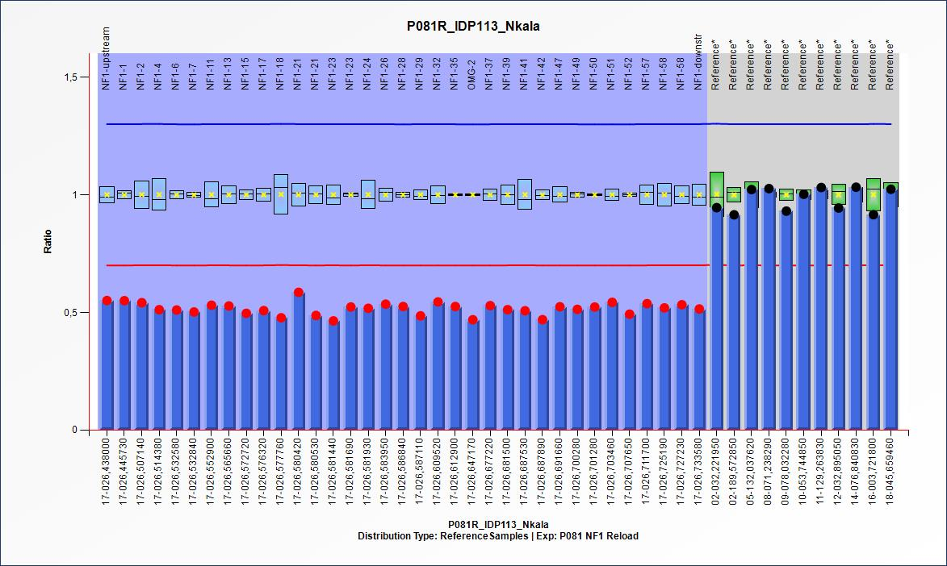
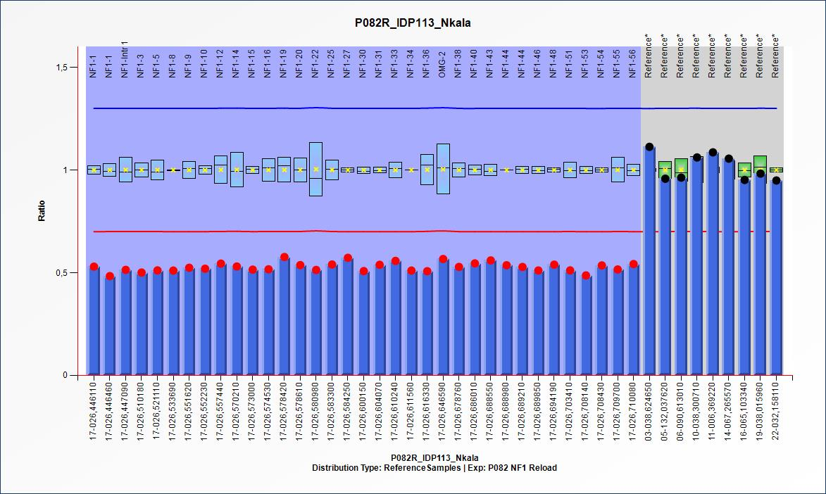
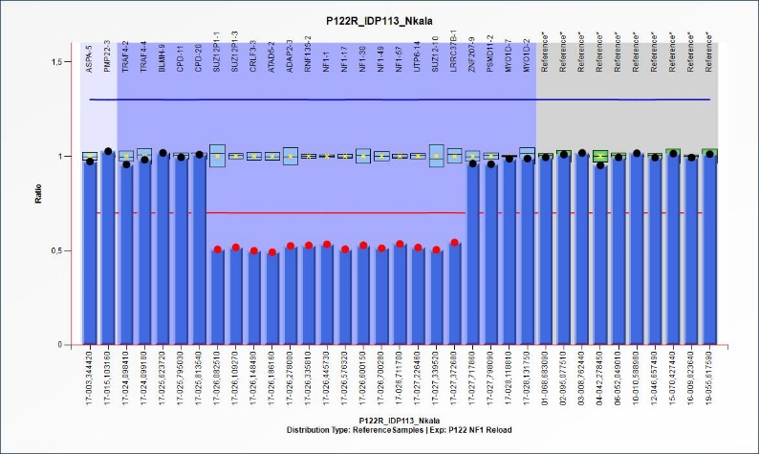
a)

b)

c)

Figure S1: Type 1 deletion shown in Patient 16; full NF1 gene deletion with extension to the genes flanking the NF1 gene (SUZ12P1, CRLF3, ATAD5, ADAP2 and RNF135 upstream); (LRRC37B, SUZ12 and UTP6 downstream) identified using MLPA probe mix P081 a), P082 b) and P122 c).

