Appendix A: Supplementary figures and tables
Figure A1: Data plots for electricity consumption (solid, RHS), EV stock (dashed, LHS), and cumulative EV sales (dotted, LHS)
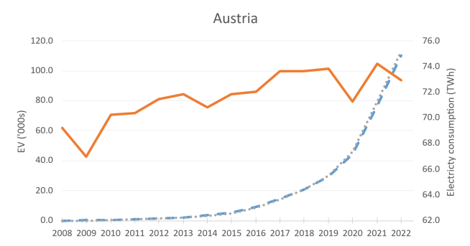 | 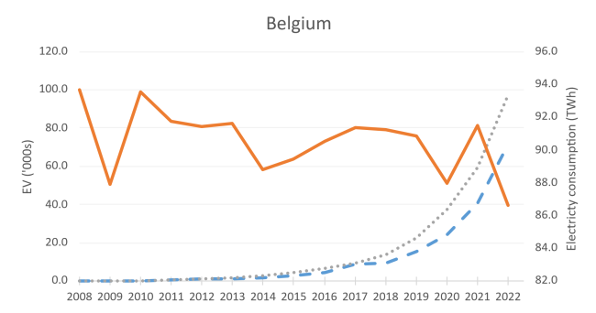
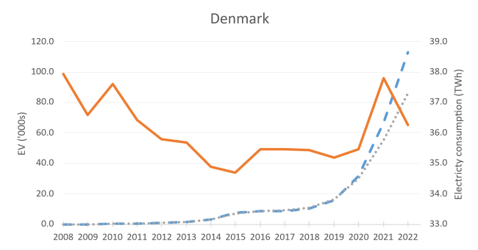 | 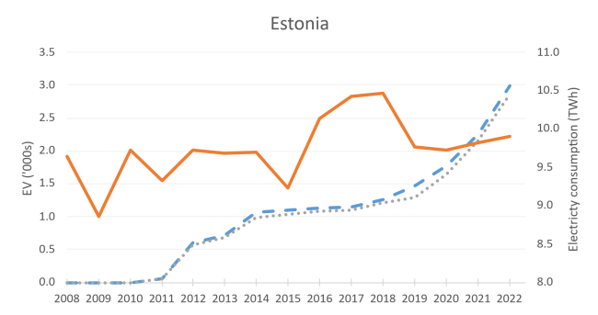
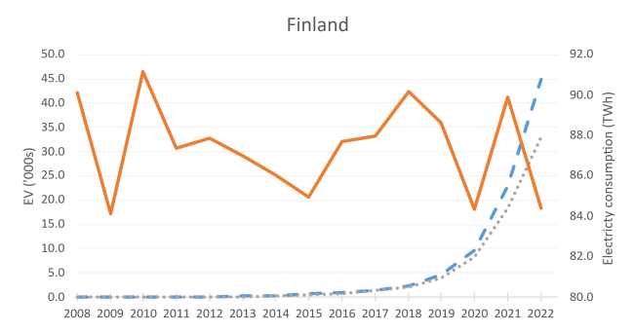 | 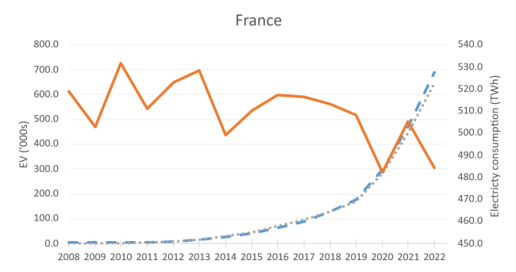
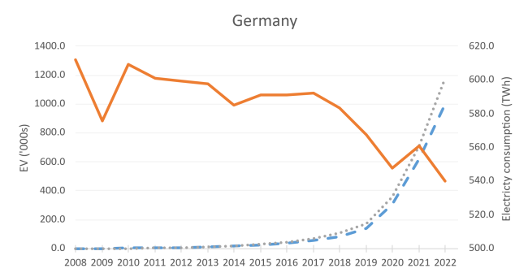 | 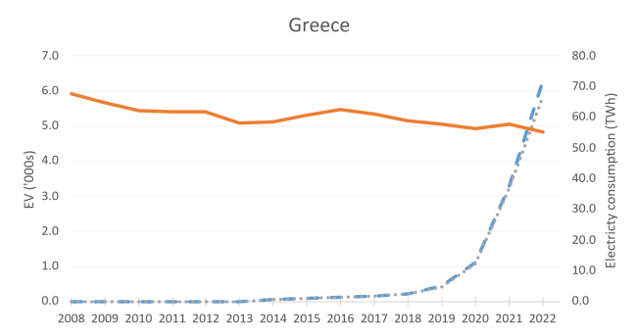
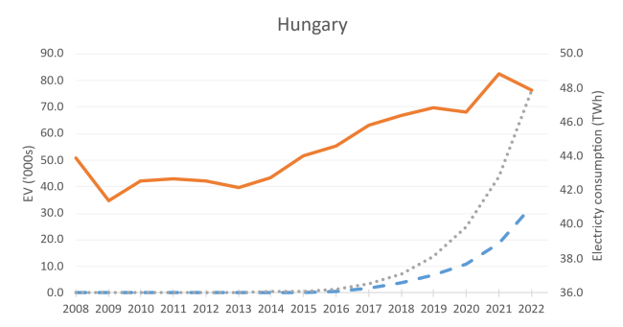 | 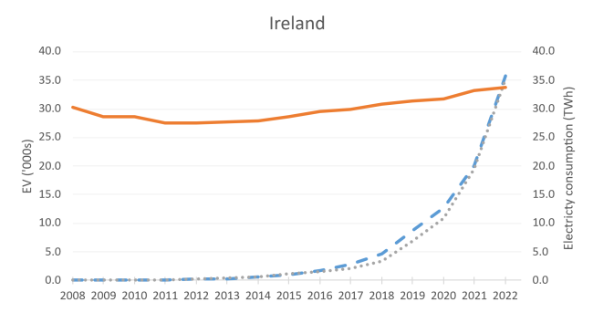
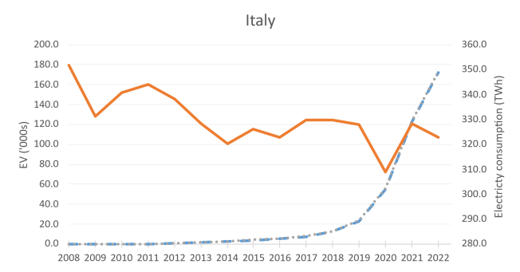 | 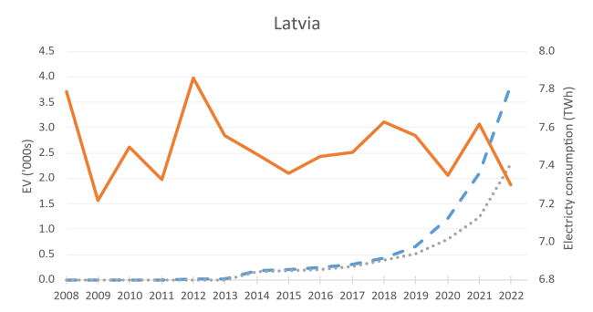
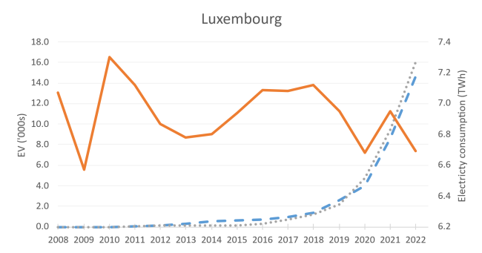 | 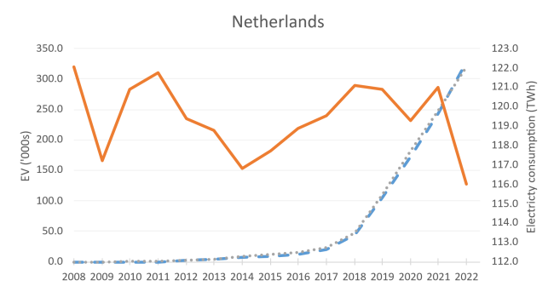
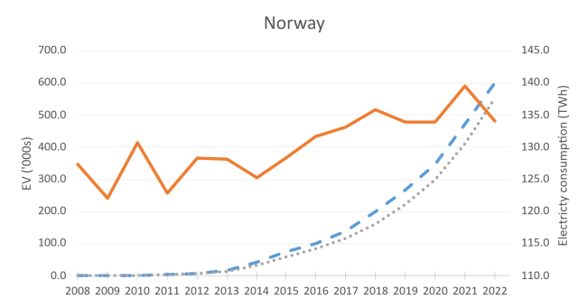 | 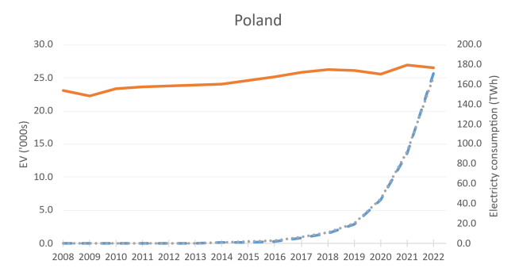
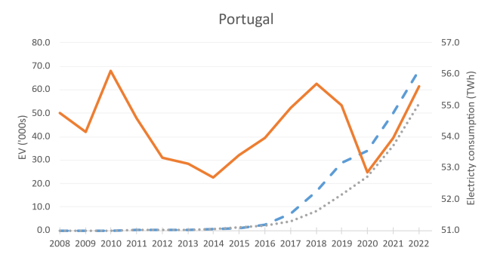 | 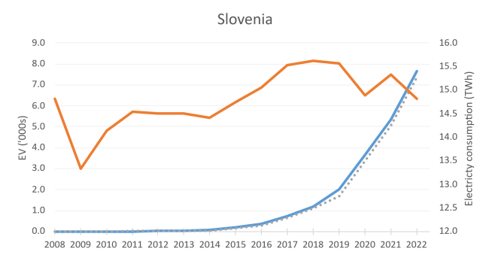
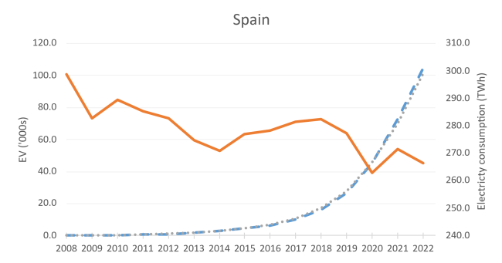 | 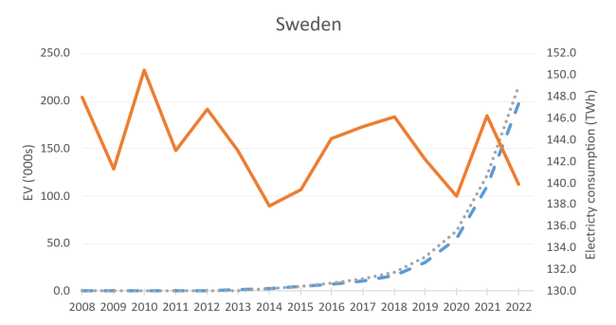
Note: The axis for electricity consumption does not start from zero, as this would remove any variation visible in the graph given the level of consumption for certain countries.

Table A1: Unitroot test results
Variable | Test type | HT |  | Breitung |  | Fisher |  |  |  | Conclusion
 |  |  |  |  |  | Dickey-Fuller |  | Phillips-Perron |  | Conclusion
Variable | Test type | Test statistic | P-value | Test statistic | P-value | Test statistic | P-value | Test statistic | P-value | Conclusion
Electricity consumption | Constant | 0.769 | 0.000 | 0.220 | 0.587 | 1.789 | 0.963 | -6.260 | 0.000 | I(1)
Electricity consumption | Trend | 0.629 | 0.046 | 0.301 | 0.618 | 1.212 | 0.887 | -3.594 | 0.000 | I(1)
FD Electricity consumption | Constant | -0.198 | 0.000 | -4.510 | 0.000 | -3.040 | 0.001 | -20.762 | 0.000 | I(1)
FD Electricity consumption | Trend | -0.166 | 0.000 | -4.516 | 0.000 | -0.520 | 0.301 | -22.307 | 0.000 | I(1)
Electricity price | Constant | 0.864 | 0.358 | 0.665 | 0.747 | 2.274 | 0.989 | -0.255 | 0.400 | I(1)
Electricity price | Trend | 0.795 | 0.988 | 0.297 | 0.617 | 1.485 | 0.931 | 4.068 | 1.000 | I(1)
FD Electricity price | Constant | 0.087 | 0.000 | -5.484 | 0.000 | -1.957 | 0.025 | -11.864 | 0.000 | I(1)
FD Electricity price | Trend | 0.097 | 0.000 | -4.275 | 0.000 | 0.096 | 0.538 | -9.906 | 0.000 | I(1)
EVstock | Constant | 0.993 | 1.000 | 2.360 | 0.991 | 0.604 | 0.727 | 7.702 | 1.000 | I(1)
EVstock | Trend | 0.654 | 0.139 | -1.280 | 0.100 | 3.943 | 1.000 | -0.463 | 0.322 | I(1)
FD EV stock | Constant | -0.121 | 0.000 | -8.410 | 0.000 | -2.608 | 0.005 | -14.618 | 0.000 | I(1)
FD EV stock | Trend | -0.115 | 0.000 | -8.315 | 0.000 | -0.293 | 0.385 | -12.640 | 0.000 | I(1)
EV sales | Constant | 0.7142 | 0.000 | 2.457 | 0.993 | 0.626 | 0.734 | 7.948 | 1.000 | I(1)
EV sales | Trend | 0.533 | 0.000 | -1.073 | 0.142 | 3.921 | 1.000 | -0.197 | 0.422 | I(1)
FD EV sales | Constant | -0.273 | 0.000 | -7.766 | 0.000 | -2.823 | 0.002 | -14.083 | 0.000 | I(1)
FD EV sales | Trend | -0.262 | 0.000 | -7.695 | 0.000 | -0.547 | 0.292 | -11.996 | 0.000 | I(1)
Cum. EV sales | Constant | 0.795 | 0.003 | 2.949 | 0.998 | 0.602 | 0.726 | 8.146 | 1.000 | I(1)
Cum. EV sales | Trend | 0.667 | 0.216 | -0.275 | 0.392 | 4.439 | 1.000 | 1.026 | 0.848 | I(1)
FD Cum. EV sales | Constant | -0.060 | 0.000 | -5.448 | 0.000 | -2.247 | 0.012 | -9.055 | 0.000 | I(1)
FD Cum. EV sales | Trend | -0.045 | 0.000 | -5.456 | 0.000 | 0.010 | 0.504 | -6.000 | 0.000 | I(1)
GDP | Constant | 0.968 | 0.999 | 2.958 | 0.999 | 1.406 | 0.920 | 3.268 | 1.000 | I(1)
GDP | Trend | 0.764 | 0.937 | 0.201 | 0.580 | -0.652 | 0.257 | -0.373 | 0.355 | I(1)
FD GDP | Constant | 0.215 | 0.000 | -4.518 | 0.000 | -1.921 | 0.027 | 0.027 | 0.000 | I(1)
FD GDP | Trend | 0.301 | 0.000 | -2.894 | 0.002 | 0.414 | 0.661 | -11.430 | 0.000 | I(1)
Population | Constant | 0.990 | 1.000 | 6.199 | 1.000 | 3.182 | 0.999 | 3.177 | 0.999 | I(1)
Population | Trend | 0.932 | 1.000 | 3.434 | 1.000 | 0.873 | 0.809 | 3.567 | 1.000 | I(1)
FD Population | Constant | 0.787 | 0.003 | -2.522 | 0.006 | 1.209 | 0.887 | -0.185 | 0.427 | I(1)
FD Population | Trend | 0.936 | 1.000 | 0.117 | 0.547 | 1.618 | 0.947 | 2.191 | 0.986 | I(1)
Cooling degree days | Constant | -0.021 | 0.000 | -3.334 | 0.000 | -0.509 | 0.305 | -15.885 | 0.000 | I(0)
Cooling degree days | Trend | -0.105 | 0.000 | -5.787 | 0.000 | 1.604 | 0.946 | -18.696 | 0.000 | I(0)
Heating degree days | Constant | 0.064 | 0.000 | -4.297 | 0.000 | 0.346 | 0.635 | -14.660 | 0.000 | I(0)
Heating degree days | Trend | -0.105 | 0.000 | -2.901 | 0.002 | 1.186 | 0.882 | -17.076 | 0.000 | I(0)

Note: All unit root tests have an H₀ of all panels containing a unit root (nonstationary).The Harris-Tzavalis (1999) and Breitung (2000) unitroot teststest this H₀against the alternative that all panels are stationary, while the Fisher tests are tested against an alternative of at least one panel being stationary. “FD” refers to the first difference.The trend specification includes a constant term as well. The shaded cells indicate the result the conclusion has considered. The Breitung (2000) test statistic report is robust to the cross-sectional correlation of the error terms. The inverse normal test statistic is reported for the Fisher tests.

Table A2: Dynamic panel estimation of the relationship between EVs and electricity consumption in first differences (growth rates)
Electricity consumption
 | Model 1 | Model 2 | Model 3 | Model 4 | Model 5
EV | 0.001  (0.001) | 0.000  (0.001) | 0.000  (0.001) | 0.000  (0.001) | 0.000  (0.001)
Electricity price | -0.048***  (0.008) | -0.045***  (0.009) | -0.045***  (0.009) | -0.042***  (0.009) | -0.042***  (0.009)
GDP |  | 0.226***  (0.058) | 0.227***  (0.057) | 0.237***  (0.054) | 0.237***  (0.034)
Population |  |  | 0.186  (0.274) | 0.208  (0.270) | 0.208  (0.263)
CDD |  |  |  | 0.004***  (0.001) | 0.004**  (0.001)
HDD |  |  |  | 0.059***  (0.018) | 0.059***  (0.017)
C | 0.007***  (0.001) | 0.002*  (0.001) | 0.002  (0.002) | 0.001  (0.002) | 0.001  (0.001)
N | 440 | 440 | 440 | 440 | 440
R^2_a | 0.638 | 0.662 | 0.662 | 0.683 | 0.679

Note: *, **, and *** indicate significance at the 10%, 5%, and 1% levels, respectively. Standard errors are given in parentheses. Country-clustered standard errors were included to account for the possible effect of cross-sectional dependence due to most countries being in the European Union. Country, year, and region fixed effects, as well as the interaction between year and region fixed effects, were included in all regressions. Robust standard errors were used in all models, aside from model 5, where we used country-clustered standard errors. The primary variable of interest is highlighted for the reader's convenience. All variables are in natural logarithm approximations, as noted in Section 3.1.

Table A3: Cointegration test results for models 1 to 5 from Table 3
Residual | Test type | HT |  | Breitung |  | Fisher |  |  |  | Conclusion
 |  |  |  |  |  | Dickey-Fuller |  | Phillips-Perron |  | Conclusion
Residual | Test type | Test statistic | P-value | Test statistic | P-value | Test statistic | P-value | Test statistic | P-value | Conclusion
Model 1 | Constant | 0.879 | 0.549 | 0.881 | 0.811 | 2.384 | 0.991 | -0.557 | 0.289 | No CI
Model 2 | Constant | 0.802 | 0.006 | -0.707 | 0.240 | 0.921 | 0.822 | -2.796 | 0.003 | CI(1)
Model 3 | Constant | 0.802 | 0.006 | -0.707 | 0.240 | 0.905 | 0.817 | -2.804 | 0.003 | CI(1)
Model 4 | Constant | 0.812 | 0.015 | -0.417 | 0.338 | 0.959 | 0.831 | -2.750 | 0.003 | CI(1)
Model 5 | Constant | 0.818 | 0.015 | -0.417 | 0.338 | 0.959 | 0.831 | -2.750 | 0.003 | CI(1)

Note: All unit root tests have an H₀ of all panels containing a unit root (nonstationary). The Harris-Tzavalis (1999) and Breitung (2000) unit root tests test this H₀ against the alternative that all panels are stationary, while the Fisher tests are tested against an alternative of at least one panel being stationary. “FD” refers to the first difference. The trend specification includes a constant term as well. The shaded cells indicate the result the conclusion has considered. The Breitung (2000) test statistic report is robust to the cross-sectional correlation of the error terms. The inverse normal test statistic is reported for the Fisher tests.

Table A4: Cointegration test results for groups 1 to 4 from Table 4
Group | Test type | HT |  | Breitung |  | Fisher |  |  |  | Conclusion
 |  |  |  |  |  | Dickey-Fuller |  | Phillips-Perron |  | Conclusion
Group | Test type | Test statistic | P-value | Test statistic | P-value | Test statistic | P-value | Test statistic | P-value | Conclusion
With EV
1 | Constant | 0.588 | 0.000 | -2.681 | 0.004 | 0.068 | 0.527 | -2.572 | 0.005 | CI(1)
2 | Constant | 0.710 | 0.002 | -0.589 | 0.278 | -2.137 | 0.016 | -2.187 | 0.014 | CI(1)
3 | Constant | 0.800 | 0.097 | 0.045 | 0.518 | -0.593 | 0.277 | -1.624 | 0.093 | CI(1)
4 | Constant | 0.659 | 0.000 | -2.380 | 0.009 | 0.583 | 0.720 | -0.982 | 0.163 | CI(1)
Without EV
1 | Constant | 0.596 | 0.000 | -2.682 | 0.004 | -0.101 | 0.460 | -2.590 | 0.005 | CI(1)
2 | Constant | 0.710 | 0.002 | -0.590 | 0.278 | -2.107 | 0.018 | -2.178 | 0.015 | CI(1)
3 | Constant | 0.810 | 0.132 | 0.157 | 0.562 | 0.152 | 0.560 | -1.412 | 0.079 | No CI
4 | Constant | 0.652 | 0.000 | -2.222 | 0.013 | 0.339 | 0.633 | -1.073 | 0.142 | CI(1)

Note: All unit root tests have an H₀ of all panels containing a unit root (nonstationary). The Harris-Tzavalis (1999) and Breitung (2000) unit root tests test this H₀ against the alternative that all panels are stationary, while the Fisher tests are tested against an alternative of at least one panel being stationary. “FD” refers to the first difference. The trend specification includes a constant term as well. The shaded cells indicate the result the conclusion has considered. The Breitung (2000) test statistic report is robust to the cross-sectional correlation of the error terms. The inverse normal test statistic is reported for the Fisher tests.

Table A5: Error correction estimation of electricity consumption(without EV sales) with countries grouped by EV sales in 2022.
Electricity consumption
Group | 1 |  | 2 |  | 3 |  | 4
LR
Electricity price | -0.000  (0.015) |  | -0.102***  (0.020) |  | -0.148***  (0.043) |  | -0.085***  (0.021)
GDP | 0.248***  (0.025) |  | 0.260***  (0.031) |  | 0.176*  (0.100) |  | -0.659***  (0.112)
Pop | -0.154***  (0.038) |  | -0.104  (0.079) |  | 1.029***  (0.338) |  | 0.675***  (0.137)
CDD | 0.004  (0.003) |  | 0.007  (0.005) |  | -0.001  (0.007) |  | 0.001  (0.007)
HDD | 0.083  (0.051) |  | -0.074  (0.056) |  | -0.033  (0.081) |  | 0.111  (0.095)
C | -1.389  (0.868) |  | 0.723  (1.031) |  | -16.241***  (4.326) |  | 12.403***  (2.922)
Cointegrated | Yes |  | Yes |  | No |  | Yes
SR
Lagged EC term | -0.382***  (0.101) |  | -0.207***  (0.070) |  | -0.118***  (0.038) |  | -0.275***  (0.072)
D.Electricity price | -0.028**  (0.012) |  | -0.025  (0.024) |  | 0.003  (0.021) |  | -0.017  (0.022)
D.GDP | 0.172*  (0.101) |  | 0.210***  (0.077) |  | 0.560***  (0.109) |  | 0.252  (0.154)
D.Pop | 0.028  (0.696) |  | 0.994**  (0.477) |  | 0.391  (0.280) |  | -0.040  (0.541)
D.CDD | 0.004**  (0.002) |  | 0.007***  (0.002) |  | 0.002  (0.001) |  | 0.005**  (0.002)
D.HDD | 0.073**  (0.029) |  | 0.028  (0.022) |  | 0.092***  (0.024) |  | 0.041  (0.039)
C | 0.004  (0.003) |  | 0.002  (0.003) |  | -0.005**  (0.002) |  | -0.003  (0.004)
N | 110 |  | 110 |  | 110 |  | 110
$$R_{a}^{2}$$ | 0.677 |  | 0.684 |  | 0.842 |  | 0.722
Countries |  | Estonia (E)  Greece (S)  Hungary (E)  Latvia (E)  Slovenia (E) |  | Finland (N)  Ireland (W)  Luxembourg (W)  Poland (E)  Portugal (W) |  | Austria (W)  Belgium (W)  Denmark (N)  Italy (S)  Spain (S) |  | France (W)  Germany (W)  Netherlands (W)  Norway (N)  Sweden (N)
Cumulative EV sales 2022 | 2,296 – 16,068 |  | 25,225 – 76,336 |  | 85,789 – 172,960 |  | 215,883 – 1,175,597

Note: *, **, and *** indicate significance at the 10%, 5%, and 1% levels, respectively. Standard errors are given in parentheses. Country-clustered standard errors were included to account for the possible effect of cross-sectional dependence due to most countries being in the European Union. Country and year-fixed effects were included in all regressions. Robust standard errors were used in all models. The primary variable of interest is highlighted for the reader's convenience. All variables are in natural logarithm approximations, as noted in Section 3.1. The results of the cointegration tests are presented in Table A4 in the Appendix. Size groups 1 to 4 correspond to the lowest EV sales in 2022 to the highest EV sales in 2022, dividing the sample into four equal groups. The short-run results for Group 3 are in italics, as there was no cointegrating relationship, however, simply to compare the size of the coefficients to the results in Table 4. Regions are given in brackets after the country names.

Appendix B: Robustness check using cumulative EV sales and EV sales
Table B1: Dynamic panel estimation of the relationship between cumulative EV sales and electricity consumption
Electricity consumption
Model | 1 | 2 | 3 | 4 | 5
Lagged dependent | 0.870***  (0.037) | 0.767***  (0.033) | 0.768***  (0.033) | 0.772***  (0.032) | 0.772***  (0.056)
EV cum. sales | 0.002  (0.001) | 0.002  (0.001) | 0.001  (0.001) | 0.001  (0.001) | 0.001  (0.001)
Electricity price | -0.020**  (0.008) | -0.021***  (0.007) | -0.022***  (0.008) | -0.023***  (0.007) | -0.023***  (0.004)
GDP |  | 0.099***  (0.017) | 0.103***  (0.019) | 0.105***  (0.018) | 0.105***  (0.024)
Population |  |  | -0.024  (0.031) | -0.031  (0.031) | -0.031  (0.046)
CDD |  |  |  | 0.005**  (0.002) | 0.005***  (0.001)
HDD |  |  |  | 0.068**  (0.026) | 0.068***  (0.019)
C | 0.740***  (0.193) | -1.429***  (0.391) | -1.137**  (0.498) | -1.685***  (0.517) | -1.685*  (0.832)
N | 440 | 440 | 440 | 440 | 440
$$R_{a}^{2}$$ | 1.000 | 1.000 | 1.000 | 1.000 | 1.000

Note: *, **, and *** indicate significance at the 10%, 5%, and 1% levels, respectively. Standard errors are given in parentheses. Country-clustered standard errors were included to account for the possible effect of cross-sectional dependence due to most countries being in the European Union. Country, year, and region fixed effects, as well as the interaction between year and region fixed effects, were included in all regressions. Robust standard errors were used in all models, aside from model 5, where we used country-clustered standard errors. The primary variable of interest is highlighted for the reader's convenience. All variables are in natural logarithm approximations, as noted in Section 3.1.

Table B2: Dynamic panel estimation of the relationship between cumulative EV sales and electricity consumption in first differences (growth rates)
Electricity consumption
 | Model 1 | Model 2 | Model 3 | Model 4 | Model 5
EV cum. sales | 0.005***  (0.002) | 0.004**  (0.002) | 0.004**  (0.002) | 0.004**  (0.002) | 0.004**  (0.002)
Electricity price | -0.049***  (0.009) | -0.046***  (0.009) | -0.046***  (0.009) | -0.043***  (0.009) | -0.043***  (0.010)
GDP |  | 0.209***  (0.056) | 0.211***  (0.055) | 0.222***  (0.052) | 0.222***  (0.038)
Population |  |  | 0.167  (0.274) | 0.189  (0.270) | 0.189  (0.261)
CDD |  |  |  | 0.004***  (0.001) | 0.004**  (0.002)
HDD |  |  |  | 0.058***  (0.018) | 0.058***  (0.018)
C | 0.004***  (0.001) | 0.001  (0.002) | -0.000  (0.002) | -0.000  (0.002) | -0.000  (0.001)
N | 440 | 440 | 440 | 440 | 440
R^2_a | 0.649 | 0.670 | 0.669 | 0.690 | 0.686

Note: *, **, and *** indicate significance at the 10%, 5%, and 1% levels, respectively. Standard errors are given in parentheses. Country-clustered standard errors were included to account for the possible effect of cross-sectional dependence due to most countries being in the European Union. Country, year, and region fixed effects, as well as the interaction between year and region fixed effects, were included in all regressions. Robust standard errors were used in all models, aside from model 5, where we used country-clustered standard errors. The primary variable of interest is highlighted for the reader's convenience. All variables are in natural logarithm approximations, as noted in Section 3.1.

Table B3: Error correction estimation of the relationship between cumulative EV sales and electricity consumption
Electricity consumption
Model | 2 | 3 | 4 | 5
LR
EV cum. sales | 0.001  (0.002) | 0.001  (0.002) | 0.001  (0.002) | 0.001  (0.003)
Electricity price | -0.033***  (0.009) | -0.033***  (0.010) | -0.034***  (0.009) | -0.034**  (0.015)
GDP | 0.281***  (0.022) | 0.282***  (0.023) | 0.283***  (0.023) | 0.283***  (0.039)
Pop |  | -0.002  (0.050) | -0.004  (0.050) | -0.004  (0.128)
CDD |  |  | 0.002  (0.003) | 0.002  (0.002)
HDD |  |  | 0.044  (0.038) | 0.044  (0.047)
C | -2.535***  (0.603) | -2.515***  (0.874) | -2.883***  (0.919) | -2.883  (2.568)
SR
Lagged EC term | -0.196***  (0.035) | -0.196***  (0.035) | -0.185***  (0.033) | -0.185***  (0.049)
D.EV cum. sales | 0.004**  (0.002) | 0.004**  (0.002) | 0.004**  (0.002) | 0.004**  (0.001)
D.Electricity price | -0.043***  (0.009) | -0.043***  (0.009) | -0.040***  (0.009) | -0.040***  (0.008)
D.GDP | 0.199***  (0.052) | 0.199***  (0.052) | 0.209***  (0.050) | 0.209***  (0.039)
D.Pop |  | 0.018  (0.260) | 0.055  (0.254) | 0.055  (0.318)
D.CDD |  |  | 0.004***  (0.001) | 0.004**  (0.001)
D.HDD |  |  | 0.058***  (0.016) | 0.058***  (0.019)
C | 0.001  (0.002) | 0.001  (0.002) | 0.000  (0.002) | 0.000  (0.001)
N | 440 | 440 | 440 | 440
$$R_{a}^{2}$$ | 0.702 | 0.701 | 0.719 | 0.715

Note: *, **, and *** indicate significance at the 10%, 5%, and 1% levels, respectively. Standard errors are given in parentheses. Country-clustered standard errors were included to account for the possible effect of cross-sectional dependence due to most countries being in the European Union. Country, year, and region fixed effects, as well as the interaction between year and region fixed effects, were included in all regressions. Robust standard errors were used in all models, aside from model 5, where we used country-clustered standard errors. The primary variable of interest is highlighted for the reader's convenience. All variables are in natural logarithm approximations, as noted in Section 3.1.

Table B4: Error correction estimation of the relationship between cumulative EV sales and electricity consumption with countries grouped by EV sales in 2022.
Electricity consumption
Group | 1 | 2 | 3 | 4
LR
EV cum. sales | 0.002  (0.003) | 0.013**  (0.006) | 0.014**  (0.005) | 0.008*  (0.004)
Electricity price | -0.001  (0.015) | -0.082***  (0.022) | -0.161***  (0.042) | -0.098***  (0.022)
GDP | 0.244***  (0.026) | 0.278***  (0.032) | 0.178*  (0.097) | -0.597***  (0.109)
Pop | -0.160***  (0.040) | -0.137*  (0.078) | 1.101***  (0.327) | 0.650***  (0.139)
CDD | 0.004  (0.003) | 0.007  (0.005) | 0.001  (0.007) | -0.001  (0.007)
HDD | 0.083  (0.051) | -0.068  (0.056) | -0.021  (0.080) | 0.116  (0.094)
C | -1.192  (0.977) | 0.565  (0.985) | -17.658***  (4.162) | 11.074***  (2.753)
Cointegrated | Yes | Yes | Yes | Yes
SR
Lagged EC term | -0.384***  (0.102) | -0.206***  (0.069) | -0.116***  (0.038) | -0.304***  (0.077)
D.EV cum. sales | 0.002  (0.003) | 0.008***  (0.003) | 0.005***  (0.002) | 0.003  (0.002)
D.Electricity price | -0.029**  (0.012) | -0.018  (0.022) | 0.002  (0.020) | -0.020  (0.022)
D.GDP | 0.160  (0.105) | 0.207***  (0.077) | 0.590***  (0.106) | 0.247  (0.155)
D.Pop | 0.029  (0.704) | 1.058**  (0.467) | 0.410  (0.282) | -0.108  (0.511)
D.CDD | 0.004**  (0.002) | 0.008***  (0.002) | 0.003*  (0.001) | 0.004*  (0.002)
D.HDD | 0.073**  (0.029) | 0.032  (0.023) | 0.094***  (0.023) | 0.049  (0.038)
C | 0.004  (0.003) | -0.002  (0.003) | -0.008***  (0.002) | -0.004  (0.004)
N | 110 | 110 | 110 | 110
$$R_{a}^{2}$$ | 0.674 | 0.692 | 0.851 | 0.727
Countries | Estonia (E)  Greece (S)  Hungary (E)  Latvia (E)  Slovenia (E) | Finland (N)  Ireland (W)  Luxembourg (W)  Poland (E)  Portugal (W) | Austria (W)  Belgium (W)  Denmark (N)  Italy (S)  Spain (S) | France (W)  Germany (W)  Netherlands (W)  Norway (N)  Sweden (N)
Cumulative EV sales (2022) | 2,296 – 16,068 | 25,225 – 76,336 | 85,789 – 172,960 | 215,883 – 1,175,597

Note: *, **, and *** indicate significance at the 10%, 5%, and 1% levels, respectively. Standard errors are given in parentheses. Country-clustered standard errors were included to account for the possible effect of cross-sectional dependence due to most countries being in the European Union. Country and year-fixed effects were included in all regressions. Robust standard errors were used in all models. The primary variable of interest is highlighted for the reader's convenience. All variables are in natural logarithm approximations, as noted in Section 3.1. The results of the cointegration tests are presented in Table A4 in the Appendix. Groups 1 to 4 correspond to the lowest cumulative EV sales in 2022 to the highest cumulative EV sales in 2022, dividing the sample into four equal groups. Regions are given in brackets after the country names.

Table B5: Dynamic panel estimation of the relationship between EV sales and electricity consumption
Electricity consumption
Model | 1 | 2 | 3 | 4 | 5
Lagged dependent | 0.871***  (0.037) | 0.770***  (0.034) | 0.770***  (0.034) | 0.774***  (0.033) | 0.774***  (0.056)
EV sales | 0.002**  (0.001) | 0.002**  (0.001) | 0.002*  (0.001) | 0.002*  (0.001) | 0.002*  (0.001)
Electricity price | -0.019**  (0.008) | -0.020***  (0.007) | -0.021**  (0.008) | -0.023***  (0.007) | -0.023***  (0.004)
GDP |  | 0.098***  (0.017) | 0.102***  (0.019) | 0.104***  (0.018) | 0.104***  (0.025)
Population |  |  | -0.022  (0.031) | -0.031  (0.030) | -0.030  (0.045)
CDD |  |  |  | 0.004***  (0.002) | 0.004***  (0.001)
HDD |  |  |  | 0.067**  (0.026) | 0.067**  (0.019)
C | 0.727***  (0.193) | -1.419***  (0.392) | -1.150**  (0.490) | -1.671***  (0.506) | -1.671*  (0.812)
N | 440 | 440 | 440 | 440 | 440
$$R_{a}^{2}$$ | 1.000 | 1.000 | 1.000 | 1.000 | 1.000

Note: *, **, and *** indicate significance at the 10%, 5%, and 1% levels, respectively. Standard errors are given in parentheses. Country-clustered standard errors were included to account for the possible effect of cross-sectional dependence due to most countries being in the European Union. Country, year, and region fixed effects, as well as the interaction between year and region fixed effects, were included in all regressions. Robust standard errors were used in all models, aside from model 5, where we used country-clustered standard errors. The primary variable of interest is highlighted for the reader's convenience. All variables are in natural logarithm approximations, as noted in Section 3.1.

Table B6: Dynamic panel estimation of the relationship between EV sales and electricity consumption in first differences (growth rates)
Electricity consumption
 | Model 1 | Model 2 | Model 3 | Model 4 | Model 5
EV | 0.004***  (0.001) | 0.004***  (0.001) | 0.004***  (0.001) | 0.003***  (0.001) | 0.003***  (0.001)
Electricity price | -0.049***  (0.008) | -0.046***  (0.009) | -0.046***  (0.009) | -0.043***  (0.009) | -0.043**  (0.010)
GDP |  | 0.212***  (0.056) | 0.214***  (0.055) | 0.225***  (0.052) | 0.225***  (0.038)
Population |  |  | 0.174  (0.269) | 0.195  (0.265) | 0.195  (0.263)
CDD |  |  |  | 0.003**  (0.001) | 0.003**  (0.002)
HDD |  |  |  | 0.056***  (0.018) | 0.056***  (0.018)
C | 0.005***  (0.001) | 0.001  (0.002) | 0.000  (0.002) | 0.000  (0.002) | 0.000  (0.001)
N | 440 | 440 | 440 | 440 | 440
R^2_a | 0.653 | 0.675 | 0.674 | 0.693 | 0.688

Note: *, **, and *** indicate significance at the 10%, 5%, and 1% levels, respectively. Standard errors are given in parentheses. Country-clustered standard errors were included to account for the possible effect of cross-sectional dependence due to most countries being in the European Union. Country, year, and region fixed effects, as well as the interaction between year and region fixed effects, were included in all regressions. Robust standard errors were used in all models, aside from model 5, where we used country-clustered standard errors. The primary variable of interest is highlighted for the reader's convenience. All variables are in natural logarithm approximations, as noted in Section 3.1.

Table B7: Error correction estimation of the relationship between EV sales and electricity consumption
Electricity consumption
Model | 2 | 3 | 4 | 5
LR
EV sales | 0.001  (0.002) | 0.001  (0.001) | 0.001  (0.001) | 0.001  (0.003)
Electricity price | -0.033***  (0.009) | -0.033***  (0.010) | -0.034***  (0.009) | -0.034**  (0.015)
GDP | 0.281***  (0.022) | 0.282***  (0.023) | 0.283***  (0.023) | 0.283***  (0.039)
Pop |  | -0.002  (0.049) | -0.006  (0.049) | -0.006  (0.127)
CDD |  |  | 0.002  (0.003) | 0.002  (0.002)
HDD |  |  | 0.043  (0.037) | 0.043  (0.043)
C | -2.528***  (0.603) | -2.500***  (0.868) | -2.853***  (0.910) | -2.853  (2.547)
SR
Lagged EC term | -0.194***  (0.038) | -0.191***  (0.038) | -0.181***  (0.035) | -0.181***  (0.052)
D.EV sales | 0.002**  (0.001) | 0.002**  (0.001) | 0.002**  (0.001) | 0.002**  (0.001)
D.Electricity price | -0.036***  (0.011) | -0.036***  (0.012) | -0.033***  (0.012) | -0.033**  (0.012)
D.GDP | 0.241***  (0.051) | 0.242***  (0.050) | 0.261***  (0.049) | 0.261***  (0.040)
D.Pop |  | 0.284  (0.255) | 0.297  (0.254) | 0.297  (0.296)
D.CDD |  |  | 0.004***  (0.001) | 0.004***  (0.001)
D.HDD |  |  | 0.064***  (0.015) | 0.064***  (0.016)
C | 0.001  (0.002) | -0.000  (0.002) | -0.001  (0.002) | -0.001  (0.001)
N | 440 | 440 | 440 | 440
$$R_{a}^{2}$$ | 0.653 | 0.654 | 0.682 | 0.682

Note: *, **, and *** indicate significance at the 10%, 5%, and 1% levels, respectively. Standard errors are given in parentheses. Country-clustered standard errors were included to account for the possible effect of cross-sectional dependence due to most countries being in the European Union. Country, year, and region fixed effects, as well as the interaction between year and region fixed effects, were included in all regressions. Robust standard errors were used in all models, aside from model 5, where we used country-clustered standard errors. The primary variable of interest is highlighted for the reader's convenience. All variables are in natural logarithm approximations, as noted in Section 3.1.

Table B8: Error correction estimation of the relationship between EV sales and electricity consumption with countries grouped by cumulative EV sales in 2022.
Electricity consumption
Group | 1 | 2 | 3 | 4
LR
EV sales | 0.001  (0.002) | 0.013***  (0.004) | 0.013**  (0.005) | 0.006  (0.004)
Electricity price | -0.001  (0.015) | -0.090***  (0.019) | -0.158***  (0.042) | -0.096***  (0.023)
GDP | 0.248***  (0.025) | 0.283***  (0.031) | 0.182*  (0.098) | -0.619***  (0.109)
Pop | -0.159***  (0.040) | -0.166**  (0.081) | 1.089***  (0.333) | 0.663***  (0.140)
CDD | 0.003  (0.003) | 0.007  (0.005) | 0.001  (0.007) | -0.001  (0.007)
HDD | 0.084*  (0.051) | -0.077  (0.053) | -0.018  (0.080) | 0.112  (0.095)
C | -1.313  (0.918) | 1.071  (1.001) | -17.592***  (4.296) | 11.486***  (2.750)
Cointegrated | Yes | Yes | Yes | Yes
SR
Lagged EC term | -0.384***  (0.102) | -0.198***  (0.071) | -0.124***  (0.039) | -0.294***  (0.076)
D.EV sales | 0.001  (0.002) | 0.007***  (0.002) | 0.003*  (0.002) | 0.002  (0.001)
D.Electricity price | -0.028**  (0.012) | -0.022  (0.021) | 0.002  (0.020) | -0.02  (0.022)
D.GDP | 0.168  (0.103) | 0.210***  (0.076) | 0.580***  (0.106) | 0.249  (0.156)
D.Pop | 0.042  (0.700) | 1.082**  (0.459) | 0.408  (0.285) | -0.083  (0.519)
D.CDD | 0.004**  (0.002) | 0.008***  (0.002) | 0.003*  (0.001) | 0.004*  (0.002)
D.HDD | 0.073**  (0.030) | 0.024  (0.023) | 0.094***  (0.024) | 0.046  (0.038)
C | 0.004  (0.003) | -0.002  (0.003) | -0.007***  (0.002) | -0.003  (0.004)
N | 110 | 110 | 110 | 110
$$R_{a}^{2}$$ | 0.674 | 0.694 | 0.847 | 0.726
Countries | Estonia (E)  Greece (S)  Hungary (E)  Latvia (E)  Slovenia (E) | Finland (N)  Ireland (W)  Luxembourg (W)  Poland (E)  Portugal (W) | Austria (W)  Belgium (W)  Denmark (N)  Italy (S)  Spain (S) | France (W)  Germany (W)  Netherlands (W)  Norway (N)  Sweden (N)
Cumulative EV sales (2022) | 2,296 – 16,068 | 25,225 – 76,336 | 85,789 – 172,960 | 215,883 – 1,175,597

Note: *, **, and *** indicate significance at the 10%, 5%, and 1% levels, respectively. Standard errors are given in parentheses. Country-clustered standard errors were included to account for the possible effect of cross-sectional dependence due to most countries being in the European Union. Country and year-fixed effects were included in all regressions. Robust standard errors were used in all models. The primary variable of interest is highlighted for the reader's convenience. All variables are in natural logarithm approximations, as noted in Section 3.1. The results of the cointegration tests are presented in Table A4 in the Appendix. Groups 1 to 4 correspond to the lowest cumulative EV sales in 2022 to the highest cumulative EV sales in 2022, dividing the sample into four equal groups. Regions are given in brackets after the country names.

